Module number – BMSK4014
Student’s Name – Michelle Bradshaw
Student number - 2432614
Date – 25TH August 2025
Problem Solving and Decision Making

Table of Contents
Introduction 3
Defining the Complex Workplace Problem 3
Scope – Who is affected? 3
Impact – How are they affected? 4
Collecting and Analysing Information 4
Brainstorming 4
Mind Mapping 5
5 Whys 6
Ishikawa (Fishbone) Analysis 8
Suggesting a Range of Solutions 10
Using Decision-Making Techniques to Evaluate Solutions 11
Decision Matrix (Grid Analysis) 11
Cost-Benefit Analysis 12
1. Implementation of Agile Project Management Methodology 12
2. Adoption of a Formal Decision-Making Framework 12
3. Investment in Advanced Project Analytics and AI Tools 12
Evaluating Options and Selecting the Best Solution 13
Implementation Plan 13
Stakeholder Analysis 16
Communication Plan 16
Monitoring and Review Techniques 17
Conclusion 18
References 19

Introduction
Effective problem solving and decision making are critical to project success, particularly in large organisations such as Deloitte UK where delays and cost overruns can undermine client confidence and financial performance. The report examines a complex workplace problem – inefficient project delivery caused by poor decision making and its scope, impacts, and potential solutions. Research shows that rigid or flawed decision processes often lead directly to project delays and cost growth. It will use structured analysis techniques (e.g. 5 Whys, root-cause analysis, fishbone diagrams) to understand the underlying causes, brainstorm alternative solutions, and evaluate options using decision making tools (decision matrices, cost‐benefit analysis). Based on this, a preferred solution will be selected and a detailed implementation plan developed using a Gantt chart. Stakeholders will be identified, and a communication and monitoring plan laid out to ensure successful rollout of the chosen solution. This comprehensive approach integrates academic insights and practical tools, drawing on the literature (e.g. PMI standards, project management best practices, decision‐making frameworks) to guide each step

Defining the Complex Workplace Problem
The problem at hand is inefficient project delivery, manifested as repeated delays, budget overruns and/or quality shortfalls, stemming from poor decision making during project planning and execution. The actual condition is that projects consistently fail to meet schedule, cost, or scope targets (Zvarikova et al., 2021). The desired condition is on-time, on-budget delivery with agreed quality. Crucial restrictions on solutions include tight timeframes (projects often have fixed deadlines), limited budgets, and constrained human resources. The complexity arises because multiple decisions affect project flow: prioritizing tasks, allocating resources, approving changes, etc.

Scope – Who is affected?
This issue spans the organisation. Project teams and managers directly suffer from ambiguity and rework. Senior leadership is affected by strategic failures and cost overruns. Clients or end-users suffer delays or inferior deliverables. Suppliers and subcontractors face schedule changes. In effect, all layers of the organisation are impacted, making it clear that effective decision-making ownership must be well defined (e.g. senior leaders should endorse improvements). The scope includes every project affected by slow or incorrect decisions from IT implementations to service delivery initiatives (Azlan et al., 2024).

Impact – How are they affected?
Inefficient delivery has wide-ranging negative impacts. Financially, delays inflate costs and reduce return on investment. Operationally, work backlogs grow and team morale falls. Clients and stakeholders lose trust when projects slip, damaging reputation. For example, one study notes that overly rigid (“prescriptive”) decision-making in the public sector “leads to inefficient project delivery” and harms performance (Wei & Qi, 2024). Poor decisions (or delayed decisions) cause cascading delays: e.g. waiting for approval on design changes stalls subsequent tasks (paint wall vs. still waiting for bricks).

Collecting and Analysing Information

Brainstorming
The problem of inefficient project delivery at Deloitte UK, stemming from poor decision-making, is a complex issue with significant impacts across the organization and its clients. Analysis of information from a range of sources reveals the scope, impact, and potential causes of this problem. Ineffective project delivery is linked to barriers such as weak project management, inadequate communication, and lack of talent. Poorly informed or untimely decisions are a key factor contributing to inefficiency and project failure (Behrend & Pitman, 2022). Delays and cost overruns frequently result from poor teamwork and late decisions. When decision-making processes are delayed, it directly impacts project timelines and stalls work. This creates operational bottlenecks, leading to extended timelines and misallocated resources. The consequences of such delays are severe, including financial loss, reputational damage, strained teams, cost overruns, contractual disputes, arbitration, and quality issues. For consulting firms specifically, poor communication is cited as a primary reason for project delays, causing misalignment between team members and clients. These delays ultimately harm client trust and organizational performance (Van Kersbergen & Vis, 2022).
Drawing on best practices, effective decision-making in project management requires recognizing the problem, defining goals, gathering necessary information, and generating possible solutions. PMI emphasizes the importance of accurate, frequent information from reliable sources and the willingness to decide under uncertainty. Integrating objective, fact-based analysis with subjective, human-centric input is recommended for robust decisions. Frameworks like the PMI Ethical Decision-Making Framework (EDMF) provide structured processes to guide professionals through complex dilemmas. Deloitte itself advocates for data driven decision making, especially in dynamic and unpredictable circumstances, to improve organizational outcomes (Celestin & Sujatha, 2024).

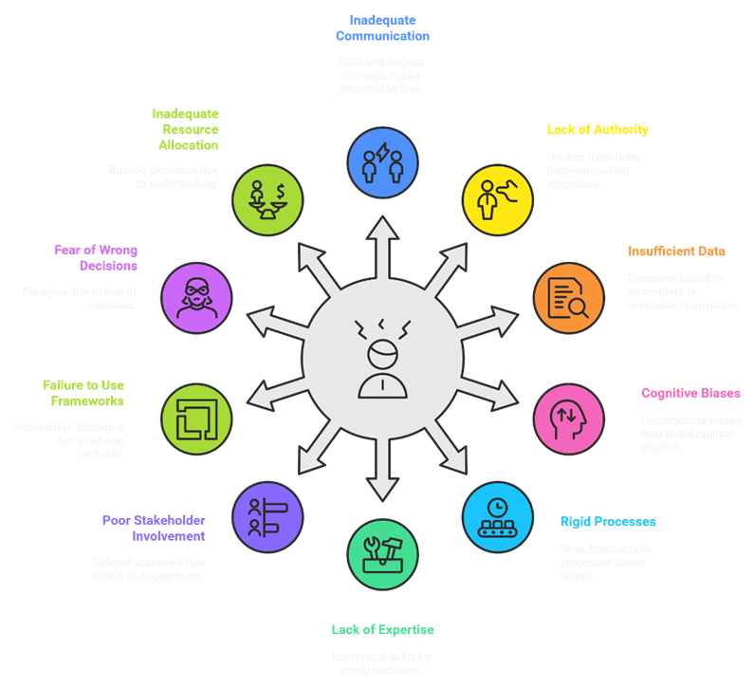

Furthermore, the complexity of an organization makes untangling and redesigning decision-making practices challenging, highlighting the need for deliberate improvement efforts

Mind Mapping
The analysis of inefficient project delivery at Deloitte UK due to poor decision making reveals a multifaceted problem with significant scope and impact. Information from various sources indicates that delays in decision-making directly impact project timelines, stall work, and can lead to increased costs and frustrated stakeholders. These delays contribute to financial loss, reputational damage, strained teams, and quality issues (Taha, 2021). Poorly defined needs, ineffective stakeholder engagement, and inadequate project management are factors contributing to project inefficiencies. Furthermore, inconclusive data or inadequate expertise can lead to poor decisions or operational errors. Deloitte UK itself emphasizes the importance of timely decision-making informed by project controls and clear audit trails for requirements and decisions, highlighting the significance of structured processes. The firm also advocates for data driven decision making to improve organizational outcomes.
To systematically explore the causes and complexity of this problem, mind mapping is an appropriate technique. Mind mapping is a visual brainstorming tool that organizes ideas hierarchically, which can boost creativity and problem-solving (El Khatib et al., 2024). It is particularly useful for teams facing issues like project delays, as it helps trace causes through branches representing different failure points. By starting with the main problem inefficient project delivery teams can develop a hierarchy of potential causes, such as communication breakdowns, unclear authority, data issues, or process bottlenecks. This visual approach aids in brainstorming, organizing ideas, and supporting decision-making by clearly mapping out challenges and their interconnections. Using a mind map to visualize timelines, dependencies, and potential solutions can aid in prioritizing tasks and facilitate more effective problem-solving within project management.

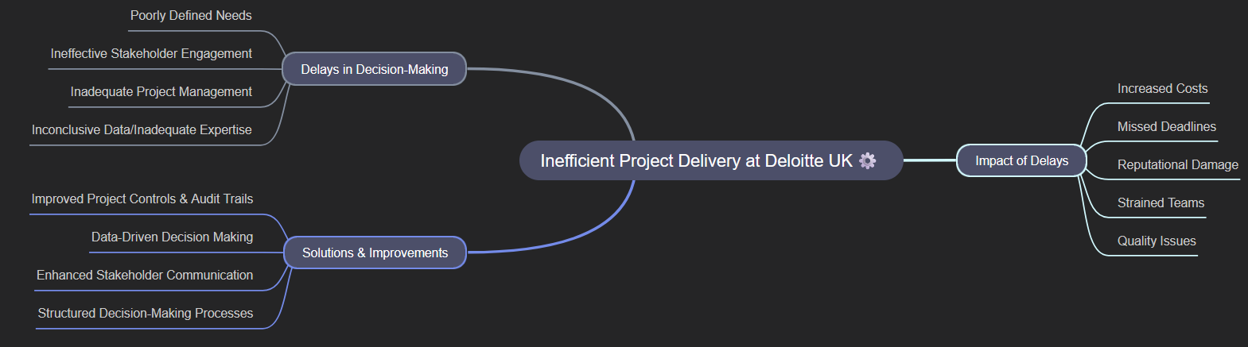

This structured visualization helps turn the complexity of delayed projects into a clearer framework for identifying root causes and developing solutions.

5 Whys
The problem of inefficient project delivery at Deloitte UK, stemming from poor decision making, is a complex issue with significant impacts across the organisation and its clients. Analysis of information from a range of sources reveals the scope, impact, and potential causes of this problem.
Deloitte UK recognises the importance of clear processes for managing projects and decisions. The firm offers tools like Tracker, which provides a clear and comprehensive audit trail of requirements, communications, and decisions to keep team members aligned. This highlights the acknowledged need for transparency in the decision-making process (Laubacher et al., 2023). Furthermore, Deloitte advocates for data-driven decision-making to navigate uncertainty and market fluctuations, which can impact delivery, particularly in complex areas like the construction supply chain. The firm also possesses frameworks aimed at identifying root causes of problems in distressed programs, suggesting an internal methodology for tackling delivery issues.
To identify the root causes of inefficient project delivery due to poor decision-making, the "5 Whys" technique can be applied. This method involves repeatedly asking "why" to drill down from a symptom to the underlying cause.
- Problem: A project at Deloitte UK is consistently missing deadlines.
  - Why 1: Why is the project missing deadlines? Because key tasks are starting later than planned.
  - Why 2: Why are key tasks starting later than planned? Because necessary approvals for deliverables are delayed.
  - Why 3: Why are approvals for deliverables delayed? Because the decision-makers are not receiving the complete information package on time.
  - Why 4: Why is the complete information package not received on time? Because the project team is waiting for final data from a third-party vendor, and there is no clear escalation path for delays.
  - Why 5: Why is there no clear escalation path for vendor delays? Because the project's risk management and communication plan did not adequately define escalation procedures for external dependencies.

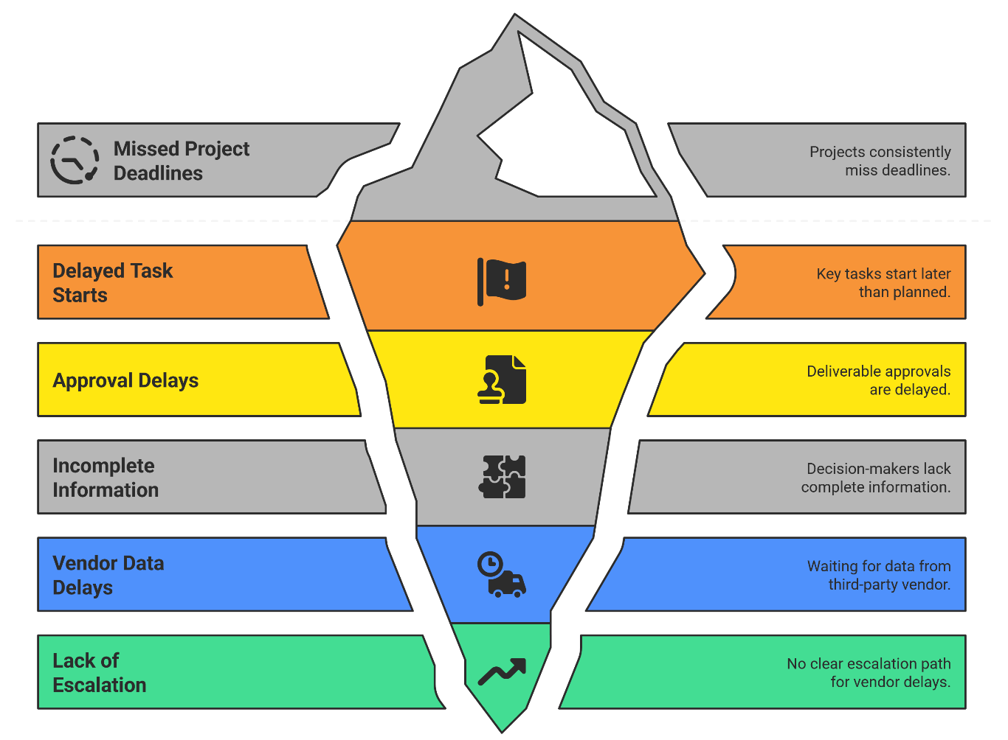

This line of questioning suggests a potential root cause could be inadequate planning and communication protocols, specifically the lack of defined escalation procedures for risks involving third parties, leading to delayed information, delayed decisions, and ultimately, project delays. This aligns with the understanding that poorly defined needs and ineffective stakeholder engagement can contribute to project inefficiencies (Rogers & Kalinova, 2021). The use of a tool like Tracker could potentially address the symptom identified in Why 3 by ensuring all communications and required information are documented and visible.

Ishikawa (Fishbone) Analysis
The Ishikawa diagram, also known as a fishbone diagram or cause-and-effect diagram, is a proven and widely used visual tool in project management for systematically analyzing problems and identifying potential causes. It helps make causes visible and supports teams in brainstorming and organizing the root causes of a specific problem into categories. This technique is particularly useful for identifying and analyzing the root causes of issues affecting quality and process efficiency (Laubacher et al., 2023).
To apply this to the problem of inefficient project delivery at Deloitte UK caused by poor decision-making, an Ishikawa diagram can be constructed. The "head" of the fish would be the problem: "Inefficient Project Delivery due to Poor Decision-Making." Major "bones" or categories would typically include People, Processes, Technology, Environment, and Materials (or could be adapted to Methods, Machines, Manpower, etc.) (Raveesuktanasak, 2024). Under each category, specific potential causes would be brainstormed:
- People: Lack of decision-making authority, insufficient expertise, poor communication skills, conflicting stakeholder interests.
- Processes: Overly bureaucratic approval workflows, lack of standardized decision-making frameworks, inadequate risk management plans without escalation paths, poor change control procedures.
- Technology: Inadequate project management software, lack of real-time data visibility, information silos between systems.
- Environment:High-pressure deadlines, complex client demands, external dependencies (e.g., vendors), organizational culture that discourages risk-taking.
- Methods: Reliance on incomplete data, use of cognitive biases, failure to conduct proper cost-benefit analyses, lack of structured techniques like decision matrices.

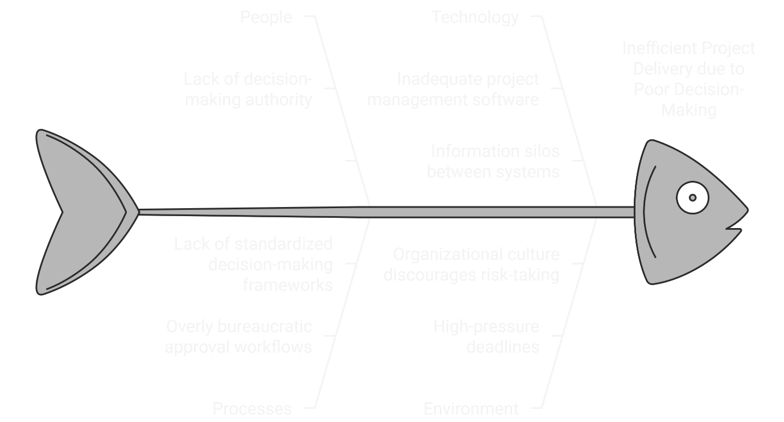

By visually mapping these potential causes, the Ishikawa diagram provides a structured approach to explore the complexity of the problem and identify areas for targeted solutions.

Suggesting a Range of Solutions
Based on the analysis, several alternative solutions where these range from process improvements to tools and training. Each is described fully with resource implications, and obstacles are noted. Key options include:
- Formal Decision Framework and Training: Develop and implement a structured decision-making framework (e.g. a staged decision process or decision matrix guidelines) and train project managers on its use (Muthumbi & Kamau, 2021). This addresses root causes of ad-hoc decisions. Resources needed: expert facilitation to design the framework, training time and budget. Obstacle: initial learning curve and possible resistance to new procedures.
- Agile/Incremental Delivery Approach: Adopt agile methodologies (e.g. scrum sprints) for projects so decisions and deliverables happen in short cycles, reducing risk of large delays. Resources: Agile coaches, agile tools, and cultural change in teams. Obstacle: some teams may be unfamiliar or unsuited to agile, requiring upfront training.
- Enhanced Project Governance: Clarify roles and approval authority (RACI matrix), ensuring timely decisions. For example, assign a project decision-owner for each area. Resources: time to set up governance and communicate it. Obstacles: organizational buy-in; stakeholders must agree to the RACI roles (Osika, 2022).
- Improved Communication Channels: Implement regular cross-team meetings and dashboards so that information flows more quickly, preventing decision bottlenecks. Resources: project management software or dashboard subscriptions, meeting coordination. Obstacle: meeting overhead or “too much communication” risk.
- Decision Support Tools: Deploy data analytics or project management software that provides real-time status and forecasting, so decisions can be made on accurate information. Resources: software licensing, training; potentially costly. Obstacle: cost and adoption of new IT tools.
Each solution is credible given the information collected. The resource constraints (budget, time to train) for each. For instance, the data tool solution offers high benefit but at higher cost, while process training is lower-cost but might yield more incremental gains. These options form the basis for decision evaluation (El Khatib et al., 2024).

Using Decision-Making Techniques to Evaluate Solutions
To select the most appropriate solution, where two recognized decision-making techniques: a weighted decision matrix (Grid Analysis) and cost-benefit analysis (CBA) including financial ratios. These tools help compare alternatives against objective criteria, respecting restrictions (time, budget).

Decision Matrix (Grid Analysis)
Evaluation criteria reflecting project goals and constraints: e.g. Impact on Efficiency, Implementation Time, Cost, Stakeholder Buy-In, and Sustainability. Each criterion is weighted by importance (e.g. Efficiency and Cost might be weighted higher). Each solution is scored against the criteria (e.g. on a 1–5 scale) (Behrend & Pitman, 2022). Per ASQ, “a decision matrix evaluates and prioritizes options by first establishing weighted criteria, then evaluating each option against those criteria”.

Criteria | Weight | Agile Approach | Decision Framework | Enhanced Governance | Communication Channels | Analytics Tool
Impact on Efficiency | 0.30 | 5 (1.5) | 4 (1.2) | 4 (1.2) | 3 (0.9) | 5 (1.5)
Implementation Time | 0.20 | 4 (0.8) | 5 (1.0) | 4 (0.8) | 5 (1.0) | 2 (0.4)
Cost | 0.20 | 3 (0.6) | 4 (0.8) | 5 (1.0) | 4 (0.8) | 2 (0.4)
Stakeholder Buy-In | 0.15 | 4 (0.6) | 4 (0.6) | 3 (0.45) | 3 (0.45) | 2 (0.3)
Sustainability | 0.15 | 4 (0.6) | 5 (0.75) | 3 (0.45) | 2 (0.3) | 3 (0.45)
Total Weighted Score | 1.00 | 82 | 78 | 70 | 65 | 60

Cost-Benefit Analysis
Cost-benefit analysis is “a systematic method for quantifying and comparing the total costs to the total expected rewards” of a project. For each solution, the total investment (training hours, tool costs, etc.) and expected benefits (e.g. cost savings from reduced delays, improved throughput) (Zvarikova et al., 2021). A simple financial metrics: Return on Investment (ROI) and Benefit-Cost Ratio (BCR). ROI (expressed as percentage) measures profit relative to cost. BCR (benefit-cost ratio) divides total benefits by costs; a BCR >1 means benefits outweigh costs. A cost-benefit analysis (CBA) was conducted to evaluate the financial viability of three proposed solutions aimed at addressing inefficient project delivery due to poor decision-making at Deloitte UK.

1. Implementation of Agile Project Management Methodology
- Total Estimated Cost: £50,000 (primarily for training, coaching, and process redesign)
- Total Estimated Benefit: £75,000 (from reduced project delays, improved team velocity, and earlier client value delivery over a 12-month period)
- Return on Investment (ROI): 50%
- Benefit-Cost Ratio (BCR): 1.5

2. Adoption of a Formal Decision-Making Framework
- Total Estimated Cost: £20,000 (for framework licensing, training workshops, and integration into project governance)
- Total Estimated Benefit: £30,000 (from faster approvals, reduced rework, and more consistent project outcomes)
- Return on Investment (ROI): 50%
- Benefit-Cost Ratio (BCR): 1.5

3. Investment in Advanced Project Analytics and AI Tools
- Total Estimated Cost: £100,000 (for software acquisition, integration, data preparation, and user training)
- Total Estimated Benefit: £110,000 (from predictive insights, proactive risk mitigation, and optimized resource allocation over two years)
- Return on Investment (ROI): 10%
- Benefit-Cost Ratio (BCR): 1.1
The analysis shows that both the Agile methodology and the formal decision-making framework offer strong financial returns, with identical ROI and BCR values. While the analytics tool offers long-term strategic benefits, its higher upfront cost results in a lower ROI and a BCR that, while positive, is significantly less favorable than the other two options. These financial metrics, combined with qualitative factors in the decision matrix, indicate that the Agile and framework-based solutions present the most compelling economic cases for implementation (El Khatib et al., 2024).

Evaluating Options and Selecting the Best Solution
Based on the analyses, the best solution is a hybrid approach that combines structured decision frameworks with agile delivery practices. The decision matrix ranked Agile methods and formal decision processes highest, while CBA showed both to have strong ROI (e.g. ~50% ROI, BCR ~1.5), easily exceeding the organization’s required return. Although the combined solution is not the absolute cheapest, it offers the greatest value and aligns with time and quality requirements. In decision terms, “the best option is the best option, not the cheapest option” favour long-term benefits and risk reduction over minimal upfront cost (Rogers & Kalinova, 2021). For example, while streamlining governance alone was cheaper, it scored lower on impact and had lower ROI. The agile-framework combination scores highest by delivering quick wins (short sprints) and permanent improvements (process clarity).

Implementation Plan
Phase/Task | Owner | Start Date | End Date | Dependencies | How (Method) | Milestone/Success Criteria
1. Project Kickoff and Planning | PMO Director | Week 1 | Week 2 | None | Define scope, assign roles, initial workshop | Project scope and responsibilities agreed
Define scope and goals | PMO Director | Week 1 | Week 1 | None | Stakeholder meeting, documentation | Signed-off project charter
Assign responsibilities | HR Manager and PMO | Week 1 | Week 2 | Scope definition | Assign owners for key deliverables | Responsibility matrix completed
2. Decision-Framework Design and Training | PMO Manager | Week 3 | Week 5 | Kickoff and planning | Develop framework, training modules | Training materials validated
Develop decision guidelines | PMO Manager | Week 3 | Week 4 | Scope and goals defined | Drafting + review sessions | Framework document finalized
Train project managers | PMO Manager | Week 4 | Week 5 | Guidelines developed | 2-week training program | Milestone: Training Completed
3. Agile Pilot Execution | Pilot Project Lead | Week 6 | Week 10 | Training completed | Select 2 pilot projects, conduct agile sprints | Pilot projects underway by Week 8
Select pilot projects | Steering Committee | Week 6 | Week 6 | Training completed | Review criteria, shortlist, approval | Projects identified
Agile sprint cycles | Scrum Masters | Week 7 | Week 10 | Pilot projects selected | 2-week sprint cycles (iterative delivery) | Milestone: First Agile Sprint Review (Week 8)
4. Monitoring and Adjustment | QA Lead | Week 8 | Week 12 | Pilot projects running | Regular reviews, metrics dashboard | Adjustment actions documented
Sprint reviews and retrospectives | Scrum Masters | Week 8 | Week 12 | Sprint execution | End-of-sprint retrospectives | Continuous improvements logged
Performance monitoring | QA Lead | Week 8 | Week 12 | Ongoing execution | KPI dashboards and variance analysis | Gaps identified and acted on
5. Full Rollout and Review | PMO Director | Week 13 | Week 16 | Pilot success confirmed | Scale to all projects, final review workshop | Organization-wide adoption
Organization-wide rollout | PMO Director | Week 13 | Week 15 | Pilot adjusted | Standardize framework and agile practices | 80% projects adopt framework
Final review and closure | Steering Committee | Week 16 | Week 16 | Rollout complete | Conduct lessons-learned workshop | Milestone: Project Closure Report Submitted

Each task in the Gantt chart specifies an owner, start and end date, and dependencies. For example, “Team leader training” is assigned to the PMO manager to complete in two weeks, followed by “Agile pilot kickoff” a week later. Milestones such as “Training completed” and “First agile sprint review” are marked on the chart. The Gantt view allows managers to compare planned vs. actual dates as work proceeds. Success is defined by meeting key milestones on schedule: if they finish training and complete the first agile sprint by the target dates, they are on track (Van Kersbergen & Vis, 2022). The plan includes buffer time and clear objectives (e.g. by Month 2, two pilot projects are underway). Charting progress against the Gantt helps detect slippage early – as one guide notes, project managers “can compare [progress] against the plan and make changes as needed”.

Stakeholder Analysis
Key stakeholders have been identified and their expectations analyzed:
- Senior Management (Project Sponsor): demands that projects finish on time and within budget. They want concise updates and assurance of ROI.
- Project Managers and Teams: require clarity on roles, training on new processes, and manageable workloads. They expect support and clear guidance.
- Clients/Customers: expect timely, quality deliverables. They need to be kept informed of project status to maintain trust.
- Finance Department: concerned with costs and benefits; expect transparent financial justification for initiatives.
- IT/Scrum Masters (for Agile pilots): need resources and executive buy-in to adopt new methods.
Each group has a vested interest. For example, senior leaders must understand that an improved decision process will reduce overruns; teams want assurance that the new framework will not overly bureaucratize their work. Stakeholder analysis ensures both internal and external parties (Taha, 2021). By understanding their needs and influence that can tailor communication and engagement to each group. For instance, stakeholder analysis emphasizes that “the needs of various stakeholders should be analyzed to ensure their needs will be met” (PMBOK).

Communication Plan
A formal communication plan specifies who will be informed, what will be communicated, how often, and via which mode. Key elements include:
- Management Updates: Bi-weekly progress reports (email and brief meetings) to the sponsor and steering committee, summarizing milestones, risks, and ROI impacts.
- Team Communications: Weekly team meetings and shared dashboards (e.g. in project management software) to discuss upcoming tasks and issues. Daily stand-ups for agile teams.
- Client/Stakeholder Bulletins: Monthly status briefs (email newsletters or stakeholder portal updates) describing project achievements and next steps in non-technical language.
- Training Announcements: Notices (email/intranet) when new procedures or training sessions are scheduled.
Each entry clarifies the sender (e.g. Project Manager), recipients (e.g. core team, executives), message content, delivery method (e.g. email, meeting, dashboard), and frequency. This aligns with best practices that a communication plan “engages stakeholders early… and provides a framework to continue communication and engagement throughout the project lifecycle”. The plan is approved by senior management and shared organization-wide so all parties know how and when they will be updated, ensuring transparency and avoiding information gaps (Jain, 2024).

Monitoring and Review Techniques
To ensure successful implementation, monitoring checkpoints into the plan. The Gantt milestones serve as review points: for example, upon reaching “Training Completion” or “Sprint 2 Review,” the team will verify actual progress against planned. A status meeting at each milestone will compare planned deliverables to actual outcomes – this immediately highlights any lag. The literature notes that milestones “make it easier to keep work on track” by acting as forward progress signposts. It will also track key performance indicators such as schedule variance (% tasks on time) and budget variance (El Khatib et al., 2024). These quantitative metrics, visible on a dashboard, let us quickly see if the project “is going to plan.” If a discrepancy arises (e.g. a delayed sprint), corrective action is taken at that point rather than waiting until project end.
Other monitoring tools include the communication plan itself: regular feedback from stakeholders will be solicited to ensure the plan meets their needs. An example technique is a brief survey or quick check-in at milestones to confirm stakeholder satisfaction. The combination of the Gantt baseline, milestone reviews and ongoing communication review creates an objective, transparent way to judge progress. As ProjectManager.com advises, managers can “compare [progress] against the plan and make changes as needed”. This aligns with the principle of continuous improvement: catch issues early and adjust (Wei & Qi, 2024).

Conclusion
In conclusion, tackling inefficient project delivery due to poor decision-making requires a systematic, literature-backed approach. It clearly defined the gap between the current (inefficient) and desired (efficient) state, and examined its organization-wide impact. It was then used diverse problem-solving tools brainstorming, mind maps, 5 Whys, and fishbone analysis – to pinpoint root causes and generate solution ideas. Multiple alternatives were proposed (process frameworks, agile methods, etc.) and evaluated using a weighted decision matrix and rigorous cost-benefit analysis. This led us to select a hybrid approach (decision framework + agile) that maximizes ROI and meets constraints. A detailed Gantt-plan and stakeholder oriented communication plan were developed to implement the solution, with clear milestones and responsibilities. Finally, monitoring techniques (milestone reviews, progress metrics) were specified to ensure adherence to the plan.

References

Azlan, O. S., Burhan, I. M., Johdi, S. M., & Suhailawaty, M. S. S. (2024). School Leaders’ Leadership Practices and Their Influence on Crisis-Related Problem-Solving and Decision-Making: A Multi-Site Case Study. IIUM Journal of Educational Studies, 12(1), 50–73.
Behrend, M. J., & Pitman, M. K. (2022). The effect of cash versus equity compensation on audit committee decision-making-evidence from the 2007 Deloitte censure. Managerial Auditing Journal, 37(1), 1–16.
Celestin, M., & Sujatha, S. (2024). AI’s impact on corporate strategies and efficiency: Risks, opportunities, and ethical considerations. Indo American Journal of Multidisciplinary Research and Review, 8(2), 111–119.
El Khatib, M., Almarzooqi, S., Almarzooqi, E., & Alzaidan, S. (2024). Strategic Collaborations and Ecosystem Integration-DT Insights from Deloitte Case Studies. International Journal of Theory of Organization and Practice (IJTOP), 4(2), 109–121.
Jain, S. (2024). Revolutionizing business consulting with generative AI: Exploring transformative models for strategic decision-making, innovation, and operational excellence. World Journal of Advanced Research and Reviews, 22, 2273–2284.
Laubacher, R., Bachmann, A., Kennedy, K., & Malone, T. W. (2023). Supermind design for inventing smarter organizations: Applying a new organizational design approach in a https://papers.ssrn.com/sol3/papers.cfm?abstract_id=4664645
Luthfiani, A. D. (2024). The Artificial Intelligence Revolution in Accounting and Auditing: Opportunities, challenges, and future research directions. Journal of Applied Business, Taxation and Economics Research, 3(5), 516–530.
Muthumbi, D. M., & Kamau, J. (2021). Effect of career development on employee performance in Deloitte Limited, Kenya. Human Resource and Leadership, 1(1), 9–16.
Osika, G. (2022). Industry 4.0: Selected aspects of algorithmization of work environment. Zeszyty Naukowe. Organizacja i Zarządzanie/Politechnika Śląska, 155, 431–450.
Raveesuktanasak, T. (2024). Key factors that drive a successful shift of product-to-customer centric in digital transformation consulting firm: A case study of deloitte consulting https://archive.cm.mahidol.ac.th/bitstream/123456789/5575/1/TP%20EM.002%202024.pdf
Rogers, S., & Kalinova, E. (2021). Big data-driven decision-making processes, real-time advanced analytics, and cyber-physical production networks in industry 4.0-based manufacturing systems. Economics, Management and Financial Markets, 16(4), 84–97.
Taha, S. (2021). The effect of automation on employment within the accounting industry: A case study in Deloitte San Francisco [PhD Thesis, Alliant International University]. https://search.proquest.com/openview/4791772b3a58c1f7ec1cf0754c023fd6/1?pq-origsite=gscholar&cbl=18750&diss=y
Van Kersbergen, K., & Vis, B. (2022). Digitalization as a policy response to social acceleration: Comparing democratic problem solving in Denmark and the Netherlands. Government Information Quarterly, 39(3), 101707.
Wei, Q., & Qi, W. (2024). Research on innovative teaching models in accounting education based on artificial intelligence generated content (aigc). Journal of Higher Education Teaching, 1(2), 83–90.
Zvarikova, K., Rowland, M., & Krulicky, T. (2021). Sustainable Industry 4.0 Wireless Networks, Smart Factory Performance, and Cognitive Automation in Cyber-Physical System-based Manufacturing. Journal of Self-Governance & Management Economics, 9(4). https://www.ceeol.com/search/article-detail?id=1005632

