University Of Wales Trinity Saint Davids
Wales Institution of Science and Art

Analysis of CAE Methods
Structural Design & Fluid Analysis (ACHA6010)

Michael Reeves
1905430
12/2023
Table of Contents
1. Introduction 2
2. Literature Review 3
3. Validation 4
3.1. Mechanical Force 4
3.2. Thermal Force 5
3.3. Mesh Study 5
4. Engine Assembly FEA 7
5. Evaluation 13
6. Conclusion 14
7. References 15

Introduction
This report aims to investigate the use of Finite Element Analysis (FEA) software, in this case Ansys, for its suitability and accuracy in critically evaluating complex models under different forces and stresses. To do this several different validation studies and a mesh independence study will be conducted on simplified cases to ensure correct answers are being achieved initially and the effect of mesh size on the accuracy of those answers.
After this has been done and the software and setup has been verified as accurate, a fully linked system will be built to evaluate the forces acting on a piston under realistic conditions in an engine. The data produced by this analysis will then be analyzed to begin an iterative design process in an effort to improve the piston design and minimize forces on it. The results which will be looked at are total stress and deformation of the piston. The rest of the assembly, the crank, connecting rod and gudgeon pin, will be simulated for the first study which will be conducted and then suppressed for the remainder as, for the intention of this report, the piston is all that will be evaluated.

Literature Review
Similar research doing FEA of a piston has shown piston temperatures of around 230°C and stresses of around 242MPa as a reference point for this study, however this was based of a piston with a mass of around ten times the mass of the piston this study has been completed on. It also only looks at the stresses caused by gas pressure and temperature, whereas this study looked into the reciprocating forces as well.
(Junfa D et al, 2019)
Another study has found deformation of a piston to be around 0.38mm again not including the reciprocating forces and on a larger piston but with much larger temperatures, giving piston surface temperatures of around 300°C. The stress analysis from this study found stress concentrations to be higher on the lower parts of the piston and higher around the gudgeon pin mount as this was used as a fixing point.
(Mitianiec W, 2018)

Validation
Validation of the CAE software will be carried out on two simplified cases, one mechanical force and one temperature based case to verify that the software is reliable and accurate, as well as to investigate the influence of mesh sizing on the results of the produced numbers.

Mechanical Force
A simplified case of a cantilever beam with a fixed support on one end and an applied force on the other, will be solved analytically and on Ansys for total deflection and stress.
Table 1
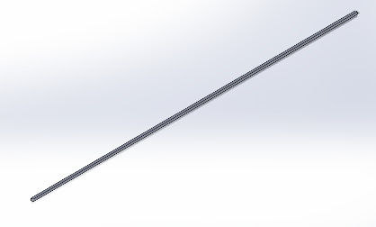
Figure 1

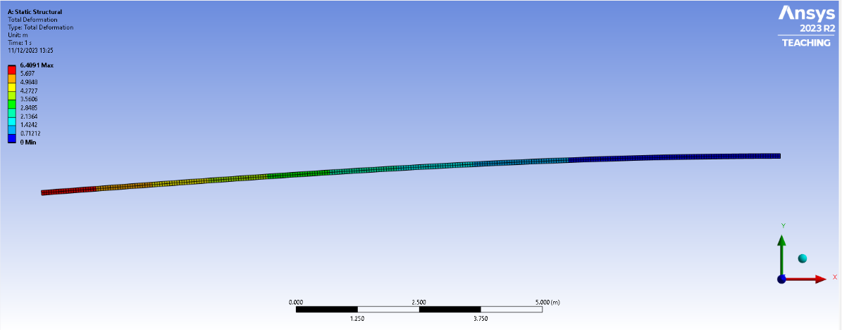

Figure 2
Table one shows the size of the beam and the applied force. The force is applied at the furthest edge from the fixed end. As can be seen, Ansys calculates a deformation of 6.4091M at the far end.
$δ=\frac{FL^{3}}{3EI}$ $I=\frac{Height×{Width}^{3}}{12}$
$$I=\frac{0.1×{0.1}^{3}}{12}=8.\dot{3}×{10}^{-6}m^{4}$$
$$δ=\frac{9500×{15}^{3}}{3×200000×{10}^{6}×8.\dot{3}×{10}^{-6}}=6.4125m$$
As can be seen the analytical and the Ansys calculated value are very similar with a percentage error of 0.05%.
The first Ansys evaluation was carried out with a mesh size of 0.05m, it was then repeated with a mesh size of 0.025m, which provided a result of 4.6098m, and 0.001m which provided a result of 6.4101m and a percentage error of 0.037%.

Thermal Force
An evaluation of a bi-metallic strip was then carried out to determine the accuracy of Ansys’ thermal solver.
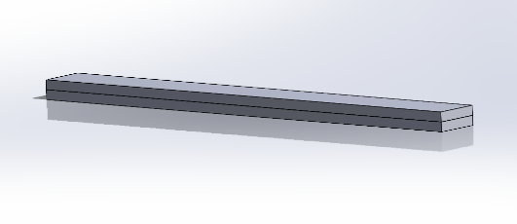
Table 2

Figure 3
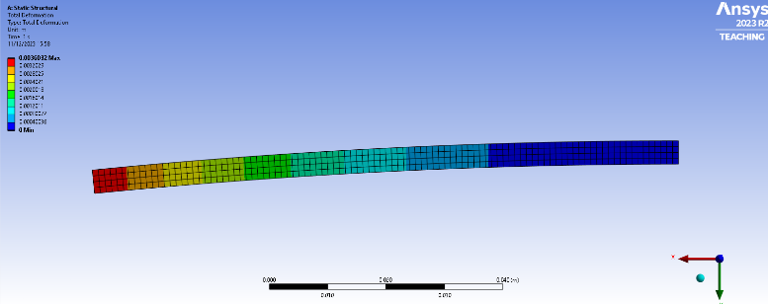
Figure 4

Ansys has calculated a deformation of 0.0036m (3.6mm), with the given inputs and a mesh size of 1mm. The analytical solution uses the formulas below;
$$K_{1}=4+6∙\frac{t_{c}}{t_{i}}+4∙{\left(\frac{t_{c}}{t_{i}}\right)}^{2}+\frac{E_{c}}{E_{i}}∙{\left(\frac{t_{c}}{t_{i}}\right)}^{3}+\frac{E_{i}t_{i}}{E_{c}t_{c}}$$
$$Deformation=\frac{6∙\left(α_{i}-α_{c}\right)∙\left(t_{i}+t_{c}\right)∙T_{c}}{t_{s}^{2}∙K_{1}}∙\frac{L^{2}}{2}=0.0035244m$$
As shown the analytical solution provides an answer of 3.5244mm giving a percentage error of 2.236%. By reducing the mesh size to 0.5mm Ansys then produced an answer of 3.6015mm giving a percentage error of 2.188%.

Mesh Study
A mesh study was carried out as part of validation. This was done with a case where an analytical solution can be found and then repeated in Ansys to find the effect of mesh size and to find the point of mesh independence for this solution. The selected study was a cantilever beam with axial load applied to the end face, pulling it away from the fixed support. The calculated stretch on the component which the specifications of are shown in table 3, was calculated at 0.0125mm, using the equations below.
$$Xmax=\frac{F_{x}L^{3}}{EA}$$
$$Xmax=\frac{5000×{1000}^{3}}{2×{10}^{11}×20×100}=0.0125mm$$
Table 3

The model was then run in Ansys with varying mesh sizes to determine the most effective mesh in terms of accuracy and run time.
Table 4

As can be seen using the cantilever beam for a mesh validation study does yield some results but does not allow for a large variation in the results due to it being a simplified case. A more complex geometry may show a larger difference in the produced results. However, it does demonstrate that mesh size does affect the accuracy of the model and when undertaking the analysis of a model that mesh size should be considered as a 0.005m mesh and a 0.0025m gave the same results however the 0.0025m took considerably longer to mesh and to solve, with a 0.001m further showing this by not solving at all due to the mesh being too fine for such a large model.

Engine Assembly FEA
The assembly to be modelled and analyzed is a piston, gudgeon pin, connecting rod and crank assembly. The piston will be analyzed under thermal conditions to assess the thermal degradations of being used under such high temperatures. The specifications of the piston and the size of the force undergone by the piston were taken from Mahle (2013), the piston material is Aluminum 6061 T6, and the temperatures and film coefficients applied to the piston were supplied.
(Noble A, 2022)
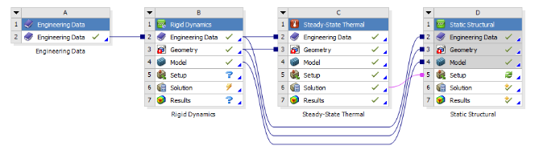

Figure 5
Figure 5 shows the setup of the model to account for all the variables which need to be considered in the analysis, with results from both rigid dynamics and steady state thermal both being fed into the setup of the static structural to give as valid a result as possible.
The rigid dynamics study was conducted to find the forces undergone due to the motion of the piston. It was simulated at 4000RPM, and the forces graph produced by Ansys peaked at 2931N. To reduce forces on the piston due to it being a product of newtons 2nd law, the only way to reduce force is to reduce the acceleration which could be done by reducing crank speed, the stroke of the engine or the mass of the piston by removing material, but this will also reduce the strength of the piston, which was analyzed in the latter part of this report.
A steady state thermal study was then carried out to find the temperature spread throughout the piston due to the external temperatures applied, the results from this were used to find the material degradation throughout the piston so a more accurate deformation and stress analysis could be carried out in the static structural study which was carried out next. As can be seen in figure 6, the peak temperature was reached on the crown of the piston, at 318°C, and minimum on the underside of the gudgeon pin of 171°C. Initial interpretation of this to reduce temperature of the piston and therefore material degradation, ideally a lower surface area on the top of the piston would be desirable to offset the higher film coefficient and lower the intake of energy, it may be desirable to increase the surface area on the skirt and underside of the piston to try and dissipate heat from there, further iterations of the piston have aimed to investigate this.
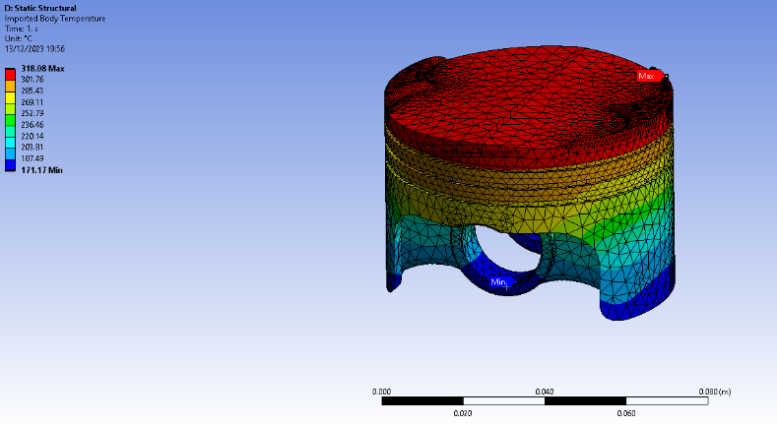

Figure 6

The peak total deformation of the piston comes out as 0.4mm, on the peak of the crown, a possible effect on the results which was introduced was Ansys wouldn’t solve just by using weak springs as a support, so the bottom of the piston skirt had to be used as a fixed support in an effort to affect the forces around the gudgeon pin as little as possible. The stress found in the piston was found to be 372MPa, however this may be incorrect as it occurred in very small, localized regions on the piston ring lands and around the gudgeon pin and may be a case of it being stress risers in Ansys rather than a realistic high stress area, so the model was re-meshed and re-run.
Figure 7
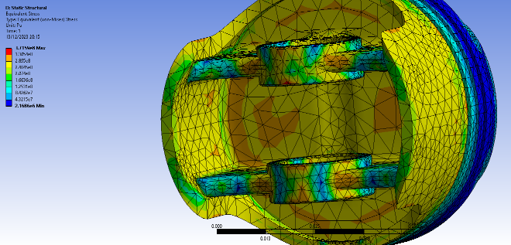
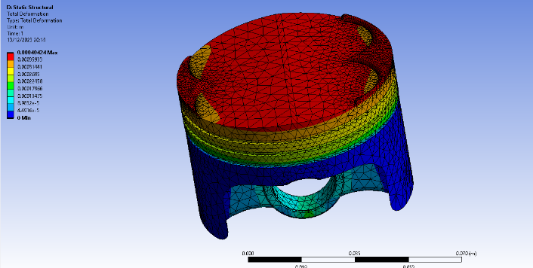
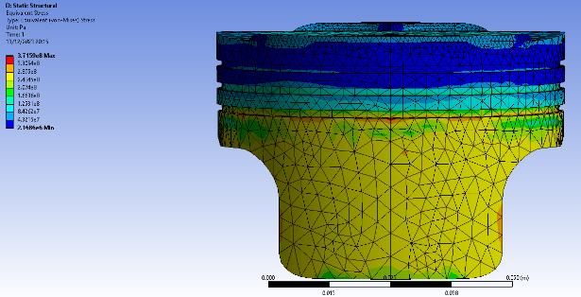
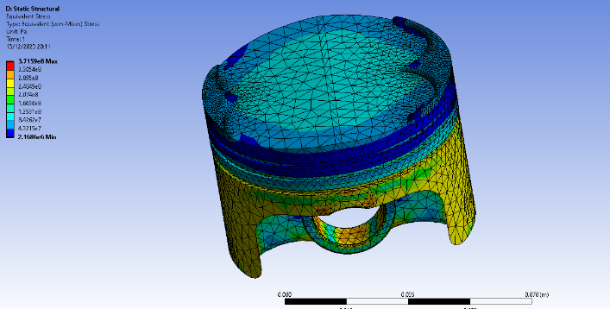
Figure 9
Figure 10
Figure 8

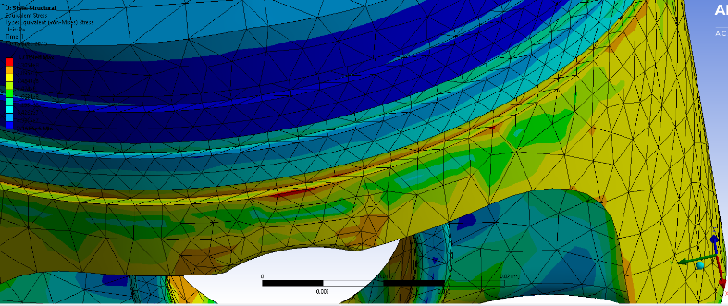

Figure 11
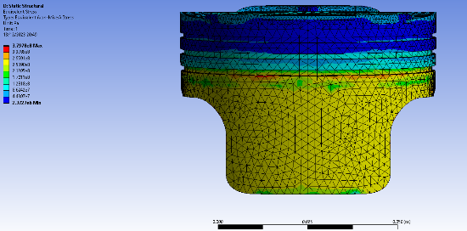
Figure 7 and figure 8 show deformation and stress respectively, figures 9 to 11 show some of the suspected stress risers in the solution, the study was run initially with a mesh size of 5mm on the body and 2mm on the valve cutouts on the piston with a slow transition. To try and determine the cause of these stress concentration points the study was re-run at 2.5mm body mesh size. This did not change the location or magnitude of the stress concentration points, so this may be a result of having to use a fixed-point constraint on the bottom of the piston skirt.
Figure 12

Iterative Design

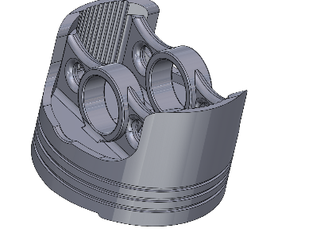
A first iteration of the improved piston design focused on weight loss from areas of lower stresses, it also increases the surface area of the underside of the piston in order to try and lower the overall temperature of the piston to reduce material degradation. It included cutouts to the inside of the piston skirt and cutouts in the support walls to the gudgeon pin mount. This reduced the rigid dynamics calculated forces from 2391N to 2369N at the same engine speeds. This would suggest a further decrease in mass is required to make a substantial difference in the stresses of the piston.
Figure 13
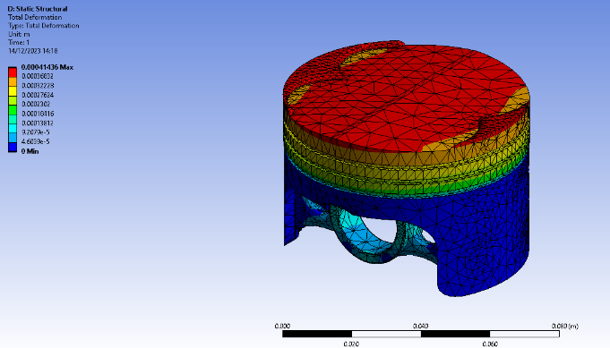
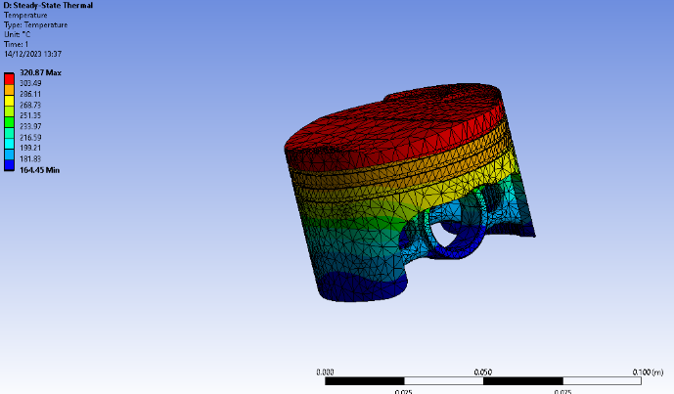
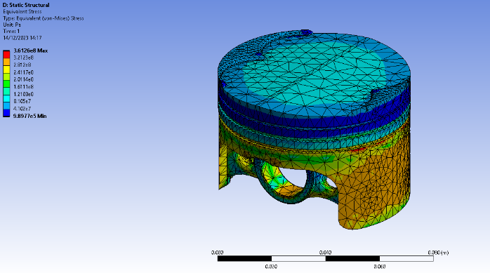
Figure 14
Figure 15

Figure 16
The reduction in piston mass did reduce the piston stress from a maximum of 372MPa to 361MPa, a reduction of 3%. However, the peak temperature of the piston was increased by 2°C but the minimum temperature decreased by 7°C, the peak temperature on the crown appears to have contributed towards an increased deformation of the crown of 0.01mm an increase of 2.4%. While the changes in the underside of the piston have not increased the peak value of stress, it has increased the overall stress of the underside of the piston in several locations creating high stress points where there was any before, as shown in figures 9 and 17 as well as a higher degree of stress on the outside of the piston skirt.
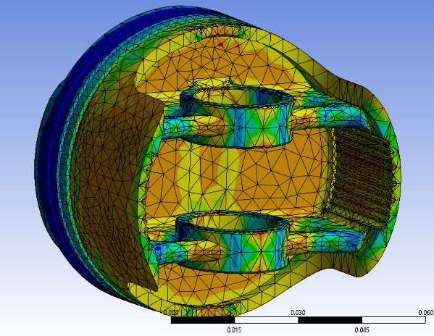
Figure 17

Another iteration was a further lightened piston with the skirt removed and supports added for the gudgeon pin mount, as shown in figure 18. Doing this lowered the dynamic force to 2133N, a reduction of 258N.
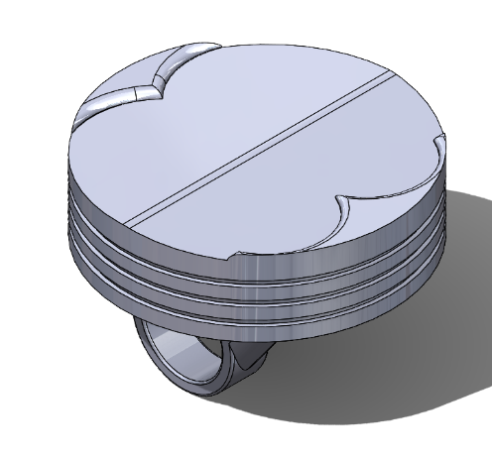
Figure 18

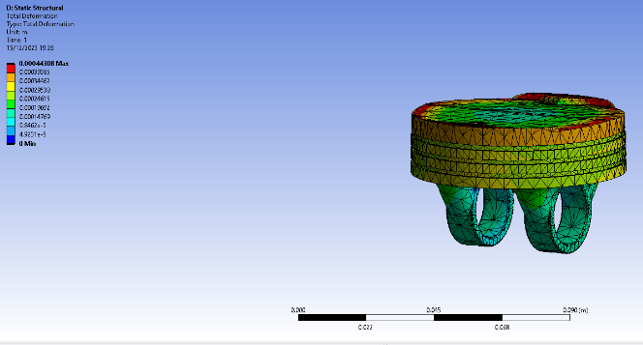
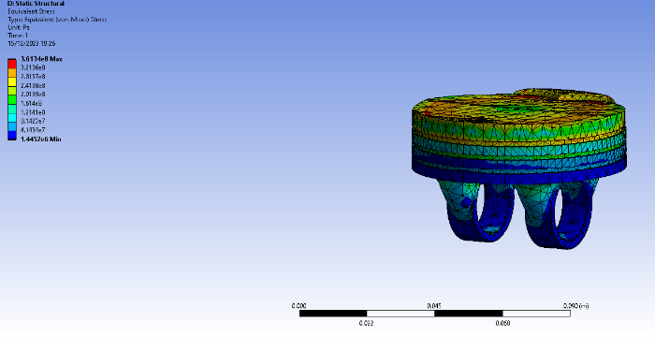
This resulted in the maximum temperature of the part increasing massively to 382°C as well as minimum temperature to 213°C.
Figure 19
Figure 20
This further lightened part has a higher deformation again, of 0.44mm, than the previous part and a slightly higher stress level of 361.3MPa, this would show that despite the lower forces calculated in the rigid dynamics portion of the study, the loss of material has compromised the structural integrity of the piston too much to allow for a more stable piston. A fixed support had to be assigned to the underside of the piston between the two gudgeon pin mounts the area is shown in figure 20, this was changed to several different locations on the underside of the piston and none made a substantial difference to the results all though they all did render slightly different answers and areas of concentration as is to be expected. The reduced mass of the piston is shown in the reduced stress areas on the gudgeon pin mounts, showing that the reduced mass of the piston has improved these areas but fails to provide the structural rigidity required for the rest of the component, as shown by the higher deformation on the top of the piston.
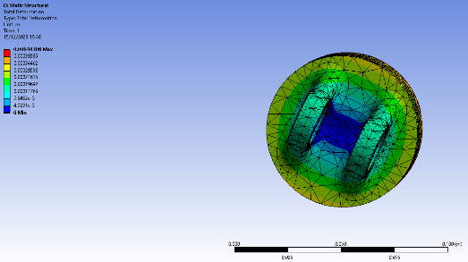
Figure 21

As reducing the mass of the piston did not greatly reduce the applied stresses a final design which focused on increasing the strength at the cost of mass was created. All the crown surfaces of the pistons were kept the same in an effort to allow the piston to still be a viable design for a real engine and to see what can be done to the piston to be optimized just on the underside.
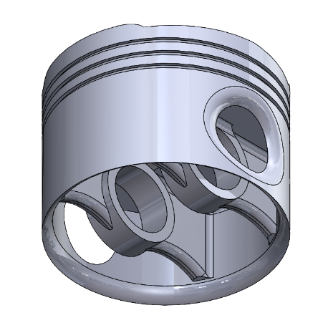
Figure 22

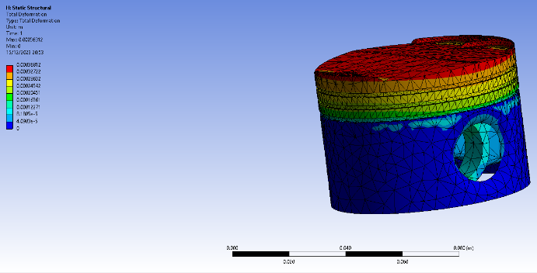
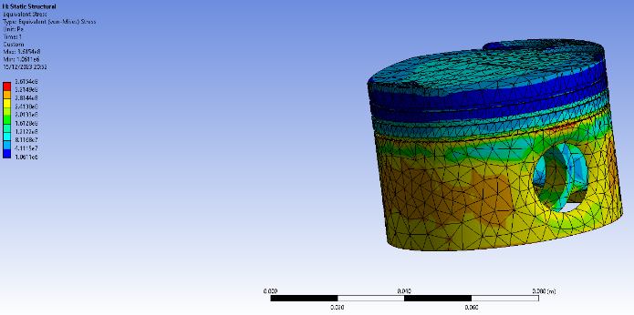
This is the final piston design, all that was changed was the skirt was continued around the entirety of the piston with holes for the gudgeon pin to go through. By doing this and increasing the mass of the piston the force from rigid dynamics has gone up to 2530N from a minimum achieved value of 2133N and an initial value of 2391N. This design provides both a lower maximum and minimum temperature of 304°C and 148°C, a reduction of 14°C and 23°C respectively. The deformation produced by this design has reduced to 0.37mm and had calculated stress values of 316.5MPa. However, this once again produced stress concentrations on the top of the skirt to oil ring area, due to this it can be assumed the results for maximum stress were being skewed due to the placement of the fixed support on the model and that in reality the stresses in these areas were lower.
Figure 24
Figure 23

Evaluation

Table 5
Piston Design | Piston Volume (CC) | Piston Mass (g) | Peak Force (N) | Peak Stress (Mpa) | Peak Temperature (°C) | Peak Deformation (mm)
Standard | 94.73 | 255.771 | 2391 | 372 | 318 | 0.4
Lightened 1st | 92.26 | 249.102 | 2369 | 361 | 321 | 0.41
Lightened 2nd | 82.85 | 223.695 | 2133 | 361.3 | 382 | 0.44
Strengthened | 100.75 | 272.025 | 2530 | 316.5 | 304 | 0.37
Aluminum 6061 T6 Density | 2.7 | g/cc

(Drossou-Agakidou V et al, 1998)
All the data collected was presented in table 3 including the calculated masses of the pistons, from the density of Aluminum 6061 T6 and the volume of the piece calculated by Solidworks. By comparing the mass of the piston to the given results, the iteration which looks to have most effect in comparison is the strengthened piston, with an increase of around 17 grams from the standard piston, the piston went through a reduction in all evaluated areas apart from the rigid dynamics forces. The 2nd lightened piston however has a reduction of weight of 22 grams from the standard, and due to this and its increased surface area to volume ratio meaning it was heated more than the other designs, allowed for more material degradation and a higher degree of deformation and stress than the other iterations although stress was still decreased from the initial design.
The high stress points which occurred on the top of the piston skirts to the oil ring were deemed to be a result of the fixed supports and to not be indicative of stresses that would be seen by the piston, however the peak values of stress were still used as they occurred in other locations which did not appear to be a result of the fixed support applied to the models. Using the fixed supports on the bottom of the piston skirts are believed to have also increased the stress results of the entirety of the piston skirt, however, as there needed to be a fixed support in this case to get a result it was placed in as similar a location between all the different models as possible, in an effort to get consistent results in all of the other geometry of the piston.
The changing of piston volume to surface area is what changed the temperature of the piston by the biggest margin as the film coefficient unit shows that the energy transferred is proportional to the surface area of the piston.

Conclusion
In conclusion, the validation studies show that Ansys can be used to get accurate results with slightly varying degrees of percentage error but will certainly give a very good estimation of the result of different forces acting on components, however due to it not being exactly accurate, if designing a component based off of these results a certain amount of tolerance should be given due to the inaccuracy, meaning that a part shouldn’t be designed 1% above its failure point based off of these results, as this may cause the actual piece to fail in use.
The mesh independence study does show that although a 100% accurate answer to the analytical was never achieved the results did converge to a point with very low percentage error while reducing mesh size. As was stated perhaps a more complicated component and forces would have been a better demonstration of the affect of the mesh and create larger differences at the larger mesh sizes, however, the component and results did show dependance on the size of the mesh.
The pistons in this report reached a peak stress of 372MPa which was achieved by the standard piston, so assuming the original piston was fit for purpose would ensure that all the other pistons were also fit for purpose due to their reduced stresses.

References
Drossou-Agakidou, V., Kanakoudi-Tsakalidou, F., Sarafidis, K., Taparkou, A., Tzimouli, V., Tsandali, H., & Kremenopoulos, G. (1998). ASM Metal Handbook, Vol. 02. European Journal of Pediatrics, 157(7), Page 405.
Junfa, D., Zhaoju, Q., Yingsong, L., Zhenzhong, Y., & Lijun, W. (2019). Diesel engine piston thermo-mechanical coupling simulation and multidisciplinary design optimization. Case Studies in Thermal Engineering, 15. https://doi.org/10.1016/j.csite.2019.100527
Mahle. (2013). Pistons and engine testing. In Pistons and engine testing. https://doi.org/10.1007/978-3-658-09941-1
Mitianiec, W. (2018). Study of influence of boundary conditions on deformation and stresses in a cooled piston of a diesel engine - Part A - models. IOP Conference Series: Materials Science and Engineering, 421(4). https://doi.org/10.1088/1757-899X/421/4/042056
Noble A, 2022, Piston Thermal Study Data, 16/12/2023

