Economics of Sustainability: Assignment One
BMSP6007

Jordan John Coller (1706820)

Lecturer: Anthony Burns

Internal Verifier: Dr Roisin Mullins

BA Business and Management

University of Wales Trinity St. David

Carmarthen Business School

Introduction
“If you really think the economy is more important than the environment, try holding your breath whilst you count your money” McPherson (2009).

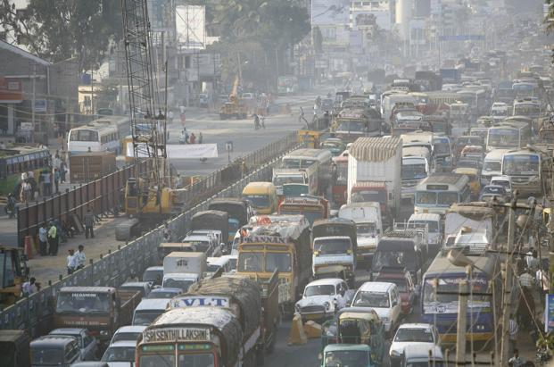

Background
Environmental pollution has been lurking in the background, disregarded by many organisations and, until recently, the term “sustainability” has been used merely as a trend by business (Lebel, Lorek and Danie, 2008; Pezzey and Withagen, 1998). Global consumers, economic professionals and organisational leaders have become increasingly aware of the environmental crises and are sensitised to the environmental dilemmas stemming from ecological damage caused by capitalism and unethical-consumerism (Vergragt, Akenji & Dewick, 2014; Callan & Thomas, 2013; Danciu, 2013). Meadows et al (1972) contemplated how the industrial civilisation could sustainably survive, given the Industrial Revolution’s capitalistic and insatiable demand for limited public goods and unsustainable material inputs, used for powering modern economies and to assimilate their waste outputs.
Even when considering today’s standard of empirical economic research, conveying the trade-off between economic performance for existential environmental detriment, corporations still captain outdated economic principals and frameworks.

Aims and Objectives
Of course, it is not expected to solve environment issues by suddenly stopping the sourcing of globalised inputs or the production of unsustainable fossil fuels, however, both consumers and corporations need to be aware that when they contribute towards the acceleration of economic growth, they both need to regard the environmental implications, including for future generations. This is where a compromise from polluting organisations is needed, understanding what levels of pollution are acceptable to ensure the inhabitation of the planet and satisfying both economic, environmental and socialistic benefits (Hess, 2016; Callan & Thomas, 2013). With this in mind, the paper aims to identify the environmental market failures of both the Petroleum and Motor Vehicle industry through the utilisation of hypothetical economic models – This will be demonstrated by using an empirically evidenced approach.
Research concerning governmental intervention will be analysed to not only monitor how industry abides to policy through various abatement methods, but through hypothetically analysing how ‘Marginal Social Benefits’ (MSB) and ‘Marginal Social Costs’ (MSC) formulates the true economic equilibrium between supply and demand within an industry (Callan & Thomas, 2013).

Main findings

Circular Flow Model

Figure 1 - Circular Flow Model
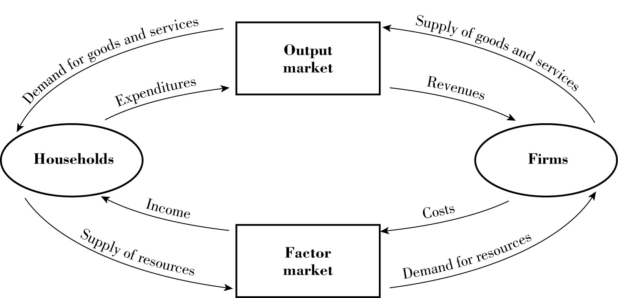
Source: Callan & Thomas (2013).

The Circular Flow Model (CFM) [Figure 1.0] underlies capitalistic economic theory, it introduces how the flow within the economy operates continuously in order to generate Gross Domestic Product (GDP) (Griffiths & Wall, 2011). Within the model, the non-monetary flow emerges counterclockwise between each of the two market sectors, from the households to the Firms. These households provide value through contributing inputs such as, labor, information and land to the Factor Market (FM), which are in demand from firms; these firms utilise said resources to create economic outputs such as goods and services. Subsequently, the above-mentioned commodities are supplied to the Output Market (OM) later to be demanded by households. When the model flows clockwise, we are introduced to the Money Flow (MF). MF represents the capitalistic method of how the expenditures of consumers generate revenues for firms, and how the costs of firms translate to the income of households. In the capitalistic world, many cultures focus upon the acceleration of the economy for GDP growth (Prieto-Sandoval, Jaca & Ormazabal, 2018; Callan & Thomas, 2013).
Nevertheless, the oversimplification/mentality of focusing upon production and consumption capacity can be deemed as outdated. Furthermore, the model of production and consumption does not explicitly translate the interdependence between economic productivity and the environment (Venkatesan & Luongo, 2019).

The Petroleum Industry
In context to the CFM, petroleum is recognised as a significant input to the economy as it allows organisations to transport commodities to the OM through the transportation of goods and services (Frank, 2005). The input of petroleum the economy can be perceived as a perfect solution for capital gain, as the sector of oil refinery’s production contributes 6.3% of global GDP (Coady, 2019). Additionally, the sector accelerates production, distribution, consumption and job creation. For example, the largest oil refining corporation, ‘Reliance Industries Limited’, employs over 1,940,056 workers alone since 1957 (Reliance Industries, 2020; Reliance Industries Limited, 2019).

Modelling the Supply and Demand of The Petroleum Industry
The market exchange relies on two independent variables: consumers and firms (buyers and sellers), both playing fundamental roles within the law of supply and demand. The purpose of the model is to intersect both supply and demand curves in order to discover economic equilibrium and price; both outputs are used for profit maximisation.
The demand of a product reflects customer response or their willingness to pay for a product at a certain price. These purchasing decisions are based on the maximisation of consumer utility (Skene & Murray, 2017). As the economy and society, relies on petroleum as a significant factor for utility, we can assume the demand per liter and rate of consumption is significantly high. For example, in The United States (US) the domestic demand for gasoline averages approximately 144.57 Billion gallons per annum (Department of Transportation and Federal Highway Administration, 2020).
As the petroleum industry is motivated by profit and economic acceleration, the basic law of supply involves, when there is a rise in price, typically firms are motivated to supply more product. In relevance to the law of supply and demand, Nakov & Nuno’s (2011) research presented a generalised equilibrium model of the global oil market. This depicts how the decisions of oil importers and the oil exporter are utilised in order to reach economic equilibrium. This is reflected within Figure 3, where the quantity of supply intersects consumer demand, hypothetically displaying what the exact price a product should be sold at in order to reach profit maximisation (Marshall & Guillebaud, 1997).

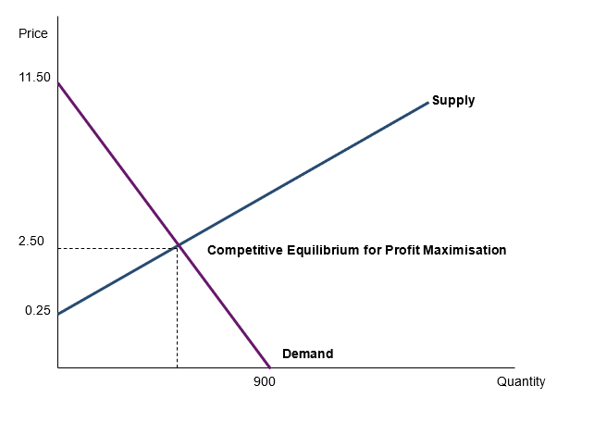
Figure 2 - Competitive Equilibrium for Profit Maximisation
Source: Based on (Callan & Thomas, 2013).

Materials Balance Model
Drawing back to both the CFM and basic Supply and Demand, the failure to depict the relationship between economic performance and the natural environment is made apparent. As the CFM becomes larger through the utilisation of ecomic variable such as, technical efficiency and a growing population, an increase in demand for consumer goods becomes evident as the acceleration influences the amount of input injected into the economy. As an increasing amount of outputs are created, by-products or residuals such as carbon emissions or liquid residuals are released into the environment, causing pollution to our environment (Callan & Thomas, 2013; Coelli, Lauwers & Van Huylenbroeck, 2007; Kneese et al., 1970).

Figure 3 - Materials Balance Model
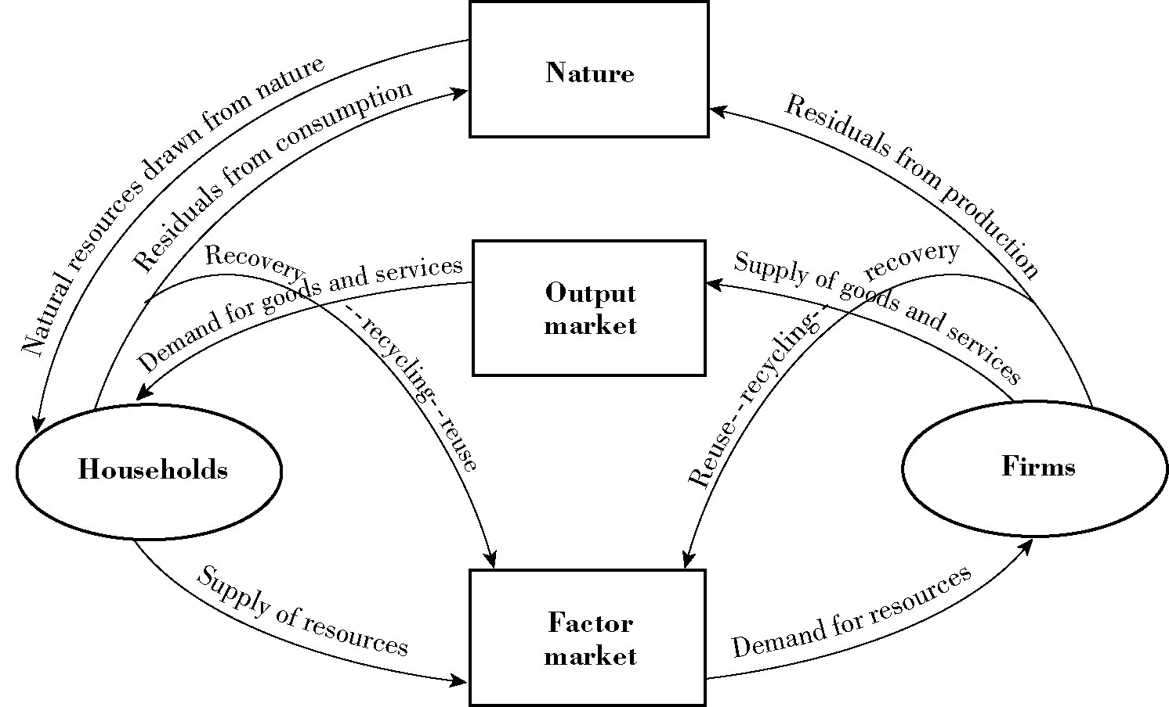

Source: Based on (Kneese et al., 1970).
In relevance to the study, as the economy accelerates, the frequency of by-produced residuals is apparent from oil refineries. Exposure to pollution can cause significant risk to one’s health, and recognised as a detrimental health risk, accounting for 4.2 million human deaths in 2018, whilst also reducing biodiversity in sensitive habitats (World Health Organisation, 2018; Environment Agency, 2018).
Conversely, the materials balance model introduces inner flows which channels the law of thermodynamics, where matter or energy is never destroyed. The incorporation of a circular economy-like strategy allows matter and energy to be reused, repaired, recycled and recovered, delaying the damage that is emitted from the CFM.

Marginal Social Costs
To achieve allocative efficiency, externality costs must be considered in order to find equilibrium in price and quantity. In most cases, when there is an increase in a price, demand and supply are diminished.
Figure 4 conveys examples of MSC’s impact on equilibria, whilst figure 4.1 emphasises the compromise between MSC and MSB (Field & Field, 2017; Callan & Thomas 2013). Drawing from this example, it is safe to assume that the cost of oil was too low before negative externalities were factored in. Additionally, in relation to demand, the marginal social benefit (MSB) should be considered, indicating that the public’s demand for an acceptable level of air quality should be decided between industries, the public and government [Figure 4.1] (Hussen, 2018).

Figure 4 - Competitive and Efficient Equilibria in the Presence MSC
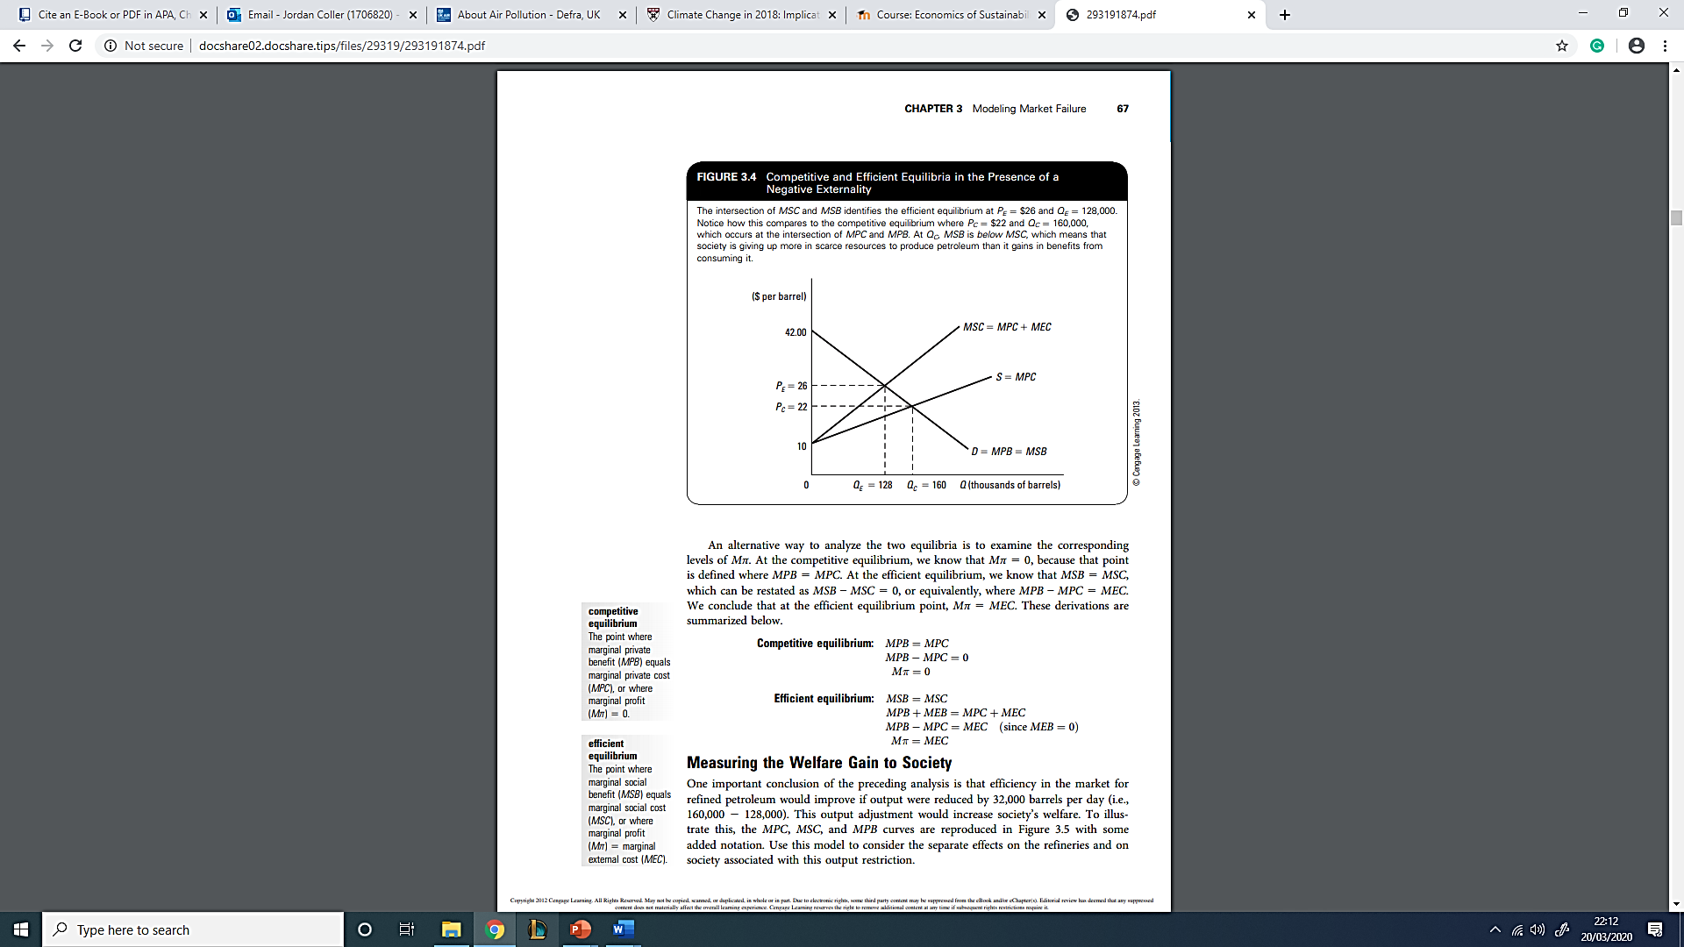
Source: Callan & Thomas (2013).

Figure 4.1 - Measuring Society’s Net Gain
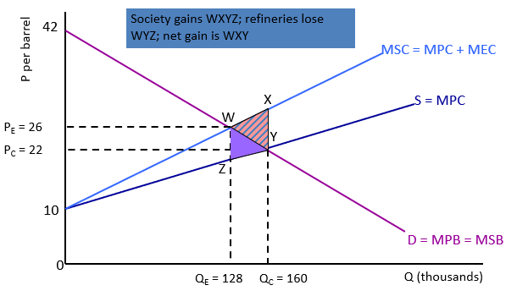
Source: Based on Callan & Thomas (2013).

The process and combustion of refining results in the release of: Carbon Dioxide (CO₂), Sulfur Dioxide (SO₂) and Nitrogen Oxide (NO_{x}) gases (Ragothaman and Anderson, 2017; Callan & Thomas, 2013). Process and combustion emissions are common pollutants which evidently impact the local air quality. During ‘The Great Smog of London of 1952’, air-pollution accounted for approximately 13,500 fatalities, due to the exposure to ‘Volatile Organic Compounds’, causing dizziness, fatigue, nausea, influenza-like symptoms and depression (Ragothaman & Anderson, 2017). Additionally, evidence towards the effects of long-term exposure to these pollutants can create long-term illnesses such as, mutations, cancer, liver and kidney disease, and may cause damage to internal nervous systems (Ras, Marcé & Borrull, 2009; Bell, Davis & Fletcher, 2004). Therefore, poor air quality negatively impacts human health, causing medical intervention. For instance, the cost of fighting asthma or lung cancer, induced from air pollution, presents direct costs to either the public health care sector or the consumer [Figure 5]. Between the years 2017-25, the total cost to the NHS and social care from air pollution is estimated to be £1.6 billion (Public Health England, 2018). Furthermore, indirect costs such as lost time from work must be considered. This is a factor that the typical process of achieving profit maximisation using supply and demand models would not necessarily convey. Therefore, the Cost of Illness must be factored into mainstream economic models (Voorhees et al., 2000; Zmirou et al., 1999).

Figure 5 –Diagram of Model Data Inputs, Assumptions and Outputs
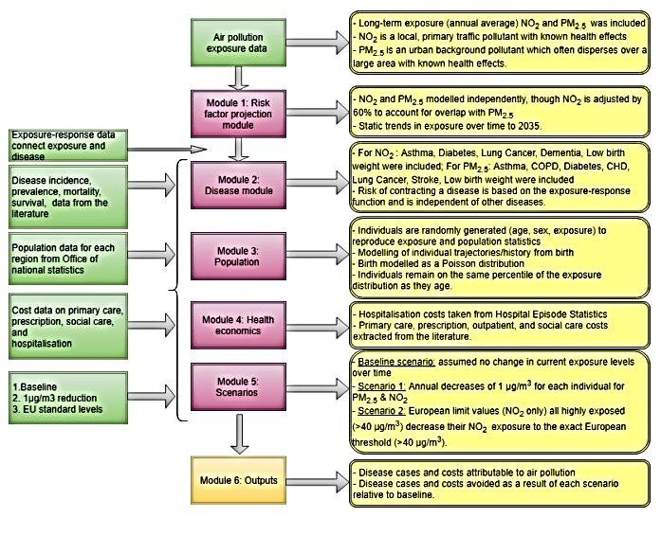
Source: Public Health England (2018).

The Solution: Government Intervention
The dilemma of handing over property rights to either the refineries or the public is a complex and biased decision; on the one hand, refineries would be given the right to pollute for profit maximization, and on the other, oil would only be refined to fit the purposes of public utility (Callan & Thomas, 2013; King, 2007; Kim, 2004; Hurwicz, 1995).
In relevance to this study, the government plays a significant role in balancing both conflicting forces by internalising environmental externalities. For instance, the government could put in place legislation to change product price, reflecting social costs or benefits through unit tax, establishing a price, or market for pollution (Callan & Thomas, 2013). For instance, U.S congress enacts legislation such as ‘The Clean Air Act’, which sets goals through two programs, the National Ambient Air Quality Standards program, and the Hazardous Air Pollutants program; both of which monitor the performance of each polluter in order to set specific targets of pollution for each single polluter (United States Environmental Protection Agency, 2020c).

Abatements Found in The Oil Industry

Technology-based standards and Equipment Subsidies
Legislated technology-based standards are regulated by governing environmental agencies such as the EPA. The standard is put in place to ensure that polluting enterprises use suitable technological equipment that meet a certain criteria outlined by the law, in order to reduce residuals. Environmental subsidies serve as ‘negative tax’, where the government pay firms not to pollute. However, failure to implement environmentally efficient technological abatements, results in a higher taxation per unit, where the cost reflects the level of pollution emitted (Callan & Thomas, 2013).
However, in the scenario of setting a command and controlled or uniform rate of marginal social abatement costs (MAC) to improve society’s well-being, the occurrence of legislative constraints can occur concerning, regional differences, non-uniformity of pollutants and cost effectiveness. Additionally, as the MAC becomes increasingly stringent, polluters have a greater tendency to evade the law. This can be counteracted by tighter monitoring and enforcement programs. To lessen the constraints that abatement has on firms, the equipment could be decided by the firms, as opposed to be being decided by the government. However, this could lead to firms spending the bare minimum, allowing firms to purchase low quality equipment in order to increase profit (Tietenberg & Lewis, 2017).
An example of abatement being established within oil refineries concerns the industry’s introduction of Claus Sulfur Recovery Units, which integrates the process of multistage catalytic oxidation of hydrogen sulfide, to decrease sulfur emissions by 90 - 95% (USEPFA, 1980). The raw material known as Sulfur is then sold and transported to Finland’s chemical industries, significantly cutting health care and biodiversity externality costs regarding air pollution (Kolsi, 2014; Callan & Thomas, 2013).

Figure 6.1 - Modeling Emission Charges: Single Polluter
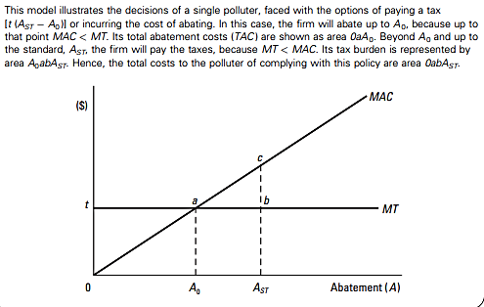
Source: Based on Callan & Thomas (2013).

Figure 6.2 - Improving a Firm’s Decision Making
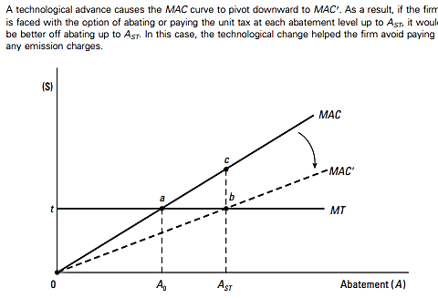
Source: Based on Callan & Thomas (2013).

Figure 6.3 – Modeling and Distributing Emission Charges Fairly: Two Polluters
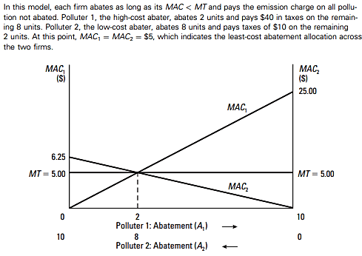
Source: Based on Callan & Thomas (2013).

Taxing Petroleum Consumption
A solution found within all major countries is the ‘Fuel Duty Tax’, where the consumer is made accountable for environmental costs and taxed depending on the amount of petrol each motorist purchases. This is conveyed within Figure 7, where from 1990–2005, tax accounted for 85% of the product’s price. Today within the UK, fuel duty rates for unleaded petrol are settled at 57.95 pence per litre (GOV.UK, 2020; Callan & Thomas, 2013; Leicester, 2005). The addition in price was implemented for the purposes of encouraging conservation, changing consumer behavior and reducing the frequency of demand. By forcing the consumer to consume less fuel, air pollution is also lessened (Leicester, 2005). Additionally, the fluctuation in price reflects the trade-off between MSB and MSC [Figure 4.1].

Figure 7 – Components of Petrol Prices 1990-05
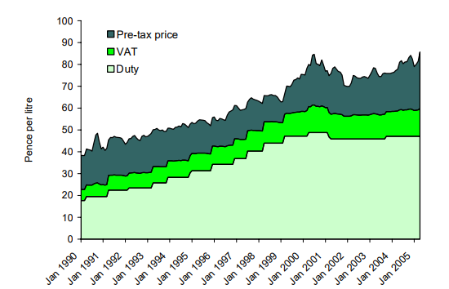
Source: (Department for Business, Energy & Industrial Strategy, 2005).

Creating Sustainable Alternatives
The increasing tax on the consumption of gasoline incentivises refineries to invest in the research and production of sustainable replacements to fossil fuels, as a way to avoid large tax rates [Figure 6.2]. Valero Ltd., a US based global oil refining enterprise, invested largely in their recently erected 11 Ethanol Power Plants, which sustainably produces a renewable, paraffin-based synthetic-fuel compound named “Green Diesel” (GD). GD is a deoxygenated fuel derived from various renewable resources such as, vegetable oils and corn (Kalnes, Marker & Shonnard, 2007). Valero are expected to increase their production capacity from 275 million to 550 million gallons per year (Gorder, 2018).

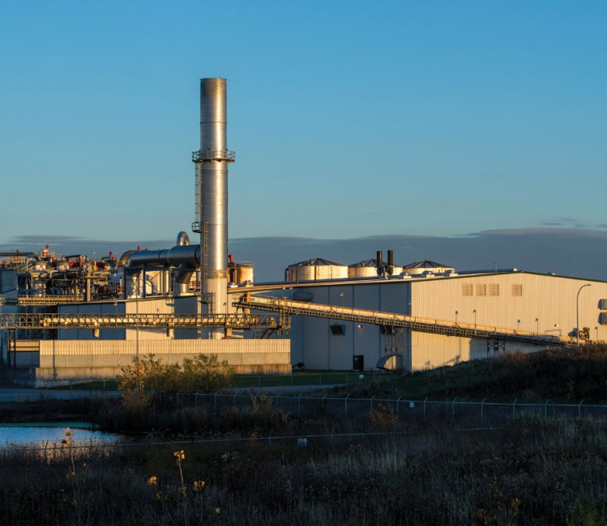
Valero Ethanol Plant: Minnesota (Gorder, 2018).

Pollution Permits
A capped number of permits are distributed to firms. Each permit allows the firm to pollute up to the unit allowance given. For instance, if the units distributed were limited to 400 units, the maximum of 400 one-unit allowances would be issued. This controls the amount of pollution emitted and is punishable by law if a firm does not follow their mandated allowance. These units can be seen as a currency of sort, as the cap-and-trade system allows each unit to be sold by low-cost abaters to high-cost abaters (Callan & Thomas, 2013).
The European Union's Emissions Trading System was launched in 2005, covering 11,000 power stations within 30 countries. As the allowances are distributed equally, the system gives firms flexibility to decide whether to abate or purchase allowances from the open market. However, The Department of Energy and Climate Change (2014) states that the market maintains a £2Billion surplus, indicating that abatement is not stimulated enough to reach long-term environmental goals. Impacts reflecting the “insufficiently ambitious target for 2020” and the economic downturn has increased the likelihood of lower demand for allowances, therefore low-carbon investment maintains a weak price signal (Sanbag, 2011).

Conclusion
The injection of petroleum is proven to accelerate the economy, generating GDP in the process. However, the resulting pollution severely impacts public, severely impacting public health and air quality. Because oil refineries were not being made accountable for the lack of air quality, this allowed them to produce and sell petroleum for a fraction of its true price needed for basic supply and demand equilibrium (minus externalities).
Government intervention through The Clean Air Act, further emphasises how the petroleum industry’s economic model failed to set a true price on their product, by making them accountable for hindering air quality and damaging public health. Firstly, the increase of technology-based standards and subsidies were put in place by the government to encourage firms to use sustainable equipment, through increasing internal taxations if they failed to do so. However, if the taxations are made too stringent, firms will evade environmental legislation altogether. Secondly, pollution permits are set to reach government targets of annual pollution caused by firms. Although the scheme encourages firms to abate, in order to save capital, the £2 Billion surplus in its market indicates its flaws.
Despite these issues, taxing the consumption of a public good seems to be effective within the model, because as demand decreases, new sustainable biofuels are being developed as a result.

References
Bell, M., Davis, D., & Fletcher, T. (2004). A retrospective assessment of mortality from the London smog episode of 1952: The role of influenza and pollution. Environmental Health Perspectives, 112(1), 6-8. doi: 10.1289/ehp.6539
Callan, E., & Thomas, J. (2013). Environmental Economics & Management: Theory, Policy and Applications (6th ed.). Delhi: Centgage Learning.
CIA World Factbook. (2020). Petroleum Consumption / Countries of the World. Retrieved 16 March 2020, from http://world.bymap.org/OilConsumption.html
Coady, D., Parry, I., Le, N., & Shang, B. (2019). Global fossil fuel subsidies remain large: An update based on country-level estimates. IMF Working Papers, 19(89), 1. doi: 10.5089/9781484393178.001
Coelli, T., Lauwers, L., & Van Huylenbroeck, G. (2007). Environmental efficiency measurement and the materials balance condition. Journal of Productivity Analysis, 28(1-2), 3-12. doi: 10.1007/s11123-007-0052-8
Danciu, V. (2013). The sustainable company: New challenges and strategies for more sustainability. Theoretical and Applied Economics, 1(9).
Department for Business, Energy & Industrial Strategy. (2005). Table_511 - Energy Prices. GOV.UK.
Department of Energy & Climate Change. (2014). UK calls for major changes to EU’s “cap and trade” emissions system (p. GOV.UK).
Department of Transportation and Federal Highway Administration. (2020). U.S. domestic demand for gasoline 2017. Statista. Retrieved 17 March 2020, from
Donaldson, T. & Preston, L.E. (1995). The stakeholder theory of the corporation: Concepts, evidence and implications. Academy of Management Review, 20(1): 65-91.
Environment Agency. (2018). The state of the environment: air quality. Chair of the Environment Agency.
Frank, A. (2005). Oil Empire. Cambridge, Mass.: Harvard University Press.
Gorder, J. (2018). Review of Climate-Related Risks and Opportunities [Ebook]. San Antonio, TX: Valero Energy Corporation. Retrieved from https://www.valero.com/en-us/Documents/Climate%20Related%20Risks%20and%20Opportunities/Review_of_Climate-Related_Risks_and_Opportunities_Web.pdf
GOV.UK. (2020). Tax on shopping and services. GOV.UK.
Griffiths, A., & Wall, S. (2011). Economics for Business and Management. Harlow, UK: Financial Times/Prentice Hall.
Henderson, R., Reinert, S., Dekhtyar, P., & Migdal, A. (2018). Climate Change in 2018: Implications for Business. Retrieved from https://www.hbs.edu/environment/Documents/climate-change-2018.pdf
Hess, P. (2016). Economic Growth and Sustainable Development (2nd ed.). New York: Routledge.
Hurwicz, L. (1995). What is the Coase Theorem? Japan And the World Economy, 7(1), 49-74. doi: 10.1016/0922-1425(94)00038-u
Hussen, A. M. (2018). Principles of environmental economics and sustainability an integrated economic and ecological approach (4th ed.). London: Routledge.
Kalnes, T., Marker, T., & Shonnard, D. (2007). Green diesel: A second-generation biofuel. International Journal of Chemical Reactor Engineering, 5(1). doi: 10.2202/1542-6580.1554
Kim, A. (2004). A market without the 'right' property rights. The Economics of Transition, 12(2), 275-305. doi: 10.1111/j.0967-0750.2004.00179.x
King, A. (2007). Cooperation between corporations and environmental groups: A transaction cost perspective. Academy of Management Review, 32(3), 889-900. doi: 10.5465/amr.2007.25275680
Kneese, Ayres, D'Arge, Ayres, Underwood, R., Ralph, C., & Resources for the Future. (1970). Economics and the environment: A materials balance approach. Washington: Baltimore; London (2 Brook St., W1Y 1AA): Resources for the Future Distributed by the Johns Hopkins Press.
Kolsi, K. (2014). Nothing goes to waste: Oil refining uses its resources very wisely. Retrieved 21 March 2020, from https://www.neste.com/nothing-goes-waste-%E2%80%93-oil-refining-uses-its-resources-very-wisely
Lebel, L., Lorek, S., & Danie, R. (2008). Enabling Sustainable Production: Consumption Systems. Dordrecht: Springer Science.
Leicester, A. (2005). Fuel taxation. The Institute for Fiscal Studies, Briefing Note #55.
Margolis, J.D. and Walsh, J.P. (2004). Misery loves companies: Rethinking social initiatives by business. Administrative Science Quarterly.
Marshall, A., & Guillebaud, C. (1997). Principles of Economics. Bristol: Overstone Press.
McPherson, G. (2009). Time for a Revolution [Blog]. Retrieved from http://guymcpherson.com/2009/05/time-for-a-revolution/
Meadows, Donella, H., Dennis, L., Randers J., & William B. (1972). The Limits to Growth. New York: Universe Books.
Nakov, A., & Nuno, G. (2011). A general equilibrium model of the oil market. SSRN Electronic Journal. doi: 10.2139/ssrn.1940384
NASA. (2020). Global Surface Temperature. Retrieved 19 March 2020, from https://climate.nasa.gov/vital-signs/global-temperature/
Nduka, J., Okafor, V., & Odiba, I. (2016). impact of oil and gas activities on acidity of rain and surface water of Niger Delta, Nigeria: An environmental and public health review. Journal of Environmental Protection, 7(4), 566-581. doi: 10.4236/jep.2016.74051
Pezzey, J., & Withagen, C. (1998). The rise, fall and sustainability of capital-resource economies. Scandinavian Journal of Economics, 100(2), 513-527. doi: 10.1111/1467-9442.00117
Prieto-Sandoval, V., Jaca, C., & Ormazabal, M. (2018). Towards a consensus on the circular economy. Journal of Cleaner Production, 179, 605-615. Retrieved from https://www.sciencedirect.com/science/article/pii/S0959652617332146
Public Health England. (2018). Estimation of costs to the NHS and social care due to the health impacts of air pollution: summary report. London: Crown.
Ragothaman, A., & Anderson, W. (2017). Air Quality Impacts of Petroleum Refining and Petrochemical Industries. Environments, 4(3), 66. doi: 10.3390/environments4030066
Ras, M., Marcé, R., & Borrull, F. (2009). Characterization of ozone precursor volatile organic compounds in urban atmospheres and around the petrochemical industry in the Tarragona region. Science of The Total Environment, 407(14), 4312-4319. doi: 10.1016/j.scitotenv.2009.04.001
Reliance Industries Limited. (2019). The Reliance Integrated Annual Report 2018-19. Mumbai. Retrieved from https://www.ril.com/ar2018-19/ril-annual-report-2019.pdf
Reliance Industries. (2020). The Reliance Story. Retrieved 15 March 2020, from https://www.ril.com/TheRelianceStory.aspx
Sanbag. (2011). What is the emissions trading scheme and does it work? Retrieved 22 March 2020, from https://www.theguardian.com/environment/2011/jun/07/ets-emissions-trading
Skene, K., & Murray, A. (2017). Sustainable Economics: Context, Challenges and Opportunities for the 21st-Century Practitioner. London: Taylor and Francis.
Statista (2020). Topic: Vehicles in use in the U.S. Retrieved 17 March 2020, from https://www.statista.com/topics/4578/vehicles-in-use-in-the-us/
Tietenberg, T. H., & Lewis, L. (2018). Environmental and natural resource economics (11th ed.). Abingdon: Routledge.
United States Environmental Protection Agency. (2020a). Effects of Acid Rain. United States Environmental Protection Agency.
United States Environmental Protection Agency. (2020b). Global Greenhouse Gas Emissions Data. United States Environmental Protection Agency.
United States Environmental Protection Agency. (2020c). Managing Air Quality - Setting Air Quality Goals.
United States Environmental Protection Federal Agency. (1980). Inorganic Chemical Industry. EPA.
Venkatesan, M., & Luongo, G. (2019). SDG8: Sustainable Economic Growth and Decent Work for All (1st ed.). Portland, OR: Emerald Publishing.
Vergragt, P., Akenji, L., & Dewick, P. (2014). Sustainable production, consumption, and livelihoods: global and regional research perspectives. Journal of Cleaner Production, 63, 1-12. doi: 10.1016/j.jclepro.2013.09.028
Voorhees, A., Araki, S., Sakai, R & Sato, H (2000). An ex post cost-benefit analysis of the nitrogen dioxide air pollution control program in Tokyo. Journal of the Air Waste Management Association. 1(50), 391–410
World Health Organisation. (2018). Air pollution. Retrieved 18 March 2020, from https://www.who.int/health-topics/air-pollution#tab=tab_1
Zmirou, D., Deloraine, A., Baldducci, F., Boudet, C., & Dechenaux, J. (1999). Health effect costs of particulate air pollution. Journal of Occupational Environmental Medicine. 1(41),847–856. doi: 10.1097/00043764-199910000-00005

