

Student name: Wahida Nagi
Student ID: 2245076
Module name: Independent Project
Module code: BMHP6020
Supervisor’s name: Jolly Nwankwo

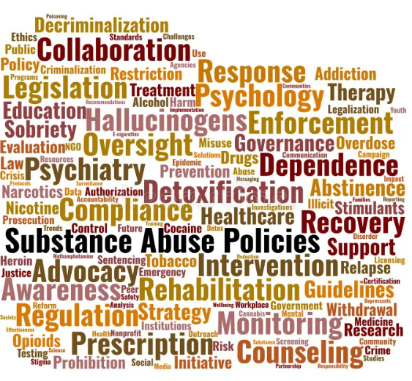 |  | Preventive Interventions in Social Work Practice for Vulnerable Adults in the UK: A Systematic Scooping Review  Aim  This study aims to critically examine the effectiveness of preventive interventions within UK social work practice and evaluate their contribution to improved outcomes for vulnerable adults (Department of Health and Social Care, 2021; Local Government Association, 2024).  Objectives:  - Examine the key principles of preventive social work practice for vulnerable adults in the UK.  - Identify major preventive interventions, including mental health support, domestic abuse prevention, substance misuse services, and community-based programme.  - Evaluate their impact on wellbeing and safeguarding outcomes.  - Identify evidence gaps to inform future research and practice. |  | 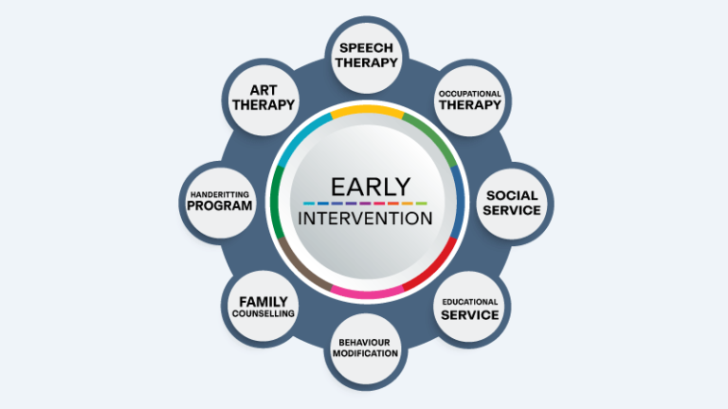
Methodology  - Research Design: A systematic review methodology was used to identify, evaluate, and synthesise evidence on preventive interventions for vulnerable adults in UK social work practice (Peters et al., 2020).  - Used thematic analysis to identify key themes, patterns, and evidence gaps.  - Conducted structured searches of academic databases to identify relevant studies.  - Applied inclusion and exclusion criteria to ensure study relevance and quality.  - Findings were synthesised to provide evidence-based recommendations for future social work practice and research. |  |  |  | Data Analysis  A thematic analysis approach was used to analyse the selected studies (Braun and Clarke, 2022).  The selected studies were analysed using thematic analysis, which identified six key themes:  - Types of preventive interventions  - Target populations  - Wellbeing outcomes  - Safeguarding outcomes  - Strengths and limitations of interventions  - Evidence gaps for future research  Ethical Considerations  - Ethical approval was obtained through the university's ethics review process before the project commenced.  - This research analyses existing published studies rather than collecting primary data and therefore did not require the involvement of human participants.  - All sources were accurately referenced to avoid plagiarism.  - Research findings were reported honestly, objectively, and transparently.  - Only credible and reliable sources were included to ensure academic integrity (UK Research Integrity Office, 2023).

Data Collection Method
• Data were collected through a systematic search of published literature using academic databases (Peters et al., 2020).
• Searches were conducted using electronic databases including PubMed, PsycINFO, ProQuest, Google Scholar, the UWTSD Library, and the British Education Index.
• Keywords included: preventive interventions, social work, vulnerable adults, safeguarding, mental health support, domestic abuse prevention, and substance misuse services.
• Study eligibility was determined using predefined inclusion and exclusion criteria to ensure consistency and relevance.
• Only UK-based studies published in English between 2016 and 2026 were included.
• Peer-reviewed articles and relevant grey literature were selected to ensure a comprehensive evidence base.

References
Braun, V. and Clarke, V. (2022) ‘Toward good practice in thematic analysis: Avoiding common problems and be(com)ing a knowing researcher’, International Journal of Transgender Health, 24(1), pp. 1–6. Available at: https://doi.org/10.1080/26895269.2022.2129597 (Accessed: 17June 2026).
Department of Health and Social Care (2021) People at the heart of care: Adult social care reform white paper. Available at: https://assets.publishing.service.gov.uk/media/6234b0a6e90e0779a18d3f46/people-at-the-heart-of-care-asc-reform-accessible-with-correction-slip.pdf (Accessed: 17 June 2026).
Local Government Association (2024) Earlier action and support: The case for prevention in adult social care and beyond. Available at: https://www.local.gov.uk/publications/earlier-action-and-support-case-prevention-adult-social-care-and-beyond (Accessed: 24 June 2026).
Peters, M.D.J., Marnie, C., Tricco, A.C., Pollock, D., Munn, Z., Alexander, L., McInerney, P., Godfrey, C.M. and Khalil, H. (2020) ‘Updated methodological guidance for the conduct of scoping reviews’, JBI Evidence Synthesis, 18(10), pp. 2119–2126. Available at: https://doi.org/10.11124/JBIES-20-00167 (Accessed: 22 June 2026).
UK Research Integrity Office (2023) Code of Practice for Research. Available at: https://ukrio.org/wp-content/uploads/UKRIO-Code-of-Practice-for-Research.pdf (Accessed 26Jun. 2026).

