


Database Systems

by
Yinjie Zhang
Lecturer: Dr Stephen Hole

December 2022

directory
1. introduction 3
2. Comparison of two Nosql databases 3
2.1.mongodb 3
2.1.1.Introduction 4
2.1.2. scheme 5
2.2.redis 7
2.2.1.Introduction 7
2.2.2. scheme 7
2.3.compare 8
2. sql database 9
3. Comparison of sql and nosql 10
3.1. Relational database 10
3.2.Nosql 10
3.3. Comparison 11
4. Combine sql and nosql 11
Reference 14

introduction
AE (Abertawe Entertainment), based in Swansea, sells a large range of text, ebook and audio books. Given the company's readiness to expand its business and the volume of transactions, traditional relational databases have become a bottleneck in system performance. A new data volume needs to be customized to handle the high concurrency, so as to prepare for future sec-kill activities.

2. Comparison of two Nosql databases

2.1.mongodb

2.1.1.Introduction
MongoDB is an open source, high performance, schema-free document database, which is designed to simplify development and facilitate expansion, and is one of the NoSQL database products. Is the non-relational database that most closely resembles a relational database (MySQL). It supports a very loose data structure in a Json-like format called BSON, so it can store complex data types while being quite flexible. A record in MongoDB is a document, which is a data structure composed of fields and value pairs. A MongoDB document is similar to a JSON object in that a document is considered an object. The data type of the field is character, and its values can include other documents, plain arrays, and document arrays in addition to the basic types.
MongoDB has the following application scenarios:
- For social scenes, MongoDB storage is used to store user information and the information of users' published circle of friends, and nearby people and places are realized through geographical location index.
- In game scenarios, MongoDB is used to store game user information. Users' equipment and credits are directly stored in the form of embedded documents, which is convenient for query, efficient storage and access.
- In logistics scenario, the order information is stored in MongoDB, and the order status is constantly updated in the process of transportation. It is stored in the form of MongoDB embedded array, and all the changes of the order can be read out in a query.
- In the Internet of Things scenario, MongoDB is used to store information of all connected intelligent devices and log information reported by devices, and these information is analyzed in multiple dimensions.
- Live video, use MongoDB to store user information, like interactive information, etc.
In conclusion, the common features of data manipulation in these application scenarios are:
- Large amount of data.
- Frequent writes (both reads and writes are frequent).
- Low value data, transactional requirements are not high.
In the selection of architecture, in addition to the above three characteristics, if you still hesitate to choose it? Some questions to consider are:①Applications do not require transaction and complex join support②New applications, requirements change, data models are uncertain, and rapid iterative development is desired.③Applications require read/write QPS of 2000-3000 + (higher is acceptable).④Applications require TB or even PB data stores.⑤Applications develop rapidly and need to be able to scale rapidly horizontally.⑥The application requires that the stored data not be lost.⑦Application needs a lot of location query, text query.
MongoDB has the following features:
- High performance: MongoDB provides high-performance data persistence. In particular, support for embedded data models reduces I/O activity on database systems. Indexes support faster queries and can contain keys from embedded documents and arrays. (Text index solves the search requirement, TTL index solves the automatic expiration requirement of historical data, and geographical location index can be used to build various O2O applications.) Multiple engines, including mmapv1, wiredtiger, mongorocks (rocksdb), and in-memory, support various scenarios. Gridfs addresses file storage needs.
- High availability: The replica tool of MongoDB is called replica set, which provides automatic failover and data redundancy.
- High scalability: MongoDB provides horizontal scalability as part of its core functionality. Sharding distributes data across a cluster of machines. Since 3.4, MongoDB supports the creation of data regions based on slice keys. In a balanced cluster MongoDB directs reads and writes covered by a zone to only those pieces within that zone.
- Rich query support: MongoDB supports a rich query language that supports read and write operations (CRUDs) such as data aggregation, text search, and geospatial queries.
- Other features: patternless (dynamic mode), flexible document model.

2.1.2. scheme
The main problems AE company is facing now are large sales volume, massive data and high concurrency. Traditional relational databases are difficult to meet, and MongoDB is a good choice here.
Without considering some complicating factors, I have designed three collections as follows:
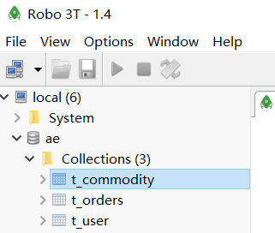
Although mongodb is a nosql database, it is the non-relational database that most resembles a relational database. Its collection can be thought of as a table in a relational database.
First, the user table. This form records the user's registration information, as well as the balance of the account.
{
"name" : "tom",
"address" : "ny",
"telnum" : "911",
"datajoin" : "2022-1-1",
"money" : "1000"
}
The second and most crucial table is the order table. High concurrency is mainly a large number of create orders and modify orders. MongoDB is directly stored in memory, which eliminates the io operation with disk and greatly speeds up the storage speed. Besides, MongoDB provides a series of complex query methods, making it able to perform some complex query operations like relational databases, which is very suitable for the current target.
{
"uid" : "63b67618b383e8070e7a7e8a",
"create_time" : "2023-1-5-15:34",
"tile" : "math",
"author" : "yinjie zhang",
"genre" : "academic",
"publisher" : "aaa",
"release_date" : "2030-1-1",
"price" : "100",
"stock_amount" : "0.01",
"blob" : "null",
"invoice_id" : "123"
}
The adaptation records the order id, the user id of the purchase, when the order was created, and some other detailed order messages. The company can look up the assets owned by a user (by indexing the user id) through an order.
Finally, there is the inventory table, which is also a table affected by high concurrency, and users need to deduct inventory for purchases.
{
"commodity_discription" : "Math,author:yinjie zhang,genre:acdamic,publisher:aaa,release_date:2030-1-1,price:100",
"commodity_flag" : "true",
"commodity_num" : "1000",
"commodity_picture" : "D:picture"
}
The table mainly records the description of the product information, whether it is on the shelf, the stock and the address of the picture. It is mainly used for front - end page display and post - state management.

2.2.redis

2.2.1.Introduction
Redis is a key - value NoSql database. Key-value means that data stored in Redis is stored in the form of key.value pairs, and value can be in various forms, including strings. Values. Even json.
Redis has the following characteristics:
- key-value: value supports multiple data structures and provides rich functions
- Single-threaded, each command is atomic
- Low latency, fast (memory based. IO multiplexing. Good coding).
- Support for data persistence
- Supports primary and secondary clusters
- Supports multi-language clients
Redis is a key-value database. key is usually String, but there are various types of value:
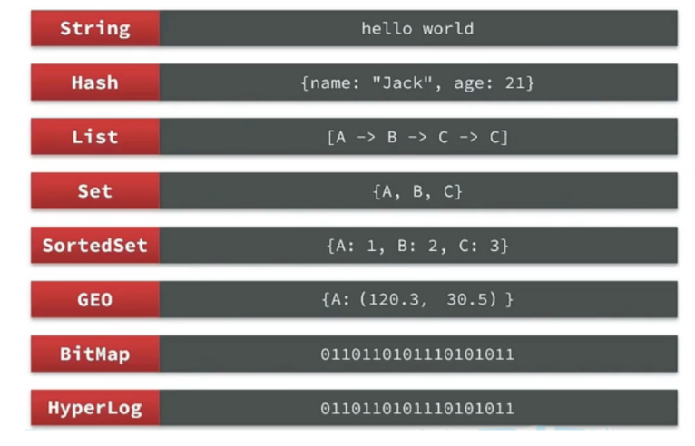

2.2.2. scheme
Here I have redis installed in Linux. First log in to redis from the console.

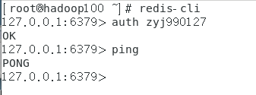
Redis doesn't have tables like MySQL or collections like mongodb. We can distinguish this by prefixing the key. As shown below, there are three keys.ae:user:id, ae:order:id and ae:commodity:id.

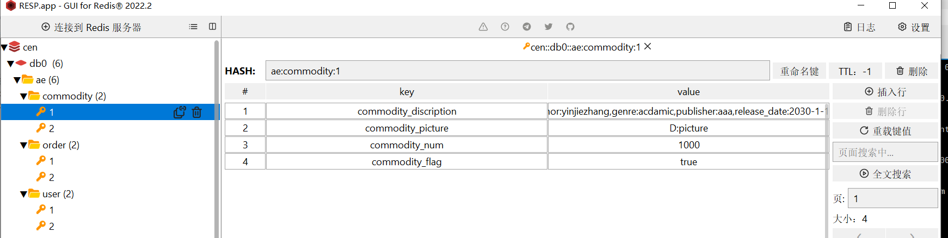
The rest of the design is not much different from the mongodb design above.

2.3.compare
1) Memory management: All Redis data is stored in memory and written to disk regularly. When the memory is insufficient, the specified LRU algorithm can be selected to delete the data. MongoDB data is preferentially stored in the memory. When the memory is insufficient, only hot data is stored in the memory and other data is stored on disks.
2) Data structure: Redis supports a variety of data structures, including hash, set, and list. MongoDB data structure is relatively simple, but it supports rich data expression, indexes, most similar to relational databases, and supports very rich query languages.
3) Data volume and performance: When physical memory is sufficient, performance, redis>mongodb>mysql. Data volume, mysql>mongodb> redis.
4) reliability: Since version 1.8, mongodb uses binlog (MySQL also uses the binlog mode) to support persistence, improving reliability. Redis relies on snapshots for persistence; AOF enhances reliability; While improving reliability, the access performance is affected. MongoDB is better than Redis in reliability.
In conclusion, redis is better for cache. For example, user tables, user assets, inventory, etc. are stored in Mysql. When the project is started, redis cache is carried out on key hot commodities and so on for hot start. The order is stored in redis when it is created and then synchronized to mysql at free time. In practice, a web project is usually composed of multiple caches, local caches, nginx, redis, and so on. redis is commonly used for cache.
MongoDB is the most appropriate for this application. The amount of data in this application is large, but it does not exceed the upper limit required for MongoDB. Moreover, this application requires some complex queries, and MongoDB is very suitable for it. If you need to join the sec-kill service in the future, you can use redis for cache.

sql database
Traditional database solution, here I choose MySQL database. Without complicated considerations, I set up four tables.
t_user
Uid | int | 0 | Primary key
Name | varchar | 255
Address | varchar | 255
TelNum | varchar | 13 |  | Telephone number
DateJoin | datetime | 0
Money | varchar | 255
t_order_master
Order_id | int | 0 | Primary key | Order id
Order_sn | bigint | 0 |  | Order number
Uid | int | 0 |  | User number
Pay_method | tinyint | 0 |  | Payment method: 1 Alipay, 2 wechat and 3 bank cards
Create_time | datetime | 0 |  | Order creation time
Invoice_id | varchar | 255 |  | Invoice title
t_order_detail
Order_sn | bigint | 255 | Primary key | Order number
title | varchar | 255
author | varchar | 255
genre | varchar | 255
publisher | varchar | 255
Release_date | datatime | 0
pirce | varchar | 255
Stock_amount | varchar | 255
blob | varchar | 255
t_commodity
commodity_id | int | 0 | Primary key | Inventory id
commodity_description | varchar | 255 |  | Product description
commodity_flag | tinyint | 0 |  | If 1 hits the shelves, 0 drops
commodity_num | int | 0 |  | inventory
commodity_picture | varchar | 255 |  | Product picture address

Comparison of sql and nosql

Relational database
Relational database and nosql database have their own usage, and the difference is relatively large. Different businesses use different databases, either relational or nosql. Only by fully understanding the characteristics of both and performing their respective duties can the advantages of database management be better played. Some of the advantages and disadvantages of relational databases and the advantages and disadvantages of nosql data are described below.
Advantages:
1) Easy maintenance: relational database has a table structure, similar to matrix, unified format, easy to manage. SQL statements are more convenient to operate.
2) sql statement easy to get started: For computer students, the first database contact is relational database and sql language. Because sql language is easy to understand and learn, you can carry out some complex additions and deletions.
3) Capable of complex CRUD: multiple tables can be linked for queries, and there is a transaction mechanism with high data security.
Disadvantages:
1) When large amounts of data are processed efficiently. Because relational databases perform disk io operations, read and write speeds are slow.
2) Once the table structure of the relational database is determined, it is difficult to modify later, and the flexibility is relatively low. The table needs to be carefully designed at the beginning. It is best not to modify the table structure in the project.
3) Similar to the first rule, the relational database is not applicable to high-concurrency scenarios due to disk I/O limitations, resulting in poor performance.

3.2.Nosql
Advantages:
1) More flexible data storage: Compared to the fixed table structure of traditional relational databases, nosql databases have more flexible storage methods. NoSql, on the other hand, has no strict constraints on the database format and is often loose and free in form. It can be key-value, document, or even graph format.
2) High scalability: Because of the fixed table structure, it is difficult to fragment data in relational database, and thus cannot do horizontal expansion of data. However, NoSQL databases can scale horizontally and can store a certain amount of different types of data.
3) Support the ultimate consistency of data: NoSQL database is based on the CAP model, but also support the BASE distributed theory, the purpose is to achieve the ultimate consistency of data.
Disadvantages:
1) Cannot use SQL syntax: SQL syntax is familiar to many beginners. And different non-relational database query syntax is very different, all kinds of miscellaneous, so that the learning cost is larger.
2) Lack of feature support: Most nosql data has no transaction mechanism, and the new version of mongodb transaction is not a true transaction mechanism. Data security and final consistency requirements are lower.
3) Most NoSQL databases are still in their infancy: whether it is nosql database books, online courses, or technical documents, the number of users and so on are not as good as relational databases. A large number of undergraduates are not familiar with nosql databases.

3.3. Comparison
Looking at the advantages and disadvantages of appeals, relational and non-relational application scenarios can be obtained.
Relational database is suitable for fixed data structure, huge amount of data, CRUD(add, delete, update and check) more frequently, and high requirements for data security.
One of the advantages of Nosql databases is that they are fast. It is suitable for high concurrency and frequent deletion, of course, it also comes with some disadvantages, such as no transaction mechanism and so on.

Combine sql and nosql
In practice, you don't use a single database. Usually relational databases are used together with nosql data. Let's take MySQL and redis as an example.
When we query the merchant information, we are directly operating the query from the database. Querying the database directly is slow due to the on-disk io, so we need to add a cache. The approximate flow of adding cache via redis is as follows:
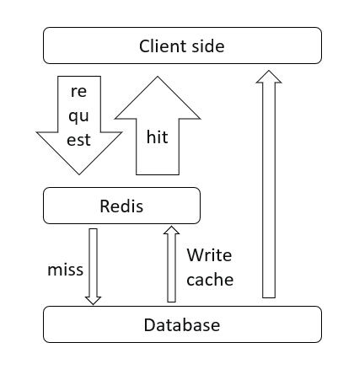
We can use this idea to query for product information. This is done as shown in the following figure:
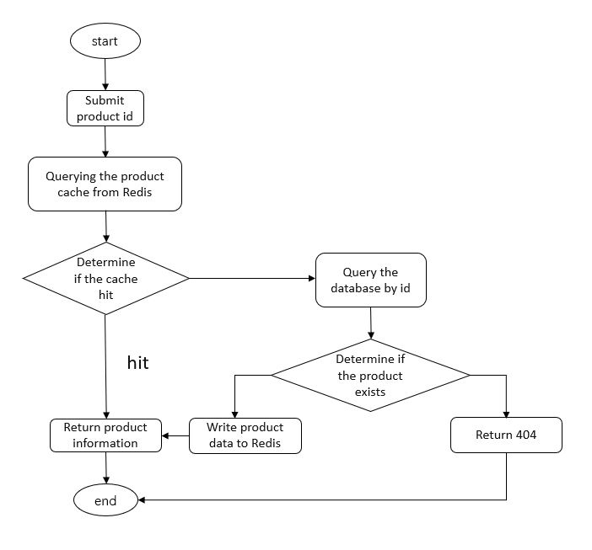
Only by giving full play to the advantages of relational data and the advantages of nosql database, can the performance of the whole project be the best.

Reference
[1]Makris Antonios;Tserpes Konstantinos;Spiliopoulos Giannis;Zissis Dimitrios;Anagnostopoulos Dimosthenis.MongoDB Vs PostgreSQL: A comparative study on performance aspects[J].GeoInformatica,2021,Vol.25(2): 243-268
[2]Muñoz-Sánchez, Pablo D.;Fernández Candel, Carlos Javier;García-Molina, Jesús Joaquín;Sevilla Ruiz, Diego.Managing Physical Schemas in MongoDB Stores[J].Lecture Notes in Computer Science (including subseries Lecture Notes in Artificial Intelligence and Lecture Notes in Bioinformatics),2020,Vol.12584: 162-172
[3]William Schultz;Tess Avitabile;Alyson Cabral.Tunable Consistency in MongoDB[J].Proceedings of the VLDB Endowment,2019,Vol.12(12)
[4]Dirk Eddelbuettel.Redis for Market Monitoring[J].2022,
[5]A High Performance Memory Key-Value Database Based on Redis.A High Performance Memory Key-Value Database Based on Redis[J].Journal of Computers,2019,Vol.14(3): 170-183
[6]Bagga, Simmi;Sharma, Anil.A Comparative Study of NoSQL Databases[J].Lecture Notes in Electrical Engineering,2021,Vol.701: 51-61
[7]Sambuu, Uyanga;Namsraidorj, Munkhtsetseg;Batbayar, S.;Bat-Ulzii, Sh.A Comparative Study of NoSQL and Relational Database[J].Smart Innovation, Systems and Technologies,2021,Vol.212: 116-122

