Marketing Plan Written for
W Hotel London

Student Name
……………Anwara Begum…………..
Student ID
…………2125645………………

Marketing Essentials BMIH4005

Lecturer: Chris Wilkin
………………..

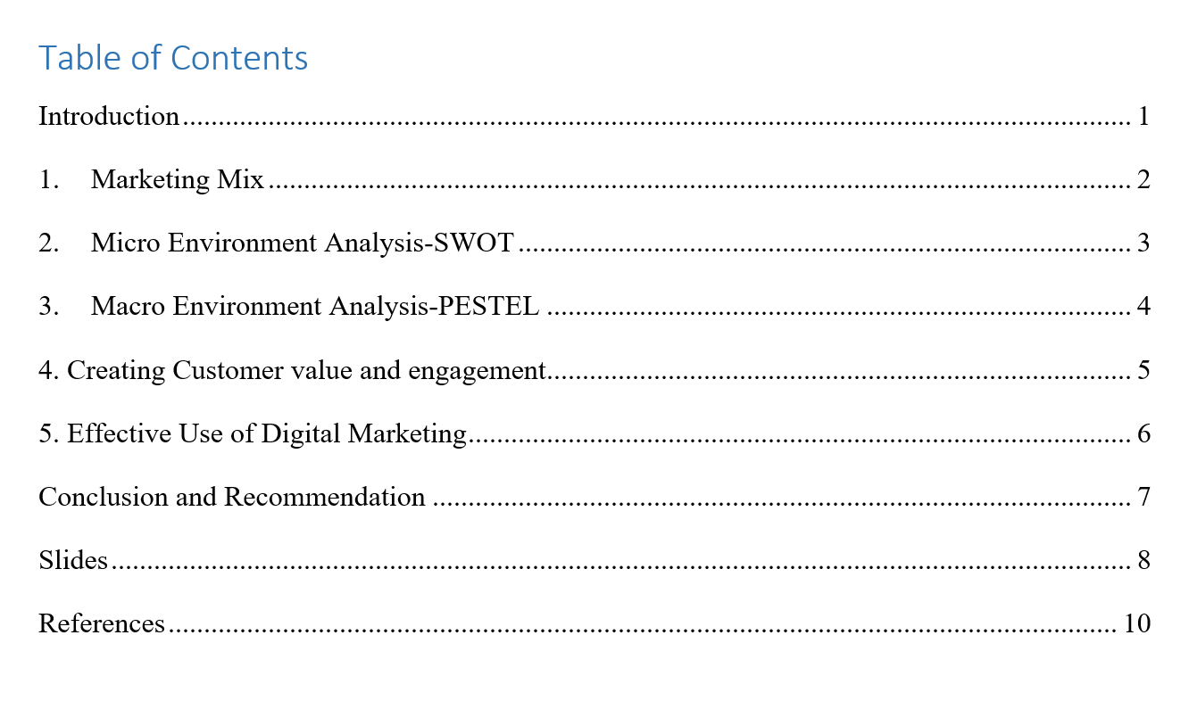

Introduction
W Hotels London is part of Marriott International's upscale lifestyle hotel brand aimed at a younger demographic. With its Whatever/Whenever service, the five-star luxury hotel in Soho is at the center of the city's cultural scene (Anderson and Han, 2018).
This marketing strategy for Marriott International's W Hotels London aims to attract new consumers by addressing global environmental hazards such as the post-pandemic condition caused by the COVID-19 virus. Due to these obstacles, the company's growth has stalled, and it is actually losing money in the hospitality industry. The development of a marketing strategy for this enterprise is something in which we would like to participate (Lee, 2020).

Marketing Mix
- Product: We'll cater our services to each customer's unique preferences. The personnel at W hotels will be taught to give excellent service and go above and beyond to meet guests' needs. W hotels' high room rates will be reflective of the superior quality of its facilities and services.
- Price: The pricing will be higher than those at comparable hotels. The W hotels in the British capital are known for their high-end amenities and service (Toma and Grădinaru, 2018). That's why it's crucial in the luxury industry to always go above and beyond for each and every consumer.
- Place: All offerings can be accessed via any W hotel's website or at any of the W's physical locations throughout the world. W London, the first hotel in the UK to use tablet technology, redefines luxury by providing one of the most cutting-edge tablet-based systems in the business, allowing you to tailor every aspect of your stay to your own preferences.
- Promotion: To further promote itself in the high-end hotel industry, W Hotels will team up with DMOs (Destination Marketing Organizations). As a part of its marketing strategy, the company plans to forge alliances with "the leading hotels of the globe" to build a strong and reputable brand name (Piramanayagam and Seal, 2022). It plans to promote its experience-based goods and services using social media platforms like Facebook, Instagram and YouTube.

Micro Environment Analysis-SWOT

Each hotel features an eclectic assortment of cutting-edge aesthetics and interests in fields as varied as haute couture, electronic dance music, architectural design, and contemporary pop culture (GIRGEN, 2021). W Hotel London embodies the brand's sensitivity to a comprehensive lifestyle experience with its innovative design, contemporary culinary concepts, spectacular nightlife, and iconic spas, making it a one-of-a-kind embodiment of modern living.
- Strengths: The W Hotel London has established itself as a high-end brand, which is a great strength. Its flagship strength is the S Preferred Guest loyalty program, which has won widespread acclaim for its successful use of creative marketing to win over repeat consumers.
- Weaknesses: Even though it's a 5-star establishment, it caters exclusively to high-end guests, which limits its potential clientele. Targets a narrow subset of consumers. An insufficient advertising effort has been made for the motel.
- Opportunities: The W hotel has a high capacity for population growth and diversification. Brand awareness and customer loyalty will increase if the company targets the millennial generation. They can expand their holdings and target a wider range of customers.
- Threats: Since the pandemic began, Marriot's overall earnings have dropped by 92% due to the following risks: shifts in general economic conditions, particularly the intensity and duration of downturns, intense rivalry to attract the market, and volatility in foreign exchange rates. Corporation profits will be threatened so long as the pandemic lasts.

Macro Environment Analysis-PESTEL
Political Environment
Because politics may be so volatile and influential at times, it is essential for businesses to keep a close eye on the political climate (Köseoglu et al., 2020). This is due to the fact that governments can impose regulations and laws that can have far-reaching effects on businesses. For instance, the W Hotel in London may see a drop in international guests as a result of Brexit's restrictions on travel.
Economic Factors
The high value of the U.S. dollar abroad is a concern for W Hotel UK since it discourages both domestic and international visitors from spending money in the city, particularly in tourist hotspots like London. Deterring business travel is also high exchange rates.
Social Factors
The hotel business is very susceptible to societal and cultural shifts, which are in turn shaped by people's tastes and spending habits. These decisions are heavily influenced by the age range of the vacationers (Moret, 2020). The hospitality sector is affected by multiple societal and cultural variables. W Hotel is aiming for a younger clientele that appreciates finer things in life.
Technological factors
Hoteliers are reaping the rewards of a new era made possible by technological developments in the hospitality business. From ensuring seamless service to providing the finest facilities, hotels benefit from technological advancements. The W Hotel's Tablet Facilities.
Environmental factors
The hospitality business can be directly affected by environmental concerns. In recent years, eco-friendly initiatives at hotels have become the norm (Lim and Seo, 2021).
Legal factors
Growth in the hotel business is strongly influenced by the regulatory framework in place in a given country. The operation of a hotel is profoundly affected by many statutes and tax regulations. This is similar to the ever-increasing pool of hotel amenities.

4. Creating Customer value and engagement
The hospitality industry is not immune to the shift in consumer expectations. It's no longer enough to choose a hotel based on whether or not it has a nice lobby or fluffy bathrobes. Customers are also aware with their digital experiences before they even arrive at the hotel. The modern consumer has come to anticipate a streamlined, individualized, and instantaneous service from all sectors (Lui and Jo, 2020). The W hotel chain in the UK, for example, provides guests with cutting-edge tablets in their rooms. Digivalet has upgraded all 192 suites and rooms with cutting-edge amenities.
The company's connection with Salesforce ensures that W hotel staff have access to any and all client data they could require. Consequently, each member of the team may provide a tailored experience at any stage of the customer's interaction with the business. In this way, they can maintain a dialogue with a consumer from any channel thanks to a complete and accurate profile of each guest. The company's top priority will be the protection of its clients (Nangpiire, Silva and Alves, 2021).
It's much more cost-effective and valuable to keep an existing customer rather than to seek out a new one. Customers that are considered "loyal" spend 67% more in months 31–36 with a brand compared to their initial six months (Touni et al., 2020). In order to ensure repeat business, the W hotel chain has a system that rewards frequent guests. Their loyalty program incentivizes existing consumers to keep utilizing their products and services. The hotel can show its appreciation for guests in a new way.

5. Effective Use of Digital Marketing
This marketing strategy will employ a multifaceted approach, making use of a wide variety of digital media and distribution channels. Case in point There will be a use for an aesthetically pleasing website. In order to find the best price, many guests search on Hotels.com or another booking engine. Many potential guests may check the hotel's website for further details or a lower rate. It follows that a visually appealing website is essential for success. Businesses can reassure their loyal clientele that they take their customers' security seriously by publishing relevant safety metrics on their websites.
Facebook advertising, as the undisputed leader in social media and the unrivalled engine of hotel digital marketing (Parvez et al., 2018). Facebook listening can help you connect with guests and impress potential buyers by demonstrating your thoughtfulness (Sousa, Magalhães and Soares, 2021). Finally, a dynamic Facebook and Instagram ad for a hotel can help spread the word about the preventative measures it has put in place in the event of a COVID epidemic (Andriany et al., 2022).
Finally, in this day of ubiquitous advertisements and social media marketing, the importance of email marketing to the hotel business cannot be overstated. Also, there is no initial investment required, making this one of the cheapest methods of audience reach. In addition, it aids in luring new guests and reviving hotel operations in the wake of the COVID pandemic.

Conclusion and Recommendation
In order to attract new customers in the wake of the pandemic, the W Hotel could adjust its pricing and offer discounts to raise awareness among its clientele of the precautions it has taken to ensure their safety. The best tool and source for teaching me about the success or failure of marketing initiatives and the impact of expanding into untapped markets. Although there are a number of obstacles following a pandemic, such as financial issues and safety issues, these can be overcome with the correct marketing approach. The corporation needs to conduct surveys of hotels and analyze the results of marketing campaigns to get a clear picture of how effective their efforts have been. This information will be invaluable as we work to create a dynamic and competitive market. They may increase their success in acquiring new customers and selling their product of assuring client safety by using the correct blend of digital media.

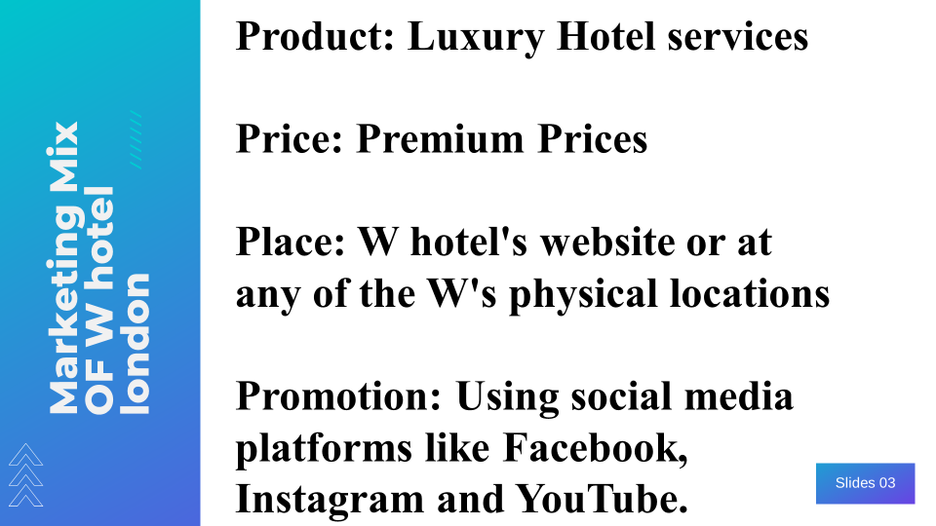
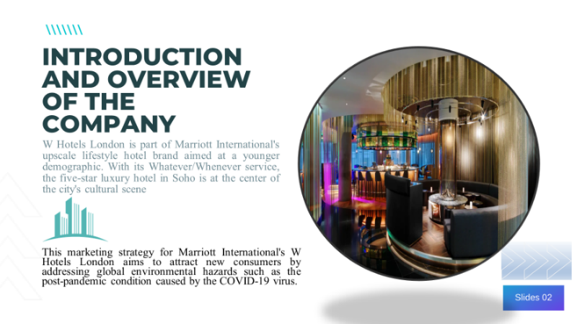
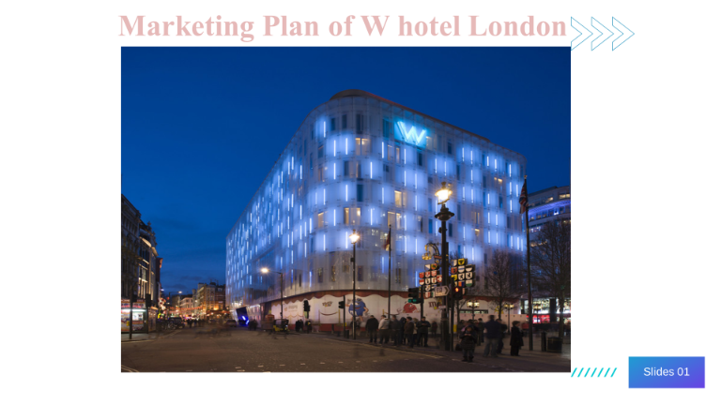
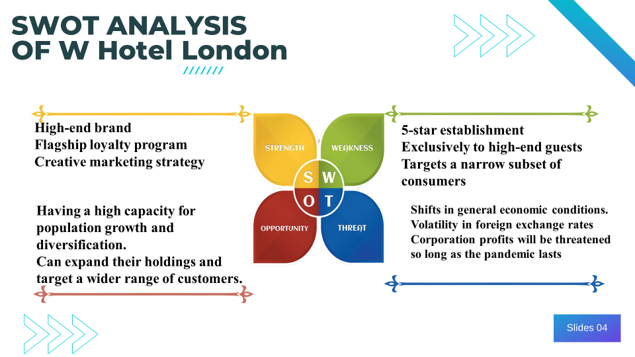
Slides
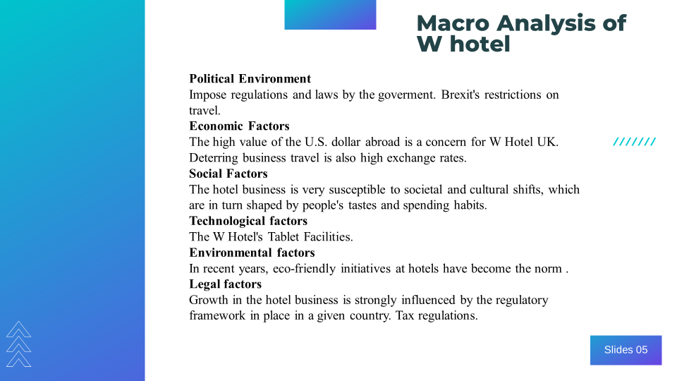
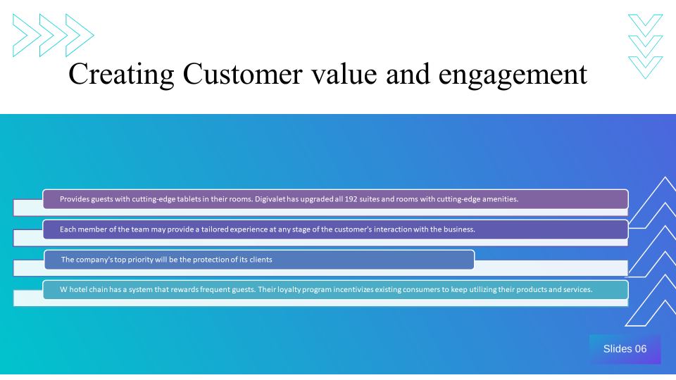

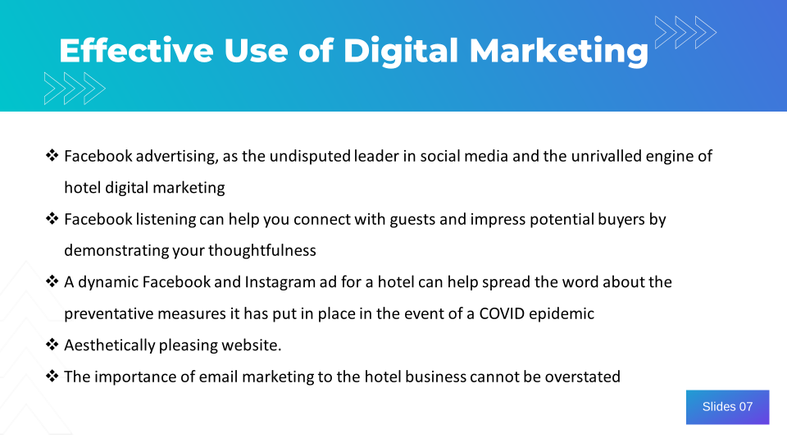

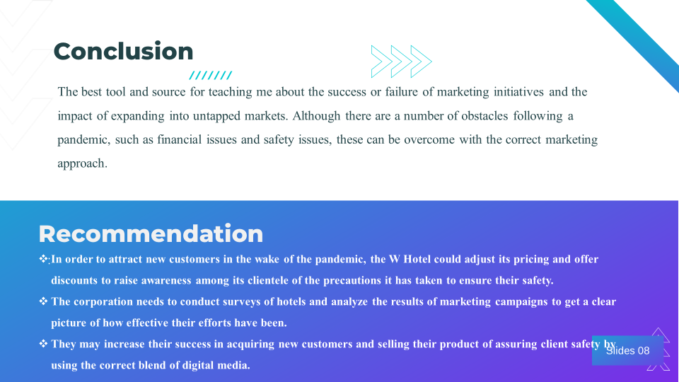
References
Piramanayagam, S. and Seal, P.P., 2022. The language of luxury: decoding the luxury hotel brand's marketing communication. In The Emerald Handbook of Luxury Management for Hospitality and Tourism. Emerald Publishing Limited.
Anderson, C.K. and Han, S., 2018. Indexing hotel brand reputation.
Lee, K.H., 2020. Marketing approach to the tourist experience. In The Routledge Handbook of Tourism Experience Management and Marketing (pp. 260-270). Routledge.
Toma, S.G. and Grădinaru, C., 2018. The marketing mix in a luxury hotel chain. The Journal Contemporary Economy, 3(2), pp.105-111.
GIRGEN, M.Ü., 2021. IMPORTANCE OF MARKETING STRATEGIES FOR TOURISM COMPANIES. Research and Reviews in Social, Human and Administrative Sciences-I.
Lim, H.W. and Seo, D.S., 2021. Improvement Strategy According to the Change of Hotel Environment. International Journal of Advanced Culture Technology, 9(2), pp.72-79.
Moret, N.J., 2020. The sustainable business model of a hotel–the case of the W Barcelona.
Köseoglu, M.A., Altin, M., Chan, E. and Aladag, O.F., 2020. What are the key success factors for strategy formulation and implementation? Perspectives of managers in the hotel industry. International Journal of Hospitality Management, 89, p.102574.
Liu, J. and Jo, W., 2020. Value co-creation behaviors and hotel loyalty program member satisfaction based on engagement and involvement: Moderating effect of company support. Journal of Hospitality and Tourism Management, 43, pp.23-31.
Nangpiire, C., Silva, J. and Alves, H., 2021. Customer engagement and value co-creation/destruction: the internal fostering and hindering factors and actors in the tourist/hotel experience. Journal of Research in Interactive Marketing.
Touni, R., Kim, W.G., Choi, H.M. and Ali, M.A., 2020. Antecedents and an outcome of customer engagement with hotel brand community on Facebook. Journal of Hospitality & Tourism Research, 44(2), pp.278-299.
Andriany, D., Murni, N.G.N.S., Triyuni, N.N., Sudarmini, N.M. and Trisnayoni, R.A., 2022. 5-Star Luxury Hotels’ Instagram Performance as a Digital Marketing Strategy during the Travelling Restriction. International Journal of Glocal Tourism, 3(2), pp.100-110.
Parvez, S.J., Moyeenudin, H.M., Arun, S., Anandan, R. and Janahan, S.K., 2018. Digital marketing in hotel industry. International Journal of Engineering & Technology, 7(2.21), pp.288-290.
Sousa, B.B., Magalhães, F.C. and Soares, D.B., 2021. The role of relational marketing in specific contexts of tourism: A luxury hotel management perspective. In Building consumer-brand relationship in luxury brand management (pp. 223-243). IGI Global.

