Mariah Edwards

ACBA 4003 Assignment

Contents
Benefits of Registering with a professional body (ICE) 2
Health and Safety Benefits 3
How do I register with a professional body (ICE)? 4
Professional Development Plan 5
References 8

As an employee at this company, I have decided to register with a professional body in the built environment sector. I believe that this step in my journey to become a chartered Civil Engineer would not only be beneficial to me but to the company as well as they ensure that technical standards and ethics are set and upheld.
After researching multiple professional bodies such as CIOB, the Chartered Institution of Builders, CITB, the Chartered Industry Training Board, CABE, the Chartered Association of Building Engineers, I decided that ICE, the Institution of Civil Engineers is a more suitable professional body to register with for my chosen career path.
ICE was founded over 200 years ago and is one of the most respected professional bodies in the construction industry with over 95,00 members around the world. They value Trust, honesty, quality and professionalism, high standards, integrity and ethical conduct, promotes the work that civil engineers do and equips civil engineering professionals like me necessary tools needed to develop in the industry.
It is important for me to join a professional body as it would give me access to a range of knowledge and professional support. According to the ICE website I would be able to join as an Associate member which would allow me the professional status of showing that I am committed to improving my skills and knowledge to both you, clients and prospective clients. It would also show that I have spent time developing my skills and I am quite competent in my field of specialism.

Benefits of Registering with a professional body (ICE)

The primary benefit of registering with a professional body is that it would allow me to have letters after my name AMICE which represents my accomplishment and symbolizes that I’m a qualified professional.
ICE also offers discounts off training, access to libraries, events, publications, free regional events and online lectures which I can benefit from.
Registering with ICE or any professional body would offer me the ability to network and communicate with individuals across the globe and exchange information which is trusted and taken seriously.
Registering for a professional body would not only be beneficial to me but would also add major benefits to this company as their qualifications are recognized worldwide. It would communicate to prospective and current clients that this company employs persons that have the right skill set and knowledge. It shows that you’re dedicated to development and learning and improving and maintaining standards.

An investigation into the growth of productivity in the United Kingdom’s construction industry and what drives it indicates that the construction industry productivity levels are consistently below the UK’s average productivity.

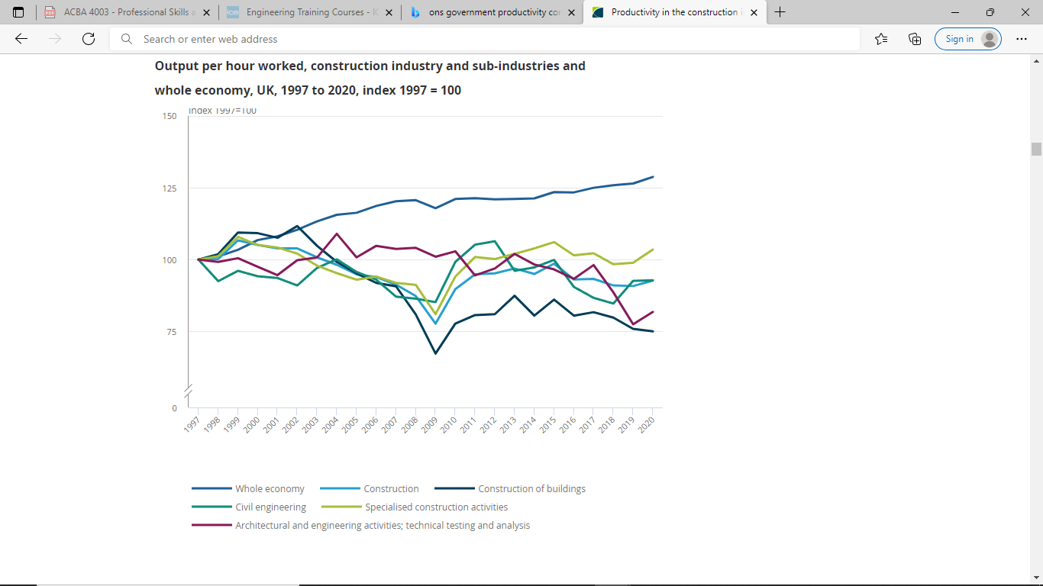
Productivity growth in UK for the period 1997-2020- Office for National Statistics (2021)
The construction industry provides the necessary infrastructure and building that the majority of the rest of the economy needs and productivity is essential if any economy is to progress hence productivity in construction is essential.
“Britain still spends too much, borrows too much, and our weak productivity shows we don’t train enough or build enough or invest enough. This we are determined to change.” (Osborne, 2015, pg.7)
I quoted this to highlight that investing and training are important to increase productivity. By my registering with a professional body which shares information and promotes high standards this would improve the productivity of the company through training and education.

Health and Safety Benefits
Registering with a professional body would demonstrate that I have an understanding about health and safety and risk management in the workplace and I am able to apply strategies to eliminate hazard and reduce risks.
It would demonstrate that I have the minimum requirement to satisfy CPD requirements, and therefore maintaining professional standards.
ICE offers training programs in Health and Safety and Risk Management and keeps members up to date on the latest regulations and publications with regards to health and safety.

How do I register with a professional body (ICE)?

To become professionally recognized I would need to complete three stages based on my academic qualifications, work experience and my professional review.
Step 1: Although I have an undergraduate degree BSc (Hons) Civil Engineering I would still need to do further learning either in education or at work in order to bring my education and experience to CEng level for professional registration. I have opted to complete an accredited MSc course as this company currently does not offer any employer-managed further learning program.
Step 2: IPD (Initial Professional Development) or work experience is where I would need to develop skills and experience to become professionally qualified. I can complete this step a number of ways, I can either complete a structured training program run by you my employer with guidance and support from a Supervising Civil Engineer that you appoint, or I can be responsible for my own training and receive guidance from an ICE appointed mentor.
Step 3: This is the last stage of my professional registration; it is where an experienced Civil Engineer Professional would be interview me and my writing skills would be assessed, I would also need to showcase my knowledge and prove that I have the skills needed to become a registered professional.

Professional Development Plan

Below I have included my professional development plan to highlight the training and skills that I would need to do for professional registration.
Name:
Job role and responsibilities:
Review of learning needs |  |  | Development plan
Reference | In what area do I need to improve my performance? | What do I need to learn in order to achieve this? | What will I do to achieve this? | What are the likely resources and support that I will need? | How will I evaluate a successful outcome?
1 | Improve Technical and report writing skills | - How to communicate effectively  - How to structure reports  - How to use software programs that help with technical writing | Complete Technical report writing training course | Time off from work to complete in person sessions.  Funding for course fee | - Completion of course assessment  - I should be able to plan and structure reports to effectively communicate so readers can understand.  - My ability to layout reports in a format that is reader friendly
2 | Widen my understanding of Health, Safety and the Construction (Design and Management) | Understand sources of hazards and risks  International standards for health and safety  Understand the different qualitative and quantitative risk assessment techniques | Complete Health, Safety, Welfare and Risk Assessment course | Time off from work to complete in person sessions.  Funding for course fee | - Completion of course assessment  - My understanding of risk and hazards  - My risk and safety assessment techniques  - My ability to complete a method statement
3 | Greater knowledge of sustainability issues | Learn about civil engineering role in sustainable development  Learn about the history of sustainability  Learn more about carbon accounting  Different environmental risks  Understand the impact of ethical decisions | Complete Introduction to Sustainable development course | Time off from work to complete in person sessions.  Funding for course fee | - Based on completion of course assessment  - my understanding of the role of civil engineers in meeting Sustainable development goals  - Be able to evaluate risks surrounding ethical decisions
4 | Improve Interview skills | Learn how to prepare for interviews and how to practice for them  How to tackle competency-based questions  How to conduct proper research before an interview | Attend ICE: Interview Tips and Techniques webinar online on the 9th March, 2022 | Further tips and advice | I will evaluate a successful outcome base on my ability to apply the skills learnt from webinar.
5 | Time Management and managing high pressure situations | Understand what high pressure situations are and how to navigate them  Learn how to avoid getting “stuck” while doing tasks.  Learn how to use the energy generated in high pressure situations positively | Prioritize tasks based on importance  Attend ICE webinar: Managing High Pressure Situations on 15th March, 2022  Practice stress relieving exercises and strategies |  | Evaluation will be based on my ability to complete complex tasks efficiently within a specified time frame.
6 | Add to academic qualifications | Complete specialization in Geotechnical Engineering | Apply to a university program | Study Leave | Certificate to show successful completion of Degree

References

The Chartered Institute of Building, B.G (2015) UNDERSTANDING THE VALUE OF PROFESSIONALS AND PROFESSIONAL BODIES. https://www.ciob.org/industry/research/Understanding-Value-Professionals-Professional-Bodies (Accessed: 30 January, 2022)

Office for National Statistics (2021) Productivity in the construction industry, UK: 2021. Available at: https://www.ons.gov.uk/economy/economicoutputandproductivity/productivitymeasures/articles/productivityintheconstructionindustryuk2021/2021-10-19 (Accessed: 30 January 2022)

Institution of Civil Engineers (2014) All Training Courses. Available at: https://www.icetraining.org.uk/Courses (Accessed: 30 January 2022)

Institution of Civil Engineers (2022) Associate Member (AMICE). Available at: https://www.ice.org.uk/membership/grades-of-ice-membership/associate-member (Accessed: 30 January 2022).

Health and Safety Executive (2015) The Construction (Design and Management) Regulations 2015. Available at: https://www.hse.gov.uk/construction/cdm/2015/index.htm (Accessed: 30 January 2022)

Institution of Civil Engineers (2022) ICE Events. Available at: https://www.ice.org.uk/events (Accessed: 30 January 2022)

Office for National Statistics (2021) Productivity in the construction industry, UK: 2021. Available at: https://www.ons.gov.uk/economy/economicoutputandproductivity/productivitymeasures/articles/productivityintheconstructionindustryuk2021/2021-10-19 (Accessed: 30 January 2022)
Institution of Civil Engineers (2017) Health and Safety Risk Management. Available at: https://www.ice.org.uk/knowledge-and-resources/best-practice/health-and-safety-risk-management (Accessed: 30 January 2022)

