Define skill in the context of your own practice and the work of two artist/ makers/ designers from the lecture series.

P132470

Architectural Stained Glass

2005 words

Julia Lockheart

There are many different types of skill, and a person can be skilled in a range of different ways. They could be a skilled thinker, maker, designer or craftsperson. Skill is also a word, which could be defined in two different ways. One interpretation being, a conscious development of ones proficiency in a particular area or activity that they have deliberately chosen to focus on. For example, a person who wishes to become good at a subject such as art or drawing could build up their skill by reading up on the subject, practicing drawing daily or following it down an educational path to be taught how to acquire that particular skill. The second way in which it could be defined is an action, that when repeated continuously over days, months and years builds up a skill unintentionally. For instance, when an animal learns instinctively to build their home. It becomes a habitual skill when it is repeated out of necessity rather than a conscious decision to actively go out and seek a skill.

Looking at skill through the first interpretation, a person who deliberately seeks out a skill, there can be evidence found as far back as early Homo sapiens that illustrates how being an advanced thinker lead to the use of lithic technology and tools. As a result of this higher level of knowledge, humans were able to build up their skills as a means to survive. Richard Sennett talks about the importance of the hand in his book, ‘The Craftsman’ and how the human race came to use the hand as a tool.
‘With greater brain capacity, our human ancestors learned how to hold things in their hands, to think about what they held; man-apes could make tools, humans make culture’ (Sennett, 2008: 150)

This idea shows that by starting to use hands as tools and thinking about them in a more sophisticated way, that the earlier generations of human were able to get ahead and managed to maintain life in a time when there was very little chance of survival. This was the very beginning of the idea of skill and thinking actively about what hands can accomplish, especially when used in unison with advanced thinking brains.

A unique and interesting expertise to look into when referring to skill would be the practice of stained glass and the dexterity built up within different areas of it. There are a lot of elements to the process of creating a stained glass window, and as a result a lot of different skills to be gained from it. For example, the first skill a person needs to master to be a successful stained glass artist is cutting glass. A special tool is made specifically for the task. It is a pen-like tool with a small wheel and a well for oil. The wheel must be pressed firmly but not aggressively onto the glass and pushed along the surface to create a tiny groove where the glass is to be broken. Next, the glass should be held firmly with both hands either side of the score line and pressure should be applied gently to snap the glass apart.

One of the more desired and notoriously difficult skills to acquire in the world of stained glass is the art of glass painting. Glass Painting is a sought after skill to acquire because it can only be accomplished through a dedication to practice over years. There are no short cuts or quick fixes to become a talented painter and only a few manage to become masters of the trade. Glass painting is not anything like painting on paper or canvas. To begin with, the paint is made up of powdered glass. This is then mixed with either water or oil and usually a gum to help adhere the paint to the surface of the glass because it is not a porous material. The paint sits on top of the glass and can be moved around. Special brushes are also used, mostly made from natural hair such as duck, crow and badger. All of the best glass painters around the world and throughout history have worked continuously over years and years to achieve the level of skill they have attained in their field. One of the more influential stained glass artists to accomplish this was Christopher Whall. He was one of the most skilled glass painters of recent history and was mostly active in stained glass from around the 1880’s, a time when the arts and crafts movement was flourishing. He was an artist, educator and author and passed on much of his knowledge through his book ‘Stained Glass Work’ (1905). On describing how to use light, colour and paint on the glass Whall states,
‘One may gradually acquire the skill to combine all the processes, in all their degrees, upon a single painting; and the only way in which you can test their relative value, either as texture or as light and shade, is to constantly practice each process in all it’s degrees’ (Whall, 1905: 101)

Christopher Whall believed in acquiring each skill within stained glass. Here, he states the importance of practice when trying to acquire a skill, whatever that particular skill may be. Whall discusses the necessity in carrying out an action repeatedly and exploring every avenue of it, to truly be able to understand and master it fully.
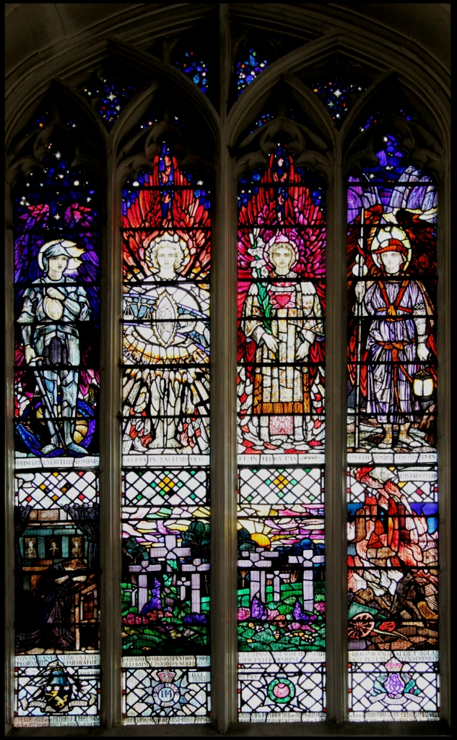
Figure 1 War Memorial Window (2006) www.buildingconservation.com
The panel displayed above (fig.1) is a memorial window in St Andrews Church, Chippenham, and is designed by Christopher Whall. He was known for his use of pot-metal, streaky glass in rich colours such as deep ruby reds and purples that he would enhance with bursts of bright yellow silver stain. Whall has a full chapter in his book dedicated to colour and how an artist should pick colours, particularly for glass.
‘You choose your purple (and, bye-the-bye, almost the only way to get a satisfactory one, except by a happy accident now and then, is to double gold-pink with blue; this is the only way to get a purple that will vibrate, palpitating against the eye like the petal of a pansy in the sun). Well, you get your purple, and you get your green- not a sage-green, or an “art-green,” but a cold, sharp green, like a leaf of parsley’. (Whall, 1905: 210)

His use of colour within his glass is world-renowned and it is a skill he passionately felt needed to be shared.

Although Christopher Whall was a very accomplished glass painter and colourist, he didn’t shy away from the other aspects involved in creating a stained glass window. He often worked with other people to make the windows, but was also able to cut, paint and lead the glass himself. Amongst many of his skills Christopher Whall was a prominent member of the arts and crafts movement. Along with people such as John Ruskin and William Morris he understood that one man should be able to do all of the tasks from start to finish whilst creating a piece of stained glass work.

Ruskin and Morris were two leading individuals within the arts and crafts movement. The group valued the ideals of a society where people worked and made things themselves, with their own hands and their own tools rather than being replaced by machinery in a time of mass industrialisation. (V&A, 2016) The Arts and Crafts Movement began in the late 19th Century and was started because people were deeply unhappy with the amount of industrialisation being introduced into Britain. The supporters of the movement prized hard work and simple hand rendered design over the ever-growing mass production industry.

‘Clayton and Bell’ was a stained glass company started in 1856, made up of the artists John Richard Clayton and Alfred Bell. Bell was particularly outspoken about the effects of mass production on the final outcome of their work. Although they made all of the panels themselves by hand and didn’t rely on machinery, the pair still began to mass-produce their stained glass windows. As a result the skill and fine workmanship began to get lost. (Banerjee, 2017) Alfred Bell had formerly worked for another artist called George Gilbert Scott, he often referenced how Bell felt about mass production. ‘No real art can stand against a constant high-pressure and working against time.’ (Scott, 1977: 222) Bell felt that by having such a high demand of work to be made, it meant that each piece had to be rushed and as a consequence of this, the skill that he had worked so hard to achieve in his career was being lost in the work.

William Morris, a prominent leader in the arts and crafts movement, also believed that the skills and craftsmanship put into a piece of work by the human hand was far superior to anything that was being mass produced by machinery. Morris believed that good design and art should be accessible to all, not just the high societies of the rich or royal. However, it soon became apparent that by moving away from mass production, things began to cost more. As things were being handmade, people had to pay for the time and skill that had gone into a product and as a result a lot of his work became too expensive for the masses to buy. Morris, as well as being a designer, maker, writer and theorist decided to become involved in stained glass. He worked mostly with another artist called Edward Burne-Jones. Burne-Jones usually designed the panels and Morris and Co. manufactured them.

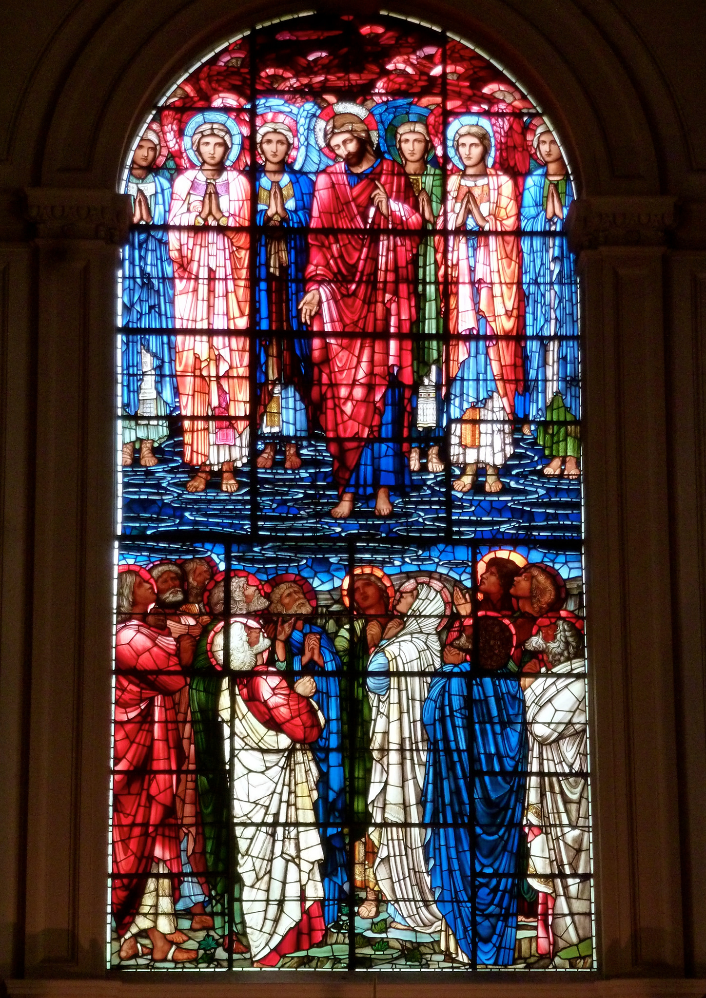

Figure 2 Burne-Jones, Morris. Ascension (1885) Arts and Crafts Stained Glass

The above image is of a panel from St Phillips Cathedral in Birmingham. It was designed by Edward Burne-Jones and made by Morris and Co. The panel is a style typical of the artists of the time. They favoured the style of mosaic glass, the attitude was that the more pieces of glass that could be included in the panel the better. They also, like Christopher Whall, tried to use strong, bold coloured glass. This panel is a prime example of this with a lot of dark reds and pinks. (Cormack, 2015) As this was a collaborative piece, different skills by different artists have been combined. Burne-Jones was the artist and only designed the piece, his skill lied in the design and the colours used. Morris loved the use of lots of lead lines and brought other skills to the collaboration in the form of manufacture.

Looking at all of the evidence presented, I believe there is definitely more than one way that skill can be defined. It can be described as habitual, in the way that it is present in animals but more importantly it can also be described as an acquired talent. Earned when a person or applied thinker deliberately sets out to gain a skill in a craft, hobby, or in this case, the art of stained glass. After looking at a few stained glass artists and reading some of the theories they have about their work I can say that I agree with the points made. Christopher Whall believed that skill could only be acquired through practice and repeating things over and over again until they became second nature. That is a tried and tested ideal that is still used today, over one hundred years later. I also believe that Ruskin and Morris have had a massive influence on skill. Their lead in the arts and crafts movement is still very much relevant in today’s day and age. Society is still trying to push Morris’s idea that art should be accessible and affordable to all. Additionally the idea that skill is lost through mass production is still being argued. Artists and designers are constantly coming up against large corporations that are able to make things on a mass scale, however the public are still willing to pay more for something if the know that it has been hand made by a skilled craftsperson.

Bibliography
Banerjee.J (2017) Stained Glass Windows by Clayton and Bell [ONLINE] Available at http://www.victorianweb.org/art/stainedglass/clayton/index.html [Accessed 12th Decemeber 2017]

Charney.D (2011) Power of Making, London: V and A Publishing

Cormack.P (2015) Arts and Crafts Stained Glass, New Haven and London: Yale University Press

Cormack. P (1979) Christopher Whall 1849-1924: Arts and Crafts Stained Glass Worker, London: The William Morris Gallery

Scott.G.G (1977) Personal and Proffessional Recollections,New York: Da Capo Press

Taylor. J (2010) Lest We Forget [ONLINE] Available at http://www.buildingconservation.com/articles/lestweforget/lestweforget.htm [Accessed 8th December 2017]

V&A (2016) The Arts and Crafts Movement [ONLINE] Available at http://www.vam.ac.uk/content/articles/t/the-arts-and-crafts-movement/ [Accessed 8th Decemeber 2017]

Whall.C (1905) Stained Glass Work, London: John Hogg

