Module Code: LCBB4003
Module Title: Introducing the Modern Workplace A2

Group :
Ana Moldovanu 2130326
Laura Bardas 2128922
Mihaela Sandu Rizea 2126225
Stefan Cristian Costache 2126833
Adriana Mihaela Petcu 2126831

Table of Contents
Section1: Student 1 (Trainer at Tesco) Laura Bardas 2128922 3
Introduction 3
Lack of engagement in Tesco 3
Role of Management of Tesco 3
Conclusion 6
References 7
Section 2: Student 2 (Senior Carer) Mihaela Sandu Rizea 2126225 8
Introduction 8
Discrimination in Parklands Care home 8
Role of Parklands Care home’s Management 8
Conclusion 11
References 12
Section 3: Student 3 (Picker with loop and Desk clerk) Adriana Mihaela Petcu 2126831 13
Employee Misbehaviour 13
What Managerial Role Should Be 13
References 16
Section 4: Student 4 (Hotel Maid) Ana Moldovanu 2130326 17
Introduction 17
Employee Misbehaviour 17
Different leadership styles 17
Conclusion 20
References 21
Section 5: Student 5 (picker with llop, stock) Stefan Cristian Costache 2128633 22
Employee Misbehaviour 22
The role of manager and leader in managing employee misbehaviour 22
References 26

Section1: Student 1 (Trainer at Tesco)

Laura Bardas

Introduction
In order to comprehend and enhance an organization's effectiveness, the field of research known as organisational behaviour examines how individuals, teams, corporate culture, and structure interact (Buchanan and Huczynski, 2019). It will encourage self-awareness, spiritual development, and a better understanding of the workplace (Jeanes, 2019). It promotes employee well-being and the development of positive working relationships (Jeanes, 2019). The manager of an organization must inspire and support employees in a decent way to act ethically and professionally (Storey and Holti, 2019).

Lack of engagement in Tesco
There are employees in many organisations that obstruct operations, steal company property, abuse coworkers, deceive management, or mislead clients. These actions by employees are referred to as employee misbehaviour (Kinley and Ben-Hur, 2015). These actions cost the organisation massively and are widespread within the organisation. Due to a variety of psychological factors, managers occasionally hesitate to confront employees about their inappropriate behaviour. Managers confront a challenge when dealing with problematic individuals (Kinley and Ben-Hur, 2015).
I am working in the warehouse as a trainer at Tesco which is the largest multi-channel retailer of hardware, accessories products and trade tools in the United Kingdom. We value providing our clients with excellent service, and we strive to make things as simple as possible. The management of our organization makes an effort to keep interested the employees. However, at the workplace of our organisation, there is a severe lack of employee engagement. Now I'm critically analysing this issue and suggesting what our management might do to stop this employee behaviour.

Role of Management of Tesco
An employer of an organization has to make good communication with his staff for getting a good outcome from him (McIlwraith, 2021). Luthans identifies four crucial managerial activities one of which is communication (Meredith and Shafer, 2022). The way things are done at work can be affected by communications, which gives the manager and employees an opportunity to make a better corporate culture (Jeanes, 2019). Employee engagement can be increased if managers and executives interact effectively with one another and with other employees in order to create a two-way information flow (Macey, 2009).
Besides this, the administration may improve communication by setting attainable goals for the workers, which can also boost productivity. Additionally, encouraging workers by thanking them for their hard work can have a significant impact on their morale. This can help management keep an eye on the people that make up the company and ensure that operations are carried out efficiently (Luthans et al., 2019).
It is detrimental to Tesco's reputation when employees call in sick frequently, barely show up for meetings or decide to stay in their offices at social events that are voluntary. Because of this employee disengagement, individuals may miss important information that has an impact on their work plan and corporate objective. Because of this, it is essential for the manager to discuss the problem with his staff.
Enhancing employee engagement is crucial for the success of Tesco. However, some individuals continue to be detached, which hinders the organization's expansion. It is necessary for the manager to check in again to see what is going on at the local workgroup level, which is controlled by the subordinate managers. For that networking is important which is one of four managerial activities. The work environment becomes more enjoyable for the employees if they feel engaged with their coworkers, manager, and supervisor. Strong relationships can be made by the employees if they are connected to their coworkers. Additionally, internal networking among team members from other departments can improve the employee members' understanding of the company and raise their level of job satisfaction. Employees who feel connected to one another are less likely to experience workplace isolation and are more likely to feel in control, appreciated, inspired, and driven. Employee engagement and turnover can be decreased by employee networking in Tesco.
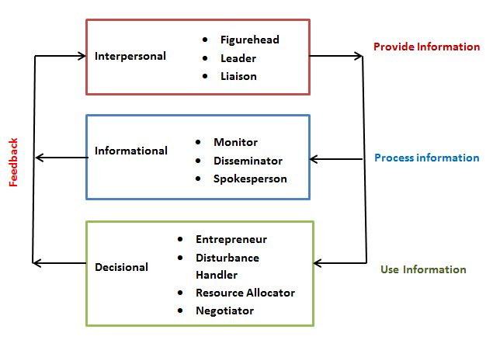
Figure 1: Henry Mintzberg’s managerial role Theory
Source: (Robbins and Coulter, 2014)
According to Henry Mintzberg’s managerial role, employee engagement is influenced by a manager's decision-making, interpersonal, and informational functions (Robbins and Coulter, 2014). The manager of Tesco has a responsibility as a leader to inspire his workers and acknowledge their accomplishments. In addition, he has to notify his staff about important facts, and he can consult with them when a critical choice needs to be made to generate fresh ideas. The manager may enhance corporate culture and employee engagement by developing horizontal relationships with people and groups both inside and outside of Tesco. He can use formal or informal sources to look for and gather information to get a better understanding of the organization's operations and surroundings.
Being practical is crucial if someone wants to get success as a manager (Verma and Sharma, 2014). The manager of Tesco cannot become a good manager by having only academic knowledge. He needs to communicate with his staff members and keep them inspired to participate in the workplace. He must teach his employees effectively using his hard and soft skills to do their duties properly. He must establish certain regulations for employee punishment.
A leader is someone who motivates a group of people to work toward a common objective (Pîrvan, 2012). It focuses on team activities that involve the workers. If the current manager is unable to lead the team, Tesco will need to hire a new manager with strong leadership skills. The connection between the management of Tesco and the staff can be a good example of leadership if it follows the power dynamic rules between followers and leaders. Employees carry out their responsibilities in accordance with the instructions provided by the organization's leader to produce successful results (Pîrvan, 2012). Improved staff engagement and change can come to Tesco under a competent leader.

Conclusion
So, it can be concluded that effective communication might be crucial in dealing with employee misbehaviour. A positive outcome may result from the effective relationship between the management and other employees. Employees are given a safe space and made to feel appreciated, in their opinion, when specific concerns are discussed with them and ideas are collected from them. The manager of Tesco will have a greater chance to boost employee engagement by being practical and using leadership skills at work.

References
Buchanan, D.A. and Huczynski, A. (2019) Organizational behaviour. Harlow, England: Pearson.
Jeanes, E. (2019) A dictionary of organizational behaviour. Oxford University Press.
Kinley, N. and Ben-Hur, S. (2015) Changing employee behaviour: A practical guide for managers. Basingstoke: Palgrave Macmillan.
Luthans, F., Rosenkrantz, S.A. and Hennessey, H.W. (2019) “What do successful managers really do? an observation study of managerial activities,” Managerial Work, pp. 165–180. Available at: https://doi.org/10.4324/9780429398599-10.
Macey, W.H. (2009) Employee engagement: Tools for analysis, practice, and competitive advantage. Malden, MA: Wiley.
McIlwraith, A. (2021) “Employee risk,” Information Security and Employee Behaviour, pp. 29–53. Available at: https://doi.org/10.4324/9780429281785-3.
Meredith, J.R. and Shafer, S.M. (2022) Project management a strategic managerial approach. Hoboken, NJ: Wiley.
Pîrvan Daniela (2012) Leadership in business. Craiova: PrintXpert.
Robbins, S.P. and Coulter, M.K. (2014) Management. Boston: Pearson.
Storey, J. and Holti, R. (2019) “Managerial and clinical leadership,” Innovating Healthcare, pp. 74–94. Available at: https://doi.org/10.4324/9780429455964-5.
Verma, P. and Sharma, R.R.K. (2014) “Relating organization culture and structure to enhance the horizontal strategy in conglomerates,” California Business Review, 2(1), pp. 35–40. Available at: https://doi.org/10.18374/cbr-2-1.5.

Section 2: Student 2 (Senior Carer)
Mihaela Sandu Rizea

Introduction
Organizational behaviour is the study and application of data referring to how people act inside organisations. It applies widely to people's behaviour in many different sorts of organisations, including corporations, administration, schools, and other institutions, and allows people, structure, technology, and the outside environment to merge together into a useful operating system (Buchanan and Huczynski, 2019). The study of organisational behaviour, which includes disciplines committed to improving job happiness, job performance, and innovation, serves as the foundation of corporate human resources.

Discrimination in Parklands Care Home
The term employee discrimination can be defined as unequal, unjust or prejudicial treatment or behaviour towards employees based on different characteristics of employees including their age, sex, ethnic origin etc. (Buchanan and Huczynski, 2019). Employee discrimination is a major concern for the business organisation since such misbehaviour of employees is detrimental to employee morale and engagement in the organisation and also to the overall performance of the organisation (Mustafa et al., 2022). I experience this employee misbehaviour at work while working as a senior caregiver in " Parklands Care home." Now I'm critically analysing the situation and making recommendations to our management on how to stop this ‘employee misbehaviour’.

Role of Parklands Care Home’s Management
The management of Parklands Care Home can put some helpful ideas from the Herzberg two-factor theory to practice for changing employee misbehaviour and boosting employee motivation. Herzberg's studies supported the concept that motivation factors have an impact on employees' behaviour which is a combination of success, inherent interest in the work, responsibility, and advancement (Mustafa et al., 2022). The combination of business policy, administrative procedures, supervision, interpersonal interactions, working environment, and remuneration constitutes another aspect called hygiene factors (Putnam, 2015).
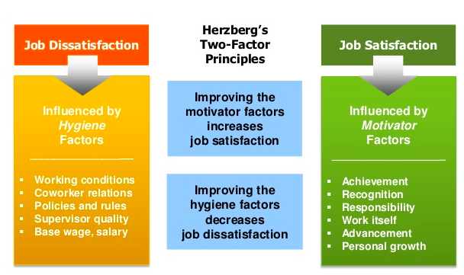
Figure 2: Herzberg's two-factor theory
Source: (Williams, 2019)
Intrinsic interest describes the impulsive propensity to look for novelty and challenges, to stretch one's abilities, to investigate, and to learn new ideas (Williams, 2019). Employees who are involved with discrimination towards others in ‘Parklands Care home’, such as discrimination, will reduce the morale of other employees, reduce job satisfaction, and lead them to lose interest in their jobs.
Some of the senior employees at "Parklands Care Home" occasionally behave impolitely at work. They occasionally used arrogant, disrespectful language or actions, as well as physical intimidation, including insulting remarks spoken in an enraged, hostile tone with their junior carer. They behave like this as a consequence of discrimination against others. By assigning responsibility, the management must make these types of bad behaviours stop. If the manager assigns them certain tasks, they will be accountable. It will be their responsibility to accept responsibility for the procedures they will follow and look for improvements. However, they must turn in their assignment on schedule. For instance, if they are assigned to care for an elderly person for two days, they will perform their duties well for the selected period otherwise they will be fired.
The manager of "Parklands Care Home" can motivate the junior and senior employees by providing advancement opportunities to them like promotions and bonuses. It will make the career path easier for the employees and help them to concentrate on their work (Long, 2010). They will provide good services to the consumers of the “Parklands Care Home” and behaves well with their juniors if they get better remuneration for their work regularly.
If the manager wants to influence employee behaviour, he must establish an "employee feedback" system based on how his employees perform their jobs (London and McFarland, 2017). An employee who discriminates against others will more likely to receive negative feedback, which will affect his career, and he may even lose his job. Obtaining them by gathering feedback about them and then taking action in accordance with it will be a quicker way to modify employee behaviour in the organization. Employees who feel they desire to perform their tasks well will not cause any disruptions at work and will receive positive feedback about themselves from their clients and co-workers.
Stress at work may result from an unsuitable or unfavourable work environment at "Parklands Care home." Additionally, it leads to mistakes being made by the employees. The potential of the employees may not be fully used as a result of an unfavourable work environment. Senior and junior staff members at the care home are experiencing stress connected to their jobs because of this which leads them to discrimination. The manager needs to concentrate on this area and enhance the "Parklands Care Home" employees' working conditions, which is a hygiene factor so that they can enjoy their work. The environment of the workplace has an impact on how motivated employees are to work hard as well as on their productivity and performance.
Growth is made possible with good supervision (Stine, 2015). Additionally, interpersonal relationships have a direct impact on the culture of the organisation (Long, 2010). In "Parklands Care home," there are some misunderstandings and miscommunication that could cause problems at work. Conflicts among employees can be fruitless and damage the working atmosphere as well as individual conduct. The employees at "Parklands Care Home" needs people nearby who can recognise their efforts and occasionally inspire them, just as in other companies. The total physical and mental well-being of the employees at "Parklands Care Home" may depend on these two crucial hygiene factors. Therefore, if the manager establishes a good relationship with the staff and supervises them, the employees will be benefited from their struggle against loneliness and make it simpler for them to break their terrible habit of discrimination towards other employees.

Conclusion
So, it can be concluded that applying the Herzberg two-factor theory will help reduce employee misbehaviour like discrimination of employees towards other employees. The two variables are the hygienic factor and the motivational factor, which are a combination of inherent interest, accountability, advancement, employee feedback, working conditions, supervision, and interpersonal relationships. In order to increase employee behaviour, which can inspire them and enhance their performance, the manager must deal with these aspects.

References
Buchanan, D.A. and Huczynski, A. (2019) Organizational behaviour. Harlow, England: Pearson.
London, M. and McFarland, L.A. (2017) “Assessment feedback,” Handbook of Employee Selection, pp. 406–425. Available at: https://doi.org/10.4324/9781315690193-19.
Long, C.P. (2010) “Control to cooperation: Examining the role of managerial authority in portfolios of Managerial Actions,” Organizational Control, pp. 365–395. Available at: https://doi.org/10.1017/cbo9780511777899.013.
Luthans, F., Rosenkrantz, S.A. and Hennessey, H.W. (2019) “What do successful managers really do? an observation study of managerial activities ,” Managerial Work, pp. 165–180. Available at: https://doi.org/10.4324/9780429398599-10.
McIlwraith, A. (2021) “Employee risk,” Information Security and Employee Behaviour, pp. 29–53. Available at: https://doi.org/10.4324/9780429281785-3.
Mustafa, M.Z. et al. (2022) “Factors influencing job satisfaction in the Malaysian Vocational College: Herzberg Two factor theory perspective,” Universal Journal of Management, 10(1), pp. 18–25. Available at: https://doi.org/10.13189/ujm.2022.100102.
Putnam, L. (2015) Workplace Wellness that works: 10 steps to infuse well-being and vitality into any organization. Hoboken, NJ: John Wiley andamp; Sons, Inc.
Stine, A. (2015) Supervision. London: Harper Voyager.
Williams, K. (2019) “Distinguishing the construct of interest from intrinsic motivation, intrinsic value, and mastery orientation,” Proceedings of the 2019 AERA Annual Meeting [Preprint]. Available at: https://doi.org/10.3102/1435996.

Section 3: Student 3 (Picker with loop and Desk clerk)
Adriana Mihaela Petcu

Employee Misbehaviour
The part of human behaviour that has an impact on how well an organisation performs is what organisational behaviour is all about (Hitt et al., 2018). It analyses individual, collective, and overall organisational levels of human behaviour. The purpose of studying organisational behaviour is to promote organisational effectiveness by learning how individuals, groups, and organisational structures affect behaviour within an organisation (French et al., 2015). It monitors internal human activities and uses the proper power to keep an organisation going. The study of organisational behaviour, which comprises disciplines that seek to improve job satisfaction, job performance, and creativity, forms the basis of corporate human resources.
Any purposeful activity by members of organisations that breaches fundamental organisational and societal norms is referred to as organisational misbehaviour (Cooper and Rousseau, 2003). Any employer may experience a wide range of issues as a result of inappropriate or illegal employee behaviour. It may lead to a loss in productivity, harm to the company's finances or reputation, injury to workers and clients, and expensive legal responsibility. Employee misbehaviour can take many various shapes, from bullying that can lead to workplace hazards that endanger personal and organizational safety (Vredenburgh, 2002). No manager wants to think about the possibility of workplace violence, yet it is a distressing reality. In my organisation, where I work as a picker and desk clerk, bullying is a problem. I'm now critically analysing the circumstance and offering suggestions to our management on how to put an end to this "employee misbehaviour."

What Managerial Role Should Be
As an employer of the organization manager should take some steps to change and stop employee misbehaviour in the organization (Putnam, 2015). The manager can modify the circumstances and improve the workplace environment for the employees by utilising Henry Mintzberg's ten managerial roles (Cooper and Rousseau, 2003). There are ten functions that managers can play in a company, and they can be divided into three main groups according to Mintzberg (Mintzberg et al., 2010). The roles fall under the following categories which are interpersonal, informational, and decisional.
The interpersonal role is a combination of roles that a manager might use to handle a situation. This role contributes to and implements thoughts and information. The subcategories of interpersonal roles are figurehead, leader, and liaison (Kalbfleisch, 2009).
The figurehead is regarded as the organization's symbolic leader. The management is therefore expected to fulfil social, legal, and ceremonial duties. Employees will not get the opportunity to act inappropriately with other employees and subordinates while performing their jobs if the manager performs symbolic tasks and is viewed as a source of inspiration and authority (Kalbfleisch, 2009). Additionally, if the manager shows leadership for his team, lower-level teams, and the department, the workers will be loyal to him. As a leader, the manager has the power to inspire, guide, advise, and train their team members (Barraclough, 2016). All of the organization's employees can have their tasks and performance managed by the manager. The workers will not be able to bully others at work if the manager takes on a leadership role. In addition to this, the manager of my organisation needs to interact with people both inside and outside the company. Otherwise, the employees will likely find their work challenging, which may be the cause of their inappropriate behaviour. To effectively communicate and sustain the information ties within and outside of the organisation, the manager must build and maintain a network of internal and external contacts.
The next role of Mintzberg is the informational role which is the combination of monitor, disseminator and spokesperson (Henry, 2007). The manager is in charge of compiling essential and valuable information for the company and keeping an eye out for crucial environmental developments. To create a positive work environment for all, the manager should personally review all obtained data, assess employee behaviour, keep an eye on team productivity and well-being, and maintain interpersonal relationships.
The manager's responsibility as a disseminator is to relay and disseminate any pertinent facts and information acquired from outside sources to the coworkers and teams operating within the organisation (Lerbinger, 2014). In my workplace, the employees occasionally experience data access issues, which makes them frustrated and leads to bullying. That is why the manager should gather and distribute data to his employees effectively.
The manager of my company will be expected to represent and speak for their organisations in speeches and reports since they are seen as representations of the organisations they work for (Meredith and Shafer, 2022). In addition, he must provide information to the company's employees. Related to the preceding function, the manager in this one is in charge of conveying to the inside and outside of the company the plans, objectives, policies, and actions of the business.
The third and final role of Mintzberg is the decisional role which is the combination of entrepreneur, disturbance handler, negotiator and resource allocator (Mintzberg et al., 2010). The fundamental responsibility of a manager is an entrepreneurial role. The manager of my company should constantly be on the lookout for chances, primarily in developing, implementing, and managing change within the company as an entrepreneur (Barraclough, 2016). He needs to start new initiatives, develop fresh concepts, find solutions to problems and spot alternatives that will help my organization's business development and employee profitability. For dealing with unforeseen disruptions that affect the organisation, the manager should assume responsibility (Meredith and Shafer, 2022). Throughout the situation, he is in charge of making necessary adjustments and managing any employee conflicts in my organization. As a manager. he should intervene and correct any misbehaviour by the employees toward their coworkers (Daniels, 2006). In addition to this, the manager of my organisation should decide how effectively to distribute the resources that are under their control throughout the company. He has to choose who receives resources, provides funding, assigns staff, and establishes timetables which are all part of his duties. Employees will find the process easier and feel more at ease at work as a result.
Therefore, it may be inferred that a manager can alter the environment of a company by utilising Mintzberg's idea. Effective communication between management and other employees may lead to a favourable conclusion. The roles that fall under the categories of interpersonal, informational, and decisional can be used to create this relationship. Employees will feel safe and valued in their opinions when particular concerns are discussed with them, and ideas are gathered from them.

References
Barraclough, S. (2016) Leadership. New York: Capstone.
Cooper, C.L. and Rousseau, D.M. (2003) Employee versus owner issues in organisations. 2nd edn. Chichester: John Wiley andamp; Sons.
Daniels, K. (2006) Employee relations in an organisational context. London: Chartered Institute of Personnel and Development.
French, R. et al. (2015) Organizational behaviour. Chichester, West Sussex: John Wiley andamp; Sons, Inc.
Henry, E. (2007) “The informational role of Supermajorities,” SSRN Electronic Journal [Preprint]. Available at: https://doi.org/10.2139/ssrn.1017553.
Hitt, M.A., Miller, C.C. and Colella, A. (2018) Organizational behaviour. Hoboken: Wiley.
Kalbfleisch, P.J. (2009) Interpersonal Communication: Evolving Interpersonal Relationships. New York: Psychology Press.
Lerbinger, O. (2014) “Corporate responsibility for human rights,” The Global Manager, pp. 129–146. Available at: https://doi.org/10.1007/978-1-137-31055-2_8.
Meredith, J.R. and Shafer, S.M. (2022) Project management a strategic managerial approach. Hoboken, NJ: Wiley.
Mintzberg, H., Ahlstrand, B.W. and Lampel, J. (2010) Management? it's not what you think! New York: AMACOM.
Vredenburgh, A.G. (2002) “Organizational safety,” Journal of Safety Research, 33(2), pp. 259–276. Available at: https://doi.org/10.1016/s0022-4375(02)00016-6.

Section 4: Student 4 (Hotel Maid)
Ana Moldovanu

Introduction
This paper intends to outline how organizational management dealt with employee misbehaviour in the workplace I used to work at. I worked in a hotel as a maid with the responsibility of cleaning rooms and other areas of the hotel. In this report, I will highlight the employee misbehaviour of violation of safety protocol and how organizational management dealt with the misbehaviour.

Employee Misbehaviour
The manner in which an employee reacts to particular circumstances or situations that arise within an organisation is what is meant to be understood by the term "employee behaviour," as defined by Weitz and Vardi (2008). In today's modern work environment, employers expect their employees to conduct themselves in a manner that is consistent with the organisational policies, cultures, and appropriate courses of action that are supportive of the achievement of the organization's goal (Mathis et al., 2016). In this context, "employee misbehaviour" refers to any behaviour on the part of an employee that is either not sanctioned by the organisation or is not what is expected of an employee while they are on the job (Werbel, J. and Balkin, 2010).
As soon as the Covid 19 pandemic began to spread, the business organization's safety protocol became more stringent to ensure the health and safety of its employees as well as its customers. As a result, the management of our company established a number of health guidelines that are expected to be followed by staff members. There were a few instances in which a few employees did not comply with the new safety protocols, and the management of the hotel strictly controlled such inappropriate behaviour on the part of employees by switching up their leadership style.

Different leadership styles
The term ‘leadership’ signifies the traits and ability of an individual to lead a group of people by leading them to achieve a certain goal by directing, controlling and motivating them (Stone, Cox and Gavin, 2020). In the course of leading others, leaders usually follow different leadership styles such as democratic leadership, autocratic leadership, laissez-faire leadership, transformational leadership, transactional leadership and so on (Giltinane, 2013).

Figure 3: Different Leadership Styles
Source: (Mathis et al., 2016)
Under democratic leadership, leaders often listen to their subordinates and value their opinions while making decisions (Dulewicz and Higgs, 2005). Both the supervisor and line manager in our hotel usually followed the democratic leadership style while making decisions. Both of them were observed to be counting on employee opinion and suggestions while making any decision within the organisation. On the other hand, autocratic leadership is the opposite of the democratic leadership style (Mathis et al., 2016). Under this leadership style, employee opinions or suggestions are not considered by the managers or leaders rather they stick to their own decision to be followed by the employees (Stone, Cox and Gavin, 2020). Regarding the changing safety protocols in the organisations, the management of the company undertook an autocratic leadership style in order to execute the new protocols because this was not only the company policy but also mandatory government regulations to be followed by organisations in order to conduct operations during the Covid 19 pandemic. The management of the hotel developed the safety protocols without any discussion with other employees or considering their opinion. This certainly reflects the traits of autocratic leadership within the workplace. Again, transactional leadership is another form of leadership in which rewarding and punishing the employees lie as a base in relation to the performance of employees (Dulewicz and Higgs, 2005). In my organisation, the trait of transactional leadership was also observed in order to control the compliance of employees with the new safety protocols in the organisation. The management of the organisation offered rewards for employees who completely follows the new safety protocols in the organisation while the punishment was devised for employees who did not comply with such protocols e.g., pay cut, temporary and permanent suspension etc.
The transformational leadership style is known as the approach to leadership in which leaders intends to make changes in the employees by motivating them (Stewart and Brown, 2019). The management in my hotel followed the transformational leadership style in order to bring positive transformation among employees to be more cautious about the new safety protocols. In this course, the management considered the needs of the employees which can influence their actions and behaviour to comply with the new safety protocols. As long as the employees' needs are concerned to motivate them can be understood using the Hierarchy of Need Theory by Maslow (Sethuraman and Suresh, 2014).
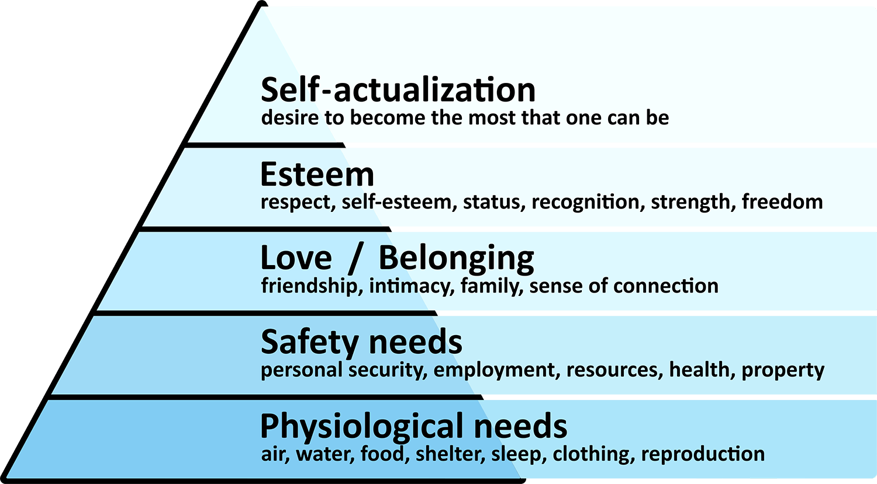
Figure 4: Hierarchy of Need Theory by Maslow
Source: (Sethuraman and Suresh, 2014)
In this theory, Maslow divided the needs of human beings into five different categories such as physiological needs, safety needs, social needs or need for love and belonging, need for self-esteem and need for self-actualisation (Stone, Cox and Gavin, 2020). Since employees are at different levels and have different types of needs, the management of the hotel I worked in considered focusing on the different needs of the employees. This enabled the management to appropriately motivate the employees to follow the safety protocols and ensure that none violates the new safety protocol. Again, another style of leadership is Laissez-Faire leadership, in which organisational leaders tend to have higher trust and reliance on the employees to let them act on their own will (Mathis et al., 2016). Usually, the management of the hotel used to follow this style of leadership for the most senior and experienced employees, but this type of leadership was absent when it came to the new safety policy execution in the organisation.

Conclusion
Above all, the managers and leaders in the organisation managed the misbehaviour of employees regarding violation of safety policy by changing their leadership style at several points. Considering the overall aspect of the leadership of the hotel management, it can be observed that there were different styles of leadership at different levels of implementing the new safety protocol of the organisation.

References
Dulewicz, V. and Higgs, M. (2005) Assessing leadership styles and organisational context. Journal of managerial psychology.
Giltinane, C.L. (2013) Leadership styles and theories. Nursing standard, 27(41).
Mathis, R.L., Jackson, J.H., Valentine, S.R. and Meglich, P. (2016) Human resource management. Cengage Learning.
Sethuraman, K. and Suresh, J. (2014) Effective leadership styles. International Business Research, 7(9), p.165.
Stewart, G.L. and Brown, K.G. (2019) Human resource management. John Wiley & Sons.
Stone, R.J., Cox, A. and Gavin, M. (2020) Human resource management. John Wiley & Sons.
Weitz, E. and Vardi, Y.O.A.V. (2008) Understanding and managing misbehavior in organizations. 21st century management: A reference handbook, 2, pp.220-230.
Werbel, J. and Balkin, D.B. (2010) Are human resource practices linked to employee misconduct?: A rational choice perspective. Human Resource Management Review, 20(4), pp.317-326.

Section 5: Student 5 (picker with llop, stock and systems support)
Stefan Cristian Costache

Employee Misbehaviour
Employee misbehaviour, also known as unorganised conflict, is a dispute that occurs spontaneously, either as a group or an individual, and that presents itself as inappropriate behaviour, such as sabotage (McGuire, 2014). Misbehaviour may take many forms, including sabotage, but the most common form is sabotage. It is commonly known that employers have certain expectations of the employees they hire, but it is also common information that these expectations are not always met (van Tuin et al., 2020). When they are at work, employees will sometimes participate in practices that are out of the ordinary, engage in behaviours that go against the organization's rules and traditions, and in general behave in ways that they should not (Swanson, 2022). Misconduct on the part of employees is quite common; over the course of their employment, the vast majority of workers, if not all of them, engage in at least one kind of inappropriate behaviour that is directly related to their jobs, although to varying degrees.
At Screwfix, where I worked as a picker, I often had to put up with unpleasant behaviour from other employees. At the company where I work, there are some employees who don't seem to have any interest in the way the business is managed. An employee who is meant to be working toward the organization's aims and objectives has taken an unexpected action here, which is startling.

The role of manager and leader in managing employee misbehaviour
One of the most significant purposes of organisational managers is to manage the overall operation of the organisation to meet the ultimate goal of the company (van Tuin et al., 2020). In this regard, organisational managers are responsible for planning, organising, directing, controlling and monitoring the functions and operations of the organisation including controlling and managing employee behaviour for the best interest of the organisation (Rehman, Sehar and Afzal, 2019). In my workplace, where I work as a picker with llop, stock and systems support, I have noticed that some employees lack engagement in the organisational performance and the management of the company managed such misbehaviour of employees strategically.
When discussing human resources (HR), the term "employee engagement" refers to an employee's level of interest in and dedication to their job responsibilities (Swanson, 2022). A fundamental concern for organisational management is a lack of employee engagement, which has a negative impact not only on the performance of individual employees but also on the performance of the organisation as a whole (Shahzadi et al., 2014). In order to address this employee misbehaviour and bring the low levels of employee engagement that exist in my organisation under control, managers implemented incentives.
Motivation from a human resource perspective denotes to the factors that affect the acts and behaviour of employees to flow in a certain way (McGuire, 2014). Hence, through motivating employees, it is possible to influence the course of action and behaviour of organisational employees. The managers in our company decided to motivate the employees to enhance their engagement by changing their behaviour and course of action. To determine the appropriate motivation to be provided to respective employees, managers did not offer similar rewards to every employee rather different motivation was offered to different employees (van Tuin et al., 2020). The hierarchy of need theory of Abraham Maslow provides for the same where Maslow has provided five distinct types of needs which may vary from person to person based on their position and fulfilment of other needs (Noltemeyer et al., 2021). The main concept of this theory is that needs come hierarchically and a subsequent need occurs only when the prior need is fulfilled.
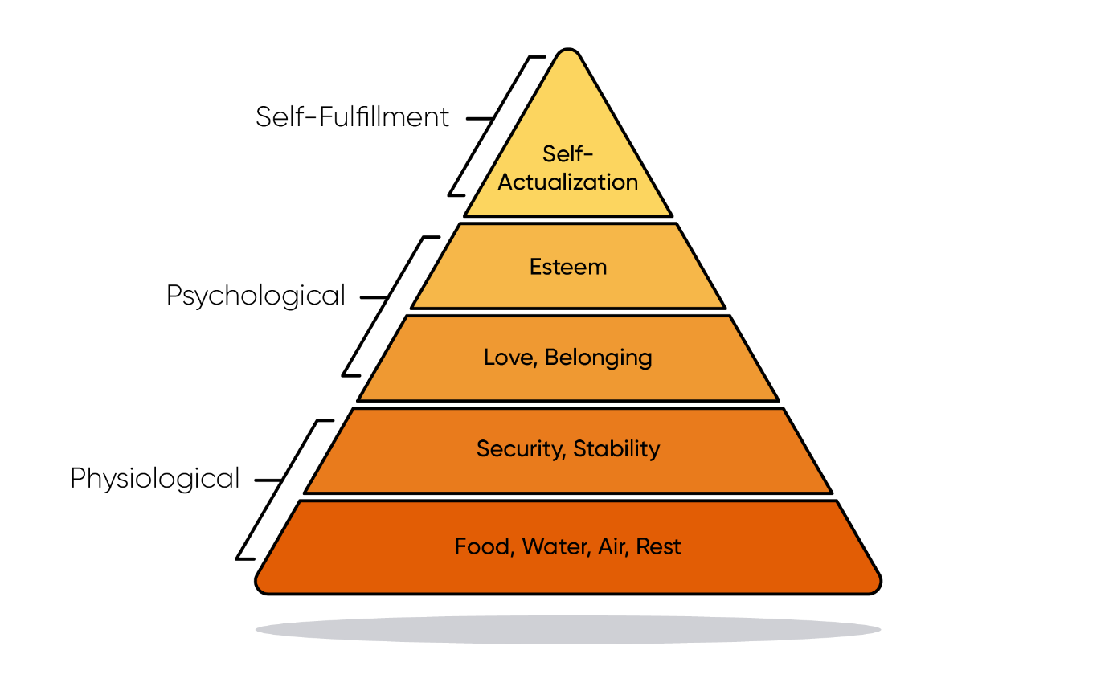
Figure 5: Maslow’s Theory of Needs
Source: (van Tuin et al., 2020)
The five types of needs outlined by Maslow are physiological needs, safety needs, social needs, self-esteem needs, and self-actualisation needs (van Tuin et al., 2020). The theory provides that the need for safety for an individual comes when his physiological needs are fulfilled. Therefore, the management in the company, where I am employed, identified the needs of the employees first to assess the appropriate type of motivation to be provided to them in order to enhance their engagement towards the company.
Again, the management of an organisation is responsible for determining the factors that will motivate their workforce in a manner that is suitable for the workforce as a whole and for developing appropriate value to meet the requirements of the workforce (Swanson, 2022). The Expectancy theory developed by Victor Vroom provides a useful framework for discussing this aspect of motivation (Shahzadi et al., 2014).
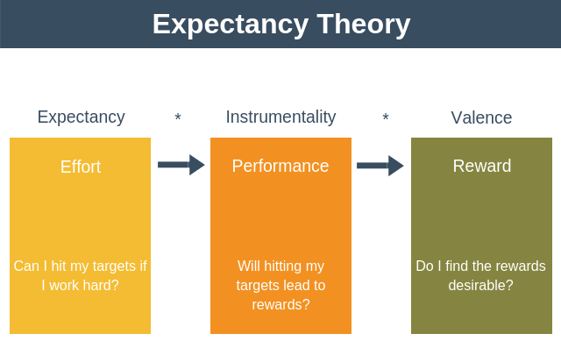
Figure 6: Expectancy Theory of Victor Vroom
Source: (Min et al., 2020)
According to this theory, Vroom proposed that in order for motivation to be appropriate and effective, it must contain all three of the following major characteristics: valence, expectancy, and instrumentality (Rehman, Sehar and Afzal, 2019). Motivation must have valence and provide value to the workers in order to be effective. Giving employees something that does not add value to their lives is not going to motivate those employees (Min et al., 2020). Aside from that, expectancy refers to the belief or anticipation held by the worker that the additional effort they put in will ultimately result in the achievement of their objective. Last but not least, instrumentality refers to the conviction that a particular action will bring about the desired result or objective (Rehman, Sehar and Afzal, 2019). Accordingly, in order to properly motivate workers, management needs to design their own motivating factors that meet the characteristics of expectancy, instrumentality, and valence as outlined in Victor Vroom's theory of expectancy.
In the course of dealing with the employee misbehaviour of lack of employee engagement, the management in my organisation decided to motivate the employees who lack engagement. The path of motivation was undertaken to influence the course of their action and behaviour so that they feel more motivated and engaged in their operation in the company.

References
McGuire, D. (2014) Human resource development. Sage.
Min, H., Tan, P.X., Kamioka, E. and Sharif, K.Y. (2020) Enhancement of Study Motivation Model by Introducing Expectancy Theory. International Journal of Learning, 6(1), pp.28-32.
Noltemeyer, A., James, A.G., Bush, K., Bergen, D., Barrios, V. and Patton, J. (2021) The relationship between deficiency needs and growth needs: The continuing investigation of Maslow’s theory. Child & Youth Services, 42(1), pp.24-42.
Rehman, S., Sehar, S. and Afzal, M. (2019) Performance Appraisal; Application of Victor Vroom Expectancy Theory. Saudi Journal of Nursing and Health Care, 2(12), pp.431-434.
Shahzadi, I., Javed, A., Pirzada, S.S., Nasreen, S. and Khanam, F. (2014) Impact of employee motivation on employee performance. European Journal of Business and Management, 6(23), pp.159-166.
Swanson, R.A. (2022) Foundations of human resource development. Berrett-Koehler Publishers.
van Tuin, L., Schaufeli, W.B., Van den Broeck, A. and van Rhenen, W. (2020) A corporate purpose as an antecedent to employee motivation and work engagement. Frontiers in Psychology, 11, p.572343.

