Strategic Management

Table of Contents
Introduction 3
M&S Background 3
M&S Mission and Objectives 3
Macro-Environment Analysis 4
PESTEL Analysis 4
Micro-Environment Analysis 6
Industry Life Cycle 6
Porter’s Industry Five Forces Analysis 7
Internal Analysis 10
M&S Strategic Resources and Capabilities 10
Value Chain Analysis 10
VRIO Analysis of Distinctive Resources and Capabilities 14
SWOT Analysis 17
Strategies to Sustain Competitive Advantage 19
Growth Strategies 21
Green Strategy 22
Conclusion 23
Recommendation 23
References 25

Introduction
Developing and implementing the company’s objectives is part of Marks & Spencer's strategic management process (harit.com, 2023). This involves both internal and external environment analysis, resource alignment, and activity coordination to take advantage of prospects, manage threats, and keep an edge over competitors in the retail sector. The research on M&S's strategic planning would examine the mission and goals of the organisation before performing a PESTLE evaluation on the global environment. In order to evaluate the sector's appeal and productivity, a micro-environment assessment would also examine the five forces model developed by Porter. A supply chain and VRIO study would be undertaken internally to determine the significant assets and skills of M&S. The business's assessment of SWOT would emphasise its benefits, drawbacks, possibilities, and dangers. The research would also look at growth approaches and the carrying out of CSR and environmentally friendly programs as well as measures for maintaining the competitive edge.

M&S Background
Marks and Spencer is a British multinational retailer that has its headquarters in London. This retail company is specialized in clothing, beauty products, and home and food products. M&S was founded in the year 1884 by Michael Marks and Thomas Spencer (britanica.com, 2023). The estimated number of employees of M&S is about 72,316. The revenue generated by M&S is estimated to be about £ 11.9 billion (statista.com, 2023). M&S has almost 959 stores all around the United Kingdom. This company also has some of its luxury food and beverages that are very popular with customers in the UK.

M&S Mission and Objectives
Mission: The main mission related to Mark & Spencer is to generate value with the guidance of a comprehensive approach related to sustainability on the basis of the environment. It has the mission of providing a superficial experience to the customers which is necessary for the generation of a positive effect on the brand image of the organisation (Beyne, 2023).
Objectives: the objective related to M&S for creating profound value with the proper use of relationships and resources (corporate.marksandspencer.com, 2023). It uses to manage the line with integrity, inspiration as well as innovation.

Macro-Environment Analysis

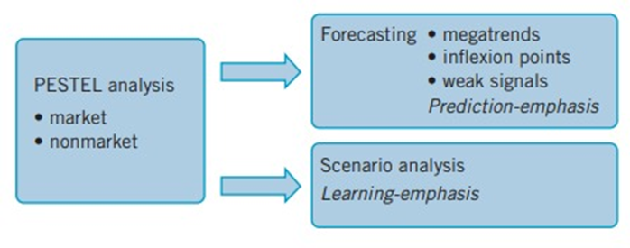
Figure 1: PESTLE Analysis
[Source: Lynch, 2018]

PESTEL Analysis
Political: the organisation has its headquarters in the United Kingdom which has a stable political atmosphere that has proven to be advantageous for the organisation in terms of operating the business. The company has got the liberty of free trade that has helped M & S to accomplish the desired objectives of becoming one of the leading as well as reputed brands in the global market. The approach of free trade has assisted the organisation in maintaining a healthy profit margin. The incident of Brexit has created some impact on the company that has generated some unfavourable possibilities for the brand.
Economic: United Kingdom has a stable economic condition that has helped M &S to earn huge revenue which has proven to be useful for the company. The presence of stability in the economic condition of the UK has been responsible for increasing the disposable income of the customers which has assisted the brand to increase its sales revenue (pestlenalysis.com, 2023). There are also certain factors related to the economy that has created some influence on the business operation of the brand such as interest rate and inflation, rate of currency exchange, and the unemployment rate as well as the confidence of consumer are responsible for affecting the business management of the company in both favourable as well as unfavourable manner.
Social: M & S has taken the initiative of ethical as well as sustainable practices that have assisted the organisation to increase the satisfaction of people and to enhance social welfare which has created a situation related to a positive impact that has made the company better off (mbaskool.com, 2023). In addition, the company has worked hard to provide services of a superficial quality that has helped it to strengthen its position in the market and has guided the organisation to generate favourable responses in society. The organisation is well known for considering the cultural differences that have enabled it to operate its business activities in different regions profoundly and has helped it in keeping its customers happy.
Technology: The organisation is extremely proficient in using the upgraded technology that has helped it in enhancing the quality of the result. The availability of innovative technology has assisted the brand to manage the business smoothly without any kind of inconvenience. The company is well known for adopting mobile technology, Artificial intelligence, Supply network technology, and payment technologies and is highly skilled to operate the business in the online platform. The company has been successful in enhancing its reputation by adopting sustainable technology which has supported the organisation to meet its goals based on sustainability.
Legal: M&S has been active in abiding by all the ethical as well as the legal norms that have guided it to stay away from any kind of legal issues (pestlenalysis.com, 2023). It is the approach that has made the brand competent enough to make its market value stronger.
Environmental: the company has worked hard towards waste management which has helped it in creating a good impression. The brand has created strategies for reducing waste as well as steps have been taken for the enhancement of energy efficiency.

Micro-Environment Analysis

Industry Life Cycle
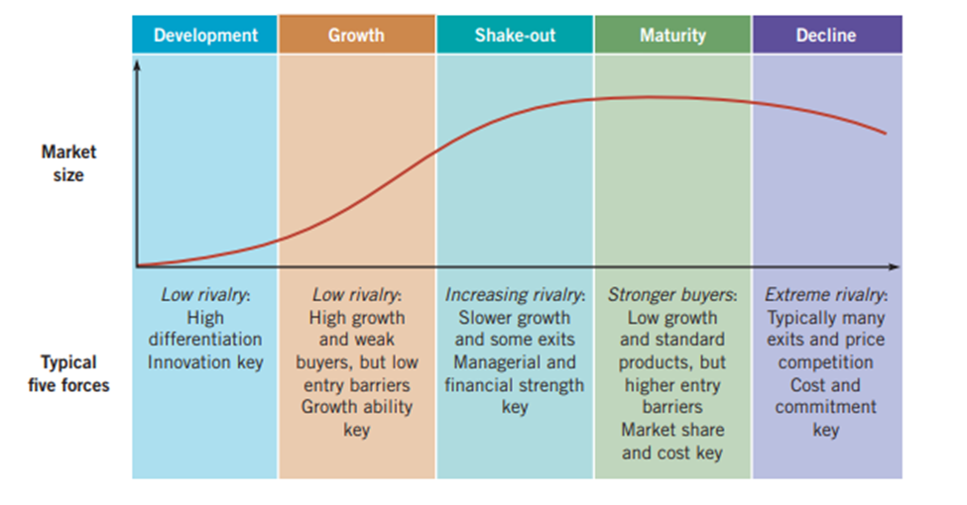
Figure 2: Industry Life Cycle
(Source: Lynch, 2018)
Since the establishment of Marks & Spencer (M&S) in 1884. It has progressed through the many phases of the industrial life cycle. M&S began as a modest market stall selling high-quality, reasonably priced apparel during its initial stage of development in Leeds, UK (Roberts, 2022). It immediately gained popularity and broadened its product offering by including culinary and household items. Early in the 20th century, the company's expansion was fueled by its dedication to excellence and customer service.
M&S rose to prominence in the retail sector throughout the ensuing expansion phase. Consumers were drawn to the brand because of its reputation for offering dependable goods and first-rate customer support. The business established its status as an established brand by opening a large number of outlets around the UK and entering foreign markets. Nevertheless, M&S had difficulties during the industry's mature phase of its life cycle (corporate.marksandspencer.com, 2023). The business found it difficult to adjust to changing consumer preferences and deal with heightened competition from both conventional stores and online marketplaces. A repositioning strategy was required as a result of the drop in sales and profitability.
M&S invested a lot of time and money into reviving the brand during the downturn stage. In addition to store closings and managerial changes, the corporation experienced restructuring. It placed a strong emphasis on upgrading its core competencies and addressing complaints about outmoded product lines. As a top retailer in the UK market, M&S sought to reclaim that position. M&S has been attempting to stabilize and revive itself lately. The business has accepted digital transformation and made investments in its online presence in order to adapt to evolving client needs. To appeal to a younger audience, it has launched fresh product lines and partnerships with famous people and designers. M&S has placed a high priority on enhancing the customer experience and has put in place programs to increase accessibility and engagement (Harba, 2019). M&S is aggressively working to adapt to the changing retail environment while yet facing obstacles because of the intense competition. M&S wants to manage the industry life cycle and position itself for a prosperous future by concentrating on its core capabilities, embracing inventiveness, and appealing to a larger client base.

Porter’s Industry Five Forces Analysis
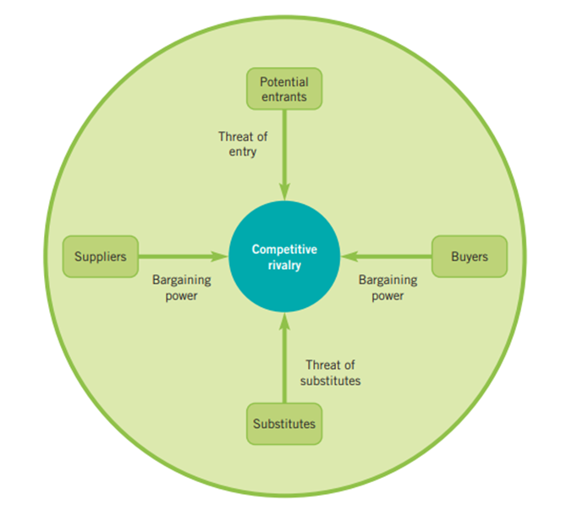
Figure 3: Illustration of Porter’s Five Forces Paradigm
(Source: Lynch, 2018)
Threats of New Entrance
The threat posed by new competitors in the retail sector is moderate. The retail industry involves substantial expenditures in inventory, logistical systems, marketing, and building a brand presence even though there are generally few barriers to entry when it comes to opening physical stores. It is challenging for new competitors to capture a sizable portion of the market due to M&S's established reputation and devoted client base (mbaskool.com, 2023). However, the growth of e-commerce has lessened entrance barriers, enhancing the competitiveness of businesses that only operate online. To keep a competitive advantage, M&S must constantly innovate and set itself apart with its products.
Bargaining Power of Supplier
Retail industry suppliers including food and clothes makers typically have a limited amount of negotiating power. M&S has an edge in obtaining favorable conditions with suppliers thanks to its well-known brand and extensive operations. However, suppliers might have more clout if there is a shortage of some products or a concentration of suppliers. Furthermore, shifts in commodity pricing or interruptions in the supply chain may have an effect on suppliers' negotiating position (casemarathon.com, 2023). In order to reduce potential risks, M&S must retain solid connections with suppliers while simultaneously looking into other procurement opportunities.
Bargaining Power of Buyers
In the retail sector, buyers' negotiating power, including that of individual shoppers and wholesale customers, is comparatively high. Customers may compare pricing and product offers across a wide range of businesses with ease. To draw in new clients and keep existing ones, M&S must offer affordable prices, superior goods, and an enjoyable experience while shopping. Buyer power is increased by the simplicity with which consumers can move to different merchants and by the accessibility of alternatives. To keep ahead of shifting consumer wants, M&S must continuously study consumer trends and preferences.
Threats of Substitutes
The retail sector faces a significant threat from substitutes. Both offline and online, consumers have a variety of options for buying food, household items, and clothing. Similar products can be found at competitive costs from other stores, e-commerce sites, and even direct-to-consumer brands. To lessen the impact of competitors, M&S needs to stand out through its reputation as a brand, the high standard of its products, its design, and its customer service. The threat of alternatives can be reduced by fostering consumer loyalty through unique experiences and limited-time offers.

Competitive Rivalry
A High level of competitiveness is typical of the retail sector. Traditional shops, supermarkets, online retailers, bargain stores, and grocery store chains are just a few of the many businesses that M&S must contend with. Due to the industry's extreme fragmentation, businesses constantly compete with one another by using aggressive pricing, marketing strategies, and promotions to draw in new clients (casemarathon.com, 2023). Offering distinct and interesting product lines, making marketing and advertising investments, and improving the customer experience as a whole are all ways that M&S may set itself apart. The fierce competitive rivalry can be overcome by M&S by fostering brand loyalty and putting an emphasis on consumer involvement.

Internal Analysis

M&S Strategic Resources and Capabilities
Strategic Resources | Capabilities
- M&S has heavily invested in modernizing infrastructure. The company has put focused on upgrading its wifi networks and cloud-based software solutions.  - The company has a vast network of physical stores, distribution centers, and warehouses (Le Thuy, and Oe, 2020).  - The company has a strong brand image for its quality and reliability.  - The company has established a strong supply champion network across the world by establishing long-term bonds with the suppliers.  - The company has the possession of intellectual properties like trademarks, brand logos, and design patents.  - CEO Steve Row’s visionary leadership has delivered growth and success to the company. | - M&S has a dedicated team who conducts research for developing innovative and attractive merchandise. This benefits the company by allowing them to quickly respond to the changing market preferences and introduce new products.  - The company has depicted a strong commitment to sustainability by implementing environment-friendly initiatives throughout its operations. This has enabled the company to attract eco-conscious customers within the retail industry (Nyame-Asiamah and Ghulam, 2020).  - The CEO has adopted and implemented a customer-centric approach in its operations.  - The company has the potential to capture the attention of the younger generation.

Value Chain Analysis
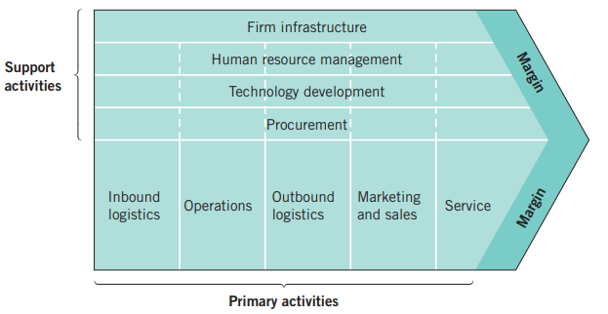

Figure 4: Value Chain Analysis
(Source: Lynch, 2018)

- Primary Activities
Inbound logistics: Marks & Spencer has been reflecting a strong dominance in using distinct strategies in procuring the required resources and raw materials, stocking as well as internally segregating the obtained materials to initiate and facilitate the production process. The company has won international awards for its resilient and sustainable supply chain management.

Operations: The company has invested in its production equipment, infrastructure as well as technology which has enabled M&S in maintaining the standard of operations (globaldata.com, 2023). The consistent investment, as well as the development, has been facilitating the organisation’s operations in terms of services as well as manufacturing.

Outbound logistics: The brand reputation of M&S has been confirmed by the efficiency of the company in maintaining an agile and well-managed logistical mechanism allowing the on-time supply of finished goods in the market thereby enabling the distribution centres of the company to maintain the stocks.

Marketing & Sales: The company has a strong print media marketing strategy that has maneuvered its sales for years. However, the organisation is gradually mobilising towards following the footsteps of its competitors in adopting a stellar digital marketing strategy to pull consumers and generate sales leads.

Services: The brand has not only incorporated apparel, home appliances, and food into its product mix but also incorporated a range of banking services as well. In addition to that, the firm's customer experience services have also been evolving.

- Secondary Activities
Firm Infrastructure: A regular investment is observed in developing the infrastructure of the company in distinct fields to increase the operational capacity of the company. In addition to that, M&S is focusing to enhance the potential of mechanised equipment as well as its infrastructure to facilitate accelerated efficiency while catering to the needs of the clients in the competitive market (academic-master.com, 2023). However, the corporation needs to enhance the infrastructure of its distribution centres by incorporating advanced features.

Human Resources Management: The management style of M&S is found to be bureaucratic which results in slow decision-making that often does not meet the needs of the hour. It has been identified that a less complex and lean management structure at the top with clear dissemination of information would be enhancing the performance as well as enhance the mobilisation of the company towards success.

Technology Development: Although the company was observed to be investing more in technology development with a sense of urgency compared to its key competitors in the market, M&S is still slow-paced in this strategic domain which is affecting the business. The mobile application of the company did not have a user-friendly interface that influenced the sales of the organisation. However, the brand is now emphasising directing its investment toward the adoption and integration of cloud-based software (academic-master.com, 2023).

Procurement: The company is reflecting a strong expertise in procuring the necessary materials, equipment, tools as well as infrastructure and technology for the development and upgradation of M&S.

VRIO Analysis of Distinctive Resources and Capabilities
Resources and Capabilities | Valuable | Rare | Imitable | Exploitable
Improved WiFi Connectivity | Yes | No | No | Yes
Cloud-Based Applications | Yes | No | No | Yes
Significant Structural Connectivity | Yes | No | No | Yes
A strong reputation | Yes | Yes | Yes | Yes
Reliable Supplier Structure | Yes | Yes | Yes | Yes
Patents and Trademarks | Yes | Yes | Yes | Yes
Research & Development | Yes | No | No | Yes
Sustainability-related Projects | Yes | No | No | Yes
Improved WiFi Networking, Cloud-Based Applications, and an Extended Physical Connection all add value to the company by enhancing connection, operational effectiveness, and client accessibility, but they are neither uncommon nor unique, making it simple for rival businesses to copy them. The company has a distinct edge when it comes to client retention (Cavaliere et al. 2021). Managing its supply chains, brand security, creativity, and luring in consumers who are environmentally conscious owing to its solid brand reputation, resilient vendor system, proprietary knowledge, technological advances, and environmentally friendly campaigns, which are valuable, rare, and surpassed assets.

SWOT Analysis
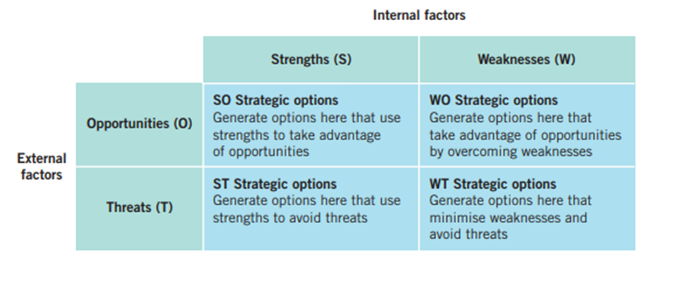
Figure 5: SWOT Analysis
(Source: Lynch, 2018)

Strength | Weakness
- Product diversification: M&S has distinguished itself from other retailers by diversifying its product line and product mix. Unlike its competitors, the company not only offers food, home appliances, and clothing but also provides banking services to clients.  - Marketing Strategy: The company has been reflecting a solid dominance in using distinct digital technology in enforcing a resilient and effective marketing strategy utilising both print as well as digital media platforms. The brand also enforces celebrity endorsement and influencer marketing to pull customers. This has been playing a dominant role in generating sales leads for the retail chain of the UK (marketingsociety.com, 2023). | - Omnichannel shopping: The company’s omnichannel purchasing strategy reflected a weak alternative to generating sales leads and retaining clients for Marks & Spencer. The user interface as well as the lack of understanding regarding the potential online value proposition of the brand affects the purchasing intention of the customers as well as the sales of the company.  - Infrastructure: The retail brand Marks & Spencer is comparatively weaker in this domain due to the low emphasis on infrastructural development in contrast to its competitors (thestrategystory.com, 2023). The focus on research as well as development as well as utilisation of technology is affecting the creativity and innovation capacity of the business.
Opportunity | Threat
- Investment approach: Marks and Spencer are reflecting a strong emphasis on investing in its distinct operational domain to increase the sales of the brand while enhancing the growth rate of the enterprise.  - Changing Supply Chain: The company has been making strategic changes to reduce its reliance on suppliers for raw materials as well as manufacturing. The organisation is gradually following the footsteps of its competitors and is striving to take manufacturing and distribution processes under its control which would be reducing its cost of operations while increasing its ability to bring the latest fashion stocks. | - Competition: Compared to its major rival companies in the market, the infrastructural as well as technological resilience and expertise of Marks & Spencer is not up to the standard (craft.co, 2023). This is gradually developing which is increasing the risk of losing its client base to its efficient competitors.  - Supply chain: The company is still immensely dependent on outsourcing and third-party agencies for its supply chain which might affect the firm's operational objectives as well as profitability.

Strategies to Sustain Competitive Advantage

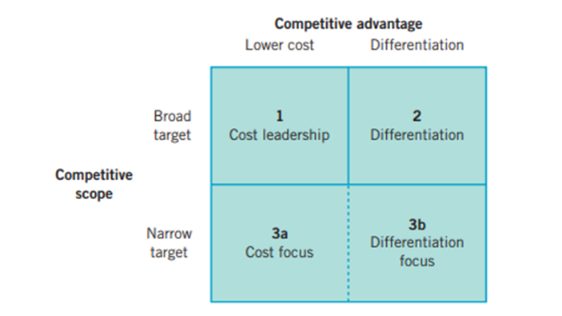
Figure 6: Strategies for competitive advantage
(Source: Lynch, 2018)
Diversification via new product development is one tactic Marks&Spencers can use (123helpme.com, 2023). The retailer is able to continually develop and provide its clients with distinctive products because of its investment in development and research. M&S distinguishes itself from rivals and draws in clients looking for originality and uniqueness by remaining ahead of the latest patterns and launching innovative and intriguing merchandise. For instance, M&S can work with designers or release limited-edition ensembles to evoke uniqueness and spark curiosity among customers. The company can maintain its edge over competitors and remain competitive in the marketplace by continually releasing fresh goods.
For the company to maintain its edge over the competition, improving its consumer experiences is another important tactic. The firm has to concentrate on offering great client service and tailored solutions. This can be done in a number of ways, including by giving personnel the right training to provide superior client service, introducing technologies to make purchasing easier, and providing incentive schemes that motivate and keep consumers. M&S may use statistical analysis and feedback from consumers to tailor offerings and proposals, making purchasing more distinctive and memorable (corporate.marksandspencer.com, 2023). By exceeding the demands of consumers, M&S can cultivate steadfast client loyalty and keep a step ahead of competitors.
Fostering environmentalism has grown increasingly crucial in today's environmentally driven society. The company may implement environmentally friendly procedures across its whole distribution network, from acquiring raw materials to cutting down on waste from packaging and supporting moral manufacturing procedures (Oham, 2022). By putting ecological sustainability first, the firm can draw in and keep customers who care about the surroundings and appreciate moral and accountable company conduct. Explicitly engaging with clients about the company’s environmental efforts can help the company stand out from rivals who might not have accepted conservation thoroughly. By identifying with the beliefs and interests of a rising customer sector, this approach can help M&S maintain its edge over its rivals.
Making digital transformation a priority is an additional crucial tactic Marks and Spencer may use to maintain its edge over rivals (globaldata.com, 2023). M&S could make investments in information technology and capabilities for e-commerce in the contemporary progressively electronic environment to give its consumers smooth shopping experiences on the internet. M&S may improve simplicity, availability, and personalisation by enhancing its web page, mobile applications, and other digital networks. Additionally, M&S can benefit from substantial knowledge of customer habits, improved management of its inventory, and customised advertising campaigns by utilising statistical analysis and tools powered by artificial intelligence. The company can keep one step above the competition and satisfy the changing demands of consumers who are technologically savvy by implementing the digital era.

Growth Strategies
Marks&Spencer has a number of growth opportunities available to it to boost its market dominance and share of the market. Expanding the market is a useful tactic. The company can look into possibilities for establishing shops in new areas, locally as well as internationally. M&S may proactively target those regions by doing an in-depth competitive study and discovering places with potential for development. By entering new areas, the firm is able to reach new client demographics, raise brand awareness, and expand its sources of income, all of which will ultimately contribute to business development.
The development of M&S's online presence and online shopping skills is a crucial component of its plan for expansion (corporate.marksandspencer.com, 2023). Shopping via the Internet has grown in popularity in the digital age today. M&S can serve the growing number of consumers who want to purchase digitally by making investments in technologically advanced and simple-to-operate platforms for shopping. M&S will be able to expand its consumer base beyond the boundaries of its offline locations by increasing its online shopping capabilities, such as frictionless website directions, tailored suggestions, and effective shipping methods.
M&S may also think about broadening its selection of products and establishing new areas as an expansion strategy. M&S can broaden its merchandise line-up and draw in new clients by introducing fresh collections of apparel, accessories, or residential products, or even by forging new partnerships in appropriate industries like fitness or beautification (ajbell.co.uk, 2023). To further increase enthusiasm and uniqueness in the range of goods and set it apart from rivals, the company has collaborated with established companies or designers to develop limited-edition ranges.
Furthermore, the company has a large chance for growth through worldwide expansion. The firm may capitalise on rising customer demand around the world and broaden its sources of income by expanding into new nations or bolstering its current overseas businesses. To guarantee a fruitful international expansion, the company must carry out an in-depth marketplace study and customise its products to suit regional tastes and peculiarities in culture.

Green Strategy
Green Strategy (Tripple bottom line)
There are five key pillars around which the green strategy of M&S revolves which are climate change, waste, sustainable raw materials, health, and fair partnership. The target of the company is ambitious while considering climate change which is becoming 100% carbon neutral and operating at 100% renewable energy by 2035. In order to reduce the carbon footprint, M&S is taking multiple measures such as investing in renewable energy sources, energy efficiency measures, and carbon offset projects. In addition to the above, the company is also conscious about its participation in unnecessary packaging, and waste generation which are being eliminated within its operations and supply chain. Following the initiatives taken towards climate change and waste management, M&S is also dedicating its resources to obtaining raw materials from sources that are sustainable. The company uses a lot of natural resources such as cotton and wood which are responsibly sourced on the basis of a robust policy which is developed by the company regarding the sourcing of the materials used for production.
The company has also admitted that it is sensitive towards deforestation from the supply chain and therefore it aims to eliminate it and continue to support practices of sustainable farming to protect the ecosystems and biodiversity (Azzone, & Noci, 1998). Another essential aspect of M&S’s green strategy is health under which the company is actively promoting healthy eating habits. It is promoting food options such as reducing salt, sugar, and unhealthy fats in its products. To assist its consumers on option for healthier food options, M&S has initiated multiple education programmes which motivate the consumers to choose better (Jones, 2023). The final key pillar of the green strategy is a fair partnership under which the company recognizes the importance of collaborating with stakeholders, including suppliers, NGOs, and communities, who have the ability to positively impact the changes.
CSR (Carol’s pyramid)
Considering the CSR option M&S follows Carol's pyramid which outlines four levels of responsibility to be taken care of economic, legal, ethical, and philanthropic. The first level covers economic responsibility which emphasizes delivering a robust financial performance and sustainable expansion. During the process of building employment opportunities and making contributions to the economy, the company is creating value for its shareholders. Next is the legal level at which the company has to ensure that the laws of labour rights, product safety, and environmental standards are being complied with. The company ensures that the suppliers also maintain the same ethical standards as followed by the company itself.
M&S actively participates at the ethical level which is the next level of the pyramid. At this level, the ethical views of the company are taken into account which includes treating employees fairly, fostering diversity and inclusion, and promoting responsible marketing practices. This is done by the company by participating in various charitable donations, employee volunteering programs, and social welfare projects (Omer, 2022). The philanthropic responsibility lies at the pinnacle of the pyramid under which the company has to actively participate in philanthropic activities, such as supporting charitable organizations, disaster relief efforts, and sustainable community development projects.

Conclusion
The above study has been conducted on Marks and Spencers which is a multinational retailer based out of London. An attempt is made to comprehend the predetermined mission and objectives of the company to proceed with the study. Then Macro-Environment analysis is conducted using PESTEL Analysis to understand the opportunities and threats around which the company operates. This is followed by Micro-Economic analysis which is conducted using the Industry life cycle which states the level at which the company is operating further, to have a better understanding of the industry Porter's five forces model has been applied. The study also includes an Internal Analysis of M&S and its Value chain Analysis to understand the operations of the company which is followed by VRIO, SWOT Analysis, Green Strategy, and CSR planning.

Recommendation
Based upon the different analyses conducted above the recommendation that is offered to the management of M&S is as follows:
Embrace Digital Transformation: Considering the rapidly evolving business landscape of the retail industry it is recommended to the company make further attempts to incorporate digital transformation (globaldata.com, 2023). For such a type of expansionary strategy, the company required a huge fund of resources to be set aside to be invested in enhancing its online presence, improving the e-commerce platform, and leveraging digital technologies to promote the effective functioning of the operations and offer better customer experiences.
Enhance supply chain sustainability: After the company's effective implementation of a green strategy, the company has achieved its goal of sustainability however, the company is suggested to make its supply chain sustainable too. This can be attained by working with suppliers and directing them continuously on practising responsible sourcing techniques (McGrath et al. 2021). These have to be accompanied by proper waste management systems by the suppliers and reduction of carbon emissions to as low as possible. This will contribute to developing a positive impression in the minds of the customers of M&S.
Strengthen Customer relationships and engagement: To build a relationship with its customer M&S is suggested to prioritise customer engagement and introduction of loyalty programs. This recommendation can be achieved by launching customized marketing campaigns, loyalty rewards, and customer service 24/7. By attaining the ability to correctly predict the demand of its customer accurately the company will be able to customize its products and services in such a manner that aligns with the demand of the customer leading to customer satisfaction and enhanced loyalty.

References
123helpme.com, (2023). Available at: https://www.123helpme.com/essay/Marks-And-Spencer-Critical-Analysis-707182 [Accessed on: 11.08.2023]
academic-master.com, (2023). strategic-analysis-of-marks-and-spencer. [Available at:https://academic-master.com/strategic-analysis-of-marks-and-spencer/] [Accessed on: 11.08.2023]
ajbell.co.uk, (2023). five-things-ms-needs-do-better-even-if-steve-rowe-starting-get-it. [Available at: https://www.ajbell.co.uk/articles/investmentarticles/131749/five-things-ms-needs-do-better-even-if-steve-rowe-starting-get-it] [Accessed on: 11.08.2023]
Azzone, G., & Noci, G. (1998). Identifying effective PMSs for the deployment of ‘green’ manufacturing strategies. International Journal of Operations & Production Management, 18(4), 308–335. doi:10.1108/01443579810199711
Beyne, J., (2020). Designing and implementing sustainability: An integrative framework for implementing the sustainable development goals. European Journal of Sustainable Development, 9(3), pp.1-1.
britannica.com, (2023). Marks-and-Spencer-PLC. [Available at: https://www.britannica.com/topic/Marks-and-Spencer-PLC] [Accessed on: 11.08.2023]
casemarathon.com, (2023). marks-and-spencer-ltd/porters-analysis. [Available at:https://casemarathon.com/ivey/marks-and-spencer-ltd/porters-analysis.php] [Accessed on: 11.08.2023]
Cavaliere, L.P.L., Khan, R., Sundram, S., Jainani, K., Bagale, G., Chakravarthi, M.K., Regin, R. and Rajest, S.S., (2021). The Impact of customer relationship management on customer satisfaction and retention: The mediation of service quality. Turkish Journal of Physiotherapy and Rehabilitation, 32(3), pp.22107-22121.
corporate.marksandspencer.com, (2023). Available at: https://corporate.marksandspencer.com/sites/marksandspencer/files/marks-spencer/m-and-s-ar22-full-ar-report.pdf [Accessed on: 11.08.2023]
corporate.marksandspencer.com, (2023). Available at:https://corporate.marksandspencer.com/media/press-releases/ms-expands-international-online-business-over-100-markets [Accessed on: 11.08.2023]
corporate.marksandspencer.com, (2023). marksandspencer/files/Annual%20reports. [Available at:https://corporate.marksandspencer.com/sites/marksandspencer/files/Annual%20reports/2020/m-and-s_ar20_strategic-report.pdf] [Accessed on: 11.08.2023]
corporate.marksandspencer.com, (2023). sustainability/our-products/responsible-marketing. [Available at:https://corporate.marksandspencer.com/sustainability/our-products/responsible-marketing] [Accessed on: 11.08.2023]
craft.co, (2023). marks-spencer/competitors. [Available at: https://craft.co/marks-spencer/competitors] [Accessed on: 11.08.2023]
globaldata.com, (2023). Available at: https://www.globaldata.com/store/report/marks-and-spencer-enterprise-tech-analysis/ [Accessed on: 11.08.2023]
globaldata.com, (2023). marks-and-spencer-enterprise-tech-analysis. [Available at: https://www.globaldata.com/store/report/marks-and-spencer-enterprise-tech-analysis/] [Accessed on: 11.08.2023]
globaldata.com, (2023). marks-and-spencer-enterprise-tech-analysis. [Available at: https://www.globaldata.com/store/report/marks-and-spencer-enterprise-tech-analysis/#:~:text=Marks%20%26%20Spencer%20(M%26S)%20has,and%20ICT%20services%20from%20vendors] [Accessed on: 11.08.2023]
Harba, J.N., (2019). New approaches to customer experience: where disruptive technological innovation meets luxury fashion. In Proceedings of the International Conference on Business Excellence (Vol. 13, No. 1, pp. 740-758).
harit.com.np, (2023). Strategic analysis. [Available at: https://harit.com.np/articles/strategic-analysis-of-marks-spencer/] [Accessed on: 11.08.2023]
Le Thuy, L. and Oe, H., (2020). An Exploratory Discussion of a British Apparel Brand in Relation to New Markets: Developing Actionable Recommendations Based on Network, Relationship, and Collaboration Perspectives. Budapest International Research and Critics Institute (BIRCI-Journal): Humanities and Social Sciences, 3(3), pp.1660-1675.
Lynch, R., (2018). Strategic management. Pearson UK.
marketingsociety.com, (2023). Sustaining brand promise. [Available at: https://www.marketingsociety.com/sites/default/files/thelibrary/marketing%20excellence%202%20m&s%20(sustaining%20the%20brand%20promise)%20case%20study.pdf] [Accessed on: 11.08.2023]
mbaskool.com, (2023). five-forces-analysis/companies/18327-marks-a-spencer. [Available at:https://www.mbaskool.com/five-forces-analysis/companies/18327-marks-a-spencer.html] [Accessed on: 11.08.2023]
mbaskool.com, (2023). pestle-analysis. [Available at:https://www.mbaskool.com/pestle-analysis/companies/18016-marks-a-spencer.html] [Accessed on: 11.08.2023]
McGrath, P., McCarthy, L., Marshall, D. and Rehme, J., (2021). Tools and technologies of transparency in sustainable global supply chains. California Management Review, 64(1), pp.67-89.
Nyame-Asiamah, F. and Ghulam, S., (2020). The relationship between CSR activity and sales growth in the UK retailing sector. Social Responsibility Journal, 16(3), pp.387-401.
Oham, C. ed., (2022). Cases on Survival and Sustainability Strategies of Social Entrepreneurs. IGI Global.
pestleanalysis.com, (2023). marks-and-spencer-pestle-analysis. [Available at:https://pestleanalysis.com/marks-and-spencer-pestle-analysis] [Accessed on: 11.08.2023]
Roberts, C., (2022). Progressive Production Practices: Developments in Design, Print, Colour Forecasting and Fabric. In Consuming Mass Fashion in 1930s England: Design, Manufacture and Retailing for Young Working-Class Women (pp. 87-135). Cham: Springer International Publishing.
statista.com, (2023). group-revenue-marks-and-spencer-mands. [Available at:https://www.statista.com/statistics/413349/group-revenue-marks-and-spencer-mands/#:~:text=In%20the%20year%20ending%20April,pounds%20from%20the%20previous%20year. [Accessed on: 11.08.2023]
thestrategystory.com, (2023). Available at: https://thestrategystory.com/blog/marks-and-spencer-ms-swot-analysis/ [Accessed on: 11.08.2023]

