
Alternative HEV Engine Design and Performance
Thomas David Sykes

University of Wales Trinity Saint David

School of Engineering

SUPERVISOR: Malcolm McDonald
Declaration of Authenticity:
This thesis is the result of the author’s original research. It has been composed by the author and has not been previously submitted for examination which has led to the award of a Degree.

Signed: T.Sykes Dated:

Abstract

Energy Efficiency and pollutant reduction are at the centre of interest and development in today’s automotive industry as environmental initiatives push for a greener industry. Alternative and renewable fuels have become a leading area of research. With HEV and EV technology being the main area of development in the automotive industry the author determined that an investigation into the kinematics and design architecture as well as an investigation into varying cycles and the benefits dependant on application.

Acknowledgements
I would like to thank DR Malcolm McDonald as my supervisor for continued council.
- Contents
1. Abstract 1
1.1. Acknowledgements 1
3. Introduction 2
4. Literature Review 2
4.1. Emissions, EV & HEV Push 3
4.1.1 Parallel Hybrids 4
4.1.2 Series hybrids 4
4.2. Atkins Cycle 5
4.1.1. Over Expansion 6
4.3. Hybrid key Engine Design considerations 7
4.4. Parallel HEV Alternative Design solutions 8
4.4.1. Gomecsys Flex engine Design Crank 8
Cycle 1 (Power Cycle) @ 90° TDC Firing 10
Cycle 2 @ 45° TDC (Greatest thermal Efficiency) 11
Cycle 3 0° @ Crank TDC 11
Cycle 4 (High Torque) -60° TDC Firing 12
5. Literature conclusion/discussion 12
Bibliography 13

ICE = Internal Combustion Engine
HEV= Hybrid Electric Vehicle
CR= Compression Ratio
ER= Expansion Ratio

Figure 1 CO2 Emissions in each sector since 1990 (European Transport Comission, 2021) 3
Figure 2 Greenhouse gas Emission in the Transport sector (European Transport Comission, 2021) 3
Figure 3 Parallel Hybrid Drivetrain (Land Transport GURU, 2021) 4
Figure 4 Effect of Over Expansion 6
Figure 10 Cam Lobes and Valve Lift profile 8
Figure 11 BSFC Example of Otto and Atkinson cycle engines 8
Figure 12 Cam chain Mechanism 8
Figure 5 Concentric Crank pin, Dog bone joints and gearing Drive train (Gomecsys, 2020) 9
Figure 6 Range of concentric motion (Gomecsys, 2020) 9
Figure 8 TDC firing (Gomecsys, 2020) 10
Figure 8 BDC Expansion (Gomecsys, 2020) 10
Figure 9 Gomecsys Main VCR Crank Engine Cycle configurations (Gomecsys.Technology, 2020) 11

Introduction

The author determined that a design study of the development of a single cylinder engine design that is capable of operating as a range extender used in conjunction with current HEV Vehicles could demonstrate the benefits and advantages to efficiency and emissions of current Internal combustion engines. With the push for reduced total greenhouse gases by 55% by 2030 (European Union, 2021) and alternative powertrain/fuel solutions, Specifically designed engine configurations that make use of alternative cycles at a constant engine speeds could provide the additional efficiency ICE’s require for future emissions targets. various types of fuelling such as viable bio-fuels could also be used to reduce the carbon footprint of range extender engines
The aims of this thesis will be to design and investigate the kinematics of small single cylinder engine design to a act as the ICE component to a parallel or series hybrid as well as advantages of over expansion. This thesis will outline a literature review of the principals of over expansion as well as the design and operational procedure of ICE engines currently used in HEV applications with the aims to demonstrate the kinematic operation that allows for the reduced emissions and increased efficiency as well as the design methodology of the engine, the author.

Literature Review

In this literary review section, the author will demonstrate the principals and mechanisms involved when considering engine design/geometry as well as methods and cycles used to increase thermal efficiency from combustion while reducing the over all emissions per kilometre as per European emissions guideline method of measuring vehicle fuel economy/emissions. According to European emissions study’s Light commercial vehicle emissions are responsible for approximately 15% of the global emissions (European union, 2021), as of January 2020 emissions regulations dictate that a maximum of 95g of CO2 per Km can be produced by manufactured light vehicles which equates to a fuel efficiency of 4.12L/100Km with aims to reduce CO2 emissions by 15% by 2025 (European union, 2021). This
Objectives and focus of research:
- Emissions regulations statistics & targets
- Current HEV design and alternative HEV solutions
- HEV application Engine Design
- Atkins Cycle
- Over Expansion
- Valve timing Dependant on Cycle choice
- Main factors when making design considerations.

Emissions, EV & HEV Push

With new emissions regulations as of January 2020 and a target of a further 15% reduction in light duty vehicle emissions by 2025 manufacturers are turning to EV and HEV solutions with 3 main configurations, plug in EV where the vehicle design requires a charging point and depends on powerplants and infostructure for charging and therefore requires no ICE and wont be considered for this study, however both series and parallel hybrids depend on conventional engines to charge the batterie or work in conjunction with EV components to operate at a greater efficiency and fuel economy leading to reduced CO2/ KM.
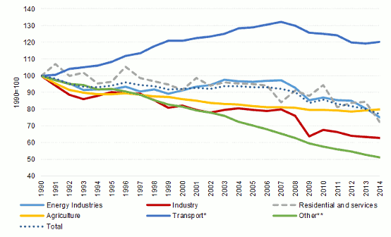
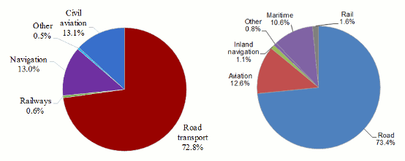
Figure 1 CO2 Emissions in each sector since 1990 (European Transport Comission, 2021)
Figure 2 Greenhouse gas Emission in the Transport sector (European Transport Comission, 2021)

Figure 1 demonstrates the emissions for each sector between 1990 and 2014, as can be seen the transport industry is the largest contributor to greenhouse emissions and with increasing number of vehicles on the roads since the 1990’s road pollution accounts for over 70% of the emissions in the transport sector according to European emissions statistics as seen in figure 2. With these statistics it clear that road emissions are the largest pollutant in the transport industry and thus the reason for new regulations pushing for lower and zero emissions vehicle, one of the most promising areas of development due to this is EV and HEV have become the main focused for mechanical design development and energy conservation.

4.1.1 Parallel Hybrids

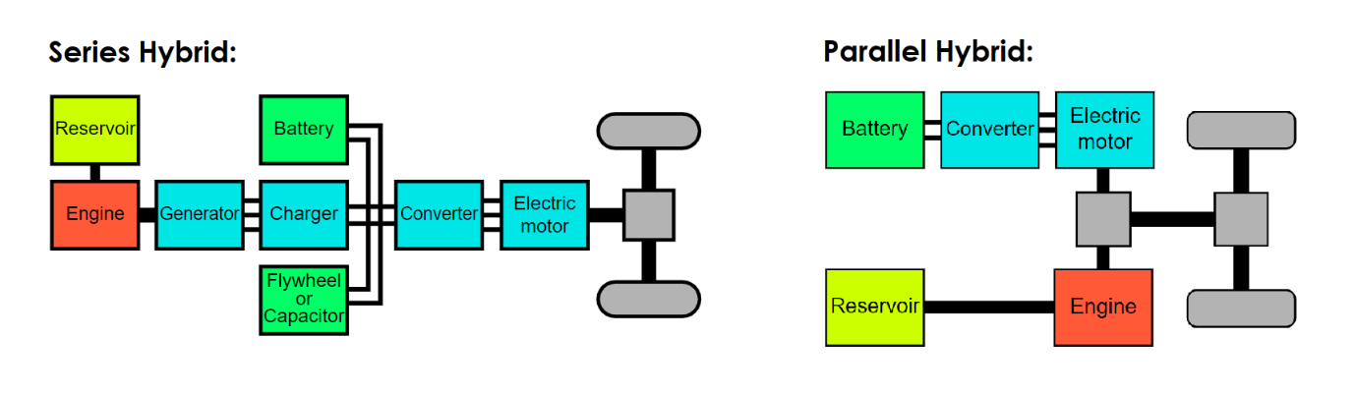
Parallel hybrids operate on the principal that both ICE and EV have active power trains to the wheel allowing for one or both to operate at will, this solution to HEV makes use of the ICE under large loading scenarios or when the EV battery’s charge reaches minimum charge limits. This HEV solution decreases the CO2 emissions per Kilometre this is due to the engine charging the batterie as the ICE operates increasing the fuel efficiency and the distance travelled on the same quantity of fuel, Figure 3 demonstrates a powertrain representation of a parallel hybrid. As can be seen the ICE and EV motors are attached to the primary drive allowing of both to act as a primary drive dependant on loading conditions and battery management.
Figure 3 Parallel Hybrid Drivetrain (Land Transport GURU, 2021)

4.1.2 Series hybrids

Series hybrids generally operate with an internal combustion engine as a range extender for the EV components, as the ICE has no mechanical connection to the drive train of the vehicle and acts solely to charge the EV battery therefore the design can be optimised to operate at a specific rpm to maximise efficiency. The configuration of series hybrids varies massively defendant on manufacturer and design purpose, many existing ICE’s can be converted by simply altering the ECU for specific RPM mapping and cam shaft alteration to allow for the Atkinson cycle or cycle variation dependent on the design. ADD?

Figure 4 Series Hybrid Drivetrain (Land Transport GURU, 2021)

Atkins Cycle

The Atkins cycle is an alternative to the otto cycle and was developed in 1882 by a British inventor, James Atkinson to increase thermal efficiency in internal combustion engines compared to the otto cycle. This was achieved by using a complex crank design allowing for variable engine strokes, this design allows for greater efficiency at the expense of power density (Connor, 2019) as the expansion stroke is larger than the compression stroke increasing the thermal efficiency of combustion. This design was developed further as an altered otto cycle as camshaft operated valve timing allow for extended inlet valve lift allowing for reverse flow in the inlet during compression which expels part of the fuel mixture and therefore generate a larger expansion ratio than compression ratio and therefore allowing for over expansion and greater thermal efficiency.
Figures 3 and 4 show a typical Pressure Vs Volume diagram of the Atkinson and Otto Cycle, as can be seen the thermal energy is released across the entire expansion stroke in the Atkinson Cycle where as the otto cycle shows a quicker release of energy indicating greater power density, with heat loss towards the end of expansion rather than only on the exhaust stroke seen when using the Atkinson cycle indicating that the thermals efficiency of the otto cycle is less than the Atkinson cycle however has greater power density emphasising the trade off of power density and fuel efficiency aforementioned.
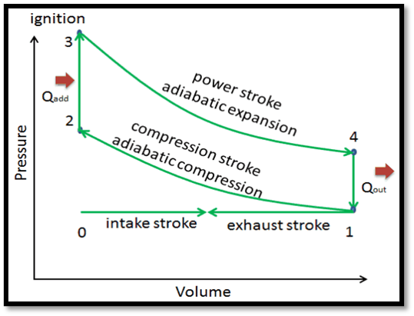
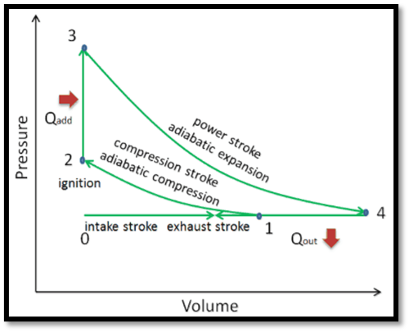
Figure 6 Otto Cycle (Connor, 2019)
Figure 5 Atkinson Cycle (Connor, 2019)
Equation 1 Thermal Efficiency (Nuclear Power.net, 21)
$$ƞ_{th}=\frac{W}{QH}=\frac{Q_{H}-Q_{C}}{Q_{H}}=1-\frac{Q_{C}}{Q_{H}}$$
Where:
- W = Work Done
- Q_{H} = Heat Added
- Q_{c} = Heat Released

Equation 2 Heat Added To the System (Nuclear Power.net, 21)
$$Q Added=MC_{V}(T_{3}-T_{2})$$

Equation 3 Heat Released by The system (Nuclear Power.net, 21)
$$Q Released \left(out\right)=MC_{P}(T_{4}-T_{1})$$

Most parallel and Series hybrids run purely the Atkinson cycle or make use of VVT to alternate between Atkinson and Otto cycles, While the Atkinson cycle inherently accounts for over expansion due to the valve timing.

4.1.1. Over Expansion

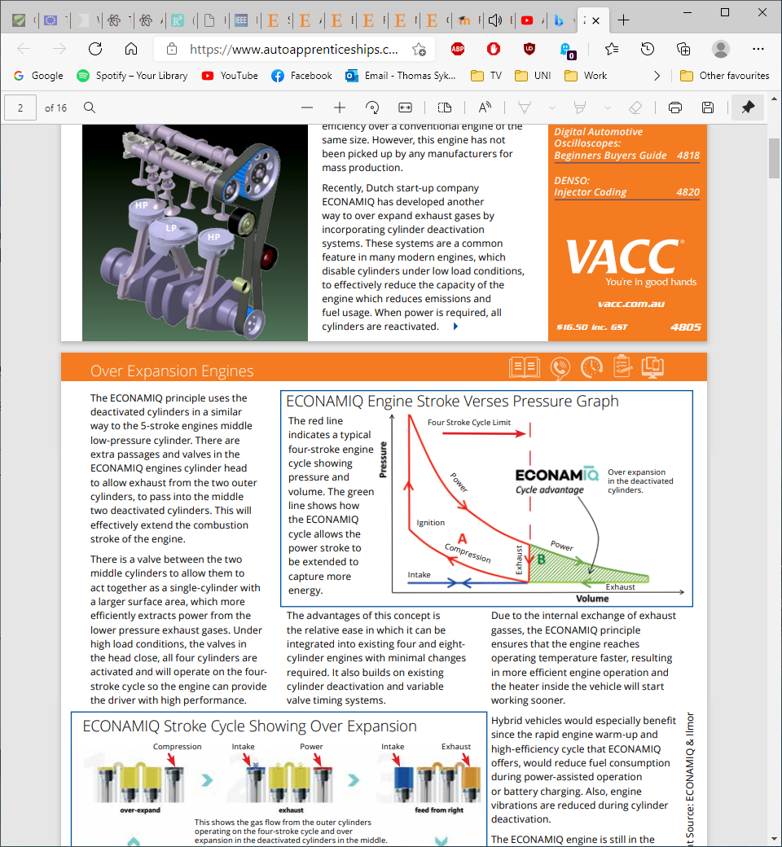
Over expansion can be defined as when the expansion stroke is greater than the Compression stoke allowing for greater thermal efficiency for the charge in the cylinder at the cost of power density, this produces different compression to expansion ratios, A larger expansion ratio (ER) is where the volume ratio of the expansion chamber is Greater than the volume on compression allowing for increased volume on expansion compared to compression and greater thermal efficiency in which more useful energy is used from combustion as well as reduced pumping losses against piston motion on compression compared to a normal engine configurations where the ER and CR are equal commonly found in Otto Cycle engines.
Figure 4 Effect of Over Expansion (Tech Talk , 2020)

Figure 4 Demonstrates the effect of over expansion when used with a conventional otto cycle as can be seen the PV diagram more accurately represents a Atkinson cycle. One of the main considerations when using extended inlet valve lift is that the compression ratio will need to be altered to account for the less in power density, this usually means increasing the ratio to increase pressure and therefore Gas force and power.
- Petrol range of Compression ratio
-typically Between 10:1 & 14:1 dependant for constant CR engines (Mishra, 2017)

- Deisel Compression ratio
-typically around 18:1 & 23:1 higher due to compression based ignition system

Hybrid key Engine Design considerations

The main consideration when designing HEV range extenders that differentiates between conventional ICE and HEV engines is the use of the Atkins cycle at a specific rpm maximise fuel efficiency when charging this would require an extended valve lift, without variable valve timing the vale lift is set at a single cycle variation, figure 9 shows an example of vale lobes that determine the valve lift as seen in the valve lift plot also in figure 9, modification of these would allow for the alteration of the cycle the engine runs for example altering the cycle form Otto to Atkinson.
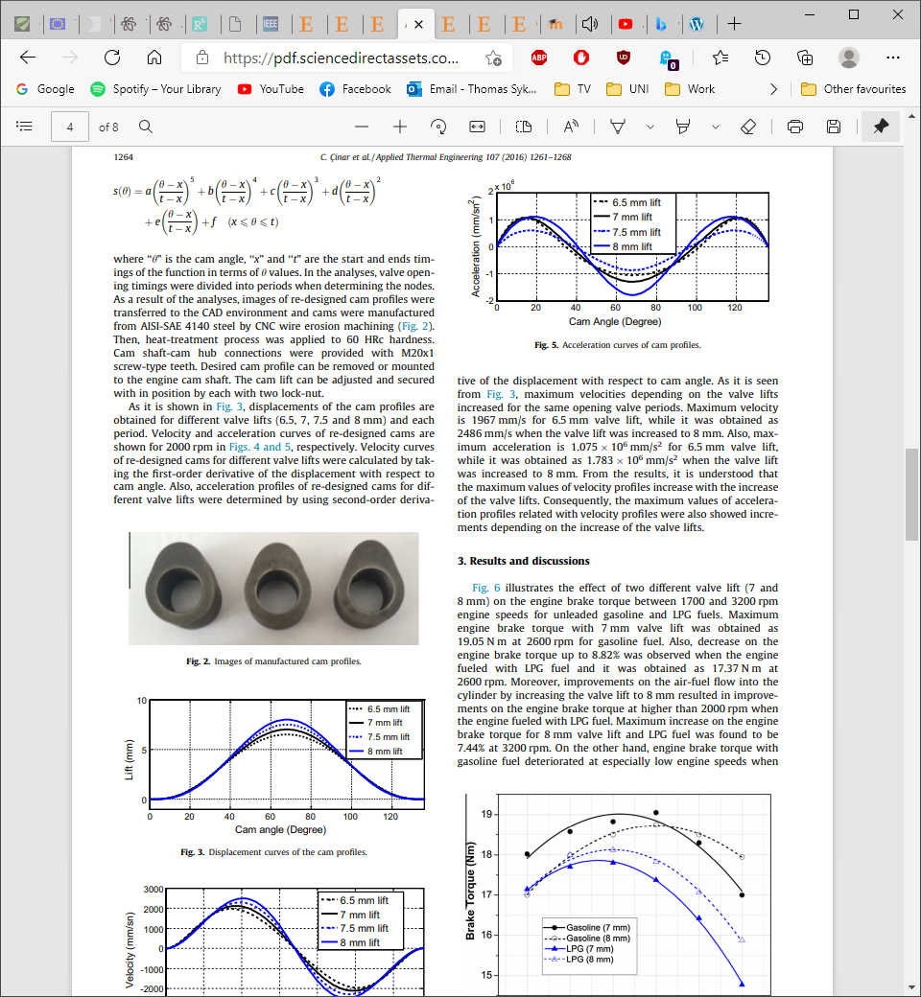
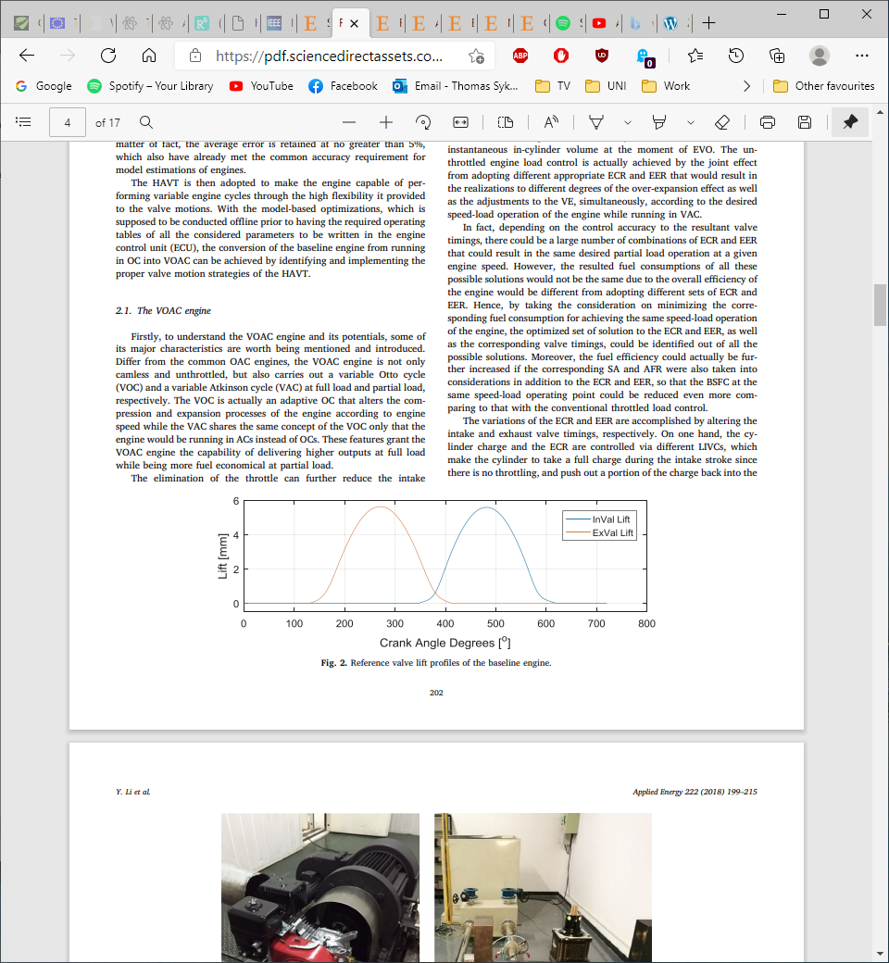
Figure 10 Cam Lobes and Valve Lift profile

Figure 12 shows the method of operating and ensuring correct valve timing where specific hearing sizes are attached to the camshaft and crankshaft which allows for the cam to be driven at twice engine speed with the correct gear ratio’s to ensure best performance, this timing would be dictated by the most fuel efficient rpm, a common indicator of this is a brake specific fuel consumption map (BSFC) as seen in figure 11.
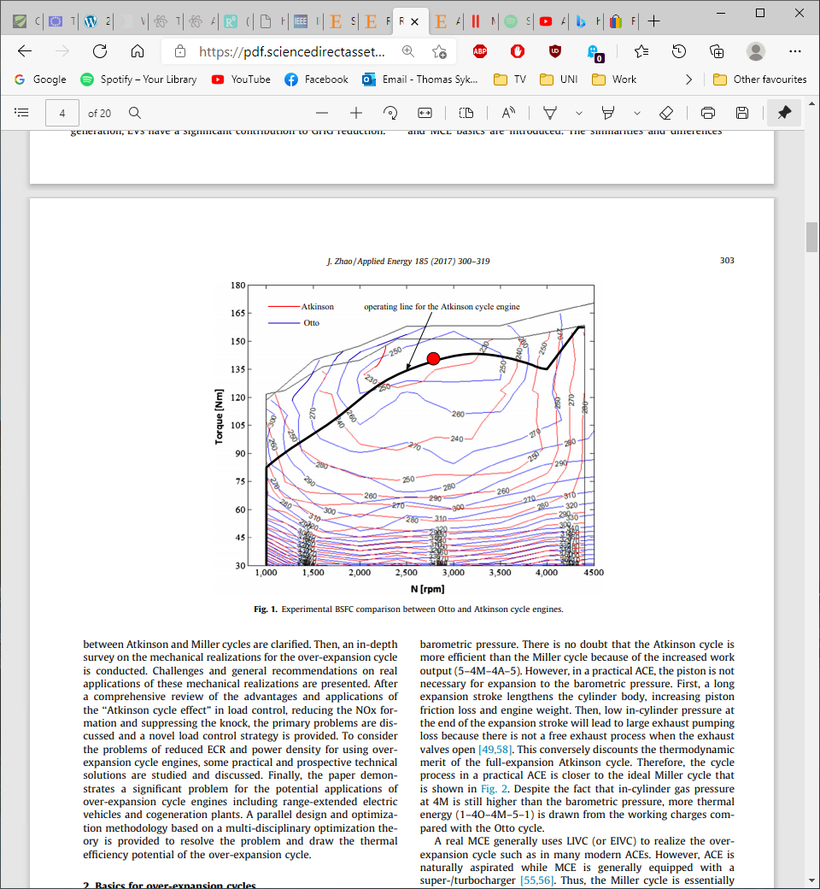
Figure 11 BSFC Example of Otto and Atkinson cycle engines

Figure 12 Cam chain Mechanism

When considering refitting ICEs to generators the engine architecture is near identical however crucial aspects such as RPM, loading and the relationship between these and vale lift duration.

Parallel HEV Alternative Design solutions

Due to the configuration of Parallel hybrids the engine must operate similarly to conventional ICE non EV vehicles as in it need to perform as the primary drive until the battery is charged or in additional load scenarios, there are however alternative design solutions to engine configuration that can increase efficiency over conventional engines such as flex engines or range extenders in the case of parallel hybrids flex engines are the most promising in the authors opinion however series hybrids with ICE’s as range extenders using the Atkins cycle and over expansion design to run at its most efficient also has merit this study and research aims to highlight the benefits and alternative solutions available when developing HEV.

Gomecsys Flex engine Design Crank

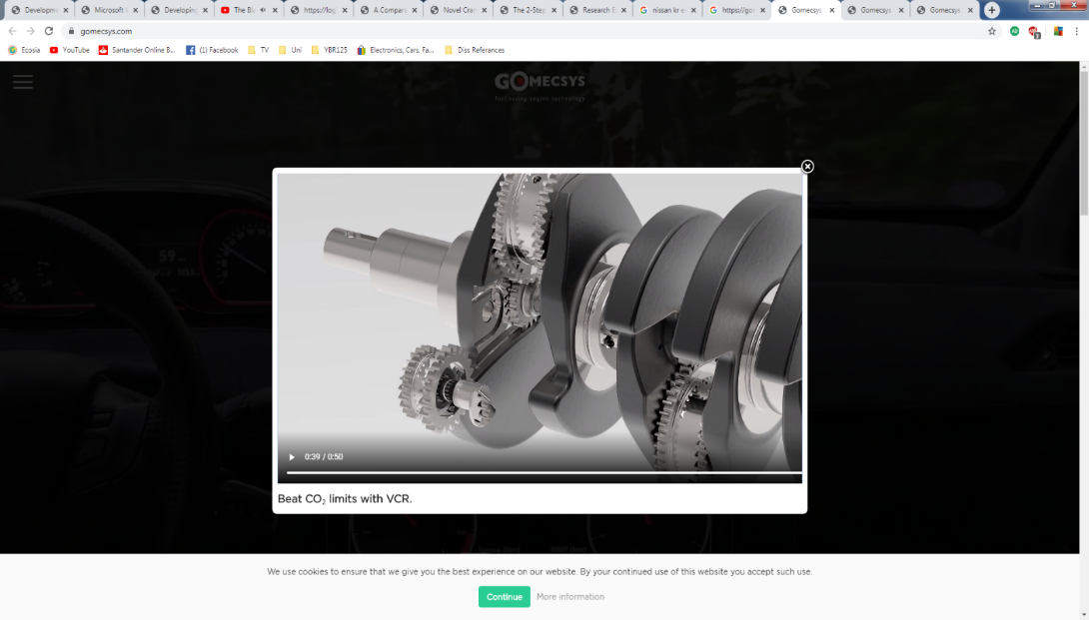

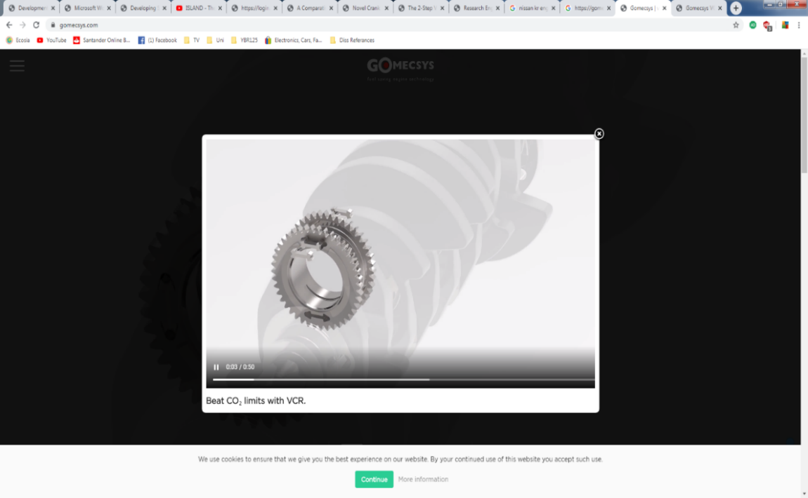
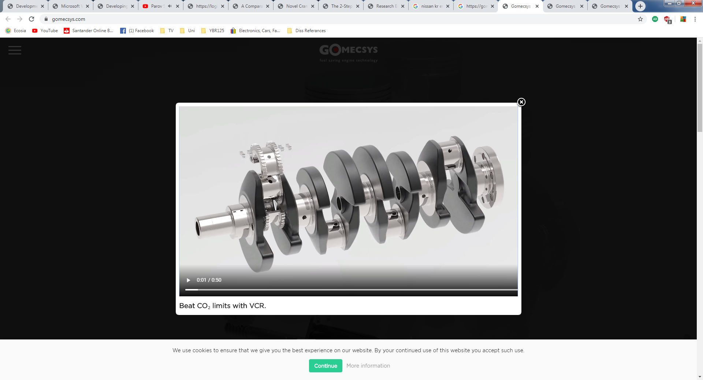
An alternative to conventional parallel hybrid engines are flex engine which allow for variable compression and over expansion as part of the kinematic design one of such designs was patented by Gomecsys which was founded 1997 with the purpose of developing more fuel-efficient flexible engine technology, the use of VCR and OE is made possible by the development Gomecsys’s own adaptation of the Waulis kinematic system which is a custom VRC crank design which operated on a geared crank to piston configuration. The Gomecsys kinematics operates in much the same way as a conventional crank to piston configuration however in this case a concentric lobe is situated on the crank Pin assembled using dog bone retainers (see Figure 4 ), this allows for the adjustment of the compression ratio from a maximum of 13.5:1 to a minimum of 8.5:1 and can be as used in engine configurations ranging from single cylinder to V8 engines with “Zero impact on existing engine architecture” according to Gomecsys (Gomecsys.Technology, 2020) . (Gomecsys, 2020) (Pohjalainen)
Driving Rod
Secondary Drive Gears
Torsion Spring & actuator
Figure 5 Concentric Crank pin, Dog bone joints and gearing Drive train (Gomecsys, 2020)
Concentric Drive Gear
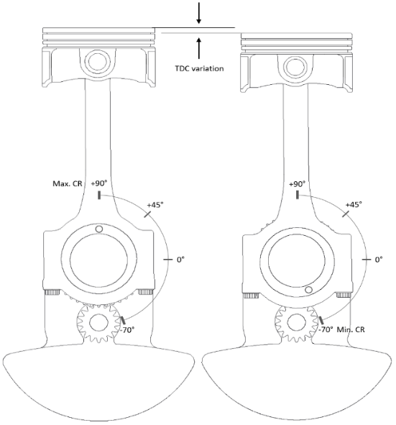
The Compression ratio is set dependant on the Degree of offset from TDC the concentric lobe is set to at the beginning of each cycle which is determined by the Electronic Control unit (ECU) depending on engine load provide the most fuel efficient and energy efficient CR. The concentric lobe operates between maximum compression ratio at 90° (crank TDC) and minimum CR at -70° allowing for a flexible compression ratio between 8.5 and 13.5, the kinematics of this design ensure that the concentric lobe is precisely timed so that when the piston is at TDC the concentric lobe sits at the desired offset at the end of the compression stroke.
Figure 6 Range of concentric motionInvalid source specified.
Gomecsys claim is that with this VCR crank mechanism a true 4 stroke cycle can be maintained while maintaining over expansion thereby increase thermal and fuel efficiency without the need for variable valve timing to alternate between the otto and Atkinson cycle. This is possible due the concentric mechanism operating at half engine speed by controlled the gearing ratio between the concentric lobe and the intermediate gears seen in Figure 4 (Gomecsys, 2020), this means that the concentric lobe that the rod is fixed to rotates from its initial position 180° for every 360° of crank rotation an example of this can be seen in Figure 10 (Gomecsys, 2020). At TDC Firing the lobe is sets the positional degree as seen in Figure 6 to select the required Compression ratio on the compression stroke, due to the rotation of the concentric lobe operating at half engine speed the lobe rotates 90° to the 0° position when set to maximum Compression ratio (see Figure 6 which enlarges the expansion stroke compared to the expansion thus generating over expansion.
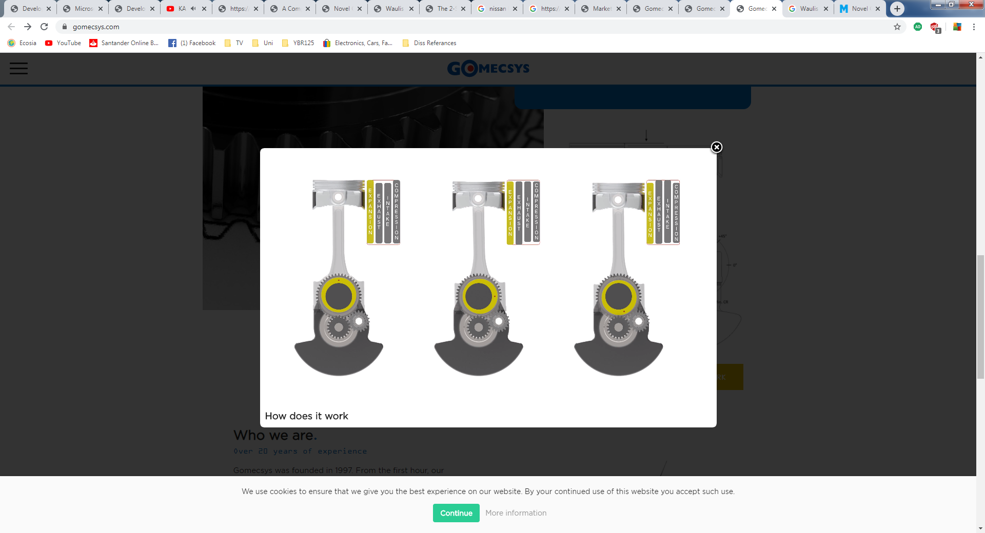
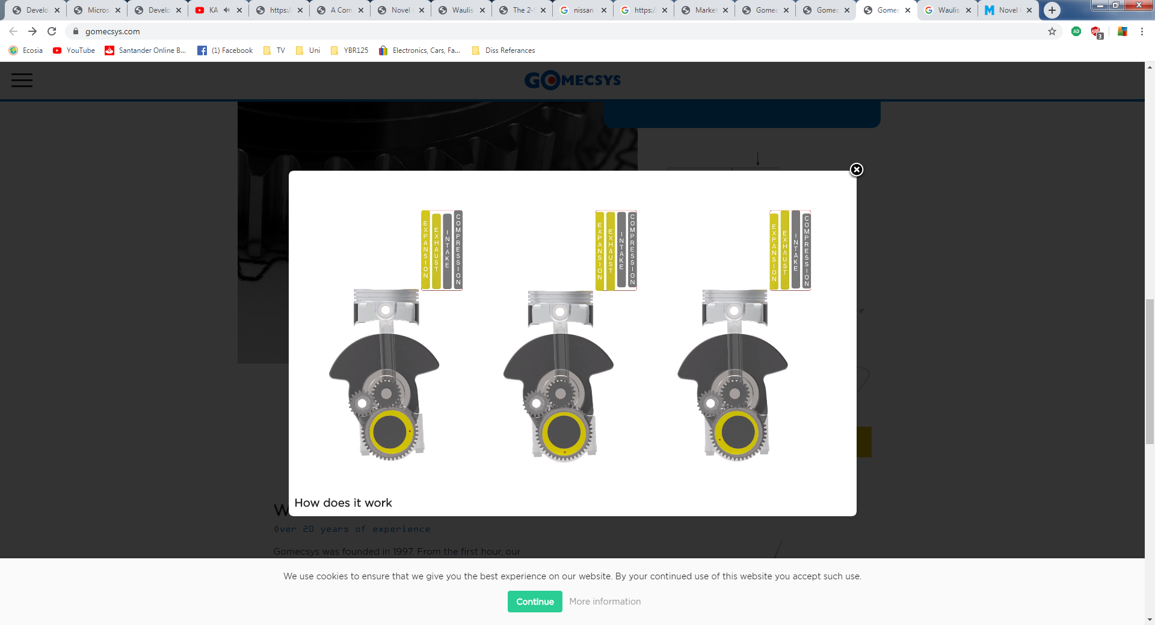
When reducing the compression ratio, the driving mechanism engages the torsion spring which activates the intermediate gears and increases the rotational velocity of the concentric lobe briefly to alter the degree of offset needed to set a new compression ratio. (Gomecsys.Technology, 2020)
Figure 8 TDC firing Invalid source specified.
Figure 8 BDC Expansion (Gomecsys, 2020)
Approx. CR of 11:1
Max CR of 13.5:1

benefits claimed by Gomecsys include:
- A claimed 8% Reduction in CO2 Emissions in cars and 10-15% in single cylinder motorcycles when tested in accordance to the World-wide light duty vehicle test cycle (WLTC) regulations.
- No additional friction in between the cylinder and piston
- No additional Gear noise.
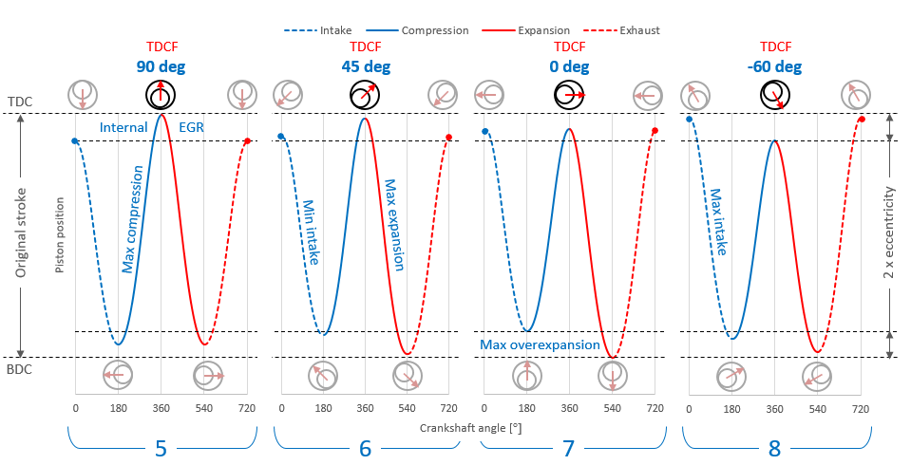
- Maintains a True 4 stroke cycle with over expansion without the need for VVT
Figure 9 Gomecsys Main VCR Crank Engine Cycle configurations (Gomecsys.Technology, 2020)
1
2
3
4
Figure 11 shows the effects of 4 CR settings that represent the desired cycle variant dependant of engine demand, the 4 mains settings and effects that this mechanism allows for can be seen in Figure 12

Cycle 1 (Power Cycle) @ 90° TDC Firing

The first cycle configuration with the concentric lobe set at 90 TDC which allows for a true 4 stroke Otto cycle as can be see by the lack of over Expansion however has the added benefit of internal EGR, this setting is designed to allow for the engine to perform close to the same as current engines while improving on particulate emissions through effectively downsizing the engine and adding internal EGR. This set-up would largely be used for Average to high performance situations where a average power demand is needed.
- Intake: The intake stroke neglects to use the entire stoke due to the configuration which allows for internal EGR and essentially downsizes the engine capacity slightly which is an approach to reducing emissions.
- Compression: The reduced charge allows for an increased CR ratio, under this situation the CR is at maximum therefore the pressure is increased through compression to account for the reduced charge
- Expansion: Equal ER to the CR allowing for a true 4 stoke cycle
- Exhaust: the exhaust stroke is at its minimum and therefore the greatest amount of burnt and unburnt particulates are retained in the cylinder for internal EGR reducing emissions.

Cycle 2 @ 45° TDC (Greatest thermal Efficiency)

Cycle 2 has the shortest intake stroke and largest expansion stroke and therefore would represent the best thermally efficient cycle with only marginally less internal ERG than the power cycle configuration, this set up would largely be low engine demand situation where power is in low demand. this cycle is best represented as a Atkinson cycle without the need for extended inlet lift. This setting would largely be used when charging the battery under low load scenarios.
- Intake: Minimum intake stroke occurs due to Concentric positioning lowering
- Compression: High compression ratio to account for reduced charge
- Expansion: Maximum Expansion stroke generating the greatest thermal efficiency Per cc of charge
- Exhaust: Exhaust stroke lengthened increasing negative work

Cycle 3 0° @ Crank TDC

Cycle 3 would largely be used in scenarios where the EV motors require assistance when under high load demand, with a relatively large intake of charge the engine can provide reasonable torque and power and also has the largest expansion offsetting the increased charge with greater thermal efficiency.

Cycle 4 (High Torque) -60° TDC Firing

- Induction: The Induction on cycle 4 is at its maximum due to the minimum compression ratio required
- Compression: When the induction stroke is at its peak the compression ratio is at its lowest to avoid knock issue in the cylinder associated with hight pressures
- Expansion: over expansion with no internal EGR however this cycle would be used the maximise toque due to maximum induction of charge.
- Exhaust: increased exhaust stroke to expel additional exhaust
cycle 4 would be used in high torque scenarios with a low CR to reduced Damaging to the engine with increased pressures due to increased charge known to cause knock, the increased volume with the addition of turbo charging would increase the output of engine to competitive with current ICE engines. Gomecsys claim better power and torque performance for test bed 1.6 Peugeot 208, with the time for alteration of the CR between cycles being approximately 0.2 seconds from maximum to minimum compression ratio.
The application of this technology to existing ICE Designs would be a considerable step in reaching new emissions legislations, Gomecsys claim that in current single cylinder engines and that utilise this design show a 10% – 15% reduction in emissions. with the VCR crankshaft HEV designs could further aid in the reduction of fuel consumption to meet new emissions legislations due by 2025.
Used in parallel with EV components this flex engine design solution could drastically decrease the fuel consumption and CO2 produced Per KM.
The cycles seen in figure 9 are indicative of otto, miller and Atkinson cycles where in common Hybrid design engines will make use of one of these operations without the use of the Gomecsys VCR Design or possibly two with the use of VVT, therefore the a conversion of an ICE for a hybrid application without VCR

Literature conclusion/discussion

In conclusion the author believes that a study into alternative ICE solutions such as converting a current ICE into a HEV Generator/Range extender would be effective in for HEV application and reducing emissions. During the research for this proposal the author discovered that very little concise studies on adapting and designing an existing engine architecture to operate as a Generator/ range extender by tuning the engine design to its most efficient. With the research shown the author believes that the investigation into converting an existing ICE into a Parallel hybrid generator through mechanical design parameters and cycle alteration to its most efficient could yield in interesting results that could be used to inform a decision when refitting current Vehicles to HEV or EV Power Trains as this is a common and more cost effective and recycles 95% of the original vehicle and components

Bibliography
Connor, N. (2019, 05 22). Thermal Engineering. Retrieved from What is Atkinson Cycle – Atkinson Engine – Definition: https://www.thermal-engineering.org/what-is-atkinson-cycle-atkinson-engine-definition/
European Transport Comission. (2021, 03 25). European Comission. Retrieved from EU Transport Emissions : https://ec.europa.eu/clima/policies/transport_en
European Union. (2021, 03 12). European Climate Action . Retrieved from Road Transport: REsucing CO2 emissions from Vehicles: https://ec.europa.eu/clima/policies/transport/vehicles/regulation_en
European union. (2021, 03 15). European Commission. Retrieved from EU Action - Transport Emissions: https://ec.europa.eu/clima/policies/transport/vehicles/regulation_en
Gomecsys. (2020). Who are we. Retrieved from Gomecsys.com: https://gomecsys.com/
Gomecsys.Technology. (2020). Gomecsys. Retrieved from Gomecys Variable compression technology: https://gomecsys.com/our-product/gomecsys-vcr-technology
Land Transport GURU. (2021, 03 22). Land Transport GURU. Retrieved from Series & Parallel Hybrid Drivetrains: https://landtransportguru.net/hybrid-buses-in-singapore/series-parallel-hybrid/
Mishra, P. (2017, 12 18). What is Compression Ratio – Petrol and Diesel Engine? Retrieved from Mechanical Booster: https://www.mechanicalbooster.com/2017/12/what-is-compression-ratio-petrol-diesel-engine.html
Nuclear Power.net. (21, 03 22). Thermal Efficiency for Atkinson Cycle. Retrieved from Nuclear Power.net: https://www.nuclear-power.net/nuclear-engineering/thermodynamics/thermodynamic-cycles/atkinson-cycle-atkinson-engine/thermal-efficiency-for-atkinson-cycle/
Pohjalainen, T. (n.d.). Waulis Motors Ltd. Retrieved from http://waulis.com/wp-content/uploads/White_Paper.pdf
Tech Talk . (2020, Jan/Feb). Retrieved from VACC Technical Publication : https://www.autoapprenticeships.com.au/wp-content/uploads/2020/02/2020_02_4805_4920.pdf?fbclid=IwAR2zQ_ThXRv_q1apMGA1b0pYM6n6d0Qh3pAey7e5YzZPeKsGY-hqpmg3DNQ#:~:text=Over%20expansion%2C%20like%20all%20new%20ideas%2C%20is%20an,had%20been%20used%20to%20push%

