


Environmental Factors impacting tesco & it’s
hr strategy
  - COURSE: HRM IN CONTEXT
  - Name: Gary DARCH (0050829)
  - DATE: 12TH December 2017

Contents
- Executive Summary ___________________________________________ 3
- Introduction_________________________________________________ 4
- Research Methodology ________________________________________ 5
- External Factors Facing Tesco___________________________________ 7
- Big Data & Competitive Advantage_______________________________ 8
- Big Data at Store Level_________________________________________ 9
- Demographic Workforce & Culture________________________________ 10
- Recommendations _____________________________________________ 13
- Conclusion ___________________________________________________ 15
- Bibliography__________________________________________________ 16
- Appendix: 1 PESTLE ANALYSIS _________________________________ 20
- Appendix: 2 PORTERS FIVE FORCES_____________________________ 25
- Appendix: 3 TRANSFORMATIONAL PLAN__________________________ 31

EXECUTIVE SUMMARY
The report sets out to provide an evaluation of Environmental factors currently affecting Tesco Plc. Detailing the impact on the organization and make suggestions for future HR Strategy. Two main business tools have been used to assess the environmental context of Tesco. The first is a PESTEL analysis and the second business tool is Porters Five Forces.
The report highlights the volatile environment that Tesco operates in from both the PESTEL identifying the current economic uncertainty and Brexit clouding its industries future, Porters Five Forces demonstrating the competitive market in which it operates, also the need to strategize to gain a competitive advantage to maintain their place in the market. The report provides big data as the key priority for Tesco to retain its competitive advantage, and looks at its limitations as well as its considerations for implementation within Tesco.
The report draws on recommendations to fully introduce big data at Tesco in order to maintain its competitive advantage. To do this the report advises the recruitment of analysts to assist in a transformational project that would look to introduce data-based decision making as a natural adoption to Tesco’s culture focusing on making analytics attractive to all age groups of employees. Also recommend the best HR Strategy to be implemented. Possible functional roles of HR Managers at store level changing, demonstrating a cost saving to Tesco.

Due to the size of the change the report suggests a transformational HR Manager conduct a trial before rolling out these recommendations.

INTRODUCTION
Tesco, is a British multinational grocery and general merchandise retailer. It is the third largest retailer in the world and the grocery market leader in the UK. The market in which Tesco operates is highly competitive, where Tesco holds a disproportionate amount of power. Tesco competes with three major competitors – Sainsbury, Asda and Morrison. These competitors all have many chains and operate a similar business model with each competitor trying to differentiate. Tesco holds just under a third of the UK market share, and almost double the amount of Asda’s market share which is the second largest supermarket chain as highlighted in (Appendix 2 - Porters 5 Forces – Figure 2). Tesco out of its three main competitors, consumes the online grocery market with a 17% share. Tesco of late has increased its sales and profitability but have lost market share, seeing the discounters gain market share (Tim Wallace, 2017).

The aims of the report is to provide an environmental snapshot of the organization and advice Tesco of its biggest priorities and also recommendations for HR strategy. Balancing both arguments for and against demonstrating the author’s ability to review and analyze an organizations external environment and provide sustainable workable solutions for Tesco to maintain its competitive advantage.
Limitations that need to be acknowledged are due to the author’s decision to use only their research to base findings. It would be wise outside of these limitations, to consult other stakeholder’s opinions on the analysis of the PESTEL and Porters 5 Forces to gain a more insightful or less subjective analysis of Tesco’s external environment. Another limitation is the costing of the recommendation as salary data is not available to the author due to data protection restrictions. Therefore the author has used their own knowledge of salaried data. This would need to be recalculated when data would be made available to ascertain the cost saving.
RESEARCH METHODOLOGY
To gather the information presented in this business report a number of strategic analytic tools have been used to explore Tesco external factors. Farnham describes that HR practitioners work in complex, changing organizational context and to address HR issues they need to understand this context in order to adapt to the needs of the organizations surroundings (Farnham, 2015). The report will introduce these and provide the pros and cons for each;
PESTEL Analysis
PESTEL is an abbreviation for political, economic, social, technology, environmental, and legal factors influencing the company. This tool aids and encourages the development of strategic thinking by analyzing each external factor. It is best used with a set of cross-functional skills and expertise from different stakeholders, due to the limitations of the report the author will use their analysis only. Therefore making any decision based on this data is subjective (see Appendix 1).
Porters Five Forces
As Porter described an analysis of the structure of the industry should be undertaken in order to find effective sources of competitive advantage (Porter, 1985). Porters Five Forces will also be used in this report to analyze valuable information concerning industry attractiveness by identifying industry forces and understanding the interaction among them in order to evaluate the likeliness of achieving a competitive advantage. The five industry forces are; the Threat of entry, the Threat of substitutes, the Power of buyers, the Power of suppliers and Competitive rivalry (see Appendix 2).

SWOT Analysis
SWOT Analysis is an abbreviation of Strengths, Weaknesses, Opportunities and Threats. Whilst a widely used and beneficial tool. The author has chosen not to use this due to its limited depth and overly simplifying of an organizations context. It fails to identify underlying issues. The author suggests the tool would be best used to evaluate retrospectively top level findings at the end of the project.

EXTERNAL FACTORS FACING TESCO
Considering both the Pestle analysis and Porters five forces, Tesco’s key challenges are underpinned by the uncertain times ahead with Brexit (Laura, Hughes, 2017). The volatile economy and uncertainty of the future threatens its Transformation strategy to pay off its debts and bring back balance to its balance sheet (Wearden, 2017). In Tesco’s volatile market, new emerging competitors are constantly after a slice of their market share. In this VUCA world (Bennett & Lemoine, 2014) Tesco needs to make the right decisions at the right time to stay ahead of its competitors. The rise in food costs will need to be offset to ensure they offer a competitive price to retain their competitive advantage with consumers. With technology providing organisations with advantages in the market place for both HR Analytics and Consumer behaviour trends there is a need for Tesco to further invest this field and to also review its HR strategy. Therefore the report suggests that Tesco’s key challenges ahead, in order of priority are:

High Priority
Big data to enhance decision making processes to gain the competitive advantage.

Medium-High Priority
Facing up to the challenge of emerging business models which compete with their own.

Medium priority
Making the right strategic decisions in an uncertain Pre Brexit World.

For the purposes of this report I will focus on big data as a High Priority in gaining a competitive advantage.
BIG DATA AND COMPETITIVE ADVANTAGE

Analytics is the discipline, which has developed at the intersection of engineering, computer science, decision-making and quantitative methods to organise, analyse and make sense of the increasing amounts of data being generated by contemporary society (Mortensen, et al., 2015). Tesco has attributed its success to technology and data in the past by tracking customer activity through its loyalty card system and has successfully managed the transition to online retailing. However, data has changed since then, Tesco now operates in a global market as a result of the complexities of the modern world (Farnham, 2015). Therefore Tesco must arm itself with the latest technology to create its competitive advantage for the future.

(Eric & Andrew, 2012) Described the challenge of big data in terms of three ‘V’s Volume, Velocity and Variety. There is much more data around and its volume is expanding. It’s getting faster and spreading everywhere. It’s available through more channels and on more devices than ever before. The Gartner model adds a fourth “V” and challenges what Value it adds to the business (CIPD, 2013). The key to using data is to leverage human capital. According to Thomas Davenport, Harvard analytics guru, suggests that ‘data driven’ organisations are 6% more productive and 5% more profitable (Davenport, et al., 2012).

The cost benefits of Big Data to Tesco with tools such as Hadoop and Cloud-Based Analytics are bringing cost advantages to business when large amounts of data can be stored helping to identify more efficient ways of doing business. The high speed of tools like Hadoop and in-memory analytics can easily identify new sources of data which helps businesses analyzing data immediately and make quick decisions based on the learnings. Utilizing HR analytics can create insight into retention issues, moral and culture of teams and use as a benchmark to demonstrate progress or value added. Analyzing big data you can get a better understanding of current market conditions. For example, by analyzing customers’ purchasing behaviors, Tesco can find out the products that are sold the most and produce products according to this trend. By this, it can get ahead of its competitors.

Analytics takes time, resource and skills which is one of its main challenges in its uptake. However, Google have replaced the 20th century subjective decision-making approach to HR. Google’s HR teams acts as internal consultants and influences people to change based on the powerful data and the action recommendations that they present (Sullivan, 2013). This has seen HR become a critical role in Googles strategic plan and holds the attention pf the Board of Directors.

BIG DATA AT STORE LEVEL

Applying big data to yield value for Tesco’s 3,738 stores would come with its challenges, with fragmented department acting in silo’s it’s hard for big data to reap the reward. Even if the silos were pooled together the volume of data being so high could cloud the decision making process and could create confusion as apposed to clarity. With the fast pace of stores workloads and constant changing customer demands time is a luxury to Line Managers and HR Managers all working towards tight and unforgiving timescales. This population who are new to the advantages of big data could see this as another task or inconvenience rather than a benefit. Knowledge and understanding of analytics based decisions need to be an integral part of the adoption of this technology.

Some organisations have sort the help of academics thinking on HR Analytics. Although, opinion is divided on whether academics can assist in providing the HR profession to upskill to a new world of strategic analytics-driven HR. Bersin (2015a) reported evidence of companies drawing on the expertise of PhDs in occupational psychology, engineering and statistics in order to take their analytics activity to the next level. However, Rasmussen and Ulrich (2015) are rather dismissive of the idea that corporate analytics teams should draw on academic expertise, because they do not think academics have a deep enough understanding of the business to ask the right questions. Whilst academics can bring the knowledge and science to the data, it has to be meaningful to the organisation and has to create value for the needs of the business. Tesco would need to acquire this knowledge by engaging the key stakeholders that have the best influence on its successful uptake.

DEMOGRAPHIC WORKFORCE AND CULTURE

Tesco’s demographic workforce and culture is an important consideration when making the data communicate in the best way to its users. Millennials and their skill sets could be of value when leveraging Human Capital through data (Delloitte, 2017). Seeing an increase in the amount of Millennials in the workforce links technology uptake as a natural progression (Landrum, 2017).

Tesco’s Culture of inclusivity needs to be harnessed evermore in a digitally competitive business environment where Millennials will be quick on the uptake. Potential considerations need to be made for other cohorts such as Baby boomer and previous as they could feel alienated and become despondent to the new ways.

HR Managers would be a key stakeholder or champion for change. Tesco’s Store Based HR Managers are heavily focused on traditional HR roles focusing on welfare aspects of the function and rely on building relationships and working on people –centered issues (Pease, et al., 2012). Identified by a recent Deloitte report. Developing the ability to use data to inform decisions comes fifth in HR professionals strategic priorities (Deloitte, 2013). This further highlights the change required and a shift from (Beer, et al., 1984) “soft” SHRM Model to a more data driven “Hard” SHRM model.

As described by (Ulrich, 1997) Tesco’s organisational HR structure adopts a multi legged model of HR functions, head office comprising of a small number of overarching Corporate HR professionals and Centres of excellence whilst store based HR professionals are more in line with carrying out the shared services roles. Undertaking a lot of HR administrative tasks and provide information and advice to Line Managers. Showing a disconnect between Head office’s strategic HR approach and that of the store based HR Shared Services approach. This is further backed up in figure 2.
Figure 2: The general translation of Ulrich’s model
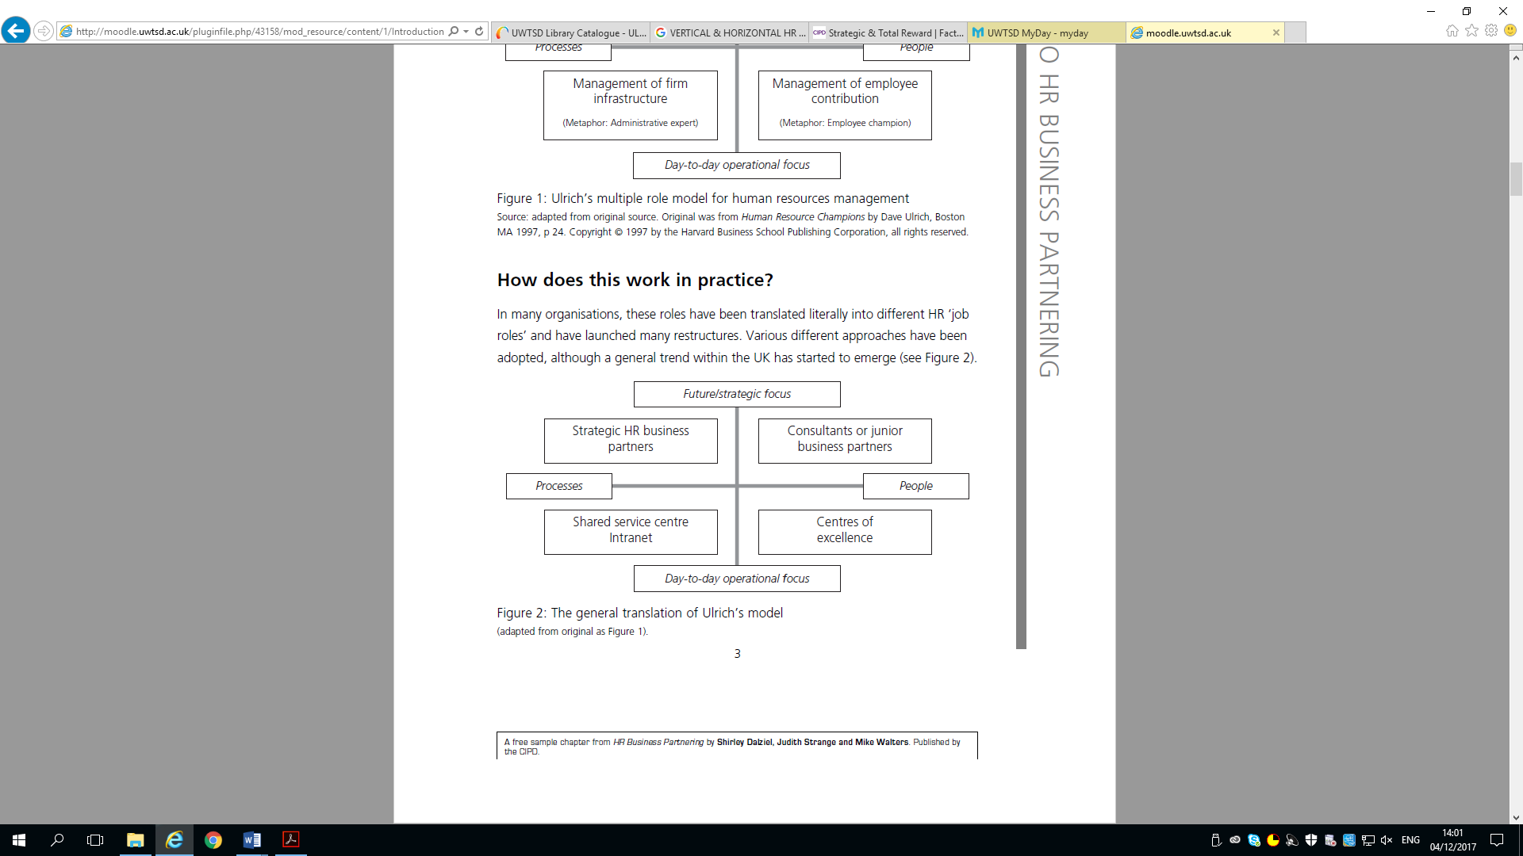
Now policies and practices are available on all devices throughout the organisation, this allows Line Managers to carry out the HR functions themselves as Line managers can also play a critical role in implementing HR policies (Renwick , 2003). As outlined by (Purcell , et al., 2003) Strengthening the relationship with employees and line managers can result in a positive approach to employee performance and motivation.
Considering the two theories on the application of HR practices debated as either Best Fit or Best Practice. (Delery & Doty, 1996) Argues that all organisations should adopt a universalistic perspective of best practice. It argues that all firms will be better off if they identify and adopt “best practice” in the way they manage people (Boxall & Purcell, 2003). (Pfeffer, 1998) Further supports this by introducing seven HR practices for “building profits by putting people first”. Best practice however does not factor at all external factors of an organization and therefore the report suggest the use of best fit approach after considering the huge external factors highlighted in the report. Tesco would benefit if its HR practices were aligned with its internal and external context (Boseline, 2010). Considering the VUCA world Tesco operates in, the report finds that context really does matter.

RECOMMENDATIONS

The short term impact to Tesco and the emergence of big data & HR analytics would hold significant advantages after considering the following possible recommendations. Combining the benefits of existing systems already in use such as data warehouses with new Teradata and free packages, including Hadoop package could provide Tesco with real-time analytics. Doing this would help Tesco deal with obstacles ranging from evolving customer behavior, to facing up to newer competitors. Many of these (such as Amazon, which recently began delivering fresh groceries) are built from the ground up as digital and data-driven organizations. As the open source data is free Tesco’s short term costs to apply this recommendation would be the cost of three additional data Analysts to research and join the Tesco Labs Team costing £76,533 per annum. Longer term costs could be evaluated once the research phase has concluded its findings. The benefits of the research phase would be to establish the need to purchase data packages or weather Tesco could recreate packages and reduce costs in the long term. Further suggestions regarding data would be to review the need for training or rather incorporate such training into ongoing learning sources already available to Tesco’s for its business leaders to lead the change in data Analysis.

Tesco’s HR Strategy needs to be re-aligned to ensure that its end to end HR processes support the company’s strategic goals and that it adopts a best fit approach. One of the recommendations is to review the HR Structure at store level and proposing the removal of the shared services role and introduce the HR Business Partner role. This would comprise of one Business Partner for every 10 stores instead of one HR Manager per store. Relinquishing the shared services responsibilities to Line Managers. The cost of this recommendation would be as follows:
Removal of Shared Services role £117,775,000.00 (3,738 currently in UK)
Introduction of Admin assistants (25hrs) £841,275.00 (373 in the UK)
New Business Partner roles (36hrs) £13,055,000.00
Total annual saving £103,878,725.00

Considering the cultural and fast pace which Tesco operates and how important data uptake would be to Tesco’s Strategic direction. The report suggests that with the introduction of analytics to the business there should be a HR transformational team that works alongside the analysts team, working collaboratively on a trial in short term to build data into Tesco’s culture (see Appendix 3 proposed transformational plan).

CONCLUSION
The business report highlights the environmental factors impacting Tesco and its HR Strategy. Both PESTLE Analysis and Porters 5 Forces identify that Tesco operates in a highly competitive environment consisting of three main competitors Asda, Sainsbury, and Morrison’s. Its growth area is online and has different competitors including Amazon to contend with. Brexit casts a lot of ambiguity on the Retailers Economic state and further pressurises the threat of increased food prices. The need for Tesco to successfully deliver competitive advantage is crucial to remaining the number one retailer in the UK. The assignment suggests the adoption of big data in Tesco providing competitive advantage and considers the advantages and disadvantages of this technology if implemented.
The HR Strategy although strategic at Head Office level and in line with the overall company’s strategy, could benefit from a more strategic approach at store level. Therefore a disconnect in the implementation of HR Strategy at store level can be seen and a solution of Business Partner role to be introduced. Introduce analytics as a transformational project recruiting Analytics to work alongside Head Office HR Experts to ensure there is a right combination of knowledge and direction applied to make stories from statistics and help make databased decisions. The report proposes the removal of shared Services roles and replacing with lower skilled admin assistants. Due to amount of change required a trial would be advised before full roll out to the UK stores.

BIBLIOGRAPHY

Andrea Felstead, 2015. Suppliers rate Tesco worst big UK supermarket. [Online]
Available at: https://www.ft.com/content/fb319088-18f1-11e5-a130-2e7db721f996
Andrew Cave , 2016. There are clearly some long established retailers who are facing real challenges. [Online]
Available at: http://www.telegraph.co.uk/business/2016/09/11/tesco-chairman-john-allan-there-are-clearly-some-long-establishe/
Anonymous, 2003. Tesco puts its new recruits in the picture. [Online]
Available at: https://www.personneltoday.com/hr/tesco-puts-its-new-recruits-in-the-picture/
Ashley Armstrong, 2016. Watchdog says Tesco knowingly delayed supplier payments. [Online]
Available at: http://www.telegraph.co.uk/finance/newsbysector/retailandconsumer/12120971/Watchdog-says-Tesco-knowingly-delayed-supplier-payments.html
Baird, L. & Meshoulam, I., 1998. Managing two fits of strategic human resouurce management. Academy of Management Review , 13(1), pp. 116-128.
Beer, M. et al., 1984. Managing Human Assets. New York: Free press .
Bennett, N. & Lemoine, J. G., 2014. What VUCA Really means for you. Harvard Business Review, Jan-Feb, pp. 12-13.
Boseline, P., 2010. Strategic Human Resource Management . In: P. Hooper, ed. A Balanced Approach . New York: McGraw-Hill Education (UK), p. 20.
Boxall, P. & Purcell, J., 2003. Strategy and Human Resource Management. New York: Palgrave Macmillan .
Bradley Gerrard, 2017. British shoppers are top of the table for buying groceries online. [Online]
Available at: http://www.telegraph.co.uk/business/2017/06/02/british-shoppers-top-table-buying-groceries-online/
Caroline Parry , 2016. Analysis: How will Brexit impact retail employment in the UK?. [Online]
Available at: https://www.retail-week.com/topics/policy-and-legal/analysis-how-will-brexit-impact-retail-employment-in-the-uk/7008820.article
Cat Rutter Pooley, 2017. Tesco-Booker merger gets provisional competition clearance. [Online]
Available at: https://www.ft.com/content/914b30f8-7341-31a8-8577-887ddb61944b
CIPD, 2013. Talent analytics and big data the challenge for HR, London: Chartered Institute of Personnel and Development .
CIPD, 2017. www.cipd.co.uk. [Online]
Available at: https://www.cipd.co.uk/knowledge/strategy/analytics/factsheet#7740
[Accessed 12 November 2017].
Davenport, T., Barth, P. & Bean, R., 2012. How Big Data is different. MIT Sloan Management Review, 10 Oct, p. Vol 54.
Delery, J. E. & Doty, D. H., 1996. Modes of theorising in strategic human resource management: tests of universalistic, contingency, and configurational performance predictions. Academy of Management , 39(4), pp. 802-35.
Delloitte, 2017. Rewriting the rules for the digital age, India: Deloitte Touche Tohmatsu India LLP.
Deloitte, B. b., 2013. High impact talent analytics: Building a world class HR measurement and analytics function. [Online]
Available at: http://marketing.bersin.com/high-impact-talent-analytics.html
[Accessed 4 Dec 2017].
Emma Glanfield, 2016. shopping WILL rise 3% thanks to fall in the pound and loss of migrant workers after Brexit vote. [Online]
Available at: http://www.dailymail.co.uk/news/article-3870814/Tesco-boss-warns-price-shopping-rise-3-thanks-fall-pound-Brexit-vote.html
Eric , B. & Andrew, M., 2012. Big Data: The Management Revolution. Harvard Business Review, 2 October.
Farnham, D., 2015. Human Resource Management in context. In: Insight, Strategy and Solutions. London: CIPD, p. 17.
Farnham, D., 2015. Human Resource Management in Context. In: Insight Strategy and solution . London: Chartered Institute for Personnel Development , pp. 256-267.
Guest, D., 1987. Human Resource Management and Industrial relations. Management Studies , 24(5), pp. 503-521.
Ian Quinn , 2017. Tesco convinces 24 of its biggest suppliers to start publishing food waste data. [Online]
Available at: https://www.thegrocer.co.uk/home/topics/waste-not-want-not/tesco-convinces-suppliers-to-publish-food-waste-data/557844.article#
Jill Treanor, 2016. Tesco Bank cyber-thieves stole £2.5m from 9,000 people. [Online]
Available at: https://www.theguardian.com/business/2016/nov/08/tesco-bank-cyber-thieves-25m
Landrum, S., 2017. Here's Why Millennials Are The Most Data-driven Generation. [Online]
Available at: https://www.forbes.com/sites/sarahlandrum/2017/08/29/an-inside-look-at-millennials-love-of-data/#6b4246e1271e
[Accessed 8 December 2017].
Laura, Hughes, 2017. Britain 'would be booming' if it wasn't for Brexit, Mark Carney says. [Online]
Available at: http://www.telegraph.co.uk/news/2017/11/05/britain-would-booming-wasnt-brexit-mark-carney-says/
Mortensen, M., Doherty, N., Robinson, S. & Mortensen, M., 2015. Operational research from Taylorism to Terabytes: A research agenda for the analytics age.. European Journal of Operational Research, pp. 241: 3, 583-595.
Nick Carroll, 2017. Online grocery clicks in the UK: Sales set to surpass £11 billion in 2017. [Online]
Available at: http://www.mintel.com/press-centre/retail-press-centre/online-grocery-clicks-in-the-uk
ONS, 2017. Overview of the UK population: July 2017, London: Office of National Statistics.
Pease, G., Byerly, B. & Fitz-Enz, J., 2012. Human Capital Analytics: How to harness the potential of your organisation's greatest asset. New York : Wiley.
Pfeffer, J., 1998. The Human Equation: Building Profits by Putting People First. Boston: Harvard Business School Press.
Porter, M. E., 1985. Competitive Advantage: Creating and sustaining Superior Performance. (The Free Press): s.n.
Purcell , J. et al., 2003. Understanding the people performance link: unlocking the black box. London : CIPD.
Renwick , D., 2003. Line Manager involvement in HRM: an inside view.. Employee Relations , 25(4), pp. 262-280.
Rob Colins, 2017. Waitrose Food & Drinks Report 2017 /2018, UK: Waitrose.
Sarah Boseley, 2016. Tesco cuts sugar in own-brand drinks to avoid sugar tax. [Online]
Available at: https://www.theguardian.com/society/2016/nov/07/tesco-cuts-sugar-in-own-brand-drinks-to-avoid-sugar-tax
Sarah Butler, 2017. Lidl overtakes Waitrose as UK shoppers turn to discounters. [Online]
Available at: https://www.theguardian.com/business/2017/aug/22/lidl-overtakes-waitrose-uk-grocer-chain-discounters
Sarah Gordon, Peter Campbell & Nic Fildes, 2017. UK business leaders tell May Brexit transition essential. [Online]
Available at: https://www.ft.com/content/84d36878-ad0d-11e7-beba-5521c713abf4
Schuler, R. s. & Jackson, S. E., 1987. Linking competitive strategies with human resource management practices. Academy of Management Executives , 1(3), pp. 207-219.
Storey, J., 1992. Developments in the management of human resources. Oxford: Blackwell.
Storey, J., 2007. HRM: A Critical Text 3rd Edition. London: Thomson Learning .
Sullivan, D. J., 2013. How Google is using analytics to completely reinvent HR. [Online]
Available at: https://www.tlnt.com/how-google-is-using-people-analytics-to-completely-reinvent-hr/
[Accessed 12 Novemeber 2017].
Tesco, 2018. Tesco PLC - Reducing our impact on the environment. [Online]
Available at: https://www.tescoplc.com/little-helps-plan/products-sourcing/reducing-our-impact-on-the-environment/
Tim Wallace , 2017. Retail sales fall for first time in four years as inflation hits Britons in the pocket. [Online]
Available at: http://www.telegraph.co.uk/business/2017/11/11/retail-sales-fall-first-time-four-years-inflation-hits-britons/
Ulrich, D., 1997. Human Resource Champions: The next agenda for adding value and delivering results. Boston, MA : Harvard Business School Press.
Wright, P. M. & McMahan , G. C., 1992. Theoretical perspectives for strategic human resource managemet. Journal of Management , 18(2), pp. 295-320.
Zlata Radionova, 2017. Pound sterling slump: The key moments in six charts – and how low it could drop. [Online]
Available at: http://www.independent.co.uk/news/business/news/pound-sterling-slump-drop-key-moments-four-charts-graphics-how-low-could-it-go-a7529136.html

APPENDIX: 1 - PESTLE ANALYSIS

Political Factors
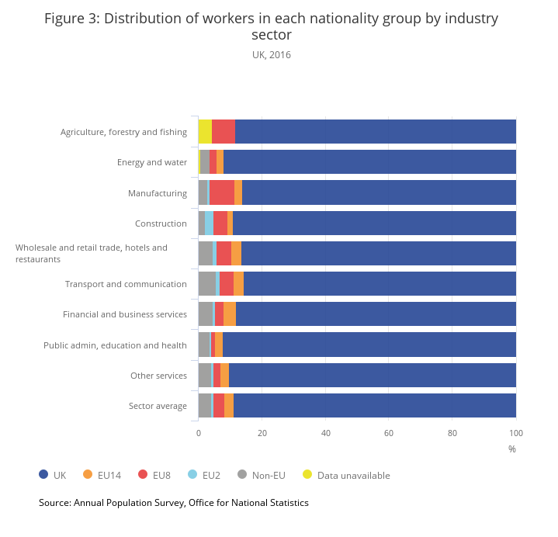
Differing Political Factors can have an impact on Tesco both directly and indirectly. Brexit negotiations and the uncertainty of the future has left it difficult to predict the impeding impacts. However, as our Chairman John Allan has described, our consumers will see food prices rise by three per cent as a result of Brexit (Emma Glanfield, 2016). Whilst immigration talks post Brexit is going to be the key factor to most food retailers, as John Allan said “My personal concern is more about the availability of labour, because a number of our agricultural suppliers are very dependent on immigrant labour” (Andrew Cave , 2016).
Table 3: Distribution of workers in each nationality group by industry sector
UK 2016
The Centre for Retail Research is less pessimistic about what will happen than many others, but ultimately it depends on what politicians, businesses and consumers do after Brexit. Reassuringly the government has emerged with a plan to meet Business Leaders to gain their feedback as they continue with negotiations and Theresa May stated “These have informed our proposal of an implementation period and commitment to continue to attract the right talent to the UK workforce,” (Sarah Gordon, Peter Campbell & Nic Fildes, 2017).
Economic Factors
Falls in share prices and the international value of the pound sterling reflect the fact that the future is unclear. Britain’s economy will grow more slowly in the short term if the country fails to secure a future trading deal with the European Union after Brexit, stated the Bank of England Governor Mark Carney (Laura, Hughes, 2017). Retail sales fall for the first time in three years as a result of inflation hitting 3% reaching its highest rate since 2012. Average wages rose by 2.1% in last year. (Tim Wallace, 2017).
Social Factors
The major social factor to be considered by Tesco is the gradual ageing of the UK population as outlined in the projected population statistics from The Office for National Statistics.

Table 1: Age distribution of the UK population, 1976 to 2046 (projected)
 | 0 to 15 years (%) | 16 to 64 years (%) | Aged 65 and over (%) | UK population
1976 | 24.5 | 61.2 | 14.2 | 56,216,121
1986 | 20.5 | 64.1 | 15.4 | 56,683,835
1996 | 20.7 | 63.5 | 15.9 | 58,164,374
2006 | 19.2 | 64.9 | 15.9 | 60,827,067
2016 | 18.9 | 63.1 | 18.0 | 65,648,054
2026 | 18.8 | 60.7 | 20.5 | 69,843,515
2036 | 18.0 | 58.2 | 23.9 | 73,360,907
2046 | 17.7 | 57.7 | 24.7 | 76,342,235
Source: Office for National Statistics
Notes:
1. Population estimates data are used for 1996 to 2016, while 2014-based population projections are used for 2026 and 2036.

This requires going more mobile and offering flexible delivery options. Whilst people are getting ever more health-conscious, there is a stronger emphasis on healthy food offers which may also attract more customers to Tesco. According to the latest research from Waitrose, shoppers are more single-minded and savvy than ever before. In an uncertain world, this desire to take charge is no surprise (Rob Colins, 2017). In the conditions of continuing consequences of Pre Brexit negotiations, keeping prices low and competitive enough may also be a beneficial approach in terms of preserving positive attitudes and popularity among consumers. 2017 has seen consumers spending beginning to switch from discretionary categories to focus on essentials due to economic impacts. Thus Tesco’s additional challenge of keeping the price of staple goods down during an uncertain time will retain customers but be a challenge for the bottom line.

Technological factors
A globally dominant technological factor affecting Tesco at present is the increasing adoption of online shopping and mobile internet technology (Bradley Gerrard, 2017). Hence, shopping in physical supermarkets becomes less popular, especially among individuals who work and have scarce time for shopping. Consumers are now demanding an experience from physical retail stores and expectations are higher to justify the visit to the store (Rob Colins, 2017). In connection with that, Tesco may retain its competitiveness by offering more interactive tools to users, such as online pre-order of goods or online ordering of delivery. Order Time is key as customers’ now value speed & efficiency more than being loyal to one retailer. Tesco’s Technology infrastructure continues to require further investment as external threats increase, such as cyber-attacks (Jill Treanor, 2016). This fuels the challenge around securing the right capability to deliver change to become an agile and responsible company.
Environmental Factors
Environmental factors determine the customers’ attitude to the company as eco-friendly and environmentally sustainable, which determines the demand for its products and its reputation In this regard, Tesco follows an explicit environmental strategy including control over greenhouse gas emissions, striving to zero net deforestation by 2020, sustainable sourcing of seafood, and focusing on the sustainable agricultural supply chains. Tesco also boasts next to zero discharge of hazardous chemicals and active involvement into reuse and recycling initiatives (Tesco, 2018). Reducing food waste remains a constant concern for our consumers and due to Tesco’s scale this can delight or disappoint customers and with it affect the brand image (Ian Quinn , 2017).

Legal Factors
Failure to comply with requirements as the regulatory environment becomes more restrictive, due to changes in the global political landscape, results in fines, criminal penalties, consequential litigation and an adverse impact on our reputation; financial results or unfavourable effects on our ability to do business. Tesco’s main concern is about monopoly and competition laws, which is the primary basis of its competitive advantage and survival in the increasingly competitive market. Tesco legal focus has been towards the current merger with Booker Group whilst it received provisional competition clearance from The Competition and Markets Authority, the merger has not yet been completed and subject to a full report out in December 2017 (Cat Rutter Pooley, 2017).

APPENDIX: 2 - PORTERS FIVE FORCES

Porter’s Five Forces Analysis of Tesco

Porter’s five forces uses five separate forces to analyze the extent of overall competition in the food retail sector, as shown in Figure 1 below:
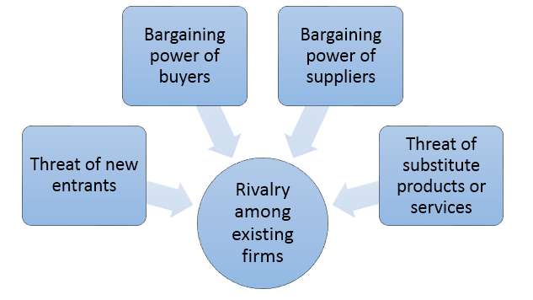
Figure 1 Porter’s Five Forces

Threat of substitute products and services
The threat of substitutes in the grocery retail market is considerably low for food items and medium too high for non-food items. Substitutes of major food retailers are fast becoming small chains of convenience stores, off licenses and organic shops which are now becoming a contender due to consumers becoming less loyal to one supermarket. Lidl’s recently has overtaken Waitrose to become the UK’s seventh largest grocer, it is the fastest-growing grocer and reaches 5.2% market share as Tesco increases sales but loses share (Sarah Butler, 2017). Tesco has responded by opening more Express stores in local towns and city centers making it difficult for these new entrants to enter the market.
Rivalry among existing firms in supermarket chain sector is fierce.
Amongst the three main competitors Asda, Sainsbury’s and Morrison’s there is a fight for differentiation of products and services playing a major factors in obtaining a competitive advantage. As it is illustrated in Figure2 below, although there are many competitors in the grocery retail industry in the UK, Tesco maintains a clear leadership position despite challenges the company currently faces.
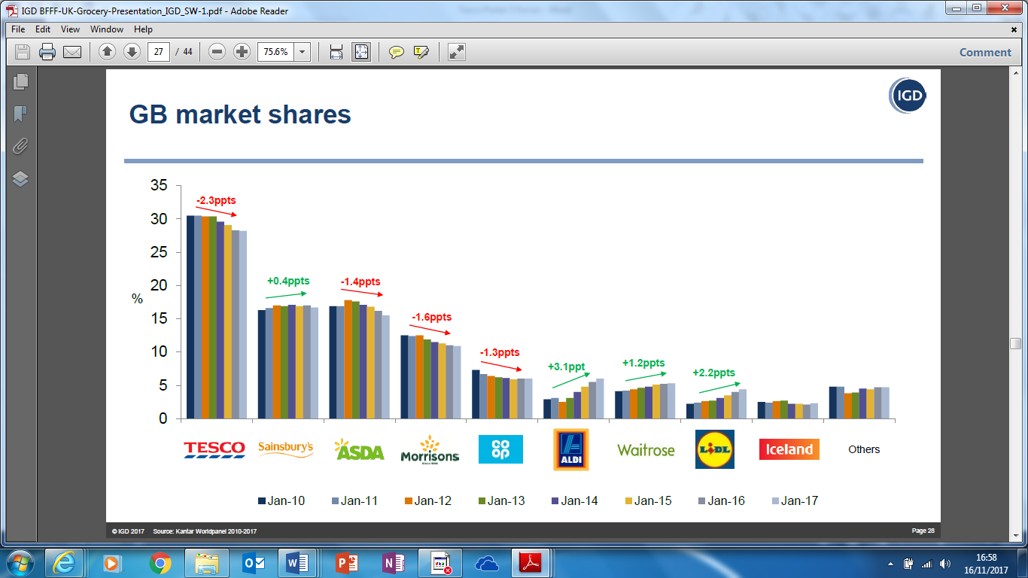
Figure 2:
IGD 2017 Source: Kantar Worldpanel 2010-2017
Grocery Online Shopping market is forecast to grow by 12% in 2017, the value of virtual shopping baskets is growing at a faster rate than physical ones. In 2016, sales in the online grocery market rose by an estimated 15%, while total food retail sales grew by just 1.5% (Nick Carroll, 2017). Tesco has the highest share of the market with 17% closely followed by Asda with 12% as seen in figure 3 below. Tesco’s latest strategy is to deliver same day groceries is its key differentiator to its competitors, yet Asda are also launching a similar strategy.
Figure 3
IGD 2017 Source: Kantar Worldpanel 2010-2017
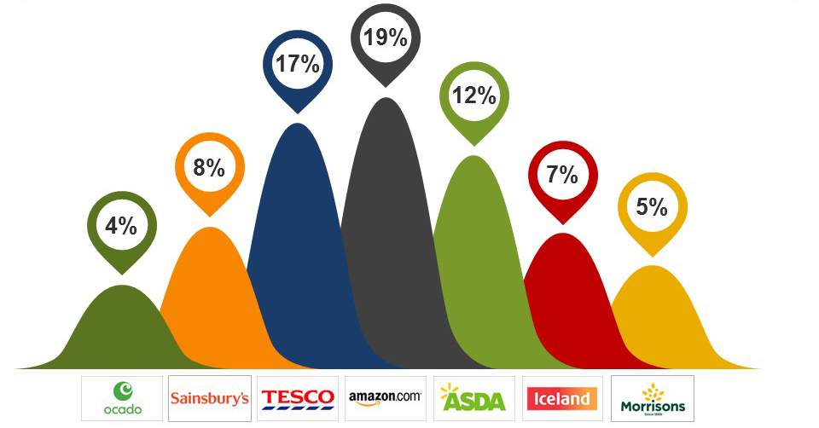
Bargaining power of Tesco suppliers is low.
The company’s history of using its power to falsify its operating profit margin by delaying payment to suppliers under the previous leadership of Phillip Clark in 2014 (Ashley Armstrong, 2016). Covered heavily by the media, Tesco new leadership team reviewed this in October 2015 and according to results of a survey, only 58 per cent of suppliers indicated that they felt satisfied with their relationship with the company (Andrea Felstead, 2015). This has since increased after the introduction of an anonymous help line put in place for suppliers to report un-ethic practices.
Bargaining power of buyers
It has been proposed that customers are attracted to low prices, and with the availability of online retail shopping, the prices can be easily compared and selected. The bargaining power of buyers is high as customer can switch from one product to another with little differentiation.

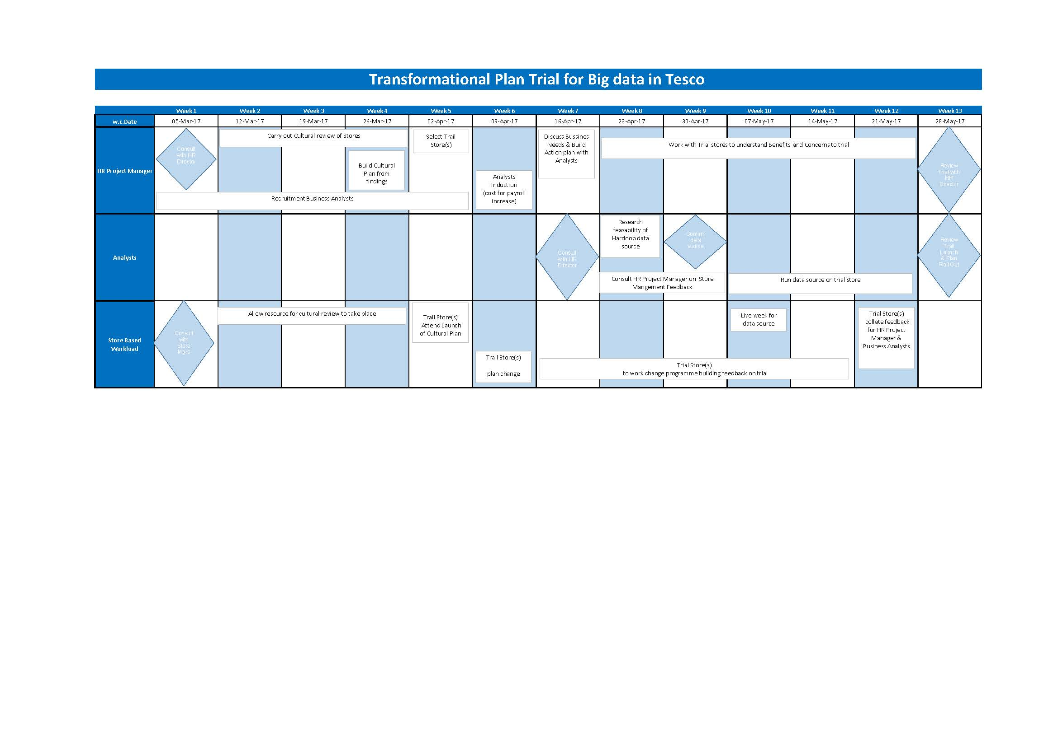
APPENDIX: 3 TRANSFORMATIONAL PLAN

