University of Wales Trinity Saint David

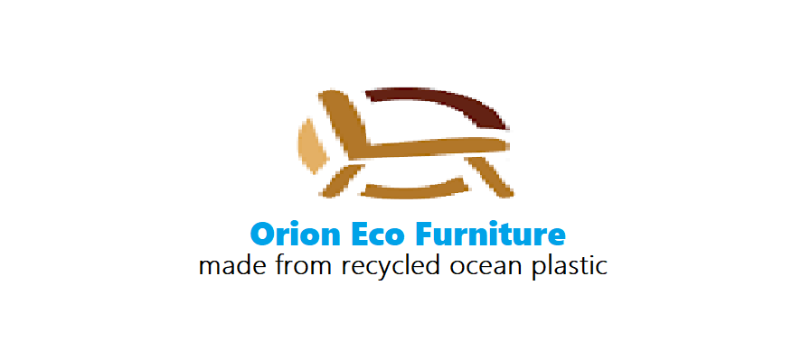
Managing Enterprise in the 21st Century (BMSW4006_LON)
Mr. Afzal Munna
Orion Eco Furniture Ltd,
Business Plan

- Page 01 - 09 Executive summary - Anil Prasanna (2023532)
- Page 10 – 16 Products - Angelika Brylewicz (2021932)
- Page 17 – 19 Marketing Strategy - Veaceslav Demerji (2024344)
- Page 20 - 24 Sales & Operations - Izabella Iliusi (2024055)
- Page 24 – 30 Manufacturing & Distribution - Manuela Dolhaescu (2024140)
- Finance - Mohammad Salim (2020481) – no work produced.
Finance data was covered by Anil in Salim’s absence.

29 August 2021

Contents
Cover Letter 3
Executive summary 3
1.1 Objectives 4
1.2 Reducing Carbon footprint 5
1.3 Mission 5
2. Sales & Profitability 5
2.1 Anticipated Cost of Sales 6
2.2 Anticipated Sales 7
2.3 Profit & Sales 7
Business Description and History 8
Management and organization 8
Start-up Summary 9
Product overview 10
Our products & designs 10
Sourcing raw materials 12
Production/sustainability - long term: 13
How will we achieve it? 13
Our Goals of eco-efficient production 13
Concepts & methods 14
Quality assurance 14
Manufacturing 15
Our services 15
Our product audience 16
How these products such be priced? 16
Market analysis and trends 17
Advantages 18
Audiences 18
Marketing Strategy 19
Marketing Objectives 19
Sales & Operations 20
SWOT Analysis Explanation 20
PESTEL Analysis Explanation 21
Operations and Costs 22
Distribution and Getting Products Out 23
Milestone plan 24
Manufacturing and Distribution 24
Overview 24
Operations and technologies 24
Distribution 27
Ways to improve the furniture store marketing 28
Conclusions and recommendations 30
Financial data 30
Stat-up Expenses (detail) 30
Cashflow Forecasts 31
References 32
Appendix 33

Cover Letter
Orion Eco Furniture Ltd.
PO BOX 1234, City Road,
EC1V 2NX
August 29, 2021
Funding Circle, 71 Queen Victoria Street,
London, EC4V 4AY.
Dear Mr. Afzal,
We are very pleased to enclose our business plan for Orion Eco Furniture Ltd. Inside, you’ll find a wealth of information about the business, a through assesment of opertunities in the market place and a detail plan to seize them.
We look forward to the posibility of working with you to make Orion Eco Furniture a success in the coming months and years. We hope that you will share our vision to clean up the planet while running a profitable business enterprise.
We are eager to hear your comments and answer any questions you may have. You can reach us at 0800423 1234.
Thank you for your time and attention.
Sincerely,
Orion Eco Furniture Ltd.

Executive summary
Orion Eco Furniture Ltd will be formed as an office furniture manufacturing company specializing in a range of products for the high-end office, resort, and commercial market. Our aim is to build a strong market position in the government institutions, banks, airports, high-end residential, and commercial development segments, the company projects revenues to grow substantially between financial-year 2 and financial-year 3. By maintaining an average gross margin of over 25%, the company estimates handsome net profits by financial-year 3.
Our products are made from 85% plastic ocean, fabric and yarn also contains at least 85% of recycled materials such as fishing nets, plastic bags, single used cups and straws.
At least eight million tons of plastics leak into the ocean each
year, an amount set to quadruple by 2050 (EIA, 2019, online). There is plastic pollution everywhere, on our beaches, oceans and researchers estimate that by 2050, there will be more plastic in the ocean than fish. (Lavit, 2019, online). There is already 150 million tons of plastic waste floating in our seas. Our oceans have turned into a to a toxic plastic soup.
We have invented a unique range of furniture made out of ocean plastic waste to solve this devastating problem. Initially there will be a selection of Three design choices with high-end finishes, along with top-of-the-line organization, customer service, and quality.
We have raised an initial capital of £60K, which covers the start-up expenses and each of our 6 members contributing £10K from their savings and owns 10% equal company shares. We do not intend to take salaries during the first 1year until we are profitable.
The company currently looking for £100K for 10% of our company.

1.1 Objectives
The company objectives are:
- Our products are made from 85% plastic ocean and are 100% recyclable. Our aim is to produce futuristic, trendy, stylish designs for modern offices that are easy to maintain yet versatile to handle and long lasting.
- To be a top office furniture supplier to banks, large corporate, government offices, universities, airports, hotels and luxury homes in the UK market. Aim to secure at least 10% of sales in the government and banking customer segment. 20% of sales in commercial development segment.
- UK furniture manufacturing 2018 £12.2 billion, 30% turnover £3.66bn is attributed to office furniture. (BFC The Industry, 2019). As a company we are arming to secure 0.1% of this over the next three years 3.66mn.
- The Global Plastic Furniture Market is expected to reach $19.7 billion by 2027, rising at a market growth of 8.7%. We want to tap into the international market after the 2nd year in business where we will have a mature, well tested product.

1.2 Reducing Carbon footprint
Oceans cover over 70% of the Earth’s surface and they play an essential role in absorbing CO₂ from the atmosphere and, critically, releasing Oxygen for us to breathe.
Sadly, whales washing up on our shores dead filled with plastic and turtles entangled in fishing nets washing up dead hungry has become a common seen on our shores (#seaspiracy, 2019, Netflix). A shocking 46% of the great pacific garbage patch is now comprised of fishing nets. Discarded fishing gear is the deadliest form of marine debris as they are designed to kill ripping those ecosystems apart.
If these animals die so, is our oceans. If our oceans die so do we!

1.3 Mission
- To deliver high-quality, uniquely stylish products, on time and within budget while also providing a fast, error free ordering system.
- Reduce the impact of ocean plastic pollution and support creating an ocean plastic economy that create opportunities for those who are underprivileged living in different parts of the world.
- Continue to offer competitive & honest service to our customers and cooperative partners in the years to come.
- Maintain strict quality standards to ensure that every product we do are made for high quality with care.
- Our prices are both fair and affordable for all people.

2. Sales & Profitability
Following graphs show our Profit and Sales over the next three years. These predictions are based on three key products that we are looking to launch in May 2022,
- Alba office: this is our uniquely stylish product range for medium to large corporate customers, government offices and banks.
- Eco-Task Mesh: lightweight and easy to assemble, this product is for small offices and home-working customers.
- Verona: this is an elegantly designed product for meeting and conference rooms. Unique characteristics of this design boasts about 85% recycled ocean plastic.

2.1 Anticipated Cost of Sales

As you can see, our aim is to start production from January next year. Initially we will be focusing on three prototypes from the each of product range. Each product will go through rigorous testing until they are launched in May-June next year. With new orders coming in the cost of sales is expected to increase at this point.

2.2 Anticipated Sales

This shows the anticipated sales volumes over the year of 2022. Initially we expect sales from the Alba range and gradually we will introduce other products to the market. These figures show that we expect a steady growth for the rest of the year with more volumes coming in from Eco-task Mesh and Verona towards the end of the year.

2.3 Profit & Sales

This graph shows our profitability over the next three years based on the cumulative figures from our first year in operation.

Business Description and History
Orion Eco Furniture Ltd is a new company that will provide expertise and quality in the office furniture supplier market. While meeting the demanding design and quality needs of public and private sector institutions, we are aiming at the residential market with our home-office concept as many works from home post pandemic.

Management and organization
The management team comprise of six individuals each holding 10% company shares. We are coming from different backgrounds some already has established businesses, others involved in IT and technology, product development and finance.
The company will operate in the following structure and our chief executive Anil will be overseeing the operation and managing the company. Angelika with her previous product development expertise will own the product development, research and development functions whilst Veaceslav will head up the marketing, biddings for government and private sector tenders.

Start-up Summary
Total start-up expenses, including tools, machinery, R&D, marketing, and related expenses are shown below. All six of us will provide the bulk of the start-up financing (£60K). At the same time, the company plans to give away 10% stake for £100K, which will help meet the cash flow requirements.

Start-up Expenses
Research and development | £1,200
Raw materials | £2,639
Plastic injection moulding machine | £16,000
Factory rental, tools & warehousing | £12,800
Office expenses | £1,631
Professional services | £185
Marketing | £730

Product overview
Our business product for Orion Eco Furniture Ltd is the making of modern furniture that will be manufactured from 85% of recycled ocean plastic. We will make a wide range of unique styles in furniture in terms of sizes, colour, and designs. we will engage in retailing and wholesale distribution, as part of our strategy that will be to create multiple of sources to have the income in line with our core business concept. We plan as a company to make the furniture safe and comfortable but also exceedingly long lasting.
Customers will buy the product to meet a need. This means the firm/company must concentrate on making products that best meet customer requirements, so as a business we need to look at what people are interested in like the designs the ideas if its modern or not. the business needs to pick out the function, appearance and cost most likely to make these products look to the target point and stand out from the rest of the competition. This is called product differentiation. (BiteSize, 2010)

Therefore, we want our product to stand not because it is nice and unique but for others to know it was made out from worthy cause as our intention on starting Orion Eco Furniture Ltd was to help the community for a clean environment also help save living creatures under water from passing away therefore we gather recycled plastics from oceans and create these fine furniture for everyone to use, we will do all that with a permitted by the law in the UK to achieve our aim and ambition. Here are some of our products, services etc down below.

Our products & designs
Our company will have many distinctive design products I will explain about the three main I have picked out.

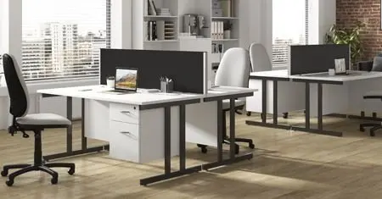 Alba office

This product is a bureau type. it is to be stylish and very modern; we produced this design as nowadays many offices such as agencies, universities, advice bureau and other big even small industries are likely to want a neat simple look for their workplace. We have estimated that our requirements to produce this fancy furniture would be the need of around 230x bins of recycled ocean plastic. our thoughts on colour would be black, white, brown and a bit of grey. For this design we think 1 week to do just the steel frame structure. Our pricing that we financially estimated would cost around £670 to the price £1400 depending on how material is saved for us.

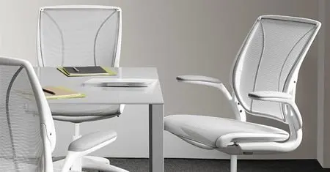 Eco-task mesh

Our bold bright full of class furniture that we have personalized for offices as well however this a design for meetings and coming together a team. To do this soft delicate desk and layed back chairs where you can relax and make work light going and comfortable. We have produced these designs we decided that an office needs a welcoming set, so people sit and feel happy and not annoyed or uncomfortable. we have picked out the colour white because white is bold and clean and matching to anything. For this product we have estimated that around 140x bins of plastic is needed for this to get made within a week9 light weight), this will contain materials such as steel frame, mesh made from fishing nets or yarn. Our cost will be £420 to the price £1188.

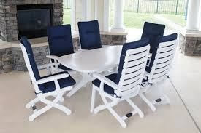 Verona

Our fine Verona model will be made for families and workplaces to eat in peace, this dining table is made for all sorts of houses and families. We want this model to be a suitable design for everyone, we will create it in varied sizes and colours but this one will be navy and white. for this piece of furniture to be made we would need around 233 x bins of the material so this could be neatly done within a month to finish as light weight, the fabric and yarn will be made out from at least 85% of recycled ocean plastic. Our pricing for this loving model will be the cost of £720 to the price £2250, this price range is considered good as this is going to use a lot of material but will be very safe and have a casual look.

We ask ourselves, why would someone buy our furniture? To begin with our furniture is designed and formed for safety. Our chairs and desks will be stable moreover they will be homely.

Sourcing raw materials
Where we get it form? We do not have the requirements and equipment for sorting the plastics from the oceans however we do get our materials imported from China. This means that China sorts out the best raw materials out for us and send it to the UK to sell it for us to reuse. However, once we have been advanced with the availability to sort the plastics out ourselves as a firm, we then will come together so we have our own sorting's done.
(Oceanworks, 2020)
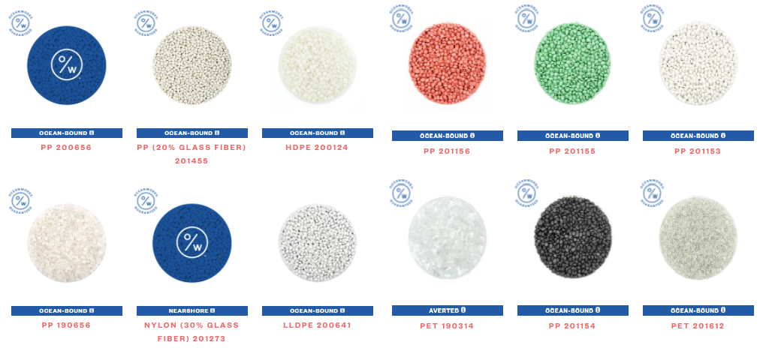

The product will need raw materials such as clean ocean-bound, nylon (30% glass fibre), fabric and yarn made from at least 85% pp yarn 30 tex and finally steel frame to hold the weight.

Production/sustainability - long term:
Our intention of starting Orion Eco Furniture Ltd was to help the community for a clean environment but also help save living creatures under water from passing away therefore we gather recycled plastics from oceans and create this fine furniture for everyone to use, we will do all that with a permitted by the law in the UK to achieve our aim and ambition. Here are some of our products and services down below.

How will we achieve it?

Our Goals of eco-efficient production
Our environmentally compatible production contains many interdependent individual goals such as.
- To Avoid any harmful emissions let out to the environment
- Well use of energy & resources
- Turning to renewable energies
- Using more sustainably produced resources such as our raw materials
- Avoid wasting and creating of material cycles & recycling
- Will try restoring and maintain the biological diversity of ecosystems

Concepts & methods
In the literature as well as in practice there are various concepts, methods and instruments to make the production of goods more environmentally friendly:
- Have a material flow analysis and its management
- Have a sustainable supply chain
- Have the Circular Economy
- Create Carbon Foot printing
- Meet the Life Cycle Assessment (LCA)
- Lastly lets Eco-efficiency analysis it

(iPoint, 2021)

We want our product to meet the achievements and production so we can create as a company these suitable furniture's for long term use.

Quality assurance
we will be testing and give the quality assurance, we estimated that the testing will take us up to at least 6 months and that will be testing it on the effects of fire, potential hazards to have a longer life span. To meet the UK/EU office safety standards.
The quality of our design needs to avoid by any features that costumers find annoying therefore we need to make our features simple and not packed our product designs will be delicate and have bold look. A design will be given a pleasing look.
Our product quality will be tested so the product lasts up to 5 plus years for our customers who purchase it.

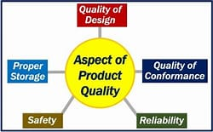
Image source here

Manufacturing
Manufacturing will be carried out and here is a summary on how it will go so to start off with, we will be adding chemical- based epoxy to produce plastic based glue then plastic will need injection of moulding and moulded components further w manual finish to reduce costs (sanding, buffing) lastly after assembling we will spray it with a protective layer to make it strong.

An average UK person spends 51hrs & 44mins a week on an office chair. Elegant designs with adjustable height and back support for comfort and safety.

Our services
As for our services we have a factory and our warehouses however no showrooms but other companies we sell our products to have their own showrooms and via through them. For example, we would sell our product to Ikea then Ikea will present our product in store as they exhibit their furniture in store moreover, they might place them in magazines or even advertise them in TVs. Once we can have our own showroom, we are absolutely considering showing what we have. We will also have pictures online on our website if costumers would want to see the look of it. Our packing will be flat pack.
Our Traditional product development process would contain the concept which will be the idea of what product we decide to do, secondly is our research where we would assess market where and what our material will be and come from then we would analysis the costs that will be taken to the financial team. We then will start our product development where we have collected all our raw materials that was sorted out for us from the ocean plastics and finally, we will launch it.
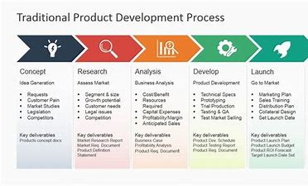Image source here

Our product audience
Our products will apply to everyone any age, gender, look, religion etc.
We aim for everyone to enjoy our furniture and to be happy to purchase it even if it came from recycled ocean plastic. For our product to succeed we our audience to review our process.

How these products such be priced?
We plan to price our products to an acceptable range. As a company we want our product price to be fair as nowadays money is not easy to save up as a firm, we do not our customers to waste money but buying our products will not be a waste. Our financial team will generate a well-designed price.

Market analysis and trends
TAKE MAKE DISPOSE

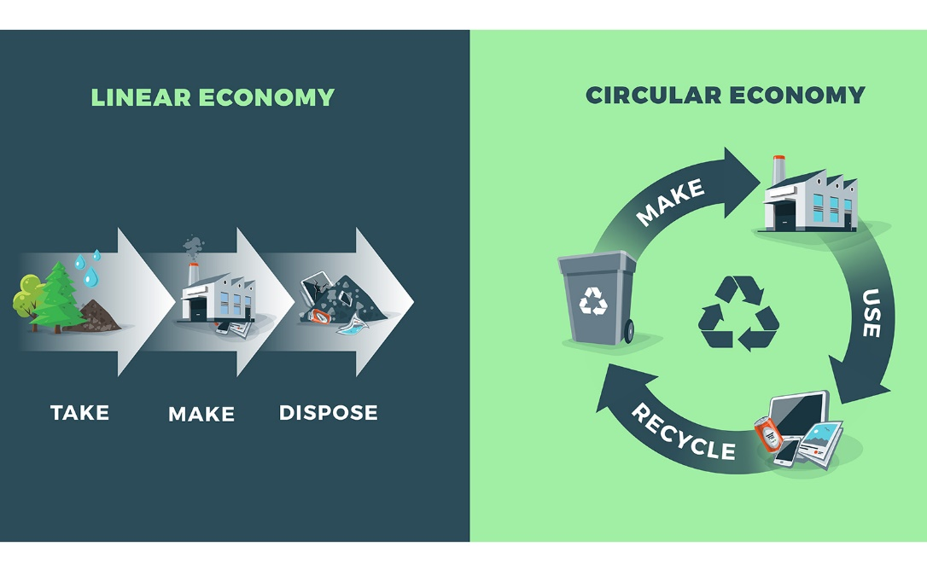
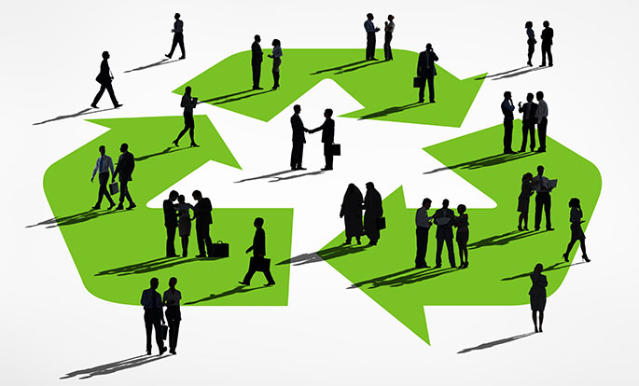
As we see the strong demand for recycled plastics is constantly growing. More and more small companies appear on the market, For the business to be successful, the owner must know the market. to learn the market, you must analyze it, a process that takes time and effort.
Analyzing the market is a way to gather facts, about potential customers, and to determine the demand, for our product.
Traditional buying patterns in this industry are based on quality, price, the reputation of the manufacturer, freight costs, delivery times, and proximity to markets.

Marketing Plan The Company has chosen to focus on the production of plastic packaging materials from recycled post-consumer beverage bottles.
DO MARKET RESEARCH Starting from your business idea you must now learn more about your customers and competitors through market research. From experience and from developing your business idea you know quite a lot about your market. But the more you know the better it is so you probably need to find out more from other sources. Here are some examples of how you can find out more about your customers and competitors:
Talk to potential customers, ask them, for example:
- What products or services they want to buy
- What quality they expect from those products or services
- What they think about your competitors
Study your competitors’ businesses. Find out
- What type of products or services they provide
- What prices they charge

Advantages
- We are a company that uses recycled materials of several types
- We are a non-governmental environmental organization working to end plastic pollution.
- We give both private individuals and businesses access to high-quality, stylish, sustainable furniture while catering to current trends
Orion Eco Furniture's truly unique selling proposition is that we combine all of these efforts into one commercial, sustainable, viable social enterprise.

Audiences
- Householders
- External groups – Community, media, and other local groups
- Internal groups – senior officers, elected members, and local government staff
- Collaborates

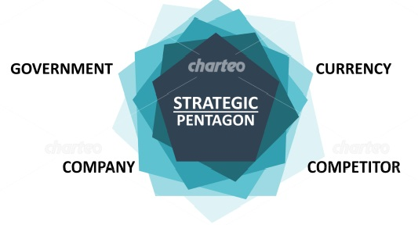

Marketing Strategy
- To disrupt the market and tap into the demand that exists for high-quality furniture and lifestyle commodities, increasing sales and profit as much as possible
- Raise awareness as much as possible of the issues at hand in terms of deforestation and the
- damage plastic in the environment. Producing furniture and products that are environmentally
- friendly and ultimately lower in cost (plastic lasts longer than wood)
- Large-scale UK and International companies that we can partner with to distribute our products.

Marketing Objectives
- To present Orion Eco Furniture as a reliable, high-quality producer of stylish furniture, outdoor and indoor products.
- To attract the attention of large corporates, tourism industry, and government in order to ensure that they improve their choices as far as furnishings go.
It is important to reinvent how people, companies, government build and furnish their homes, offices, hospital (stadiums, airports, and more), by providing access to environmentally friendly, high-quality, stylish products and promote a circular economy.
The aim of Orion Eco Furniture is to close the loop between production and waste.
Institutions that can help us develop our business
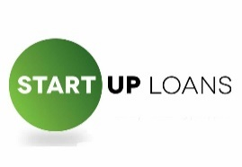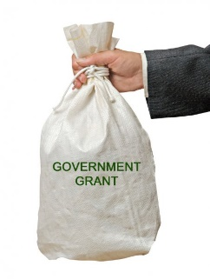

Sales & Operations

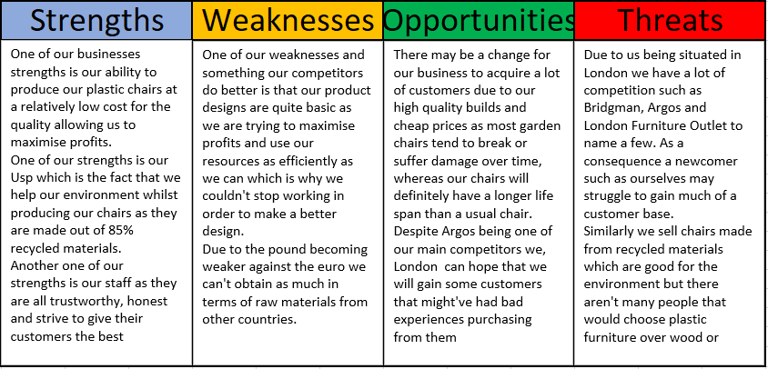

SWOT Analysis Explanation
- We are going to produce furniture using ocean plastics, which will reduce our carbon footprint, we will have high quality builds, competitive prices and our manufacturing costs will be low…. these are some of our STRENGTHS STRENFS
- At the same time, we have our WEAKNESSES to focus on, as we are a new, small company with a low capital investment as well as a low marketing budget. We also are in lack of influencers because of our weak marketing which has a negative impact on our sales.
- So, in the first 3 years we don`t expect to have much profit and even if we do, we are going to invest all of it into our designs and our production line which might give us an opportunity of earning up to £3.6 million after our third year.
- One of the risks starting our business in 2021 is the fact that a lot of people have been working from home and might’ve already purchased garden furniture during the lockdown as most people couldn’t and didn’t go out. Similarly, some of the others threats FRETS are that we don`t know exactly our furniture’s durability, and whether our designs are original enough to stand out from the competition.

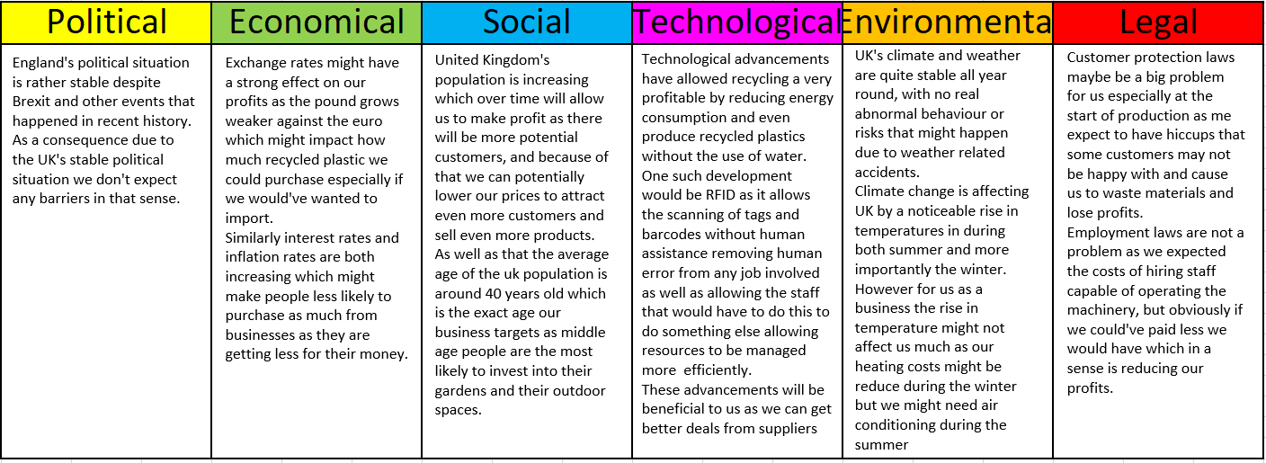

PESTEL Analysis Explanation
- We have to know if our strategy aligns with UK and global environmental regulations, as well as know new regulations that might’ve been implemented after Brexit such as limitations on import and export and such.
- Also, we have to keep in mind the fact that during and after lockdowns due to Covid most people were working from home which may cause an increase in our online customers compared to our physical store. This could also mean that having a website over a physical store might be more beneficial than having a store with no website. As well as the fact that most people even post-lockdown have realised how efficient work from home is which might make a difference in the number of customers purchasing from our website compared to a store.
- Polyurethane is a plastic that can be modelled into various different shapes and sizes. It is also a very resistant material once modelled and is a great material when used for stronger structures such as garden furniture. New technologies are continuously growing when it comes to injection moulding, with an eco-friendly painting techniques and protective coating that gives the product shine at no cost in the long run which will allow us to offer our customers the best of both worlds in terms of quality and resistance as well as a nice and interesting design.
- Additionally, the climate has been stable although we have seen a noticeable rise in temperature both during the summer and the winter. This will be of great benefit to us as people might spend more time in their gardens as it wouldn’t be cold during the winter. It goes without saying that the more people are out in their garden the more people will need furniture and possibly we will get more customers because of it.
- Also, it`s very important the legal side of our business, we are mindful about UK`s strict safety law and penalties as far as our air pollution when producing our merchandise as well as rules regarding customer conduct and employee’s rights such as making workers redundant if we need to fire staff and always treating workers fairly and equally.

Operations and Costs
- Firstly, as we aim to produce chairs from mostly recycled plastics a lot of our budget will be invested in acquiring the machinery needed to remodel the recycled plastics into our preferred designs. This cost could be rather large depending on the productivity or quality. Rather than purchasing machinery it would probably be more profitable short-term to rent the equipment as
- This would most likely save money and allow us to choose the highest quality plastics whilst allowing us to keep more of our budgets in case of an unexpected costs since we wouldn't have to purchase all of the machinery at once and rather than that we could purchase machines over time, and we wouldn’t take as much of a financial hit as purchasing it all at once.
- Obviously other costs that would affect the manufacturing of our chairs would be other raw materials such as the plastic we will choose as well as rent, bills, wages and packaging to list a few. It’s rather hard finding actual figures related to the costs of our production as a lot of suppliers are open to negotiations. As well as these costs, our business would need a website to promote our business and make ourselves even easier to contact. A website brings a lot of costs whilst being created and after as you would have to worry about the design and functionality of the website.
- Together with the creation of the website a lot of maintenance costs arise from keeping the experience pleasant for the customers, as well as the price of owning a server and unexpected costs that might appear such as a flow of people accessing the server which we might not be able to provide for and finding a way to provide a good experience for everyone trying to access the website.
- As a new, small business in the garden furniture market we will spend a significant amount of our remaining budget on marketing and different methods in order for us to reach the masses and in return to gain new customers. These could range from posters to flyers and maybe even a billboard or a radio advert depending on what our budget is and our demographic as well as which method will be the most effective at reaching them. This is necessary as we need to increase the number of customers that visit our shop and this would be our best way to go about achieving that. As a result of that we may a large increase in sales which would allow us to invest more into new designs or an expansion.

Distribution and Getting Products Out
- We were planning to distribute our product through distribution chains where we would sell our furniture to wholesalers, retailers and individual buyers such as Argos, Amazon and www.officefurnitureonline.com We would sell to both individual buyers and retailers or wholesalers that might buy in bulk and we can achieve this by having our own physical store as well as a online website. Both our online and physical shop will allow both bulk purchases as well as individual or lower quantity purchases. This is because we are trying to reach as many people as fast as possible from the start. Also, by selling through these companies we might gain some customers ourselves as they would recognise or products and branding which will be huge in the fight to differentiate ourselves from our competition.

Milestone plan
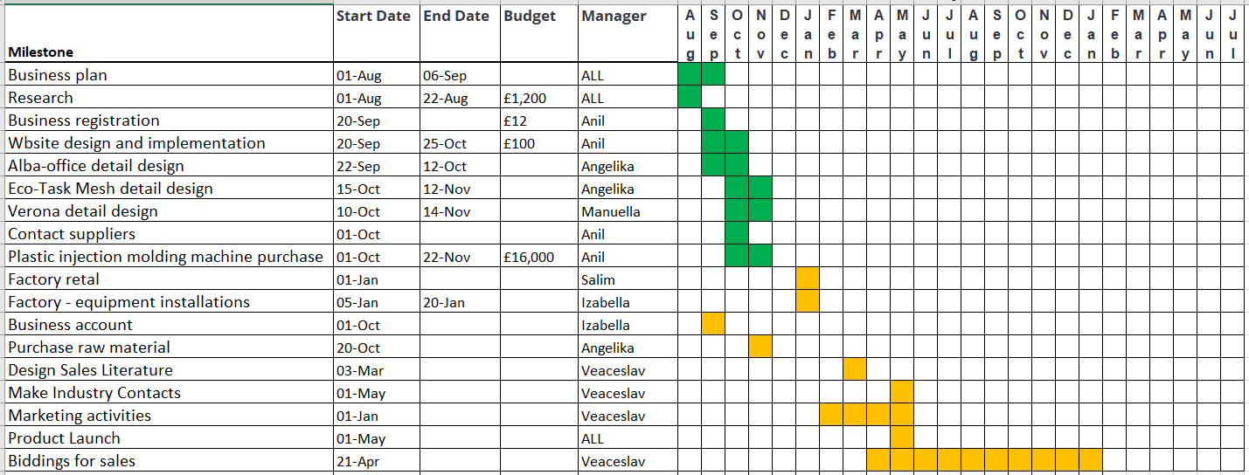

Manufacturing and Distribution

Overview
In this study I spoke about the operations and technologies that occurs during the furniture fabrications. Injection moulding is used in obtaining the moulded products. These are obtained through injecting the plastic materials, than heating into a mould, and then cooling and solidifying them.
The operation has 2 stages. Stage 1: the mould closes. The injection mould closes holding together the two valves of the injection mould, and the cycle timer begins. Stage 2: Injection. The heated plastic is injected into the mould while the displaced air is leaving along the parting line and through the vents in the injection pins.
The study is treating the distribution of the furniture. The primary distribution channels of the chairs it can be supermarkets, hyper marks, online market, shopping online through apps and websites. Multiple channel strategy: eCommerce, digital first retail.

Operations and technologies
The company is receiving the recycled plastic from another company. We have to realise the injection moulding and assembling the parts to obtain the product.
Recycled plastic materials for injection moulding
There are some situations when recycled plastic is not always “friendly” for producing the furniture.
Working with recycled materials in plastics remains a focus of protecting resources and the environment. Taking into consideration the recycled plastic benefits, applications in different sectors including it for injection moulding can determine manufacturing and product-quality challenges.
Apart from recycling-related costs, injection moulding further contends with recycled plastics differing properties and melting points, which can cause cross contamination procedural complications and variations affecting the quality of the product.
Working with the right recycled plastic injection moulding company
To know when to use and not use recycled materials is having an associate that can:
- Show you how to identify and understand the sources of recycled materials in plastics;
- Clarifying and avoiding the difficulties using certain recycled materials in plastics;
- Determine when a recycled plastic is fit for injection moulding;
- Sometimes it is indicated to mix recycled and virgin materials to offset properties lost during recycling;
- Bringing the ideas and strategies for using less material in realising more product.

We have become front runners in the market for environmentally friendly recycling services.
For a sustainable furniture the design world has been channelling its effort into material research, pushing towards a more circular way of producing furniture and these chairs are ready-to-use results of extensive experimentation.
Injection moulding is used in obtaining the moulded products, by injected plastic materials, than healing into a mould, and then cooling and solidifying them.
Mould design
Injection mould design is a process that continues with computer programs and ends with necessary improvements after injection.
Developing of the technology gave us the chance to do very easy 3D studies in programs such as SOLIDWORDS.
We initiate the production in line with the required of our customers after making the most notable design and getting their approval. The design has become easier with technology. The process is difficult if we analysed the factors such as surface, quality type of raw material, and the machine to which the moulds will be connect.
For ensuring that the product to be produced is at the desired efficiency, the mould design is tested and analysed many times in programs such as Moldflow, CAD and CAE. The necessary outcomes are obtained after the approval of the received data by the client. The design is analysed to the machine park.
Injection moulding can handle extremely complex parts along with the ability to realise a lot of virtually identical components.
The injection moulding has two stages.
- Stage 1. The mould closes. In this stage the injection mould closes holding together the two valves of the injection mould, and the cycle timer begins.
- Stage 2. Injection. The heated plastic is injected into the mould while the displaced air is leaving along the parting lime and through the vents in the injection pins.
Moulding
Plastic mould industry sector
It has growing with the expanded use of plastic. Our company which uses the high technologies, has made many progress and updates in the field of plastic mould/injection mould.
By directing the design process, to the machine park, the needed mould set for mould manufacturing is controlled. The raw material of the incoming mould set is selected in agreement to the product and product type. Quality and performance are kept at the best level in works that need high precision. In addition to the injection mould the company also produces zero split lines, hot runner mould, blow moulds, rubber press moulds, and insert moulds.
The mould designed in the CAM phase is programmed for processing on CNC machines.
This way, the processes that require dimensional precision are reviewed again. After programmed, the mould is processed on the CNC machine. Milling machines are used for slots and ejector pins, EDM plunge erosion is used for surface treatment. Before the injection mould is set up, the moving parts are analysed for the last time.
After all inspections, the mould is set up and sent for trial injection.

Plastic injection
Injection moulding is the core business of the company and the most common mechanism of mass-manufacturing plastic parts. It is a highly effective process for generating large numbers of identical parts at a acceptable cost.
Injection mould production is a complex process that cannot be undervalued. The resulting product is the main element to be used in injection moulding apparatus. Therefore at every stage of the process there is progress that need to be realise in line with the research and the data obtained from these analysis.
The operation started with the diagnosis of the samples we collected, continues in the design and injection stages.
A big part of the plastic products, are realised by injection methods. This is a method widely use in a lot of countries. During the process of injecting the melting raw need to be at a certain temperature and proportion and there is achieving the plastic product after cooling.
The company also house the plastic injection process, which is an indispensable part of our injection mould production, within our company plastic injection raw material amount, machine-temperature, runner temperature, cooling time, etc.
Injection moulding is a process that includes many elements at the same time. If it is not done by experts which sees quality and satisfaction as equivalent, has made and is continuing to make all necessary investments.
Injection mould and plastic injection products realised within our company, all processes from raw material to runner temperature, from mixing ratios to cooling time are meticulously monitored and reported. The analyses and tests are carried out completely, the production process and the solution to the encountered problem is provided as soon as possible.

Distribution
The company is trying to adopt the products to the new tendencies of the clients needs and testes. We have become front runners in the market environmentally friendly recycling services.
The transition from linear to circular economy requires significant transformations at micro and macro levels, from innovation at business model and value chain level to the introduction of supporting policy measures.
Distribution of the chairs includes in almost all of the situations: a producer, a wholesaler, a retailer, and the end one, the consumer.
The chairs retail market is decided by distribution channels:
- Large scale specialist distributors (furniture chains, franchises, buying groups);
- Independent furniture retailers;
- Non-specialist distributors (department stores, multi-stores, DIY, eCommerce);
- Others (direct sales and craftsmen).
The primary distribution channels of the chairs: supermarkets, hyper markets, online market with growing digitalisation, the shopping online through apps and websites, specially stores and e-commerce.
Multiple channel strategy: eCommerce, digital first retail.
Distribution of the chairs can occur to:
- All countries.
- Based in UK: people will purchase our products in the manner: when we get the email alert and payment confirmed we will distribute it to the houses via Argos, Amazon for the household market, office furniture online;
- We were planning to distribute our products through distribution chains where we would sell our furniture to wholesalers, retailers and individual buyers. We would sell to both individual sellers and retailers or wholesalers what might buy in bulk.

Ways to improve the furniture store marketing
We started to adopt 5 ways for improving the furniture store marketing. Marketing the furniture store is an important part of driving sales. Many retailers are intimidated by furniture marketing ideas because there are a lot of moving parts.
Furniture store advertising it wasn’t an obstacle for us when the business was a small one and now that it started to grow. We are using the 5 effective ways for improving the store marketing.
- Update the website store
Because many people make the research to the online companies before they shop we was improving the e-commerce website to be attractive, optimized and user-friendly. We used tools like augmented reality or 3D technology that are helping the customers to display the furniture online. Digital renderings give the customers the possibility to explore the products. The augmented reality can offer them the ability to see how the furniture will look in their environment.
- Create a comprehensive marketing strategy
Every good marketing strategy is dressing all the bases.
There are people that are not online yet

Digital marketing
For us the digital marketing is very important. If you’re not marketing digitally you can lose sales. For increasing online traffic we need to find seo services to bring local traffic and ppc services to increase the search fast.
The basics methods are: search engine optimisation, pay per click ads rich content, social media marketing, podcasting, videos, and more. Both types of marketing should work together to drive online and in-store sales.

- Engaging the audience where they are
It is important to identify the audience and contact them where they are. For this we need to reach out to them and not to wait for them to come to us.

Who is our audience?
It is very helpful for us to know who our audience is, what age group are them, how much money did they allocated for new furniture, what are their hobbies, and their pain points. This is helping us to develop more targeted marketing companies. We can use social media to our advantage, like one of the most powerful marketing tools. Posting the pictures on Instagram, or target the audience on Facebook are helping tools, as well. This way we can find where the people most likely to buy are, and meet them there.

- Keep your customers coming back

It is a good measure to keep the customers coming back, make them faithful to our brand. In this way we need to make them feel good about their purchases, and supported in their ideas.

- Give your sales team good training
The sales team needs adequate training for knowing how to close a deal, to advice potential customers in their choice. This way they can answer, to the potential customers questions, they can earn the tools they need to demonstrate the benefits of our products. The sales team should be able to effectively close a deal on the phone. The customers service representative should be able to troubleshoot problems and clear up customers issues in a positive manner.

Conclusions and recommendations
The study was treated the operations and technologies that are occurring in the furniture fabrication on our company. It contains the stages during the injection moulding, the mould design, injection moulding process, how to work with the right recycled plastic materials.
The study is also analysing the distribution of the furniture, importance of the online market, websites, strategies to apply for a good process, all contributing to a strong business.

Financial data
NB- everything on this section was covered by Anil Prasanna in Mohamed Salim’s absence.
Stat-up Expenses (detail)
As the table shows the key start-up expenditures and we need to raise £75,432 to start the business and operate until we launch our products. With intensified production and marketing activities we would assume that we will need at least extra £60K to get through the first year.
Please note that this does not include our salaries as we do not intend to take salaries until the business is profitable.
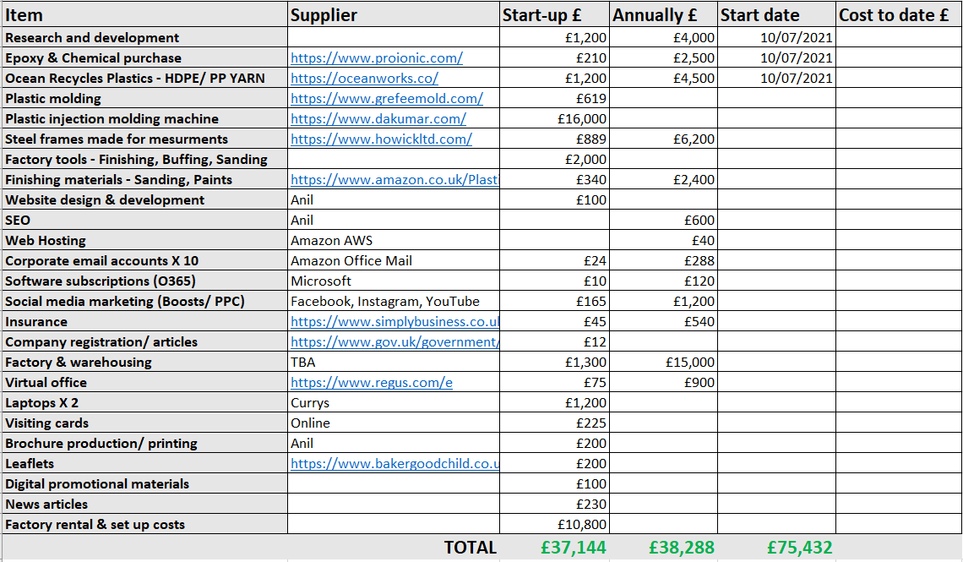

Cashflow Forecasts
This table shows our costs, expenditures and our forecasted cashflow based on estimated sales volumes as per our initial research.

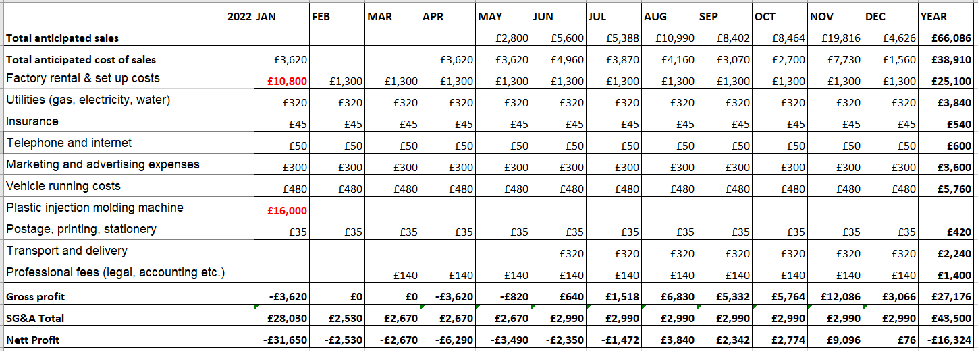
Please see more details on these figures attached in the appendix section.

References
Page 01 - 09
- Furniture Manufacturer Business Plan (online) https://www.bplans.com/furniture-manufacturer-business-plan/ [Accessed 20 August 2021]
Page 10 – 16
- BiteSize What is a product? - BBC Bitesize (online) https://www.bbc.co.uk/bitesize/guides/zjkd2hv/revision/1 [Accessed 20 August 2021]
- Oceanworks (online) https://oceanworks.co/ [Accessed 20 August 2021]
- iPoint Sustainable production – How to achieve it? (online) here [Accessed 13 August 2021]
Page 24 – 30
- https://www. LinkedIn.com
- Plunkett analytics reports (2027), Home residential & institutional furniture manufacturing industry (US), Plunket research LTD
- Mound, A., Schlick, M. and Tinkler, P. (2017), Certificate in higher education. Skills for the workplace student yearbook, Sage publications
- Morgan, P. (2016). The business student’s guide to study and employability. Sage publications
- ACAS. (2016), Help and advice for employers and employees, (online), available at: https://www.acas.org
- Kotler, P., Armstrong, G., Saunders, J., Saunders, P.J., and Wong, P.V. (2001), Principles of marketing: European edition, 3rd edn., Harlow, England: Financial Times prentice hall
- Marsh, R. (2012), Skills for employability, part one, Preemployment, Christal publication

Appendix
- Business Plan Presentation
- Milestone Plan
- Financial Data Sheet

