STUDENT NAME: REGINA BEMPAH OWUSU
STUDENT ID: 2427848
MODULE CODE: BMHP5016
MODULE TITTLE: PRINCIPLES OF HEALTH AND SOCIAL CARE PRACTICE
LECTURER’S NAME Dr FARAH WIITA
THE SOCIAL MODEL OF DISABILITY AND ITS ROLE IN PERSONCENTRED HEALTH AND SOCIAL CARE

The Social Model of Disability and Its Role in Person-centered Health and Social Care- Health and Social Care
Introduction
The social model of disability is a key theoretical framework that informs modern approaches to person-centred practice within health and social care. It draws a clear distinction between impairment, a physical, cognitive, or sensory condition and disability, which it defines as the product of environmental, structural, and attitudinal barriers that limit people’s participation in everyday life (Oliver, 1990; Union of the Physically Impaired Against Segregation, 1976). This represents a fundamental contrast to the medical model, which locates disability within the individual body and emphasises diagnosis, treatment, and remediation (Shakespeare, 2013).
The value of the social model lies in its reframing of disability as an issue rooted in inequality rather than personal deficiency. By placing responsibility on society to remove obstacles and promote inclusion, it aligns closely with core principles of person-centred care, including autonomy, respect, and empowerment (Goodley, 2017; NHS England, 2019). Despite its influence, the model has also faced criticism for not fully capturing the complex interplay between impairment and lived experience, and for the practical challenges associated with embedding it in contemporary health and social care systems (Shakespeare, 2013; Thomas, 2007).
This essay explores how the social model emerged and evolved, examines its major criticisms and subsequent developments, and evaluates how effectively it has been applied within health and social care policy and practice. It also considers areas of tension and limitation and offers recommendations to strengthen its implementation, concluding with a reflection on its continued relevance today.
The Development of the Social Model of Disability
The social model of disability emerged during the 1970s as part of a wider movement led by disabled activists who sought to challenge dominant assumptions about disability. In the United Kingdom, the Union of the Physically Impaired Against Segregation (UPIAS, 1976) played a crucial role by rejecting the prevailing medical view, which positioned disability as an inevitable consequence of bodily or cognitive impairment. Instead, UPIAS argued that disability was created by socially constructed barriers that restricted participation. This represented a profound conceptual shift, as it reframed disability not as an individual tragedy but as a form of social exclusion produced by inaccessible environments, discriminatory practices, and exclusionary attitudes (Oliver, 1990).
Mike Oliver further developed this perspective and introduced the term “social model of disability” into academic and policy discussions. In his early work (1990), he conceptualised disability as a type of structural oppression, drawing parallels with other forms of social inequality such as racism or sexism. Oliver’s later writings (1996) expanded on this by examining how institutional arrangements such as segregated education, inaccessible housing, and inflexible workplace practices systematically disadvantage disabled people. His contributions helped establish disability studies as a distinct academic field and provided intellectual foundations for national and international disability rights campaigns (Goodley, 2017).
The influence of the social model extends beyond academic discourse to global policy frameworks. The United Nations Convention on the Rights of Persons with Disabilities (CRPD) (United Nations, 2006) embodies many core principles of the model. It defines disability as the result of interactions between individuals with impairments and various barriers that hinder full and effective participation in society. This rights-based approach positions governments and institutions as responsible for removing obstacles and promoting equality (Shakespeare, 2013). More recent developments within disability studies have incorporated intersectional perspectives, recognising that disability intersects with other axes of marginalisation such as gender, ethnicity, socio-economic status, and cultural context (Goodley, 2017; Thomas, 2007).
Despite its significant influence, the social model has faced numerous critiques. One of the most persistent challenges concerns its treatment of impairment. Shakespeare (2013) argues that the model’s strict division between impairment and disability is overly reductionist, as the realities of pain, fatigue, and cognitive limitations are central to many disabled people’s lives and cannot be entirely resolved by removing social barriers. This is particularly evident in health and social care settings, where medical support remains essential for many individuals.
Another key critique comes from Thomas (2007), who introduced the concept of psycho-emotional disablism to highlight the internal and emotional consequences of disability. She argues that experiences such as stigma, internalised oppression, and diminished self-confidence are important aspects of disabled people’s lives that the social model does not fully address due to its emphasis on external barriers.
Additionally, scholars have criticised the social model for its tendency towards structural determinism. By focusing almost exclusively on social barriers, it may underplay the complex interplay between biological, psychological, and social factors (Engel, 1977; Shakespeare, 2013). This critique has contributed to the development of alternative frameworks, including the biopsychosocial model, which aims to offer a more holistic understanding.
Lastly, the model has been questioned for its uneven applicability across impairment groups. While it provides a strong framework for understanding physical disability, critics argue that it does not fully address the experiences of people with mental health conditions, learning disabilities, or fluctuating impairments (Goodley, 2017). Supporters maintain, however, that the social model’s primary strength lies in its political orientation and its capacity to expose structural inequality (Oliver, 1996). Although not a complete explanatory framework, it remains a vital tool for promoting social justice and guiding inclusive practice.
Application of the Social Model in Health and Social Care Policy and Practice
The social model of disability has played a transformative role in shaping contemporary health and social care frameworks, influencing both legislation and everyday practice. It has contributed to a shift away from seeing disability purely through a clinical lens toward recognising the societal and environmental factors that restrict participation. In the United Kingdom, this influence is evident in key policies such as the Equality Act 2010, which places a legal duty on organisations to ensure disabled people are not disadvantaged. The requirement for “reasonable adjustments” reflects the principle that disability results from societal barriers, and therefore these barriers must be removed or reduced to achieve equal access (HM Government, 2010; Goodley, 2017). Through this legislation, the ideals of the social model are embedded into statutory expectations, making inclusion a legal as well as ethical obligation.
In practice, the application of the social model encourages health and social care professionals to adopt holistic, personcentred approaches that go beyond addressing impairment. Instead, practitioners are expected to consider how social, physical, economic, and attitudinal factors shape an individual's wellbeing and opportunities (NHS England, 2019). For instance, ensuring that appointment letters are provided in accessible formats, offering sign language interpreters, or designing clinical spaces that accommodate mobility devices are all practical applications of the model’s principles (Shakespeare, 2013). Likewise, the social model encourages practitioners to challenge stereotypes and discriminatory attitudes that may influence clinical decision-making or limit the expectations placed on disabled individuals.--making or limit the expectations placed on disabled individuals.
One of the most significant areas where the social model has shaped policy is in the development of independent living and personalisation initiatives. Policies such as personal budgets and direct payments empower individuals by enabling them to take greater control over their support arrangements (Ferguson, 2007). This aligns strongly with person-centred care by promoting autonomy, dignity, and choice. For many disabled people, the ability to hire personal assistants, choose service providers, or tailor support to their lifestyle represents a move toward meaningful independence rather than dependence on institutional or standardised services.
However, the adoption of personalisation has generated debate. While these mechanisms reflect social model principles by redistributing power to service users, critics argue that they also risk individualising responsibility for care. In contexts marked by austerity, reduced social care funding, and rising demand, personal budgets may mask deeper structural inequalities rather than eliminate them (Ferguson, 2007; Goodley, 2017). For example, individuals may be given choice in theory but find that options are limited by cost, service availability, or local authority cuts. This illustrates a key challenge: although the social model informs policy rhetoric, structural conditions frequently restrict its implementation.
Another barrier to fully embedding the social model is the continued dominance of the medical model within health systems. Despite shifts in policy language, many clinical environments prioritise diagnosis, treatment, and risk management, often at the expense of social and environmental considerations (Shakespeare, 2013; Thomas, 2007). This tension becomes particularly visible in multidisciplinary settings, where professionals may struggle to balance biomedical priorities with enabling, person-centred approaches. For instance, a physiotherapist may prioritise functional improvement, while a social worker focuses on environmental adaptations demonstrating the diverging assumptions that persist within the system.
Resource constraints further limit the practical application of the social model. Achieving accessibility, whether through modifying environments, investing in staff training, or updating communication systems, requires sustained funding. In underresourced services, these changes may be deprioritised, resulting in inconsistent or partial implementation (Goodley, 2017). The consequence is that disabled individuals may continue to encounter barriers even when the policy framework supports inclusion.
Additionally, while the social model has provided a powerful critique of societal barriers, it has been criticised for not fully addressing broader socio-economic inequalities. Disabled people are disproportionately affected by poverty, unemployment, and inadequate housing, issues that health and social care services alone cannot remedy (Thomas, 2007). These challenges suggest that while the social model provides a strong foundation for policy, its practical effectiveness depends on wider social reforms.
At the same time, its conceptual clarity and political focus remain valuable. The social model shifts attention away from seeing disability as a personal deficit and instead frames it as a collective responsibility. This perspective continues to drive advocacy efforts, encourage inclusive design, and challenge societal assumptions about what disabled people can and should be able to do.
Recommendations for Policy and Practice
To enhance the effectiveness of the social model within contemporary health and social care, several key recommendations can be proposed.
First, policy and practice would benefit from adopting a more integrated framework that draws on the strengths of both the social model and an understanding of impairment. While the social model rightly highlights the role of environmental and attitudinal barriers, it is also important to recognise that many individuals continue to rely on medical, therapeutic, and rehabilitative support (Engel, 1977; Shakespeare, 2013). A balanced approach often described as a biopsychosocial perspective would ensure that disability is not reduced to either purely medical or purely social factors, but understood as an interaction between the two.
Second, improving accessibility across health and social care settings should remain a central priority. This includes investing in inclusive physical environments, ensuring access to assistive technologies, and providing appropriate communication support for people with sensory, cognitive, or linguistic needs (Goodley, 2017). Such measures not only promote independence but also demonstrate organisational commitment to removing structural barriers.
Third, ongoing education and professional development are essential. Staff training should move beyond basic awareness and foster a critical understanding of disability, power, and inequality. This would equip practitioners with the knowledge and confidence to challenge discriminatory practices and adopt inclusive approaches in their everyday work (Thomas, 2007; NHS England, 2019).
Fourth, embedding co-production within service design and delivery is crucial. Involving disabled people as equal partners in decision-making processes ensures that services reflect lived experience and respond to real needs rather than organisational assumptions (Ferguson, 2007). Co-production strengthens accountability and enhances the relevance and quality of support.
Finally, policy reform must consider the broader social determinants that shape disabled people’s lives. Issues such as inadequate housing, unemployment, poverty, and social exclusion continue to undermine well-being and cannot be resolved through health and social care alone (Goodley, 2017; Thomas, 2007). Addressing these wider structural inequalities is essential to realising the transformative potential of the social model.

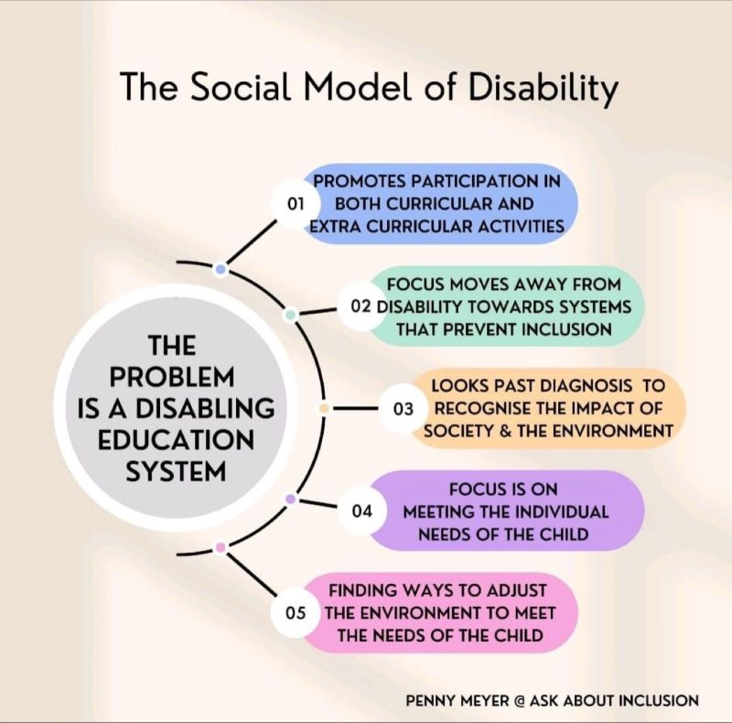

Conclusion
The social model of disability has been central in advancing person-centered approaches within health and social care, largely by shifting attention toward the societal barriers that restrict participation and by advocating for inclusive environments. Its influence on policy and practice has been substantial; however, its limitations are well documented. The model’s limited engagement with the lived realities of impairment, alongside the practical challenges of embedding its principles within complex healthcare systems, demonstrates the need for a more nuanced and integrated framework.- approaches within health and social care, largely by shifting attention toward the societal barriers that restrict participation and by advocating for inclusive environments. Its influence on policy and practice has been substantial, however, its limitations are well documented. The model’s limited engagement with the lived realities of impairment, alongside the practical challenges of embedding its principles within complex healthcare systems, demonstrates the need for a more nuanced and integrated framework.
Despite these critiques, the social model continues to offer a vital lens through which disability can be understood as a matter of social justice rather than individual deficit. By combining its strengths with complementary perspectives and addressing the wider structural inequalities that shape disabled people’s lives, health and social care services can more effectively uphold the values of autonomy, dignity, and empowerment that underpin person-centred care

References
Engel, G.L., 1977. The need for a new medical model: A challenge for biomedicine. Science, 196(4286), pp.129–136.
Ferguson, I., 2007. Increasing user choice or privatizing risk? The antinomies of personalization. British Journal of Social Work, 37(3), pp.387–403.
Goodley, D., 2017. Disability studies: An interdisciplinary introduction. 2nd ed. London: Sage.
HM Government, 2010. Equality Act 2010. London: The Stationery Office.
NHS England, 2019. The NHS Long Term Plan. London: NHS England.
Oliver, M., 1990. The politics of disablement. London: Macmillan.
Oliver, M., 1996. Understanding disability: From theory to practice. London: Macmillan.
Shakespeare, T., 2013. Disability rights and wrongs revisited. 2nd ed. London: Routledge.
Thomas, C., 2007. Sociologies of disability and illness. Basingstoke: Palgrave Macmillan.
Union of the Physically Impaired Against Segregation (UPIAS), 1976. Fundamental principles of disability. London: UPIAS.
United Nations, 2006. Convention on the Rights of Persons with Disabilities. New York: United Nations.

