Intro
Methodology
While researching material for this dissertation, the author engaged in four different strategies:
- Library research and documentary sources
- Fieldwork with site visits to conduct first-hand research
- Government and legislative data
- In depth case study analysis

Following on from the recent Covid-19 pandemic, this has meant that a lot of information is now easily accessible online. However, I was still able to conduct my site visits as required and gain valuable first-hand information to coincide with my online research.

- Library research and documentary sources
At the beginning of the period of study, a desktop research was conducted into the ‘greenest’ cities in the world, which revealed that in order to futureproof a city, it simply must become more sustainable. Through the literature research, the researcher used historical books on the topic of sustainability in order to gain a wider understanding of the topic to utilise when analysing the case studies later on in the dissertation. There were also several government-published documents that were analysed by the researcher in order to gain a sense of how the two comparative cities have arrived at their current positions when it comes to sustainability and discover what has already been implemented in regards to sustainability.

- Site visits to conduct first-hand research
The researcher of this dissertation carried out constant site visits throughout the research process to various locations throughout Swansea. Ranging from visiting the location of one of the case studies analysed later in the dissertation, to visiting local transportation hubs and gaining first-hand experience of the sustainable transport options throughout Swansea. The researcher also conducted a visit to the Swansea Museum and the National Waterfront Museum in order to gain a wider understanding of how the transport of Swansea has developed throughout history.

- Government and legislative data
Both the Swansea and Copenhagen Governments have produced a number of significant reports that have been read and referred to as part of the literature review for this dissertation. It has also been useful to collect and analyse comparative data from other notable bodies such as the Welsh Government and the Danish Government as this has helped to provide a wider knowledge of the position of the two cities when compared to on a national scale.

- In depth case study analysis
The author of this dissertation carried out an in depth case study analysis into two key pieces of sustainable architecture from both cities. There were also case studies already carried out on both buildings by various architects and architectural critics around the world, these documents helped to gain a wider understanding of the two buildings and how they are viewed by others. Some of these case studies proved to be key pieces of literature that were referred to throughout this dissertation and helped the author gain a wider knowledge on the buildings in question.

Aims & Objectives
Dissertation question:
The regeneration of Swansea: What can be learnt from the greening of Copenhagen?

Aim
To analyse the greening of Copenhagen and understand how the regeneration of Swansea can learn from this.

Specific Objectives
- To understand how Copenhagen has become a green city.
- To understand what is currently being done in Swansea to become a green city.
- To examine and analyse key sustainable architectural projects in both cities.
- To consider if any lessons can be learnt from Copenhagen and utilised in the regeneration of Swansea to improve its sustainable position.

Key Words
Regeneration – The investment of public and/or private funds to improve/enhance an urban landscape socially, economically and environmentally (Schurig, 2018).
Green City – A city which puts special consideration on energy production/consumption, green space, sustainable transport and renewable energy generation (Anderson, 2022).
Carbon Neutral – The making of or resulting in no net release of carbon dioxide into the atmosphere (Wollerton, 2021).
Carbon Footprint – A measure of how much carbon dioxide is released into the atmosphere as a result of the activities of a particular organisation, city or community (Selin, 2023).

Introduction to Case Studies
The author has chosen Swansea and Copenhagen as the two main focal points of this dissertation, along with two key examples of sustainable architecture within the two cities; Copenhill and The Active Classroom and Office. Swansea was chosen due to being the hometown of the author, and therefore being easily accessible for site visits and first-hand research. Swansea has a population of approximately 314,000 which is on the upwards trend, increasing around 0.64% per year (Macro Trends, 2023). With the population on the rise and the regeneration of Swansea in the near future, the author will be exploring what can be done to make Swansea a green city. Copenhagen was chosen by the author as the initial investigation into exemplar green cities revealed that Copenhagen is seen as one of the greenest cities in the world. It has a population of approximately 644,000 which similarly to Swansea, is on the upwards trend, increasing at a faster rate of around 0.97% per year (Statista Research Department, 2022). Copenhagen is quite obviously a larger city than Swansea, with just over double the population, however due to its progress towards becoming a carbon neutral city, the author has chosen to examine Copenhagen and analyse what factors have contributed to its success.

Literature Review
Within the literature review, the author has used significant reports during the research of the dissertation such as the Danish Energy Agency’s 2021 Energy Statistics Report, the European Environmental Agency’s Renewable Energy in Europe 2017 Report, the Welsh Government’s Energy Generation in Wales 2020 Report and Swansea Council’s Climate Change and Nature Strategy 2022 Report. Significant government legislation such as the Copenhagen 2025 Climate Plan (2012) and the Swansea Bay City Deal (2017) were thoroughly examined by the author of this dissertation when analysing both cities comparatively.
Furthermore, significant publications which the author referred to within the literature review include various architectural publications such as the Architects Journal, Dezeen, RIBA Journal and Archdaily. Similarly, news companies such as Wales Online and The Guardian were also used to compare the opinions of the public with those in the architectural publications. In addition to this, a thorough examination of Joanna Clarke’s in depth case studies; Active Classroom Case Study (2020) and Active Office Case Study (2020) were analysed to supplement the findings from various web pages. All of the above was then further supplemented with various research visits to the Active Classroom and Office, as well as the Swansea Museum and the National Waterfront Museum by the author.

Chapter 1: Why Copenhagen?
There are various reasons why Copenhagen has been chosen as a comparative model to Swansea which this chapter will explore. According to ‘C40 Cities Climate Leadership Group’ Copenhagen has earned itself the title of the ‘Greenest city in the world’ over the past fifty years or so (Co, 2022) and this was not achieved overnight, dating all the way back to 1973, which was the origin of Copenhagen’s push to be in a position that earned them this title today (Rudiger, 2014). Copenhagen has earned numerous prestigious awards and titles both on a continental and world level, ranging from the ‘European Green Capital’ back in 2014 (European Commission, 2012) to winning the ‘International Climate Prize’ in 2017 awarded at the C40 Cities Awards in Chicago (Heiburg, 2017) and many more. These awards are not just handed out to any old city that installs a few solar panels on a couple of their buildings and claims to be a ‘sustainable city’, they have to be earned with huge significant steps in the right direction to becoming ‘carbon neutral’ or a ‘sustainable city’. For example, to be awarded the ‘International Climate Prize’ by the C40 Cities Commission in 2017, Copenhagen implemented an impressive energy surveillance plan across a two-year span starting in 2015. A mere 100 pilot buildings from 2015 was converted to a massive 550 (450% increase) municipal buildings in 2017 with the purpose of monitoring and optimising energy consumption taking steps towards Copenhagen’s aim of reducing energy and water consumption in public buildings by 25% by 2025 (Heiburg, 2017). A comprehensive list of all the prestigious awards and titles can be found in the footnotes. The energy strategy implemented by Copenhagen that earned them the aforementioned award of the ‘International Climate Prize’ mentions the year 2025, therefore leads one to question the significance of this date and why Copenhagen have chosen this date as a target.
According to the CNCA Copenhagen aims to be the first Carbon Neutral Capital by 2025 despite the population being expected to grow by around 20% in the next decade (CNCA, 2020). In order to achieve this goal, Copenhagen adopted the CPH 2025 Climate Plan back in 2012 which, in short, has four main pillars to adhere to; Energy Consumption, Energy Production, Mobility and City Administration Initiatives (CNCA, 2017). Energy Consumption within Copenhagen has dropped considerably since adopting the CPH 2025 Climate Plan in 2012 as shown in the graph below (fig 1). It can be seen that the energy consumption dropped from an index of 100 in 2012, down to around 90 in 2021 demonstrating a general downwards trend in the overall consumption. The slight spike in 2021 was the product of the global Covid-19 pandemic, which if taken into consideration, is a major factor in energy usage within the homes of the public, therefore to keep this as minimal as possible is an achievement in itself (Danish Energy Agency, 2020). Energy consumption is a major factor in becoming a ‘green city’ and ‘carbon neutral’ as it is estimated that around two thirds of the global greenhouse gas emissions are linked to the burning of fossil fuels for energy used for heating, electricity, transport and industry (European Environmental Agency, 2017). In 2012, when Copenhagen adopted the CPH 2025 Climate Plan, it was estimated that around 43% of total energy consumption was attributed to heating, about 29% to electricity and 28% transport (see fig 2) (Mathiesan et al., 2015). In response to this, Copenhagen developed a large scale district heating network that covers roughly 98% of the City, which in turn, acts as damage limitations for the 43% of energy consumption that the heating accounts for in Copenhagen (see fig 3). The district heating system contributes significantly to the EU and national energy targets through a reduction in carbon emissions and a greater increase in renewable energy usage, all of which are massive factors that the Danish Government considered when introducing the system to the capital (Interreg, 2020). Not only is this an environmental benefit to Copenhagen, but it also helps boosts the city’s economic profile, creating more ‘green jobs’ within the city as well as increasing the energy ratings of any new build developments within the City (Interreg, 2020).
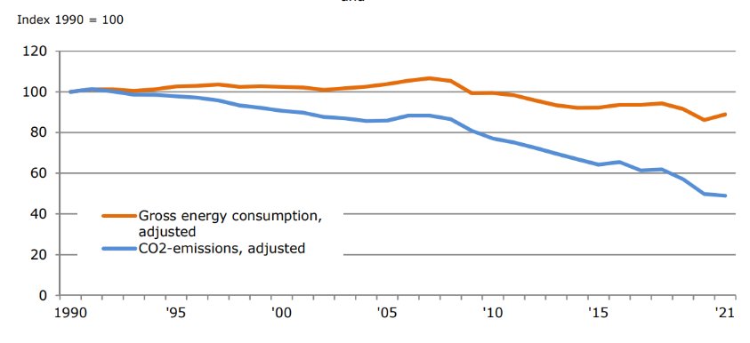
Figure X: Showing Energy Consumption in Copenhagen compared to CO2 emissions (Credit: Danish Energy Agency)

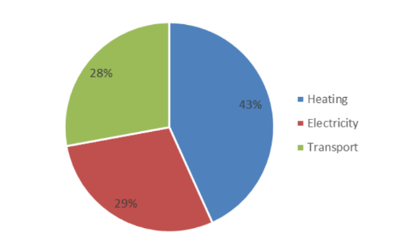
Figure XX: Graph Showing the estimated energy split of Copenhagen in 2012
(Credit: European Environmental Agency)

As well as the energy consumption, Copenhagen has attempted to develop its energy production systems over recent years to further decrease its carbon footprint with the use of combined heat and power (CHP) plants and renewable energy sources. Firstly, Copenhagen has put an enormous focus on renewable energy production by implementing strategies such as wind farming and biomass energy production throughout the city. Combined, these two methods of energy production account for around 67% of Copenhagen’s electricity, roughly split up of 46% from wind farms and 11% from the biomass farming (Braff, 2023).
One of Denmark’s most profound wind farms powering Copenhagen is known as ‘Anholt wind farm’ (fig 4) consisting of around 111 turbines all contributing to the 46% of electricity produced for Copenhagen. The wind energy produced by Anholt wind farm alone is enough carbon-free power to cover the annual consumption of up to 400,000 homes, totalling to around 4% of Denmark’s total power consumption as a nation (Orsted CDN, 2016).

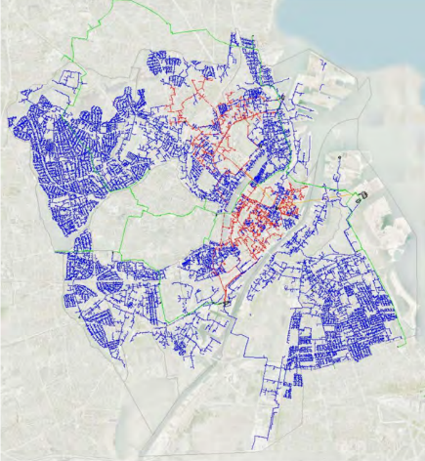
Figure XXX: Map of Copenhagen’s District Heating Network Coverage
(Credit: Elsman, 2009)

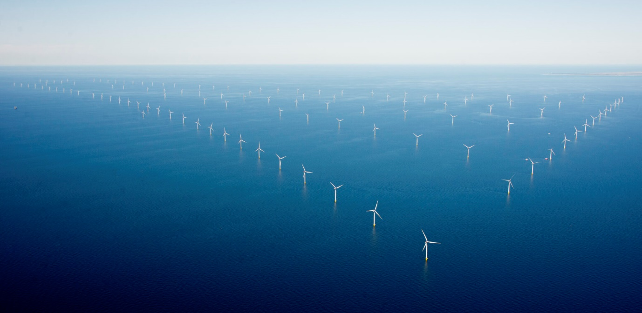
Figure XXX: Image of Anholt Wind Farm
(Credit: Orsetd, 2022)

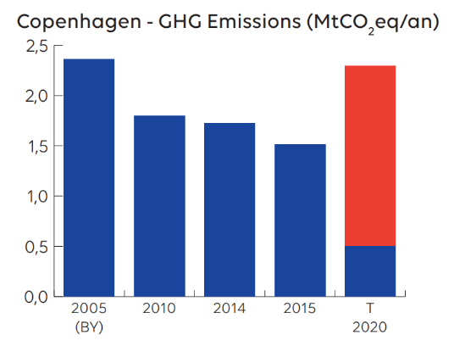
Figure XXX: Graph showing Copenhagen’s Green House Gas Emissions from 2005-2020
(C40 Cities, 2022)
Not only does Copenhagen make use of wind farming to produce energy, but it also places emphasis on biomass farming, and trying to replace fossil fuels with biomass fuels where possible. As previously mentioned, Copenhagen is home to “The world’s largest district heating network” (C40 Cities, 2022) covering roughly 98% of the City (Interreg, 2020). This heating system is currently on a 15-year decarbonisation plan put in place by ‘The Greater Copenhagen Utility’ or ‘HOFOR’ to make the system completely carbon neutral by 2025, transitioning from using fossil fuels such as gas, oil and coal to being powered solely with sustainable biomass energy and is hugely reliant on one of this paper’s case studies; Copenhill (Johansen, 2022). The heating system currently utilizes CHP, which is a highly efficient method of both heat and electricity from a single fuel source, where any waste heat from the electricity production is then fed back into the district heating network to heat water for the city, reducing the system’s energy waste (Bundgaard & Tatum, 2020). According to Orsted, Biomass energy use as a whole is a key factor in Copenhagen’s mission of becoming ‘Carbon Neutral’ by 2025 as not only is it a renewable method of energy production, but it is also an efficient technique that allows for the re-use of any waste energy production from producing electricity for the city, putting this to use in other sectors for the city such as the heating of water, reducing the demand for more fuel.
As previously mentioned, Copenhagen has an aim to become carbon neutral by 2025 according to the CNCA, and the aforementioned energy strategies of the city are by-products of a very innovative and pioneering approach to legislation. Obviously, the main driver of the sustainability legislation would be the previously mentioned CPH 2025 Climate Plan, and is being delivered in three main phases, the first of which came to an end in 2016, second phase dating from 2017-2020 and the final being 2021-2025 (Association Climate Chance, 2018). The first phase introduced in 2013 had the main objective of converting the city’s energy production to be as sustainable as possible and in turn beginning to lower Copenhagen’s ‘Green House Gas’ (GHG) emissions. At the start of 2012, Copenhagen had annual GHG emissions of around 1.9 million tonnes of CO2, which was already a considerable decrease from the previous 2.4 million tonnes in 2005 (fig 5).
This initial decrease was mainly down to the legislation put in place after the 2009 UN Climate Change Conference that was actually hosted in Copenhagen, which in short, set a target of a 20% reduction in the baseline emissions from 2005 which was actually met in 2011 ahead of schedule (WWF, 2014). Following the conference in 2009, there were three main policies out of the five implemented worldwide that all played their part in Copenhagen’s emissions reduction. The 2010 Cancun Agreements was the first main policy that was introduced, which in short, set out a framework for addressing climate change and established a goal of limiting global warming to 2 degrees Celsius. This framework consisted of a mitigation pledge, a new Green Climate Fund for developing countries and a system to help verify a countries’ actions in regards to limiting global warming (C2ES, 2017). The second policy that played its part in Copenhagen’s initiative to lower GHG was the Paris agreement of 2015, which essentially brought together 195 countries to commit to reducing greenhouse gas emissions with a clear framework for monitoring and reporting the progress (UNFCCC,2021). The third and final policy that played its part in Copenhagen lowering the GHG emissions was the ‘Renewable energy incentive scheme’ implemented as a result of the conference in Copenhagen. This policy essentially encouraged countries worldwide, including Denmark, to implement subsidies and other incentives for the development of renewable energy sources such as solar and wind power. Copenhagen benefitted first hand from these policies as it opened up an array of funding in the renewable energy sector that played a key part in developing the technologies that Copenhagen make use of today (Bundgaard & Lexner, 2011).
The second and third phases of the CPH 2025 Climate Plan share similar initiatives with each other, focusing on the aforementioned pillars of; Energy Consumption, Energy Production, Mobility and City Administration Initiatives. According to the C40 Cities’ knowledge hub, around 80% of the reduction in Copenhagen’s Greenhouse Gases will come from switching over to sustainable fuels where possible, replacing coal powered plants with biomass-fired power plants and utilising the wind farms such as Anholt Farm as mentioned above. This is huge when considering the original first phase of the climate plan was to reduce greenhouse gases, as the initial stepping stones had been set in the years previous to really gain traction in phases two and three to reduce the greenhouse gases as much as possible. Copenhagen has also implemented a bigger focus on ‘retro-fitting’ as many of the existing buildings within the city as needed in order to help reduce the energy consumption of the city, building by building (City of Copenhagen, 2014). Utilising this architectural technique when developing the city for the future would prove crucial in lowering the energy consumption of the capital as it allows Copenhagen to maintain the architectural prowess of the historic buildings, while utilising modern energy efficient technologies such as triple glazing or modern insulation methods. According to ‘The Copenhagen Adaptation Plan’, Copenhagen aims to reduce the cities electricity usage by 10% and heating consumption by 20% by utilising these modern day technologies in the newly ‘retro-fitted’ buildings. In addition to the retro-fit approach, advanced technology is also being employed where buildings will be fitted with a ‘visual monitor’ that will be able to track the overall water and energy usage of the buildings and able to indicate how much heat is actually lost from the building (City of Copenhagen, 2014).
The Danish and local Copenhagen government have also brought in various city administrative and legal initiatives to assist in Copenhagen’s carbon neutrality charge and these initiatives have played a key part in the ‘Greening’ of Copenhagen today. According to ‘The European Green Capital’ section 3: Green urban areas, it is now municipal policy that all residents of Copenhagen must “have the ability to access a park within 15 minutes walking distance from their homes” known as the ‘Park-policy’. Policies like this are what proves to have a profound effect on the everyday lives of the people of Copenhagen as not only does this encourage the sustainable travel aspect, but also giving the residents the opportunity to have access to facilities like this all within walking distance can really improve the health and well-being of the city’s population (Douglas & Douglas, 2021). Another example of the initiatives taken in the City is the 2009 action plan which focuses on integrating public spaces within the urban landscape of the city, called ‘Pocket parks, trees and green areas’ (Trimon, 2014). This policy essentially changed the way redevelopers looked at Copenhagen, focusing more on how they can fit more green space etc in and around the existing buildings, rather than just erecting more new-builds with little to no consideration for green space. Further initiatives have been taken within the city to aid in water use and handling, more specifically the drainage from the city. Every new development established within the City must have a Sustainable Urban Drainage System (SUDS) in order to reduce water waste and somewhat reduce the carbon footprint of the new developments (Kaye, 2015). This innovative outlook on new development requirements within the city, and similar policies, are key drivers in Copenhagen’s sustainability push and clearly help take the necessary steps in the right direction to adhere to the CPH climate plan.
Finally, Copenhagen as a city is extremely interlinked, with various different forms of public transport and sustainable travel options available to the residents at any time. According to James Thoem of ‘VisitCopenhagen’, approximately 49% of all trips to either work or school in Copenhagen are via bicycle, which has increased by about 14% from 10 years ago. This is a huge percentage of people within the city that have committed to cycling to either work or school, and this begs the question ‘why?’. This is purely down to the city’s infrastructure and how easily and safely accessible everything is within the city via cycling, there are four main options when cycling; traffic calmed streets, painted bike lanes, separated cycle tracks and green routes all interlinked enough to get around the entirety of the city (Ariza, 2020). Figure 6 shows a map of Copenhagen today, demonstrating how extremely well interlinked the city is via bike showing all the cycle routes in red across the city (Copenhagen, 2022).

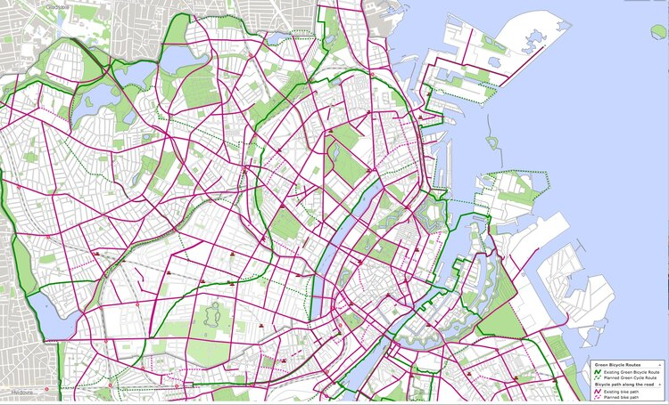
Figure 6 XXX: Showing a map of Copenhagen via cycling routes
(Credit: Heward, 2022)

One can begin to analyse the above map of all cycling routes of Copenhagen and start to understand why exactly the city has such a profound love of the bicycle. The city itself almost seems somewhat designed with the bicycle in mind from the get go whereas in many other cities this feels very much like an after-thought. According to Andrew Edwards and Max Leonard, the authors of ‘City Cycling – Copenhagen’ one can access near enough everything you would need for everyday life within the city, from supermarkets to coffee shops, and work places to hardware stores, all are of ease access with bicycle, and it can be argued that access via bicycle is easier than the car (Leonard & Edwards, 2014). Furthermore, Copenhagen is also well known for its public transport options within the city, ranging from harbour buses (ferries), to metro lines, to train travel, there are a variety of different options if one does not want to travel via car (Rasmussen, 2022). According to DIS Copenhagen (2022), Travel by harbour bus is one of the most sustainable options of travel through the city and is one that both tourists and locals like to utilise regularly. This method of transport has been strictly run on ‘green electricity’ since 2020, meaning that any energy consumed by the ferries is all renewable energy that is produced in a sustainable way (Rasmussen, 2022). The metro travel systems in place in Copenhagen are also something to boast about when it comes to sustainable travel within the City, as shown in figure 7, the city is extremely well connected and accessible.
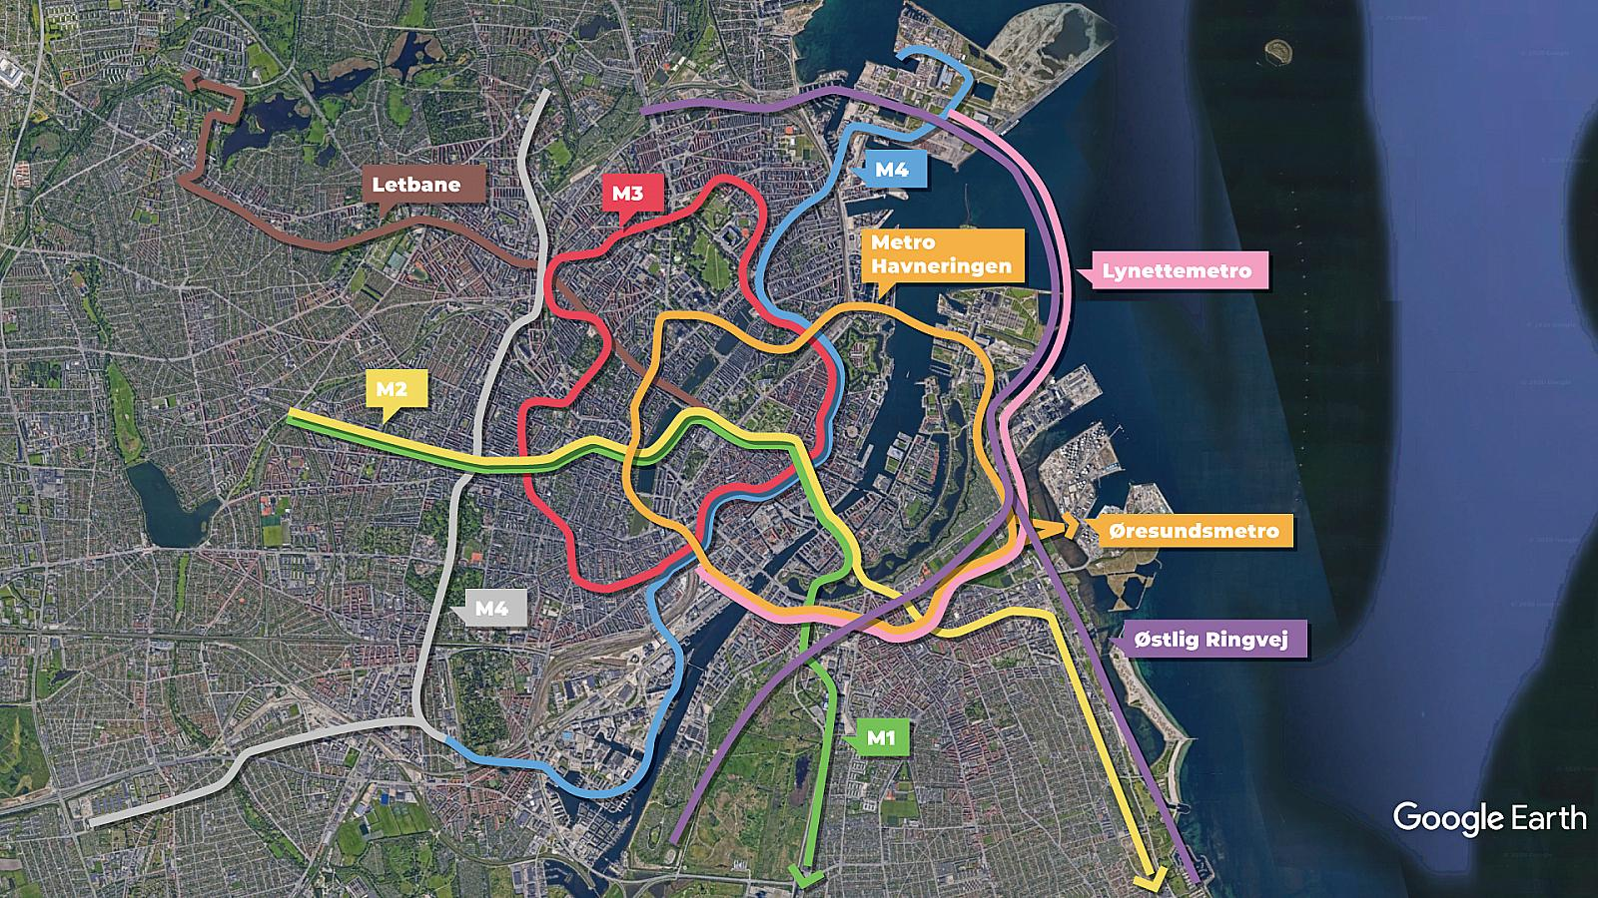
Figure 7 showing a map of Copenhagen’s Metro lines
(Google Earth, 2023)
According to Nexus.org, metro travel helps cut carbon emissions by two thirds when compared to travelling by car, therefore it must be highlighted that this is yet another method of sustainable travel available to the people of Copenhagen, further eliminating the need for a car. Overall, Copenhagen’s travel options within the city are in many ways, softly encouraging the average citizen to step away from carbon heavy methods such as car travel not only with the interconnectivity of the city, but the very design of the infrastructure, and according to Mark Stratton of ‘National Geographic’ is a key factor in Copenhagen’s efforts to becoming the first ‘Carbon Neutral City’ (Stratton, 2020). To summarise, Copenhagen has ‘earned its stripes’ when it comes to sustainability and the ‘greening’ of a city, from winning various awards on a national and international level, to the local legislation and policies implemented within the city. The ‘Green Capital’ boasts extremely strong sustainable travel options that according to Solver of ‘Lonelyplanet’, it could be argued that the car is one of the most inefficient modes of transport within the city (Solver, 2022). These various factors all play a huge role in Copenhagen’s 2025 carbon neutral charge, and are all important factors to consider when analysing the city’s success in sustainability, which then leads into the question ‘okay, so how does this compare to Swansea?’.

Chapter 2: An Introduction to Swansea
Swansea is often over-looked as a city when people look at Wales due to the obvious reason of Cardiff being the capital of the country, and is often times referred to as Wales’ ‘Second city’ (Kennedy, 2020). According to ‘Businesswales.gov, the coastal city of South of Wales has in fact began to embrace the sustainability crisis already, becoming a hub for renewable energy, eco-tourism and sustainable transportation. Despite the city’s humble reputation both nationally and worldwide, Swansea was actually voted ‘The 3rd best city to bring up children in the UK’, being beaten by only Middlesbrough and Aberdeen (Swansea Bay News, 2023). This title was awarded based on five main factors all shown in figure 8 below, demonstrating the ranking system used by ‘Comparethemarket’ and their life insurance team.

Figure 8 showing a table of the top 10 Cities to bring up children in the UK
Rank | City/Town | Average rent for a 3-bed property (£) | Average property price per m2 (£) | Pollution Index (out of 100) | Crime Index (out of 100) | Quality of life score (out of 240)
1 | Middlesbrough | 600 | 2,300 | 20 | 44 | 197
2 | Aberdeen | 827 | 2,171 | 27 | 33 | 195
3 | Swansea | 1,000 | 1,395 | 24 | 34 | 187
4 | Stoke-on-Trent | 723 | 850 | 43 | 44 | 182
5 | Norwich | 1,157 | 2,350 | 37 | 26 | 184
6 | Leicester | 900 | 1,900 | 34 | 44 | 182
7 | Edinburgh | 1,188 | 3,231 | 28 | 30 | 183
8 | Milton Keynes | 1,320 | 3,000 | 18 | 50 | 201
9 | Cardiff | 1,070 | 2,200 | 33 | 37 | 174
10 | Newcastle upon Tyne | 933 | 2,228 | 33 | 38 | 179

(Comparethemarket,2021)
Upon closer examination of the above figure, there is one metric in particular that is important for this paper is the ‘Pollution Index’. Swansea is actually relatively low in pollution when compared to the rest of the cities in the list, even Aberdeen that is statistically one place higher than Swansea. This is an interesting perspective as it would lead the reader to believe that Swansea has already implemented certain strategies to lower the pollution in the city, and in turn, the carbon footprint. According to ‘Business News Wales’, Swansea has been named as one of the ‘Top five green cities to invest in’ in 2022 (Businessnewswales, 2022) and scored particularly well in the number of environmentally friendly office buildings within the City. Other factors were also considered such as CO2 emissions and roadside pollutants by the huge international banking group BNP Paribas as part of their study named ‘Next X’ that, in short, was a study conducted to assess the most investable sustainable cities for the future. Swansea Council Leader, Rob Stewart said: “We need to create a greener Swansea to attract more private sector investment and employment which include zero carbon office developments, more greenery across the city, and the installation of more electric car charging points.”. He later explained that these actions would help to cut Swansea’s carbon footprint and make the city more biodiverse and help take the necessary steps towards carbon neutrality (Stewart, 2022). Swansea shares a similar aim to that of Copenhagen in becoming a carbon neutral city, however the timeline for this is 25 years behind that of Copenhagen’s (Swansea.gov, 2022). According to Swansea.Gov, the city had initial plans to achieve net zero emissions by 2030, however, the official carbon neutral target of 2050 was agreed during the Paris agreement of 2015, a by-product of the above mentioned Copenhagen conference in 2009. Despite Swansea ranking highly in terms of sustainability within the UK, there is still a big difference when comparing the cities sustainability agenda with that of this papers counterpart, Copenhagen. The 25-year gap between the two cities to reach the same goal of carbon neutrality begs numerous questions to the reader such as ‘What is Copenhagen doing different?’ or ‘What can Swansea learn from Copenhagen?’
Despite being behind Copenhagen in terms of carbon neutrality, as well as the unofficial titles that Swansea has gained in recent years in regards to sustainability and future proofing, the city has won a number of awards regarding the aforementioned sustainability agenda. The ‘Green Flag Award’ is among one of the awards that Swansea has earned itself in its sustainability push. According to the ‘Green Flag Award’ website, the award is given in recognition of outstanding publicly accessible green spaces and parks, which are of the highest standard (greenflagawards.org, ND). There are various factors that are considered when judging this award for green spaces, including cleanliness, community involvement, environmental management and many more (Owens, 2018). In 2018, Swansea Bay University Campus, shown in figure 9 below, won the green flag award for its outstanding areas of
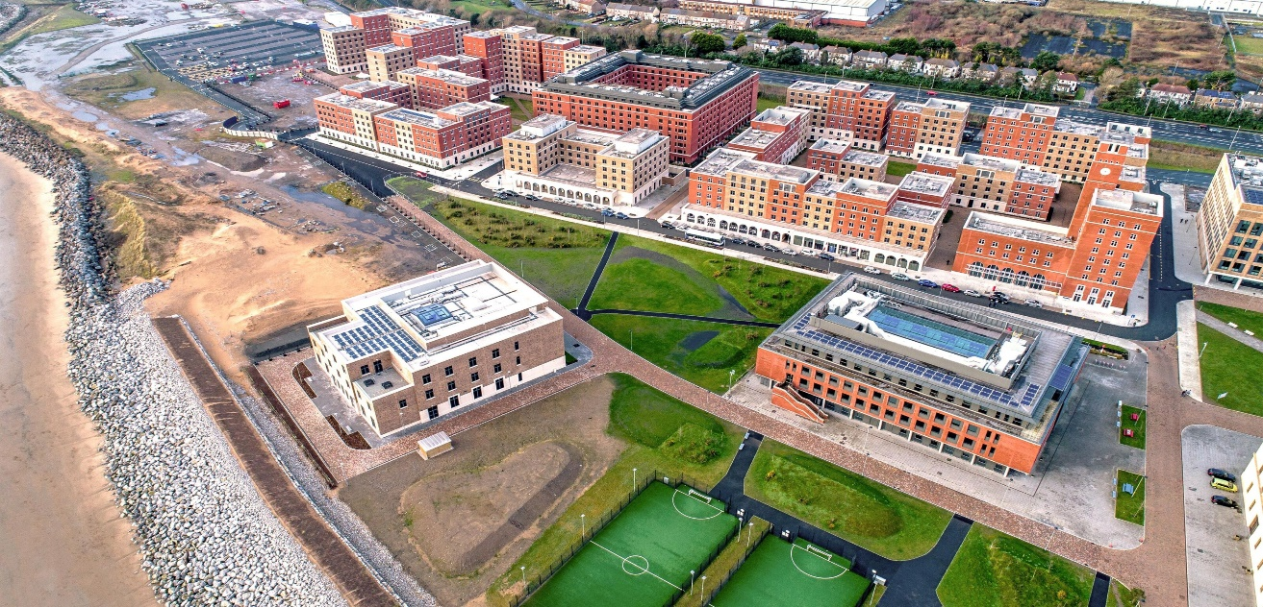
Figure 9 showing Swansea Bay University’s green spaces
(Glancy Nicholls, 2022)
green space and parks, in which the students and members of the public are able to access with ease, which in a built up city is very much a luxury (Owens, 2018). In the years to follow, many more green spaces within Swansea were recognised and actually given the ‘Green Flag Award’ such as Clyne Gardens, Singleton Botanical Gardens, Brynmill Park, the list goes on, and all of these spaces were recognised for their vital role in boosting the residents’ wellbeing and improving the natural environment (Swansea.Gov, 2021). Following on from the Green Flag Award, Swansea also has various local, smaller scale sustainability awards and accolades that are more specifically designed to encourage sustainability throughout the city and recognise small-scale businesses and individuals, an example of which would be the Swansea Environmental Forum (SEF) Awards. The SEF awards are an annual event that recognises and celebrates individuals, businesses and organisations within the city that have made significant contributions to sustainability within the city (McDonnell, 2016). The awards themselves are split into various categories including the ‘Sustainable Business Award’, the ‘Environmental Champion Award’, the ‘Green Innovation Award’ and the ‘Young Environmentalist Award’ (McDonnell, 2021). These type of smaller scale initiatives within the city are extremely important when it comes to taking the necessary steps towards a carbon neutral city, as it is just as crucial that the smaller scale individuals and businesses play their part in the sustainability push and not just the large scale companies.
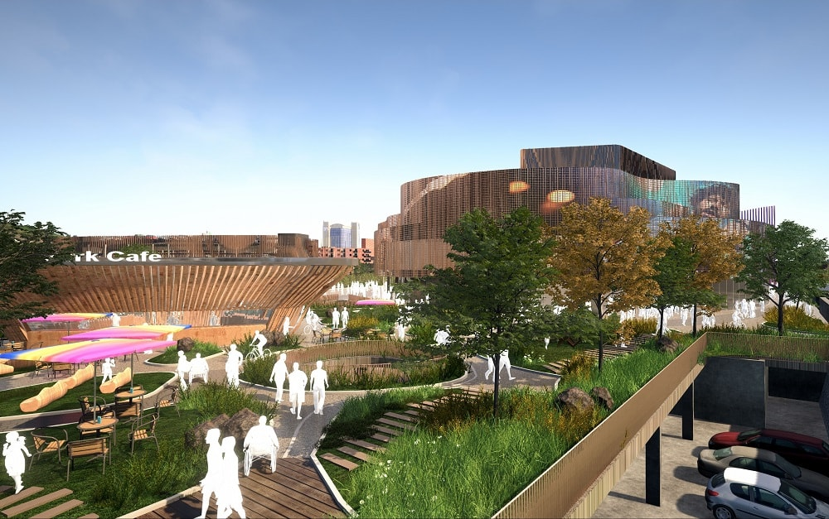
Moving on from the awards and various sustainable initiatives that are already in place in Swansea to encourage both businesses and individuals in their pledge for sustainability, there is also a new £1.3 billion project which is set to transform the city (Phillips, 2022). The ‘Swansea Bay City Deal’ is a major new development that has been secured by Swansea to improve the city’s infrastructure and develop new opportunities within the city, with funding from both the UK and Welsh Governments (Swansea.gov, 2021). A digital district village is currently in the process of being built in the city which will contain three major elements; a 3500 capacity arena hosting various cultural events, a state-of-the-art shared office space development and an innovation matrix development at the University of Wales Trinity Saint David in SA1 for start-up businesses.
(Swanseabaycitydeal.wales, 2021)
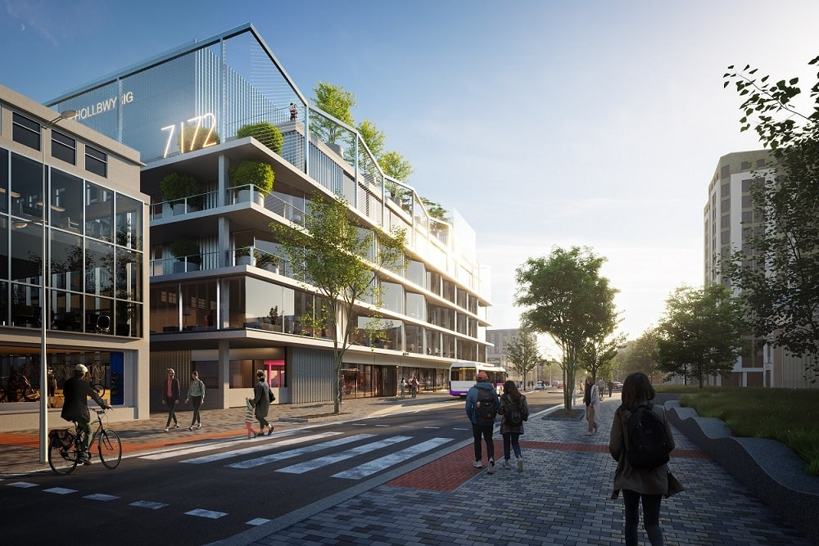
(Swanseabaycitydeal.wales, 2021)
The first element of the digital district village (figure X) not only provides a new cultural arena for the city, but also creates new green spaces in the surrounding area for the public to explore and greater pedestrian access through the city as the development is raised above and over the road below, further encouraging greener travel options (tradeandinvest.wales, 2021). The second element of the project (figure XX) is providing around 115,000sq ft of low cost, shared office spaces with extremely high speed digital connectivity. The building has been designed to accommodate Swansea’s ever-growing digital technology businesses providing a shared working environment for multiple businesses to take advantage of and in turn lower the energy that would have been used if said businesses were to operate in their own buildings individually (tradeandinvest.wales, 2021). This stage of the project is currently in the tender process for construction and is set to be complete by summer 2023 (Swansea.gov,2022). The final element of the project, the innovation the village, is set to be built on the University of Wales Trinity St David’s SA1 campus and will provide a space for start-up businesses and entrepreneurs to develop their ideas in a positive environment. The project will be particularly important in attracting new business and investment into the city, which in turn could help place even more significance on developing sustainable initiatives in an ever-growing city as well as further develop the economy (tradeandinvest.wales, 2021).
Another project taking place in Swansea as part of the ‘City Deal’ is a development planned for a ‘box village’ within the University of Wales Trinity St David, the purpose of which is to provide a cheap, flexible space for start-up companies to utilise (Barry, 2017). The village will be built using thousands of recycled shipping containers across a 23-acre site right next to the university in order to allow the start-up companies ease of access to the university’s facilities and expertise (tradeandinvest.wales, 2021). There are many benefits to utilising recycled shipping containers in construction ranging from cost efficiency, to speed of construction, but the obvious factor for choosing to build with recycled containers would be the sustainability of the method (Welch, 2022). The development and approved planning for projects such as this is huge for Swansea as it can open the door for more developments with sustainability at the heart, helping to take the necessary steps needed to get closer to the carbon neutral vision of 2050.
The final project of the ‘City Deal’ that is hugely significant in Swansea’s carbon neutrality push, is the ‘Homes as Power stations Project’. The brief of the project is to introduce new state-of-the-art design and energy efficient technologies into thousands of properties across the city, facilitating the integration of renewable energy technology into both new build and retrofit programmes (swanseabaycitydeal.wales, 2021). The project aims to prove the concept of this type of sustainable technology within homes across the city at small scale at first, with the intentions of scaling up across the city both in the private and public sector (Pearce, 2020). The project aims to facilitate the renewable technology into roughly 10,300 properties across the city within 5 years, split between 7000 retrofit and 3300 new build, with the aim of improving the residents’ health and well-being by further reducing the areas carbon footprint (Pearce, 2020). To date, this project has been approved by the UK and Welsh Governments, leaving the £505 million development in its early stages of funding acquisition, set to receive around £15 million from the city deal budget, and the remaining budget to be raised through the private sector (Pearce, 2020). Not only does this project further improve the sustainability push for carbon neutrality, but it also aligns with the ‘Well-being of Future Generations Act 2015’ in Wales which is another key piece of legislation in place by the national government to help develop the country. The act has seven main criteria to satisfy which are as follows;
- Create a prosperous Wales
- Create a Resilient Wales
- Create a Healthier Wales
- Create a More Equal Wales
- Create a Cohesive Community
- Promote Vibrant Culture and the Welsh Language
- Satisfy Wales’ Global Responsibilities
(futuregenerations.wales, 2020)
According to Pearce, the ‘Homes as Power Stations Project’ will satisfy all seven of the above criteria, however there are three main factors that align with the carbon neutral agenda which have been highlighted within Pearce’s work. Firstly, the project has outlined that in order to ‘Create a Resilient Wales’ it will tackle poverty and the global threat of climate change by aiming to make the energy more ‘affordable, sustainable and decarbonised’. Secondly, the project states that in order to ‘Create a Healthier Wales’ the low-carbon, energy efficient homes will have a profound effect on the health and well-being of the inhabitants. Finally, in order to ‘Satisfy Wales’ Global Responsibilities the project is minimising the carbon footprint of the new-builds and retrofitted properties that are in the scheme, helping to battle the global crisis of climate change and fossil fuel implications (Pearce, 2020). Overall, this project is a positive sign for the future for Swansea and its Carbon Neutral push, and the sooner the project can begin being implemented in the city, the better, as not only does it align with the 2050 deadline, but it also fits in with the national ‘Future Generations Act’ making the development an exemplar for others to follow.
Moving on from the ‘City Deal’, Swansea also has huge potential when it comes to green energy production and has begun in recent years to take the necessary steps needed in order to get closer to a greener energy system (Youle, 2023). According to the Welsh Government, the year 2020 was the first year that Wales had zero electricity generated from coal, and that in fact around 33% of total electricity generated was via renewable energy. In the ‘Energy Generation in Wales’ report available on the Welsh Government website, it was actually stated that when split by region, Swansea Bay generated the most renewable energy in Wales, joint with the North Wales region as shown in the figure below.
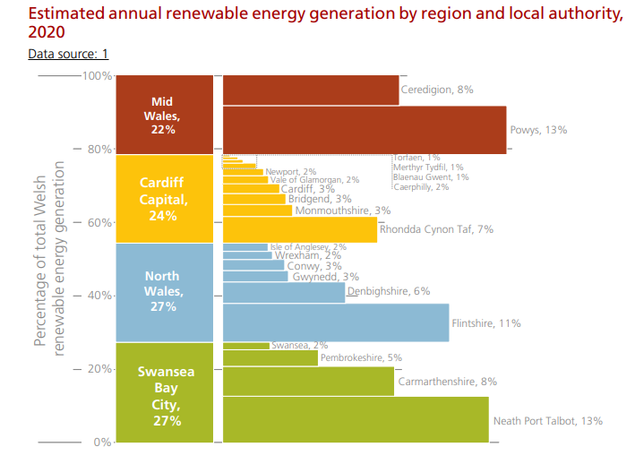
Figure XXXX: Graph showing the estimated regional renewable energy production of Wales
(Credit: Gov.Wales, 2021)

North Wales as a region has the same renewable energy output as the Swansea Bay City region, there is one key difference between the two regions that could tilt the scales in favour of North Wales, which is the green light for the North Wales ‘Conwy Tidal Lagoon’. Essentially, North Wales Council has had the green light for the development of the tidal lagoon that will be constructed along the coast between Prestatyn and Llandudno which in turn could make a huge difference in the renewable energy output of the area (Moore, 2022). Now the reason this is relevant to Swansea is because there were similar plans back in 2018 for a tidal lagoon to be built in Swansea Bay, however this was not diligently considered by the UK and Welsh Governments at the time as it was seen as ‘too expensive’ when compared the alternative routes such as nuclear power or offshore wind farming, and the plans got put on hold and moved to the private sector for potential funding (Vaughan & Morris, 2018). The potential that Swansea Bay has for this project is remarkable as the aforementioned tidal lagoon had plans that consisted of a floating solar farm, tidal energy plant and even more green space within the Swansea area, all of which would play key roles in the development of Swansea as a ‘Green City’ (Youle, 2023). Therefore, it is extremely difficult to discuss what Swansea is currently doing in terms of sustainability without mentioning this huge potential tidal lagoon that is currently ‘on the back burners’ as many, such as Mark Shorrock, chief executive of the company behind the plans, and many Labour party MPs all agree this would be a profound step in the right direction with Swansea and Wales as a country’s goals of becoming carbon neutral (Vaughan & Morris, 2018).
As of June 2022 there were 164,600 licensed vehicles in Swansea, which included 127,500 cars (Swansea Council, 2023). In recent years Swansea has taken positive steps to develop a sustainable travel and transportation strategy (Swansea Council, 2022). The strategy includes the continued promotion of active travel, the development of sustainable public transport systems in the region, the installation of electric vehicle charge points across the city and the replacement of council fleet vehicles to electric. By 2022 Swansea achieved progress in their transportation strategy together with progress towards their Net Zero 2050 pledge via actions that included the growth of the cycle network by 25%, installation of electric vehicle charge points in council car parks and improvements to the council’s fleet of vehicles with a steady conversion to electric vehicles (Swansea Council, 2022).
Swansea promotes cycling as a means of sustainable transportation and the city has developed a comprehensive network of cycle paths and lanes. In 2018 Swansea City Council implemented a bicycle sharing scheme in conjunction with Santander and Swansea University, allowing individuals to rent bicycles for short trips around the city. By June 2022 the scheme had reached 100,000 rentals (Swansea Bay News, 2022). Swansea Council received more than £8 million of transport funding from Welsh Government to fund the design and construction of new walking and cycle routes with the aim to further promote active travel. (Swansea Council, 2022). The current active travel network in Swansea has over 120km of on and off road cycle and walking routes which means Swansea is working in line with the Welsh Government Active Travel (Wales) Act 2013 (Active Travel (Wales) Act 2013, 2023). The image below (fig 1) shows the active travel network map for the Swansea area detailing the existing and the potential future walking and cycle routes (Data Maps Wales, n.d.).
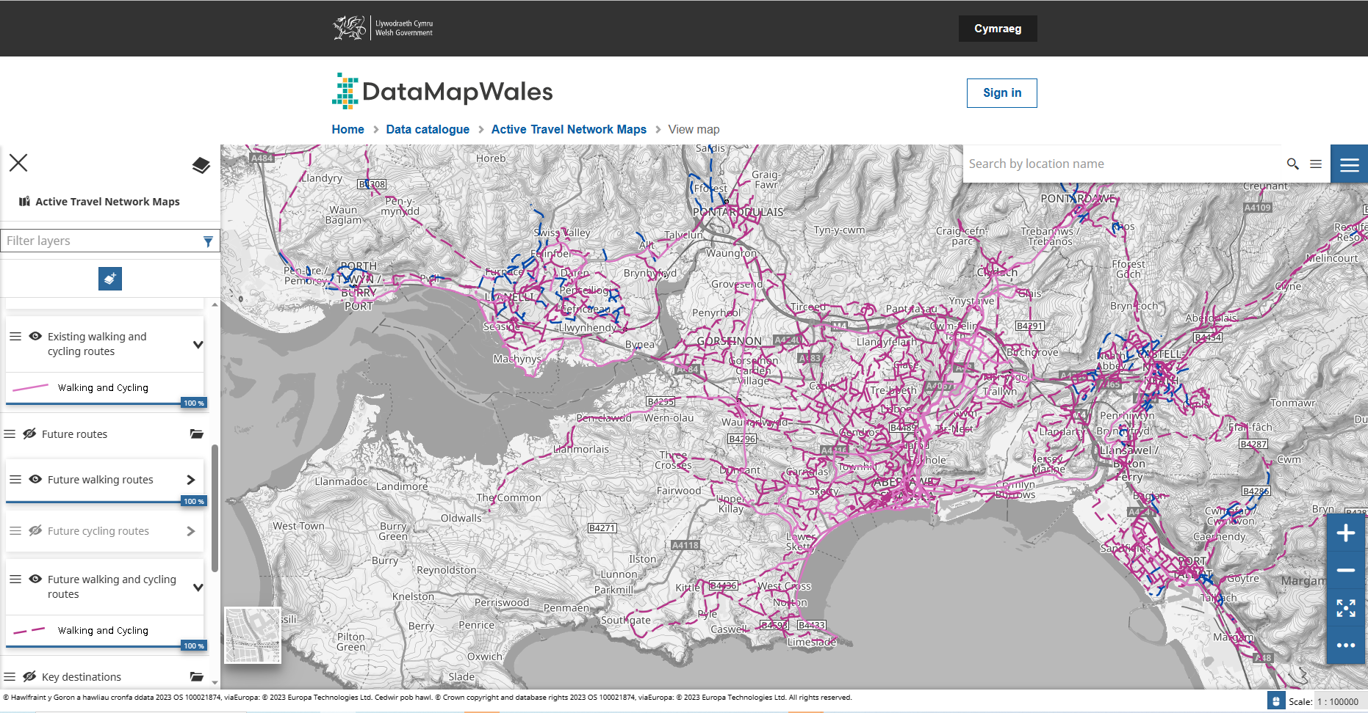
Fig 1 – Active Travel Network Map for Swansea (Data Maps Wales n.d.)

A further initiative of the sustainable travel and transportation strategy is the development of a bus rapid transit (BRT) system in Swansea and the Swansea Metro, which aims to reduce congestion and improve public transport services. The BRT operates on dedicated lanes, and passengers benefit from reduced travel times, increased reliability, and improved air quality (First Cymru, n.d.). The rail network in and around the city of Swansea is currently part of the South Wales Metro development which aims to transform transport for people in the area. The project was confirmed in 2018 with an initial investment of £738m to develop the rail network to improve connectivity and sustainable travel across South Wales, including Swansea (Transport for Wales, 2023).
Overall, Swansea as a city is clearly already taking significant steps towards the aim of being Carbon Neutral by 2050 and in turn becoming a ‘Green City’ that somewhat align with those of Copenhagen, however there are still clearly numerous opportunities that are being passed up on or not recognised within the City that could further help accelerate this process and perhaps close the gap between the two cities when it comes to achieving the Carbon Neutral goal.

Chapter 3: Case Study 1 – Copenhill
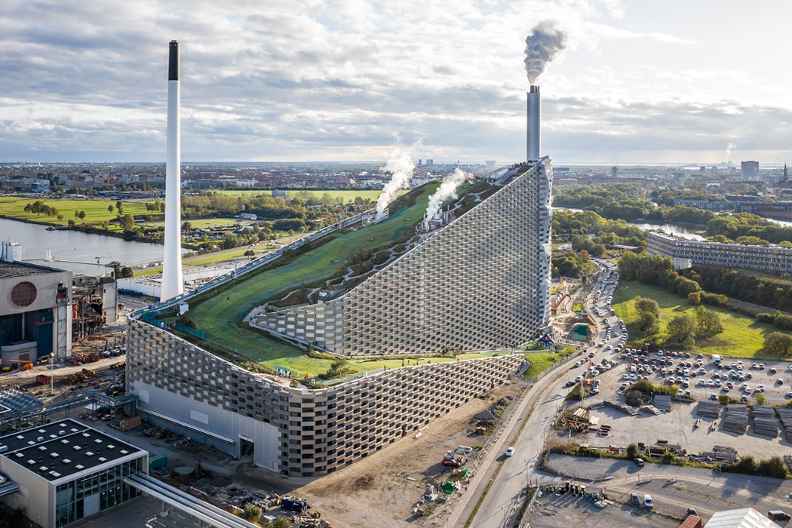
Figure XXX: Image of Copenhill
(Credit: Bernas, 2020)

Project Name: | Copenhill
Project Location: | Amager, Copenhagen (Ijeh, 2019)
Designed by: | Bjarke Ingles Group (Ijeh, 2019)
Budget: | 3.5 billion DKK (£415 million) (Ijeh, 2019)
Completion Date: | 30th March, 2017 (Stevens, 2021)

Copenhagen has many outstanding pieces of architecture that play a huge part in the city’s push for carbon neutrality, perhaps one of the most significant is pictured above; Copenhill (Baldwin, 2020). Copenhill began as an idea/concept birthed from an ever-growing strive to decrease the landfill and waste within the city and increase the recycling numbers of Copenhagen and Denmark as a whole further decreasing the City’s carbon footprint (Cooper, 2018). Decades before Copenhill was even dreamed of, both the city of Copenhagen and Denmark as a whole were striving to reduce landfill and waste numbers from as early and the 1990s (Cooper, 2018). In Denmark as a whole, it has been prohibited to landfill any organic waste since 1997, whilst in Copenhagen, this prohibition dates back even further to 1990 (Europa,2012). Following on from these prohibitions, the idea of Copenhill was actually birthed in 2002, when an analysis of the existing decades old waste-to-energy plant was conducted, the Danish Government came to the conclusion that this existing facility simply was substandard to the requirements needed to align with Copenhagen’s carbon neutrality push (Greenroof, 2022). What was originally proposed as an early design philosophy was to create a public green space in one of the most built up urban areas of Copenhagen, by creating a ski slope topographical green space on top of the largest department store in the city, however this idea was rejected at the time, but birthed the first seeds of the idea of Copenhill (Baldwin, 2019). Nearly a decade after this original philosophy was conceived, in 2011 Bjarke Ingles had won the international design competition put out by the client, Amager Resource Centre (ARC), to reimagine Copenhagen’s waste-to-energy plant and begin designing the facility of Copenhill (Baldwin, 2019).
At the early stages of development, the brief for Copenhill was simple; ‘To create a state-of-the-art waste-to-energy plant that would be environmentally friendly and provide space for public recreation’ (Mairs, 2022). The building needed to be able to process the waste from the city of Copenhagen and turn it into renewable energy whilst also being a visually striking building that would engage the public both visually and physically (Baldwin, 2019).
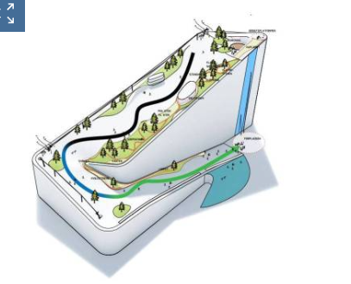 | 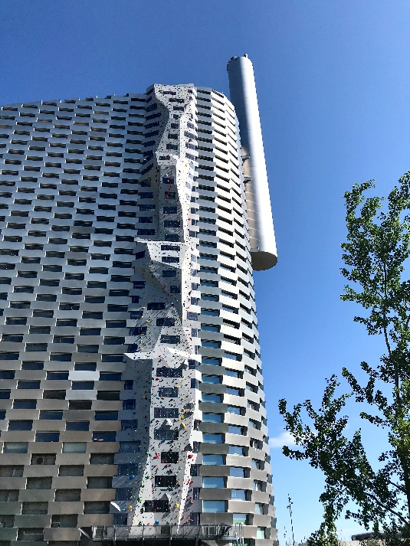
(skiresort.info, 2022) | (copenhill.dk, 2022)

As the project developed, it became apparent that the building needed to have certain facilities to attract the public and really make the building a success. Firstly, it was decided that the building was to house an outdoor ski slope on the roof for public use, as well as an observation deck that provided a view over the city (Crook, 2019). Next, the idea of a hiking trail alongside the ski slope was birthed, stretching approximately 450m, according to the Copenhill.dk website, as it ascends the sloped roof to reveal a view of the city. Finally, a climbing wall, but not just any climbing wall, the largest artificial climbing wall in the world, ascending approximately 85 metres was to be another key element of the building that would attract the interaction of the public (Slavsky, 2020). Bjarke Ingles had the challenge of meeting all of the above criteria, while still ensuring that the building was integrated seamlessly into the surrounding urban landscape, attempting to create a harmonious relationship between both the building and the surrounding context (Architectmagazine, 2019).
Despite the development of the brief for the Copenhill project, there were some challenges that had to have been considered when both planning and constructing the building and even some objections to the building all together (Bjerke, 2019). Starting with the planning of the project, there were a few concerns raised by the Danish Government initially that in fact nearly got the whole project declined at the time. Initially, there were questions on the motive for designing such a large scale waste-fired plant, as ARC (Amarger Resource Centre) who are in fact a public non-profit, energy firm who were developers of this project alongside Bjarke Ingles, started to highlight the potential profitable side of the development, something that was not originally discussed in the early plans (Kohl, 2019). According to Kohl’s research, questions were asked as to if the building was still purely being planned/designed with the ethical and sustainable aspects at the heart of the project, or if it had slowly started to be seen as somewhat of a profitable opportunity for the ‘non-profit’ organisation which caused serious tension during the planning stages (Kohl, 2019). Another problem that was faced in the development of Copenhill was regarding the sheer scale of the energy plant and the amount of fuel needed to power it. There were worries initially that Denmark as a whole simply would not produce enough waste to incinerate within the facility, and would need to import waste from other countries to power the plant (Gurzu, 2019). This would then present another factor that would have to be considered within the proposal, as if waste was required to be imported from other countries, would the carbon footprint of the transportation of said imported waste counteract the benefit of burning the waste in the power plant? Copenhill also faced challenges when applying for funding of the project according to zerowasteeuropa.eu, the Copenhill project was originally declined a loan guarantee of around £470m from the municipal of Copenhagen as it was requested that a ‘smaller’ capacity plant was to be developed with a “greater focus on recycling and reuse”. The main concerns about the size of the project were that it would send a message to the people of Copenhagen that it was acceptable to burn otherwise recyclable materials (zerowasteeuropa.eu, 2021).

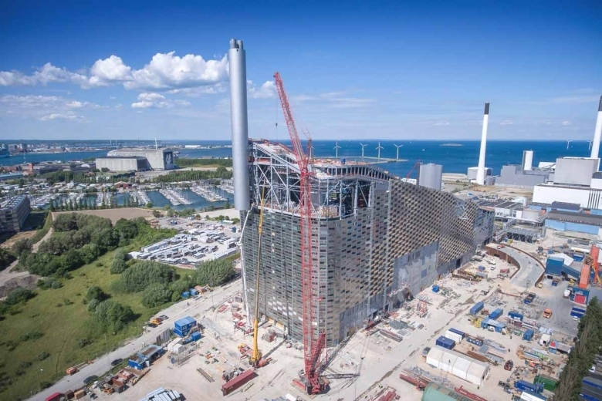
Figure XXX: Image of Copenhill under construction
(Credit: Jeremy Williams, 2017)

One of the biggest tasks facing Bjarke Ingles when designing Copenhill was the challenge of creating such a large scale energy plant that was structurally sound, yet built sustainably as the major driver for the project was the sustainability aspect (Architectmagazine, 2019). The building, as per the brief, had to ‘blend in’ seamlessly with the surrounding urban context, which for an 85m tall energy plant, could prove to be difficult (Architectmagazine, 2019). Ingles opted to go for an entirely steel framed construction as shown in figure XXX which, when analysing the benefits of steel frame construction, appears to make sense for a project of this scale (Ijeh, 2019). Firstly, steel frame construction provides excellent longevity and durability when compared with other materials such as timber frame or masonry, as well as having the ability to withstand high loads with little material (Baker, 2023). Steel is also a recyclable material, meaning that it can be reused exponentially without losing any of its core durability (Baker, 2023). Lastly, the energy required to produce raw steel has decreased significantly over the years. Carbon Dioxide by-products can be recaptured and reused in other areas, further decreasing the carbon footprint of this construction method (Baker, 2023). Moving on from the structural steel frame, Copenhill also utilised concrete within the construction of the building, mainly in the foundations, however as can be seen in figure XXX, the concrete was also used in elements of the walls that required extra support (Elematic.com, 2023). Concrete was also the element of choice for the roof of the structure, which required a solid base as it was also acting as a floor for the ski slope above. According to Elematic.com, around 1,700sq metres of precast concrete walls and approximately 21,000sq metres of hollow-core concrete slabs were used in the construction of the building, all being used to reinforce the elements of the building that would be sustaining large amounts of pressure (Elematic.com, 2023).

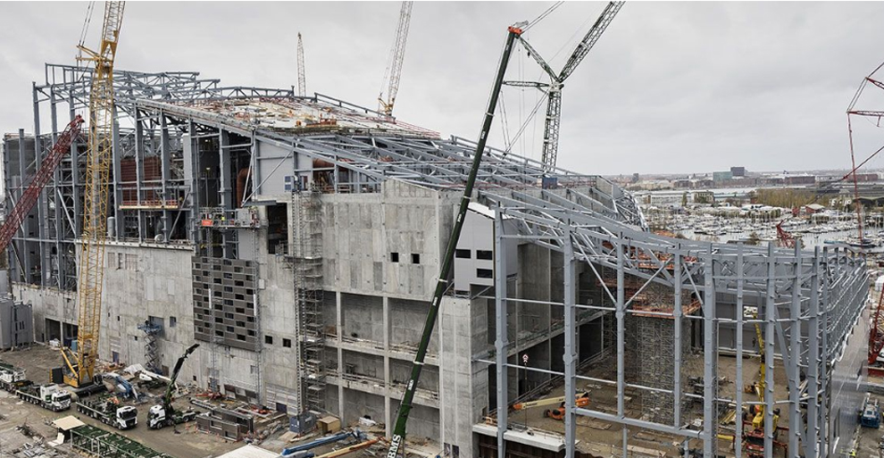
Figure XXX: Showing the Steel Frame Construction of Copenhill
(Credit: De La Paz, 2020)

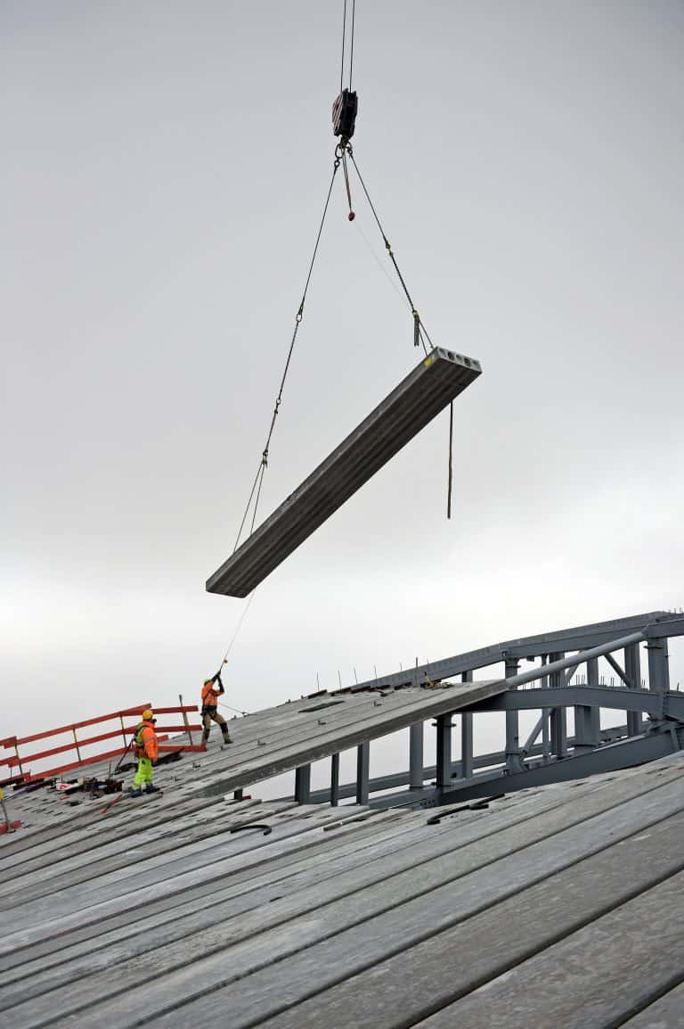
Figure XX: Showing the hollow-core roof slabs in the construction phases of the project
(Credit: Mestour, 2018)

Another element used in the construction of Copenhill, is the aluminium façade which is the main visual element that can be seen on the completed building today. The façade is actually a dual layered structure, where the inside layer consists of a concrete fibre reinforced polymer with ventilation breaks and the outer layer being the 1.2m by 3.3m aluminium brick façade in a checked pattern (Kolnaar, 2021). What is particularly innovative about this façade, is the fact that the aluminium ‘bricks’ double up as planters which are used to encourage the biodiversity and wildlife in the area by providing a place for various wildlife and vegetation to inhabit in the vertical garden (Bernas, 2020). As well as the encouragement of biodiversity, the aluminium bricks themselves are a sustainable material choice. Aluminium is “one of the most environmentally friendly metals on the planet” according to Alexandra Giles of origin-global.com and in fact is 100% recyclable and around 75% of the 1 billion tons of aluminium produced in the last 100 years is still in use today (Fbsprofilati, 2020). In between the aluminium façade bricks, there is a layer of translucent glazing that is designed to both let natural daylight into the facility, as well as illuminate the building in the evening/night (Bernas, 2020). Overall, the material choices for Copenhill can be seen as a balance between sustainable, practical and visually pleasing. The steel frame elements providing the structural support and aluminium façade both are highly recyclable materials and can be reused whenever required (metalwarehouse.co.uk, 2021). The precast concrete elements that were used for both the wall support and the roof slabs provide the structural support needed for a building of this scale and also have thermal benefits in keeping the energy cost of the building down, further decreasing the carbon footprint of the building (theconcreteinitiative, 2007).
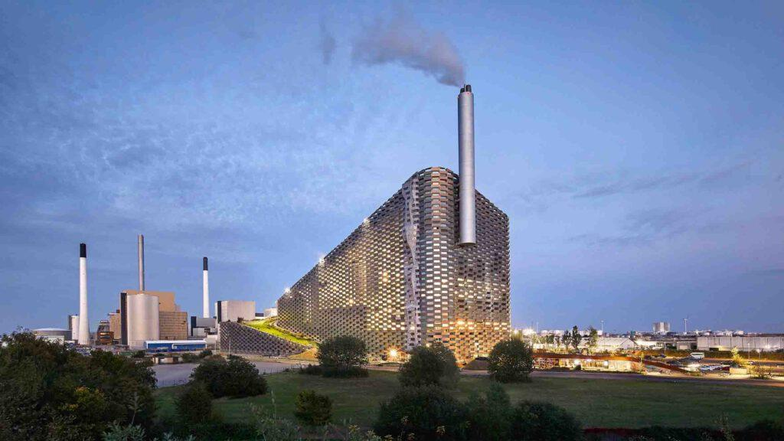
Figure XX: Showing the Aluminium façade with the translucent panels
(Credit: Hufton & Crow, 2020)

Moving on from the materiality of Copenhill, one can begin to analyse the performance of the building now it has been in operation for approximately six years (Stevens, 2021). The main purpose of the building is quite obviously to incinerate the waste of Copenhagen and convert this into energy to be used throughout the city (Crook, 2019). The first full year the facility was open, 2018, it was reported to have processed approximately 450,000 tonnes of waste, converting this into to district heating for around 72,000 homes and electricity for a further 30,000 homes (Hartman, 2019). Concerns were raised about the waste demands of the facility as during this period it was reported that around 30,000 tonnes of waste was shipped to the plant from the UK and Ireland, meaning that Denmark alone were not producing enough waste to power the plant themselves (Hartman, 2019). Hartman goes on to explain that the plant itself was intended to serve five municipal areas around Copenhagen, however it ended up being too large to be solely powered by these five municipals. When questioned about the oversized facility, Amager Resource Centre (ARC) director Jacob Hartvig Simonsen justified this as a “climate win” as he explained the benefits of importing waste to be burnt in the facility outweigh the negatives, even when transportation of the waste is considered (Hartman, 2019).
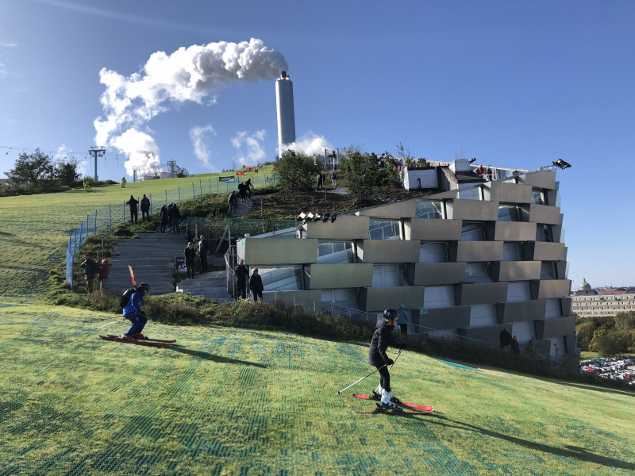
Figure XX: Image of the ski slope of Copenhill in use
(Credit: saalbach.com, 2020)

Copenhill obviously does far more than just incinerate waste to convert to energy, the leisure facilities available to the public that the building possesses also have a huge part to play in the significance of the building (Grasmus, 2020). According to Hartman from the Architect’s Journals, the building was expected to have approximately 300,000 annual visitors each year to make use of the various leisure facilities available at the plant (Hartman, 2019). There are various leisure facilities and activities available at the energy plant today, from the 400m ski slope, to the 85m climbing wall and not to mention the hiking trail that ascends alongside the ski slope to the top of the building (Crook, 2019). These leisure facilities are what makes Copenhill so unique, as the people of Copenhagen would usually have to leave the city or even Denmark all together to go skiing or go for a mountainous hike as the city itself is very flat and densely populated (thestylemate.com, 2021). Finally, the waste-to-energy plant also has its educational purposes, intended to educate the public on the procedure of waste-to-energy and spark some curiosity into the subject (Crook, 2019). Crook explains that there is a 600m2 educational centre within the facility that is designed to host school trips, sustainability conferences and informational events. It is also possible to book guided tours of the facility on the Copenhill.dk website, stating that the tours typically last around 60 minutes during which one will be guided through the facility and taken in the glass elevator which overlooks the entire plant. Overall, it can be argued that aside from the main purpose of waste-to-energy conversion, Copenhill has a range of uses both educational and recreational, both of which provide value to both the people of Copenhagen and Denmark, and the tourists that visit the city (Medea, 2018). Copenhill has become one of Copenhagen’s most renowned tourist attractions that boasts the ‘best view of the city’ according to the Copenhill.dk website and hosts hundreds of thousands of tourists each year.

After the above analysis of Copenhill, one question remains to be answered, how successful was the project? One can begin to determine the success of the project purely from an architectural point of view by analysing the impact of the development after completion. When the head architect of the development, Bjarke Ingles, was questioned about the success of the project, he stated that Copenhill was a “blatant architectural expression of something that would otherwise have remained invisible: that is the cleanest waste-to-energy power plant in the world…” Ingles then went on to say that he believed Copenhill was an excellent example of “Hedonistic Sustainability” and demonstrated that a sustainable city can be better for both the environment and the people living in it (Hartman, 2019). According to Brooke Kaz of architectural digest, Ingles explained that he believed the project to be “economically, environmentally and socially profitable” due to its impact on both the tourism and economy of the city, the carbon footprint of the city’s energy production and the recreational opportunities it creates for the people of Copenhagen to take advantage of (Katz, 2018). Copenhill was also viewed as a success in the eyes of architects all around the world, winning multiple prestigious awards such as ‘ArchDaily 2020 Building of the Year award’ and ‘Building of the Year 2021’ at the fourteenth annual World Architecture Festival as well as many more (Worldachitecture.org, 2021). The client of the project, ARC, have also expressed their gratitude and satisfaction when asked their opinion on the development stating that they are “very proud to have built the most energy efficient waste-to-energy plant in the world.” (Hartman, 2019). ARC highlighted the fact that the energy plant has such minimal environmental emissions, allows it to have members of the public living within 200m of the establishment and really makes the building feel a part of the city (Pintos, 2019). Finally, one can look at Copenhill from the viewpoint of those who inhabit the city, both Government and general public. In the Governments eyes, Copenhill aligns with their bigger plan of becoming the first carbon neutral city by 2025 as it has helped take a huge step towards Copenhagen becoming a completely renewably powered city (Urbannext.net, 2019). However, there is still an argument that the energy plant is too large due to the need for imported waste every year, however as previously mentioned, this is labelled as a “climate win” by the director of ARC (Gurzu, 2019). In regards to the people of Copenhagen, they too see the benefits of Copenhill as they have access to facilities such as the ski slope and mountainous hiking path that they otherwise would not have or would have to travel far out the city to access (Thestylemate.com, 2021). Not to mention the benefits seen for the local businesses in and around the surrounding area to Copenhill, as it attracts around 300,000 visitors each year, some of which will be venturing out into the city and surrounding area spending money in the local business (Valence, 2019). Therefore, overall it can be said that Copenhill as a project was a huge success and continues to have a significant impact on the city of Copenhagen today, providing the residents with leisure and the city with energy, the energy plant can be looked at as an exemplar piece of hedonistic architecture and demonstrates the vital steps that architects can help take to tackle the sustainability issues of today’s society (Hartman, 2019).

Chapter 4 – Case Study 2: Active Classroom and Active Office
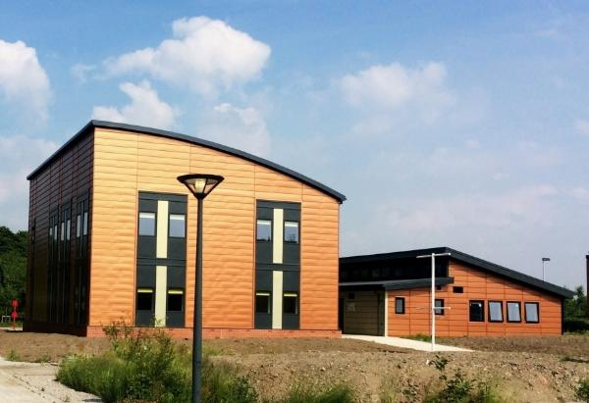
Figure X: Swansea’s Active Classroom and Office
(Credit: Sullivan, 2018)

Project Name: | Active Classroom and Active Office
Project Location: | Swansea University Bay Campus, Swansea (Jones, 2017)
Designed by: | Joanna Clarke (Educationbuildings.wales, 2022)
Budget: | £1.2million (10.1 million DKK) (Gov.uk, 2017)
Completion Date: | September 2016 / June 2018 (Specific.eu.com, 2023)

Swansea as a city has taken huge steps in the sustainability crisis in recent years with various plans for future developments and improving infrastructure all to help tackle today’s issues of climate change (Youle, 2020). In particular, Swansea University has been one of the leading forces at the forefront of the sustainability crisis trying to find new, innovative ways to help tackle the issue, and their latest efforts have produced what is known as the ‘Active Classroom and Office’ (Sullivan, 2017). Swansea’s Active Classroom and Office are, in short, two separate buildings that actually have a positive energy impact, meaning they both produce more energy than they are actually using (Sullivan, 2017). The Active Classroom was the first of the two building project to be complete in September 2016, followed shortly by the Active Office in June 2018 (Specific.eu.com, 2023a). SPECIFIC, who according to their website, are a UK innovation and knowledge centre who are currently one of the leading companies in energy technology research and full-scale development, were one of the key forces behind the planning and development of the two projects and played a huge role in securing financial and government support (Swansea.ac.uk, 2022). According to the Swansea University website, SPECIFIC are a research company that is led by the University itself and funded by UK Research and Innovation (UKRI). SPECIFIC also has some industrial partners that are committed to helping the research and development of innovative energy strategies in any way they can, and showed their support with materials and services in both the active building developments, these companies are Tata Steel, Akzo Nobel and NSG Group (Specific.eu.com, 2023a). These industrial partners were a crucial aid in seeing the Active Classroom and Office come to fruition as they provided expert industrial knowledge and access to key elements such as Tata Steel’s ‘Colorcoat Urban’ Steel cladding system, a lightweight, strong cladding system that has very low carbon production (Tata Steel, 2012).
As per SPECIFIC’s website, an active building is described as “a building that supports the wider grid network by intelligently integrating renewable energy technologies for heat, power and transport” (Clarke, 2023). The actual concept of ‘Active Buildings’ was initially developed by the Active Building Centre (ABC) who have now made it their mission to ‘deliver transformational change in the construction and energy sectors’ (Tradeandinvest.wales, 2021). There are six main principles to follow when designing an ‘active building’ which are:
  - Building Fabric and Passive Design – Making use of various architectural tools and techniques in order to provide comfort for the occupant at a low level of energy expenditure e.g. Natural lighting, natural ventilation etc. (Clarke, 2023)
  - Energy efficient Systems with performance monitoring - Intelligently monitored and controlled energy systems such as lighting or heating, that are designed to be as efficient as possible while using real-time data of the occupant’s usage habits. (Clarke, 2023)
  - On-site Renewable Energy generation – Integration of renewable energy sources where possible, for example installation of solar panels where possible etc. (Clarke, 2023)
  - Energy Storage – Thermal and electrical storage should be utilised in order to ensure there is minimal energy wastage and possibility to transport energy back to local infrastructure. (Clarke, 2023)
  - Electric Vehicle Integration – The popularity of electric cars is growing considerably, the sustainability benefits of this vehicle choice is ten-fold when compared to standard current fossil fuel powered cars. Integration where possible will encourage a switch over to electric vehicles at a faster rate. (Clarke, 2023)
  - Intelligently manage integration with micro-grids & national energy network – Active Buildings should be able to manage the on-site demand of energy required from the wider national energy network and limit the uncontrolled import/export of energy where it is possible. (Clarke, 2023)
These main principles that Clarke laid out to define an ‘Active Building’ were a huge part of the development of Swansea’s Active Classroom and Office as they were the driving force behind the research and innovation that was being carried out within the early stages of SPECIFIC’s projects (Clarke, 2019). In the United Kingdom alone, buildings account for approximately 40% of energy consumption as well approximately 40% of greenhouse gas emissions (Neosnetworks.com, 2023) which quite clearly offers a massive opportunity for improvement. Both the Active Classroom and Active Office were developed as a direct response to this statistic, as Swansea University and SPECIFIC wanted to demonstrate that with the use of various technologies, steps can be taken in the construction of new builds and the retrofitting of existing buildings in order to help tackle this and reduce not just Swansea, but the United Kingdom’s carbon footprint (Clarke, 2021).

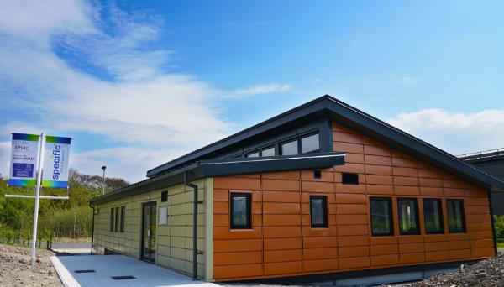
Figure XXX: Showing Swansea’s Active Classroom
(Credit: Sullivan, 2017)

The official brief for Swansea’s Active Classroom was to serve as somewhat of a demonstration/trial of SPECIFIC and Joanna Clarke’s concept of creating an ‘Active Building’ (Clarke, 2020a). The main purposes of the building outlined in the brief were;
- To act as a showcase for SPECIFIC and their industrial partner’s new innovative technologies (Clarke, 2020a).
- To be energy positive and produce more energy than what is required in its annual cycle (Clarke, 2020a).
- To be designed with net zero considerations such as the use of low carbon materials and recycled materials where possible (Clarke, 2020a).
- To act as a tool to educate the government, companies, students etc. about the ‘Active Building’ concept (Clarke, 2020a).
- To be used as a teaching facility for the University, to be used as a ‘test bed’ for new technologies that are being trialled which could be retrofitted in large scale across the city (Clarke, 2020a).
- To be used to generate and analyse data on energy usage of the facility and how it can be manipulated (Clarke, 2020a).
Joanna Clarke also goes on to highlight the fact that the project was to serve as a demonstration to a concept, while the technologies on display at the time of completion in 2016 were the latest and greatest at the time, she recognises that technology is evolving rapidly and hopes that the concept on display within the building can be adapted/improved with the technology (Clarke, 2020a).

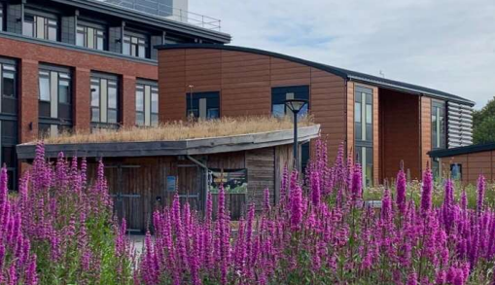
Figure XX: Showing Swansea’s Active Office
(Credit: Clarke, 2020b)

While the Active Office that was designed and built around 2 years after in 2018 had an identical brief to the Active Classroom, there were some unique requirements asked of the Active Office which were;
- To use commercially available technologies that could be utilised easily by other companies/developers if so desired (Clarke, 2020b).
- To be repeatable, therefore offer a solution that could be repeatable by other companies and implemented within their businesses (Clarke, 2020b).
- To have integrated electric vehicle charging points (Clarke, 2020b).
- To be used as its intended purpose, as an office building (Clarke, 2020b).
Similarly, Clarke states yet again that this development was to serve as an example of the concept of an ‘Active Building’ and recognises that the technologies available at the time of construction in 2018 could be improved/evolved in years to come (Clarke, 2020b). Overall, both buildings were specifically designed for the sole purpose of evoking thoughts of change within the construction industry and demonstrating that these types of renewable technologies can be utilised in the ‘Active Building’ concept and helping tackle the carbon footprint of the building industry, perhaps offering a step in the right direction of taking not just Swansea, but the United Kingdom closer to the goal of becoming Carbon Neutral by 2050 (Sullivan, 2020).
As previously stated in the brief of both of Swansea’s Active Buildings, a major part of SPECIFIC’s concept of an ‘Active Building’ is the use of new innovative materials to construct the buildings that have low embodied carbon (Passivehouseplus.ie, 2017). SPECIFIC themselves highlight on their website that they have partnerships with three key manufacturers that provided a lot of the materials used in the construction of the classroom and office. The partners are; Tata Steel, NSG and Akzo Nobel all of whom provided key elements that were used in, and a vital part of the success of, both the Active Classroom and Active Office (Specific.eu.com, 2023b). The Active Classroom takes advantage of its lightweight nature and is sat upon a steel frame sub structure as shown in figure XX (Clarke, 2020a). The steel was supplied by one of SPECIFIC’s industry partners, Tata Steel, and according to the Tata Steel website, all of their steel that is used today is 100% recyclable and reusable as they are truly committed to align with the Carbon Neutral 2050 goal (Tatasteeleurope.com, 2023). The substructure of the classroom has minimal implications to the surrounding environment according to Clarke’s case study on the building, in which she outlined that she opted for this method of construction due to its minimalistic demand for resources and environmental impact (Clarke, 2020a).
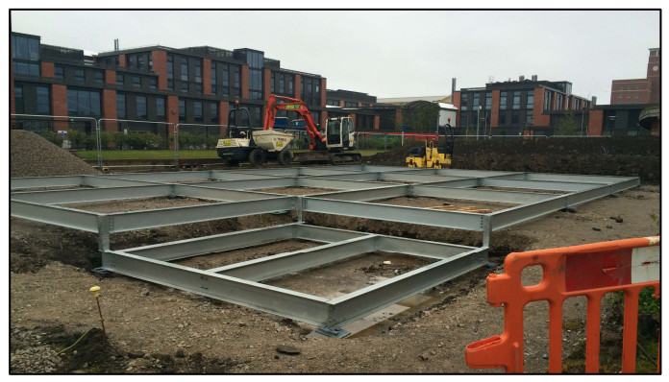
Figure XX: Showing The Active Classroom’s Steel Frame substructure
(Credit: Clarke,2020a)

In comparison, the Active Office that was constructed two years later opted for a different approach when it came to the substructure of the building. The office is a lot larger than the classroom, and therefore is lot heavier so the construction methods of choice had to be adapted to suit. The office sits on top of a concrete pad foundation as shown in figure XX, which then supports the steel frame construction of the building above, approximately 12 steel frame modules that were constructed off site were used to create the structure of the building (Clarke, 2020b). These steel frame modules are constructed in a controlled environment by Wernick, the supplier, whom state on their website that all waste steel, aluminium and timber is recycled resulting in “next to no landfill” (Fennell, 2019). It is also stated on the website that there are environmental benefits to opting to go with Wernick’s offsite modular construction as it greatly decreases the construction programme which results in less environmental implications on the surrounding site (Fennell, 2019). Lastly, Fennell also goes on to state that where possible, Wernick seek labour and materials locally, to reduce travel implications and support local businesses and communities, all of which is beneficial in Swansea’s carbon neutrality push.
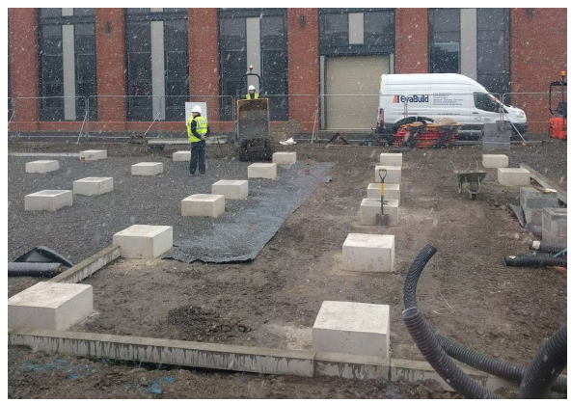
Figure XX: Showing The Active Office’s Concrete Pad substructure
(Credit: Clarke, 2020b)

Both buildings also make excellent use of the various products that SPECIFIC’s partners have available to them and in fact developed specifically for the concept of an ‘Active Building’. Firstly, NSG group’s glazing manufacturers, Pilkington UK, provided two of their patented products for both projects; The Pilkington Sunplus BIPV Glass and The Pilkington EnergiKare Advantage Glass (Britglass.org, 2023). The ‘Sunplus BIPV Glass’ is Pilkington’s innovative approach to architectural glazing. The glass is essentially a renewable energy generator, as it cleverly uses the solar energy from the sun to produce and store energy to be used within the building (Pilkington.com, 2023). There are many benefits gained from using said glass in the construction of a building, however the main factor that made Clarke opt for this during the development of the Active Classroom and Office is the durability, ease of construction and of course the sustainability benefits from the production of renewable energy (Britglass.org, 2023). The ‘EnergiKare Advantage Glass’ also supplied by Pilkington is another innovative product that Clarke opted for in the design of the two projects. The glass is known as Pilkington’s ‘most optimal’ glazing for thermal efficiency as, according to archiexpo.com, it provides triple glazing performance with only two panels of glass (Archiexpo.com, 2023). The glazing is ‘twice as efficient as standard double-glazing’ according to Pilkington’s website, as it utilises advanced dual coated glass panels which allow for less heat loss and more solar gain, resulting in again greater energy efficiency (Britglass.org, 2023).
Tata Steel also contributed significantly to both projects with the use of various different components manufactured in Port Talbot steel works, the key elements being; ‘Tata Steel Colorcoat Prisma pre-finished steel’ and ‘Tata Steel transpired solar collectors’ (Tatasteeleruope.com, 2023). The ‘Tata Steel Colorcoat Prisma pre-finished steel’ is what can only be described as a pre-fabricated cladding system that has an extensive aesthetic guarantee (Tatasteeleurope.com, 2019). The prefinished cladding was coated with Tata Steel’s ‘clear coat technology’ which enhances the UV protection and life span of the cladding system, the total lifecycle is boosted up to a 40-year span with promised weathering protection for the duration (Tatasteeleurope.com, 2019). When explaining her choice to opt for Tata Steel’s ‘Colorcoat Prisma’, Clarke explained that the prefinished cladding had a range of colours that matched the contextual surroundings of the existing buildings, and the clear coat technology attracted her to the material as it had the guarantee that the finish would last, therefore needing less maintenance in the long run keeping the operating cost of the buildings to a minimal (Clarke, 2020b). Finally, Tata Steel’s ‘Transpired Solar Collectors’ were also utilised in both the active classroom and office. This element is essentially an active solar air heating solution that provides a renewable ‘pre-heating’ option for space heating (Brown, 2014). The system captures solar energy from the sun and pulls it into the building by using the collectors that are on the exterior of the building, this then heats the fresh air that is in the cavity of the walls and is used to ‘pre-heat’ the main system, resulting in far less energy consumption by the main heating system (Erhlich, 2016). Clarke explained that the use of this system in the active buildings has been an essential part of lowering the energy consumption of the buildings due to its energy saving nature, and believes it plays a crucial role in the success of the buildings (Clarke, 2021).
Finally, it can be argued that both the ‘Active Classroom’ and ‘Active Office’ were successful projects by SPECIFIC and Joanna Clarke as they both demonstrated the concept of an ‘Active Building’ extremely well (Bevan, 2022). The ‘Active Classroom’ has been utilised extensively since its construction in 2016, ranging from being used as an actual classroom, to being used as an educational centre on SPECIFIC’s ambitions/projects (Bevan, 2022). The classroom has acted as a focal point for SPECIFIC’s research and has enabled them to demonstrate, monitor and validate new innovative technologies that could be taken to the larger scale industry (Bevan, 2022). Despite being a small scale project, it has sparked conversations within the wider industry as the building has proved that a lot of the sustainable technologies from SPECIFIC’s partners have worked extremely well and produced unarguable data (Bevan, 2022). Since completion, the ‘Active Classroom’ has produced 1.6 times the amount of energy its consumed, which is essentially what Clarke set out to achieve with the building, creating an energy positive piece of architecture (Specific.eu.com, 2020). While the ‘Active Office’ was seen as a slightly larger project, it still was designed and built for the same purpose as the classroom, to demonstrate the concept of an ‘Active Building’ (Greaves, 2021). The office has been used on a day to day for the university staff, students as well as local businesses who wish to learn more about sustainable solutions within the construction industry. In its first year of operation, the office energy use came down by around 12% and the average operational costs were around 43% lower than offices of a similar size (Greaves, 2021). Overall the office is said to produce more solar energy than it consumes which, again, was the original target from Clarke to demonstrate the renewable energy strategies of SPECIFIC, and it can be argued that the ‘Active Office’ achieved this with ease. The office saves around 1.2 tonnes of CO2 annually and has been recognised with numerous awards such as ‘The Most Innovative Building Project’ and ‘The Most Innovative Public Sector Project’ at the 2021 Buildings Innovation Centre (Nakedenergy.com, 2022). Overall, both projects achieved what they set out to achieve in demonstrating the renewable technologies of the time, and therefore showing the concept of an ‘active Building’ has a place in society moving forward.

After careful analysis of both Copenhagen and Swansea, including Copenhill and the Active Classroom and Office, one can begin to draw comparison between the two cities and explore what, if anything, Swansea can learn from Copenhagen. It is clear that both cities have made significant efforts to creating a more sustainable future, however there are some notable differences.
It can be argued that Copenhagen is around 25 years ahead of Swansea in its push for carbon neutrality as both cities share the same vision of becoming carbon neutral, only Copenhagen aims to achieve this by 2025, while Swansea by 2050 (Nikel, 2019). Copenhagen’s sustainability push dates back to around 1973 (Rudiger, 2014) and since then it is obvious that the Danish government have consistently introduced more legislation/infrastructural developments with sustainability at the core. Copenhagen has had a clear sustainability strategy set in place with the adoption of the 2025 climate plan back in 2012, and this has led to some of the most significant steps in Copenhagen’s carbon neutral push (Srivastava, 2022). From the introduction of Copenhagen’s district heating system, to the investment in off shore wind farms, it is apparent that the Danish government and other stakeholders in the city understand the significance of renewable energy production and consumption in becoming carbon neutral. Renewable energy production has increased during the greening of Copenhagen, now being at a point where approximately 50% of the total energy produced in the city is from renewable sources such as wind farms or biomass plants (State of Green, 2021).
When comparing this to Swansea, it becomes clear that renewable energy production is an area for improvement if Swansea is to begin closing the 25-year gap between the two cities. According to the ‘Energy generation in Wales’ report by the Welsh Government in 2020, Swansea produces approximately 27% renewable energy, nearly half of Copenhagen. One could argue that this represents the first opportunity for Swansea to learn from Copenhagen as clearly there is a vast difference between the two cities. Swansea has the potential to produce more renewable energy with projects such as the ‘Swansea Tidal Lagoon’ yet to come to fruition (Hinson, 2018). The lack of ambition to support sustainable projects like this from both the Swansea and UK governments is one of the major differences between the two cities and part of the reason why Copenhagen is so far ahead of Swansea in its carbon neutrality push. Copenhagen has had a clear objective since the adoption of the 2025 climate plan which Swansea could learn from, as it is evident that the guidelines in place, Copenhagen really has put sustainability at the heart of the majority of its major developments in recent years, which leads one to believe that Swansea would benefit massively from a similar action plan, not just a carbon neutral goal date.
Finally, upon analysis of Copenhagen’s sustainable transport options, it becomes apparent that this is perhaps another learning opportunity for Swansea. Copenhagen demonstrates an exemplar sustainable transport network throughout the city, boasting over 200 miles of curb segregated cycle lanes (Davis, 2023) and an extremely well interlinked public transport systems including the metro bus and train (Duggan et al., 2022). According to the ‘Carbon Neutral Cities’ website, Copenhagen has successfully managed to lower its transport emissions by approximately 42% since 2005, and this is mainly due to the transportation infrastructure of the city. Swansea on the other hand has a more limited sustainable transport network, with more focus on leisure cycling rather than integrating cycling into everyday transportation. The city does have small initiatives like the Santander bike sharing programme, and slowly installing more electric car charging points across the city, but these initiatives are yet to gain real traction and car is still very much the preferred method of transport in the city (Swansea Bay News, 2022). This presents another opportunity in the regeneration of Swansea to perhaps work to encourage the use of sustainable travel options more throughout the city. Learn from Copenhagen’s dedication to integrating sustainable travel in everyday life with the use of infrastructural developments like dedicated cycle lanes through the city, this could shift the preference of the people of Swansea from the car, and opt more for bike or public transport.
Overall, the three main lessons to be learnt from Copenhagen in the regeneration of Swansea are as follows;
- To develop a clear strategic plan to follow, like Copenhagen’s 2025 climate plan, in order to achieve the carbon neutral vision of 2050.
- To invest more into renewable energy projects throughout the city on a larger scale, one of the biggest drivers of a green city is its renewable energy generation.
- To continue to develop the city’s sustainable transport routes further, with the eventual goal of making sustainable travel more appealing than car travel etc.
If Swansea take these three lessons away from the Danish capital, then it could be argued that this would benefit the city massively in their carbon neutrality push and perhaps speed up the process to a pace that is more similar to that of Copenhagen, future-proofing the city and improving the lives of its inhabitants all while helping tackle the ever-growing issue of global warming on the planet.

Bibliography
Websites
Co, G. (2022) Green City Goals: 8 reasons why Copenhagen is the world's Greenest City, 8Shades. Available at: https://www.8shades.com/green-city-goals-copenhagen-sustainability/ (Accessed: 21 March, 2023).
European Commission (2012) Copenhagen European Green Capital 2014 European Green Capital Copenhagen European Green Capital 2014 Comments. Available at: https://ec.europa.eu/environment/europeangreencapital/copenhagen-european-green-capital-2014/ (Accessed: 21 March, 2023).
Heiburg, M. (2017) Copenhagen wins International Climate Prize, Wonderful Copenhagen. Available at: https://www.wonderfulcopenhagen.com/convention-bureau/copenhagen/copenhagen-wins-international-climate-prize (Accessed: 21 March, 2023).
Copenhagen (2020) CNCA. Available at: https://carbonneutralcities.org/cities/copenhagen/ (Accessed: 21 March, 2023).
CNCA (2017) Copenhagen, Carbonneutralcities.org. Available at: https://carbonneutralcities.org/cities/copenhagen/ (Accessed: 21 March, 2023).
Interreg (2020) Benefits of district heating, Guide to District Heating. Available at: https://guidetodistrictheating.eu/about/benefits-of-district-heating/#:~:text=District%20heating%20has%20many%20economic,comfort%20and%20reduced%20fuel%20poverty. (Accessed: 21 March, 2023).
Braff, D. (2023) Green City: Copenhagen, Denmark, Green City Times. Green City Times LLC. Available at: https://www.greencitytimes.com/copenhagen/#:~:text=Energy%20from%20wind%20farms%20(such,needs%2C%20on%20particularly%20windy%20days. (Accessed: 29 March, 2023).
CITIES100: Copenhagen - Carbon Neutral District heating (2022) C40 Cities. Available at: https://www.c40.org/case-studies/cities100-copenhagen-carbon-neutral-district-heating/ (Accessed: 29 March, 2023).
Johansen, K. (2022) Something is sustainable in the state of Denmark: A review of the Danish District Heating Sector, Renewable and Sustainable Energy Reviews. Pergamon. Available at: https://www.sciencedirect.com/science/article/pii/S1364032122000466 (Accessed: 29 March 2023).
Bundgaard, K. and Tatum, J. (2020) T wo approaches to buildings decarbonization - carbon neutral cities, Carbonneutralcities.org. Available at: http://carbonneutralcities.org/wp-content/uploads/2020/12/Two-Approaches-To-Buildings-Decarbonization.pdf (Accessed: 17 April, 2023).
Association Climate Chance (2018) Copenhagen - Becoming the first carbon neutral city, Copenhagen - becoming the first carbon-neutral city. Available at: https://www.citego.org/bdf_fiche-document-1869_en.html#:~:text=The%20implementation%20of%20phase%201,by%20the%20end%20of%202016. (Accessed: 29 March, 2023).
Copenhagen Climate Plan (2014) WWF. Available at: https://wwf.panda.org/wwf_news/?229197%2FCopenhagen-climate-plan (Accessed: 29 March, 2023).
Cop 16 cancun (2017) Center for Climate and Energy Solutions. Available at: https://www.c2es.org/content/cop-16-cancun/#:~:text=In%20large%20measure%2C%20the%20Canc%C3%BAn,to%20help%20verify%20countries'%20actions. (Accessed: 29 March, 2023).
Trimon, J. (2014) Pocket parks research: Small public urban green spaces (SPUGS) in Copenhagen, Denmark, Biophilic Cities. Available at: https://www.biophiliccities.org/pocket-parks-research-small-public-urban-green-spaces-spugs-in-copenhagen-denmark (Accessed: 29 March, 2023).
Kaye, L. (2015) Copenhagen reveals World's first neighborhood adapted for climate change, TriplePundit. Available at: https://www.triplepundit.com/story/2015/copenhagen-reveals-worlds-first-neighborhood-adapted-climate-change/37506 (Accessed: 29 March, 2023).
Ariza, M.C. (2020) Sustainable urban transport: What can we learn from Copenhagen?, Ciudades Sostenibles. IDB. Available at: https://blogs.iadb.org/ciudades-sostenibles/en/sustainable-urban-transport-what-can-we-learn-from-copenhagen/ (Accessed: 29 March, 2023).
Copenhagen by Bike, (2022) Cycle City Copenhagen. Available at: http://danishdesignreview.com/copenhagen-by-bike/category/planning (Accessed: April 1, 2023).
Rasmussen, D. (no date) How to get around Denmark with public transport, VisitDenmark. Available at: https://www.visitdenmark.com/denmark/plan-your-trip/public-transport (Accessed: 1 April, 2023).
Taking the Harbor Bus (ferry) (2022) DIS Copenhagen Semester. Available at: https://disabroad.org/copenhagen/student-resource/how-to-get-around-copenhagen/taking-the-harbor-bus-ferry/#:~:text=The%20clean%20harbor%20is%20not,trip%20takes%20about%20an%20hour. (Accessed: 1 April, 2023).
Stratton, M. (2020) Carbon-Free copenhagen: How the Danish capital is setting a green standard for cities worldwide, National Geographic. Available at: https://www.nationalgeographic.co.uk/travel/2020/03/carbon-free-copenhagen-how-danish-capital-setting-green-standard-cities-worldwide (Accessed: 01 April 2023).
Kennedy, P. (2020) Swansea - Wales's Second City, Propeterra. Available at: https://www.propeterra.com/resource-center/swansea-waless-second-city (Accessed: 02 April 2023).
Swansea Bay News (2023) Swansea ranks as the third-best UK city for raising children, Swansea Bay News. Available at: https://swanseabaynews.com/2023/03/21/swansea-ranks-as-the-third-best-uk-city-for-raising-children/ (Accessed: 03 April 2023).
Elsman, P. (2009) System of the year award, System of the Year Award - International District Energy Association. Available at: https://www.districtenergy.org/membership-services/awards-scholarships/system-year-award (Accessed: 06 April 2023).
Solver, C. (2022) Best ways to get around Copenhagen, Lonely Planet. Available at: https://www.lonelyplanet.com/articles/getting-around-copenhagen (Accessed: 06 April 2023).
Business News Wales LTD. (2022) Swansea named one of UK's most investable Green Cities Business News Wales. Available at: https://businessnewswales.com/swansea-named-one-of-uks-most-investable-green-cities/ (Accessed: 06 April 2023).
Green flag award (no date) Green Flag Award. Available at: https://www.greenflagaward.org/ (Accessed: 07 April, 2023).
Owens, S. (2018) It's been a record-breaking year for the Green Flag Awards in Wales, WalesOnline. Available at: https://www.walesonline.co.uk/special-features/more-green-flags-been-awarded-14921555 (Accessed: 07 April, 2023).
City parks flying the Green Flag for Excellence (2021) Swansea. Available at: https://www.swansea.gov.uk/article/11385/City-parks-flying-the-green-flag-for-excellence (Accessed: 7 April, 2023).
Glancy Nicholls Architects (2022) Swansea University Bay Campus, Glancy Nicholls Architects. Available at: https://www.glancynicholls.com/work/swansea-bay-campus (Accessed: 12 April, 2023).
McDonnell, P. (2016) Swansea Environmental Forum - ppt download, SlidePlayer. Christopher Harvey. Available at: https://slideplayer.com/slide/12999916/ (Accessed: 12 April, 2023).
McDonnell, P. (2021) Discover Swansea & The World, RISW. Available at: http://www.risw.org/events-and-activities.htm?id=86 (Accessed: 12 April, 2023).
Phillips, L. (2022) The £1.3bn Swansea bay city deal and its nine projects, WalesOnline. Wales Online. Available at: https://www.walesonline.co.uk/news/wales-news/what-13bn-swansea-bay-city-23627622 (Accessed: 15 April, 2023).
Swansea Bay City deal (2021) Swansea. Available at: https://www.swansea.gov.uk/article/9586/Swansea-Bay-City-Deal (Accessed: 17 April, 2023).
Swansea Digital Waterfront District (2021) Wales. Available at: https://tradeandinvest.wales/regional-strengths/swansea-digital-waterfront-district (Accessed: 17 April, 2023).
71 and 72 the Kingsway (2022) Swansea. Available at: https://www.swansea.gov.uk/article/7645/71-and-72-The-Kingsway#:~:text=We%20have%20appointed%20Bouygues%20UK,for%20completion%20by%20summer%202023. (Accessed: 17 April, 2023).
Barry, S. (2017) Plans to create 'box village' for Swansea built from shipping containers, WalesOnline. Available at: https://www.walesonline.co.uk/business/business-news/plans-create-new-innovation-village-12393546 (Accessed: 17 April, 2023).
Welch, A. (2022) Can shipping containers be used in construction industry?, e-architect.com. Available at: https://www.e-architect.com/articles/can-shipping-containers-be-used-in-construction-industry (Accessed: 18 April, 2023).
Green light for multi-million Pound Homes as Power Stations Project (2021) Swansea Bay City Deal. Available at: https://www.swanseabaycitydeal.wales/news/green-light-for-multi-million-pound-homes-as-power-stations-project/ (Accessed: 18 April, 2023).
Well-being of Future generations (wales) act 2015 (2020) The Future Generations Commissioner for Wales. Available at: https://www.futuregenerations.wales/about-us/future-generations-act/ (Accessed: 18 April, 2023).
Youle, R. (2023) Tidal lagoon, floating solar farm and Battery Plant 'will be delivered', WalesOnline. Available at: https://www.walesonline.co.uk/news/wales-news/swansea-council-blue-eden-lagoon-25956956 (Accessed: April 18, 2023).
Moore, C. (2022) North Wales £7bn tidal lagoon gets thumbs up from Council, Ground Engineering (GE). Available at: https://www.geplus.co.uk/news/north-wales-7bn-tidal-lagoon-gets-thumbs-up-from-council-03-03-2022/ (Accessed: April 18, 2023).
Vaughan, A. and Morris, S. (2018) Government rejects plan for £1.3bn tidal lagoon in Swansea, The Guardian. Guardian News and Media. Available at: https://www.theguardian.com/business/2018/jun/25/government-rejects-plan-for-tidal-lagoon-in-swansea (Accessed: April 18, 2023).
Waste and recycling (2012) environment.ec.europa.eu. Available at: https://environment.ec.europa.eu/topics/waste-and-recycling_en (Accessed: 20 January, 2023).
Ijeh, I. (2019) Projects: Copenhill Ski Slope and energy-from-waste plant, Copenhagen, Building. Available at: https://www.building.co.uk/buildings/projects-copenhill-ski-slope-and-energy-from-waste-plant-copenhagen/5102285.article (Accessed: 20 January, 2023).
Stevens, P. (2021) Bjarke Ingels Group's Copenhill Power Plant opens in Copenhagen, designboom. Available at: https://www.designboom.com/architecture/bjarke-ingels-group-copenhill-power-plant-copenhagen-10-04-2019/ (Accessed: 20 January, 2023).
Cooper, J. (2018) Copenhagen – will its waste be wonderful?, letsrecycle.com. Available at: https://www.letsrecycle.com/news/copenhagen-waste-wonderful/ (Accessed: 20 January, 2023).
Baldwin, E. (2020) Exploring big's Copenhill, the clean energy plant with its own ski slope - architizer journal, Architzer. Available at: https://architizer.com/blog/practice/details/bjarke-ingels-group-copenhill/ (Accessed: 20 January, 2023).
Copenhill (2022) Greenroofs.com. Available at: https://www.greenroofs.com/projects/copenhill/ (Accessed: 20 January, 2023).
Baldwin, E. (2019) Copenhill: The story of big's iconic waste-to-energy plant, Archdaily. Available at: https://www.archdaily.com/925966/copenhill-the-story-of-bigs-iconic-waste-to-energy-plant (Accessed: 19 April, 2023).
Mairs, J. (2022) Copenhill named WAF World Building of the Year, Architecture Today. Available at: https://architecturetoday.co.uk/copenhill-big-world-building-of-the-year-world-architecture-festival-2021/ (Accessed: 19 April, 2023).
Slavsky, B. (2020) World’s tallest climbing wall built on Copenhagen Power Plant, Climbing.com. Available at: https://www.climbing.com/news/worlds-tallest-climbing-wall-built-on-copenhagen-power-plant/ (Accessed: 19 April, 2023).
Crook, L. (2019) Big opens copenhill power plant in Copenhagen with rooftop ski slope, Dezeen. Available at: https://www.dezeen.com/2019/10/08/big-copenhill-power-plant-ski-slope-copenhagen/ (Accessed: 19 April, 2023).
Copenhill, by Bjarke Ingles Group | architect magazine (2019) Architectmagazine.com. Available at: https://www.architectmagazine.com/project-gallery/copenhill_o (Accessed: 20 April, 2023).
Bjerke, C. (2019) Big's skiable Copenhill Power Plant is a contradictory landmark, The Architect's Newspaper. Available at: https://www.archpaper.com/2019/10/big-skiable-copenhill-powerplant-crit/ (Accessed: 20 April, 2023).
Gurzu, A. (2019) Not enough's rotten in the state of Denmark, POLITICO. POLITICO. Available at: https://www.politico.eu/article/denmark-garbage-gamble-amager-bakke-plant-waste/ (Accessed: 20 April, 2023).
A Danish fiasco: The Copenhagen Incineration Plant (2021) Zero Waste Europe. Available at: https://zerowasteeurope.eu/2019/11/copenhagen-incineration-plant/#:~:text=A%20controversial%20background&text=In%20January%202012%2C%20the%20Amager,focus%20on%20recycling%20and%20reuse. (Accessed: 20 April, 2023).
Williams, J. (2017) Building of the week: Copenhill Power Plant, The Earthbound Report. Available at: https://earthbound.report/2017/10/27/building-of-the-week-copenhill-power-plant/ (Accessed: 21 April, 2023).
Baker, T. (2023) 06 Jan is structural steel a sustainable material?, Baker Steel Trading. Available at: https://www.bakersteeltrading.co.uk/is-structural-steel-sustainable/ (Accessed: 21 April, 2023).
Urban skiing on top of a waste management plant (2023) Elematic precast technology. Available at: https://www.elematic.com/concrete-issues/urban-skiing-on-top-of-a-waste-management-plant/ (Accessed: 21 April, 2023).
Kolnaar, T. (2021) Specification case study: Amager Bakke / copenhill by big, Archello. Available at: https://archello.com/news/specification-case-study-amager-bakke-copenhill-by-big (Accessed: 21 April, 2023).
Bernas, F. (2020) Copenhill: A waste to energy plant with a ski slope, DirectIndustry News. Available at: https://emag.directindustry.com/2020/11/30/copenhill-a-waste-to-energy-plant-with-a-ski-slope/ (Accessed: 21 April, 2023).
Fbs (2020) The world's most sustainable building material? aluminium, Fbs Profilati. Available at: https://fbsprofilati.it/sustainable-products/#:~:text=Aluminium%20is%20arguably%20the%20most,takes%20to%20create%20primary%20aluminum. (Accessed: 21 April, 2023).
The lifespan & recyclability of aluminium and steel (2021) Metals Warehouse. Available at: https://www.metalswarehouse.co.uk/lifespan-recyclability-aluminium-steel/ (Accessed: 21 April, 2023).
Concrete for energy- efficient buildings - the concrete initiative (2007) theconcreteinitiative.eu. Available at: https://www.theconcreteinitiative.eu/images/ECP_Documents/ConcreteForEnergyEfficientBuildings_EN.pdf (Accessed: 21 April, 2023).
Hartman, H. (2019) Big's copenhill waste-to-energy plant-cum-ski slope opens in Copenhagen, The Architects' Journal. Available at: https://www.architectsjournal.co.uk/buildings/bigs-copenhill-waste-to-energy-plant-cum-ski-slope-opens-in-copenhagen (Accessed: 21 April, 2023).
Grasmus (2020) Copenhill Recreation Center, Unusual Places. Available at: https://unusualplaces.org/copenhill-recreation-center/#:~:text=Copenhill%20is%20a%20multi%2Duse,far%20into%20the%20sky%20above. (Accessed: 22 April, 2023).
Copenhill: Copenhagen's Center for Urban Mountain Sport (2021) THE Stylemate. Available at: https://www.thestylemate.com/copenhill-denmark-copenhagens-epicenter-for-urban-mountain-sport-architecture/?lang=en (Accessed: 22 April, 2023).

Medea, R. (2018) Copenhill: Waste plant to become a Copenhagen tourist spot with Rooftop Entertainment Park, Life & Soul Magazine. Available at: https://lifeandsoulmagazine.com/2018/09/14/copenhill-waste-plant-aims-to-become-copenhagens-tourist-spot-with-new-rooftop-entertainment-park/ (Accessed: 22 April, 2023).
Katz, B. (2018) Big's Bjarke Ingels on his singular vision for Copenhill-the power plant–ski slope, Architectural Digest. Architectural Digest. Available at: https://www.architecturaldigest.com/story/big-bjarke-ingels-copenhill (Accessed: 22 April, 2023).
Pintos, P. (2019) Copenhill Energy Plant and Urban Recreation Center / Big, ArchDaily. ArchDaily. Available at: https://www.archdaily.com/925970/copenhill-energy-plant-and-urban-recreation-center-big (Accessed: 22 April, 2023).
Big-designed Copenhill / Amager Bakke Wins World Building of the Year Award for 2021 (2021) World Architecture Community. World Architecture Community. Available at: https://worldarchitecture.org/article-links/emcpe/big-designed-copenhill-amager-bakke-wins-world-building-of-the-year-award-for-2021.html (Accessed: 22 April, 2023).
Copenhill: Hedonistic sustainability – urbannext (2019) Urban Next. Available at: https://urbannext.net/copenhill/ (Accessed: 22 April, 2023).
Valence, S.D. (2019) The slopes are green at Copenhagen's first ski hill. really., The New York Times. The New York Times. Available at: https://www.nytimes.com/2019/10/23/travel/copenhagen-ski-hill-powerplant.html (Accessed: 22 April, 2023).
Jones, R. (2017) Swansea University's 'Buildings as power stations' project backed by UK Government funding, Business News Wales. Available at: https://businessnewswales.com/swansea-universitys-buildings-power-stations-project-backed-uk-government-funding/ (Accessed: 25 April, 2023).
Joanna Clarke (2022) Education Buildings Wales. Available at: https://www.educationbuildings.wales/speaker/joanna-clarke/ (Accessed: 25 April, 2023).
Welsh secretary: UK Government is investing in Swansea's infrastructure for the long term (2017) GOV.UK. Available at: https://www.gov.uk/government/news/welsh-secretary-uk-government-is-investing-in-swanseas-infrastructure-for-the-long-term (Accessed: 25 April, 2023).
The Active Office (2023a) Specific. Available at: https://www.specific.eu.com/the-active-office/ (Accessed: 25 April, 2023).
The Active Classroom (2023b) Specific. Available at: https://www.specific.eu.com/the-active-classroom/ (Accessed: 26 April, 2023).

Youle, R. (2020) What Swansea is doing to become a Greener City, WalesOnline. Available at: https://www.walesonline.co.uk/news/wales-news/swansea-climate-change-environment-council-17601030 (Accessed: 25 April, 2023).
Sullivan, K. (2017) Tomorrow’s office, today – Uk’s first energy-positive office opens in Swansea, Swansea.ac.uk. Available at: https://www-2018.swansea.ac.uk/press-office/news-archive/2018/tomorrowsofficetoday-uksfirstenergy-positiveofficeopensinswansea.php#:~:text=This%20new%20building%2C%20known%20as,Centre%20led%20by%20Swansea%20University. (Accessed: 25 April, 2023).
Our innovative Active Buildings are generating, storing and releasing their own energy (2022) Swansea University. Available at: https://www.swansea.ac.uk/research/research-highlights/steel-innovation/active-buildings/ (Accessed: 25 April, 2023).
Tradeandinvest.wales (2021) The Active Building Centre. Welsh Government. Available at: https://tradeandinvest.wales/regional-strengths/active-building-centre#:~:text=The%20Active%20Building%20design%20principle,Knowledge%20Centre%20at%20Swansea%20University. (Accessed: 25 April, 2023).
Clarke, J. (2023) What are active buildings and their core principles?, Specific. Available at: https://www.specific.eu.com/what-are-active-buildings/ (Accessed: 25 April, 2023).
Clarke, J. (2019) Designing active buildings, Active Building Centre. Available at: https://www.activebuildingcentre.com/designing-active-buildings/ (Accessed: 25 April, 2023).
The Public Building 'Energy Efficiency' report: Where can improvements be made to meet net-zero decarbonisation targets? (2023). Available at: https://neosnetworks.com/resources/blog/the-public-building-energy-efficiency-report-where-can-improvements-be-made-to-meet-net-zero-decarbonisation-targets/ (Accessed: 25 April, 2023).
Clarke, J. (2020a) Active Classroom Case Study, Specific.eu.com. Available at: https://specific.eu.com/uploads/Active_Classroom_Case_Study.pdf (Accessed: 26 April, 2023).
Clarke, J. (2021) Active building demonstrators: Specific: Swansea University: Sustainable Buildings, Carbon Copy. Available at: https://carboncopy.eco/initiatives/active-building-demonstrators (Accessed: 26 April, 2023).
Clarke, J. (2020b) Active Office Case Study, Specifc.eu.com. Available at: https://www.specific.eu.com/uploads/Active_Office_Case_Study.pdf (Accessed: 26 April, 2023).
Sullivan, K. (2020) Designing low carbon buildings: Swansea team's know-how gathered in new toolkit for others to use, Swansea University. Swansea University. Available at: https://www.swansea.ac.uk/press-office/news-events/news/2020/11/designing-low-carbon-buildings-swansea-teams-know-how-gathered-in-new-toolkit-for-others-to-use.php#:~:text=The%20Active%20Building%20design%20principle,for%20heat%2C%20power%20and%20transport. (Accessed: 26 April, 2023).
UK's first energy-positive classroom opens its doors (2017) passivehouseplus.ie. passivehouseplus.ie. Available at: https://passivehouseplus.ie/news/projects/uk-s-first-energy-positive-classroom-opens-its-doors (Accessed: 26 April, 2023).
Sustainable Construction in Steel (no date) Tata Steel in Europe. Available at: https://www.tatasteeleurope.com/construction/sustainability/sustainable-construction-in-steel (Accessed: 26 April, 2023).
Fennell, L. (2019) New Wernick Modular Building System • Wernick, Wernick. Available at: https://www.wernick.co.uk/new-wernick-modular-building-system/ (Accessed: 26 April, 2023).
Pilkington UK supports ground-breaking energy-positive office project (2023) Britglass.org. Available at: https://www.britglass.org.uk/news-comment/pilkington-uk-supports-ground-breaking-energy-positive-office-project (Accessed: 26 April, 2023).
Pilkington Sunplus™ bipv (2023) Pilkington Sunplus™ BIPV. Available at: https://www.pilkington.com/en/global/products/product-categories/solar-energy/pilkington-sunplus-bipv#benefits (Accessed: 27 April, 2023).
ENERGIKARE™ advantage - low-e glass panel by Pilkington: ArchiExpo (2023) The B2B marketplace for architecture and design. Available at: https://www.archiexpo.com/prod/pilkington/product-5773-1560107.html (Accessed: 27 April, 2023).
Colorcoat Prisma® (2019) Tata Steel in Europe. Available at: https://www.tatasteeleurope.com/construction/products/coil-flat-sheet/prefinished-steel-cladding/colorcoat-prisma (Accessed: 28 April, 2023).
Brown, C. (2014) Transpired solar collector installations in Wales and England, Science Direct. Elsevier. Available at: https://www.sciencedirect.com/science/article/pii/S1876610214002665 (Accessed: 28 April 2023).
Erhlich, B. (2016) Transpired solar collector performance: More than hot air, BuildingGreen. Available at: https://www.buildinggreen.com/news-article/transpired-solar-collector-performance-more-hot-air (Accessed: 28 April 2023).
Clarke, J. (2021) How the low-carbon active building works, RICS. Royal Institution of Chartered Surveyors (RICS). Available at: https://ww3.rics.org/uk/en/journals/built-environment-journal/how-the-low-carbon-active-building-works.html (Accessed: 28 April 2023).
Bevan, G. (2022) The future of the active classroom: Deconstructability of buildings for a circular economy, Specific. Available at: https://www.specific.eu.com/future-of-the-active-classroom/?utm_source=rss&utm_medium=rss&utm_campaign=future-of-the-active-classroom (Accessed: 28 April 2023).
Active classroom - specific (2020) Active Classroom Web Case Study. Available at: https://www.specific.eu.com/assets/downloads/casestudy/Active_Classroom_Web_Case_Study.pdf (Accessed: 28 April 2023).
Greaves, M. (2021) Transforming construction, Active Office – Transforming Construction. Available at: https://tc-catalogue.strongerstories.org/stories/active-office/ (Accessed: 28 April 2023).
Specific IKC – the active office (2022) Naked Energy. Naked Energy. Available at: https://nakedenergy.com/case-studies/specific-ikc (Accessed: 28 April 2023).
Nikel, D. (2019) Copenhagen aims to be world's first carbon neutral capital by 2025, Forbes. Forbes Magazine. Available at: https://www.forbes.com/sites/davidnikel/2019/08/22/copenhagen-aims-to-be-worlds-first-carbon-neutral-capital-by-2025/?sh=440c88a77fb3 (Accessed: 29 April 2023).
A record year: Wind and solar supplied more than half of Denmark's electricity in 2020 (2021) State of Green. Available at: https://stateofgreen.com/en/news/a-record-year-wind-and-solar-supplied-more-than-half-of-denmarks-electricity-in-2020/ (Accessed: 29 April 2023).
Brown, E. (2019) The world’s first combination ski slope-power plant is finally open, Fast Company. Fast Company & Inc. Available at: https://www.fastcompany.com/90414117/the-worlds-first-combination-ski-slope-power-plant-is-finally-open (Accessed: 30 April 2023).
Srivastava, S. (2022) The sustainable city: Learning from Copenhagen's plan for Zero carbon, SPUR. Available at: https://www.spur.org/news/2022-08-31/sustainable-city-learning-copenhagens-plan-zero-carbon (Accessed: 30 April 2023).
Hinson, S. (2018) Tidal Lagoons - House of Commons Library, House of Commons Library. Available at: https://commonslibrary.parliament.uk/research-briefings/cbp-7940/ (Accessed: 30 April 2023).
Davis, R. (2023) The Best Bike Lanes in the world: 12 cities doing it right, Discerning Cyclist. Available at: https://discerningcyclist.com/best-bike-lanes-in-the-world/ (Accessed: 30 April 2023).
Duggan, A. et al. (2022) Public transportation in Copenhagen, ArcGIS StoryMaps. Esri. Available at: https://storymaps.arcgis.com/stories/a55f8e424bb249b5ae7ccba79c4e485b (Accessed: 30 April 2023).
Rudiger, M (2014) The 1973 Oil Crisis and the Designing of Danish Energy Policy, Vol. 39, No. 4 (150), 2014, Special Issue: The Energy Crises of the 1970s: Anticipations and Reactions in the Industrialized World. Available at: https://www.jstor.org/stable/24145529 (Accessed: 12 March 2023)
Swansea, UK metro area population 1950-2023 (2023) MacroTrends. Macro Trends LLC. Available at: https://www.macrotrends.net/cities/22882/swansea/population#:~:text=The%20metro%20area%20population%20of,a%200.64%25%20increase%20from%202020. (Accessed: 1 May 2023).
Anderson, M. (2022) Green City: What is a sustainable city and why is it important?, Green City: What Is a Sustainable City and Why Is It Important? Milwaukee Tool. Available at: https://onekeyresources.milwaukeetool.com/en/green-city (Accessed: 1 May 2023).
Published by Statista Research Department and 1, J. (2022) Copenhagen: Total population 2022, Statista. Available at: https://www.statista.com/statistics/1303909/population-copenhagen/ (Accessed: 1 May 2023).
Schurig, S. (2018) Regenerative cities - an urban concept whose time has come!, Medium. TheBeamMagazine. Available at: https://medium.com/thebeammagazine/regenerative-cities-an-urban-concept-whose-time-has-come-e08b5271ccf8 (Accessed: 1 May 2023).
Wollerton, M. (2021) What does carbon neutral mean?, CNET. CNET. Available at: https://www.cnet.com/home/energy-and-utilities/what-does-carbon-neutral-mean/ (Accessed: 1 May 2023).
Selin, N. (2023) Carbon footprint, Encyclopædia Britannica. Encyclopædia Britannica, inc. Available at: https://www.britannica.com/science/carbon-footprint (Accessed: 1 May 2023).

Academic Papers
Rüdiger, Mogens. “The 1973 Oil Crisis and the Designing of a Danish Energy Policy.” Historical Social Research / Historische Sozialforschung, vol. 39, no. 4 (150), 2014, pp. 94–112. JSTOR, http://www.jstor.org/stable/24145529. (Accessed 21 Mar. 2023).

Mathiesan, B. et al. (2015) Copenhagen Energy Vision: A sustainable vision for bringing a capital to 100% renewable energy. rep. Aalborg University, pp. 14–16. (Accessed 21 March. 2023)
Ulrik Kohl (2019) ‘The Copenhill Crisis: The Dark side of planning the greenest waste-fired power plant ever seen’, Masters Thesis, Malmo University, Malmo. (Accessed 20 April, 2023)

Books

Bundgaard, J. and Lexner, K. (2011) ‘Denmark’s Tax Incentives to Promote Renewable Energy’, Tax notes international. Available at: https://corit-advisory.com/wp-content/uploads/2011/12/61TI0515-Bundgaard_Lexner1.pdf
(Accessed: 29 March, 2023)
Leonard, M. and Edwards, A. (2014) “1,” in City Cycling copenhagen. London: Thames & Hudson, pp. 10–18.

Government Documents

Danish Energy Agency, (2022) 2021 Data, tables, statistics and maps: Energy Statistics 2021. Available at: https://ens.dk/sites/ens.dk/files/Statistik/energy_statistics_2021.pdf
(Accessed: 29 March, 2023)
Energy and climate change (2017) European Environment Agency. Available at: https://www.eea.europa.eu/publications/renewable-energy-in-europe-2017 (Accessed: 21 March, 2023).
UNFCCC (2021) The Paris Agreement, Unfccc.int. Available at: https://unfccc.int/process-and-meetings/the-paris-agreement (Accessed: 29 March, 2023).
Net zero 2050 (2022) Swansea. Available at: https://www.swansea.gov.uk/netzero2050 (Accessed: 6 April, 2023).

Informational Brochure
Orsted CDN (2016) Anholt Offshore Wind Farm. Copenhagen: Orsted CDN.
City of Copenhagen (2014) Copenhagen: Solution for sustainable cities, 3rd ed. P.32, 36, 40,
45
Pearce, N. (2020) Homes as Power Stations Business Case. rep. Swansea: Neath Port Talbot CBC, pp. 2–6.
Tata Steel (2012) Colorcoat Urban. Tata Steel UK Limited. Available at: https://www.iplanarchitecture.co.uk/uploads/3/0/8/3/30831017/corus_colorcoat_urban_brochure1.pdf (Accessed: April 25, 2023).

News Articles
Douglas, K. and Douglas, J. (2021) “NewScientist,” Green spaces aren't just for nature - they boost our mental health too!, 24 March.
Bernas, F. (2020) “Copenhill : A Waste to Energy Plant with a Ski Slope,” Direct Industry E-Magazine, 30 November, pp. 1–1.

