

A Study of Machine Learning Models to identify feature-based trends in Vehicle Taxation Compliance

by
Craig Oldham

Supervisor: Mark Huntly

Project submitted as part of the requirements for the award of
BSc (Hons) Computing (Data Information Systems)

July 2026
DECLARATION

I, Craig Robert Oldham declare that I am the sole author of this Project; that all references cited have been consulted; that I have conducted all work of which this is a record, and that the finished work lies within the prescribed word limits.

This work has not previously been accepted as part of any other degree submission.

Date : 17th August 2026

FORM OF CONSENT

I, Craig Robert Oldham hereby consent that my Project, submitted in candidature for the B.Sc.(Hons) Computing (Data Information Systems) degree, if successful, may be made available for inter-library loan or photocopying (subject to the law of copyright), and that the title and abstract may be made available to outside organisations.

Date : 17th August 2026

Abstract
The reporting of Vehicle Excise Duty (VED) compliance within the Driver and Vehicle Licensing Agency (DVLA) focuses primarily on compliance outcomes and provides little insight into the factors influencing compliance behaviour.
The aim of this project was to investigate whether machine learning techniques could be used to identify feature-based patterns in the VED compliance data while assessing the influence fleet management companies have on overall compliance rates.
The objectives were to evaluate appropriate classification algorithms, identify the key predictors of compliance, and improve understanding of compliance behaviours through explainable AI (XAI) techniques.
A quantitative research methodology was used using historical DVLA data for tax reminders and transactions, supplemented by vehicle record information. Following data preparation and feature engineering, Logistic Regressions, Random Forest and Support Vector Machine (SVM) models were trained and evaluated using balanced accuracy, precision, F1-score, recall and ROC-AUC metrics. The interpretability of these models was supported by Random Forest feature importance analysis and SHAP explanations.
Initial experimentation achieved near-perfect predictions; however, further analysis identified there was significant target leakage cause by compliance-related and transaction-derived features. After the removal of these features, model performance reduced to more realistic levels. Random Forest consistently achieved the strongest results, with a balanced accuracy of 0.629 and ROC-AUC of 0.675.
The age of a vehicle was identified as the most influential predictor of compliance behaviour, while fleet membership, taxation class, vehicle type and licensing characteristics also contributed to model performance. Although fleet-managed vehicles demonstrated slightly higher compliance rates, their overall influence was limited.
The study concludes that machine learning can identify meaningful feature-based patterns within VED compliance data and provide valuable insight into compliance behaviour. The findings also demonstrate the importance of feature selection, target leakage detection and model interpretability when developing predictive models. It is recommended that future research focuses on improving the identification of non-compliant cases, addressing class imbalance, and evaluating additional machine learning techniques and data sources to enhance predictive performance.

Contents
Abstract 3
Table of Figures 9
Current Solution 13
Research Question 17
Project Aim 17
Project Objectives 17
Report Structure 18
Chapter 2 - Research and Review of Literature 19
2.1 Machine Learning and Compliance Analysis 20
2.2 Logistic Regression 22
2.3 Support Vector Machine (SVM) 23
2.4 Random Forests 25
2.5 Explainable AI 27
2.6 Conclusion 29
Chapter 3 - Research Methodology 30
3.1 Research Methodology 30
3.2 Research Philosophy and Research Design 31
3.2.1 Research Philosophy 31
3.2.2 Research Approach 31
3.2.3 Research Strategy 31
3.2.4 Methodological Choice 32
3.2.5 Time Horizon 32
3.2.6 Data Collection and Analysis 32
3.3 Experimental Hypothesis 32
3.4 Hardware 33
3.5 Software 33
3.6 Inputs 34
3.7 Data Preparation 34
3.8 Validity, Reliability and Generalisability 35
3.8.1 Validity 35
3.8.2 Reliability 35
3.8.3 Generalisability 35
3.9 Experimental Procedure 36
3.9.1 Experiment Workflow 36
3.9.2 Data Preparation and Cleansing 37
3.9.3 Dataset Splitting 37
3.9.4 Model Training 38
3.9.5 Model Evaluation 38
3.9.6 Explainability Analysis 38
3.9.7 Reporting 38
Chapter 4 - Design and Implementation 39
4.1 Additional Features 39
VED Reminder Files 39
Licensing Transaction Files 40
Quarterly Vehicle Record Extract (Census) 41
4.2 Initial Experiment Results 42
4.3 Experiment 1: Full Model 45
4.4 Experiment 2: Rule Features Removed 48
4.5 Experiment 3: Behavioural Model & Fleet Vehicle Analysis 52
4.6 Experiment 4: Final Behavioural Model Evaluation 56
Chapter 5 – Evaluation 61
Chapter 6 - Conclusions and Recommendations 64
6.1 Conclusion 64
6.2 Recommendations 65
CHAPTER 7 – REFLECTION 66
References 67
Annex A: Data Input Source Definitions 71
V11 VED Reminder Tables 71
Monthly Licensing Tables 71
Vehicle Record Quarterly Extract (Census) 71
Annex B – DVLA Transaction Definitions 72

Table of Figures
Figure 1: Section of Python Script used to generate VED Compliance 13
Figure 2: Section of Python Script used to update report Dataset 14
Figure 3: Underlying Dataset for VED Compliance Report 14
Figure 4: 3 Year comparison of Final VED Compliance 15
Figure 5: Timeline of VED Compliance at Key Dates 15
Figure 6: Monthly Timeline of VED Compliance (Volume and Percentage) 16
Figure 7: Feature filters currently available for VED Compliance 16
Figure 8: Linear vs Non-linear SVM decision boundaries (Adapted from geeksforgeeks.org) [10] 23
Figure 9: Random Forest Prediction Diagram (Taken from medium.com) [18] 25
Figure 10: Research Workflow Diagram 36
Figure 11: Available features in the VED Reminder File 39
Figure 12: Available features in the Transaction Files 40
Figure 13: Example of Fields available in the Quarterly Vehicle Record Extract 41
Figure 14: Experiment Results from Machine Learning Models 43
Figure 15: SHAP Analysis of Experiment 4 44
Figure 16: Experiment 1 Model Performance Metrics 45
Figure 17: Experiment 1 Feature Importance Analysis Results 46
Figure 18: Experiment 2 Model Performance Metrics 48
Figure 19: Experiment 2 Feature Importance Analysis Results 49
Figure 20: Experiment 2 SHAP Feature Analysis 49
Figure 21: Experiment 2 Target Leakage Results 50
Figure 22: Experiment 3 Model Performance Metrics 52
Figure 23: Experiment 3 Feature Importance Analysis Results 53
Figure 24: Results of Fleet company keepership analysis 55
Figure 25: Experiment 4 Model Performance Metrics 56
Figure 26: Experiment 4 Feature Importance Analysis Results 57
Figure 27: Experiment 4 Shap Feature Analysis 59
Chapter 1 - Introduction
As an executive agency for the Department for Transport [1], the Driver and Vehicle Licensing Agency (DVLA) are responsible for the maintenance of nearly 53 million driver records and 47 million vehicle records and collected £8.4 billion in Vehicle Excise Duty (VED) for the financial year 2024 to 2025.
While it is the responsibility of a vehicle keeper to ensure the correct VED is obtained for their vehicle(s), the DVLA issue reminder letters to prompt the customer to comply. Based on the 2023 Vehicle Excise Duty Evasion Statistics [2], we know that around 98.7% of customers are compliant. However, there is very little reported on the features of those customers, and little trend analysis is done from the data available.
Although overall compliance remains high, even small improvements can have a significant impact due to the scale of the vehicle population and the value of Vehicle Excise Duty revenue collected each year. Understanding the characteristics associated with compliant and non-compliant behaviour could enable more targeted interventions, improve reporting capabilities and support evidence-based policy decisions.
Any analysis currently undertaken is carried out manually by Data Analysts working for the DVLA or the Department for Transport and requires a considerable amount of analyst time and resource, which is not always available.
To address this challenge, this project investigates whether machine learning techniques can be used to identify feature-based patterns within VED compliance data and determine the influence of fleet management companies on compliance behaviour. By combining predictive modelling with Explainable Artificial Intelligence techniques, the research aims to provide both accurate predictions and meaningful insight into the factors associated with compliance outcomes.

Current Solution
VED Compliance is currently generated each month using a Python triggered SQL script which compares the relevant month’s reminder file to transaction files, joining the data based on the Vehicle Registration Mark, and returning the earliest transaction where one is present (Figure 1).
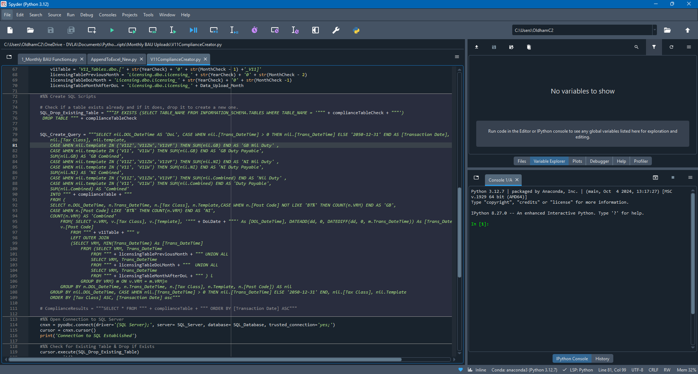
Figure 1: Section of Python Script used to generate VED Compliance
Another script (Figure 2) then reads the results and updates them into an Excel file (Figure 3) which is used as the dataset for the final report.
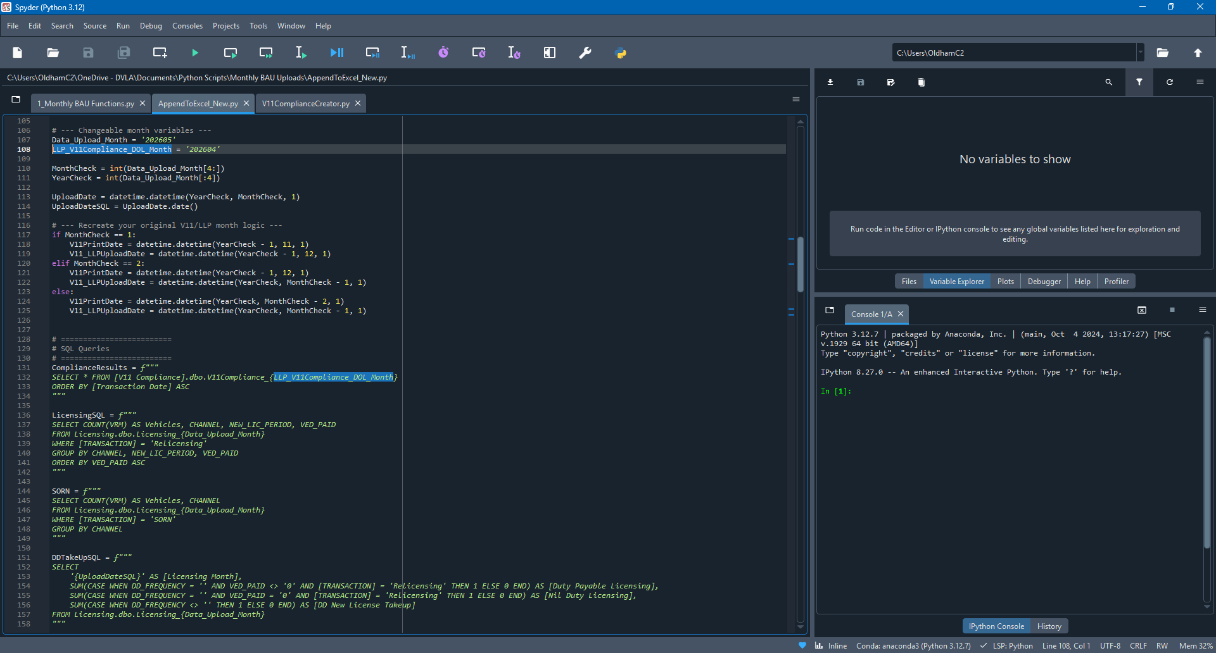
Figure 2: Section of Python Script used to update report Dataset
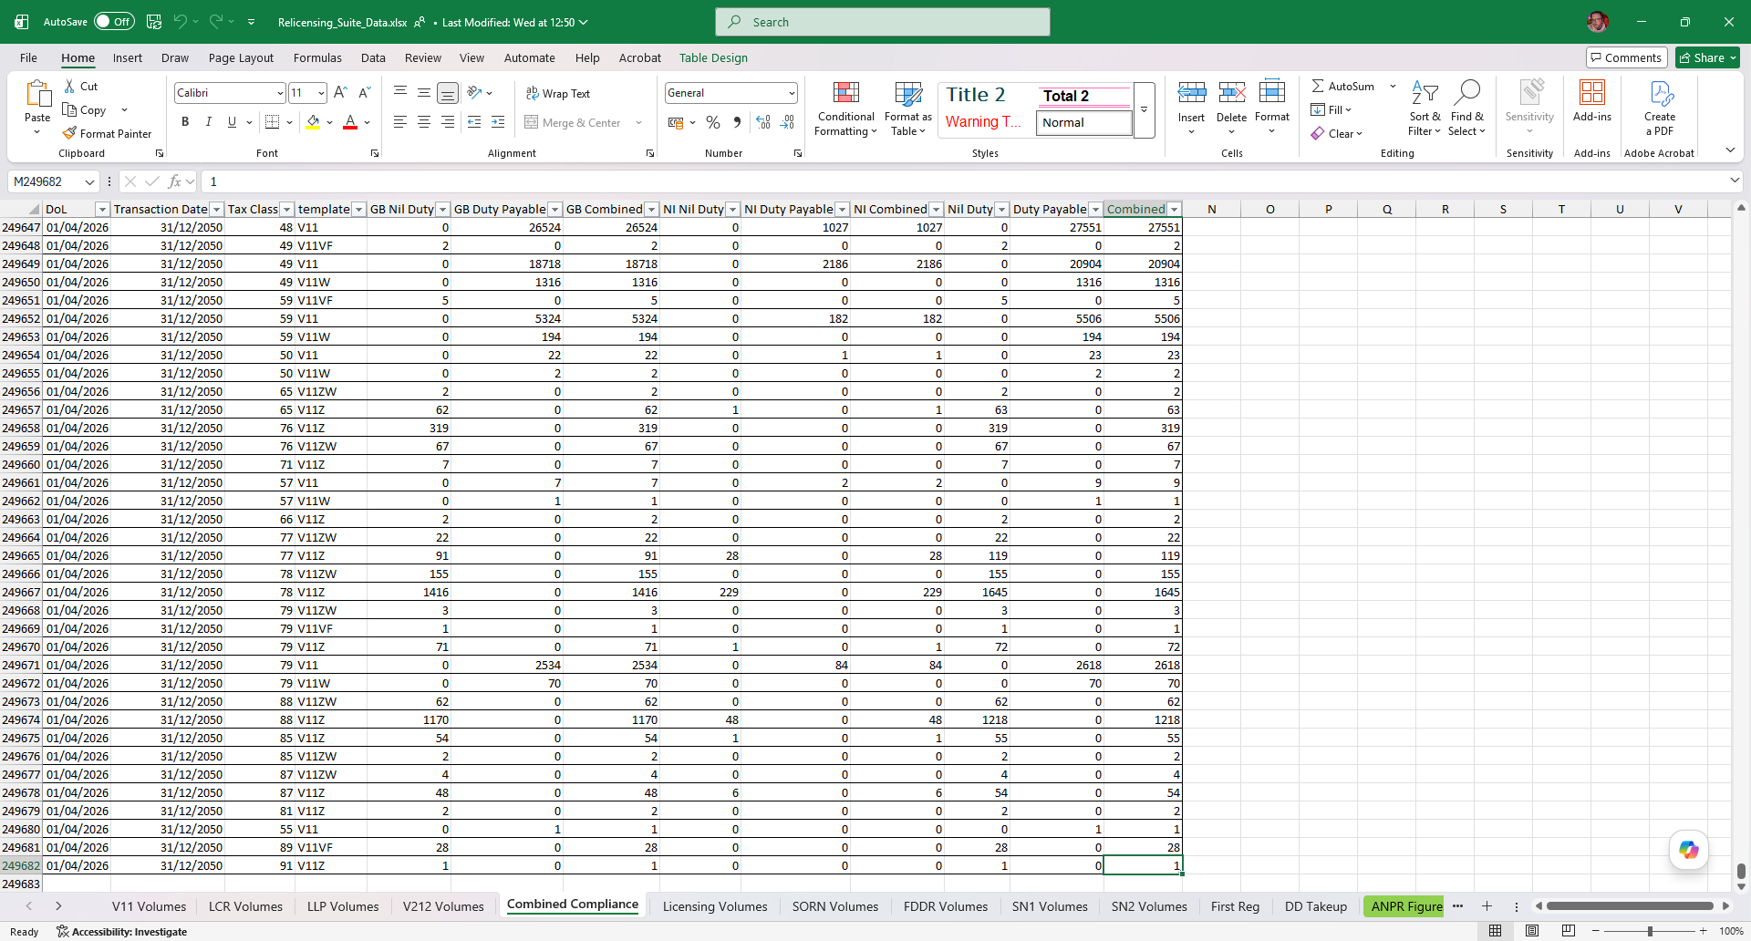
Figure 3: Underlying Dataset for VED Compliance Report
As this shows, currently we report on a time-series of when a customer transaction takes place, what Taxation Class (a definition which determines the rate of VED) the vehicle is registered in, the template of the VED reminder that was used, and what region of the UK the vehicle is currently registered in.

This data is then connected to a Power BI model, and the final reports are generated to display total VED Compliance (Figure 4), compliance at specific points during the period checked (Figure 5) and the timeline of compliance (Figure 6) which shows more clearly when in the compliance period our customers comply early, and those who are late complying.
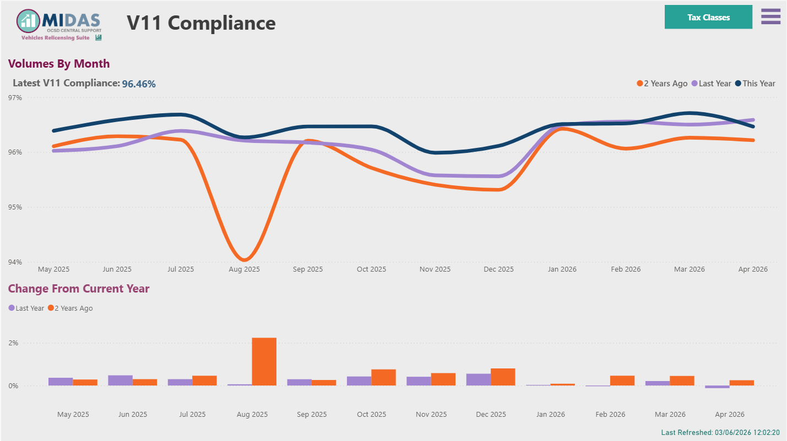
Figure 4: 3 Year comparison of Final VED Compliance

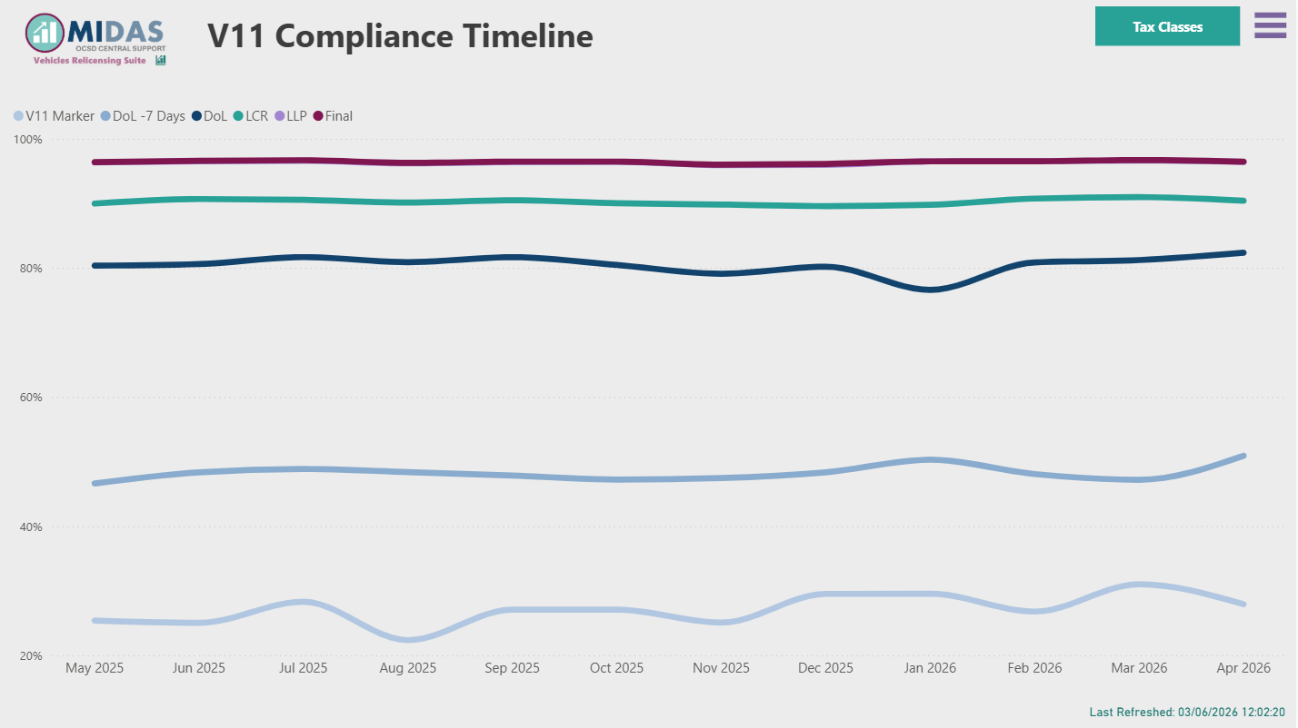
Figure 5: Timeline of VED Compliance at Key Dates
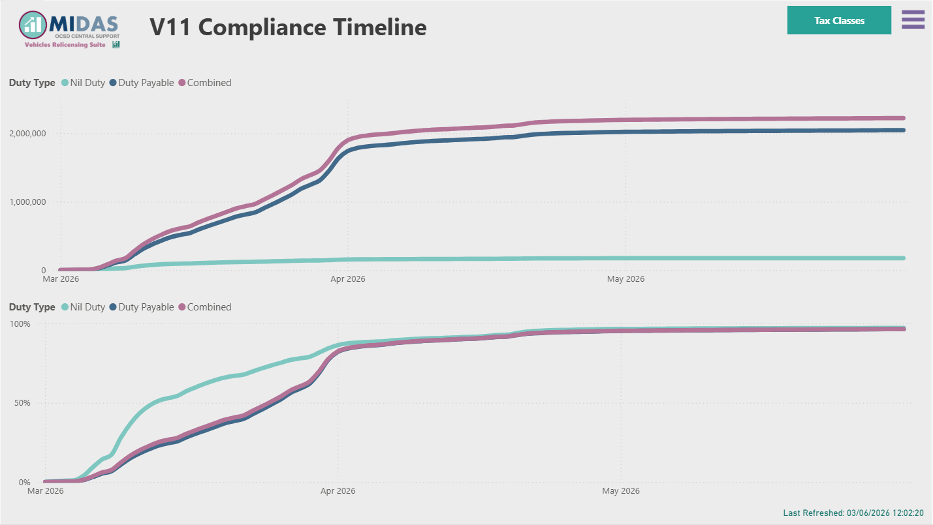
Figure 6: Monthly Timeline of VED Compliance (Volume and Percentage)
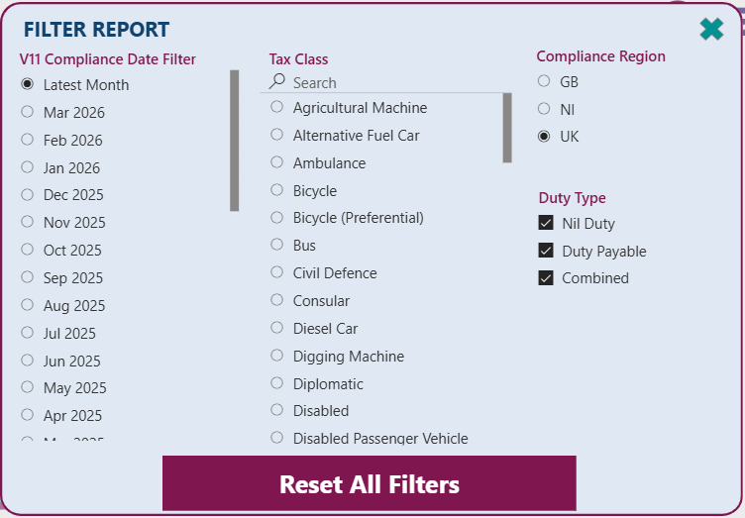
Figure 7: Feature filters currently available for VED Compliance
As can be seen in Figure 7 the features previously mentioned are filterable in the report, allowing users of the report to view the compliance in different ways. However, there are more features that are available that could provide greater insight into what type of customer is likely to be compliant compared to those who do not comply on which we do not currently report.
There are other features that we can enrich the data with which will form part of the experiment.

Research Question
Can machine learning identify feature-based patterns in VED compliance data and assess the influence of fleet management companies on compliance rates?

Project Aim
To apply appropriate machine learning techniques to VED compliance data to identify patterns and feature-based trends, and to assess the impact of fleet management company involvement on overall compliance rates through analytical and visual reporting.

Project Objectives
- To critically review existing machine learning algorithms and interpretability techniques to identify suitable approaches for VED compliance analysis.
- To preprocess and prepare VED compliance data, including feature selection and transformation, and to develop and train selected machine learning models.
- To evaluate the performance of the trained models using appropriate metrics (e.g., accuracy, precision, recall, or error measures) in identifying patterns and trends within the data.
- To analyse model outputs using interpretability methods (e.g., feature importance or SHAP/LIME) and present findings through visual and analytical reporting on factors influencing compliance rates.

Report Structure
Chapter 2 reviews the existing literature on machine learning classification techniques and Explainable Artificial Intelligence. Chapter 3 describes the research methodology and experimental design adopted for the study. Chapter 4 presents the design and implementation of the solution. Chapters 5 and 6 evaluate the findings and present conclusions and recommendations, while Chapter 7 reflects on the project process and lessons learned.

Chapter 2 - Research and Review of Literature
Current VED compliance reporting focuses primarily on measuring compliance outcomes rather than identifying the factors that influence those outcomes. As discussed in Chapter 1, the volume of data generated from V11 reminders, licensing transactions and vehicle records makes manual identification of underlying patterns challenging. Machine learning offers a potential solution by enabling large datasets to be analysed automatically and by identifying relationships between features and compliance behaviour that may not be apparent through traditional reporting methods. Consequently, this literature review examines machine learning classification techniques and explainability methods that may be suitable for identifying feature-based patterns within VED compliance data.
The objective of this research is not simply to predict compliance outcomes, but to identify the characteristics associated with compliant and non-compliant behaviour. From an analytical perspective, the problem can be viewed as a binary classification task, where historical vehicle and keeper characteristics are used to predict whether a vehicle keeper will comply within the required taxation period. Successful implementation of this type of approach could provide insights beyond traditional descriptive reporting by highlighting the factors most strongly associated with compliance behaviours and enable more targeted investigations in to non-compliant keepers.

2.1 Machine Learning and Compliance Analysis
Machine learning has emerged as one of the most successful branches of artificial intelligence, enabling computers to identify patterns within data and make predictions without being explicitly programmed for every scenario. The foundations of machine learning can be traced to Turing’s question of whether machines could think, a concept that has evolved into modern systems capable of learning from large volumes of data and adapting their behaviour based on previous observations [3].
Machine learning is now widely used across healthcare, finance, transportation, and government services to support decision making. In many of these domains, machine learning models are applied to classification problems, where the objective is to determine which category an observation belongs. Examples include fraud detection, medical diagnosis, and customer behaviour prediction [4].
Vehicle Excise Duty (VED) compliance can similarly be viewed as a classification problem. Each vehicle keeper can be categorised as either compliant or non-compliant based on whether the required licensing transaction occurs within the expected compliance period. Despite the availability of substantial operational data, current analysis within VED compliance reporting remains descriptive and is reliant on manual investigation undertaken by analysts. This approach can be time-consuming and may be influenced by pre-existing assumptions regarding the factors that affect compliance.
Machine learning offers an alternative approach by enabling models to identify significant relationships and feature-based trends directly from historical data. Rather than simply reporting compliance outcomes, machine learning can be used to determine which characteristics are most strongly associated with compliant behaviour and whether factors such as fleet management company involvement influence compliance rates.
As the compliance outcome is already known within the historical dataset, supervised learning techniques are the most appropriate class of algorithms for this research. Several candidate models have been identified within the literature, each offering different advantages in terms of predictive performance, interpretability, and practical implementation.

2.2 Logistic Regression
Regression techniques are among the most widely used supervised machine learning methods for modelling relationships between features. Das Hait et al. describe regression as a statistical approach that identifies relationships between a dependent feature and one or more independent features, with the objective of minimising prediction error [5]. Whilst linear regression is commonly used to predict continuous outcomes, classification problems involving binary outcomes require an alternative approach. As VED compliance can be categorised as either compliant or non-compliant, Logistic Regression provides a more suitable extension of regression principles for this study.
As the outcome variable in this study is binary, consisting of compliant and non-compliant vehicle keepers, Logistic Regression represents a natural extension of traditional regression techniques. Unlike linear regression, which predicts continuous values, Logistic Regression estimates the probability that an observation belongs to a particular class using a logistic function. Hosmer, Lemeshow and Sturdivant [6] describe the technique as one of the most widely adopted approaches for binary classification due to its ability to model the relationship between explanatory Features and categorical outcomes. A further advantage is the interpretability of the resulting coefficients, which can be expressed as odds ratios and used to explain the contribution of individual Features to the predicted outcome [7]. However, Logistic Regression may struggle to model highly complex or non-linear relationships without additional feature engineering, which has led researchers to explore more flexible machine learning approaches in recent years.

2.3 Support Vector Machine (SVM)
Originally introduced as Support Vector Networks in the 1990’s [8], Support Vector Machines (SVMs) are supervised learning algorithms that construct optimal separating hyperplanes within a high-dimensional feature space.
SVMs were introduced to address classification problems by identifying an optimal boundary between classes [8]. Unlike regression approaches which attempt to model relationships directly, SVMs focus on finding the decision boundary that maximises the separation between observations belonging to distinct categories [9].
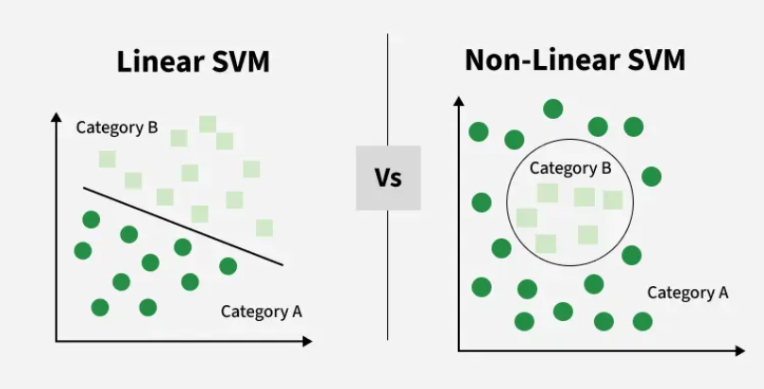
Figure 8: Linear vs Non-linear SVM decision boundaries (Adapted from geeksforgeeks.org) [10]
The principal advantage of SVMs is their ability to perform effectively within high-dimensional datasets containing large numbers of features. Using kernel functions, SVMS can model both linear and non-linear relationships, allowing them to identify complex patterns that would be difficult for simpler algorithms to detect [11][12].
Research consistently highlights the strong generalisation capabilities of SVMs. By maximising the margin between classes, the models often achieve high predictive performance whilst reducing the risk of overfitting [13]. This characteristic has contributed to their successful application across fields such as image recognition, bioinformatics, and behavioural prediction.
However, these benefits come with several limitations. SVMs can become computationally expensive when applied to large datasets and may require substantial parameter tuning to achieve optimal results [14] [15]. Performance can also deteriorate when classes are heavily imbalanced, a potentially important consideration given that VED compliance rates exceed 98% of vehicle keepers [2].
Despite these challenges, SVMs remain a strong candidate for this research because they are specifically designed for binary classification problems and can identify complex relationships between features and outcomes. This makes them particularly relevant to VED compliance analysis, where the objective is to distinguish between compliant and non-compliant vehicle keepers and identify the characteristics associated with each group.

2.4 Random Forests
Ensemble learning refers to machine learning techniques which combine the predictions of multiple models to generate a single prediction. The idea behind ensemble methods is that aggregating outputs of multiple learners can improve the performance of predictions by reducing variance, bias, or both, compared to reliance on a single model.
Random Forests represent one of the most successful ensemble learning approaches in modern machine learning. Introduced by Breiman [16], the technique combines the predictions of multiple decision trees to improve both accuracy and robustness.
Rather than relying on a single decision tree, Random Forest models construct numerous trees using randomly selected subsets of observations and features. The final prediction is determined through the aggregation of individual tree outputs, typically by majority voting in classification problems [16] [17].

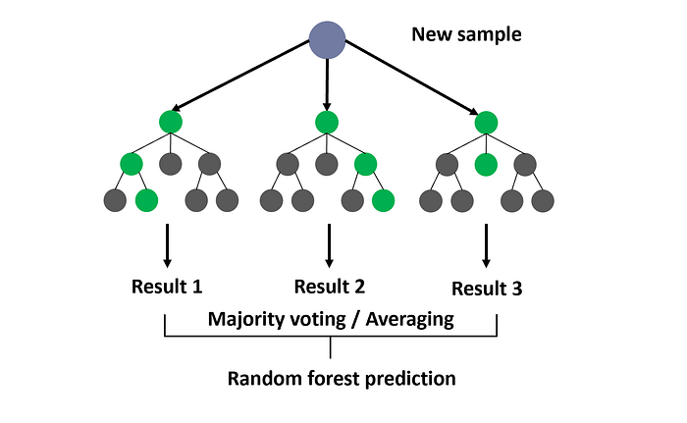
Figure 9: Random Forest Prediction Diagram (Taken from medium.com) [18]
The literature identifies several advantages associated with Random Forests. The technique can model complex non-linear relationships, cope effectively with high-dimensional data and is resistant to overfitting due to its ensemble structure [19] [20].
Random Forests have also demonstrated strong predictive performance across a wide range of domains without requiring extensive assumptions regarding data distributions [21].
An additional benefit is the ability to generate measures of feature importance. These measures can provide insight into which Features contribute most strongly to model predictions, offering a degree of interpretability that is often absent in other high-performance machine learning approaches [22].
Despite these strengths, Random Forest models are frequently criticised for their limited transparency. Whilst overall feature importance can be calculated, the full decision-making process remains difficult to understand due to the substantial number of trees involved [23]. This has led some researchers to describe Random Forests as black-box models, particularly when deployed within high-stakes domains where decision justification is essential [23] [24].
Nevertheless, the balance between predictive performance and partial interpretability makes Random Forests particularly attractive for compliance analysis and explains their inclusion within this study.
Compared with Logistic Regression, Random Forests offer greater flexibility in modelling non-linear relationships and feature interactions. However, this increased predictive capability comes at the expense of transparency, reinforcing the need for Explainable AI techniques when interpreting model outputs [23] [24].

2.5 Explainable AI
The increasing use of machine learning within operational decision-making has created a growing requirement for model transparency. While highly accurate models may produce strong predictive performance, many operate as "black-box" systems in which the reasoning behind individual predictions is difficult to understand. Arrieta et al [25]. argue that Explainable Artificial Intelligence (XAI) has emerged as a response to this challenge by providing methods that allow humans to understand, trust, and validate machine learning predictions.
Explainability techniques can be broadly divided into global and local approaches [26]. Global methods attempt to explain the overall behaviour of a model across an entire dataset, while local methods focus on explaining individual predictions. Molnar suggests that both perspectives are important, as global explanations provide an understanding of general trends whereas local explanations reveal how specific decisions are reached.
Two of the most widely adopted XAI techniques are Local Interpretable Model-Agnostic Explanations (LIME) and SHapley Additive exPlanations (SHAP). Ribeiro, Singh and Guestrin [27] developed LIME to explain individual predictions through local surrogate models while Lundberg and Lee [28] proposed SHAP as a theoretically grounded framework based on game theory that quantifies the contribution of each feature to a particular prediction. SHAP has subsequently become one of the most widely used XAI approaches because it provides both local and global explanations whilst remaining model agnostic.
Explainability is particularly important within this study because the objective extends beyond predicting VED compliance. The research seeks to identify the characteristics associated with compliant and non-compliant behaviour, including the influence of fleet management companies, vehicle characteristics, and transaction attributes. Applying XAI techniques will therefore enable the machine learning models to provide meaningful insight into the factors that contribute most strongly to compliance outcomes.
In a public-sector application, explainability would not only be concerned with improving the understanding of a model, but also with ensuring transparency, accountability and stakeholder trust.
Decisions that are influenced by machine learning outcomes may affect operational policies and resource allocation, making it all the more important that anyone analysing these predictions understand why they are made, rather than relying on just the predictive performance.

2.6 Conclusion
In summary, the literature highlights that, while a variety of machine learning models can be applied to classification problems, their suitability depends on the balance between predictive performance, interpretability, and implementation complexity. Logistic Regression provides a transparent and easily interpretable baseline for binary classification, while Support Vector Machines offer strong classification performance through their ability to identify complex decision boundaries. Random Forests provide a flexible ensemble approach capable of modelling non-linear relationships whilst retaining a degree of interpretability through feature importance measures. Furthermore, Explainable Artificial Intelligence techniques such as SHAP and LIME provide additional insight into how model predictions are generated and which features have the greatest influence on outcomes. Consequently, this study will evaluate Logistic Regression, Support Vector Machine and Random Forest models, alongside Explainable AI techniques, to identify the factors most strongly associated with VED compliance and assess the influence of fleet management companies on compliance behaviour.

Chapter 3 - Research Methodology

3.1 Research Methodology
This study adopts a quantitative research methodology. Quantitative research is appropriate because the study uses large volumes of structured numerical data relating to Vehicle Excise Duty (VED) compliance outcomes. The research aims to measure the predictive performance of machine learning algorithms, identify feature-based patterns within the data, and compare model performance using metrics such as balanced accuracy, precision, recall, F1-score and ROC-AUC.
The study seeks to determine whether machine learning algorithms can identify characteristics associated with compliant and non-compliant vehicle keepers and assess the influence of fleet management companies on compliance behaviour. As these objectives require the statistical analysis of numerical data rather than the collection of opinions or experiences, a quantitative approach is considered most appropriate.
To ensure the research design is appropriately structured, the methodology follows the principles of Saunders et al.'s Research Onion framework. The selected philosophy, approach, strategy, methodological choice, time horizon and data collection methods are discussed in the following sections.

3.2 Research Philosophy and Research Design

3.2.1 Research Philosophy
This research adopts a positivist research philosophy. Positivism assumes that knowledge can be derived from objective observations and measured through empirical investigation. As the study relies on historical operational data and measurable machine learning performance metrics, a positivist philosophy provides an appropriate foundation for the research.

3.2.2 Research Approach
This research uses a deductive approach. Existing literature suggests that machine learning algorithms, particularly Random Forests, Support Vector Machines and Logistic Regression, are effective classification techniques capable of identifying patterns within structured datasets. The experiments are therefore designed to test whether these approaches can successfully identify factors associated with VED compliance and determine the influence of fleet management companies.

3.2.3 Research Strategy
The research utilises an experimental strategy, whereby multiple machine learning models are trained and evaluated using progressively refined feature sets. The results of each experiment are compared to assess the impact of feature selection and identify factors influencing predictive performance.

3.2.4 Methodological Choice
A mono-method quantitative design is used. All data analysed within the study consists of structured numerical records sourced from DVLA operational systems. No interviews, questionnaires or qualitative data collection methods are employed.

3.2.5 Time Horizon
The study utilises a cross-sectional time horizon, as the analysis is conducted using a snapshot of historical compliance data covering a specific period rather than tracking behavioural changes over multiple years.

3.2.6 Data Collection and Analysis
The research uses secondary operational data obtained from DVLA reminder files, licensing transaction datasets and vehicle census extracts. The data are prepared, transformed and analysed using Python and SQL Server before being evaluated using machine learning algorithms and Explainable AI techniques.

3.3 Experimental Hypothesis
It is hypothesised that Logistic Regression, Support Vector Machine and Random Forest models can predict Vehicle Excise Duty (VED) compliance behaviour with measurable accuracy and identify the features most strongly associated with compliance and non-compliance, including the influence of fleet management companies.

3.4 Hardware
The research is conducted using a standard laptop with sufficient processing capability to run SQL Server and Python-based machine learning models. No additional specialised hardware is required.

3.5 Software

SQL Server (Local Instance)
The dataset is stored in a local SQL Server instance. SQL Server Management Studio (SSMS) is used for data extraction and preparation.

Python (Spyder IDE)
Python is used to preprocess data, train machine learning models, and evaluate results. Outputs are exported as CSV files for further analysis.

Microsoft Office
- Excel is used for project planning, timeline tracking and supplementary analysis.
- Word is used for documentation of the methodology, experiments and findings.
- PowerPoint is used for presentation materials associated with project assessments.

Power BI
Power BI is used to visualise model performance and feature importance for business stakeholders.

3.6 Inputs
The dataset is constructed using the following sources (see Annex A for definitions):
- V11 VED Reminder Tables
- Monthly Licensing Tables
- Vehicle Record Quarterly Extract (Census)

3.7 Data Preparation
The dataset is constructed by combining V11 reminder data, licensing transaction data and vehicle census data. Records are then matched using the Vehicle Registration Mark (VRM) to create a single analytical dataset containing both compliance outcomes and vehicle characteristics.
Data cleansing activities include the removal of duplicate records, validation of key fields and the handling of missing values where appropriate. Additional features, including fleet management company indicators, vehicle age, vehicle type, taxation class, payment method and Vehicle Excise Duty amount paid, are derived from the source systems.
As several machine learning algorithms require numerical inputs, categorical features are transformed using appropriate encoding techniques prior to model training. Following preprocessing, the target variable is defined as either compliant or non-compliant, and the dataset is divided into training and testing subsets for model evaluation.

3.8 Validity, Reliability and Generalisability

3.8.1 Validity
The experiment is valid as it directly investigates VED compliance behaviour using real-world, operational DVLA datasets. The selected features are relevant to compliance decisions, and the use of supervised learning models aligns with the objective of predicting compliance outcomes.

3.8.2 Reliability
Reliability is supported through consistent data preprocessing, fixed train/test splits and the use of standard evaluation metrics, including balanced accuracy, precision, recall, F1-score and ROC-AUC. Where models are re-run, the outputs are compared to assess the consistency of performance metrics and feature importance findings.

3.8.3 Generalisability
The findings may be applicable to other DVLA compliance processes that utilise similar administrative and behavioural datasets. However, the results are derived specifically from VED compliance data, and additional validation is required before applying the models to other compliance domains.

3.9 Experimental Procedure

3.9.1 Experiment Workflow

Figure 10: Research Workflow Diagram
Figure 10 presents the overall experimental workflow adopted within this research. This workflow is designed to ensure the dataset could be constructed, processed and analysed in a reproducible manner.
This process is as follows:
- Extract V11 reminder data
- Extract licensing transaction data
- Extract vehicle census records
- Join datasets using Vehicle Registration Mark (VRM)
- Create the VED compliance target variable
- Engineer additional behavioural and vehicle-related features
- Encode categorical variables for model input
- Split the dataset into training and testing subsets
- Train Logistic Regression, SVM and Random Forest models
- Evaluate model performance using balanced accuracy, precision, recall, F1-score and ROC-AUC
- Conduct feature importance and SHAP analysis
- Report findings through visualisations and Power BI outputs

3.9.2 Data Preparation and Cleansing
Raw data is cleaned, transformed, and combined into a structured dataset. Features are engineered and encoded as required.

3.9.3 Dataset Splitting
The dataset is divided into training and testing subsets prior to model development.

3.9.4 Model Training
Three supervised learning models are evaluated: Logistic Regression, Support Vector Machine and Random Forest. Logistic Regression provides an interpretable baseline model, Support Vector Machines are used to assess whether more complex decision boundaries improve classification performance, and Random Forests are evaluated for their ability to identify non-linear relationships and feature interactions.

3.9.5 Model Evaluation
Accuracy alone is considered insufficient due to the high proportion of compliant vehicle keepers within the dataset. Consequently, precision, recall, F1-score, balanced accuracy and ROC-AUC are used to assess classification performance and the models' ability to correctly identify non-compliant cases.

3.9.6 Explainability Analysis
SHAP values are used to interpret model outputs and identify the features most strongly associated with compliance behaviour. Feature importance measures generated by Random Forest models are also examined and compared with SHAP outputs.

3.9.7 Reporting
Results are visualised using Python plotting libraries, and a final Power BI dashboard is developed for business stakeholders. These outputs are documented within the final report.

Chapter 4 - Design and Implementation

4.1 Additional Features
There are fields which are available within the base datasets and an additional supplementary set which can be used as additional features to help identify characteristics the lead to compliance or non-compliance.

VED Reminder Files
The VED Reminder Files (Figure 11) contain two extra features that can be used, one of which is key to answering the research question:
- Fleet – A number present in this field indicates the vehicle is registered to a fleet management company
- ART – If a value is present, indicates that the vehicle is subject to a higher rate of Vehicle Excise Duty
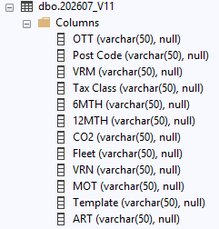
Figure 11: Available features in the VED Reminder File

Licensing Transaction Files
The additional features that can be used from the Transaction files (Figure 12) include:
- CHANNEL – The route the customer used to transact with the DVLA
- VED_PAID – Where applicable, how much was paid for Vehicle Excise Duty (not required for a Statutory Off Road Notification – See Annex B)
- TRANSACTION – Whether the customer paid for VED or made a Statutory Off Road Notification
- DD_FREQUENCY – Where present, indicates the customer has chosen to pay for VED via the Direct Debit service.

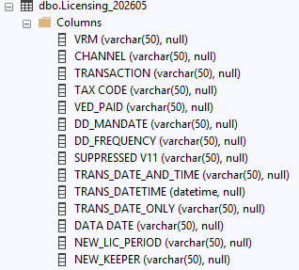
Figure 12: Available features in the Transaction Files

Quarterly Vehicle Record Extract (Census)
From the Quarterly Vehicle Record Extract (Figure 13), there are several fields that can be included as features, some that will explain why vehicles have not been classified as compliant, and others that provide additional characteristics for the type of vehicle that customers are more compliant with.
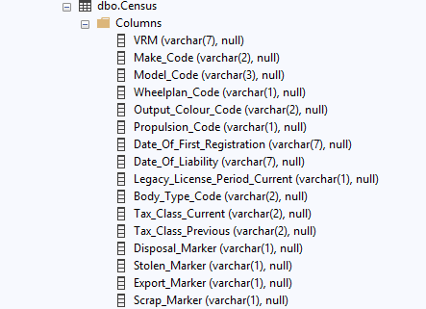
Figure 13: Example of Fields available in the Quarterly Vehicle Record Extract
The fields which will allow us to add extra characteristics will be:
- Vehicle Type
- Year_Of_Manufacture
Vehicle type is a grouping of vehicle body types, and is categorised as Cars, Goods Vehicle, Motorcycles and Other. This will allow us to determine if the type of vehicle affects compliance. The year of manufacture will give us the age of the vehicle and could identify if keepers of newer vehicles more compliant than those of older ones.

Initially, it was intended to include fields that can change a classification from non-compliant to compliance, such as:
- Disposal Marker
- Export Marker
- Scrap Marker
Each of these are notifications that a keeper no longer has a vehicle in their possession and, as such, show that a compliance transaction is no longer to be expected.
It was also intended to change the classification of any vehicle where a transaction had taken place outside of the window we would usually check but had updated the vehicle record. See Annex C for an explanation to why this occurs.

Initial Experiment Results
The machine learning models were run including the scrap, export and disposal marker fields included, and where reclassification had taken place when a later Date of Liability was found in the Census Extract. Each dataset was run through Logistic Regression; Random Forest then Support Vector Machine algorithms in order.
The first set of experiments produced unexpected results, with almost perfect results across all 3 models. This suggested that either the classes are extremely separable, or important target information was imbedded in the data. This could either have been due to overfitting as the literature suggested, or data leakage.
It was further identified that fields that are only present if a vehicle is compliant with taxing may have been causing this, and subsequent experiments were carried out removing those fields from the training and testing data to try and identify if this was the case.
In each experiment, more features were removed, but the performance of the models on predicting compliant vehicles did not change much.
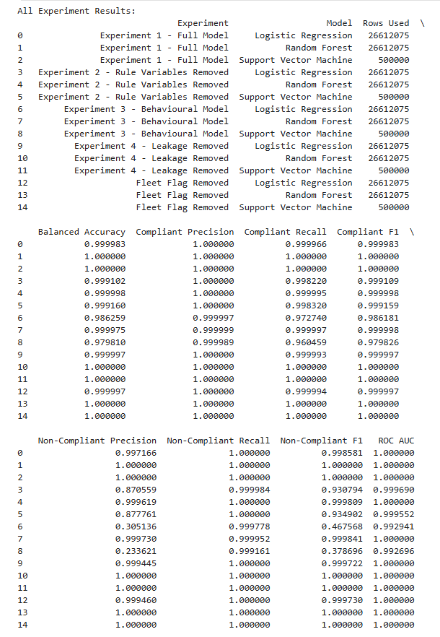
Figure 14: Experiment Results from Machine Learning Models
The performance against the non-compliant vehicles highlighted the issue of the class imbalance within the data. With the marker fields included in the data, we were achieving almost 100% compliance to begin with.
However, these initial experiments did highlight that a Random Forest algorithm performed best out of the three, so SHAP analysis was carried out on the outcome of the final experiment.
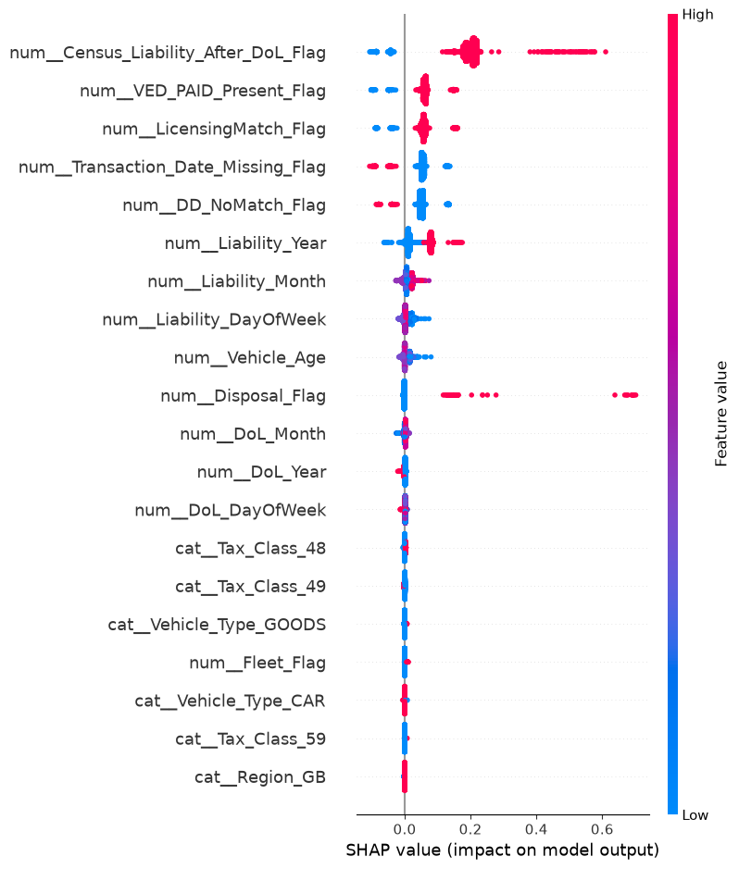
Figure 15: SHAP Analysis of Experiment 4
This was when it was identified that, due to the census extract being run quarterly, with the extract used for this experiment being created in May 2026, and the V11 data being compared was for the 2025-2026 Financial year (April to March), the presence of those markers without dates, and the reclassifying of outcomes based on Dates of Liability recorded in the extract, meant that at the point of the compliance check, a marker or date that is present now, may not have been present then, or related to a transaction that took place at the time.
With this level of overfitting, it was decided that the experiments should be re-run, this time excluding the reclassification these 4 fields produced, and the base dataset was recreated to carry out these experiments.

4.3 Experiment 1: Full Model
This first experiment acted as a baseline model and included all available predictor features except direct identifiers. All three algorithms (Logistic Regression, Random Forest, and SVM) achieved perfect performance, with balanced accuracy, precision, recall, F1-score, and ROC-AUC all equal to 1.00 (Figure 16). No classification errors were recorded, indicating that every compliant and non-compliant record was classified correctly.
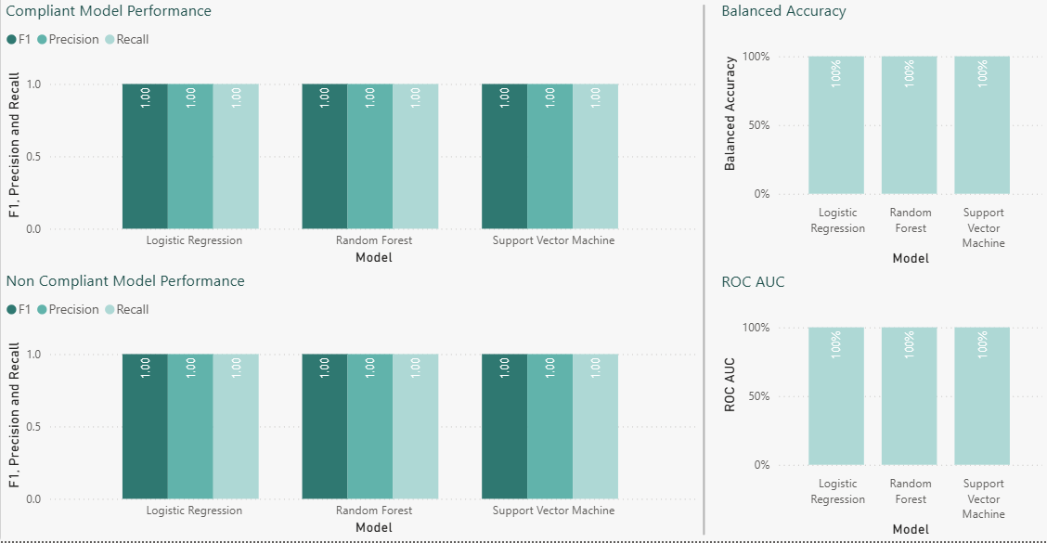
Figure 16: Experiment 1 Model Performance Metrics
Whilst high predictive performance was expected due to the inclusion of compliance-related features, the perfect performance achieved across all evaluation metrics exceeded what would normally be anticipated in a real-world classification problem.
Feature importance analysis showed that Features such as VED_PAID_Present_Flag, DD_NoMatch_Flag and Transaction_Type were among the strongest predictors (Figure 17). These features contain information that is closely related to the compliance outcome itself. As a result, the algorithms were able to identify clear relationships between the predictor Features and the target variable.
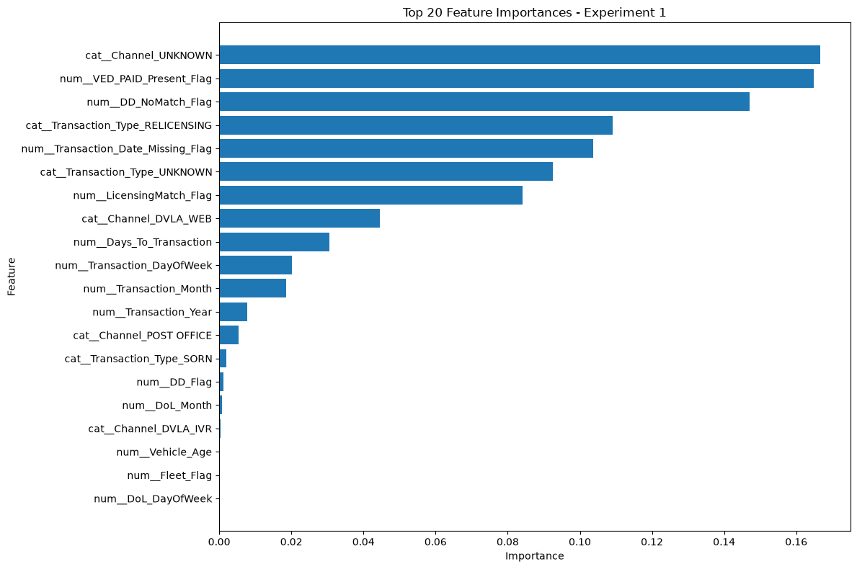
Figure 17: Experiment 1 Feature Importance Analysis Results
While the perfect scores achieved may initially suggest an exceptionally successful model, they more importantly indicate the presence of target leakage. In a real-world prediction scenario, many of these Features would not be available at the point a prediction is required. The results should therefore be interpreted with caution.
Rather than demonstrating a genuine ability to predict future compliance behaviour, this experiment demonstrates that machine learning algorithms can accurately reproduce the compliance rules already embedded within the dataset.
The perfect performance achieved across all three algorithms was inconsistent with what would normally be expected from a real-world classification problem. This suggests that information linked to the target outcome remained within the dataset and reinforces the need for further experimentation using more restrictive feature sets.
The perfect agreement across all three algorithms provides additional evidence for this conclusion, as it is highly unusual for fundamentally different machine learning techniques to produce identical results on a genuinely predictive classification task.
Fundamentally, all three algorithms use different approaches to classification. While Logistic Regression models the relationship between predictor features and the target outcome using a linear decision boundary, SVM will seek to maximise class separation through an optimal hyperplane. Random Forest uses an ensemble of decision trees to capture complex, non-linear relationships and feature interactions.
Under typical classification conditions, some variation in performance is to be expected due to the differing modelling assumptions. The fact that all three achieved identical perfect results suggest that the classes were almost completely separable within the feature space.
Rather than learning behavioural patterns associated with compliance, the models were likely identifying predictor variables that acted as direct or indirect proxies for the target outcome.
As a result, the performance of the algorithms provides strong evidence that target leakage was present within the dataset and justify the need for further experimentation using progressively restricted feature sets.

4.4 Experiment 2: Rule Features Removed
Despite removing the explicit compliance-rule features from the first experiment, while still retaining transaction-related features, this experiment still achieved perfect performance across all three algorithms, with balanced accuracy, precision, recall, F1-score, and ROC-AUC all equal to 1.00 (Figure 18). At first, these results suggested that sufficient information remained within the dataset to perfectly distinguish between compliant and non-compliant vehicles.
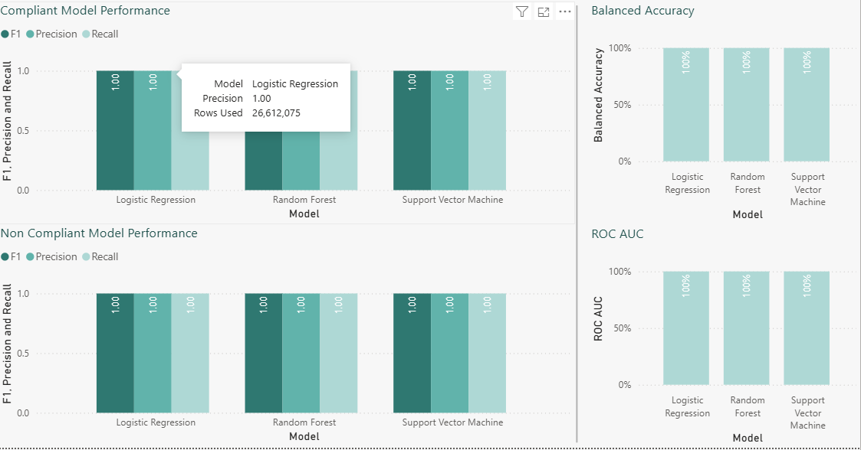
Figure 18: Experiment 2 Model Performance Metrics
These outcomes were not initially expected. By removing the strongest compliance-rule features, it was anticipated that the model’s performance would reduce.
However, feature importance analysis revealed that the model relied heavily on transaction-related features such as Transaction_Type_UNKNOWN, Channel_UNKNOWN and Transaction_Type_RELICENSING (Figure 19).
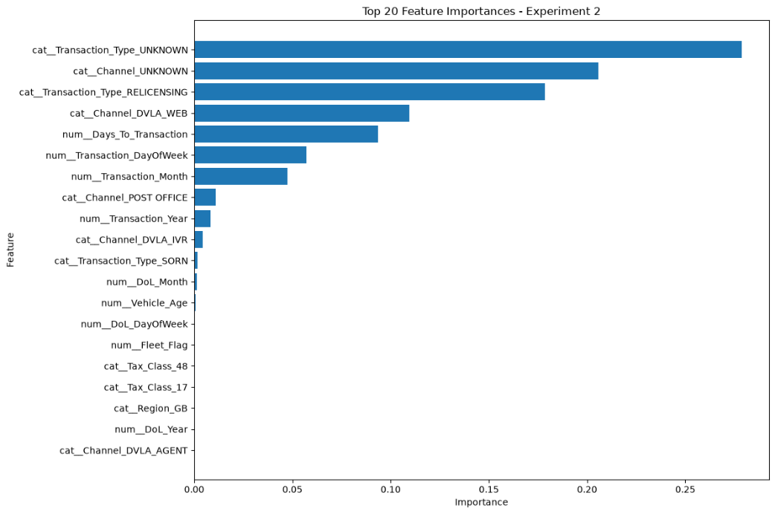
Figure 19: Experiment 2 Feature Importance Analysis Results
SHAP analysis confirmed that these were responsible for most model predictions (Figure 20).
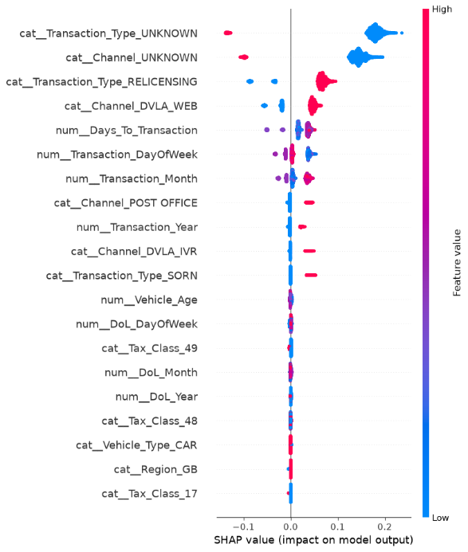
Figure 20: Experiment 2 SHAP Feature Analysis
Further investigation into the dataset provided an explanation for the unexpected performance. Analysis of feature missingness showed that features such as Transaction_Date, Transaction_Year, Transaction_Month, Transaction_DayOfWeek, and Days_To_Transaction were populated for compliant vehicles but completely absent for non-compliant vehicles (Figure 21). This meant that the model could effectively infer the target outcome from the presence or absence of transaction information alone.
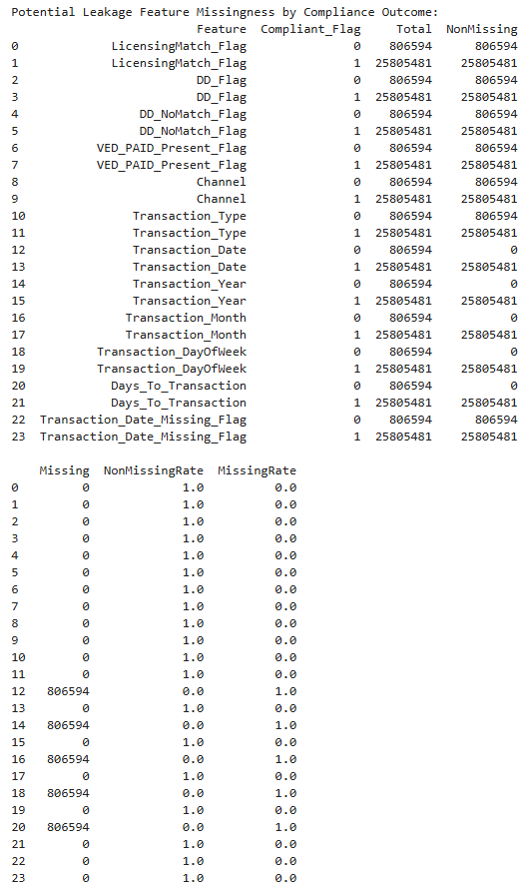
Figure 21: Experiment 2 Target Leakage Results
This finding is particularly significant because it demonstrates a less obvious form of target leakage. Unlike the first experiment, where leakage originated from features directly linked to compliance rules, this experiment demonstrated how operational process features can indirectly reveal the target outcome. From a machine learning perspective, the results highlight the importance of understanding both feature values and availability within a dataset.
While considerable attention is often given to removing variables that directly encode the target outcome, the analysis demonstrates that patterns of missingness can be equally informative. In this case, transaction-related information acted as a proxy for compliance behaviour, creating an artificial separation between classes that would not exist in a genuine prediction scenario.
The dominance of transaction-related features in both the feature importance and SHAP analyses also suggests that the models were learning characteristics of the compliance process, rather than the underlying behavioural factors associated with compliance.
As a result, target leakage was shown to arise from not only explicitly outcome-related features, but also from operational processes that create systematic differences in feature availability. These findings provided strong justification for the removal of transaction-derived features in the next experiment, where the intention was to evaluate whether genuine behavioural and vehicle-related features could predict compliance.
Overall, Experiment 2 demonstrated that removing explicit compliance-rule features alone was insufficient to create a genuinely predictive model. Although all three algorithms achieved perfect classification performance, the results indicate that the models were still learning from information that would not realistically be available at the point a compliance prediction would need to be made.

4.5 Experiment 3: Behavioural Model & Fleet Vehicle Analysis
This experiment removed the transaction-related features identified as potential leakage sources and retained only behavioural, vehicle and licensing characteristics. This represented the first genuine attempt to predict compliance using information that would realistically be available before compliance behaviour occurs. Performance declined substantially when compared with earlier experiments. Random Forest achieved the strongest results with a balanced accuracy of 0.629 and a ROC-AUC of 0.675, while Logistic Regression and SVM achieved balanced accuracies of approximately 0.558 and ROC-AUC values of approximately 0.579 (Figure 22).
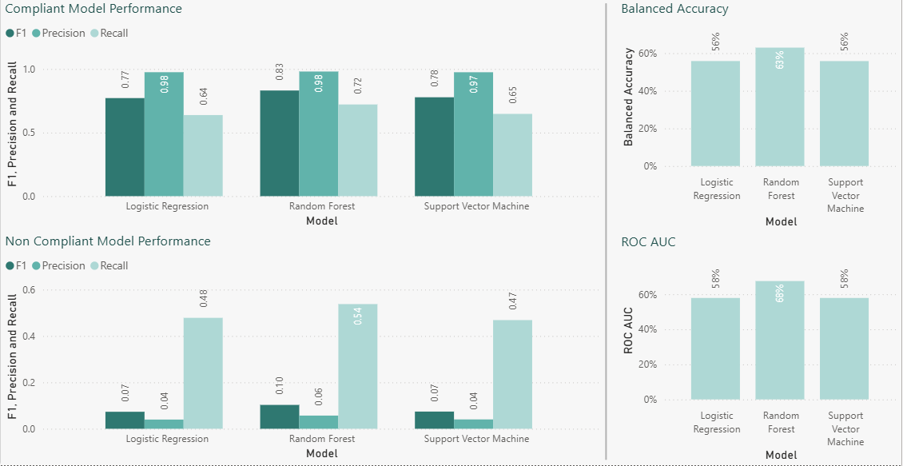
Figure 22: Experiment 3 Model Performance Metrics
These results were expected as, once the leakage-prone features had been removed, a significant reduction in performance was anticipated. The decline in performance confirmed that much of the predictive power from the previous experiments came from the features that directly or indirectly belonged to compliance outcomes.
Although classification performance reduced substantially, this should not be seen as a weakness of the model. Instead, the reduction provides additional evidence that the leakage-prone features were responsible for much of the predictive capability observed in the earlier experiments. By removing these features, the models were forced to rely on behavioural and vehicle-related characteristics that would realistically be available before a compliance outcome occurs. As a result, the performance metrics proved a more realistic assessment of the predictive information contained within the dataset.
Feature importance analysis revealed a major shift in the factors that drove the model performance. The age of a vehicle became the dominant predictor, accounting for 67% of total Random Forest importance (Figure 23).
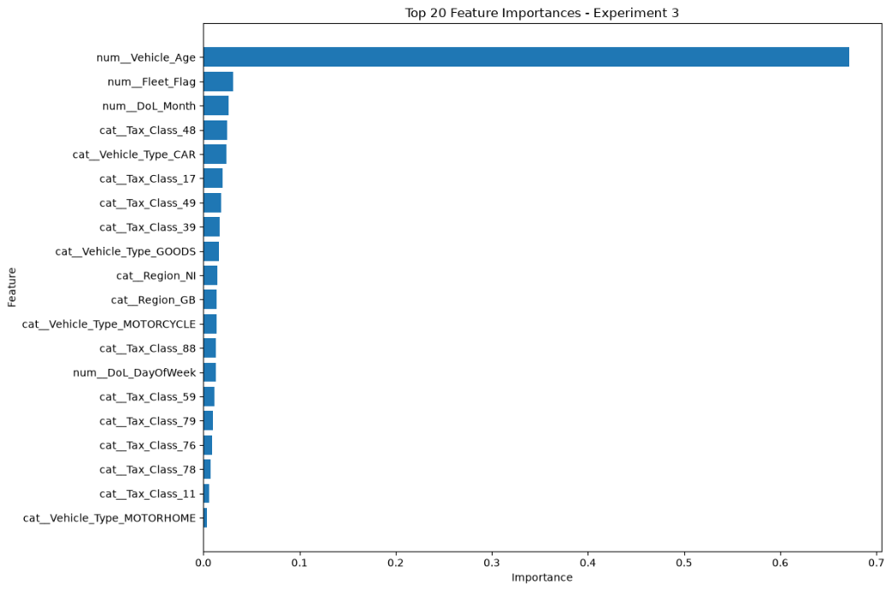
Figure 23: Experiment 3 Feature Importance Analysis Results
Secondary predictors included Fleet_Flag, DoL_Month, several taxation classes, and vehicle type indicators. Unlike the previous experiments, transaction-related features no longer contributed to the model’s performance.
The importance of vehicle age suggests there may be a relationship between the age of a vehicle and compliance behaviour. Older vehicles may be associated with different ownership characteristics, vehicle values or administrative behaviours which go on to influence a customer’s licensing decision.
The dominance of vehicle age is highlighted most by it accounting for almost 67% of the total Random Forest feature importance. Such a substantial contribution suggests that the vehicle age may act as a proxy for other factors not directly captured within the dataset, including vehicle value, ownership patterns, maintenance costs or keeper demographics. While the precise mechanisms driving this relationship cannot be determined with the currently available data, the results indicate that vehicle age is strongly associated with compliance behaviour and warrants further investigation.
Random Forest consistently outperformed both Logistic Regression and SVM across all evaluation metrics. This suggests that the relationships between the predictor features and compliance outcomes are unlikely to be purely linear. The superior performance of Random Forest indicates that non-linear interactions exist between features such as vehicle age, fleet membership and taxation characteristics. These findings align with the literature review, which identified Random Forest as particularly effective at modelling complex feature interactions within structured datasets.
While fleet-operated vehicles displayed slightly higher compliance rates, the difference was relatively small. Although the fleet flag consistently appeared as an important predictor, its contribution was significantly lower than that of the vehicle age.
This suggests that fleet membership may influence individual compliance behaviour but does not appear to have a major impact on overall compliance levels within the dataset (Figure 24).
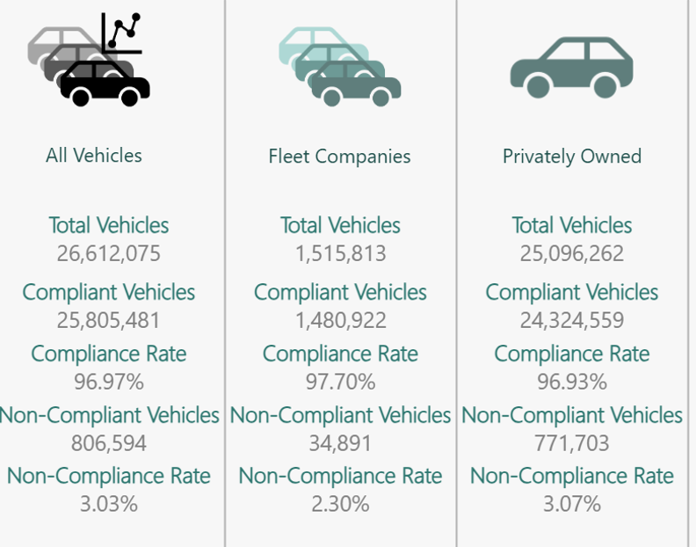
Figure 24: Results of Fleet company keepership analysis
Overall, this experiment represented the first genuinely predictive model within the study. Unlike the earlier experiments, where target leakage dominated the learning process, the models were required to identify behavioural and vehicle related factors associated with compliance outcomes. The results demonstrate that such characteristics do contain predictive information, although their predictive power is considerably lower than the compliance and transaction-related features identified in Experiments 1 and 2.
This provides a more realistic estimate of the extent to which machine learning can identify feature-based patterns in VED compliance behaviour.

4.6 Experiment 4: Final Behavioural Model Evaluation
This experiment represented the final model configuration and removed the final transaction-derived feature, Transaction_DayOfWeek. The purpose of this experiment was to determine whether compliance could still be predicted using a reduced set of behavioural, vehicle and licensing characteristics. Random Forest again produced the strongest performance, achieving a balanced accuracy of 0.629 and ROC-AUC of 0.675, while Logistic Regression and SVM achieved balanced accuracies of approximately 0.558 and ROC-AUC values of approximately 0.579 (Figure 25).
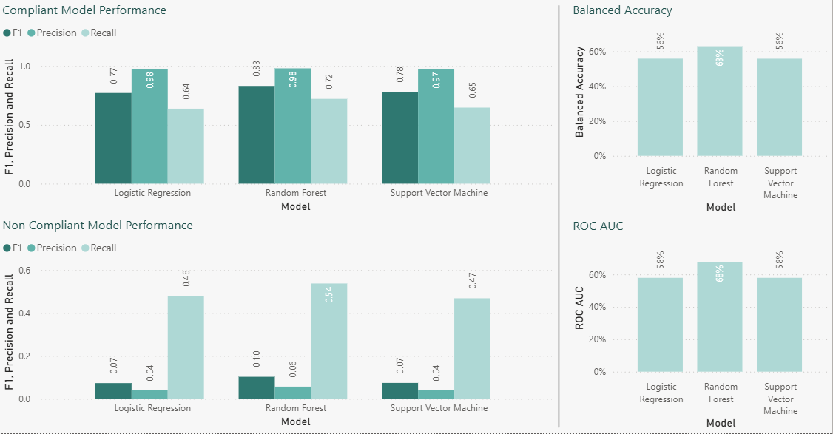
Figure 25: Experiment 4 Model Performance Metrics
These results were expected because only one feature had been removed from the previous dataset. If this feature had contained important predictive information, a reduction in performance would have been anticipated. Instead, the minimal change in performance suggests that the remaining features contained most of the predictive information available within the dataset. This interpretation is further supported by the feature importance analysis produced for the model (Figure 26), which remained highly consistent with the findings from Experiment 3.
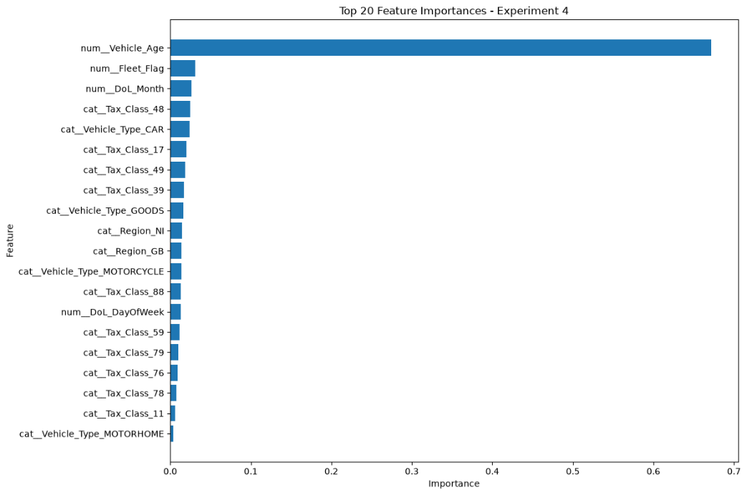
Figure 26: Experiment 4 Feature Importance Analysis Results
Vehicle_Age remained the dominant predictor, while Fleet_Flag, DoL_Month, Tax_Class and Vehicle_Type continued to contribute to model performance. The persistence of these features across the last 2 experiments suggests that the relationships identified are relatively stable and reproducible, rather than being dependent upon a single feature or model configuration. This is particularly important because robust predictors should continue to demonstrate influence when less informative variables are removed. The consistency of flags such as Vehicle_Age, Fleet_Flag, DoL_Month, Tax_Class and Vehicle_Type increases confidence that these characteristics are genuinely associated with VED compliance behaviour.
To provide additional model interpretability, the Random Forest model was subsequently re-run to generate SHAP explanations. During this process, a number of modelling parameters were adjusted, including changing the train/test split from 80/20 to 70/30 and modifying several Random Forest hyperparameters. Consequently, the SHAP outputs should not be interpreted as a direct continuation of the original experimental results, but instead as an independent validation of the factors influencing model behaviour.
Despite these changes, the SHAP analysis produced findings that were highly consistent with the original feature importance results (Figure 27). Vehicle_Age remained the most influential feature, while Fleet_Flag, DoL_Month, Tax_Class and Vehicle_Type continued to demonstrate meaningful contributions to model predictions.
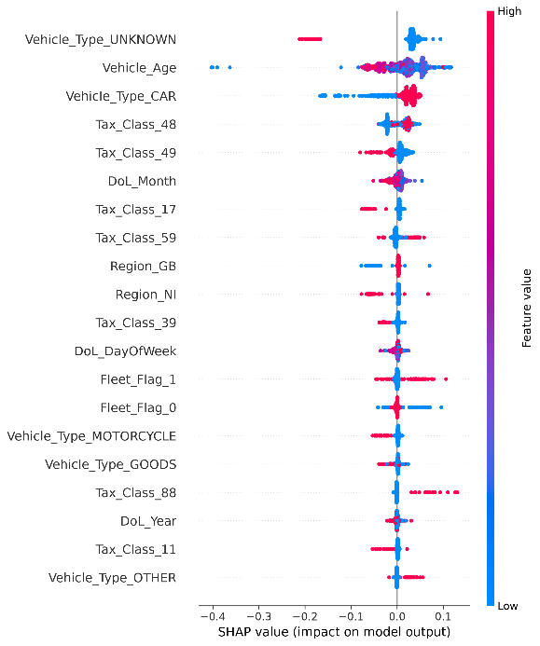
Figure 27: Experiment 4 Shap Feature Analysis
This consistency provides additional confidence that the patterns identified within the dataset are robust and not heavily influenced by a particular train/test split or Random Forest configuration.
The agreement between two independent interpretability approaches strengthens the validity of the findings, as both methods identified the same core predictors despite the changes made to the underlying model configuration.
The comparative performance of the three algorithms also aligns with expectations established in the literature review. Logistic Regression provided an interpretable baseline model but achieved the weakest predictive performance, while SVM produced similar results despite its ability to model more complex decision boundaries. The superior performance of Random Forest suggests that the relationships between the predictor variables and compliance outcomes are unlikely to be purely linear. While Logistic Regression assumes a linear relationship between the features and the target variable, Random Forest can model more complex interactions and non-linear effects. The results therefore indicate that compliance behaviour is influenced by combinations of characteristics rather than any single predictor acting independently.
Importantly, the results also provide a direct answer to the research question. While Fleet_Flag consistently contributed to model predictions, its importance remained substantially lower than that of Vehicle_Age and several licensing-related characteristics. This suggests that fleet management company involvement has some influence on compliance behaviour, but is not among the strongest determinants of compliance outcomes within the analysed dataset.
Overall, this experiment confirmed the findings of Experiment 3 and demonstrated that meaningful patterns in VED compliance behaviour can still be identified after the removal of leakage-prone and low-value features. The stability of both the model performance and feature importance rankings suggests that the identified predictors are robust and reproducible. Furthermore, the agreement between Random Forest feature importance and SHAP explanations provides additional evidence that the relationships identified reflect genuine patterns within the dataset rather than artefacts introduced by a particular modelling approach.

Chapter 5 – Evaluation
The results show that machine learning can successfully identify patterns within VED compliance data. However, they also highlight the importance of carefully selecting features before training a model.
While the first models achieving perfect classification appeared promising, further analysis showed that they were learning from features that directly or indirectly revealed the compliance outcome. As a result, the models were not genuinely predicting future compliance behaviour but were instead reproducing information already embedded within the dataset. Once these features were removed, model performance reduced substantially, providing a more realistic assessment of how effective behavioural, vehicle and licensing characteristics are when predicting compliance behaviour.
These findings generally support the literature review. Logistic Regression provided a useful baseline model but delivered the weakest predictive performance once outcome-related features had been removed. SVM achieved only modest performance despite its ability to identify more complex decision boundaries. Random Forest consistently produced the strongest results, supporting the literature which suggested that ensemble methods are effective at modelling complex non-linear relationships and feature interactions.
The findings also support the use of Explainable Artificial Intelligence techniques. Both Random Forest feature importance analysis and SHAP identified similar features as influential, providing additional confidence in the factors identified by the models and demonstrating the value of explainability techniques when interpreting machine learning outputs.
One area not anticipated at the start of the project was the extent to which compliance-related and transaction-derived features influenced model performance. The perfect classification achieved in the initial models highlighted the importance of critically assessing the available data and not relying solely on performance metrics when evaluating a model.
Collectively, the results demonstrate that machine learning can be used to identify meaningful feature-based patterns within VED compliance data. Vehicle age, taxation class, vehicle type, fleet membership and licensing characteristics all contributed to model predictions and provided additional insight into compliance behaviour. While fleet-managed vehicles demonstrated slightly higher compliance rates than non-fleet vehicles, the difference was relatively small, suggesting that fleet membership is not one of the primary factors influencing compliance outcomes.
One factor likely to have influenced the results was the significant class imbalance present within the dataset, with approximately 98% of records representing compliant vehicles. This meant the models were trained on substantially more examples of compliant than non-compliant behaviour. The impact of this imbalance became more apparent once outcome-related features had been removed, with the models generally identifying compliant vehicles more successfully than non-compliant vehicles. This also justified the use of balanced accuracy, precision, recall, F1-score and ROC-AUC rather than relying solely on overall accuracy.
Overall, the findings were broadly in line with expectations. Machine learning could identify patterns within the dataset and Random Forest consistently produced the strongest results. The most unexpected outcome was the perfect performance achieved by the earliest models, which ultimately led to the discovery of features that directly or indirectly revealed the target outcome.
If the project were undertaken again, greater emphasis would be placed on identifying potential leakage-prone features earlier in the research process. Additional algorithms such as XGBoost and LightGBM could also be evaluated, and further validation techniques could be implemented to assess model stability across multiple train/test splits.
The project objectives were successfully achieved through the review and evaluation of Logistic Regression, Support Vector Machine, Random Forest and Explainable Artificial Intelligence techniques, the creation of a combined analytical dataset from reminder, licensing and census data, and the evaluation of model performance using balanced accuracy, precision, recall, F1-score and ROC-AUC metrics. Random Forest feature importance analysis, SHAP explanations and Power BI visualisations provided additional insight into the factors associated with compliance behaviour. Achieving these objectives enabled the overall project aim to be met by identifying meaningful feature-based patterns within VED compliance data and assessing the influence of fleet management companies on compliance behaviour. As a result, the research question was answered, demonstrating that machine learning can identify meaningful patterns within VED compliance data and that fleet management company involvement has a measurable, albeit relatively limited, influence on compliance outcomes.
In conclusion, the project achieved its aim and objectives, demonstrating that machine learning can identify meaningful feature-based patterns within VED compliance data whilst highlighting the importance of careful feature selection, model interpretation and validation.

Chapter 6 - Conclusions and Recommendations

6.1 Conclusion
This project explored whether machine learning techniques could be used to identify feature-based patterns in Vehicle Excise Duty (VED) compliance data and assess the influence of fleet management companies on compliance behaviour.
A series of experiments were conducted using progressively refined datasets, training Logistic Regression, Random Forest and Support Vector Machine algorithms and evaluating the outcomes using a variety of performance metrics, adding feature importance analysis and SHAP explanations to Random Forest results to improve model interpretability.
The findings demonstrated that machine learning can identify patterns within VED compliance data but also highlighted the importance of feature selection. Initial results appeared highly successful but were later shown to be influenced by features which revealed the compliance outcome. Once removed, Random Forest consistently outperformed the other algorithms, identifying the age of a vehicle as the most important feature.
Overall, the aims of this experiment were achieved, proving that machine learning algorithms can identify patterns in VED compliance data, and provided evidence that fleet owned vehicles do contribute to the compliance predictions, but their influence is small when compared to other characteristics present in the data.

6.2 Recommendations
From the results, it is recommended that earlier identification of features that reveal the compliance outcome, whether directly or indirectly, should take place to ensure that less model runs are required.
Discussions with peers around the findings can take place to identify other machine learning techniques can improve predictive performance using behavioural and vehicle-related characteristics alone.
Class imbalance is a key issue with the data, and while it is representative of the real-world data being worked with, future research could investigate techniques to improve the identification of non-compliant vehicles.
The use of additional datasets could be explored to determine whether stronger predictors of non-compliance exist without revealing the compliance outcome.
Finally, evaluating the model performance over different time periods could determine if the identified relationships remain stable over time.

Chapter 7 - Reflection
I feel that this experiment has achieved what I initially set out to do. It has shown that Supervised Machine Learning Models can successfully identify key features that drive vehicle tax compliance behaviours. This opens a whole new avenue for analysis of our compliance data and will be something that I am looking to take forward in future work within my role.
The project has also increased my confidence in applying machine learning techniques to real-world business problems and interpreting their outputs for stakeholder decision-making.
The class imbalance issue also highlighted the need for more investigations to be carried out to identify models that will perform better with such a largely imbalanced dataset.
I have definitely learned a lot about the implementation of Machine Learning algorithms in carrying out these experiments, particularly the need to identify features which should not be included in training datasets as early as possible.

References
[1] gov.uk. "Driver & Vehicle Licensing Agency." gov.uk. Accessed: 29/05 2026. [Online]. Available: https://www.gov.uk/government/organisations/driver-and-vehicle-licensing-agency
[2] Department for Transport. "Vehicle excise duty evasion statistics: 2023." Accessed: 29/05 2026. [Online]. Available: https://www.gov.uk/government/statistics/vehicle-excise-duty-evasion-statistics-2023/vehicle-excise-duty-evasion-statistics-2023
[3] Alan M. Turing, "Computing Machinery and Intelligence," pp.23–65, Nov 23 2007, doi: 10.1007/978-1-4020-6710-5_3.
[4] K. Du, R. Zhang, B. Jiang, J. Zeng and J. Lu, "Understanding Machine Learning Principles: Learning, Inference, Generalization, and Computational Learning Theory," vol. 13, no. 3, pp.451, 2025, doi: 10.3390/math13030451.
[5] M. Das Hait, P. Das, W. Akram and S. Chatterjee, "A Comparative Analysis of Linear Regression Techniques: Evaluating Predictive Accuracy and Model Effectiveness," pp.127–139, Jul 9 2025, doi: 10.38124/ijisrt/25jul349.
[6] D. W. Hosmer, S. Lemeshow and R. X. Sturdivant, "Applied Logistic Regression," Stat.Med., vol. 21, no. 13, pp.1963–1964, 2002, doi: 10.1002/sim.1236.
[7] J. Tolles and W. J. Meurer, "Logistic Regression: Relating Patient Characteristics to Outcomes," vol. 316, no. 5, pp.533–534, Aug 2 2016, doi: 10.1001/jama.2016.7653.
[8] Javier M. Moguerza and Alberto Muñoz, "Support Vector Machines with Applications," vol. 21, no. 3, pp.322, Aug 1 2006, doi: 10.1214/088342306000000493.
[9] K. Du, B. Jiang, J. Lu, J. Hua and M. N. S. Swamy, "Exploring Kernel Machines and Support Vector Machines: Principles, Techniques, and Future Directions," vol. 12, no. 24, pp.3935, Dec 1 2024, doi: 10.3390/math12243935.
[10] GeeksforGeeks. "Support Vector Machine Algorithm." GeeksforGeeks. [Online]. Available: https://www.geeksforgeeks.org/machine-learning/support-vector-machine-algorithm/
[11] K. Du, B. Jiang, J. Lu, J. Hua and M. N. S. Swamy, "Exploring Kernel Machines and Support Vector Machines: Principles, Techniques, and Future Directions," vol. 12, no. 24, pp.3935, Dec 1 2024, doi: 10.3390/math12243935.
[12] R. Damaševičius, "Introductory Chapter: Recent Trends and Progress in Support Vector Machines," in Federated Learning - A Systematic Review, S. AhmadEds., Meshal AlharbiEds., Sudan JhaEds., Aleem Ali and Robertas Damaševičius, Ed., London: IntechOpen, 2025. doi: 10.5772/intechopen.1005410.
[13] A. Grønlund, L. Kamma and K. G. Larsen, "Near-Tight Margin-Based Generalization Bounds for Support Vector Machines," 2020, doi: 10.48550/arxiv.2006.02175.
[14] W. H. Khoong. "When Do Support Vector Machines Fail?" Towards Data Science. (-08-29, 2021). Accessed: Jun 22, 2026. [Blog]. Available at: https://towardsdatascience.com/when-do-support-vector-machines-fail-3f23295ebef2/
[15] M. Jabardi, "Support Vector Machines: Theory, Algorithms, and Applications," vol. 17, no. 1, pp.66–75, 2025, doi: 10.36244/ICJ.2025.1.8.
[16] L. Breiman and L. Breiman, "Random Forests," vol. 45, no. 1, pp.5–32, 2001, doi: 10.1023/A:1010933404324.
[17] H. A. Salman, H. A. Salman, A. Kalakech and A. Steiti, "Random Forest Algorithm Overview," vol. 2024, pp.69–79, 2024, doi: 10.58496/BJML/2024/007.
[18] R. Y. PhD. "Random Forests." Medium. Accessed: Jun 29 2026. [Online]. Available: https://medium.com/@roiyeho/random-forests-98892261dc49
[19] B. Liu and R. Mazumder, "Randomization Can Reduce Both Bias and Variance: A Case Study in Random Forests," 2025, doi: 10.48550/arxiv.2402.12668.
[20] E. Halabaku and E. Bytyçi, "Overfitting in Machine Learning: A Comparative Analysis of Decision Trees and Random Forests," vol. 39, no. 6, pp.987–1006, 2024, doi: 10.32604/iasc.2024.059429.
[21] H. A. Salman, A. Kalakech and A. Steiti, "Random Forest Algorithm Overview," vol. 2024, pp.69–79, Dec 15 2024, doi: 10.58496/BJML/2024/007.
[22] H. Lingjun, R. A. Levine, J. Fan, J. Beemer and J. Stronach, "Random Forest as a Predictive Analytics Alternative to Regression in Institutional Research," vol. 23, no. 1, pp.1, 2018,
[23] M. Haddouchi and A. Berrado, "A survey and taxonomy of methods interpreting random forest models," 2024, doi: 10.48550/arxiv.2407.12759.
[24] M. L. Wallace et al., , "Use and misuse of random forest variable importance metrics in medicine: demonstrations through incident stroke prediction," BMC Med.Res.Methodol., vol. 23, no. 1, pp.144–12, 2023, doi: 10.1186/s12874-023-01965-x.
[25] A. Barredo Arrieta et al., , "Explainable Artificial Intelligence (XAI): Concepts, taxonomies, opportunities and challenges toward responsible AI," vol. 58, pp.82–115, Jun 2020, doi: 10.1016/j.inffus.2019.12.012.
[26] C. Molnar, Interpretable machine learning : a guide for making black box models explainable, 3rd Ed. S.l.: Christoph Molnar, 2019. [Online]. Available: https://cir.nii.ac.jp/crid/1970304959906131969
[27] M. T. Ribeiro, S. Singh and C. Guestrin, ""Why Should I Trust You?"", inpp. 1135–1144. doi: 10.1145/2939672.2939778.
[28] S. Lundberg and S. Lee, "A Unified Approach to Interpreting Model Predictions," Ithaca, 2017. [Online]. Available: https://www.proquest.com/docview/2077007862

Bibliography
Akomodi, J. O., The Efficacy of Statistics in All Major Fields of Research: A Focus on Regression Analysis, 2025.
Anandhi, P. and Nathiya, E., Application of Linear Regression with Their Advantages, Disadvantages, Assumption and Limitations, 2023.
Aysel, H. I., Cai, X. and Prugel-Bennett, A., Explainable Artificial Intelligence: Advancements and Limitations, 2025.
Badillo, S., Banfai, B., Birzele, F., Davydov, I. I., Hutchinson, L., Kam-Thong, T., Siebourg-Polster, J., Steiert, B. and Zhang, J. D., An Introduction to Machine Learning, 2020.
Bazdaric, K., Sverko, D., Salaric, I., Martinovic, A. and Lucijanic, M., The ABC of Linear Regression Analysis: What Every Author and Editor Should Know, 2021.
Bhadula, S., Adnan, M. M., Kumar, R., Rana, A., Kaliyaperumal, G. and Rao, B. D., Optimizing Random Forest Algorithms for Large-Scale Data Analysis, 2024.
Darst, B. F., Malecki, K. C. and Engelman, C. D., Using Recursive Feature Elimination in Random Forest to Account for Correlated Variables in High Dimensional Data, 2018.
Hoffman, K. and Montesinos-Yufa, H. M., Assessing the Quality of Ordinary Least Squares in General Lp Spaces, 2024.
Kuchibhotla, A. K., Brown, L. D., Buja, A. and Cai, J., All of Linear Regression, 2019.
Lee, K. J., Wiest, M. M. and Carlin, J. B., Statistics for Clinicians: An Introduction to Linear Regression, 2014.
Liu, X., Huang, D., Yao, J., Dong, J., Song, L., Wang, H., Yao, C. and Chu, W., From Black Box to Glass Box: A Practical Review of Explainable Artificial Intelligence (XAI), 2025.
Parsons, J. and Bao, L., A Unified Approach for Outliers and Influential Data Detection: The Value of Information in Retrospect, 2022.
Rahman, M. Z., A Comprehensive Review of Machine Learning: Techniques, Applications and Future Research Directions, 2024.
Ridley, M., Human-Centered Explainable Artificial Intelligence: An Annual Review of Information Science and Technology (ARIST) Paper, 2024.
Roustaei, N., Application and Interpretation of Linear-Regression Analysis, 2024.
Younes, L., Introduction to Machine Learning, 2025.

Annex A: Data Input Source Definitions

V11 VED Reminder Tables
These are files which are generated monthly to issue the V11 Tax Reminder letter to customers based on the expiry date of their current Vehicle Tax. These files contain upwards of 2 million rows of data and form the base dataset for generating Vehicle Excise Duty Compliance.

Monthly Licensing Tables
This dataset is generated from the monthly transaction logs for customers who tax or declare a Statutory Off Road Notification (SORN) at the Post Office or through one of the DVLA’s Online services (EVL).
For compliance, 3 months of licensing data is combined to create the timeline for checking for a transaction, from the month before a vehicle’s current tax expires to 2 months after the expiration date.
If a vehicle from the V11 file matches with a transaction during this period, it is classed as being compliant.

Vehicle Record Quarterly Extract (Census)
Taken in February, May, August and November, this extract provides a snapshot of the current state of every active vehicle record and can be used to provide additional features to enhance the VED Compliance output.

Annex B – DVLA Transaction Definitions
Statutory Off Road Notification – A notification made to the DVLA that a vehicle is being kept off the road and not used or kept on a public road, allowing a customer to stop taxing and insuring it.
Annex C – Missed Compliance Transactions
While most of the Licensing or Statutory Off Road Notification transactions are completed via the DVLA online services, or at a Post Office, some customers still transact through traditional postal applications. The data from these manual transactions are not available to Data Analysts at a level where they can be compared to the V11 reminder files.
Matching the Vehicle Registration Number to the Census will highlight these transactions to us and allow us to better mirror what the Department for Transport produce in their Road-Side Survey statistics.

