BA Computer Animation and VFX
UWTSD / Year 2

ACCA5038
ADVANCED CHARACTER ANIMATION

Submission Date: 14th January 2026

2400891
ROMAN WOODS [Toni Pigg]

#1 / Initial Approach & Exploration
I decided to choose the theme ‘Navigating Territory’ for my animation(s), with a focus on animalistic figures and the effect of physical status relative to movement. I want to explore how quadrupeds move, especially when under effects that might affect their ability to move cohesively.

During my initial tests, I tried to explore various shapes and animals before narrowing down to any specific thing. I began to narrow down my workflow towards the end.

For my final work, I decided to focus on general quadruped shapes - I wanted as least 4 different animations exploring slightly different avenues of this prompt. Those would be: Jumping, Slipping, Running and Struggling.
For jumping, I decided a rat would be a good choice of animal - not only do I have pet rats (which provides a good physical reference), but their body is structured slightly differently compared to other quadrupeds, so trying it out would be a good change of pace.
Rats have a lot of character, and while they’re pretty hard to get good photos of, generally seeing them move gave a lot of insight into how I could exaggerate emotion and shape in them.

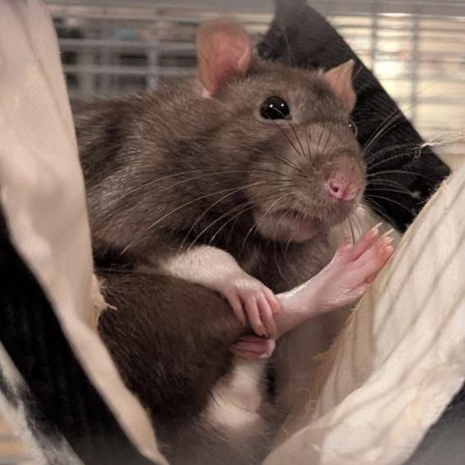
fig. 1: Juno and Jasper, my pets (source: Primary), fig. 2: Example of character in Juno (source: Primary)

Plus, the internet has many references I was able to skip through and analyse. Here’s some of the helpful things I found while doing my initial research.

Video references:
Movement reference: https://youtube.com/shorts/pwGPl7zNoMM?si=urxhUBuKOA_pZ4Yd [1]
Jumping reference: https://youtube.com/shorts/dl8v0jWaylw?si=OXaomj8aGM0Ooh5f [2]
Rat animation: https://youtube.com/shorts/erntKbeyqOc?si=i3BSKBigvFQXgHlk [3]

Photo References & Studies:
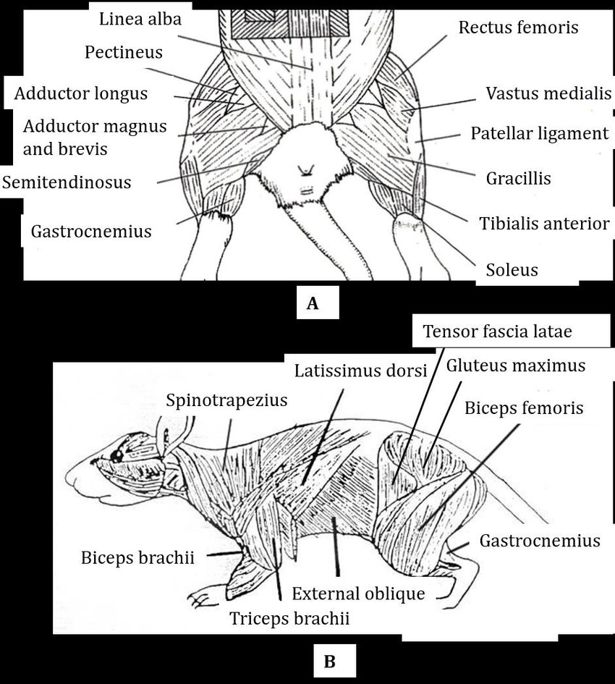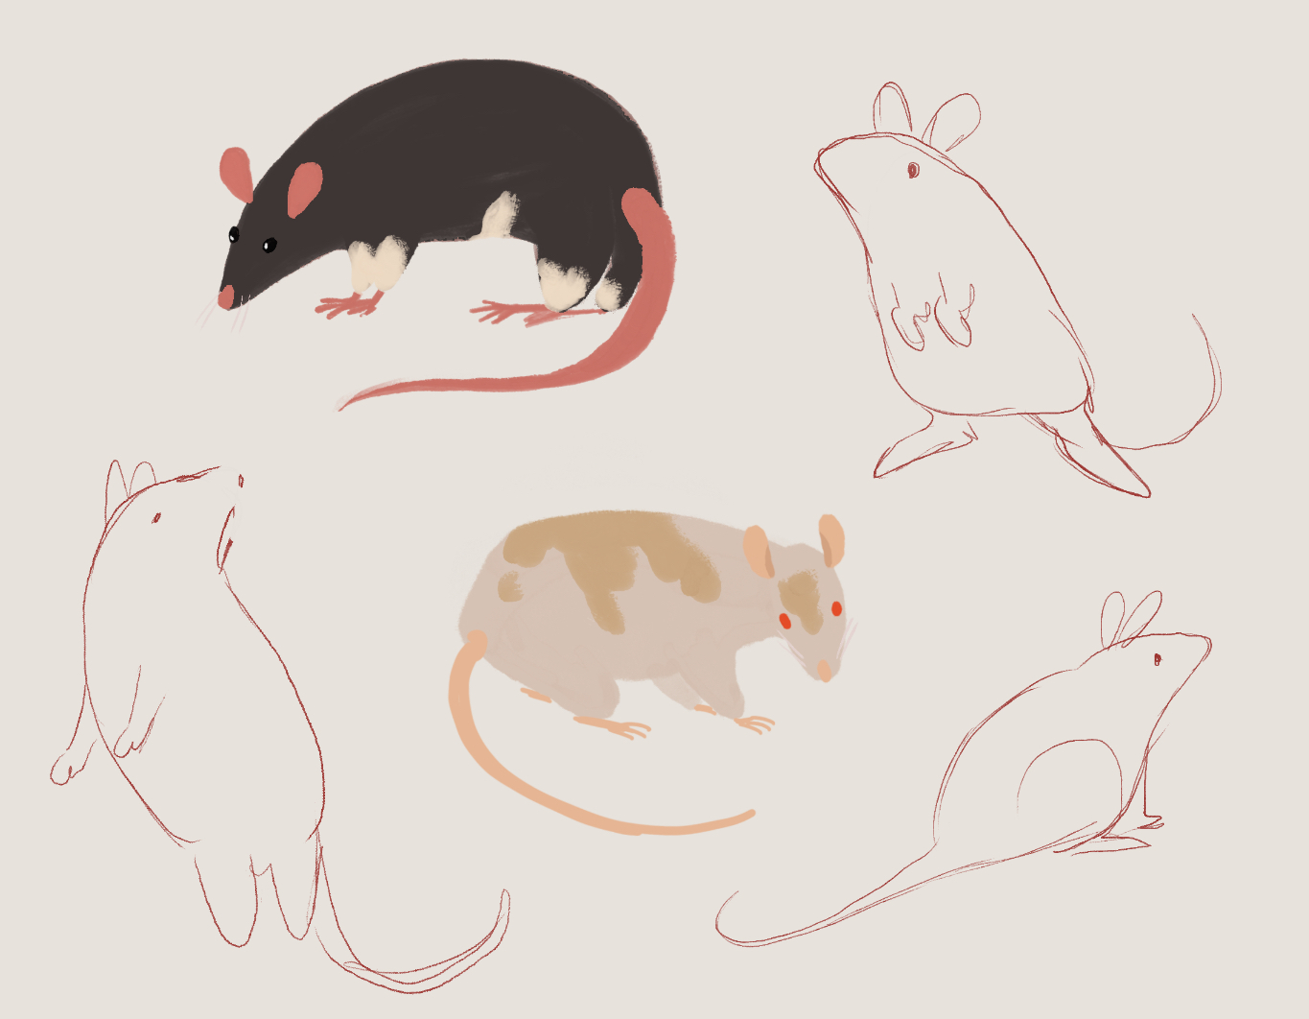
fig. 1: Muscle anatomy of a rat [4], fig.2: Early shape tests [source: primary]

I also re-watched Disney’s Bambi recently and admired how the animators were able to show the movements so well - I thought this would provide a good reference point for my own animation, specifically one where a creature was struggling with the terrain. I contemplated other options for a while, such as quicksand or tar, but I thought the long legs of a baby deer were very compelling for both character and movement. I was interested to try out an animation of this nature myself, using clips like these as reference:
Bambi learning to walk: https://youtu.be/KiiSUlZaO5w?si=kCHPhVoPf_WAKWri [5]
Bambi walking on snow/ice: https://youtu.be/gSh1eLrxiqs?si=aRpk5KD5LzKcStLo [6]
Impala learning to walk: https://youtu.be/AGLAC_IWfss?si=zxoPBsyJw367j7Q6 [7]
Deer learning to walk: https://youtube.com/shorts/bkb_9EmgYg4?si=tJ2OZcnxWvPs-5SD [8]

For my 3D work, I found this rig I thought would be a great base for the remaining animation:
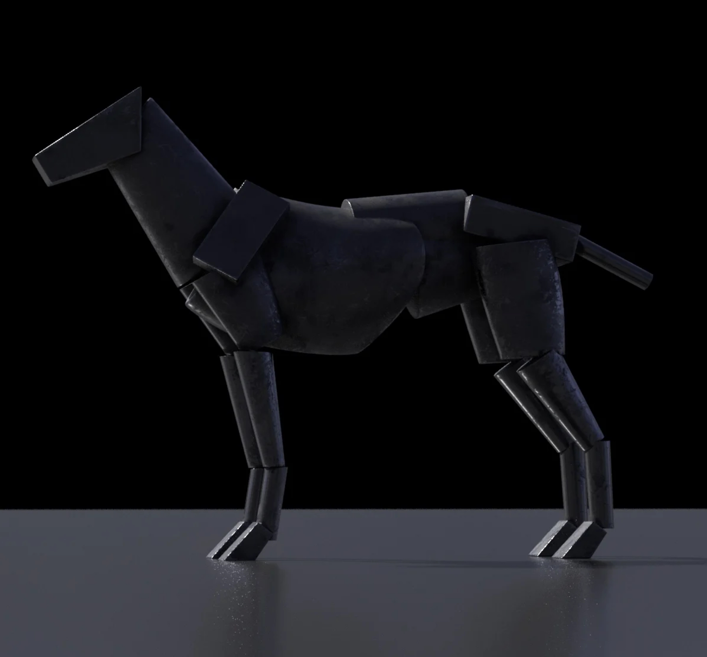
fig. 1: Quadruped model [9]

In the future I’d like to try rigging myself again, although I’m not confident enough in it at this stage to make any final product with it.

#2 / Tests & Progression
Video Link: https://youtu.be/7n1M_ztAXDw?si=OctLIyneJIFkQvxz
This video includes early animation tests and progression I made before and while producing my final animations. I experimented with movement, character and expression a few different ways.
Since I was focusing on animals, I thought including a walk cycle would be a good idea to establish an understanding of an average quadruped’s movements. I used this test phase to focus on that in particular, using both 2D and 3D to explore how an animal (such as a canine) moves.
I also explored a human form with a quick zombie-inspired walk cycle - since I hadn’t been focusing on human shapes, I thought exploring movement in a different way would provide good insight going forward.
I also included some keyframes here as visual reference.

#3 / Final Outcome(s)
Video Link: https://youtu.be/9Qs0DmxUsL8?si=jzDfg49dHpHQj6E5

Resources and References
Other resources used:
- Model used: https://truongcgartist.gumroad.com/l/generalizedAnimal?layout=profile [9]
- Quadruped Animation guide: https://animationapprentice.blogspot.com/2024/09/dog-run-animation-tutorial.html [10]

Bibliography:
[1] petcollective, “Rat Loves Doing Agility Course With Mom,” YouTube, [Online]. Available: https://youtube.com/shorts/pwGPl7zNoMM?si=urxhUBuKOA_pZ4Yd

[2] Jadynlemi, “Rat jumping attempts,” YouTube, [Online]. Available: https://youtube.com/shorts/dl8v0jWaylw?si=OXaomj8aGM0Ooh5f

[3] firytwig, “Rat Run Cycle Animation,” YouTube, [Online]. Available: https://youtube.com/shorts/erntKbeyqOc?si=i3BSKBigvFQXgHlk

[4] Z. Lonbani, “Figure: The rat’s muscle anatomy,” ResearchGate, [Online]. Available: https://www.researchgate.net/figure/The-rats-muscle-anatomy-The-rats-muscle-anatomy-is-shown-in-particular-the-medial-A_fig3_290536963

[5] Bambi, Directed by D. Hand, J. Algar, S. Armstrong, et al. Burbank, CA, USA: Walt Disney Studios, 1942. [Digital Steaming].

[6] Bambi, Directed by D. Hand, J. Algar, S. Armstrong, et al. Burbank, CA, USA: Walt Disney Studios, 1942. [Digital Steaming].

[7] Caters Clips, “Baby Impala Learns To Walk,” YouTube, [Online]. Available: https://youtu.be/AGLAC_IWfss?si=zxoPBsyJw367j7Q6

[8] DiscoverWildPaws, “15 Seconds Old Baby Deer Learns To Walk,” YouTube, [Online]. Available: https://youtube.com/shorts/bkb_9EmgYg4?si=tJ2OZcnxWvPs-5SD

[9] Truong CG Artist, “Generalized Animal Boxy Rig,” Gumroad, [Online]. Available: https://truongcgartist.gumroad.com/l/generalizedAnimal

[10] A. Williams, “Dog Run Animation Tutorial,” Animation Apprentice, Sep. 2024. [Online]. Available: https://animationapprentice.blogspot.com/2024/09/dog-run-animation-tutorial.html

