UJUNWA JUSTINA ONUIGBO
2307748
1000 – WORD COUNT
10TH OF NOVEMBER 2023

Content page
Table of Contents
Procedure 1
Introduction 2
Personal and professional development process 3
Type chapter title (level 2) 4
Type chapter title (level 3) 5

- Procedure – the document reports has been complied through lecture materials,
from week 1to week 4, youtube content of the lectures and reflective journals and Amazon website
- Introduction
The assessment is based on Professional Career Development (BMSW4012_SWAN) by Badir Miftah (b.miftah@uwtsd.ac.uk)
Explain why professional career development is important for career success.
Professional career development is important because it improves your knowledge, develop your skills, enhance job prospects, keeping up to date, improve your understanding and ensures you are employability ready to in the ever-changing professional careers and success in your chosen career path.
Develop skills: Ability to develop new skills and expertise can open doors to endless opportunities, promotions in today's fast-paced world, staying updated with the latest trends and technologies will keeps you competitive and adaptable to changes in your industry.

Enhance job prospects: Developing new skills and expertise can open doors to promotions and leadership roles within your organization. Employers often value employees who show a commitment to self-improvement and are proactive about their professional growth.
Enhanced Job Satisfaction: Continuous learning and growth can lead to increased job satisfaction. Feeling stagnant or stuck in a role can lead to dissatisfaction. Pursuing professional development keeps you engaged and motivated in your career.
Long-Term Career Planning: Professional development helps you align your skills and interests with your long-term career goals. It allows you to plan your career trajectory strategically, making informed decisions about the direction you want to take.
Time management and organizational skills are vital for handling multiple tasks and meeting deadlines. Being able to prioritize assignments, plan effectively, and stay focused can significantly enhance productivity. Moreover, a strong work ethic, including qualities like reliability, dedication, and attention to detail, is indispensable for creating a positive impression and gaining the trust of employers.
In summary, being employment-ready involves a combination of technical expertise, excellent communication and interpersonal skills, problem-solving abilities, effective time management, emotional intelligence, a strong work ethic, and a commitment to ongoing learning and self-improvement. Job seekers who possess these qualities are not only more likely to secure employment but also to thrive and excel in their chosen careers.

- Highlighting your understanding of the personal and professional development process
Personal and professional development is a lifelong process of improving and expanding knowledge, skills, attitudes, and behaviours to enhance one's personal life and career prospects. This process is essential for individuals to adapt to changing environments, overcome challenges, and achieve their goals.
Personal Development: | Professional Development:
Self-awareness: Understanding one's strengths, weaknesses, values, and emotions. This awareness forms the basis for personal growth. | Skills Enhancement: Identifying and developing skills relevant to one's profession, staying updated with industry trends and advancements.
Goal Setting: Setting clear, achievable goals provides direction and motivation for personal development efforts. | Networking: Building and maintaining professional relationships, both within and outside the workplace, to gain new perspectives and opportunities.
Continuous Learning: Actively seeking new knowledge, whether through formal education, reading, or experiences, to broaden one's understanding of the world. | Leadership Development: Learning to lead and inspire others, understanding different leadership styles, and honing leadership skills.
Emotional Intelligence: Developing empathy, social skills, and the ability to manage emotions effectively, fostering better relationships and communication. | Effective Communication: Developing strong verbal and written communication skills, as well as active listening abilities, to convey ideas clearly and understand others' perspectives.
 | Critical Thinking: Enhancing problem-solving skills, analyzing situations, and making informed decisions based on evidence and sound reasoning.
 | Career Planning: Setting long-term career goals, identifying steps to achieve them, and being proactive in seeking opportunities for career advancement.

The Development Process:
Assessment: Reflecting on current skills, knowledge, and personal/professional circumstances to identify areas that need improvement.

Planning: Setting specific, measurable, achievable, relevant, and time-bound (SMART) goals based on the assessment, and creating a roadmap for development.

Action: Taking deliberate steps to acquire new skills, knowledge, or experiences, which may include formal education, on-the-job learning, workshops, or mentorship.

Reflection: Regularly evaluating progress, celebrating achievements, and learning from setbacks. Reflection helps in adjusting goals and strategies as needed.

Feedback: Seeking feedback from mentors, peers, or supervisors to gain external perspectives and identify blind spots for further improvement.

Iteration: Personal and professional development is an ongoing process. Repeating the cycle of assessment, planning, action, reflection, and feedback ensures continuous growth and adaptation.

- Findings
One of the challenges faced was the inability to identify myself, and the skills I needed to accomplish certain tasks. Applying the self-awareness objectives and the personality profiling has strategically helped me to scale down on how to achieve my goals.
How can I apply this learning to my career development journey?
Identify a SMART goal for yourself.

State that the aim of your report is to reflect and review your learning journey through personal development whilst identifying what and how you will develop these.
SWOT
One of strengths after taking the Myers Briggs personality profiling test is Thinking and Judging (reference copy attached at the button of the report)
And to apply the SWOT to my SMART goal, I believe that Thinking about the ways to help improvement something is paramount especially when it pertains to decision we make on our everyday lives.
In this instance, the environments is one of the things I am passionate about and working on improving it for withing my local area for the next generation.
Analyse 2 learning styles you have completed – share your results, did you agree with them or were you surprised – if so, why? How can you APPLY this learning?
I have analysed the 2 learning styles that was discussed during the lectures namely :
Myers Briggs personality profiling and Vark learning styles
Myers Briggs breaks down the different catergories that one can fall into which ultimately matches their personality eg – Extrovert, introvert, sensing, intuitive, thinking, feeling, judging and perceptive. Upon completing the test, it appears that I have scored 5 points on both thinking and judging, however I was a bit surprised and having review each of the questions that lead to the output and the literal definition (thinking – feeling on how a person processes information. Judging- how a person organises all their life events) I actually believe the report of the test.

Identify what employability skills are relevant to achieve your SMART goal and how you will acquire these.
Improve knowledge- in order to progress in any career, one must either learn new skill or sharpen their already acquired skills. With the plan I have set out in my SMART goal I am working on improving my knowledge in order to achieve this goal.
Prepare a Personal Development Plan with at least 2 learning objectives (see lecture notes for samples). Link your objectives to employability skills
The objective of the development plan is to improve my self-aware- discovering myself through different mechanism, my preference, needs and personality perception, what my strengths and weakness is and how to improve on them.
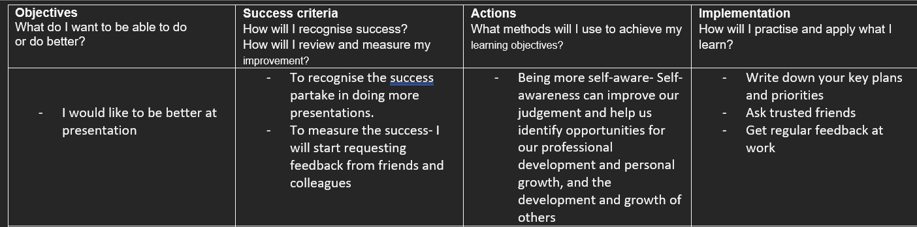

Conclusion:
Self-awareness is an important tool when applied correctively and learn from.
Reference :
Amazon.co.uk
Tedx by Tash Eurich one Self-Awareness
Lecture material by by Badir Miftah (b.miftah@uwtsd.ac.uk)

Appendix

