Introducing Modern Workplace

Assessment 1
Student`s ID :2009466
Gabriel Ciprian Muntean
Lecture : Dr Gregory Cowan
Contents
Table of Figures 2
Introduction 3
Relationship Between Organisational Structure, Culture, People and Performance 4
Organisational Structure 4
Organisational Culture 6
Organisational People 7
Organisational Performance 7
Management and Leadership 8
Managerial Works: Functions and Processes 8
Role of Leadership 8
Variables for Effective Leadership and Management 9
Behavioural Approach of Management and Individual Behaviour 9
Conclusion 11
References 12

Table of Figures
Figure 1-Divisional Organisational Structure (orgcharting.com, 2021) 4
Figure 2-Matrix organisational structure (orgcharting.com, 2021) 5

Introduction
Organisational behaviour is a set of humans' different gestures and traits inside any organisations' structural boundary like interacting with other people, leading, and following. An organisation is a disciplined structure used for achieving common or individual goals. In this report, organisational behaviour will be discussed in a business context to cope with the subject integrity. Any business organisation or company always tries to achieve maximum profit, which is possible to attain with organisational castigation and punctuality. This report deals with organisational behaviour and its effects on Unilever, PLC. The selected company's aspects will be described and critically analysed to identify critical factors of organisational behaviour.

Relationship Between Organisational Structure, Culture, People and Performance

Organisational Structure
Organisational structures are systems within the company to run the company in a disciplinary manner. The organisational structures are mainly a pyramid flow of power from hierarchy to average employees. The structures of the organisations are denoted as centralised and decentralised structures. If any company is focused on singular objectives, then the organisation opts for a centralised structure led by a CEO. Otherwise, a multidimensional corporation usually chooses a board of directors or multiple COOs for running the company systematically. This type of organisational structure is known as a decentralised structure. Unilever corporation follows the decentralised structure for operational management (Dugdale and Lyne, 2010).
Organisational structures can be differentiated in four ways to find similarities with a real-life example.
Functional structure: Among the common organisational structures implemented into the real world, the operational systems are most common. It is also known as bureaucratic organisational structures described as a company based on its workforce's specialisation. Small and medium-sized businesses mainly implement these types of fractional systems by dividing the farm into departments consisting of marketing operations and sales (Turi and Sorooshian, 2019).
Multidivisional or Divisional Structure: this type of structure is most common among large corporations with many business units. To systematically run and organise these units, the corporations need a format to manage the company efficiently. This format is the second type of structure that is less famous than functional structures.
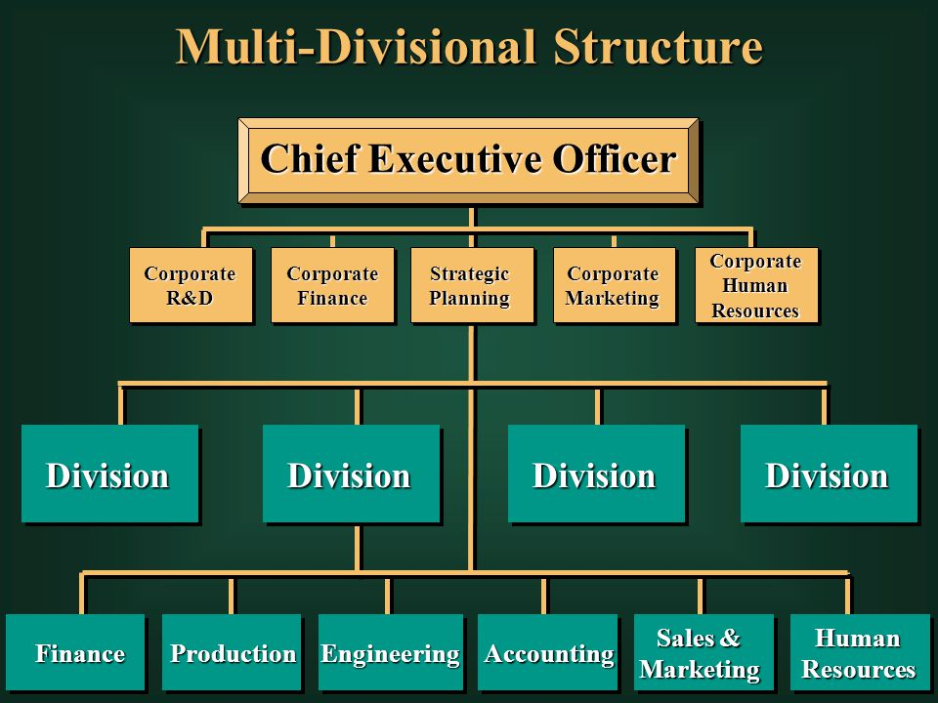
Figure 1-Divisional Organisational Structure (Bush, 2017).
Flatarchy Structure: Flatarchy structure is a comparatively new approach for managing any company methodically. It is common among the start-ups that entrepreneurs operate. It flattens the apex of power and gives its employees a lot of liberty in decision-making. This system is gaining more popularity with every passing day due to its treatment towards employees and functionality (Steyn, 2020).
Matrix Structure: Matrix structure is the least famous and used structure of all. The main reason behind the widespread reluctance of using this structure is its complexity of the function. In this tower, employees and leaders are part of different blocks that interconnects for specific purposes. This structure creates awkward scenarios where one employee can be part of both the accounting and sales department. Due to increased confusion, this structure is losing its popularity day by day.
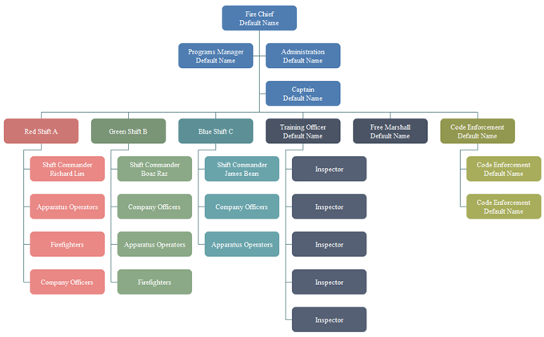
Figure 2-Matrix organisational structure (orgcharting.com, 2021)
The selected organisation Unilever Limited is a massive corporation. As a result, it applies a divisional structure to maintain functionality among the company—the main features of Unilever company that it has a product type divisional organisational structure. The company is divided into four types of product focus: the first one is personal care, the second one being cleansing products for home, the third division is based on food, and the fourth and the final division is based on refreshment. These divisions are standard in their regional divisions divided into three major regions: Asia and Africa, Europe, and the Americas. The regional divisions are extended to country offices for every country for ensuring operational ease.

Organisational Culture
Culture is a set of beliefs formed by the organisation's vision, values, norms, systems, symbols, language, assumptions, ideas, and habits (Needle, 2014). The organisational culture is determined by its reputation, philosophy, expectations, and experiences. It is a driving force or belief that inspires the employees to stand for a unified motive that binds all the organisation's components. The connection between organisational culture and organisational behaviour is solid. The company's behavioural uniqueness found as a general trait inside any organisation is a direct outcome of practising the corporate culture at an individual level (Idowu, 2016).
Unilever Limited has a rich culture of best quality production and global domination through their products and marketing. Well-structured management helps to achieve enormous success on the organisational level (AJDAROVSKA and ATTAR, 2020).

Organisational People
Any organisation is a combination of people for different roles under the command of superiors. In business organisations, superior people are recognised as executives, and the people working under their authority are identified as employees. This process is the basic structure of any organisation. But everyone working in this company are equally responsible for the success and failure achieved by the organisation. To form a sustainable design, equal representation and respect of every single people are essential. All the people working in the hierarchy of any organisation are known as the organisational people. The administrative people's combined force forms the structures, practices the culture, and achieves any organisation's goals (Holbeche, 2018).
The total number of employees work in the Unilever PLC is 155,000. These people form the corporation's organisational people as a society or family (Unilever.com, 2021).

Organisational Performance
Performance represents the outcomes of any action against the expectations of any group of people or organisation. Performance can be positive or negative, which depends on the previous actions taken by the organisation. A combination of organisational structure, culture, and people all are responsible for the performance found as a result of the approaches taken by the organisation for profit maximisation. The interaction with various constituencies can accomplish positive organisational performance. Organisational performance reflects behavioural aspects inside any corporation that can be considered the image of corporate integrity (Zgrzywa-Ziemak, 2015).
Unilever PLC has a rigorous outline for organisational performance, which helps every employee sort their goals and act accordingly to achieve individual goals. The corporation distributes performance bonuses to motivate the employees for meeting personal goals and meeting industry goals eventually (Bbc news, 2021).

Management and Leadership

Managerial Works: Functions and Processes
Managers are the integral component of any organisation who combines the employees and the company executives like a link or bridge. Managers receive an order from the executives about company goals and pass it through as orders and requests to the employees to meet the respective executives' expectations. The job of a manager and his/her actions is jointly acknowledged as managerial works. Managerial works are commonly divided into two parts: functions and processes.
Functions of a Manager: Most positions and departments within a business are tasked with specific duties based on any professional's knowledge, expertise, or company needs. Managers within the organisations are no different. According to the previously mentioned criteria, the managers operate in four other functions. They are— planning, organising, leading, and controlling. Planning is the first part of any function as it is denoted as the brain for any action. Organising any work with perfection is the prerequisite of success, which means systemising the action before implication. Leading is another vital function of a manager which is used during the signing of any plan. Controlling is the final managerial function essential for acknowledgment and ordering the action's pace and outcome (Quinn et al., 2018).
Processes of a Manager: The process of a manager is remarkably like the functions of a manager. The method of a manager means the approach of tasks that the manager does as actions.

Role of Leadership
In business, a leader is a person who takes control and accountability of a business organisation to achieve various goals. A leader is the spokesperson of any team. One cannot be a leader unless he/she is not a good speaker. A good speaker is always crucial for performance as a good speaker will always motivate and influence others with an inspirational speech, which boosts the work ethic. A leader is also the team's guardian, responsible for the group's positive or negative actions. A leader is also a team worker who will help the team members in different situations, accept constructive criticism and correct their mistakes if needed (Bailei, 2019).
The leaders follow the leadership theory and face the consequences. Whether a leader is pursuing the idea or not, the decision made by them always gets paid. Unless a public manager thinks of themselves as the leader, others will not follow them. A manager is more of occupational identity, and a leader has an inspiring and daring identity.

Variables for Effective Leadership and Management
Leadership and management are two closely related separate terms in the business context. Despite many similarities, there are some differences too. The main differences are a manager orders to do any work where the leader takes part in it. A leader creates a circle of influence where a manager makes a leader's process, and a manager values count while a leader values creation (Bush, 2019). But both leaders and managers influence various corporate social contexts.
In the contemporary business context, the quality of leadership and management is represented by three variables— time, money, and resources (Bush, 2017).
Time is an asset that is the primary variable for effective leadership and management. Efficient time administration is one of the most celebrated attributes in the business world. Managers and leaders of any organisation who respects the time and shows punctuality are appreciated in their job and demonstrates prosperity.
Money and budget are closely interrelated in any company. In the corporate world, wastage of capital is considered a destructive and destabilising factor for business. So, for efficient management and leadership, the variable money is significant.
Apart from money and time, managers and leaders also handle other resources like— workforce, types of machinery, and other capitals. In this era of economic repercussions, efficient and best-used resources are the most valuable asset. This resource is a type of variable that determines leaders' and managers' efficiency on a global scale.

Behavioural Approach of Management and Individual Behaviour
Organisational behaviour is an essential attribute to industrial prosperity and success. Organisational behaviour is formed by the organisational structure, organisational culture, businesspeople, and organisational performance. The behavioural approach is a feature that avails many characteristically driven actions in business organisations (Kengatharan and Puviraj, 2021).
Business leaders and their views are vital deciding factors towards forming unique beliefs and norms in any business organisation. The leader's decisions and motions often become the organisation's core culture, which passes through generations of that company until another influential leader evolves the culture in new dimensions. So, business leaders are integral and significant in informing and changing organisational culture, which is part and parcel of organisational behaviour.
Individual behaviour is a reflection of human nature, which is influenced by external and internal dynamics. External factors are a direct inspiration from organisational behaviour, and internal dynamics are instigated by moral views, culture, ethics, and sustainability. Solid and unique individual behaviour creates a huge influence in the evolution of organisational behaviour. It can be an X-factor for any business organisation's success or failure according to the behavioural change's positive or negative nature (Snygg and Combs, 2019).

Conclusion
Business organisations are an integral part of the world economy and supply chains. Various internal and external factors define the traits of any organisation and its behaviour. Influential leadership and management create a considerable impact on the different type of corporation according to the structure, culture, people, and performance of the corporation. All these factors form and practices the organisational character and behaviour of the business entities. Leadership and management can be influential and vital by achieving efficiency and performing accordingly. The role of a manager or leader is essential to the formation of organisational behaviour. Individual behaviour reflects many external or internal factors and drives any business organisation towards success or destruction. In conclusion, organisational behaviour is a variable attribute that affects the organisation positively and negatively.

References
AJDAROVSKA. Z. and ATTAR, M, (2020). ANALYSING THE RELATIONSHIP BETWEEN ORGANISATIONAL CULTURE AND ORGANISATIONAL AMBIDEXTERITY. Business & Management Studies: An International Journal, 8(3), pp.3550-3581.
Bailei. M., (2019). Managers as leaders. 9th ed. Boston: Harvard Business School Press.
BBC News, (2021). Unilever - BBC News. [online] Available at: <https://www.bbc.co.uk/news/topics/c40rjmqdqvlt/unilever> [Accessed 5 April 2021].
Bush. R, (2017). Effective Nonprofit Management: The Leadership Factor. Nonprofit Management and Leadership, 12(3), pp.327-333.
Bush. T, (2019). Distinguishing between educational leadership and management: Compatible or incompatible constructs. Educational Management Administration & Leadership, 47(4), pp.501-503.
Dugdale. D. and Lyne, S, (2010). Budgeting practice and organisational structure. Oxford: CIMA.
Holbeche, L, (2018). Organisational effectiveness and agility. Journal of Organizational Effectiveness: People and Performance, 5(4), pp.302-313.
Idowu, (2016). Understanding Organisational Culture and Organisational Performance: Are They Two Sides of the Same Coin? Journal of Management Research, 8(4), p.12.
Kengatharan. N. and Puviraj, M, (2021). Employer branding on organisational citizenship behaviour: A moderated moderation model of organisational politics and organisational dissent behaviour. SMART Journal of Business Management Studies, 17(1), pp.91-102.
Needle. David, (2014). Business in Context: An Introduction to Business and Its Environment.
orgcharting.com, (2021) [online] Available at: <https://www.orgcharting.com/matrix-org-chart-function/>[Accessed 5 April 2021].
Quinn. R., Faerman, S, Thompson, M., McGrath, M. and Bright, D, (2018). Becoming a master manager. 7th ed. London: Pearson.
Snygg, D. and Combs, A, (2019). Individual behaviour. 28th ed. New York: Harper.
Steyn. R, (2020). Leadership Styles and Organisational Structure. International Journal of Human Resource Studies, 10(3), p.98.
Turi. J. and Sorooshian, S, (2019). The impact of organisational structure on organisational learning. Middle-East J. of Management, 6(2), p.204.
Unilever.com, (2021). At a glance | Unilever. [online] Available at: <https://www.unilever.com/our-company/at-a-glance/> [Accessed 5 April 2021].
Zgrzywa-Ziemak. A, (2015). The Impact of Organisational Learning on Organisational Performance. Management and Business Administration. Central Europe, 23(4), pp.98-112.

