Project Management in Organisations
(BMSK5104_SWAN)
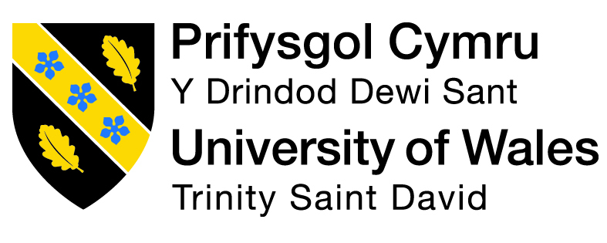

Lecturer
Dr, Shehla Khan

By Badsa Miah ID:1815821 Date:1/07/2022

CONTENTS
CONTENTS 2
INTRODUCTION 4
2.0 Main Body 5
2.1 Project initiation phase 5
2.2 Planning 6
2.3 Stakeholders Analysis 7
2.3 Project Execution Phase 8
Work Breakdown structure 9
2.4 Project Closure Phase 10
Risk Assessment Tool 11
Summary/Recommendations 13
REFERENCE 14

INTRODUCTION

This report is compiled together looking at tools and techniques used to manage projects.
A project is a plan to successfully deliver on listed goals and objectives as well as deliverables, on a project time frame. A key distinction between project management and management is that project management has a defined result and deadline, whereas management is an ongoing process. As a result, a project manager must possess a varied set of skills, including technical knowledge, people management, and business skills (The Chartered Body of The Project Profession, 2022).
There are 5 principles to a (pm) role addressing the important matters and discuss. They draw up a road map of the project, scope and goals as well as communicate and assign roles, share expectations and objectives of the teams, and monitor teams progress and identifying any issues, making sure deliverables are met and finalises the projects closure. Also keeping an attention on scope, quality, time, cost. (Campbell, 2014)
Healthy living is the project the group have undertaken to deliver, to make people become more aware of their lack of exercise and their eating habits that may contribute to their unhealthy lifestyle. The project being explored in this report is looking at creating awareness of healthy living through exercise and eating habits. Various project tools were implemented such as Quad chart and WBS (Work Break-down Structure) to create a flyer and questionnaire.

2.0 Main Body
A Project life cycle consists of 5 stages that need to be implemented to complete a project and work through each stage. A (PM) also needs to keep a focus on the 3 constraints of the Iron triangle, which is the project’s Time, Cost, Quality which determines the outcome being successful or unsuccessful. (Anderson, D. and Merna, T., 2003).
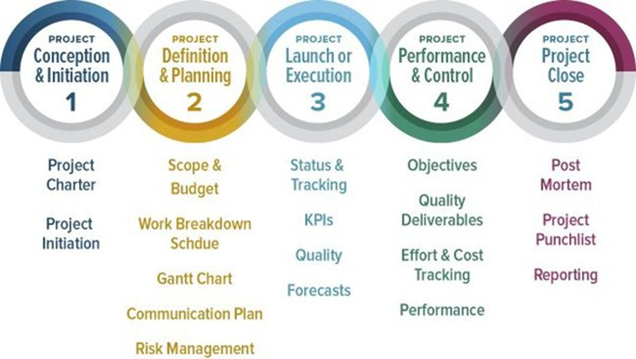
(Kloppenburg, T. and Petrick, J. 1999.)

2.1 Project initiation phase

The initiation phase of the project is to define the goal of the project which usually starts with a project charter or business case. Enlisting stakeholders managing them and selecting the team. It Is also the steps before a project is approved before planning.
What is the reason for this project? how will it deliver value for the Organisation for conducting this project. What is the Scope, Budget, Time, Cost? As well as creating a project charter outlining objectives and its deliverables as well as identifying stakeholders in the project’s? Once the project is given the go ahead.
A team is formed using Bruce Tuckman’s theory on how to build an effective team to deliver on the project, Forming, Storming, Norming, Adjourning. This builds mutual understanding between team members. (Teambuilding.co.uk. 2022) Each member will also undertake a Belbin’s team role questionnaire so the (PM) can understand which roles each team members can carry out and whom can be assigned certain tasks, we know different individuals have different Qualities they possess as well as strengths and weaknesses, this help to better understand the teams’ dynamics and formulate an effective team that can deliver on project successfully. (Belbin, M.R. 2012)

2.2 Planning

Once team roles have been assigned, the planning phase begins, and the team will create a quad chart which is a formal document.
A quad chart has 4 quadrants where the 1st quadrant helps the team to focus on its aims and objectives, the 2nd quadrant will identify your stakeholders, the 3rd quadrant tells you what desired outcomes and the 4th quadrant tells you how you will measure the project success analysis. This provides a high-level of summary of the project. The diagram below will show you Healthy livings Quad chart. (Keenan, V., 2022).
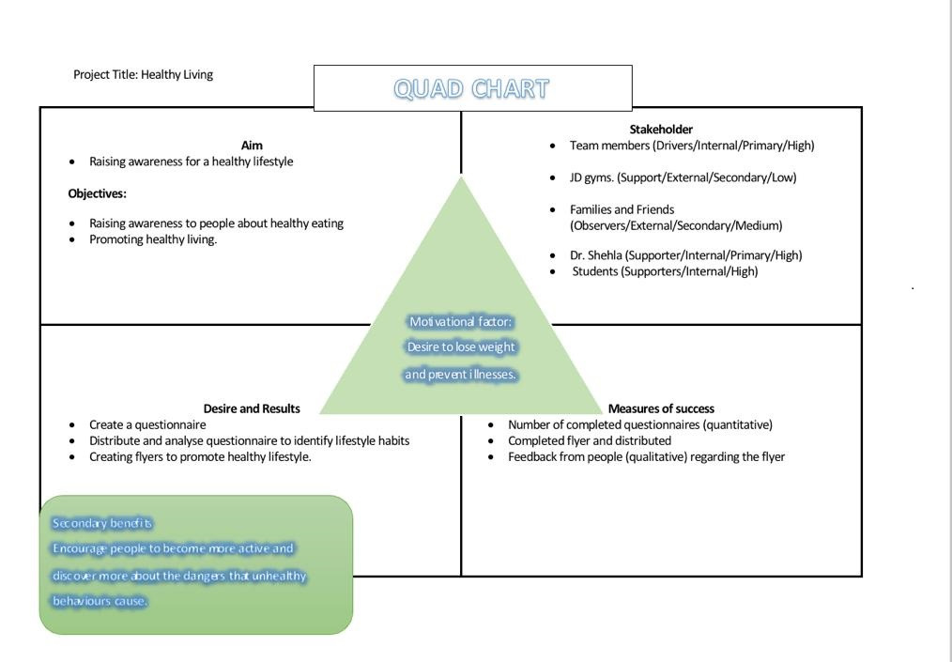
The 1st Quadrant shows the Aim and objectives, the aim is to raise awareness for a healthy lifestyle and the objectives are to promote healthy living as well as raise awareness of healthy eating for people. The 2nd Quadrant shows who are the stakeholders, the stakeholders are, Team members, JD gyms, families and friends, Dr Shehla, and students. The 3rd Quadrant is desired and results, this highlights the tasks that will be needed to be done to achieve the goal, create a questionnaire, distribute and identify lifestyle habits, also creating a flyer to promote healthy lifestyle. The 4th Quadrant will measure the success, this can be measured through number of questionnaires completed, completed flyer and distributed and also feedback knowledge gained. (Keenan, V., 2022).

Advantages of a Quad chart is that it provides a visual tool as well as helps to break down the project into 4 key areas which helps to identify projects deliverables and outcomes.
The limitations of the quad chart are that it only provides an overview of the project and doesn’t show the 3 constraints a project may face such as Time, Cost and Quality.

2.3 Stakeholders Analysis
Every project requires stakeholders to buy in, without them there is no project. Stakeholder analysis is a tool used to gain information on stakeholders knowing and prioritising them if they are internal/external part of the project. Internal stakeholders need to be updated at certain intervals of the project because they are key decision makers in the project success, while external stakeholders are stakeholders that work outside the project such as investors, shareholders and customers. (Freeman, 2010). Below is the stakeholder’s diagram

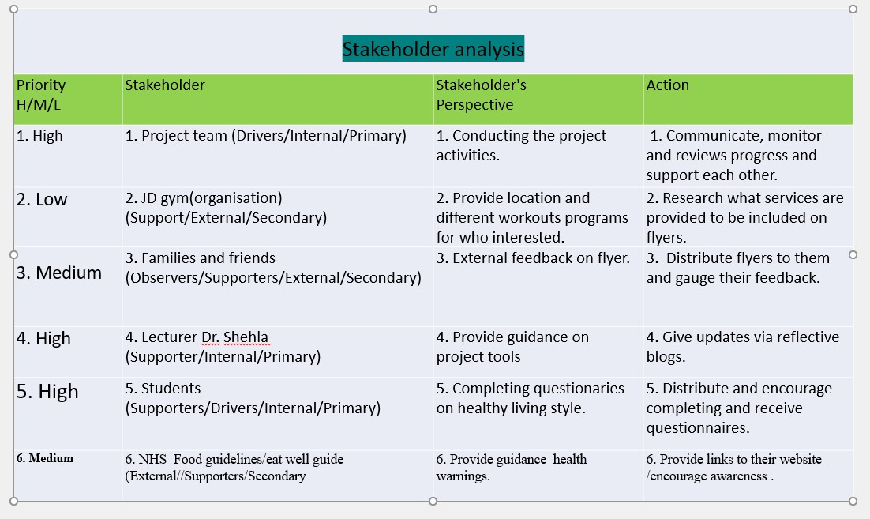
(LARION. 2022)
The diagram shown stakeholders have been ranked high/medium/low priority.
The internal stakeholders are primary drivers they will communicate with each other to achieve the objectives and have a say if they are not kept informed, they can stop the project from progressing, Such as the 1st stakeholder is a high whom the project relies on delivering the project if team don’t communicate provide support it will face challenges and barriers i.e., not being able to complete the project or attain the objective. 2nd stakeholder is a low priority their role is a supporter of the project and is an external/secondary they benefit from services they can provide the project. (Freeman, 2010)
The primary drivers are the project team and the students, the project requires the team to make sure they can deliver on the objectives the students will be required to complete the questionnaire and provide feedback.
The supporters are JD gym, Dr Shehla, NHS, students and families as well as friends who can help raise awareness for the project.
Advantages, Board members often have a stake in a company's success. This stakeholder's value comes from his business knowledge and relationships.
An experienced company leader may help a business owner. The shareholder can give coaching and help the business expand while avoiding costly mistakes, for example the 4th stakeholder provides the expertise for the project.
Disadvantages, Sometimes, stakeholders are self-absorbed. External stakeholders are usually community groups or political appointees who may not act in a company's best interest if it doesn't help them with their constituents. This situation impacts external stakeholders regularly, but not exclusively. For example, Stakeholders interest may change. (Dorobantu, Aguilera, Luo and Milliken, 2018)

2.3 Project Execution Phase
Project execution is generally the longest and hardest phase.
Execution: is when the group executes tasks, develops deliverables, and delivers them to project stakeholders.
The project manager will execute and oversee all operations to achieve deliverables as planned. It is routinely check that milestones and deliverables are on schedule as well as allowing the team to implement the project strategy, setbacks can be avoided if seen early. Execution phase is the last part where internal stakeholders are informed.
The team will handle most execution-phase tasks. He must give the team flexibility while keeping everything on track.

Work Breakdown structure

(WBS) tracks project completion, sets milestones, and allocates budget resources. Project managers may rely on the 100% criterion to guarantee that no "surprise" deliveries are underfunded.
Making and using a WBS will break down an entire project into smaller tasks, group can use a "top down" methodology. Decomposition of the job continues until the individual tasks or work units are well defined and quantifiable. This approach is increasingly common since it is a systematic technique to first find a problem solution and then dissect the solution into the phases required to achieve it. (Norman, Brotherton and Fried, 2011)
The team have decided to employ a top-down strategy for the project since it was the most obvious one for team needs. As a result, it was simpler for the team to implement because it was more organised and easier to follow the procedures.
Here is a diagram (WBS and Gantt chart)
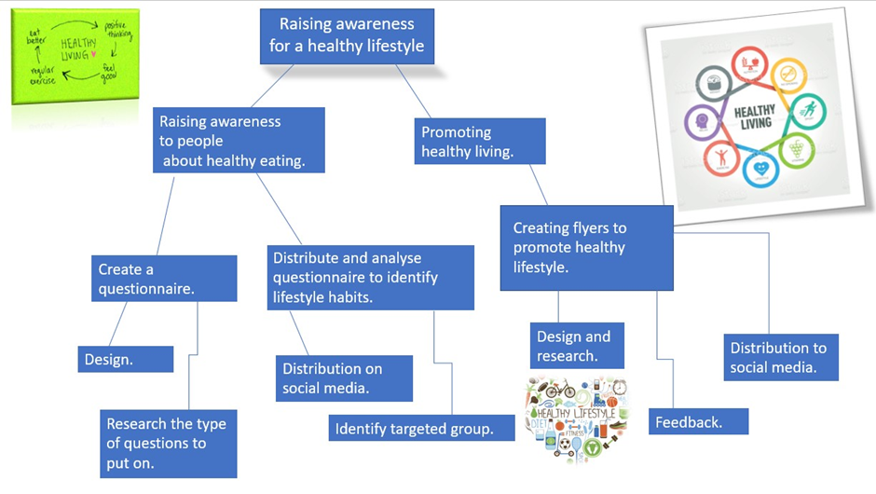
Second row
Third row
First row

The first row of the WBS connects to the 1st quadrant of the quad chart highlighting project aims and objectives while the second row of the WBS focuses on the 3rd quadrant of the quad chart which is the project’s desired outcome and results. The third row of the WBS is to measure tasks that will be required to be completed and deliverables met. by using this quad chart, the team was able to create WBS, into smaller segments so it can be managed and provide a more detailed view and time frame it can be achieved by.
This WBS break down allows the group to formulate a Gannt chart to monitor time and deadlines as well as maintaining a clear visual on the project. at this point the internal stakeholders will be addressed and making sure they are still on board.
Advantages, it breaks down the task into subcategories, detailed picture as well as helped to formulate a timetable for the Gantt chart and shows and assign accountabilities and responsibilities, can also estimate cost of the project, it also helped the group estimate time to do certain tasks.
Limitations Project managers must determine the precise amount of detail to be included in the WBS. Too little and the project lacks definition. Too much and the project becomes too bureaucratic.
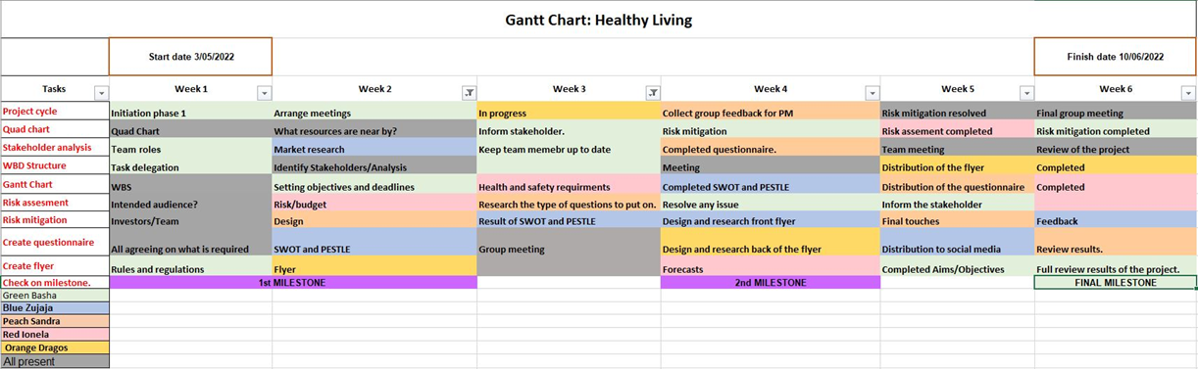
Advantages A Gantt chart provides a visual plan that can monitor a projects timeline and help to maintain project course, This is created at the planning phase and can be updated if project facing issues i.e., when a team member was no longer available, the Gantt chart needed to be updated (Gantt.com. 2022)
Disadvantage And the primary drawbacks of Gantt Charts are the complexity of chart preparation and management.

2.4 Project Closure Phase

Monitoring/Evaluation
The monitoring and controlling phase involve comparing the actual progress of the project to the plan and taking corrective action as necessary. No matter how thoroughly you plan, they must always be cautious with tracking and reporting. (Maylor, 2021)
This is where the (PM) monitors any issues setbacks the project might face using the risk assessment tool to mitigate action for example a team member was assigned to carry out a task and provide updates for the team leader which he did not. All team members raised the issue with the (PM). A team’s meeting was called by the (PM) and he decided that the member would be dismissed, he gave the opportunity for any objections vote was passed and his task were given to members, by the (PM). Members agreed and the project Gantt was updated. (Simplilearn. 2022).
Monitoring is a way for systematically examining a project's actions to see if it can reach its objectives. Evaluation analyses the success of a project or programme in achieving its objectives.

Risk Assessment Tool
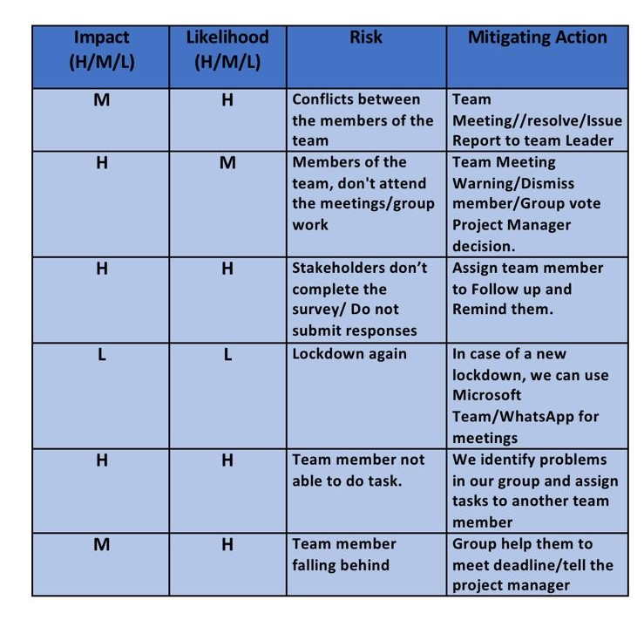
The benefit of the Risk assessment tool is that it can highlight the risk’s likelihood of occurring as well as the level of impact it has on the project which can be reviewed and resolved. For example, when a team member is failing to meet the deadline, it is highlighted as high impact because this could affect the progress of the project and the course action will be required to move forward. It was also highlighted as high for the likelihood of occurring which could be due to team members personal reasons or difficulty in understanding.
Certain risks are high due to the consequence of the risks, and some are low due to of overcoming the risk
Swot and pestle analysis also aided the project success by providing internal as well as external factors and motivated the group and provided information formed part of the risk assessment. (Wrike.com. 2022)
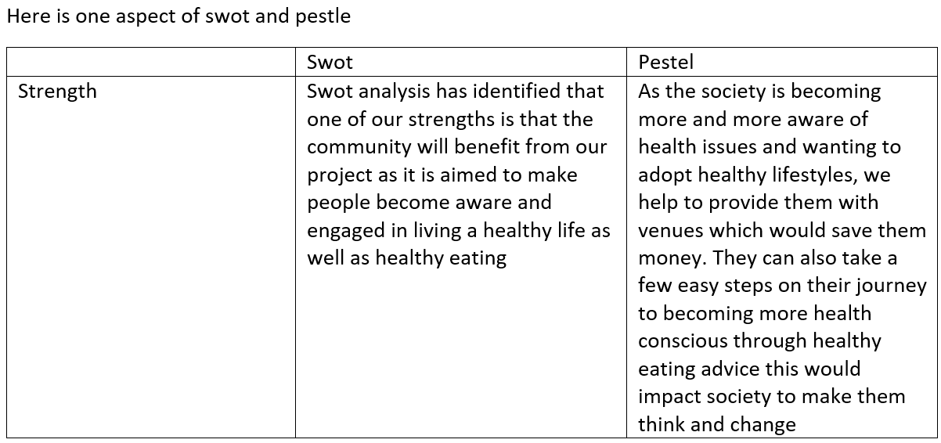
(Insights Spotter. 2022.)
Project evaluation
Evaluation helps you to demonstrate your program's success or growth. The information you collect enables managers explain the effect of your programme to others, which is crucial for public relations, employee morale, and obtaining and keeping the support of existing and new investors. (Pancer and Westhues, 1989)
Formative and summative are the two basic forms of evaluations. Formative evaluations are undertaken throughout programme planning and execution and are valuable if you want guidance on how to attain your objectives or enhance your programme. Once your programmes are well-established, you should conduct summative assessments to determine the degree to which they are meeting their objectives. (Mediell and Dionne, 2016)
In the quad chart the 4th quadrant showed the measure of success which was done.
- Completed flyer and distributed
- Number of completed questionnaires (quantitative)
- Feedback from people (qualitative) regarding the flyers

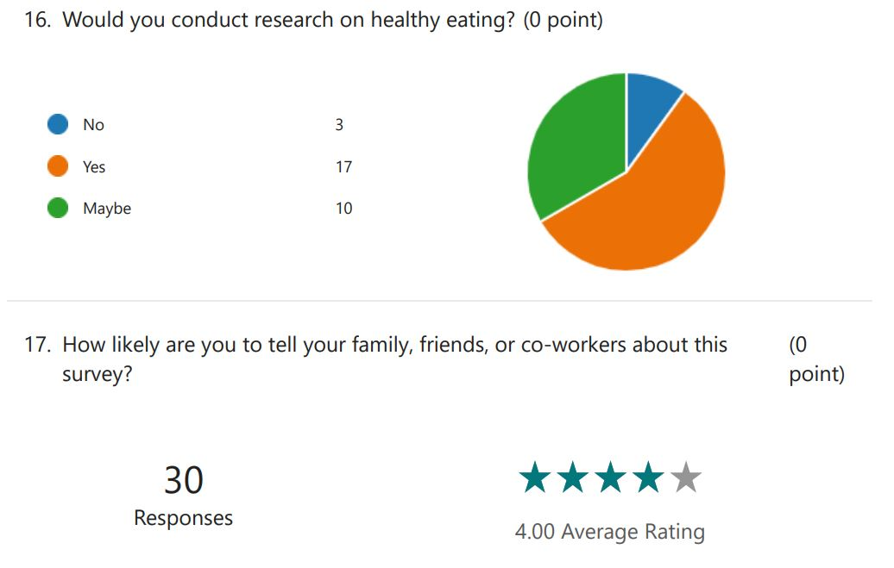

We were able successfully deliver our deliverables which we stated in our 1st quadrant of the quad chart, one of the hard outcomes was that it provided the project with completed questionnaire this was summative as well as rating our flyer 4 star. The soft outcome was that it gave positive feedback, generated awareness and people thinking about their lifestyle habits which was also summative. Which was also measured using 4th quadrants of the chart. This diagram above on questionnaire shown from feedback people are interested.
We collected information as we where progressing this was a formative evaluation it helped reduce issues with the deliverables and project goals and kept team on track for example a team member was able to complete task before the deadline that increased the success factor on the project.

Summary/Recommendations

Through this project the project life cycle and the role of the project manager has been shown to be crucial in how a project can be managed and delivered. In addition, it also outlines the importance of each phase of the project life cycle and how tools can be used within them to produce the project’s success and extinguish any flaws and risk that may hinder its success. It also demonstrates how team working plays a vital role in delivering the project and communication between all parties in the project. The project was also delivered on time and deliverables met, the feedback received was positive, as well as lessons were learnt, and improvements can be made next time. Should a project arise.
The Belbin’s team roles stated the manager is a strong coordinator, Implementer and shaper. It has also shown areas of allowable weaknesses, in certain areas where the manager needs to make improvements and gain knowledge on.
Manager can improve their ability and strengthen their roles as well as overcome weaknesses by adopting new techniques, such as learning to delegate tasks more efficiently and take more responsibility on their own role, as well as build a more balanced team that can operate smoothly. This can be overcome by learning with experience. Communicating with teams on what went well and what didn’t go well, or the team didn’t like when PM implemented tasks. Additionally, techniques such as hiring the right talent which can be done through interview session to better understand their skill sets to make a more informed decision. This will be employed to improve upon choosing the right people for tasks in the project as it will bring the highest level of productivity
As a manager who is a perfectionist, they will need to start accepting that good enough is okay as well as accept that mistakes will occur.

REFERENCE

Anderson, D. and Merna, T., 2003. Project Management Strategy—project management represented as a process-based set of management domains and the consequences for project management strategy. International Journal of Project Management, 21(6), pp.387-393.
Belbin, R.M. (2010) Team roles at Work. Butterworth-Heinemann Title; 2 edition Magen, M. (2004) Making teams Work: 24 Lessons for working together successfully. McGraw-Hill Pub.
Campbell, G., 2014. Project management. New York, NY: Alpha.
Cooke, H., Tate, K. and Cooke, H., 2011. Project management. New York: McGraw-Hill.
Dorobantu, S., Aguilera, R., Luo, J. and Milliken, F., 2018. Sustainability, stakeholder governance, and corporate social responsibility.
Forbes.com. 2022. Available at: https://www.forbes.com/advisor/business/what-is-work-breakdown-structure/ [Accessed 27 May 2022].
Freeman, R., 2010. Strategic management, A Stakeholders Approach. Cambridge University Press.
Gantt.com. 2022. Gantt.com. Available at: https://www.gantt.com/ [Accessed 27 May 2022].
Insights Spotter. 2022. PESTLE In Project Management: What Do You Need To Know?. Available at: https://insightspotter.com/pestle-in-project-management/#:~:text=PESTLE%20is%20a%20strategic%20planning,indicate%20potential%20opportunities%20and%20threats. [Accessed 3 June 2022]
Kloppenborg, T. and Petrick, j, 1999. Leadership in Project Life Cycle and Team Character Development. Project Management Journal, 30(2), pp.8-13.
LARION. 2022. LARION - Stakeholder management strategies and practices during a project course. Available at: https://larion.com/resource/scope-management-pmbok/stakeholder-management-strategies-and-practices-during-a-project-course/ [Accessed 10 June 2022].
Lock, D., 2007. Project management. 9th ed. Gower publishing Ltd: 2007.
Maylor, H., 2021. Project Management EBook. Harlow: Pearson Education, Limited.
Mediell, M. and Dionne, E., 2016. McDavid, J. C., Huse, I., &amp; Hawthorn, L. R. L. (2013). Program Evaluation and Performance Measurement: An Introduction to Practice (2nd ed.). Thousand Oaks, CA: Sage Publications.
Norman, E., Brotherton, S. and Fried, R., 2011. Work Breakdown Structures. Hoboken: John Wiley & Sons.
Pancer, S. and Westhues, A., 1989. A Developmental Stage Approach To Program Planning and Evaluation. Evaluation Review, 13(1), pp.56-77.
Tuckman, B.W. and Harper, B.E. 2012 Conducting educational research. 6th edition. United States: Rowman & Littlefield Publishers.
Wrike.com. 2022. How to Conduct a SWOT Analysis in Project Management | Wrike. Available at: https://www.wrike.com/blog/tips-swot-analysis-in-project-management/#:~:text=A%20SWOT%20analysis%20is%20a,and%20threats%20they%20may%20face. [Accessed 3 June 2022].

