DS 1 Template

My Screenshots/Photos
- Please add 4–6 screenshots or photos of your digital life.
- You can use your phone or laptop.
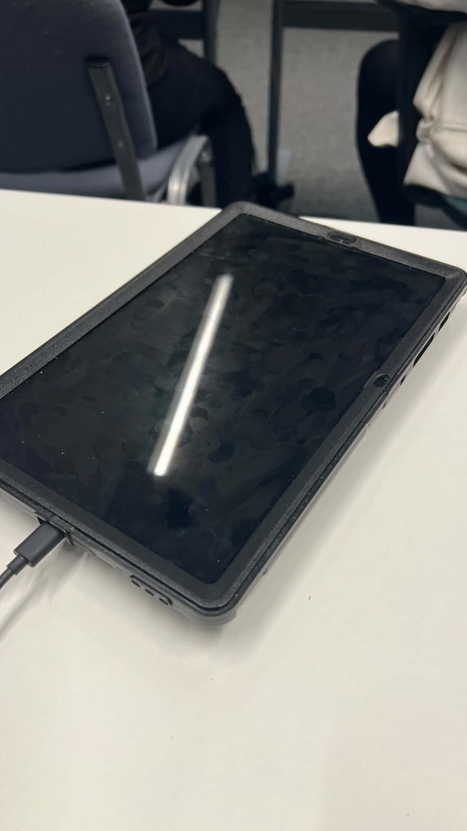
- For each screenshot, write one or two sentences explaining what it shows.

Screenshot/Photo 1
I use digital tools to study, find information and complete my university work. They make my life easier because I can learn and work faster

Screenshot/Photo 2
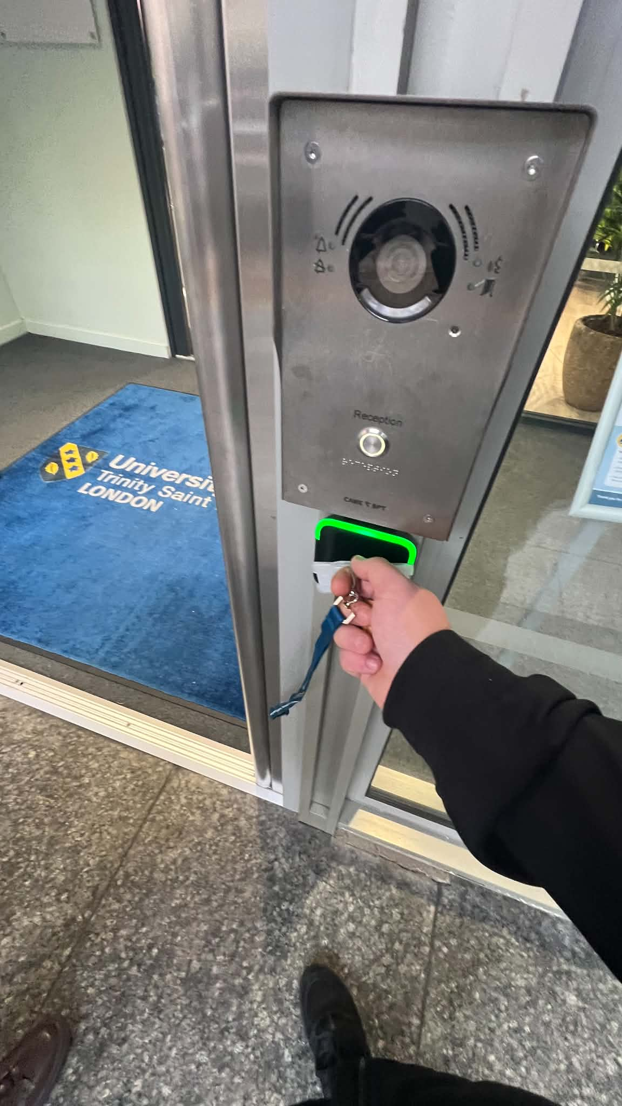
I use digital tools to enter my university with my student card. It makes my daily life easier and safer

Screenshot/Photo 3
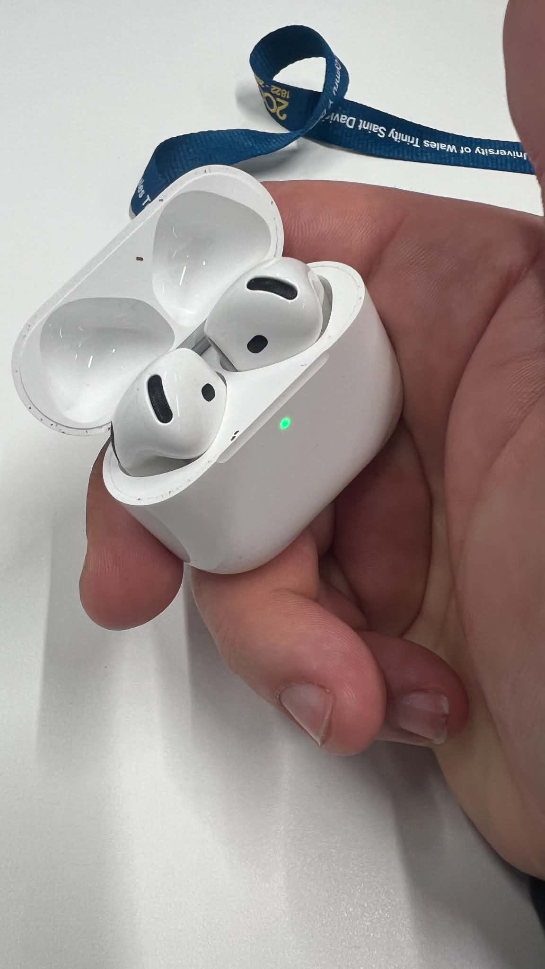
I often use these tools to listen to music, watch videos and make phone calls . They help me relax and communicate with other people.

Screenshot/Photo 4
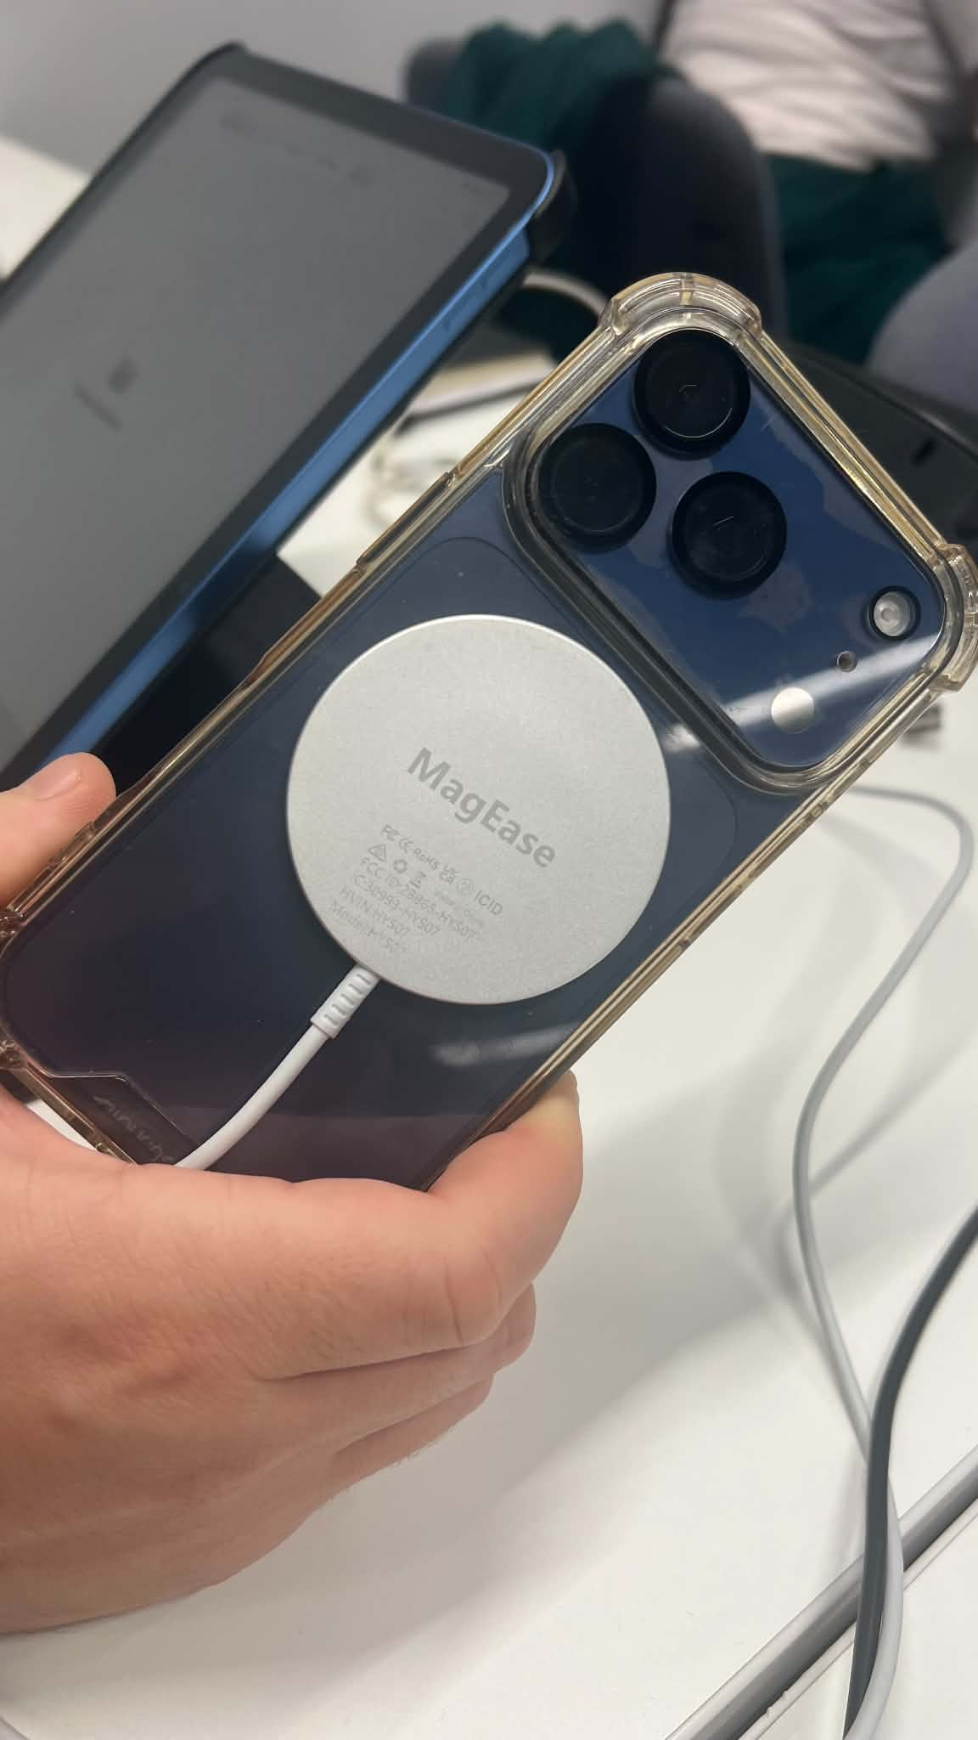
I use my phone every day to communicate, study and find information. Wireless charging makes it easier to keep my phone ready to use.

Screenshot/Photo 5
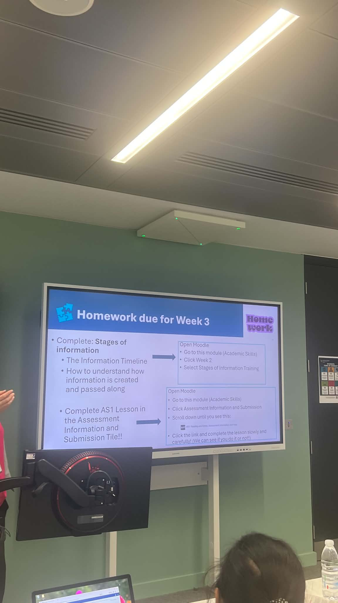
I use digital tools to study and follow lessons on the digital board. It helps me understand information better and learning easier.
I use digital tools to control devices in my home , such as lights , heating and security. They make my life more comfortable, safe and convenient

Screenshot/Photo 6
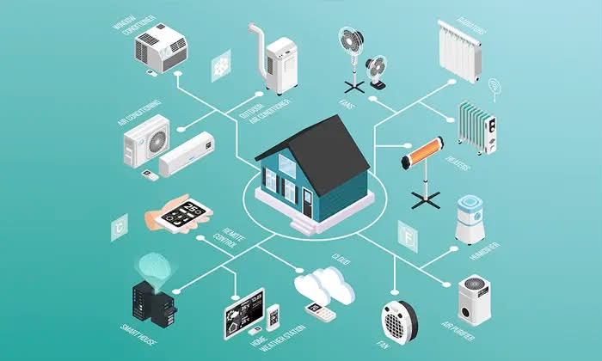

My Short Reflection
- Write 5–8 simple sentences about your digital life.
- You can use the sentence starters below if helpful.
I use digital tools every day for study, communication and entertainment.
I often use my phone, laptop and headphones.
I feel confident when I use apps and online services.
I want to improve my digital skills for university and work.
Sometimes I feel nervous when I use new technology.
I hope this module will help me understand digital tools better.
Digital skills are important for me because they make my life easier and help me learn faster.

Sentence starters
- I use digital tools to …
- I feel confident when I …
- I want to improve …
- I often use these tools: …
- I sometimes feel nervous about …
- I hope this module will help me …
- Digital skills are important for me because …

You can write more if you want.
Submission Checklist
Before you submit, please check:
​​​ ☐ I added 4–6 screenshots
☐ I wrote short sentences for each screenshot
☐ I wrote my short reflection
☐ My work is my own
☐ My file opens correctly
​​☐ My file opens correctly

