
Skills for the Workplace
Module Assignment Submission
Student Name: | Katie Carpenter
Student Number: | 1911202
Module No: | BMSK4003
Module Title: | Digital Skills and Research Methods

Statement of Confirmation of Authenticity
By the act of making this submission, the student declares that this is the work of the student named above. The work has not, in whole or in part, been knowingly presented elsewhere for assessment, or where assessment has been built on a previous assessment, this has been identified. Where materials have been used from other sources it has been properly acknowledged. If this statement is untrue, the student acknowledges that an assessment offence has been committed.
Attention is drawn to the plagiarism and unfair practice policies of both the University and of ILM.
Permission for ILM to use this script
ILM uses learners’ submissions – on an anonymous basis – for assessment standardisation. By submitting, both the centre and the learner agree that ILM may use this script on condition that identifying information is removed. However, if you are unwilling to allow ILM use this script, please refuse by ticking the box: □

Table of Contents
What has been the impact of 21st Century Technologies on the modern workplace? 3
Part 1 3
An Overview of the 21st Century Workplace 3
An in-depth look at technologies used in own workplace 3
Part 2 4
An exploration of the use of social media in the workplace generally 4
An in-depth look at the use of social media in own workplace 4
The use of social media to enhance networking and career prospects 4
LinkedIn Profile 4
Conclusion 5
References 6
Appendix 1 7
Appendix 2 8

What has been the impact of 21st Century Technologies on the modern workplace?

Part 1

An Overview of the 21st Century Workplace

Technology within the 21st century workplace has progressed an enormous amount. Enabling businesses to grow. It has had a massive impact on how businesses communicate on a global level. There was the introduction and continuous growth of many things. Including smart phones, the increasing use of social media and many companies even have personalised apps. There has also been an increased level of security for both the company themselves and for customer. (Dukes 2019) Meaning there has been an increase in productivity and efficiency, contributing to the improvement in the customers experience.
The growth of technology has had positive and negative impacts within the workplace. Communication being one very big advantage, this is because workplaces can become more flexible. Allowing employees to be able connect and talk to the rest of the work force while on the go. This is possible by using apps like WhatsApp. Which is proving to be used more and more by employees. This has been found to work extremely well for connectivity, but mainly with customer service-based companies and organisations. This is because there is now a high expectation of companies to be able to reply to customers online fairly quickly. However, despite this having a positive effect for the customer, in some cases it is having a negative impact on the employee. It has been found that is contributing to employees experiencing work related stress as employees are needing to be constantly available even after office hours.
Mobile friendly solutions have been one of the major changes in the modern workplace. With 60% of employees already using mobile apps for work related duties. This has been seen as a major positive as it gives the employee more of a choice with how they want to complete the duties required of them, enabling them to use whatever devise they choose. This has then been found to improve productivity and engagement.
(Fast Company, 2010.) I completed secondary research where I came across a recent survey with 1000 business professionals. Below you will be able to see a bar and pie chart which were completed with data from the survey. The bar graph was asking the question – which of the following inboxes do you check regularly? From the results I could see that LinkedIn and Facebook where among the highest results. With 55.1% of top management checking Facebook and Facebook groups regular. I can see a clear pattern from these results that social media is becoming a major part of the workplace, with it becoming an important tool to keep updated with. It is a major part of networking within the workplace. On the pie chart you can see how checking inboxes could be having a major impact on productivity within the workplace. A staggering 42.6% of business professionals checking inboxes more often than they would like to. With a further 23.2% checking as soon as new information shows up. The employees estimated that they checked emails and social media for about 4 hours of their working day. That equivalates to half a shift in many cases.

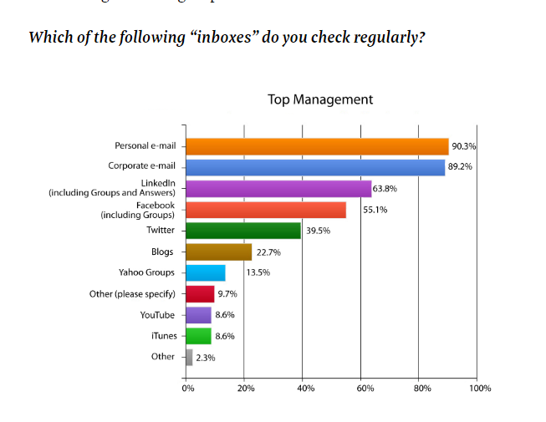

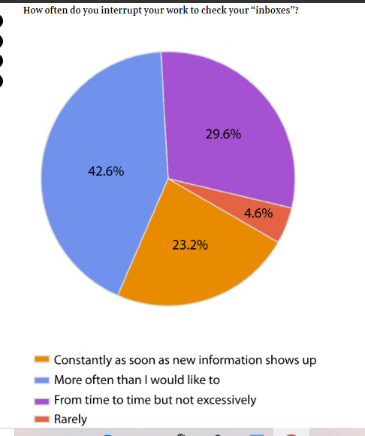

An in-depth look at technologies used in own workplace

Within my own workplace there are many different technologies which have been introduced, with a number in the pipeline for future years. I performed a few different forms of research methods within my workplace to understand what technologies have been deployed. I completed this research through discussion with my senior manager and conducting research on the gov.uk/DVLA website as I work for the DVLA. One of the many things that I have witnessed myself within the workplace which totally changed the dynamics with how we make the customers journey with DVLA more enjoyable. This was the introduction of multichannel teams. Known as MCT, which allows the customer to have a broader route to contact DVLA. We now can offer webchats, emails with the possibility of a chat bot being introduced in the future. Allowing the customer to complete data protection before interacting with an advisor. Helping to improve customer satisfaction. So far, the MCT teams have proved to be a massive success with plans to expand within the next year. In November 2019 the DVLA reached a total of 1 million webchats answered, which was a great accomplishment. Feedback received from customers is that it is a simpler way to contact the DVLA without having to call in and a much faster service.
Another piece of equipment which was implemented within my workplace was a machine called KREP, this machine is able to filter through simple postal applications and be able to electronically issue a driving licence. This then means that little human interaction is required enabling more applications to be processed at any given time which is a big positive as licences are able to be issued within advised timescales. However, this can also have a few negative points that come with it too. This is because there can be errors with the information that is printed on to licences. As there is no human interaction, the next person to check the licence is the customer when the licence is received at their home, which can then result in licences having to be returned and, in some cases, even escalate to a complaint.
(Assets.publishing.service.gov.uk, 2013) Also, another step the DVLA took in order to become more digitalised was the closure of local offices across the UK. 39 DVLA local offices with closed by the end of 2013. This was called” Digital by Default” And was the first step to introducing the online services. By being able to introduce the online services it then meant that customers were able to complete applications at any given time, without being restricted to opening hours. It also meant that the processing time for applications in many cases improved as the DVLA were able to issue many documents out as quick as the next working day. I discovered an interesting publication which was released at the time of the closers which explained how the closure of local offices was in fact the first step in the journey towards a digital business at DVLA. This step did prove to be a very wise move for the DVLA as many customers opted to use the online service and prefer it too, however going digital did also have its downfalls too. One major problem the DVLA face is the high number of non-affiliated websites which are in current circulation. Many customers mistake their website for gov.uk and then as a result find themselves paying extortionate prices for applications, which in many cases are either free or a fraction of the cost. The issue with these websites is no matter how many the DVLA fraud department get shut down, double of them will appear the following day. Because of this we find that some customer then have little trust with the DVLA online applications, so then they either refuse to complete an application all together regardless for what it was for and the implications it could have on them by doing so. Or, it does just mean that many revert to the original way and completing a postal from and then sending that off instead.

Part 2

An exploration of the use of social media in the workplace generally

The use of social media within the workplace is ever expanding. Many businesses now use social media sites which were primarily for personal use as a platform for their business. For example, sites like Facebook, Twitter, Instagram, YouTube are now being used to be able to reach their target audience. Marketing on social media does have many advantages for the workplace. I read on (Business Queensland. 2016) that social media can be used to promote your business, your brand and what your business is, advertising what you have to offer. Attracting new customers and building a good rapport with existing ones. This is because the target audience is much larger. Allowing you to reach millions of people worldwide. Many forms of social media are free of charge, allowing you to promote your business. With some having the option of a low additional cost. An example of this would be Facebook.
Facebook has an option for business to advertise a specific post which will then promote it on Facebook to an even larger audience. Also, its very fast meaning that information can be distributed quickly. It then allows personal accounts and businesses to connect easier, whether it is on a personal or customer basis. (Facebook for Business, 2020) 1.6 billion use Facebook on a daily basis with more than 7 million advertisers that are currently active on there. When creating the ad on Facebook you have the option of being able to target core audiences to be able to implement more custom. Along with advertising specific posts, there is also the option to promote your business page to be able to optimize promotions on your page.
However, along with it does come with some downfalls. This is because there is the potential risk of mass amounts of information about the business. (Kablakin. D, 2019) This could be things like the wrong information posted or even negative comments posted by other people. It is vital for businesses on social media to have a social media policy. This can reduce the risks of it being misused and providing safe networking practices. Also, the potential influence on bland reputation for review sites. A bad review could have a detrimental effect on the business’ reputation. In 2017, 97% of customers admitted that they use the internet to find local businesses which had increased from the previous year. (Local consumer review survey, 2017) found that 85% of customers trust online reviews, just as much as personal recommendations. From the bar chart below you can see that 68% of consumers said that positive reviews seen online influence whether a business is used. For me these highlight just how important reviews are for any business.

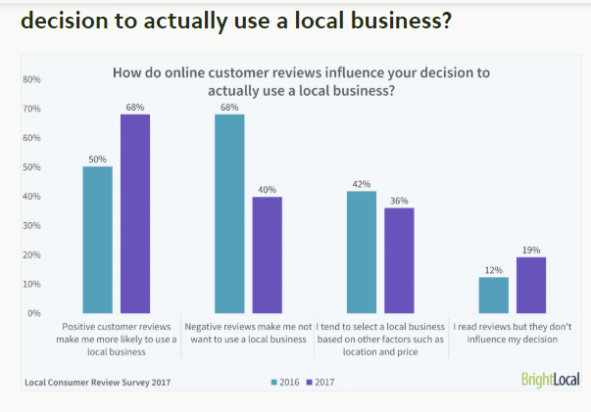

There are also the potential risks of legal problems arising if privacy legislation and copyright laws aren’t followed. GDPR is a recent regulation that became enforceable on the 25th May 2018. GDPR protects customers rights with every business. So, by social media being a communication platform for both businesses and customers it is vital that personal information is used and stored securely. (Dma.org.uk, 2019) As a result of this, it is a legal obligation for businesses to train staff and fall in line with cyber security in order to be able to protect customers personal data. Secure and encrypted systems should be used and be password protected. By doing this, the threats for both the business and safety of the customer is minimised.

An in-depth look at the use of social media in own workplace

The use of social media within my workplace has proved to be fairly successful. Both of employees and customers. The DVLA has many social media accounts including Facebook, LinkedIn, twitter and a YouTube channel. Which is updated regularly to update information by a digital communications manager who is employed specifically for this. An advantage of having an employee to manage these platforms is a way to be able to ensure that appropriate information is uploaded. I think the DVLA using social media is a great asset to the business. This is because the DVLA has a large target audience seeing as it’s a government agency, so it is very important that both customer and employees are kept in the loop with any important updates or changes. For example, a topic which is being posted about regular at the moment is Brexit. This is because it could potentially have a detrimental effect on licence holders who are resident in the EU. So, as a result of this any time we receive more information with regards to this we update the information on gov.uk and use social media as a tool of awareness. However, The DVLA being on social media does have its disadvantages too. Due to the sheer volume of calls and applications received daily, it means that there is a small fraction of customers that are unhappy with the processes and procedures that must be followed. As a result of this, many people result to using social media to vent their opinions on this. Which then portrays the agency in a negative way, which at times is hard to turn it around as The DVLA are very limited on what can be said on social media as it is a part of a government agency. So, must be seen acting in a responsible manner.

The use of social media to enhance networking and career prospects

As an individual trying to enhance my career there are many opportunities available for this which is accessible online via social media websites. Utilizing social media can give your career prospects a boost. This can be by doing simple things such as using social media to broadcast your expertise. There may be customers or potential businesses that are looking for what you have to offer. So, by having things like a professional profile or a Facebook page you would be able to show your target audience that they would be able to benefit for your skills. Even if it is just a personal account on social media it would be very important to ensure that if it was to be looked as from a professional level that the only things visible would be suitable. You would want to show case your best face to an employer and not your personal life.
(Swallow, 2011) A staggering 68% of recruiters said that they would recruit a candidate because of what they have seen on social media. With a mass of 76% of those using Facebook to be able to perform those checks. Meaning that the first impression of your social media really is everything. It is vital to show a positive personality with good communication skills. Something that may be very small to yourself could have a massive outlook on the employer’s decision. An example would be an email address, by having an inappropriate one could go against you. It would portray a negative image rather than the professional image you would want them to see.
Personal safety online is also important as this can have a major effect on your professional career. Any social media being used should also have the highest privacy classification in use, with only the basic of your information being displayed. Things like your home address or contact number should never be online nor visible to people who aren’t friends. This is because this information could then get into the wrong hands. (Getsafeonline.org, 2020) is an article I came across which gives many pointers on tips how you can be safe online. One of the main things is not disclosing personal information and being specifically vigilant when it comes to people trying to befriend. That applies both to personal and professional accounts.

LinkedIn Profile

I created a LinkedIn profile which is used to investigate its use within the workplace. I followed the simple hints and tips which were advised when first setting it up. I uploaded a photo of myself, added information on my profile as to where I work and where I am from and currently studying. A screenshot of my LinkedIn profile can be seen in the appendix.
From here, I then started to conduct some research. Starting by looking at my tutor Julia Ault’s profile and then expanding my search further by looking into my employer and potential opportunities in the future. At the beginning I did find the whole thing quite daunting and panicked about how I was going to be able to use it and set it up. When I realised it had hints and tips it put me at ease. I liked how there was the option to use hashtags to start my research. I was looking at hashtags for leadership and business. I found these interesting and inspiring, with advice for future prospects and also what is and isn’t acceptable in the workplace. From these hashtags I was then also able to find further connections to LinkedIn accounts that were relevant to my current employer and university course.
Regardless of creating a profile I’m not sure it is something I would continue to use in the future. This is because within my workplace we have something called Chatter. This enables all employees regardless of grade or level within The DVLA to be able to communicate with each other. With the profiles being quite similar to the layout on LinkedIn. Personally, while I am working for the DVLA I think I will continue to use Chatter over LinkedIn as it has more prospects for me to be able to progress. However, I do think that it is something that I would either use from time to time to keep it up to date or something that I will come back to in the future if I ever was to leave The DVLA. I do feel that it is a very useful tool to be able to showcase your skills and talents to potential employers.

Conclusion

Overall, I think that the development of technology in the 21st has been partially good and bad. I feel that there have been many advantages as well as disadvantages. Yes, the development of technology has helped businesses grow on an extraordinary level. Aiding progression and promotion within the workplace. However, I would that in ways it has failed colleagues at points in their careers. This is because not every member of staff is computer literate. Therefore, would struggle with the ever-expanding technology as less and less human interaction is needed. As well as that there is the factor of cyber bullying in social media within the workplace. I do believe that the technology within the workplace is something that will continue to grow into the future. However, I feel that despite it growing it is really important that employee productivity doesn’t reduce anymore than it already has and that customer continues to be the businesses main priority.
Despite this, within my own workplace I feel that the increase in technology and social media has benefited The DVLA on an enormous level. The DVLA contact centre receives over 3000 calls a day, so by being more modernised it has helped simplify and speed up customer calls. Making it both easier for the advisor and customer. Being one of the agents that handles these calls daily, means I welcome in more technology enhancements.

References

Business Queensland (2018) Using social media to market your business: the basics, [online] available at: https://www.business.qld.gov.au/running-business/marketing-sales/marketing-promotion/online-marketing/social-media accessed January 2020

Assets.publishing.service.gov.uk. (2013). [online] Available at: https://assets.publishing.service.gov.uk/government/uploads/system/uploads/attachment_data/file/250142/INF259_151013.pdf [Accessed 17 Jan. 2020].
CIPHR. (n.d.). Three technologies that are changing the workplace as we know it - CIPHR. [online] Available at: https://www.ciphr.com/features/three-technologies-that-are-changing-the-workplace/ [Accessed 28 Jan. 2020].
Dma.org.uk. (2019). 10. Cybersecurity and Training. [online] Available at: https://dma.org.uk/uploads/misc/social-media,-the-gdpr-and-data1.pdf [Accessed 30 Jan. 2020].
Dukes, E. (2019). 5 Ways Technology in The Workplace Has Improved Our Lives. [online] Iofficecorp.com. Available at: https://www.iofficecorp.com/blog/4-ways-technology-has-changed-the-modern-workplace [Accessed 13 Jan. 2020].
Facebook for Business. (2020). Marketing on Facebook. [online] Available at: https://www.facebook.com/business/marketing/facebook?ref=sem_smb&utm_source=GOOGLE&utm_medium=fbsmbsem&utm_campaign=G_S_Alpha_BusinessAds_NonBrand_UK_EN_Acquisition_General&kenid=_k_EAIaIQobChMI6cediKCn5wIVh7HtCh3upQDiEAAYAiAAEgIM7vD_BwE_k_&product=NoDimensionAssigned&utm_keyword=social%20media%20advertising&gclid=EAIaIQobChMI6cediKCn5wIVh7HtCh3upQDiEAAYAiAAEgIM7vD_BwE [Accessed 28 Jan. 2020].
Fast Company. (2010). How Social Media Has Changed the Workplace [Study]. [online] Available at: https://www.fastcompany.com/1701850/how-social-media-has-changed-workplace-study [Accessed 28 Jan. 2020].
Getsafeonline.org. (2019). Get Safe Online. [online] Available at: https://www.getsafeonline.org/protecting-yourself/privacy/ [Accessed 15 Jan. 2020].
Harris – Briggs, N. (2018). How does technology impact the workplace? (online) available at: https://www.avocor.com/blog/how-does-technology-impact-the-workplace/ [ accessed 15/01/20].
https://careerenlightenment.com/7-smart-ways-social-media-can-boost-career-success 17/07/20
Kablakin, D. (2019) Pros vs Cons of social media at work, (online) available at: https://www.helioshr.com/2015/07/pros-vs-cons-of-social-media-at-work/ 15/01/2020
Local customer survey review, (2017) decision to actually use a local business, (online) available at:https://www.brightlocal.com/research/local-consumer-review-survey-2017/ accessed 27/01/2020
Prasad, A. (2019). 10 Ways Technology Has Reshaped the Modern Workplace | QuickFMS. [online] QuickFMS. Available at: https://www.quickfms.com/blog/6-ways-technology-has-reshaped-the-workplace [Accessed 13 Jan. 2020].
Swallow, E. (2011). How Recruiters Use Social Networks to Screen Candidates [INFOGRAPHIC]. [online] Mashable. Available at: https://mashable.com/2011/10/23/how-recruiters-use-social-networks-to-screen-candidates-infographic/#S1A6t3JI9aqc accessed [Accessed 23 Jan. 2020].

Appendix 1



