Design of a pressure washer- a systems engineering approach
Samuel Page (1910580)

University of Wales Trinity Saint David
Advanced Systems Engineering (ACDA 6006)

Abstract
In this report, a customer has complained about the functionality of a Karcher K3 Pressure Washer. These complaints are the pressure washer running dry and various other complaints about its environmental conditions not being considered. In this report, the author was tasked with re-designing the system to satisfy the customer requirements. The systems engineering process was followed and the pressure and impellor drive elements were found to be the most critical. The author proposes many solutions and concludes that a re-designed impellor and a pressure feedback loop would solve problems. Then the Manufacturing process was thought of and control factors such as robotic manufacture were deemed to be the ones subject to the least amount of variance. A re-designed sub-system is shown at the end of the report.
Contents
Abstract 1
1. Introduction (The Task) 3
2. Key Customer Requirements 4
2.1. Stake holder Identification 4
2.2. Stake Holder Influence Map 6
2.3. Use Case 6
2.4. Voice of Customer 6
2.5. Requirements Set 7
3. Critical System Functionality 8
3.1. Quality Function Deployment 1 (QFD 1) 8
3.2. Pair-wise Diagram 8
4. Concept Derivation and Designs 9
4.1. Function Flow 9
4.2. Function Means Analysis (FMA) 9
4.3. Function Means Selection 10
4.4. Concept Derivation 10
4.5. Pugh Diagram 10
4.6. Alternatives to Pugh Diagrams 11
5. Potential Failure Modes 11
5.1. Failure Modes and Effects Analysis 11
5.1.1. Design Failure Modes and Effects Analysis (DFMEA) 11
5.1.2. Other types of FMEA 12
5.2. Parameter Diagram (P-Diagram) 12
5.3. What-why Table 14
6. Critical Design Features 16
6.1. Quality Function Deployment 2 (QFD 2) 16
6.2. Functional Failure Modes and Effects Analysis (FFMEA) 17
7. Manufacturing Processes 17
7.1. Quality Function Deployment 3 (QFD 3) 18
7.2. Critical Process Techniques 19
7.3. Quality Function Deployment 4 (QFD 4) (Important Control Measures) 20
7.4. Process Control Measures 20
8. Overall Sub-system design and Integration 21
Annex A 23
Annex B 24
References 25

Introduction (The Task)

The author has been tasked with taking a systems engineering approach to the design of a household object that has dissatisfied the customer for specific reasons. This report focusses on the design of a high-power pressure washer. A systems engineering approach uses a set of tools that aim to capture the stakeholders needs and requirements to design functional and physical architectures to realise a final complex system [1]. This tends to follow a process that is thought of as a “V” diagram that details requirements flow down and integration validating designs at every stage [1]. This diagram is shown in Figure 1.
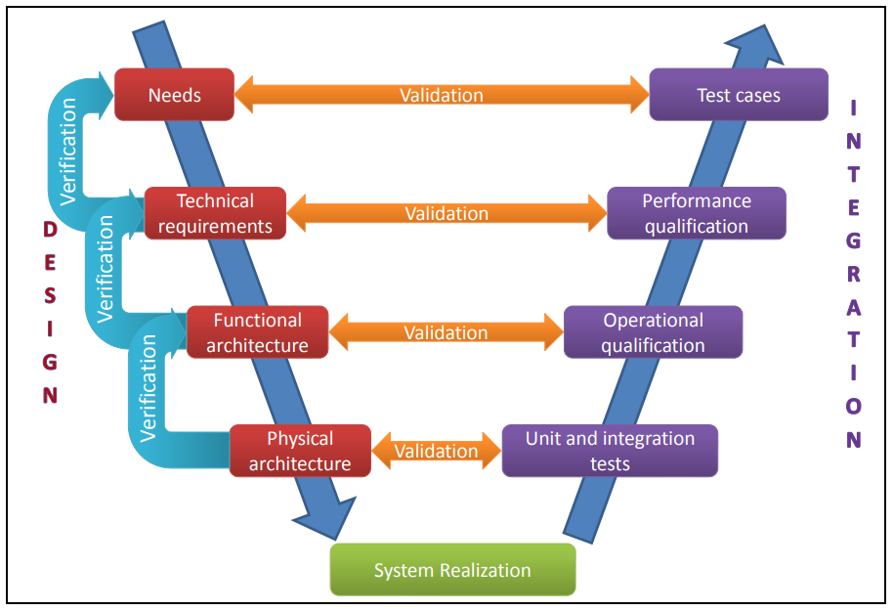
Figure 1 - V-Diagram for Systems Thinking [1]
A key part of Systems Engineering is creating a traceable and logical paper trail to identify systems realisations. This is the idea of “left-shifting” our thought process so that we engineer reliable systems that fulfil the customers’ needs and meets some uncommunicated needs. These are known as delighters. Provided in Figure 2 is a representation of the Kano Model on customer satisfaction. Systems Engineering always states that you should start with the end in mind [2].
Figure 3 also gives a summary of the outputs of the Kano Model.
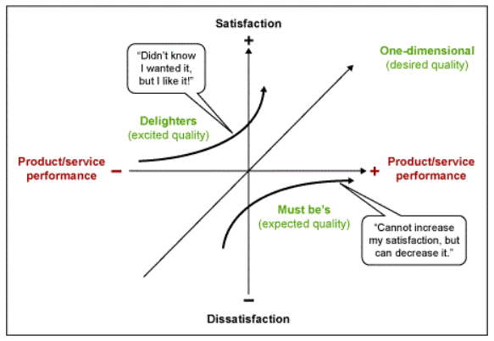
Figure 2 - The Kano Model of Customer Satisfaction [3]
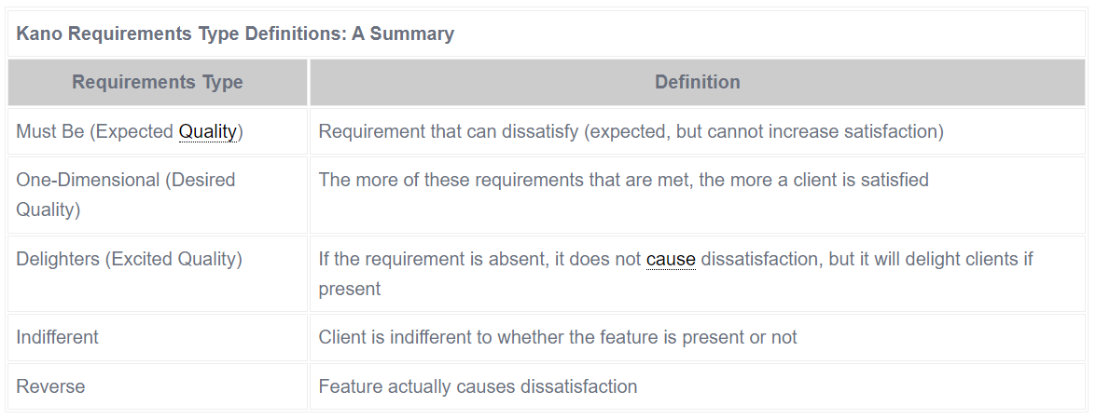
Figure 3 - Different types of Requirements based on the Kano Model [3]

Key Customer Requirements

Stake holder Identification
Stakeholder Identification isn’t an easy task and is liable to miss important groups who have an influence on the design of your system. Stakeholders for any systems can ordinarily be defined as Users, Developers, Legislators and Decision-Makers [4]. These “baseline” stakeholders then have other influencers from those groups. It is always worth exploring within those groups to identify all stakeholders; however, this can get to be along and lengthy process that ends up producing too many stakeholders to be able to satisfy [4]. Provided in Figure 2 is a proposed system for identifying Stakeholders. In this report, a different approach has been taken. An attempt to capture primary stakeholders has been made and then these stakeholders have been grouped as shown in Figure 3. A Stake Holder Influence Map was then produced as shown in Section 2.2, Figure 4. The limitation to this though, is if there isn’t the required knowledge and experience during this stage, stakeholders can be missed entirely.

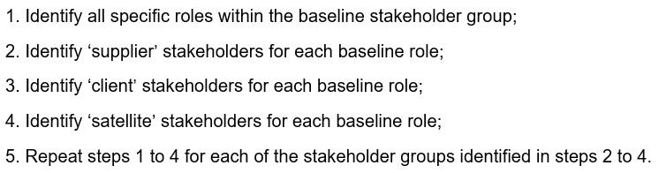
Figure 4 - An Approach to identifying all stakeholders [4]

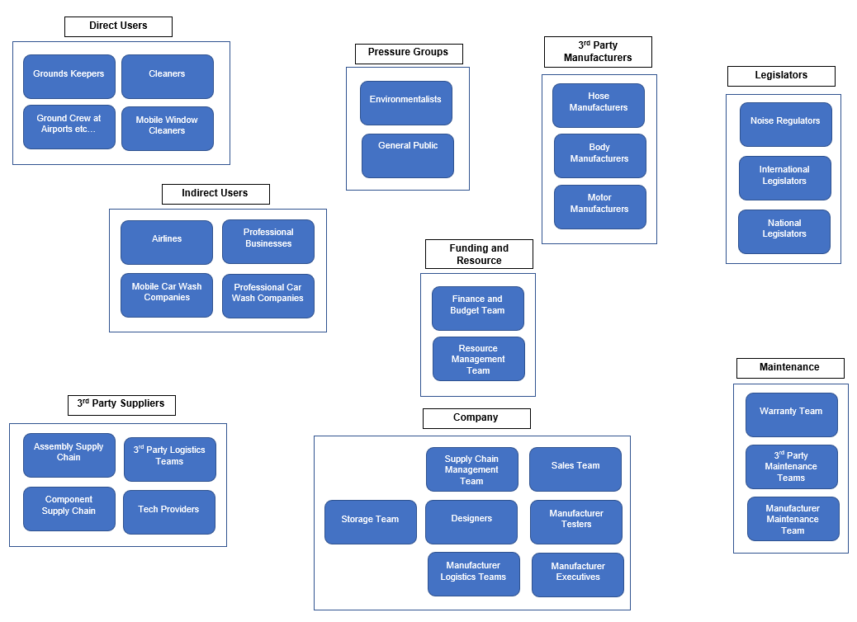
Figure 5 - Stakeholder Groups Identified for the Design of a New Pressure Washer
Another useful tool that could be used alongside the tools used for this report, is a Requirement Elicitation Plan as this allows you to place timescales and provide details on the way in which you will capture the requirements from different stake holders. These methods can be anything from interviews to past case reviews [5]. This can prove to be a vital process when gathering requirements and can even be key in defining the direction the design takes [5]. Widely regarded as the most useful technique is the stakeholder interview because you can gain inciteful information if you manage to get the right mix of expertise and less experienced members involved [5].

Stake Holder Influence Map
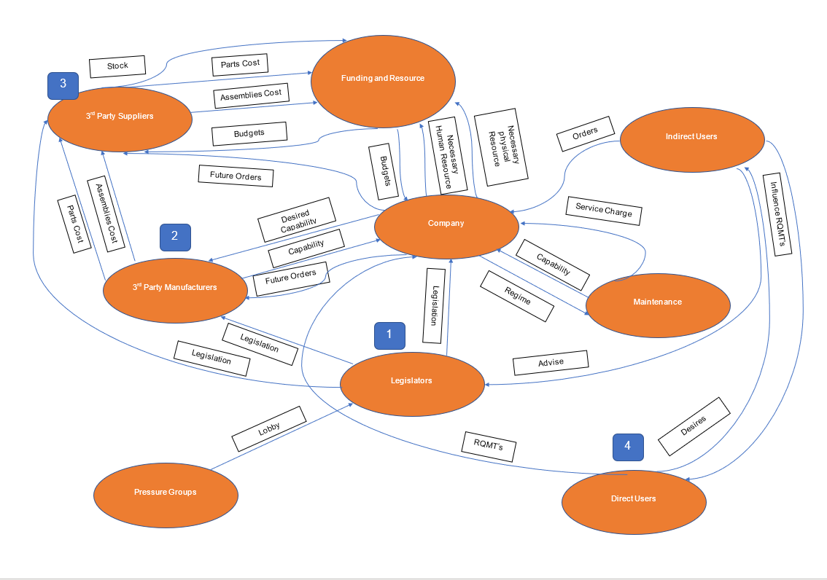
Figure 6 - Stakeholder Influence Map for a Pressure Washer

Use Case
A Completed Use Case for the Pressure Washer can be seen in Annex A. Use Cases are a tool that are able to identify a logical flow of events expected by a particular interactor (or actor) [6]. Use cases can and should be applied at both system and sub-system level as it gives an insight into how users would expect, and want, to interact with a system. However, instead of just using the use case at the requirements capture stage, as is described here, they can be engineer facing and incorporated during the specification phases of development too [6]. Alongside this perfect flow of events is also an exception flow that helps to detail exactly how success might be prevented giving an early insight into where the failures might occur and how the user views these potential failures [6].

Voice of Customer
In this report, another approach that was taken to requirements capture was Voice of Customer. This is a really good way to capture a worth and reliable set of desires directly from the users of a device [7]. Requirements capture is referred to as the “fuzzy front-end” by many engineers as this stage can be very subjective and often includes ad-hoc decisions [7]. However, the requirements capture is one of the most important steps and is vital for ensuring that you always design the correct system. It has been found that businesses with a clear strategy for capturing the voice of customer have been up to 70% more successful when designing new systems or services [7]. Provided in Figure 5 is a completed Voice of Customer table for a pressure washer.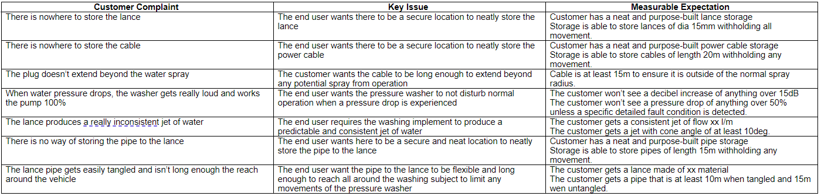
Figure 7 – Completed Voice of Customer for a Pressure Washer
When it comes to the Voice of Customer, a good way to identify the proper requirements set is to approach it in the “five why’s” method. This is asking a series of why’s to get to the real reason that the customer wants a certain solution implemented or why the product fell short of their expectations [8].

Requirements Set
Another tool used for identifying general functionality that may also be useful. This tool is an Affinity Diagram. Affinity diagrams allow a large disorganised, confusing, and seemingly unrelated information to be collated into groups that have natural relationships [9]. It is good to apply this tool at this early stage because it is best used when the participants don’t have much experience as these communicated ideas will be lacking detail and this allows you to obtain the desired general functionality using these groupings [9]. It also gives Systems Engineers a visual way of determining if groupings are both complete and free from redundant needs [8]. The generic functionality should have a verb-noun relationship.
In Figure 6 is a basic requirements set for a pressure washer and provided in Figure 7 is the identified generic functionality from the use case.
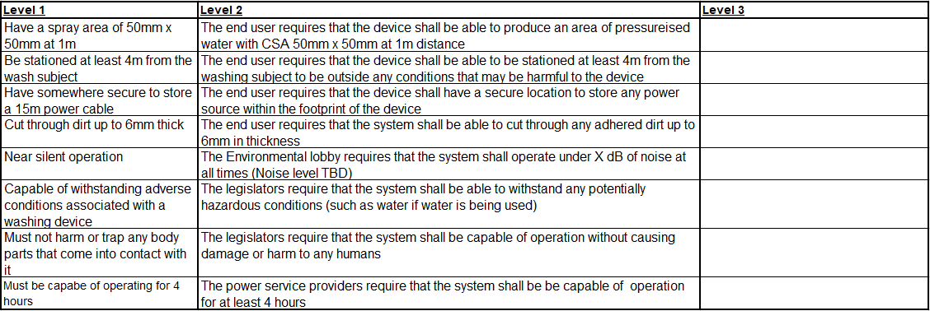
Figure 8 - Requirements Set for a Pressure Washer

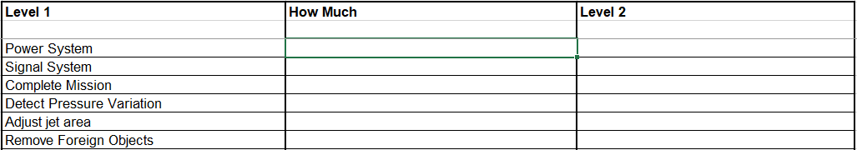
Figure 9 - Generic Functionality for a Pressure Washer

Critical System Functionality

Quality Function Deployment 1 (QFD 1)
Quality Function Deployments (QFD) are a vital tool to use at all stages of the design and manufacture process. The purpose of performing a QFD is that it translates requirements and desires into appropriate technical requirements at each stage [10]. Developed in Japan in the late 1960’s it has uses for various tasks such as Engineering concept evaluation and identifying critical aspects of all engineering design steps [10]. At this stage, a QFD 1 is performed to take the generic functionality shown in Figure 7 and identify the critical system functions. The functions identified this far are exclusively Non-functional system. However, later in this report, we will need to capture all other functionality. The QFD 1 is the start of this process. Provided in Annex B is the QFD 1 for a pressure washer. The Functional Importance Graph is shown in Figure 10. The most important function identified is “power system”, however, that is standardised through legislation, so the function that was next most important was “detect water pressure”. Therefore, this was taken forward for further exploration.
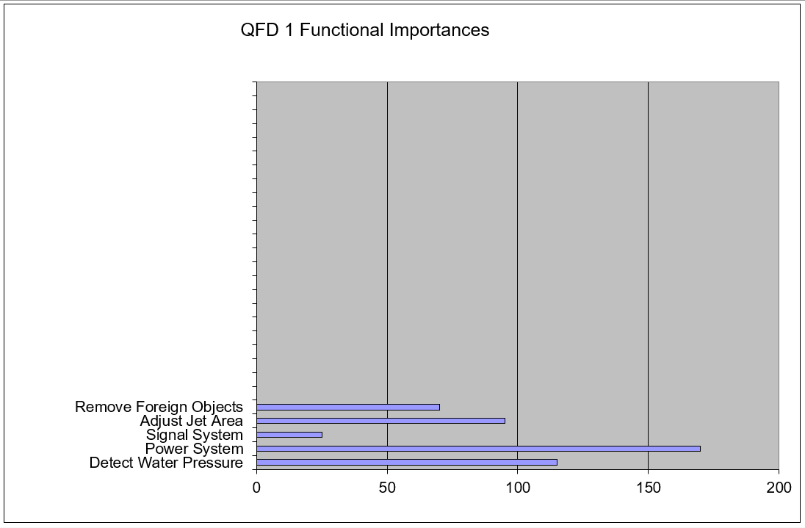
Figure 10 - Functional Importance Graph

Pair-wise Diagram
It is important that alongside QFD 1, a comparison of the requirements is performed to establish a hierarchy to ensure we spend the most time on the important requirements otherwise the customers’ expectations won’t be met. A pairwise diagram allows you to compare the requirements with themselves giving a numerical weighting that is normalised. There are other tools that can be used such as the Analytical Hierarchy Process, Wiegers’ Priority Matrix and Borda’s Method [8]. These can be time consuming though, so this report focusses on a pairwise comparison. Figure 10 shows a Pairwise comparison template that can be used for the system and the subsequent Requirements Importance Graph that is produced.
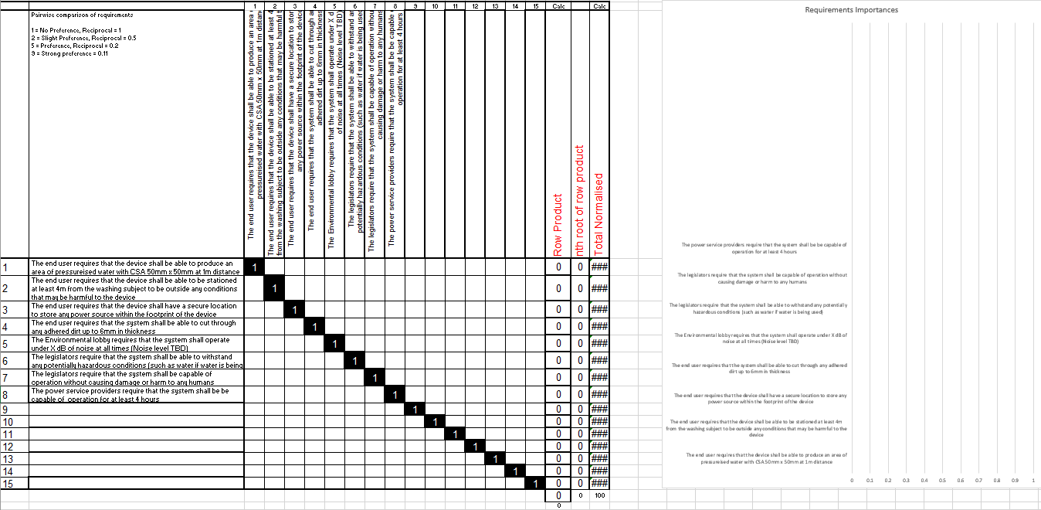
Figure 11 - Pairwise Comparison of requirements

Concept Derivation and Designs
This next section focusses on the derivation of concepts and selection of the most appropriate systems. The most logical place to start is by performing a function flow.

Function Flow
A function flow diagram is a very useful tool to identify a logical flow of functions for a system and helps to identify any functional interactions [11]. From this simple task as well, some potential failure modes can be identified along with any knock-on effects. This will aid later in the process and this report when we look at Functional Failure Modes and Effects Analysis.
Another key output from the Function Flow is that you start to identify Functional Requirements that are quite often missing from the original proposed customer requirements which are exclusively Non-functional System.

Function Means Analysis (FMA)
Function Means is a very highly structured approach to generating design solutions and presenting all systems designs alongside each other [12]. With these solutions presented together, selection/deselection criteria can be easily applied to generate whole system solutions [12]. Another benefit to performing an FMA is that it allows all system design decisions to be recorded which will help any outside interactors, such as maintenance or operators [12]. An example Function Means table is shown in Figure 11 and a basic function means for the “detect water pressure” function of the pressure washer is provided in Annex D.
Figure 12 - Function Means for Detect Water Pressure
Function Means also serves another purpose. It is a way of shifting from the functional domain to the object domain and starts to identify architectural functionality that might have been missed [12]. This can be objects such as physical casings or fixings. These are just assumed but quite often get overlooked.

Function Means Selection
The next step of the design process is to apply selection/de-selection criteria to the function means table. This allows you to accept or decline solutions based on qualitative criterion such as cost, lack of technological maturity or having an established solution with a wealth of experience being employed in similar systems. For the “Detect Water Pressure” several solutions were proposed, however, due to the maturity of certain technologies such as optical sensors, salinity and alkalinity sensors, a few different options were chosen. These were a pressure transducer, a flow meter and a load sensor on the impellor motor. These options are also relatively low cost.

Concept Derivation
From the Function Means, after selection/de-selection has taken place, a full concept can be derived. Ordinarily this will lead to multiple concepts which leaves us with the other important question… how do we determine which is better? This paper focussed on a Pugh Diagram which is a multi-criteria analysis tool in Section 4.5.

Pugh Diagram
A Pugh Matrix is just one of many multi concept analysis tools and can be used at any stage in the design process where solutions need to be compared. The way it works is to take a currently marketed solution and compare your new concepts to this design to meet the set of defined functions [13]. A completed Pugh matrix for the Detect Water Pressure function is shown in Figure 13. The baseline design was a Karcher K3 Power Washer. The outcome of this Pugh matrix showed that Concept 2 which was using a pressure transducer with a feedback loop was the most effective solution.
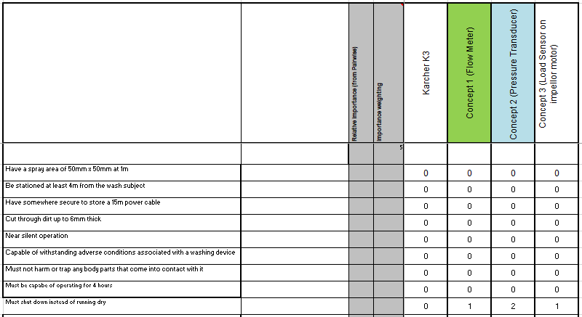
Figure 13 - System Pugh Matrix

Alternatives to Pugh Diagrams
There are limitations to Pugh Diagrams though. These can be incomplete selection criteria or the wrong selection criteria [13]. If this is the case, alternatives such as a desirability vote may be favoured.

Potential Failure Modes

Failure Modes and Effects Analysis

Design Failure Modes and Effects Analysis (DFMEA)
A DFMEA was performed on the system to understand what the knock-on effect was of that failure. There are 5 types of failure in Systems Engineering
- Over Function
- Under Function
- No Function
- Intermittent Function
- Unintended Function
An FMEA can be performed on all these modes to create a complete picture of the consequences of failure from any part of the design. For this report, a focus on the Pressure transducer was taken due to it being identified as a the most important design feature to control in QFD2 later in this report. Also, the most severe case was chosen (No-function)
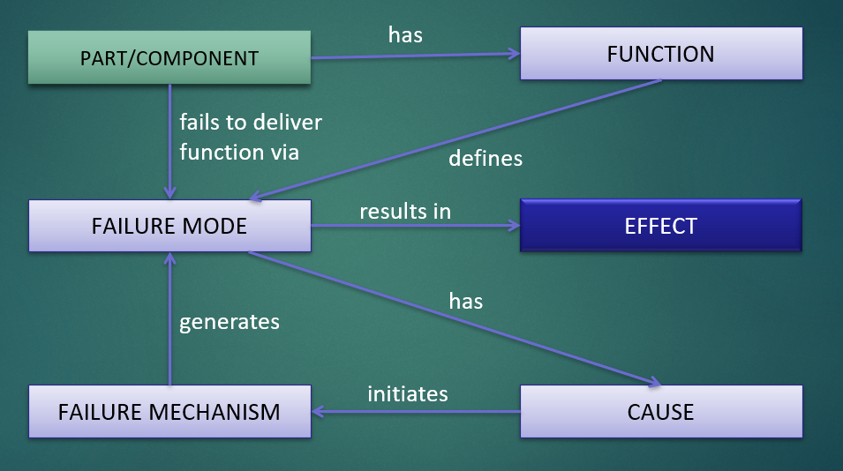
Figure 14 - DFMEA Approach [14]
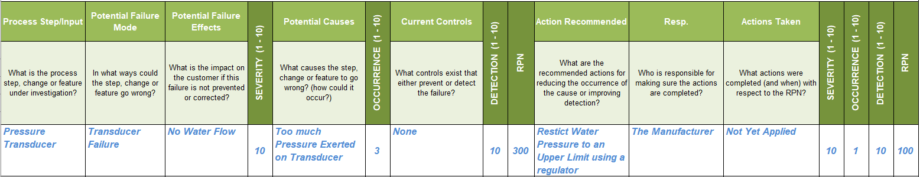
Figure 15 - DFMEA for the Pressure Transducer

This failure mode could also lead to a failure of more key parts such as the impellor. This can be determined by reviewing past failure reports. This must mean that we have also missed some important functionality as the impellor drive motor wasn’t defined in any requirements or functionality capture. This would be a functional requirement so addition to the original QFD 1 would be necessary to ensure that the system was designed in a robust way. This hasn’t been done for the purposes of this report. This is a clear representation that a systems engineering approach is an iterative process.

Other types of FMEA
There are various other types if FMEA. These apply at different times in the design process. For example, a Functional Failure Modes and Effects Analysis would be performed at the start of the design process to determine the outcome of a function not being performed. This would paint a picture of the knock-on effects on the end user and the system. Also, there is a Process Failure Modes Effects and Analysis that does the same for the manufacturing process and a Use Failure Modes and Effects Analysis for how it could fail in use [15].

Parameter Diagram (P-Diagram)
A Parameter diagram (P-Diagram) can now be performed on the design to assess its ability to withstand any noise in the systems operation. These task all determine if the system can perform as expected and if we are achieving the best possible performance but only if everything is in its optimal working conditions. This allows the designers to decide if they want to try to achieve a less precise result but one that is more robust to noise. This is illustrated in Figure 15 and Figure 16.
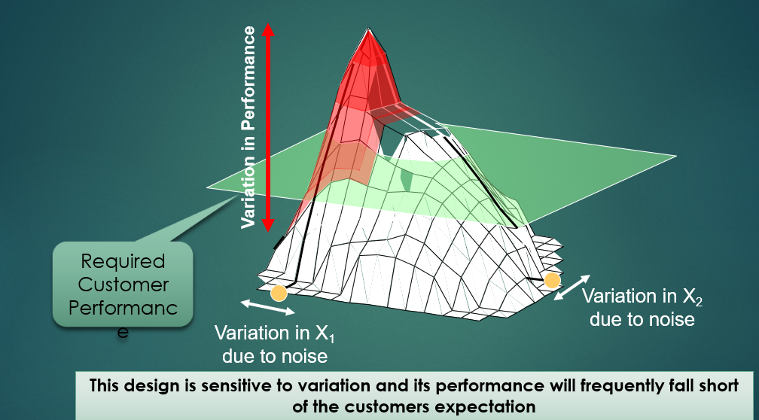
Figure 16 - System Design Space Sensitivity [16]
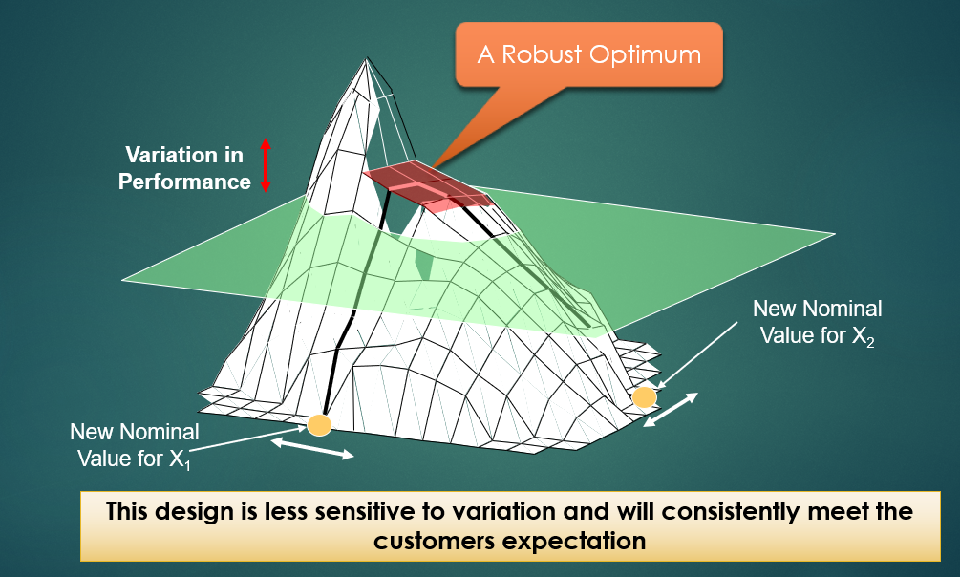
Figure 17 - A less ambitious system, less sensitive to natural variation [16]
A Completed P-Diagram is provided in
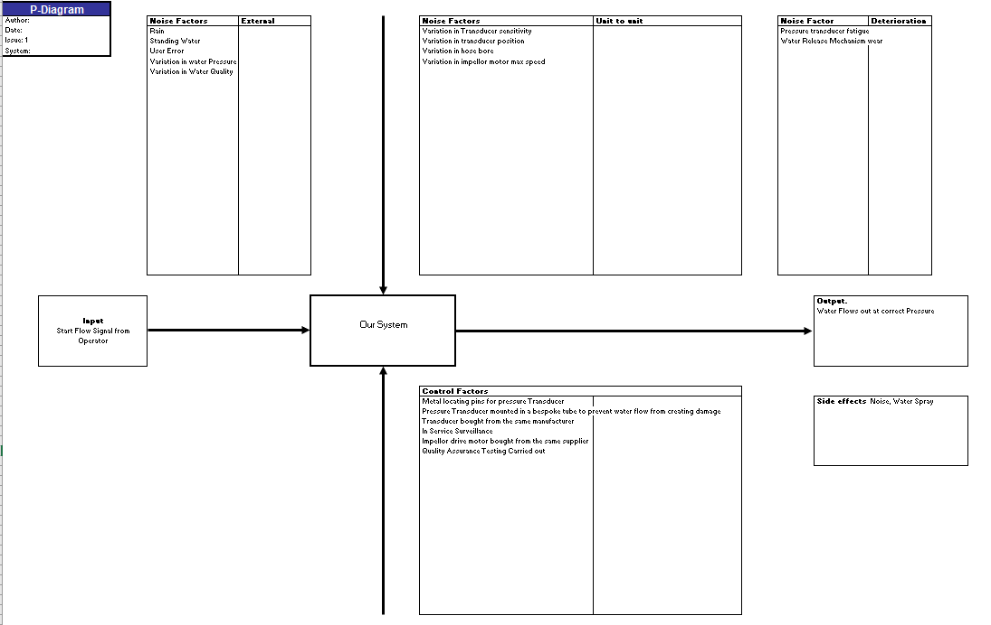
Figure 18 - Parameter Diagram

What-why Table
Following on from this a What-Why table can be produced. This is where you use the noise factors from the P-Diagram show in Figure 17 and see how they are affected by the control factors. The amount the control factors are affected by noises will show what are the important control factors and which noises you need to focus on removing or mitigating against in your design. A completed What-Why table is shown in xx
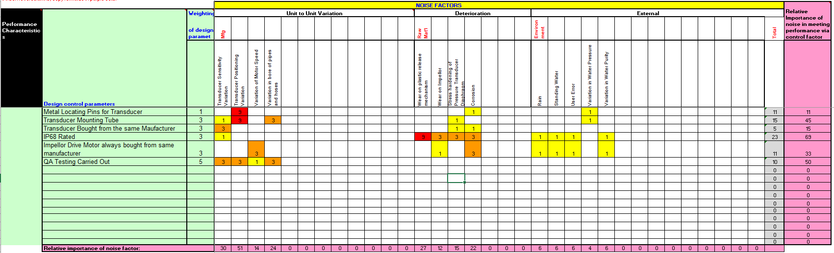
Figure 19 - What-Why Table
From this, an importance graph is produced for both the noises and the control factors showing a priority. These Graphs are shown in Figures…
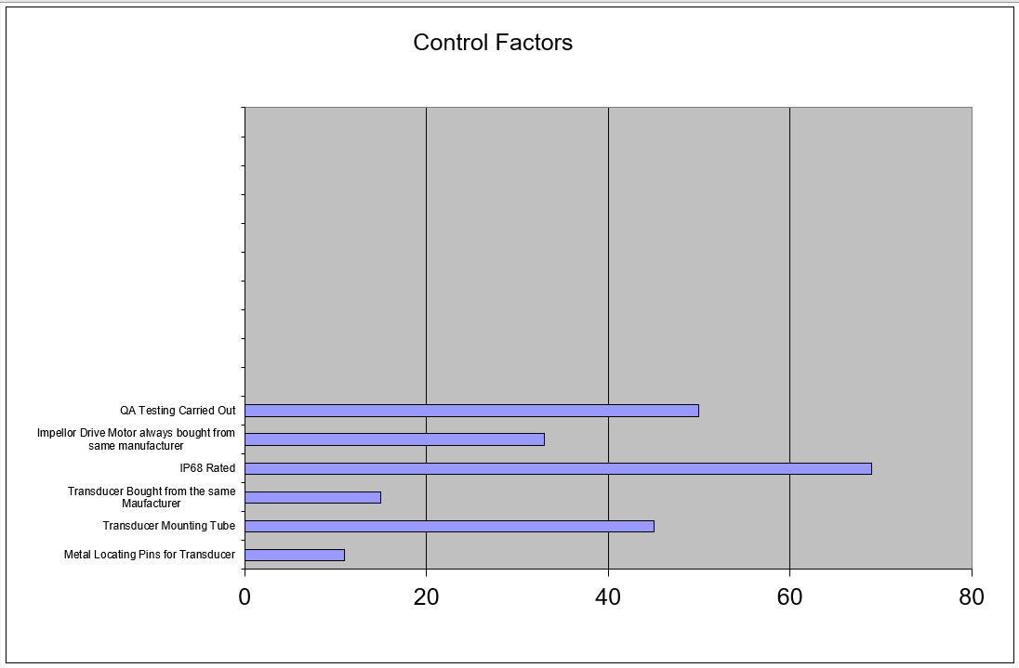
Figure 20 - Control Factors Importance Graph
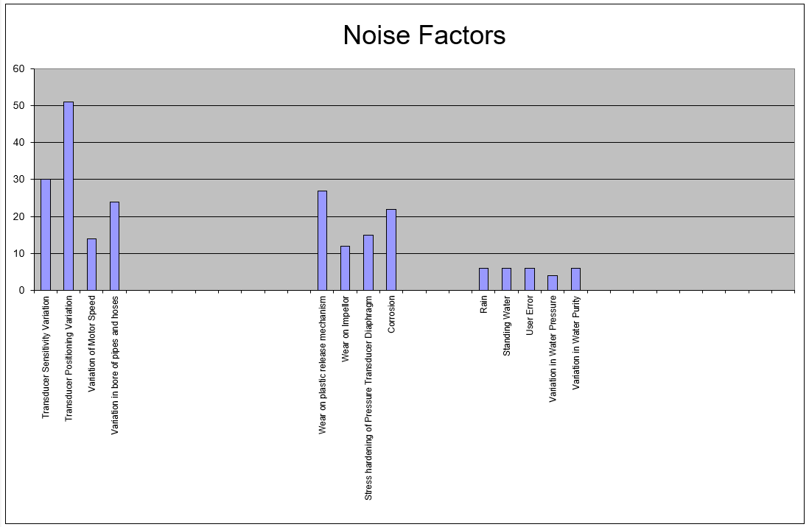
Figure 21 - Noise Factors Importance Graph
As can be seen from these graphs, the most important noise factor is the position of the pressure transducer, and the most important Control Factor is ensuring that the product is IP68 rated followed by the Pressure Transducer Mounting Tube.

Critical Design Features

Quality Function Deployment 2 (QFD 2)
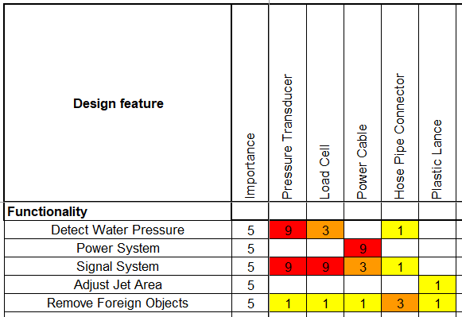
Figure 22 - QFD 2 for Pressure Washer System
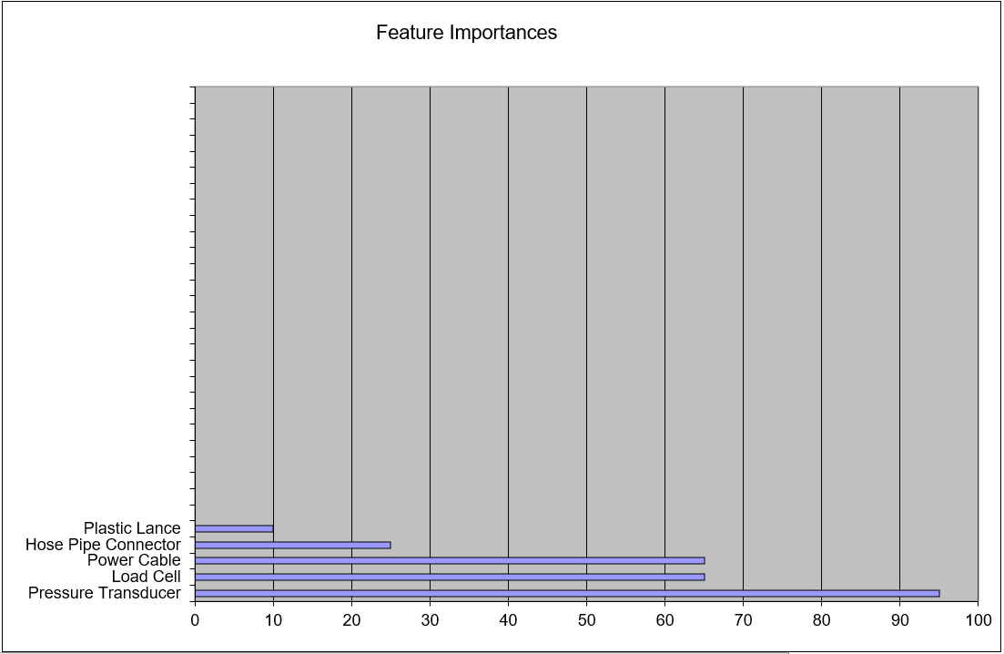
Figure 23 - Feature Importance Chart
As described in Section 3.1, a second QFD was performed by taking the important functions from QFD 1 and assessing them against the design solutions. Outputted from this QFD stage is the important design feature. The author now knows what they must ensure is designed in a robust way. In the case of the pressure washer, it was the pressure transducer that needed to be designed and implemented in a robust manner to ensure the system doesn’t fail.

Functional Failure Modes and Effects Analysis (FFMEA)
An FFMEA was performed on the Function “Detect Water Pressure” to assess the effect on the system if the function wasn’t performed. This is shown in Figure 23
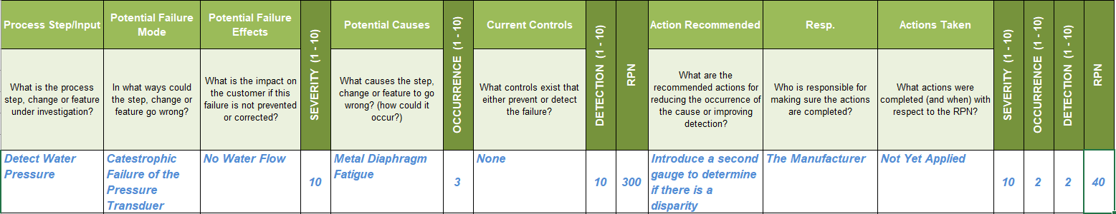
Figure 24 - FFMEA for a single function

Manufacturing Processes
A large part of the manufacturing component of Systems Engineering is repeating the process for the design section again but this time with a focus on the manufacturing requirements. So, you need to follow through a requirements elicitation plan and follow through with a Manufacturing QFD 1 and 2 so that you obtain an understanding of the important manufacturing process steps. From this, a QFD 3 can be performed which shows us our important process techniques and a QFD 4 can be performed to detail how we will control those. The process of the Manufacturing QFD’s is detailed below.
The full process for identifying stakeholders, their influence and requirements elicitation won’t be presented in this report as the same process was followed as in Sections 1 to 4.
Below are the major manufacturing requirements identified
- Reliable Manufacturing
- Low-Cost Manufacturing
- Low Variance (Quality Assurance)
- Low Maintenance Cost
- Low Capital Cost
These were expanded for QFD 3. A Manufacturing QFD 1 Importance Chart is shown below in Figure 25.
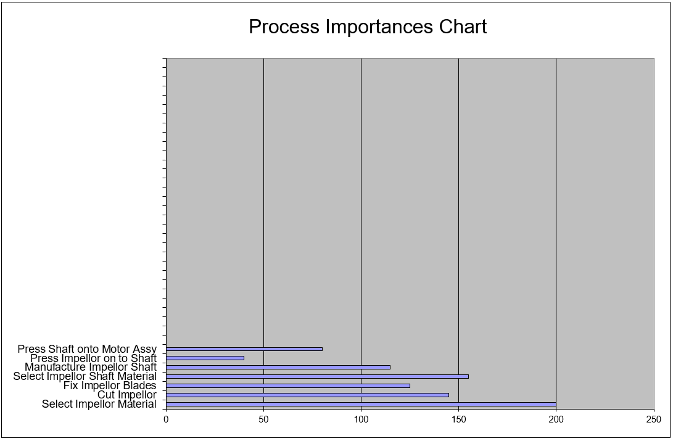
Figure 25 - Manufacturing QFD 1 Importance Chart

Quality Function Deployment 3 (QFD 3)
Leading up to QFD 3, a full QFD 1 and QFD 2 would be performed as the output from this process gives the most important manufacturing process designs and a function means would be performed along with a process Pugh to give the desired way to deal with those Manufacturing processes. Quite often this gets at architectural functionality of the system. The output is the important process techniques so we know what we will need to control.
This QFD step compares the manufacturing requirements against the actual processes used to achieve the successful manufacture of a system. For this section of the report, the impellor was focussed on as a review of past failure cases showed that even though the pressure variation caused the systems to run dry, the actual material failure occurred at the impellor.
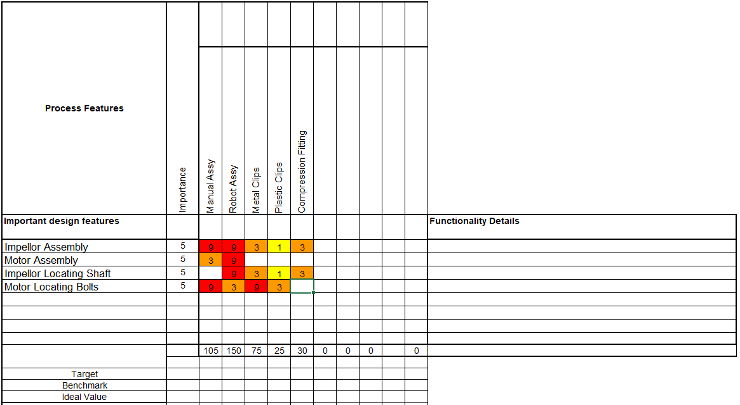
Figure 26 - Quality Function Deployment 3 for the Important Manufacturing System Designs
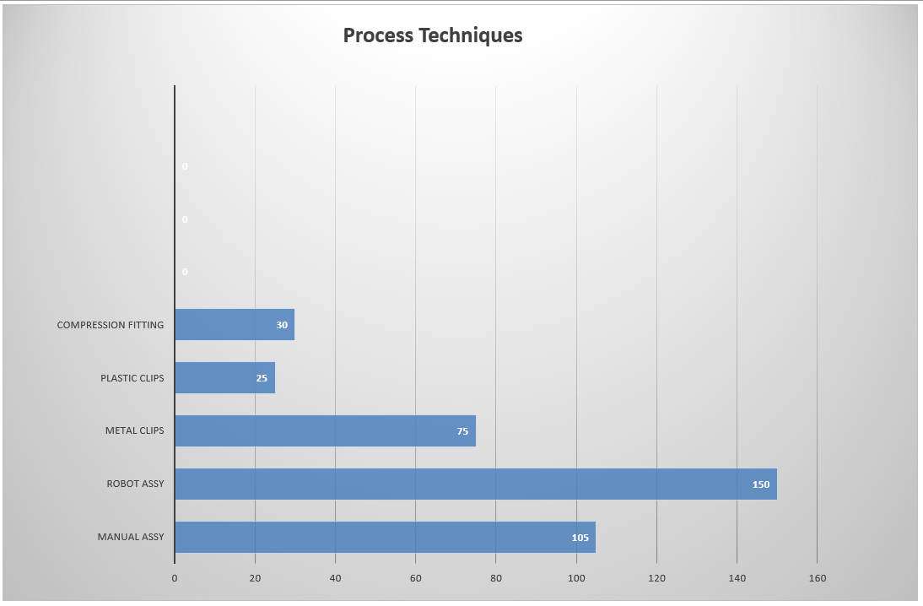
Figure 27 - Important Process Techniques Graph from QFD 3

Critical Process Techniques
The Critical Process Techniques were the two assembly methods of Robot Assembly and that of Manal Assembly

Quality Function Deployment 4 (QFD 4) (Important Control Measures)
The final step is to perform a QFD 4. This takes the processes and compares them to the control measures we put in place in the manufacturing process. It shows us the important control measures in our manufacturing system. These control measures ensure that we manufacture the thing to the required spec with the required tolerance to noise, with the required design, which meets the requirements of the customer.
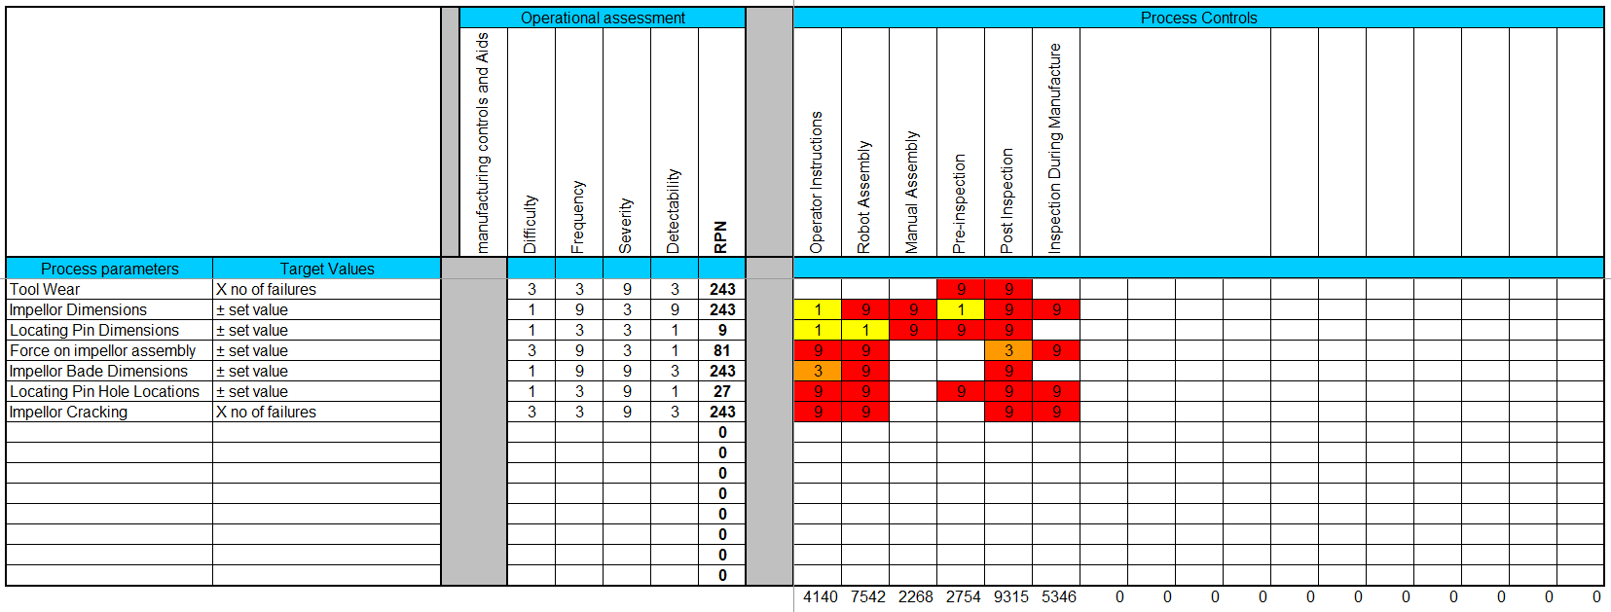
Figure 28 - QFD 4 for the Impellor sub-system
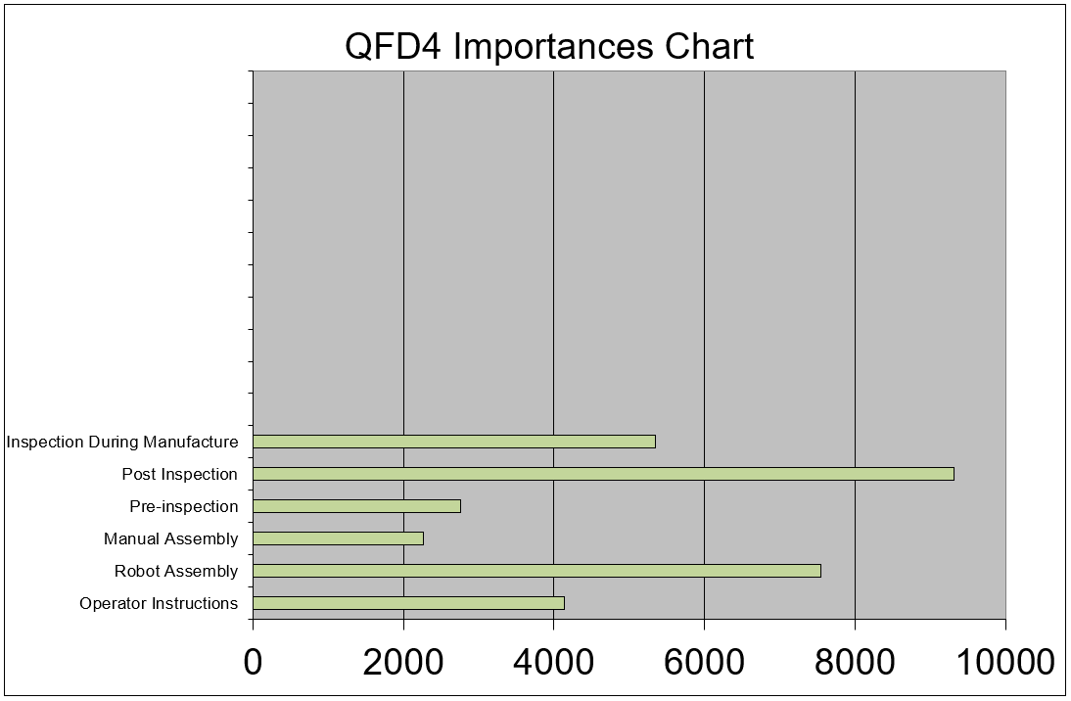
Figure 29 - QFD 4 Control Importance Graph

Process Control Measures
It can be seen for the impellor sub-system; the most important control measure is the post-Inspection of the completed sub-system. This would be down to proof testing of concept design.
The other important control measure is to assemble most components via robot to reduce the chance variation of using skilled labour and the assignable variation from having to use shifts of different workers.

Overall Sub-system design and Integration
The overall design remains fairly similar to the original Karcher K3, but a new sub-system has been added consisting of a pressure transducer mounted on a remote tube within the water delivery pipe. A diagram is shown in xx. This was identified to be the most important design step and additional functionality over what was already there. A further study of failure cases led to the author going through the Manufacturing QFD process on the impellor and motor drive system as this also proved to be a weak point in the design that displeased the customer. Therefore, it was decided that the material type was important for the manufacturing requirements as corroborated by Figure 25. The redesigned system would therefore have a moulded plastic impellor connected via an aluminium shaft to the motor secured with a metal split pin. This motor then has a feedback loop to the pressure transducer to detect the water pressure. If a fault condition is encountered, it will then shutdown and stop the motor from running dry.
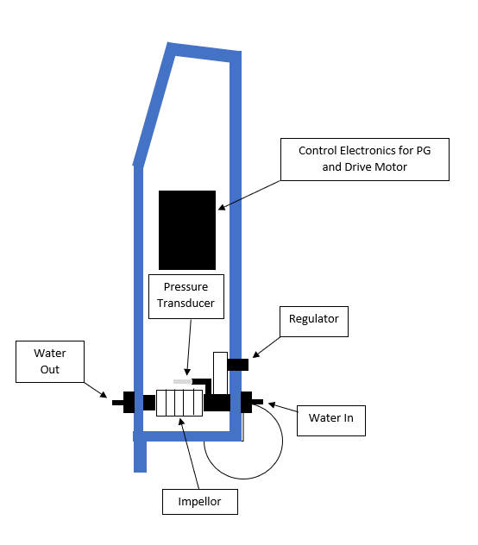
Figure 30 - Overall Design for the Impellor Drive Motor and Pressure Transducer

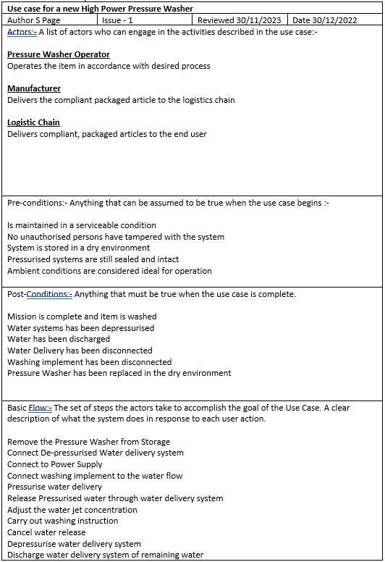
Annex A
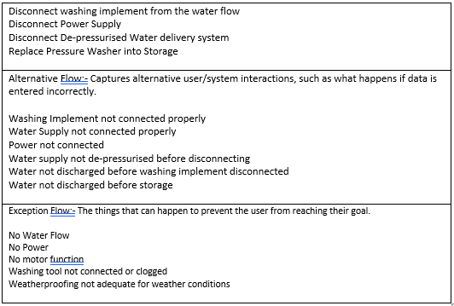

Annex B
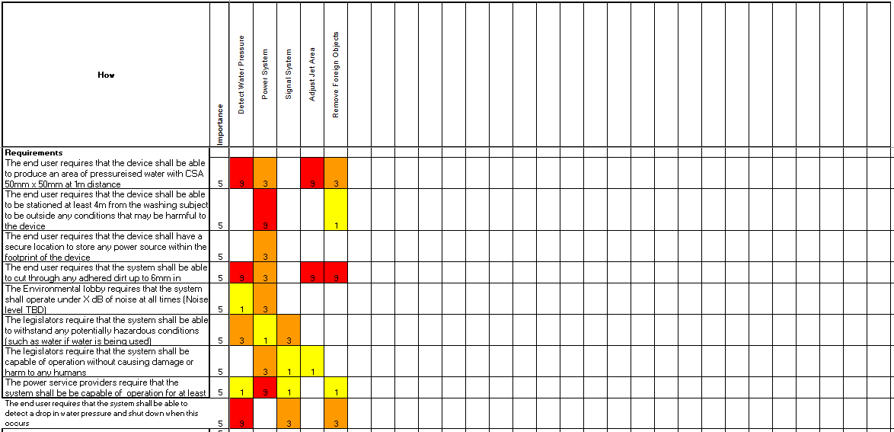
Figure 31 - Design QFD 1

References

[1] | G. Auriol, C. Baron, V. Shukla and J.-Y. Fournois, “System Engineering Method for System design,” in Systems Engineering - Practie and Theory, B. Cogan, Ed., London, IntechOpen, 2012.
[2] | D. Terry and J. White, “Simply Systesm Engineering,” Aegis ITS, Los Angelese.
[3] | J. D. Stroud, “The Kano Analysis: Customer Needs are Ever Changing,” ISIXSIGMA, 2020. [Online]. Available: https://www.isixsigma.com/tools-templates/kano-analysis/kano-analysis-customer-needs-are-ever-changing/. [Accessed 04 12 2022].
[4] | H. Sharp, A. Finkelstein and G. Galal, “Stakeholder Identification in the Requirements Engineering Process,” University College London, London.
[5] | C. Pacheco, I. Garcia and M. Reyes, “Requirements elicitation techniques: a systematic literature review based on the maturity of the techniques,” IET Software, vol. 12, no. 4, pp. 365 - 378, 2018.
[6] | I. Alexander, “Introduction to Systems Engineering with Use Cases,” Computing and Control Engineering, vol. 13, no. 6, pp. 289 - 297, 2003.
[7] | S. Vanalli and C. Cziulik, “Seven Steps to the Voice of Customer,” in International Conference on Engineering Design, Stockholm, 2003.
[8] | Y. Bijan, J. Yu, J. Stracener and T. Woods, “Systems requirements engineering - State of the Methodology,” Systems Engineering, vol. 16, no. 3, pp. 267 - 276, 2013.
[9] | B. Purushothama, “Internal quality audits: a strong tool for quality management,” Effective Implementation of Quality Management Systems, pp. 56 - 94, 2010.
[10] | L.-K. Chan and M.-L. Wu, “Quality Function Deployment: A literature review,” European Jouurnal of Operational Research, vol. 143, no. 3, pp. 463 - 497, 2002.
[11] | S. Burge, “The Systems Engineering Toolbox,” Burge Hughes Walsh, Rugby, 2011.
[12] | S. Burge, “The Systems Engineering Toolbox - Function Means Analysis,” Burge Hughes Walsh, Rugby, 2006.
[13] | S. Burge, “The Systems Engineering Toolbox - Pugh Matrix,” Burge Hughes Walsh, Rugby, 2009.
[14] | S. Burge, “A Systems Approach to Failure Modes, Mechanisms, Effects and Causes,” Burge Hughes Walsh, Rugby, 2014.
[15] | D. Holley, 7. Performing Functional Analysis, Swansea: University of Wales Trinity Saint David, 2022.
[16] | D. Holley, 9. Designing Systems and Specifying Sub-systems, Swansea: University of Wales Trinity Saint David, 2022.

