Thomas Myers – 1704226
Advanced Cyber Security – ACCB6000
Dr. Carlene Campbell
Assignment 1

Contents:

- Abstract
- Introduction
- Literature review
  - Future trends within Cybersecurity
- Analysis of intrusion tools
  - Email Tracker
  - Cryptool
  - Virtual Private Network
  - Clone Phishing
  - Availability of these tools and how they could be used to prevent future attacks.
- Real Life Scenario synthesis
  - The Network Design
  - Password Encryption
  - Firewall
  - Access Control Point
  - Intrusion Prevention/Detection System
- Use of Penetration Testing to benefit the Network
- Conclusion
- References & Bibliography

- Abstract

The following report will cover the debatable topic of the future trends of cybersecurity and how cyber attackers are now using different ways to gain access into networks. Furthermore, different types of intrusion tools will be performed and documented in this report with an analysis of results showing how these tools could be used in future to prevent any further attacks. Finally, a designed home network will be implemented by simulation using cisco packet tracer to fit the need of the University of Wales Trinity Saint David smart campus.

- Introduction

Within this report, there will be many topics covered. As technology continues to evolve rapidly over the years so does the need for internet security. Being able to surf the internet daily is a wonderful privilege but is equally just as dangerous as enjoyable. With that being said, the first part of this project will be a literature review of the current state of security within two different internet security fields. This will be researched through the use of books and articles. These research fields within internet security will be as follows; The future trends in cybersecurity. In the next section, an analysis of a number of penetration tools ran through a network will be held. The results of these tests will be recorded and documented and then analysed where opinions on the security exposure of members of the publics internet traffic will be documented based on those recorded results. Furthermore, it will be discussed how penetration tests on network security can be used to identify any potential vulnerabilities to the network privately within their own network. The final section of this report is to identify a potential real-life scenario within cybersecurity and demonstrate a designed network and portray certain security measures to keep the network as secure as possible.

- Literature Review

Within this section, books and articles will be thoroughly researched to find information on a certain field within cybersecurity. This field is the future trends in cybersecurity. The mentioned fields in cybersecurity has to be investigated due to the rise of both technology and the security issues that continue to arise with this new technology. It is essential that different types of computer networks around the world are secure due to the rise in the different types of penetration tools.

The internet and the way we use it continues to evolve as time progress and shows no sign of deterioration any time soon. Once the internet first started being implemented into homes and companies years ago it had very basic use. Now in 2020 the internet has many different uses and capabilities. For example within companies board members would no longer have to meet in the same room to participate in a board meeting as with the use of the correct hardware and software the internet gives the capability of holding video conferencing where these important business meetings could be held virtually instead of face to face encounters. This particular use of the internet has certainly become very important to many companies in 2020. Due to the ongoing situation regarding COVID-19 where most countries are on lockdown meaning that only workers deemed essential workers such as employees of the ‘National Health Service’ [1]are allowed to leave their home to work. For example, the United Kingdom went into lockdown on the ‘23rd of March 2020’ [2] to help reduce the strain on the United Kingdom’s National Health Service meaning that all of the general public that are not deemed as essential workers must stay at home. The use of video conferencing almost became essential to many businesses around the United Kingdom due to the general public being ordered to stay at home to reduce the spread of COVID-19. A great public example of the use of video conferencing came very recently as the prime minister of the United Kingdom ‘Boris Johnson’ who himself contracted the COVID-19 virus used video conferencing tools to hold a conference meeting with Members of Parliament from the majority of the ‘Conservative’ [3] and ‘Labour’ [4] parties constituencies to discuss lockdown plans and ways to move forward with tackling the COVID-19 outbreak within the United Kingdom. Video conferencing is one of many examples of how the internet has evolved within the last decade. Other examples such as Internet of Things devices, Sensor Monitoring and Cloud storage services are relied on by big corporations to operate on a day to day basis.

  - Future Trends in Cybersecurity

With new internet-based technology being developed continuously year in and year out, the need for protection while using the internet has never been more essential than today. With new software comes new opportunities for hackers to find vulnerabilities within the new coded software which is why it is essential that internet security remains at the same standard as the technology that’s needing protecting. Due to this new technology, network security constantly has to be looked at.

There are many different trends within cybersecurity over the last few years that has become a serious problem to network security within either a home or at a company. As technology continues to evolve cyber hackers continue to find vulnerabilities in both new and old network security systems. These vulnerabilities are then exposed in a number of ways. Due to new technology being made available to cyber hackers, cyber-crime continues to rise. These ‘computer aided crimes’ [5] can be implemented within a number of ways. Some of these ways include; ‘using data to alter image of certain groups, forging data to gain advantage, obtaining use of a high-end computer system to gain publicity for a common cause’. [5]

More specifically, the most common trend within hackers intruding networks is through ‘Data Breaches’. [6] A data breach is where an unauthorised personnel gains access to a system and specifically the system data via a network intrusion most likely using different penetration tools to carry out the attack. A data breach has been described by the United States department of Justice as ‘the loss of control, compromise, unauthorized disclosure, unauthorized acquisition, access for an unauthorized purpose, or other unauthorized access, to data, whether physical or electronic’ [7]. A hacker could choose a number of ways to attempt to breach data of a certain company network. Four potential methods an intruder attempted a data breach might use to penetrate the network are as follows; ‘Denial Of Service, Malware, Phishing, Ransomware.’ [7] Denial Of Service is a method used by hackers in attempt to breach data that ensures a ‘network resource’ [7]attacked is unreachable to end users communicating traffic through the network either ‘temporarily or indefinitely’ [7]. This is achievable by spamming the network with a sufficient amount of data requests that the network infrastructure cannot handle at the same time. This is continued until the original data requests on the network cannot be processed. The cyber-attacker could differ by either only using one device to perpetrate the attack or many devices to perpetrate the attack depending on the size of the network and the amount of data that could be breached. Usual operating internet functions such as email, websites, online banking accounts.’ [8] can be affected by a denial of service attack. Another method that could be used by a cyber attacker to perform a data breach is a Phishing attack. This type of attack is a scam that is commonly used by many hackers worldwide to manipulate an end user in passing over sensitive information such as online login credentials. This is usually done by a cyber attacker impersonating a big corporate company such as a bank available in the targets country via email to manipulate the intended target into believing that the email received is from a legitimate business and is not a mimicked email by a cyber attacker attempting to manipulate the user so online credentials can be stolen. If the user believes that the email is from a legitimate business, then it is likely the end user would unintentionally pass over sensitive information such as online login credentials to the hacker. It is important that the cyber attacker impersonates a company that is familiar to the intended target otherwise it is unlikely that the intended target will fall for the email. Three different types of Phishing attacks are used by hackers; Clone Phishing, Spear Phishing and Whaling. Clone Phishing is where a cyber attacker replicates an interface or a specific email structure of a corporate business in attempt to make the intended target believe that the email is from a legitimate business which could then lead to the intended target giving out sensitive online credentials. Spear Phishing is where a cyber attacker would monitor a user’s network traffic to see what websites are frequently used by the intended target. Once the websites have been identified, the cyber attacker will then proceed into sending fake emails to the intended target impersonating the frequently used website in attempt to steal private credentials from the end user. The final type of phishing attack is whaling where a cyber attacker attempts to impersonate high-end personnel within a big corporate company such as company presidents with the overall target being to retrieve online credentials or gain financial information from network users within that company. A whaling attack could also be used to enter a network and conduct crimes acting as a user on that network. Another way a data breach attack could be conducted by a cyber attacker is by the Ransomware method. This particular method is a piece of coded software that ‘gains access to and locks down access to vital data.’ [9] The system of files on the hard drive that have been acquired by unauthorised personnel will most likely be locked by the cyber attacker and will most likely negotiate a price with the victim of the cyber-attack to retrieve the files. ‘Cryptocurrency’ [9] is the likeliest currency that will be demanded by the cyber attacker. A Ransomware attack is most commonly achieved by the development of a specific software which has to find its way into the intended targets system. This is usually achieved in file attachments via either email or software downloaded from unofficial third-party software developing websites. The final data breach method discussed is Malware. This particular data breaching cyber-attack method uses coded software that once installed on the users PC, sensitive data can be stolen. The cyber attacker attempts to manipulate the intended target to install the coded software on to their system. This could be by either impersonating popular software such as Microsoft Office or sending messages to the intended target attempting to make the end user that downloading the software is essential for smooth running of a system. Different types of malware have different purposes. Some types of malware can look into different websites surfed on the system that has installed the malware. Some types of malware has different capabilities depending on the strength of security on the system that has installed the malware. Malware is commonly picked up by phishing. Malware can hide from firewalls by using identical names and codes to legitimate files on the system that has installed the malware.

The next major trend discussed within cybersecurity is ‘cloud storage security issues’. [6] This is a major trend within cyber security due to the increased development of cloud services. Cloud Services is ‘the delivery of computing services – including servers, storage, databases, networking, software, analytics and intelligence – over the Internet (“the cloud”) to offer faster innovation, flexible resources and economies of scale.’ [10] With cloud services becoming increasingly innovated over the last few years, the security risks also increase due to hackers finding vulnerabilities in new technologies. Many internet users are attracted to the prospect of using cloud computing as the idea of having virtual storage and servers is attractive. With new popular technology comes new security issues that have to be addressed. The first main security issue within cloud computing is the previously discussed Denial of Service attack. Denial Of Service is a method used by hackers in attempt to breach online cloud storage data that makes sure a device on a network is unreachable to end users that are exchanging data through the network and passing through traffic. This is achievable by loading the network with a huge amount of data requests that the network infrastructure cannot handle all at once. This is continued until the original data requests on the network cannot be processed. The cyber-attacker could differ by either only using one device to perpetrate the attack or many devices to perpetrate the attack depending on the size of the network and the amount of data that could be breached. Usual operating internet functions such as email or websites can be affected by a denial of service attack. A ‘Distributed Denial Of Service Attack’ [11] is a type of Denial of Service attack that puts cloud storage under big threat when operated successfully. A Distributed Denial of Service attack (DDOS) is where cyber attackers use a huge number of devices to attack the targeted network with data requests making it almost impossible to handle for the network with it not being used to so much traffic at once. Due to cloud computing being so large as its based on the internet it was thought that cloud computing would be safe from Distributed Denial of Service attacks due to the amount of devices needed to perform an attack on a network so large but due to the amount of ‘ Internet of Things devices, smartphones, and other computing systems as there are available’ [11] it makes the attack easier to perform on the cloud computing system. If this Distributed Denial of Service attack is successful through overloaded traffic, then it has the ability to make the cloud computing service unavailable for an allotted amount of time. Lighter issues such as slow upload speeds could also occur if the Distributed Denial of service attack was not as strong. Another security issue within cloud computing is ‘Shared Cloud Computing Services’ [11]. This is a major security issue within cloud computing as different types of cloud computing services have different levels of security when it comes to file sharing online. It has become known that some cloud computing services are incapable of detecting malicious files saved within the cloud storage. This is a major issue as if this uploaded malicious file was shared to other users then just like if malware was installed on a solid hard drive, it would have the capability to view end users files and possibly even steal those files for the cyber attacker use in whatever way he chooses. Those stolen files could contain online credentials for sensitive websites such as banks. Another security issue within cloud computing is ‘Phishing and Social Engineering Attacks’ [11] As previously mentioned, phishing is a scam that is frequently used by cyber-attacks across the globe to influence an end user in exchanging sensitive information such as online login credentials. This is commonly done by a hacker imitating a large business such as a bank available in the targets country via email to influence the end user into believing that the email received is from a legitimate business and is not an impersonated email by a hacker attempting to influence the user so online credentials can be stolen. If the user believes that the email is from a legitimate business, then it is probable the intended target would unintentionally hand over sensitive information such as online login credentials to the hacker. Cyber attackers using email phishing could acquire the intended targets cloud storage login credentials which would then enable them to login to the cloud computing system and steal the victims files or use that account for criminal purposes. The final flaw within cloud computing security that will be discussed is the data syncing within cloud storage. Sometimes data syncing could fail due to a poor internet connection leaving the cloud computing user a potential victim to ransomware. As previously discussed, ransomware is a piece of coded software that can retrieve and encrypt files from the victim with the purpose of demanding a sum of money to decrypt the files. The system of files on the cloud server that have been acquired by unauthorised personnel will most likely be locked by the cyber attacker and will most likely assign a price with the intended target of the ransomware attack to retrieve the files. A Ransomware attack is most frequently attained by the development of a specific software which has to find its way into the victim’s system. This is typically attained in file attachments via either email or software downloaded from unofficial third-party software developing websites. If the cloud storage does not back up properly due to poor connection between client and server then the cloud service user could fall victim to a ransomware attack. If the ransomware attack occurred but the data was backed up the end user would be relaxed about the intrusion as no data has been stolen as the backup is ready to restore the data instead of paying cryptocurrency for the decryption key for the encrypted files to restore them.

The final future trend within cyber security that will be discussed is the ‘risks with Internet of Things Devices’ [6]. Due to the Internet of Things devices being developed are rarely new they bring lots of security issues as cyber attackers continue to explore vulnerabilities with new devices as they are yet to be tested due to the internet of things devices not being available for long. As internet of things devices haven’t long been developed making security potentially weaker due to insufficient penetration tests within the system security, these devices could ‘serve as a point of entry’ [6]into the network by cyber attackers. The biggest flaw within Internet of Things security is the lack of tests on the security infrastructure. It is common within the early stages of Internet of Things devices that the security is only updated if a major flaw has been exposed by a cyber attacker otherwise the updating of these types of devices remain minimal. This is thought to be due to Internet of Things developers being ‘more eager to produce and deliver their devices as fast as they can, without giving security too much of a thought’ [12]leaving these Internet of Things devices set for potential exposure with intrusion. Another security flaw with Internet of Things devices is the factory password assigned to these devices. Within internet security in general, leaving the existing password on a device without changing it at all brings major potential for intrusion. With many software penetration tools available on the ‘Kali Linux operating system terminal’ the Internet of Things device password could easily be cracked. It is thought that developers of Internet of things devices do not remind end users to change these default passwords to reduce the risk of intrusion. If an end user that is a beginner within internet security is not told to change the password of the Internet of Things device then it is likely that they will not proceed to do so leaving the end user as risk of a security intrusion. Another security risk of Internet of Things devices is the risk of malware and ransomware entering the system. It is thought that although malware and ransomware have different purposes as previously explained in this section, some pieces of software have formed a ‘hybrid’ of both malware and ransomware to ‘merge the different types of attack.’ [12] A merge example of the malware and ransomware hybrid would be that the webcam of a smart tv would be ‘locked and footage funnelled to an infected web address which could extract sensitive data using the malware access point and demand ransom to unlock the device and return the data.’ [11] A big security risk within Internet of Things devices through ‘Cryptomining With IoT Bots.’ [12] The aim of Cryptomining is to use a large number of ‘Botnets’[15] to detect cryptocurrency stored within Internet of Things Devices and not to harm the Internet of Things system. To make this a successful attack a sufficient amount of Botnets must be used as one is not powerful enough to detect and steal cryptocurrency.

- Analysis of Intrusion Tools

Within this section of the report, four different intrusion tools will be analysed and the results will be recorded and documented ready for investigation. Furthermore, opinions will be given where applicable on the security of systems and the exposure through free public resources. Also it will be discussed how those tools demonstrated can detect vulnerabilities within a network to help with future security measures.

  - Email Tracker

Firstly, the windows-based program EmailTrackerPro must be installed on your device.

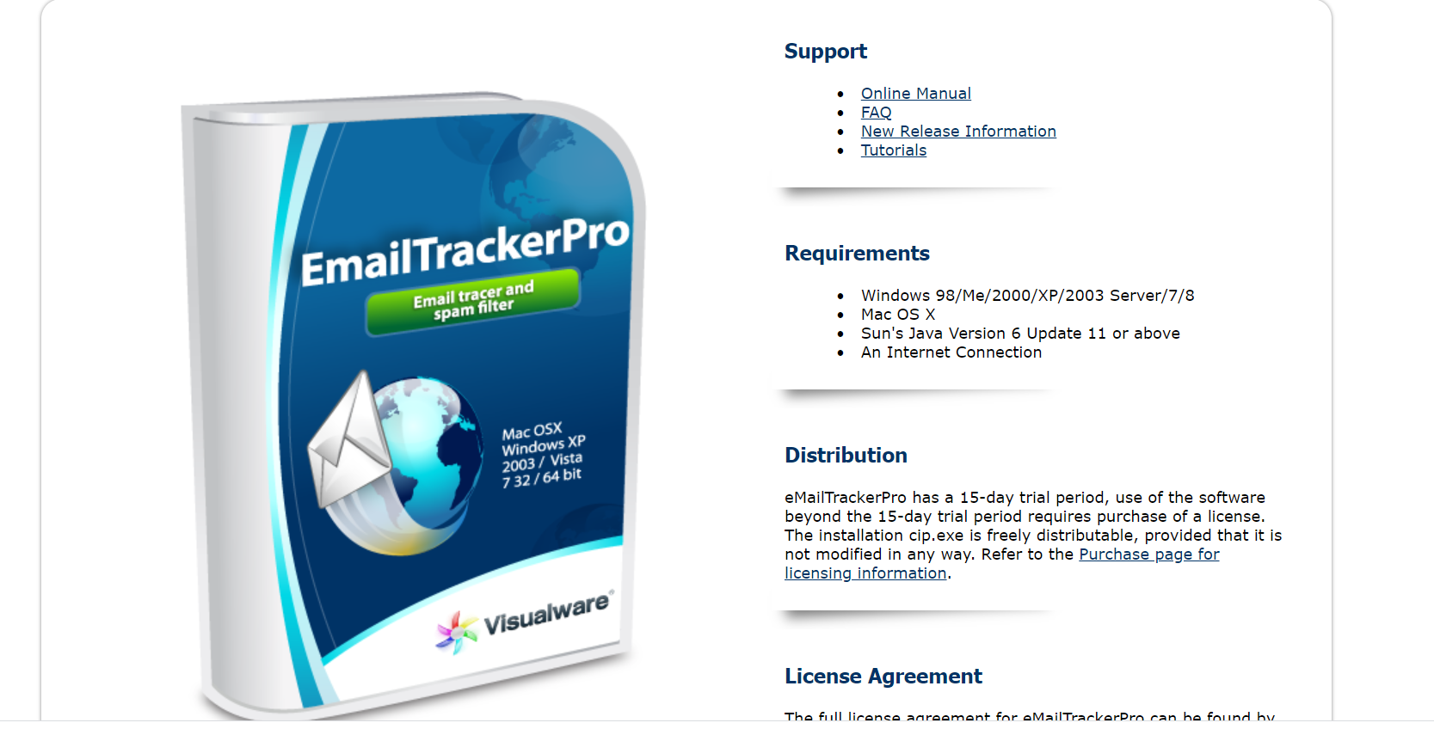
Figure 1

After the EmailTrackerPro installation on your windows device is complete, there are two setup options; Basic and Advanced setup. The correct option for this particular experiment is the advanced option due to the features needed for this demonstration will be on the advanced setup. After this selection, the program sets up in advanced mode and the program is ready to use. The first step within the program is to click on the ‘My Trace Reports’ tab. The My Trace Reports tab enables the end user to create a report from the email.

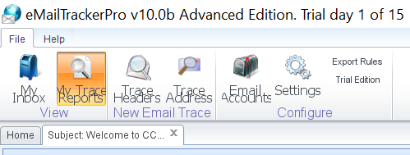
Figure 2

Once opening My Trace Reports, a prompt box comes up with two options; Trace an email or look up network responsible for an email address. The option selected is the trace an email option. Once this is selected the box at the bottom of this prompt box allows the end user to enter the details of the email. This is found within the ‘show original code’ within your email browser. Once that original code is code the end user will then proceed to copy the code into the prompted box.



Figure 3

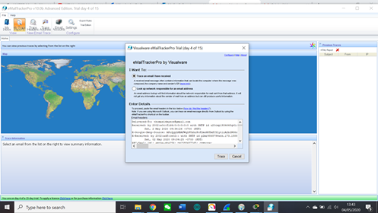

Figure 4

Once the trace button was clicked on the prompt box, the emailtrackerpro software would proceed to produce a report on the selected email. The generated report would succeed to obtain the sent emails IP address along with the route of the email. The generated report would display to the end user that the email was tracked to Denver, Colorado. The report also shows that the IP address is 167.89.23.27. Furthermore, the generated report shows the route map of the sent email.

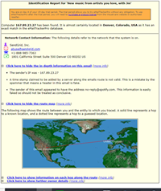
Figure 5

The final import from the emailtrackerpro’s generated report shows the different IP address routes for the email from sender to receiver.

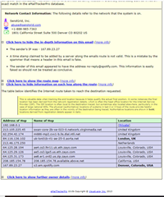
Figure 6

To Conclude the use of the EmailTrackerPro, this is a piece of software that has the capability of tracking an email from where it was sent if the end user has the original code from the email the end user wants tracked. The EmailTrackerPro software has the capability to generate a report that shows both the IP address of the sender and also the route of the email. Furthermore, the report will show the tracked IP addresses between sender and receiver.

  - Cryptool

First, you must download the Cryptool software to proceed with the demonstration. Once this is complete and the Cryptool is launched a multi-coloured box appears displaying a possible beginners guide for first time users which is able to be closed by the close button. After that is closed the first main window of the program appears with a starting example window, this can also be closed.

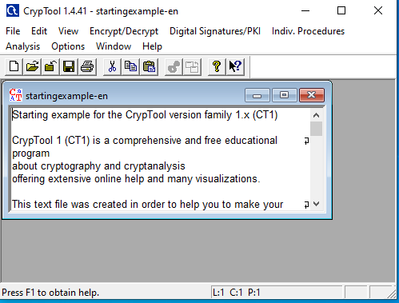
Figure 1

The first step to encrypt is to click on file from the menu and then new. An unnamed box will appear where content can be typed into it. This will be the message that we will be decrypting. The example message used here is ‘This message will be encrypted.’

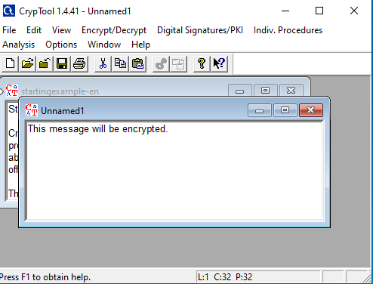
Figure 2
The next step is to select the Encrypt/Decrypt option in the menu and then navigate to ‘Symmetric Modern’ which gives you a number of options. The tool we need here is ‘RC2’. Once that has been opened a prompt box appears allowing the user to enter the key length using hexadecimal numbers. The hexadecimal numbers used here is 05. The key length can also be altered. For this experiment the key length is 8 bits.

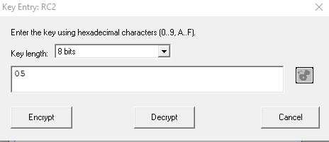
Figure 3

The RC2 encryption tool should then encrypt the message displaying the encrypted message below.

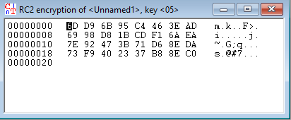
Figure 4

The purpose of this tool is to encrypt messages to send across certain networks to ensure the message is not detected by other users on the network and is encrypted end to end from sender to receiver. If the receiver of the message wanted to decrypt the message using Cryptool then the same process is applied as to encrypt the file except where the hexadecimal numbers are entered, instead of clicking encrypt you opt to click decrypt instead.

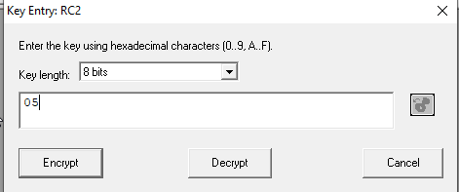
Figure 5

Once the Decrypt button has been hit, the message should then decrypt from 05 hexadecimal numbers at 8 bit key length to the decrypted message ‘This message will be encrypted’.

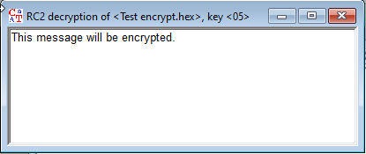

To Conclude, the Cryptool is a piece of software that encrypts messages and saves them as files to be delivered to an end user. The purpose of encryption is to hide messages uses hexadecimals when sending them from peer to peer.

  - Virtual Private Network

Within this experiment, NordVPN was used to mask an IP address of your own network with the purpose of hiding the location of where the network traffic is coming from. This is done by using the application to use a forge an IP address from the applications servers instead of your own so if a corporation attempts to track your IP address it would lead to the server base of the VPN instead of your own IP address leaving your identity anonymous.

Once the Nord VPN is opened, the interface loads showing every different location you can connect to using their servers.

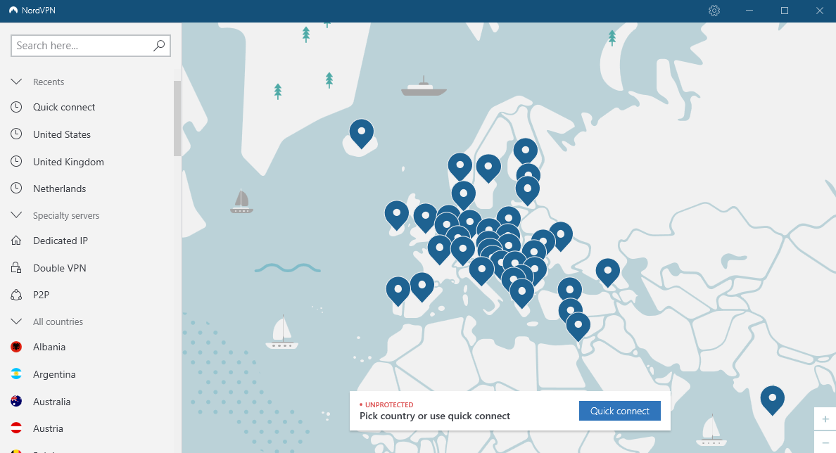
Figure 1

Once a server has been chosen it will then redirect the end user to be connected to the server based within that country. Within this demonstration, the country chosen to be based at is Vietnam. The purpose of this is to show the range of different IP locations that can be chosen when using a suitable Virtual Private Network supplier.

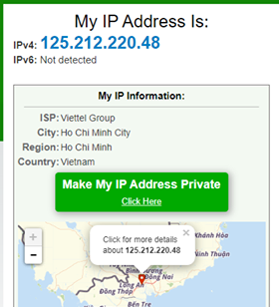
Figure 2

The final screenshot demonstrates that the country that the IP address has been detected from is Vietnam and not in Wales where the actual IP address is based.

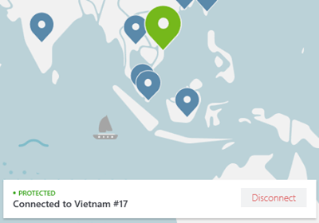
Figure 3
To conclude the experiment on Virtual Private Networks, it has been learned that Virtual Private Networks are used to ensure the identity of the network user remains anonymous. This is achieved by using a separate IP address borrowed from a third-party VPN supplier and choosing a location provided by the third party VPN supplier.

  - Clone Phishing

The final experiment to be demonstrated is the use of Clone Phishing. First, the Kali Linux operating system must be in use and installed on either on your network device or on a Virtual Machine such as VirtualBox. Once Kali is installed then the command terminal must be run to perform this attack. Once this has been opened, the code ‘sudo su’ must be entered into the terminal to unlock administrative rights to perform the attack. Once that has been entered, we proceed to type in ‘setoolkit’ then using the number system to pick the correct type of attack we want to perform. The correct attack we want is the Social-Engineering attacks.

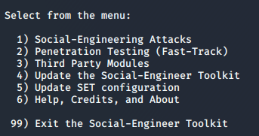
Figure 1

Once Social-Engineering Attacks has been entered into the terminal, the next step is to choose the Website Attack Vectors option.

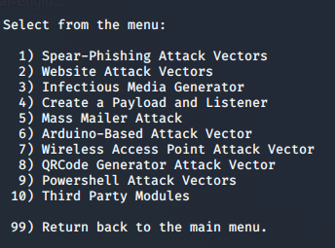
Figure 2

After that previous step has been completed we are prompted with another menu where we select the Credential Harvester Attack Method which would then lead us on to our final option.

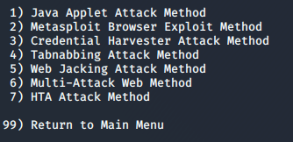
Figure 3

The final option menu within this sequence is to choose the specific type of tool we are going to use to carry out this experiment. The type of phishing attack we are going to carry out is a Clone Phishing attack.

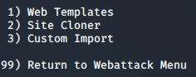
Figure 4

Once the Clone Phishing option has been chosen, we proceed to choose what specific web page will be cloned in attempt to fool an end user into believing the web page is legitimate. For this example, the social media website ‘twitter.com’ was demonstrated.

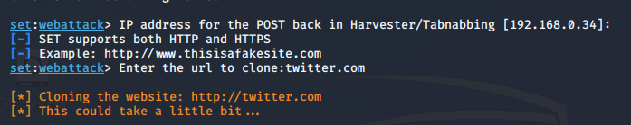
Figure 5

Once deployed correctly the specific link could be emailed to a potential target where they could be fooled into clicking the link and entering their login credentials. If this were to be the case as figures 6 and 7 show then the login credentials would be visible to the cyber attacker.

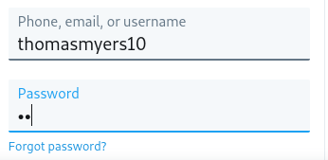
Figure 6

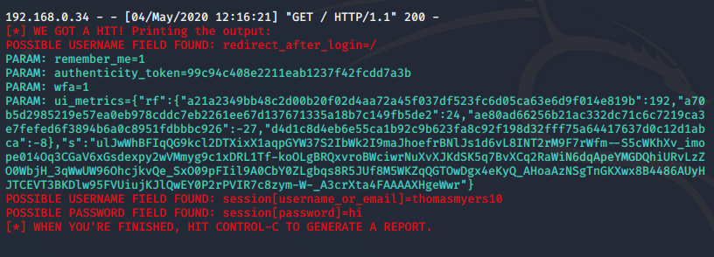
Figure 7

To conclude, clone phishing is a tool that impersonates a website to its exact interface in attempt to trick the intended target into believing it’s a secure website. The end user would then proceed to type in their login credentials which would then be visible to the cyber attacker.

  - Availability of these tools and how they could be used to prevent future attacks.

As demonstrated throughout section 4 of this report, the availability of these tools to the general public are severely open and in hindsight should not be as these tools can cause serious harm while used correctly to attack an intended targets network as demonstrated within this section. While free tools like these previously demonstrated tools are available to the general public to maliciously use, there are benefits of having these tools free to the general public. Network administrators can use these specific tools to test against their own network to make suited adjustments to ensure that the network do not get exposed to free public tools available via the internet.

5.Real Life Scenario Synthesis

The final section will use the knowledge and understanding of the subject of cybersecurity gained from the investigated subject to design a network for the new IQ building at the university of wales trinity saint David smart campus that has strong security measures put in place. The network must be adequate for an organisation to safely transmit data and communicate traffic through the network using end devices that are connected to the designed network. The network must also support students that bring their own devices into the campus meaning these devices must be able to safely transmit data and communicate traffic through the network.

Within this section, A secure network will be designed using Cisco Packet Tracer to demonstrate sufficient security measures to help aid the prevention of a potential cyber intrusion. Within the designed network. A firewall has been implemented to block certain IP’s from being able to ping the network. Furthermore, access control lists have been implemented onto the network alongside encrypted passwords to ensure no one within or out of the network can clearly see the set password for both the router and the switch.

5.1 The Network designs

Firstly, the network has been split into two parts to demonstrate the different security measures that have been put in place. Figure 1 shows the hardware structure of 5 PC’s connected to a switch. That particular switch is then connected with a copper straight through cable to a router which will act as the source of internet connectivity via a wired connection. The router is then connected to a server that is implemented to handle large amounts of data requests if needed to. Figure 2 shows a simpler design with just a Cisco switch connected to 2 PC’s, An access point so wireless devices can have access to the network and a laptop acting as an end device.

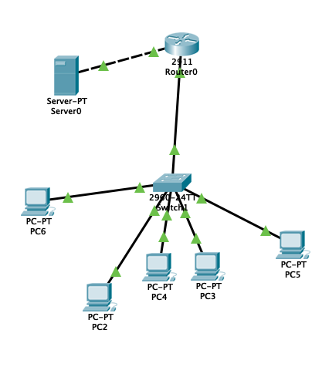

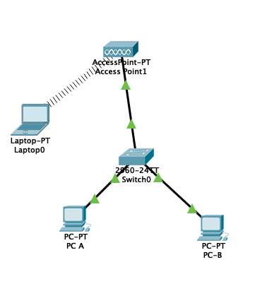
Figure 2

Figure 1

5.2 Password encryption

The first security measure implemented into the network is the password encryption. Firstly, a password was implemented on all routers and switches to ensure the network configurations were password protected. Even though the network had a numerous amount of passwords attached to these devices it was not deemed enough to keep the network as secure as possible from cyber attackers. Using the CLI command line on both the routers and switches of the network the command ‘service password-encryption’ was implemented to ensure the password was encrypted. This command ensures that the password is changed from plain text that was previously visible on the network to Cipher text meaning the password is now stored on the network with hexadecimals and not plain text. This password encryption coding will give strong protection against potential cyber intruders using password crack attacks in attempt to break into the network. Usually, encrypting the passwords on all routers and switches will protect the network owner from certain man in the middle attacks such as eavesdropping the traffic being communicated through the network. Figure 1 shows the ‘service password-encryption’ command being implemented into the network using the CLI terminal on one of the switches within the network. The command remains the same on each device with no differential. The only differential would be if the network administrator wanted a different password for each device.

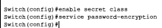
Figure 1

5.3 Firewalls

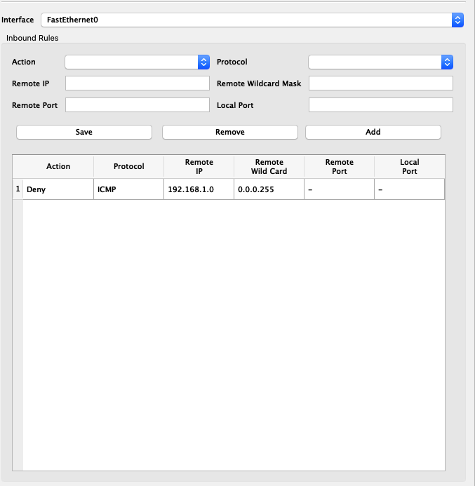
The next security measure implemented on the network built for the IQ building at University of Wales Trinity Saint David is the use of a firewall. The firewall on a network is implemented to make sure all unauthorised access is prohibited. A big benefit of implementing a firewall into the network is that the network administrator can monitor network traffic meaning the network administrator can overlook who is entering and departing the network. The firewalls restrictions can be altered to let certain access to certain devices attempting to enter the network but within this scenario only the implemented devices and the student’s devices will be authorised to enter the network. Figure 1 shows the implemented block of a certain IP address while figure 2 shows the time out request of the requested ping. The purpose of this implementation is to ensure all data requests from certain subnets will be turned down which demonstrates the security of the firewall in place. This is achievable by implemented the subnet of 0.0.0.255 as the remoted wildcard and disabling the IMCP Protocol.

Figure 1

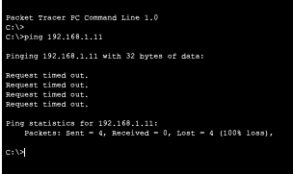
Figure 2

5.4 Access Control lists

The next security measure implemented into the network is the use of access control lists. This particular security measure maps out what devices on the network have access to each particular element of the system. For example, an access control list could tell the network administrator if a certain PC connected to the network can install software onto the network. PC’s that are allowed to install software on the network are usually preferred to as PC’ with ‘admin rights’. Within this network, a PC has been unauthorised to communicate network traffic with other PC’s on the network through the use of the access control list. Figure 3 below shows the access table representing that an end device network IP address has been blocked from communicating traffic. Figure 3 also shows the IP address of 192.168.10.2 is the only IP address that has been blocked from communicating network traffic. Using access control lists within a university is essential to ensure a student PC does not have the capability to complete network administrative tasks.

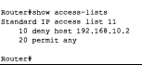
Figure 3

5.5 Intrusion Detection/Prevention Systems

Cyber attackers everyday attempt to find new ways to intrude a home or business computer network. Alongside the implementation of firewalls, password encryption and access control centres, a good investment to help ensure your private network is secure as possible is an Intrusion Protection/Detection system. Software such as Anti-Virus that has the capability to search for Malware within your system would be an excellent implementation into the network. Depending on the level of security the network administrator believes is needed for the university system, there is an option for most anti-virus programs to upgrade to a professional version for a set license fee. This particular type of software will stop potential malware entering your system with real time protection with constant scans of the network. This particular software will also detect emails with malware loaded into it.
Furthermore, the use of the previously researched Virtual Private Network could be a strong addition to the security measures on the system. This is because It would hide the university network traffic alongside preventing cyber attackers to be able to monitor the university network.

5.6 Use of Penetration Testing to benefit the Network

Once the network has been designed and implemented to fit the purpose of the scenario, the Kali Linux operating system command terminal can be used to test and highlight any potential threat to the network with the free available penetration tools on the terminal. A common penetration test that could be used is an ARP spoof. ARP spoofing is where fake IP addresses are used to trick the network into thinking the ARP requests are legitimate which then allows the cyber attacker to eavesdrop and act as an intermediate to the network overlooking network traffic through the Kali Linux app Wireshark. The network traffic being eavesdropped by Wireshark is demonstrated in figure 1. This figure shows the network traffic between client and server and most specifically the web addresses accessed by the client.

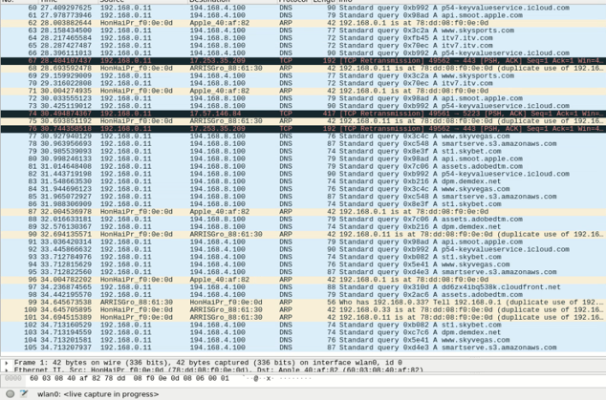
Figure 1

The use of a VPN is a great way to avoid an ARP spoof attack as the cyber attacker must have the correct IP address to perform the attack and as previously researched a VPN ensures the real IP address of the network is hidden. Another researched Kali Linux tool that can be used to attempt to penetrate the network is Clone Phishing where the end user can be tricked into believing that an email received is from a legitimate business where in reality it is from a cyber attacker attempting to steal credentials. The best way to prevent this is to use a real time anti-virus protection system in attempt to detect clone phishing emails. Furthermore, the use of EmailTrackerPro could come in handy to track specific emails if end users have any suspicions of a potential threat.

6. Conclusion

To Conclude, this report has thoroughly researched the future trends within cybersecurity to gain understanding and knowledge to be able to provide a solution to the University of Wales Trinity Saint David on how to implement a secure home network within a smart campus. Furthermore, different types of intrusion tools has been researched and carried out to test what could be used to intrude a network and what could be used to help make the network more secure to these attacks in future.

7. References & Bibliography

Bibliography

[1] | "National Health Service," 17 April 2020. [Online]. Available: https://www.nhs.uk/.
[2] | "When did the UK lockdown start and how long will it last?," 1 May 2020. [Online]. Available: https://www.heart.co.uk/news/how-long-uk-lockdown-last/. [Accessed 2 May 2020].
[3] | "Unleash Britains Potential," [Online]. Available: https://www.conservatives.com/. [Accessed 21 April 2020].
[4] | [Online]. Available: https://labour.org.uk/. [Accessed 22 April 2020].
[5] | J. Pierson, "New technologies and future trends in computer security," Industrial Management & Data Systems, vol. 94, no. 8.
[6] | Z. Banach, "Top 10 Cybersecurity Trends to Look Out For in 2020," Netsparker, 19 November 2019. [Online]. Available: https://www.netsparker.com/blog/web-security/top-10-cybersecurity-trends-to-look-out-for-in-2020/. [Accessed 23 April 2020].
[7] | R. Sores, "107 Must-Know Data Breach Statistics for 2020," Varonis, 29 March 2020. [Online]. Available: https://www.varonis.com/blog/data-breach-statistics/. [Accessed 24 April 2020].
[8] | "Understanding Denial-of-Service Attacks," 20 November 2019. [Online]. Available: https://www.us-cert.gov/ncas/tips/ST04-015. [Accessed 25 April 2020].
[9] | [Online]. Available: https://www.varonis.com/blog/malware-protection/.
[10] | "What is Cloud Computing?," Microsoft, [Online]. Available: https://azure.microsoft.com/en-gb/overview/what-is-cloud-computing/. [Accessed 26 April 2020].
[11] | "10 Biggest security challenges for IoT," Peerbit, [Online]. Available: https://www.peerbits.com/blog/biggest-iot-security-challenges.html. [Accessed 27 April 2020].
[12] | "Top 10 Biggest IoT Security Issues," [Online]. Available: https://www.intellectsoft.net/blog/biggest-iot-security-issues/.

marking criteria and Student FEEDBACK

This section details the assessment criteria. The extent to which these are demonstrated by you determines your mark. The marks available for each criterion are shown. Lecturers will use the space provided to comment on the achievement of the task(s), including those areas in which you have performed well and areas that would benefit from development/improvement.

Common Assessment Criteria Applied (Assignment 1) | Marks available | Marks  awarded
1. Engagement with Literature Skills
Extent of research and/or own reading, selection of credible sources, application of appropriate referencing conventions.
You have used mainly websites for your referencing and engaged with limited academic peer review article to make your work credible. Websites require careful consideration. Key concept considered. Utilise the University online resources and journals. (Grade mark: 66.67%) | 45 | 30
2. Knowledge and Understanding Skills
Extent of knowledge and understanding of concepts and underlying principles associated with the discipline.
3. Cognitive and Intellectual Skills
Analysis, evaluation and synthesis; logic, argument and judgement; analytical reflection; organisation of ideas and evidence
You have demonstrated good research knowledge in the research aspects but could do more with critical analysis of it. You have explained the lab exercises satisfactory and could interrelate more how they could aid others and organisations. (Grade mark: 66.67%) | 45 | 30
4. Practical Application Skills
Deployment of methods, materials, tools and techniques; application of concepts; formulation of innovative and creative solutions to solve problems.
5. Transferable Skills for Life and Professional Practice
Attributes in professional practice: individual and collaborative working; deployment of appropriate media; presentation and organisation.
Your work could do with formatting to make it looks more professionally. Some minor errors and could flow better. (Grade mark: 60.00%) | 10 | 6

Assignment Mark (Assessment marks are subject to ratification at the Exam Board. These comments and marks are to give feedback on module work and are for guidance only until they are confirmed. ) | Late Submission Penalties (tick if appropriate) |  | 66%
 | Up to four weeks late |  | 66%
 | First Attempt? |  | 66%

marking criteria and Student FEEDBACK

This section details the assessment criteria. The extent to which these are demonstrated by you determines your mark. The marks available for each criterion are shown. Lecturers will use the space provided to comment on the achievement of the task(s), including those areas in which you have performed well and areas that would benefit from development/improvement.

Common Assessment Criteria Applied (Assignment 2) | Marks available | Marks  awarded
1. Engagement with Literature Skills
Extent of research and/or own reading, selection of credible sources, application of appropriate referencing conventions.
2. Knowledge and Understanding Skills
Extent of knowledge and understanding of concepts and underlying principles associated with the discipline.
You demonstrated relevant knowledge and understanding by explaining the theories and concept in a meaningful way. Could be improved if more peer reviewed articles were used. (Grade mark: 75.00%) | 20 | 15
3. Cognitive and Intellectual Skills
Analysis, evaluation and synthesis; logic, argument and judgement; analytical reflection; organisation of ideas and evidence
You have discuss the physical packet tracer design. How does this implementation combat or enhance challenges to the University; this should be interrelated in your discussion. (Grade mark: 75.00%) | 20 | 15
4. Practical Application Skills
Deployment of methods, materials, tools and techniques; application of concepts; formulation of innovative and creative solutions to solve problems.
Your practical design is two isolated LANs that are not interconnected. They are not labelled in a meaningful way. No redundancy. The implementation coverage did not reflect the case study. Security measures in place. (Grade mark: 50.00%) | 60 | 30
5. Transferable Skills for Life and Professional Practice
Attributes in professional practice: individual and collaborative working; deployment of appropriate media; presentation and organisation.

Assignment Mark (Assessment marks are subject to ratification at the Exam Board. These comments and marks are to give feedback on module work and are for guidance only until they are confirmed. ) | Late Submission Penalties (tick if appropriate) |  | 60%
 | Up to four weeks late |  | 60%
 | First Attempt? |  | 60%

