Psychological Classifications and Provisions
Module Code BMHP6029

Name Sobia Noreen
Student Number 2319984
Lecturer Neale Haddon
Assignment Title Component 1: Individual Presentation (Academic Poster)

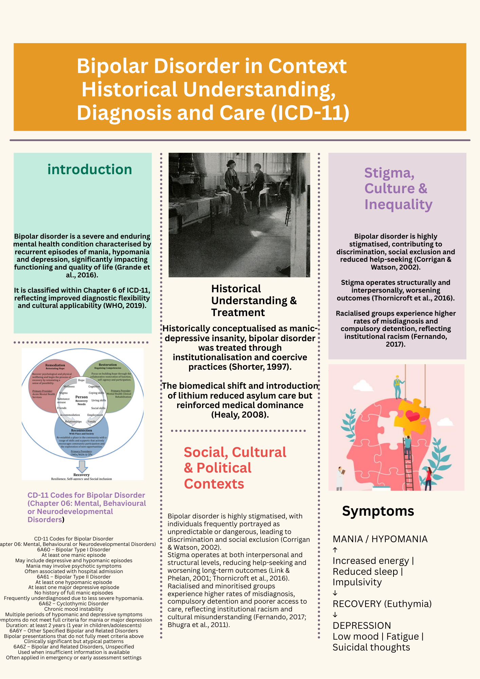

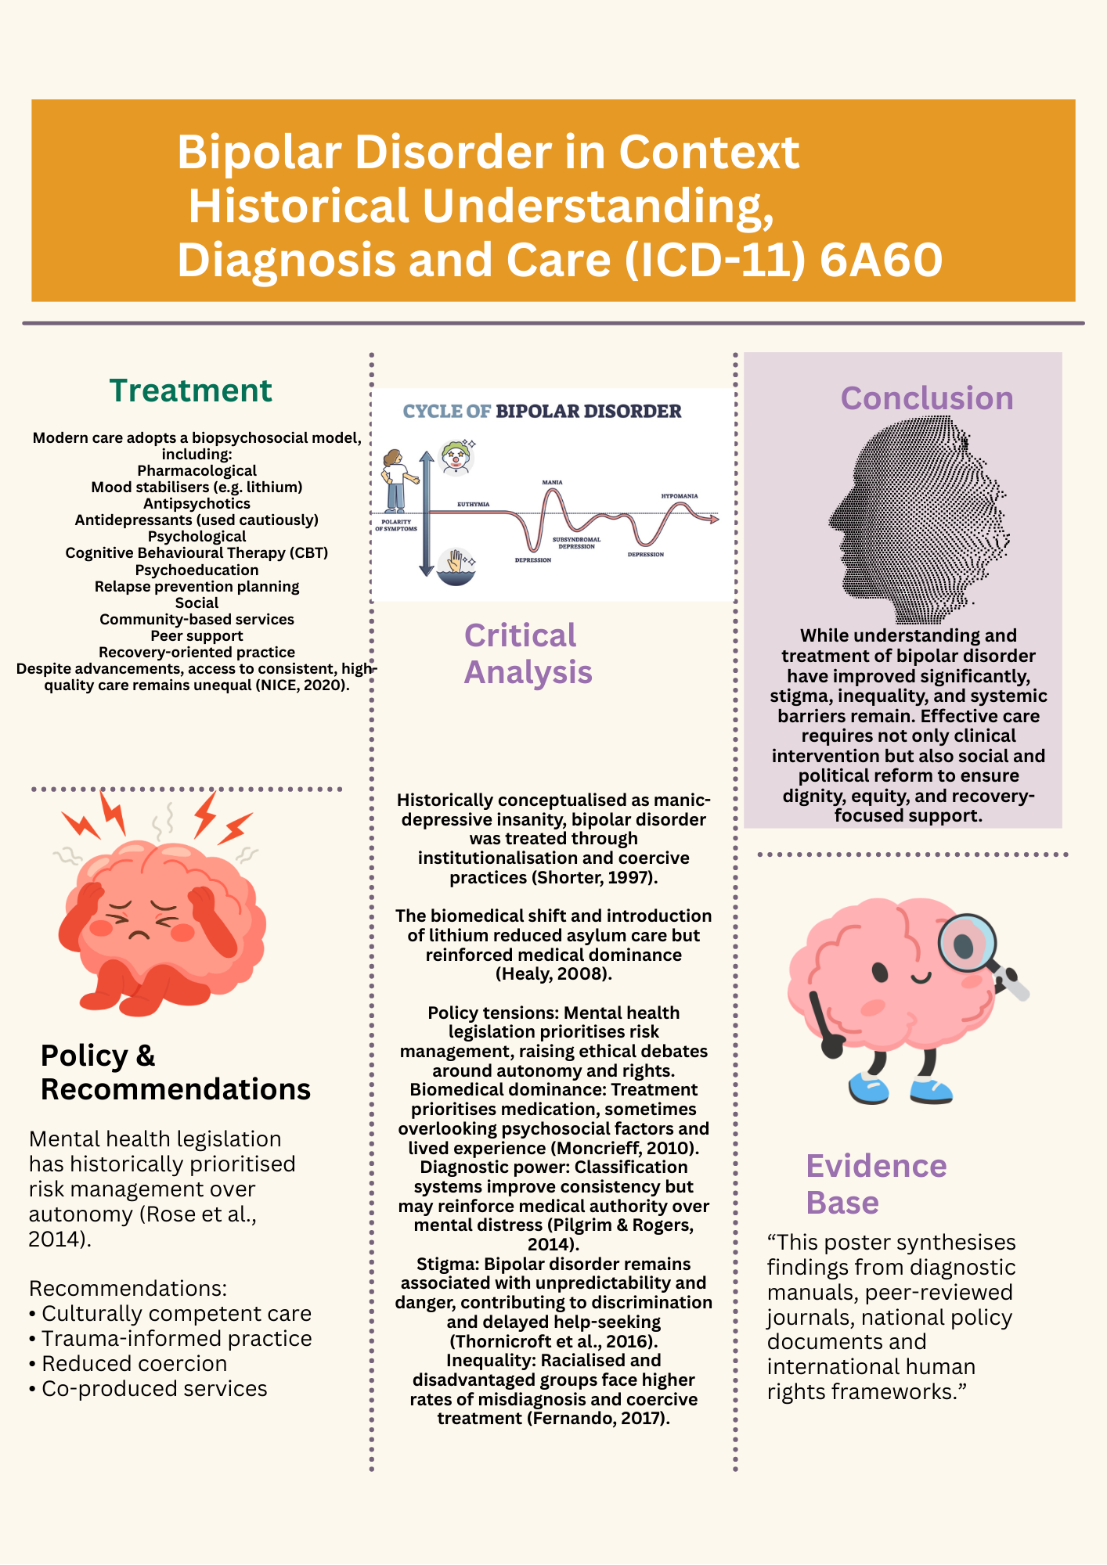

References
Foucault, M. (2006) History of Madness. London: Routledge.
Goodwin, F.K. and Jamison, K.R. (2007) Manic-Depressive Illness. 2nd edn. Oxford: Oxford University Press.
Mental Health Foundation (2021) Bipolar Disorder Statistics and Inequality. London: MHF.
NICE (2020) Bipolar Disorder: Assessment and Management (CG185). London: National Institute for Health and Care Excellence.
United Nations (2017) Convention on the Rights of Persons with Disabilities. Geneva: UN.
World Health Organization (2019) ICD-11: Clinical Descriptions and Diagnostic Guidelines. Geneva: WHO.
American Psychiatric Association (2013) DSM-5: Diagnostic and Statistical Manual of Mental Disorders. 5th edn. Washington, DC: APA.
Baldessarini, R.J. (2013) Chemotherapy in Psychiatry. 3rd edn. New York: Springer.
Berk, M. et al. (2011) ‘Pathways underlying neuroprogression in bipolar disorder’, Neuroscience & Biobehavioral Reviews, 35(3), pp. 804–817.
Bhugra, D. and Bhui, K. (2018) Textbook of Cultural Psychiatry. Cambridge: Cambridge University Press.
Corrigan, P.W. and Watson, A.C. (2002) ‘Understanding the impact of stigma on people with mental illness’, World Psychiatry, 1(1), pp. 16–20.
Foucault, M. (2006) History of Madness. London: Routledge.
Geddes, J.R. and Miklowitz, D.J. (2013) ‘Treatment of bipolar disorder’, The Lancet, 381(9878), pp. 1672–1682.
Goodwin, F.K. and Jamison, K.R. (2007) Manic-Depressive Illness. 2nd edn. Oxford: Oxford University Press.
Grande, I., Berk, M., Birmaher, B. and Vieta, E. (2016) ‘Bipolar disorder’, The Lancet, 387(10027), pp. 1561–1572.
Hawton, K. et al. (2005) ‘Suicide and bipolar disorder’, Journal of Affective Disorders, 84(2–3), pp. 171–178.
Jones, S. et al. (2015) ‘Recovery-focused care in bipolar disorder’, British Journal of Psychiatry, 206(1), pp. 1–3.
King’s Fund (2022) Mental Health Funding and Policy in England. London: The King’s Fund.
Laursen, T.M. (2011) ‘Life expectancy among persons with bipolar disorder’, Bipolar Disorders, 13(2), pp. 183–194.
Link, B.G. and Phelan, J.C. (2001) ‘Conceptualizing stigma’, Annual Review of Sociology, 27, pp. 363–385.
Mental Health Foundation (2021) Stigma and Discrimination in Bipolar Disorder. London: MHF.
Miklowitz, D.J. (2011) The Bipolar Disorder Survival Guide. New York: Guilford Press.
NICE (2020) Bipolar Disorder: Assessment and Management (CG185). London: National Institute for Health and Care Excellence.
Patel, V. et al. (2018) ‘The Lancet Commission on global mental health’, The Lancet, 392(10157), pp. 1553–1598.
Rose, D. (2014) Service User Perspectives in Mental Health. London: Palgrave Macmillan.
Sartorius, N. (2007) ‘Stigma and mental health’, The Lancet, 370(9590), pp. 810–811.
Scott, J. (2011) ‘Psychotherapy for bipolar disorder’, British Journal of Psychiatry, 199(6), pp. 421–423.
Thornicroft, G. (2006) Shunned: Discrimination against People with Mental Illness. Oxford: Oxford University Press.
United Nations (2017) Convention on the Rights of Persons with Disabilities. Geneva: UN.
Vieta, E. et al. (2018) ‘Bipolar disorders’, Nature Reviews Disease Primers, 4(1), pp. 1–16.
Walker, E.R., McGee, R.E. and Druss, B.G. (2015) ‘Mortality in mental disorders’, JAMA Psychiatry, 72(4), pp. 334–341.
World Health Organization (2021) Guidance on Community Mental Health Services. Geneva: WHO.
World Health Organization (2019) International Classification of Diseases 11th Revision (ICD-11): Clinical Descriptions and Diagnostic Guidelines. Geneva: WHO.

