GEERT HOFSTEDE

What about the UK?
If we explore the British culture through the lens of the 6-D Model©, we can get a good overview of the deep drivers of British culture relative to other world cultures.

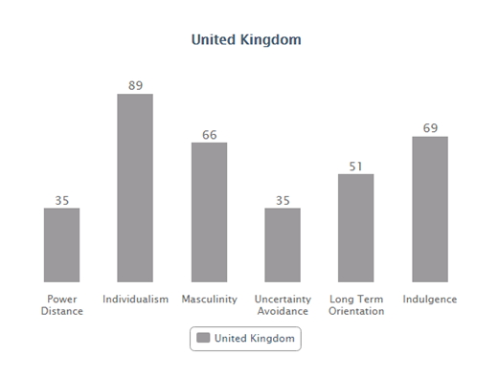
Power Distance
This dimension deals with the fact that all individuals in societies are not equal – it expresses the attitude of the culture towards these inequalities amongst us. Power Distance is defined as the extent to which the less powerful members of institutions and organisations within a country expect and accept that power is distributed unequally.
At 35 Britain sits in the lower rankings of PDI – i.e. a society that believes that inequalities amongst people should be minimized. Interestingly is that research shows PD index lower amongst the higher class in Britain than amongst the working classes. The PDI score at first seems incongruent with the well-established and historical British class system and its exposes one of the inherent tensions in the British culture – between the importance of birth rank on the one hand and a deep seated belief that where you are born should not limit how far you can travel in life. A sense of fair play drives a belief that people should be treated in some way as equals.
Individualism
The fundamental issue addressed by this dimension is the degree of interdependence a society maintains among its members. It has to do with whether people´s self-image is defined in terms of “I” or “We”. In Individualist societies people are supposed to look after themselves and their direct family only. In Collectivist societies people belong to ‘in groups’ that take care of them in exchange for loyalty.
At a score of 89 the UK is amongst the highest of the Individualist scores, beaten only by some of the commonwealth countries it spawned i.e. Australia and the USA. The British are a highly Individualist and private people. Children are taught from an early age to think for themselves and to find out what their unique purpose in life is and how they uniquely can contribute to society. The route to happiness is through personal fulfillment. As the affluence of Britain has increased throughout the last decade, with wealth also ‘spreading North’, a much discussed phenomenon is the rise of what has been seen as rampant consumerism and a strengthening of the ‘ME’ culture.
Masculinity
A high score (Masculine) on this dimension indicates that the society will be driven by competition, achievement and success, with success being defined by the winner/best in field – a value system that starts in school and continues throughout organisational life.

A low score (Feminine) on the dimension means that the dominant values in society are caring for others and quality of life. A Feminine society is one where quality of life is the sign of success and standing out from the crowd is not admirable. The fundamental issue here is what motivates people, wanting to be the best (Masculine) or liking what you do (Feminine).
At 66, Britain is a Masculine society – highly success oriented and driven. A key point of confusion for the foreigner lies in the apparent contradiction between the British culture of modesty and understatement which is at odds with the underlying success driven value system in the culture. Critical to understanding the British is being able to ‘’read between the lines’’ What is said is not always what is meant. In comparison to Feminine cultures such as the Scandinavian countries, people in the UK live in order to work and have a clear performance ambition.
Uncertainty Avoidance
The dimension Uncertainty Avoidance has to do with the way that a society deals with the fact that the future can never be known: should we try to control the future or just let it happen? This ambiguity brings with it anxiety and different cultures have learnt to deal with this anxiety in different ways. The extent to which the members of a culture feel threatened by ambiguous or unknown situations and have created beliefs and institutions that try to avoid these is reflected in the score on Uncertainty Avoidance.
At 35 the UK has a low score on Uncertainty Avoidance which means that as a nation they are quite happy to wake up not knowing what the day brings and they are happy to ‘make it up as they go along’ changing plans as new information comes to light. As a low UAI country the British are comfortable in ambiguous situations - the term ‘muddling through’ is a very British way of expressing this. There are generally not too many rules in British society, but those that are there are adhered to (the most famous of which of course the British love of queuing which has also to do with the values of fair play).

In work terms this results in planning that is not detail oriented – the end goal will be clear (due to high MAS) but the detail of how we get there will be light and the actual process fluid and flexible to emerging and changing environment. Planning horizons will also be shorter. Most importantly the combination of a highly Individualist and curious nation is a high level of creativity and strong need for innovation. What is different is attractive! This emerges throughout the society in both its humour, heavy consumerism for new and innovative products and the fast highly creative industries it thrives in – advertising, marketing, financial engineering.
Long Term Orientation
This dimension describes how every society has to maintain some links with its own past while dealing with the challenges of the present and future, and societies prioritise these two existential goals differently. Normative societies which score low on this dimension, for example, prefer to maintain time-honoured traditions and norms while viewing societal change with suspicion. Those with a culture which scores high, on the other hand, take a more pragmatic approach: they encourage thrift and efforts in modern education as a way to prepare for the future.
With an intermediate score of 51 in this dimension, a dominant preference in British culture cannot be determined.

Indulgence
One challenge that confronts humanity, now and in the past, is the degree to which small children are socialized. Without socialization we do not become “human”. This dimension is defined as the extent to which people try to control their desires and impulses, based on the way they were raised. Relatively weak control is called “Indulgence” and relatively strong control is called “Restraint”. Cultures can, therefore, be described as Indulgent or Restrained.
A high score of 69 indicates that the British culture is one that is classified as Indulgent. People in societies classified by a high score in Indulgence generally exhibit a willingness to realise their impulses and desires with regard to enjoying life and having fun. They possess a positive attitude and have a tendency towards optimism. In addition, they place a higher degree of importance on leisure time, act as they please and spend money as they wish.

Comparison between the UK and Poland:

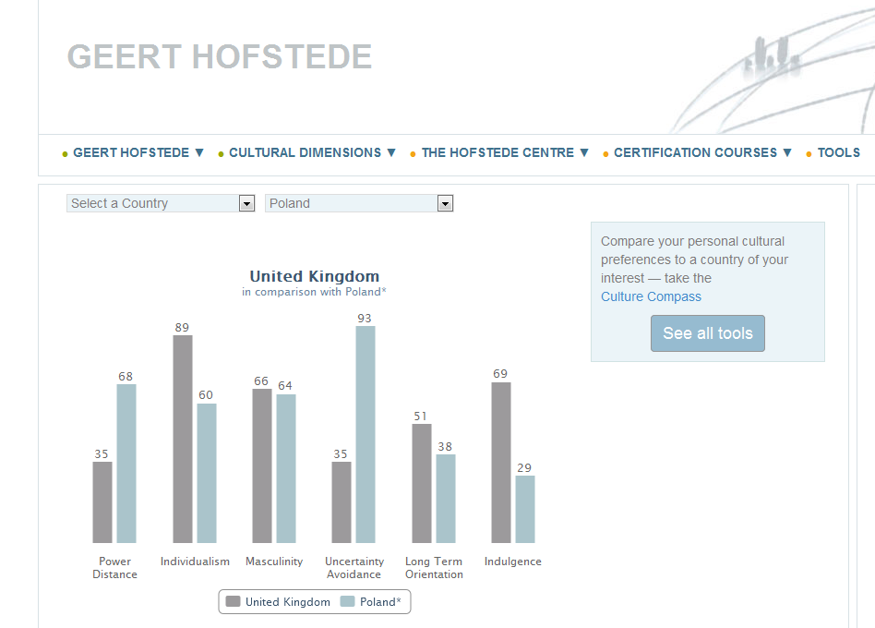

Comparison between the UK and China:

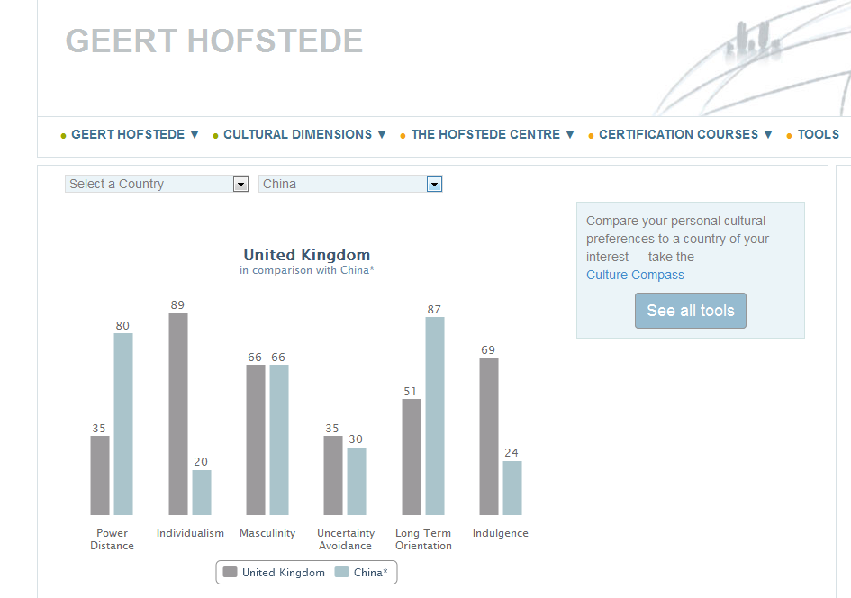

Comparison between the UK and the Philippines:

