BSc Health and Social Care

Student Name: Leanne Fahy
Student Number: 2425000
Module Code: BMHP5014
Module Title: Changemakers: Creativity and Value Creation
Assignment Title: Component 1 - Online Portfolio of Set Exercises
Lecturer Name: Tomy Adattu Chacko

Task 1– Concept Map

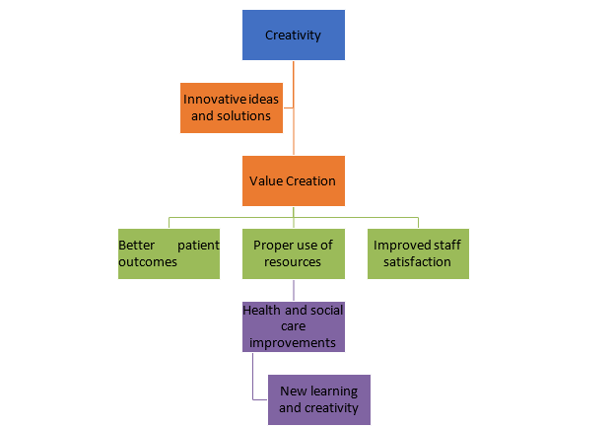

Figure: Concept Map
Source: (Own)

This concept map demonstrates the relationship between creativity, value creation, and health and social care improvement. Creativity is the starting point because it encourages professionals to generate innovative ideas and solutions that address challenges in health and social care. These ideas may include introducing new technologies, improving communication, redesigning care pathways, or developing more person-centred approaches to service delivery.
Creativity contributes to value creation by improving the quality, efficiency, and effectiveness of care. Value is created when organisations use resources appropriately while delivering better outcomes for patients and service users. As shown in the concept map, value creation results in better patient outcomes, effective use of resources, and improved staff satisfaction. Motivated staff are more likely to work collaboratively, provide compassionate care, and contribute to continuous service improvement.
These outcomes lead to Health and Social Care improvement, where services become safer, more efficient, and responsive to the changing needs of individuals and communities. Organisations can further support improvement by investing in staff training, professional development, and a culture that encourages innovation and learning. This enables healthcare professionals to adapt to new challenges and maintain high standards of care.
The relationship between these concepts is continuous rather than linear. As services improve, organisations gain new knowledge and experience, which encourages further creativity and innovation. This ongoing cycle strengthens organisational performance and promotes sustainable improvements in health and social care. Ultimately, creativity drives value creation, which enhances patient experiences, staff wellbeing, and the overall quality of health and social care services (Glasby, Year; Sutton et al., 2023)

Task 2- Self-Reflection of Group Activity

Description: During the activity, I worked with my peers to particate in the paperclip thinking activity which explored divergent and convergent thinking. My group generated different uses for a paperclip before selecting the most practical ideas. This activity encouraged creative thinking and helped me to understand how innovation can contribute to improvements in Health and Social Care.
Feelings: I was feeling nervous because I had never taken part in a paperclip thinking activity before. I lacked confidence in my sharing my ideas and worried that they would not be creative enough. However, I became more confident after listening to my classmates’ suggestions and all working together.
Evaluation: This activity was enjoyable and helped me appreciate the importance of teamwork. Listening to different perspectives allowed our group to generate more creative ideas than I could have developed individually. It has showed me that there is often more than one solution to a problem.
Analysis: The paperclip activity demonstrated the value of combining divergent and convergent thinking. Divergent thinking skills helped me to generate a range of ideas. Convergent Thinking skills helped me evaluate and select the most practical solutions. These skills are essential where professionals must balance creativity with safe and person-centred decision making.
Conclusion: Overall, this activity has helped improved my confidence, communication and creative thinking skills. It has also helped me understand how innovation can contribute to improving Health and Social Care services.
Action Plan: In future, I will participate more actively in group discussions, using brainstorming techniques to develop creative ideas and continue improving my critical thinking skills. This will help me become more effective and innovative in Health and Socal Care.
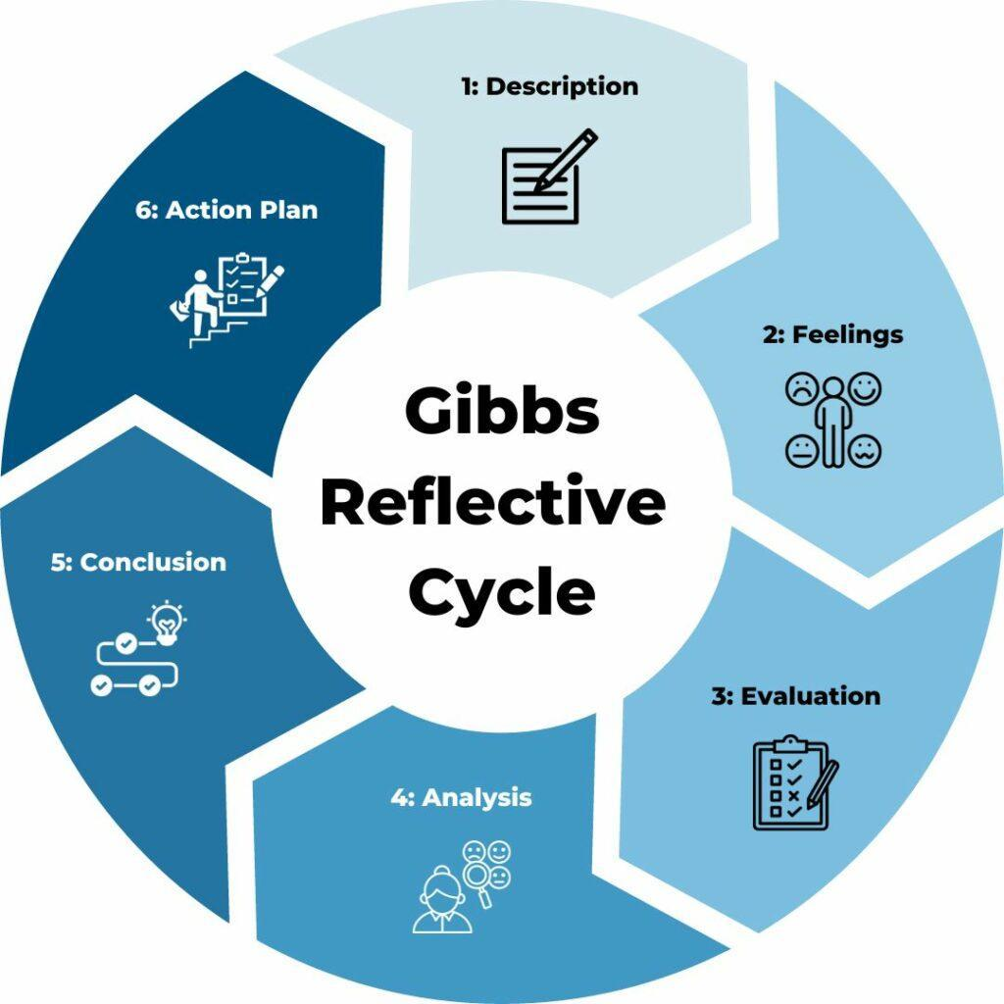

Figure: Gibbs’ Reflective Cycle
Sources: Gibbs, G. (1988). Learning by Doing: A guide to Teaching and Learning Methods. Oxford: Oxford Polytechnic.
Channell, M. (2023). Gibbs Reflective Cycle – A Practical Guide. [online] TSW Training.

Task 3- Case Study: NHS at Home – Remote Monitoring to Reduce Hospital Admissions

The NHS at Home initiative is an innovative healthcare programme designed to reduce unnecessary hospital admissions by enabling patients with long-term conditions, such as diabetes, heart disease and respiratory illnesses, to monitor their health from home. The programme uses digital technology, including wearable devices, home-monitoring equipment and artificial intelligence (AI), to support patients while allowing healthcare professionals to monitor their condition remotely. This approach aims to improve patient outcomes, reduce pressure on NHS services and promote person-centred care (NHS England, 2023).
The creative driving force behind this innovation is the use of digital technology to transform traditional healthcare delivery. Instead of relying solely on face-to-face appointments or hospital admissions, patients can use wearable devices to record vital signs such as blood pressure, heart rate and blood glucose levels. This information is transmitted securely to healthcare professionals, enabling early identification of any deterioration in the patient’s condition. AI and predictive analytics also support clinical decision-making by identifying health risks before they become emergencies. As a result, healthcare professionals can provide timely interventions while reducing avoidable hospital admissions (NHS England, 2023).
This innovation creates significant value for patients by increasing independence and confidence in managing their own health. Patients are encouraged to understand their health data, participate in decisions about their care and receive treatment in the comfort of their own homes. This improves patient satisfaction, reduces travel to hospitals and enhances quality of life, particularly for those with long-term conditions or limited mobility.
The NHS at Home programme also creates value for healthcare organisations. By reducing unnecessary admissions and supporting early intervention, the initiative helps ease pressure on hospital beds, improves the use of healthcare resources and enables staff to focus on patients with more complex needs. Remote monitoring also supports continuous communication between patients and healthcare professionals, leading to more personalised and efficient care.
Overall, NHS at Home demonstrates how digital innovation can improve health and social care by combining technology with person-centred care. It supports better patient outcomes, enhances service efficiency and contributes to a more sustainable healthcare system. This case study highlights the importance of innovation in meeting the increasing demands on NHS services while improving the quality and accessibility of care.

Sources
NHS England (2023) Virtual wards including Hospital at Home. Available at: https://www.england.nhs.uk
The King’s Fund (2022) Digital technology and innovation in health and social care. Available at: https://www.kingsfund.org.uk

Task 4- Research Task

Mental Health Stigma
Mental Health Stigma is major issue in Health and Social Care, which makes patients less engaged and motivated for Health and Social Care activities (Glasby, 2026). Mental Health discourages people from seeking professional support and can delay diagnosis and treatment. The fear of discrimination, lack of awareness and negative attitudes can reduce access to appropriate care and worsen Health outcomes.
Academic Research 1
Gautam, S., Jain, A., Chaudhary, J., Gautam, M., Gaur, M. and Grover, S. (2024). Concept of mental health and mental well-being, its determinants and coping strategies. Indian Journal of Psychiatry, 66(Suppl 2), pp. S231-S244.

In this journal, the authors discuss the different core concepts of mental health and mental well-being these are discussed in detail with different strategies to determine the mental condition in individuals or patients to design and offer better health and social care facilities. It also explores the relationships between culture and mental health, with mental well-being strategies to offer proper support for mentally ill patients (Gautam et al., 2024). The article also examines the relationship between culture and mental health, highlighting the importance. The journal was able to evaluate the neurobiology of mental well-being and identify a range of different protective factors and coping strategies, which can help individuals manage their mental health more efficiently. The research suggests that understand these factors can improve mental health well-being, encourage early intervention and enable Health and Social Care professionals to provide more effective person-centred support for individuals experiencing mental health problems.

Academic Research 2
Singh, V., Kumar, A. and Gupta, S. (2022). Mental health prevention and promotion—A narrative review. Frontiers in psychiatry, 13, p.898009.

In this narrative review, the authors highlight a range of activities and strategies that can promote mental health and help prevent mental health-related issues. They provide detailed information on the importance of mental health prevention and explain why early invention is essential for improving overall well-being. The review also evaluates the scopes of mental health promotion and prevention in the current situation with the concept of preventive psychiatry (Singh, Kumar and Gupta, 2022). The narrative review discussed terms, definitions, and concepts of different mental illnesses with proper examples and findings to inform the readers more about different mental issues and preservation strategies. It highlighted how to explore digital technology, and other innovative approaches can be used support mental health promotion and protection. However, it acknowledges that there are challenges in implementing these strategies, including lack of awareness and limited resources. Overall, the authors conclude that prevention, education and improved access are essential for improving mental health outcomes.

Task 5- Podcast

Audio file
my-recording.mp3

Transcript
Speaker 1
Hello everyone and welcome. Today we're discussing one of the biggest challenges in the NHS facing hospitals which is long waiting times in accident and emergency or A&E as others call it. There are several reasons why patients Experience delays. Firstly, increasing numbers of people are attending A&E, including those with non-emergency conditions. Secondly, staff shortages are limited. Hospital beds can slow down treatment and admissions. Delays in diagnostic tests, such as blood tests or x-rays, can also increase waiting times. In addition, patients who are medically ready to leave hospital may remain because suitable community or social care is unavailable, reducing bed capacity. There are several ways to improve patient flow. One solution is to increase staffing during busier times and ensuring staff receive ongoing training. Improving triage systems helps identify the most urgent cases quickly while directing less serious cases to appropriate services such as urgent care centres or GPs. Hospitals can also speed up access to diagnostic tests to improve communication between departments to reduce unnecessary delays. Better discharge planning can free up beds more quickly, allowing patients in A&E to be admitted sooner when needed. Reducing waiting times requires good teamwork, good planning, efficient use of resources. By improving patient flow, staffing and triage, hospitals can provide safer, faster and higher quality care for everyone. for everyone. Thank you for listening.

Task 6- NHS Leadership Framework Analysis

The NHS leadership framework outlines the knowledge, skills and behaviours needed for effective leadership across Health and Social Care. According to Carroll et al. (2023), strong leadership contributes to better organisational performance and higher-quality healthcare services. The framework includes several key components, including demonstrating personal qualities, working with others, managing services, improving services, setting direction and creating a vision are some key domains of the NHS leadership and management framework, which makes the medical staff and business leaders more accountable for their organisational roles and responsibilities. These components help leaders make informed decisions, communicate effectively, build strong teams and deliver high quality, patient-centred care. The leadership of the NHS also sets direction and is involved in informed decision-making to improve service quality and patient satisfaction (Elkomy, Murad and Veleanu, 2023). Furthermore, the framework of NHS leadership relates to creating a vision for the medical staff and enhancing delivery strategies to better resource management and bring sustainable outcomes in business. The NHS Leadership Framework provides guidance that will help leaders create positive working environments and improve outcomes for both patients and Healthcare professionals.

Encourage Creativity and Enhance Care at The NHS.
Working with others is an important component of the NHS Leadership Framework because it encourages teamwork, communication and collaboration between healthcare professionals. Leaders can use this component to create an environment where staff feel confident sharing ideas, solving problems and suggesting new ways to improve patient care.
According to Tissiman et al. (2023) collaborative leadership improves staff engagement and supports the development of innovative solutions that enhance patient care. Working with other domains of NHS leadership can encourage the medical staff in decision-making and network development, which are effective for innovation and creativity. In addition, Carroll et al. (2023) state that effective leadership encourages teamwork, supports professional development and improves the quality of patient care. By applying the “Working with Others” component, NHS leaders can create a positive workplace culture that encourages creativity, strengthens teamwork and ultimately improves patient outcomes and the overall quality of NHS services.

Sources
Carroll et al. (2023)
Tissiman et al. (2023)

Task 7- Self-Reflection Journal Entry

During the Changemakers: Creativity and Value Creation module, I have learned a lot about innovation and creativity in the health and social care sector of the UK. I also learned the importance of innovation and creativity in the medical sector to create more value for the patient and improve the overall quality and quantity of medical and social services (Channell, 2023). Through this “Changemakers: Creativity and Value Creation” module, I was able to evaluate the changing needs and demands of the health and social care sector of the UK, where organisations like the NHS adopt changes in the business leadership framework. So, it makes me more engaged and motivated for innovation and creativity, to make my upcoming academic and professional career successful and competitive. At the beginning of the module, I was feeling so tense due to my limited previous knowledge about creativity and value creation. I also received regular support in this module with the guidance of my mentors to generate good knowledge and skills in creativity and innovation, which supports value creation in academic and professional purposes. So, after this module of Changemakers: Creativity and Value Creation, it can be said that now I have good knowledge and skills about creativity, data analysis and innovation to make my upcoming academic and professional activities more productive, innovative and successful (Glasby, 2026).

References

Carroll, Á., Collins, C., McKenzie, J., Stokes, D. and Darley, A. (2023). Application of complexity theory in health and social care research: a scoping review. BMJ open, 13(3), p.e069180.
Channell, M. (2023). Gibbs Reflective Cycle – A Practical Guide. [online] TSW Training. Available at: https://www.tsw.co.uk/insights/gibbs-reflective-cycle/.
Elkomy, S., Murad, Z. and Veleanu, V. (2023). Does leadership matter for healthcare service quality? Evidence from NHS England. International Public Management Journal, 26(2), pp.147-174.
Galli, F. and New, K.J., (2022). Gibbs’ cycle review. Emotions as a part of the cycle. E-Motion: Revista de Educación, Motricidad e Investigación, (19), pp.92-101.
Gibbs, G. (1988) Learning by Doing: A Guide to Teaching and Learning Methods. Oxford: Oxford Polytechnic
Glasby, J., (2026). Understanding health and social care. In Understanding Health and Social Care. Policy Press.
Kosiol, J., Silvester, T., Cooper, H., Alford, S. and Fraser, L., (2024). Revolutionising health and social care: innovative solutions for a brighter tomorrow–a systematic review of the literature. BMC health services research, 24(1), p.809.
Lillywhite, M. (2024). Gloucestershire Artlift sessions ‘reducing GP visits’. 18 Apr.
NHS England (2023). NHS England. [online] England.nhs.uk. Available at: https://www.england.nhs.uk/.
NHS England (2023) Virtual wards including Hospital at Home. Available at: https://www.england.nhs.uk
The King’s Fund (2022) Digital technology and innovation in health and social care. Available at: https://www.kingsfund.org.uk
Sutton, C., Prowse, J., McVey, L., Elshehaly, M., Neagu, D., Montague, J., Alvarado, N., Tissiman, C., O'Connell, K., Eyers, E. and Faisal, M., (2023). Strategic workforce planning in health and social care–an international perspective: A scoping review. Health policy, 132, p.104827.

