BMSE4009D
Social Enterprise: Theory and Practise
Essay
Exploring the opportunities and challenges facing social enterprise.
2520282 Capraru Bogdan
Lecturer: Jessica Shore

Introduction
Social enterprises have become more and more popular in the UK throughout the past decade, where organisations involving social (or environmental) mission alongside business-specific trading operations form. In the UK sense, the definition is frequently one that puts strong emphasis on a business whose major social/environmental goals are surpluses that are primarily used back into the business or community other than being distributed out to shareholders and owners. This essay discusses existing opportunities and challenges of social enterprise in the UK using a SWOT framework. It will also rely on applicable scholarly theory (e.g., hybrid organisations, social entrepreneurship and social value theories) and apply examples of UK-based industry in order to present the analysis. This will assist in substantiating a systematic debate of the internal advantages and disadvantages of the industry, as well as external threats and opportunities in the UK surrounding circumstances.

SWOT analysis

Strengths
A hybrid nature of social enterprises in the UK is one of the key strengths of this type of organisations because they are located between profit making organisations and no-profit ones. This hybridity brings benefits: they will be able to integrate business and social purpose by establishing potential sources of sustainability and impact (Ridley-Duff & Bull, 2019). Social enterprises are more resilient and can grow because the capacity to trade provides greater autonomy than grant-funded charities (White et al., 2022). The other strength is that they are aligned to social value creation. Social enterprises can imprint mission driven values within a governance system, and are becoming more competent at social impact measurement (Ridley-Duff & Bull, 2019). This ability makes them credible to the stakeholders (investors, government, communities) and helps them to be legitimate. The UK ecosystem on social enterprise is somewhat developed: an example can be the national membership body Social Enterprise UK and its Knowledge Centre that offer evidence, research and support activities to the industry. It is a strength since this institutional support is part of a favourable environment (Teasdale et al., 2017). Moreover, social enterprises have a robust community base and stakeholder involvement, creating a sense of trust, social capital and attentiveness to local demands. An example is that community-business models in the UK usually imply democratic control and local ownership, providing a good foundation of legitimacy and influence (Aiken et al., 2021).
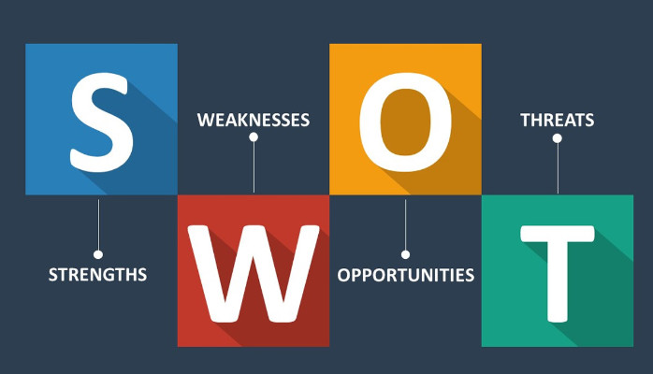
Figure: SWOT analysis (Teasdale et al., 2017).
The case of the social enterprise Catch22 (based in the UK) illustrates how an organisation that focuses on social mission and still operates in a commercial manner can provide extensive services (such as alternative education, employability, rehabilitation) which, despite their social focus, still encompass social mission (Catch22, 2023). This is the way in which power in making business and social purpose come true can be achieved.

Weaknesses
Irrespective of the strengths, social enterprises in the UK are facing serious weaknesses internally. A major weakness is necessarily linked to the tension of the hybrid model will be the conflict of priorities between pursuing the two main goals of financial sustainability and social mission, which may lead to a loss of focus, mission drift or confusion of identity (Doherty et al., 2014). The empirical research on UK social enterprises shows that this hybridity management has been a significant issue (Aiken et al., 2021). The second limitation is that many social enterprises are relatively small and do not have the capacity. Most of them are small or micro-organisations and have weak resources (financial, human, and technical). This limits their scope of being able to invest in growth, marketing, measurement systems or innovation. According to the 2023 State of Social Enterprise report, the industry is expanding, and several organisations still face the problem of resource limitations. (Social Enterprise UK, 2024)
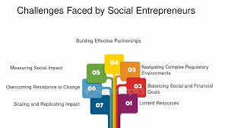
Figure: Challenges (Battilana and Dorado, 2010).
Since this is related to it, measurement of impact is a perpetual weakness. Social enterprises, in its turn, are making more efforts in trying to quantify social value even though social accounting practises remain not yet sufficiently rigorous, comparable, and standardised (Ridley-Duff & Bull, 2019). The other weakness within is leadership and ability to govern. Social enterprises are frequently funded through volunteer boards, mixed business/purpose background staff and might not have professional competency in such areas as finance, marketing, governance or scaling. The meta-analysis of the UK social enterprise ecosystems determined structural, skills and resource constraints still hinder success. (White et al., 2022) Lastly, sometimes flexibility is restricted by legal and organisational form. Social enterprises (charity, CICs, CLGs, co-operatives) in the UK have a great number of legal ways of being incorporated, and this can confuse the social enterprise externally, making it harder to regulate, find funding, and understand how it works (Aiken et al., 2021).

Opportunities
The opportunities of social enterprises can be assessed as many in the UK under the changing external conditions and policy tendencies. Among the major opportunities are growing demand of business models with social orientation and the propensity of consumers towards ethical consumption (Doherty et al., 2014). Further opportunities are the policy and regulatory drivers. As an illustration, the interests of the UK Government in the third sector, social value procurement, transformation of making public services available and encouraging social investment imply that social enterprises are likely to get access to new contracts and funding sources. The other opportunity is the partnership with the government and nongovernmental organisations. With economy and funding pressures putting pressure on the provision of social services and austerity, social enterprises can also provide services in collaboration with government or even be innovative in social provision. The meta-analysis of UK social enterprise ecosystems highlights that social enterprises may become the substitute additions of conventional entrepreneurial ecosystems in underserved geographies. (White et al., 2022). There are additional opportunities provided by the emergence of digital technologies, data analytics, and social innovation. Technology can help social enterprises to scale up impact, cut expenses, develop new service delivery, and address beneficiaries and communities more effectively. (Doherty et al., 2014).

Lastly, social enterprises on the UK market have a new thematic opportunity also due to global and environmental policies (e.g. the UN Sustainable Development Goals): climate change, circular economy, inclusive growth, community resilience. Associating themselves with these agendas is what will help social enterprises to tap into new funds, partners and markets. Theoretically, the idea of the social enterprise ecosystem states that social enterprises do not exist in a vacuum, but rather they are enclosed within a network of actors (government, investors, support organisations, civil society) and processes (funding, policy, markets) (White et al., 2022).
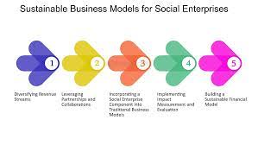
Figure: opportunities facing social enterprise (Battilana and Dorado, 2010).

Threats
Although the opportunities are numerous, external threats to social enterprises in UK are quite high. Competition and market pressures are one of the threats. However, social enterprises trade, they may find it difficult to compete with other firms in the private sector that are more endowed, better marketed and have economies of scale as well as access to capital. This may squeeze margins, pose risk of survival and compel mission compromise. The other threat is a funding and investment risk. Despite an increase in social investment, availability to affordable or appropriate finance continues to be a challenge by most social enterprises. There is the problem of market failures in social investment, regional imbalances, and risk of uncertainty of the returns. The meta-analysis conducted on ecosystem revealed that social enterprises still need structural, financial and skills management assistance. Without finance, the growth or survival is jeopardised (White et al., 2022). There are also policy and regulation changes that are threatening. As an example, shifts in the social enterprise operating environment may be caused by alterations in the public procurement policies, decreased local government funding, doubts associated with Brexit, or unfavourable shifts in policies. The other risk is mission drift and reputation risk. Without being focused on the purpose, rather on the trading revenue, social enterprises run the risk of losing stakeholder trust, weakening their social mission, and losing credibility. The conflicting character of the dual mission (economic/social) introduces the potential vulnerability to such threats (Doherty et al., 2014). Lastly, there are measurement and proof-of-impact threats. Unless social enterprises can prove credible impact, it is possible that they become restricted with no contracts, funding, or interest of investors. Weak evidence can be an impediment to differentiation in a market filled with organisations that are purported to be socially impactful. Additionally, the hybridity theory highlights that the dual nature of social enterprise may result in conflicting logics (economic vs social) that should be resolved through the administrative, culture and leadership (Battilana and Dorado, 2010).
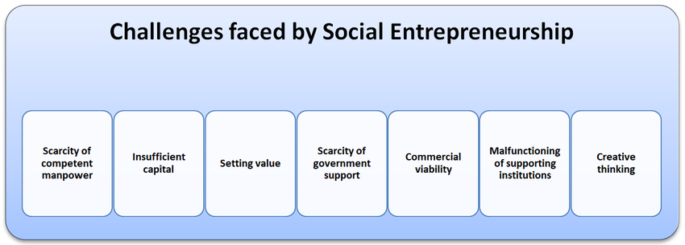
Figure: challenges facing social enterprise (White et al., 2022).

Conclusion
Thus, the UK provides social businesses with an ample environment of opportunities that are fuelled by the changing consumer behaviours, governmental policies, collaborations, and international agenda. Internal capacities, which include mission-driven hybridity, institutional support as well as community legitimacy, support them. Yet, these organisations have to grapple as well with internal limitations capacity constraints, governance, measurement and external threats such competition, financial unpredictability’s, policy changes and mission drift. As the adaption of a SWOT model illustrates, to succeed, social enterprises must develop internal resources (including resources, leadership, measurement systems), and work with their overall ecosystem strategically (including policy, investment, partnerships). It is important to mention good internal governance, unfocused mission articulation practises and measurement practises. The future of the UK social enterprises can be bright in case they can negotiate through their internal hazards, utilise external opportunities, and avoid external threats using strategic deliberation and sound internal governance.

References
Aiken, M., Spear, R., Lyon, F., Teasdale, S., Hazenberg, R. & Kopec M.A. (2021) Social Enterprise in the UK: Models and trajectories. Northampton: University of Northampton Press.
Battilana, J. & Dorado, S. (2010) ‘Building sustainable hybrid organisations: The case of commercial micro‐finance organisations’, Academy of Management Journal, 53(6), pp. 1419-1440.
British Council (2016) The State of Social Enterprise: United Kingdom. London: British Council. FB
Doherty, B., Haugh, H. & Lyon, F. (2014) ‘Social enterprises as hybrid organisations: A review and research agenda’, International Journal of Management Reviews, 16(4), pp. 417-436.
Mswaka, W., Aluko, O., Hussein, S., dos Santos de Sousa, A. & Cai, H. (2023) ‘Financing social enterprise in the UK: Responding to new challenges in competitive markets’, Voluntas, 34, pp. 345-365.
Ridley-Duff, R. & Bull, M. (2019) Understanding Social Enterprise: Theory and Practice (3rd edn). London: SAGE.
Robinson, C. (2020) ‘Social enterprise and social entrepreneurship: Developing the evidence base using the UK small business survey’, Journal of Social Entrepreneurship, 11(2), pp. 103-123.
Samuel, A., White, G.R.T. & Peattie, K. (2021) ‘Social Enterprise Places: A place-based initiative facilitating legitimacy’, Journal of Rural Studies, 84, pp. 34-46.
Social Enterprise UK (2021) No Going Back – The State of Social Enterprise Survey 2021. London: SEUK.
Social Enterprise UK (2023) ‘Diversity at work: Leadership demographics and outcomes in social enterprise’. London: SEUK.
Social Enterprise UK (2024) The State of Social Enterprise: Mission Critical – Survey 2023. London: SEUK.
Teasdale, S., Lyon, F. & Baldock, R. (2017) ‘Playing with numbers: A methodological critique of the social enterprise growth myth’, Journal of Social Entrepreneurship, 8(2), pp. 113-131.
Turner, S., Russell, J. & Smith, A. (2022) ‘Towards social innovation strategy: An analysis of UK social enterprises’, Technological Forecasting & Social Change, 180, 121724.
White, G.R.T., Allen, R., Samuel, A., Taylor, D., Thomas, R. & Jones, P. (2022) ‘The ecosystem of UK social entrepreneurship: A meta-analysis of contemporary studies’, in Pickernell, D.G. et al. (eds) Disadvantaged Entrepreneurship and the Entrepreneurial Ecosystem, Vol. 14. Leeds: Emerald Publishing.

