Baia Mare Cyanide Spill, Romania
Module: Environmental monitoring and Remediation Module code: M5X01868 | 10th May 2019

Cerys Elizabeth Gulley
[Year]
Contents
1. Abstract 2
2. Background 3
2.1 Location and Features 3
3. Baia Mare Mining 4
4. The Disaster 5
4.1Reasons for the Failure of the Dam 5
5. Impacts 8
5.1 Environmental Consequences: Changes in water and soil 8
5.2 Effects on social and economic life 9
6. Conclusion 12
7. References 13

1. Abstract
The environmental disaster in Baia Mare in January 2000 was looked at for a case study. A failure of tailings for the 20-metre-wide dam resulted in the contamination of adjacent hydrology systems which spanned three countries and eventually ended in the Black Sea.
Various studies and reports have deduced that adverse weather conditions and poor design were the main reasons of the disaster.
This report will highlight:
- What happened and why
- The consequences
- The aftermath of how this has impacted the region
- If there is any contamination still present almost 20 years later

2. Background

2.1 Location and Features
The Maramus County lies in the northern border of Romania and comprises of the Lapus and Baia Mare Depressions (Prieto, 2014). Baia Mare is a alongside the Săsar River, in north-western Romania and is the capital of Maramureș County (Baia Mare, 2019). It is approximately 600 kilometres (373 miles) from Bucharest, 70 km (43 mi) from Hungary, and 50 km (31 mi) from Ukraine (Baia Mare, 2019). In 2011 it was estimated that Baia Mare had a population of 140,738 and population of 137,976 in 2002 (baia mare population , 2018).

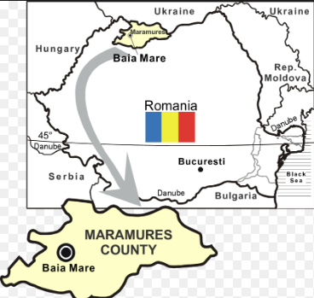

Figure 1: Map of the Maramures County and Baia Mare (Morcovescu, 2019)
With seven key mining locations this region has an extensive mining history and is rich in heavy metals such as gold (Au), silver (Ag), Manganese (Mn), lead (Pb) and Zinc (Zn) (Center, 2000).
Wastewater and materials from the mines are stored in floatation ponds and tailing dams (Tailings Dam, 2019). The design and quality of the dams will depend on geological mapping and surveys in order to determine its practicality and success (Safe Tailings Dam Construction, 2001). Due incidents caused by poor design and inaccurate predictions of various factors, twelve out of nineteen tailing dams within the Maramures County have been abandoned (Prieto, 2014).
3. Baia Mare Mining
In the 1990’s it was acknowledge that for the growth and development of Baia Mare three tailing ponds would need to be cleaned and recovered (Prieto, 2014). Concerns were shared for those who livid within close proximity of the highly toxic ponds as there was clear environmental benefits from removing the waste sites (Baia Mare Gold Mine Cyanide Spill: Causes, Impacts and Liability, 2000).
The World Health Organization (WHO) classifies “Baia Mare as a health risk hotspot, with the population’s exposure to lead being among the highest ever recorded. Lead in the blood of some adults’ averages almost 2.5 times above safety levels. In some children, it averages nearly six times above safety levels. High lead levels in humans are now thought to be associated with impaired learning ability, mental retardation, problems with kidney and neurological functions, hearing loss, blood disorder, hypertension and death” (Center, 2000).
An international partnership between Australia and Romania was born in expectations that mining sites could be cleaned with the intention that waste would be transported away from the city to new dams with zero discharge (Prieto, 2014) and remaining heavy metals could be recovered with modern technology in the near future (Center, 2000). This new modern dam was constructed with the objective to be safe, efficient and meet the requirements of the authorities involved (Prieto, 2014). This was important to the Government and involved companies as the Baia Mare plant was predicted to process 2.5 million tonnes of tailings comprising of 1.6 tonnes of gold and 9 tonnes of silver per annum over a 12 year period (Center, 2000).

4. The Disaster
On 30th January 2000 at approximately 22:00 a dam encircling a tailings pond at site managed by Aurul SA in Baia Mare ruptured and subsequently released 100,000 cubic meters of lethal waste water containing roughly 100 tonnes of cyanide and various heavy metals (Kamrun, 2015). The toxic wastewater flowed over farmland into the rivers Sasar, Lapus, Somes, Tisza and Danube before ending in the Black Sea (Center, 2000).
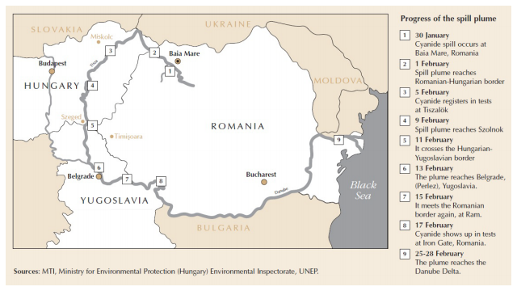
Figure 2: Map illustrating the flow of the cyanide spill (Prieto, 2014)

4.1Reasons for the Failure of the Dam
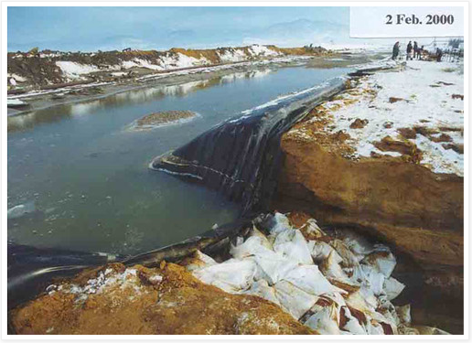
The dam was built to benefit from the surround mountains. The design of the dam included a decanting well to re-circulate slurry back to the plant, a drainage system as extra protection against seepage and was constructed so that it could cover 93 hectares and deal with storm run-off up to 118mm (Reasons the Dam failed, 2000). The region experienced approximately 40mm of rain and 120mm snowfall from December to late January and this accumulated in the pond in liquid and solid form with the temperature of the water plummeting to -10 ˚C.
It was constructed with new dam walls on top of a previous dam with the belief that tailings would heighten the wall as more slurry entered and hydro-cyclones were added to aid the plastic lining to prevent seepage into the environment (Center, 2000).

Figure 3: Rupture of tailing dam on 30th January 2000 (Prieto, 2014)
The failure of the dam was thought to be due to design defects, adverse weather and unexpected operating conditions. The higher than usual levels of melting snow and rain meant that volume was exceeded and over 25 meters of wall was carried away by the wastewater (UNEP/OCHA ASSESSMENT MISSION, 2000). Reports carried out after the disaster stated that the dam was not engineered to cope with such rise in water levels or to catch any potential overflow of toxic wastewater (Prieto, 2014).
Mining company officials usually state that tailing flotation ponds are based on the engineering assumption that they are zero discharge sites. Comments like these that are distributed to the public need to be investigated (Center, 2000).

Things to note:
- Tailing dams are not truly zero discharge, even if they don’t fail they all leak to some degree and many reports indicated ground contamination before the spill (Kamrun, 2015).
- The lining membrane is 1mm thick under the dam and 0.5mm thick in the pond floor area. There was no further protection provided in the event of a puncture (UNEP/OCHA ASSESSMENT MISSION, 2000).
- Water-balance assumptions were clearly not used in the design of the dam otherwise if they had collected data to give accurate runoff volumes it would not have failed due to additional rain. (Tailings Dam, 2019).
- Large quantities of toxic slurry and water were pumped through an extensive network of unprotected pipelines (UNEP/OCHA ASSESSMENT MISSION, 2000).
- The slurry must have enough coarse materials to add to the dam and enough fine material to create a dry beach within the dam. Site visits on 26-27 February 14 Baia Mare 2000 showed that the quantity of coarse material may have been insufficient (UNEP/OCHA ASSESSMENT MISSION, 2000).
All the above issues are unfortunately not just problems specific to this case. If companies who use toxic chemicals want to put their sites within close proximity to human populations, they must ensure that a sound design is constructed and that disasters such as Baia Mare have a slim chance of occurring (Center, 2000). The issue with many big companies is that they often pay the person regulating the standards and are unlike to make recommendations that would exasperate their client (Kamrun, 2015).

5. Impacts
When the contaminated water reached the rivers and sea many countries were seriously damaged and it affected environmentally, economically and socially (Prieto, 2014).

5.1 Environmental Consequences: Changes in water and soil
Very high concentrations of metals such as copper, iron, manganese and zinc were detected.
- Copper – 412.3mg/l
- Iron – 31.3mg/l
- Manganese-18mg/l
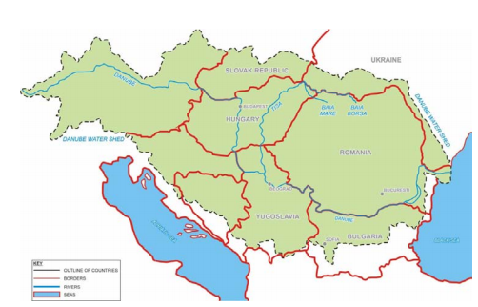
- Zinc-14.5mg/l

Figure 4: Contaminated rivers and streams (Prieto, 2014)
The water pH levels changed from the chemical reactions taking place due to the high levels of cyanide in the wastewater (5 years after the cynaide spill, 2005)

5.2 Effects on social and economic life
Approximately 80% of all fish in the Tisza River died and all varieties of fish were affected; they had up to 2.6mg of cyanide per kg of weight. It wasn’t just fish that was affected, up to 60% of plankton was killed and there was considerable damage to the fauna which subsequently had detrimental effects on birds and carnivores (Prieto, 2014).
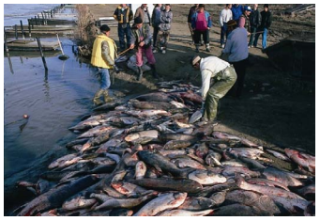

Figure 5: Dead fish as a result of the spill (Baia Mare Gold Mine Cyanide Spill: Causes, Impacts and Liability, 2000)
The estimated loss within the fishing industry is USD 5,839,000 and this equates to 1,241 toxic dead fish, and luckily only one fisherman’s company was affected by it (Prieto, 2014). The heavy metals persist in the environment and due to bioaccumulation are in various living organisms (The Cyanide Spill at Baia Mare, Romania, n.d.).
The accident in Baia Mare is reiterated within talks of future mining facility plans as authorities are looking to prevent such disaster from happening again. They are also looking to improve the amount of discharge leaving tailing dams and hope to get discharge figures as close to 0% as possible with modern technology (The Cyanide Spill at Baia Mare, Romania, n.d.).

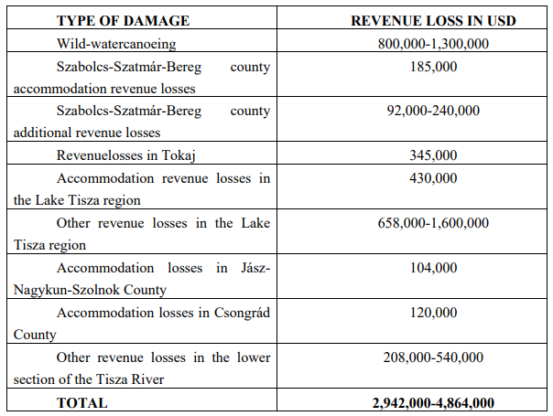
Figure 6: Table showing some of the losses due to the disaster (Prieto, 2014)

6. Conclusion
Nineteen years ago this disaster happened and its affects are still found within the environment and it is considered one of the worst environmental disasters since Chernobyl (17 years of legacy, 2017). However, thanks to this disaster key stakeholders developed codes of best practices within the mining industry and now this International Cyanide Management Code emphasizes the need to use proven/reliable methods within the industry (17 years of legacy, 2017). This also outlines how companies can sample, measure, detect and quantify the amount of chemicals and heavy metals within the wastewater with the expectation that such disasters do no reoccur (17 years of legacy, 2017).

7. References
Baia Mare. (2019, February 23). Retrieved from wikipedia: https://en.wikipedia.org/wiki/Baia_Mare
Baia Mare Gold Mine Cyanide Spill: Causes, Impacts and Liability. (2000, April 12). Retrieved from reliefweb.int: https://reliefweb.int/report/hungary/baia-mare-gold-mine-cyanide-spill-causes-impacts-and-liability
baia mare population . (2018). Retrieved from population city: http://population.city/romania/baia-mare/
Center, T. R. (2000, June). The Cyanide Spill at Baia Mare, Romania. Retrieved from archive.rec.org: http://archive.rec.org/REC/Publications/CyanideSpill/ENGCyanide.pdf
Kamrun. (2015, march 25). Case Study: Baia Mare Cyanide spill. Retrieved from blog.nus.edu.sg: http://blog.nus.edu.sg/kamrun123/2015/03/23/case-study-the-baia-mare-cyanide-spill/
Morcovescu, S. (2019). Map of the Maramures County. Retrieved from ResearchGate: https://www.researchgate.net/figure/The-map-of-the-Maramures-County_fig1_265925769
Prieto, N. P. (2014, October). Application to Aurul Tailing Pond in Baia Mare. Retrieved from oa.upm.es: http://oa.upm.es/32788/1/PFC_Natalia_Perez_Postigo_Prieto.pdf
Reasons the Dam failed. (2000). Retrieved from baiamare-romania.blogspot.com: http://baiamare-romania.blogspot.com/p/dam-structure.html
Safe Tailings Dam Construction. (2001, September 21). Retrieved from ec.europa.eu: http://ec.europa.eu/environment/waste/mining/pdf/mining_dams_seminar.pdf
Tailings Dam. (2019, April 25). Retrieved from https://en.wikipedia.org/wiki/Tailings_dam
The Cyanide Spill at Baia Mare, Romania. (n.d.). Retrieved from archive.rec.org: http://archive.rec.org/REC/Publications/CyanideSpill/ENGCyanide.pdf
UNEP/OCHA ASSESSMENT MISSION. (2000, March). Retrieved from reliefweb.int: https://reliefweb.int/sites/reliefweb.int/files/resources/43CD1D010F030359C12568CD00635880-baiamare.pdf

