Module Name: Managing Enterprise in the 21st Century
Module Code: BMSW4006

Business Plan
“Baby Fasho”

Student Name: Iuliana Margareta Muntean
Student ID: 2030029
Lecturer : Zainab Atta

Executive Summary
The business plan is about a clothing retail store for kids. It is a private limited company with five different partners. The business produce and sell good quality and sustainable clothes for babies that they will feel comfortable and stylish wearing. The name of the clothing shop is “Baby Fasho” and the tagline of the business is “Make your baby happy with comfort”. A market analysis has been conducted to gather knowledge about how this business is doing in the market. For the marketing strategy, a marketing mix has been analyzed as well. The shop’s goal is to produce sustainable products that can restrain from harming the environment. In addition, the financial analysis is done according to the past data of the market. However, the shop is having an exit plan ready so that if anything goes wrong, it can exit the market without huge losses.
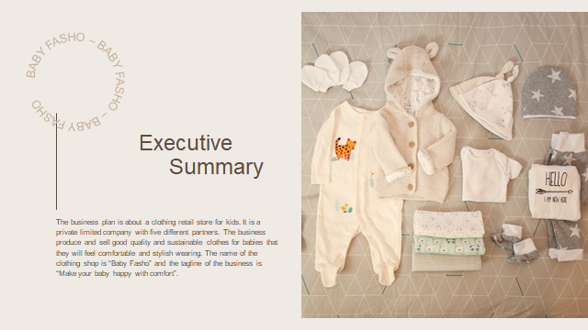

The Company
A business plan specifies how a company's operations and management will be carried out. The business plan outlines the clothing shop's business description, as well as the market and demand for baby clothes, the steps that are taken to maintain the shop, how to use technology for growth, how to set up the right management for the organization's operations, and how to prepare the necessary funds.
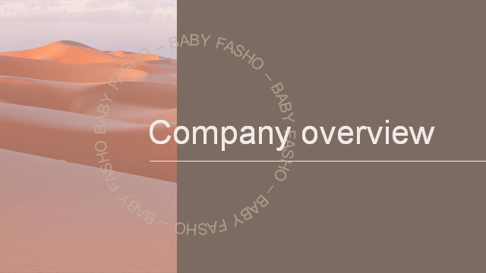

Company Profile
The company is privately held because the five business partners and investors are the proprietors . The business partners each own an equal share of the company, and the investors receive revenue or dividends from the company, as well as other perks. The partners are running the business, and marketing methods are created to reach out to more clients and spread the word about the shop.
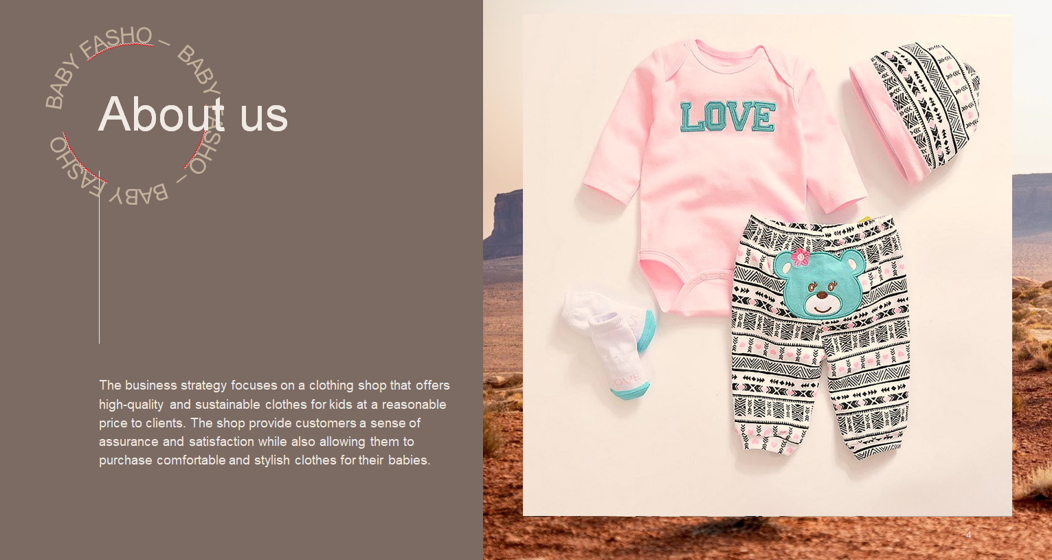

The business strategy focuses on a shop that offers high-quality and sustainable clothes for kids at a reasonable price to clients. The shop's name "Baby Fasho" provide customers a sense of assurance and satisfaction while also allowing them to purchase comfortable yet stylish clothes for their babies at a reasonable price. The shop's name expresses happiness and the products of this shop aspire to make its tiny consumers feel happy. "Make your baby happy with comfort" the shop's tagline, encapsulates the happiness that the clothing shop is providing to its clients with sustainability and high quality. The company's motto show the concept it represents as well as the level of assurance it gives to its customers.
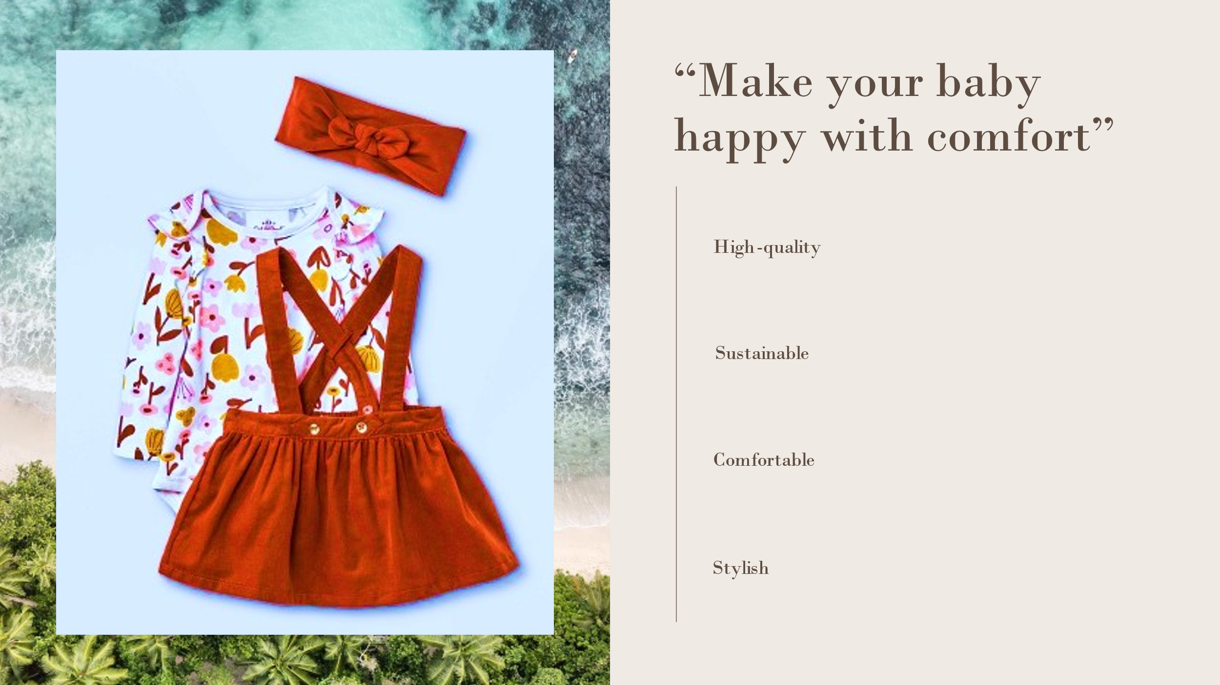

The company's objective is to serve the most comfortable clothes for babies so that it can have the customers' first priority to come to the shop whenever they are in need of clothes for their babies. The company's other objective is to provide sustainability so that the company can assure that they are contributing to the environment and it may generate more income by attracting customers who are fond of sustainability. The costs of the clothes vary according to the quality and the product lines are available in a variety of sizes for buyers to pick from. The store is located in the center of London, which make it easier to cater to the target market, as people's hectic lives need them to have the essentials for their baby always available to them. “Baby Fasho”also include baby accessories that customers need regularly sides such as shoes, socks, bennies, and travel bags.
The materials for clothes are purchased directly from the suppliers, which assist to decrease the company's costs while also ensuring that the products are made with great care at the factory so that they will be of good quality.
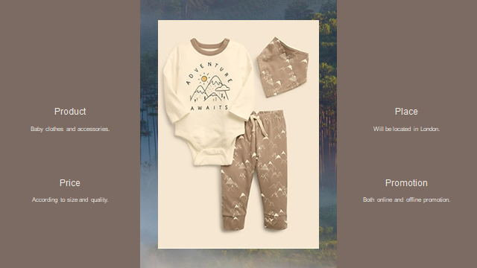

Price
The cost of clothes and accessories depends on the size and quality. The product are divided into six sizes: newborn, one-year-old, two-year-old, three-year-old, four-to-five-year-old, six-to-eight-year-old; customers are able to choose any size according to their baby's age, and the price is dependent on the clothing type, size, and quality. Offering high-quality products at a lower price help the shop to build a loyal customer base in a short period and ensure that customers return to the clothing shop regularly.

References
Armstrong, G., Kotler, P. and Opresnik, M., 2019. Marketing. 8th ed. Harlow, United Kingdom: Pearson Education, Limited.
Cahill, D., 2012. Lifestyle Market Segmentation. 4th ed. Hoboken: Routledge, Taylor and Francis.
Hawkes, N., 2012. UK sets out to measure happiness alongside GDP. BMJ, 341(nov26 2), pp.c6824-c6824.
Ortiz, R., 2015. Promotion. 4th ed. Alexandria, VA: Alexander Street Press.
Wedel, M. and Kamakura, W., 2013. Market segmentation. 6th ed. Boston, Mass: Kluwer Acad. Publ.

