BMBM7001:

Designing, Delivering and Evaluating Learning

and Development Provision

By: Amanda Glanville
Student number: 1810229
Word Count: 3840

Executive Summary
Following the recent global pandemic, this report outlines a significant learning need that exists within Hywel Dda University Health Board (HDUHB). A new Management Skills Programme (MSP) was identified as a result of assessing both internal and external factors, recognising that managers now need a new set of skills in order to manage remote teams, build trust and deal with a fatigued workforce. This report highlights the identified need, focusses on a fully accessible management training programme and highlights the need for different people management techniques as a result of the pandemic. It recognises the additional focus of moving to a new HR Disrupted EACH model, where Employees are treated as Adults, Consumers and Humans (Adams, 2017) with less focus on policies and more focus on people.

This report identifies why HDUHB need to invest in Learning and Development (L&D) and outlines different perspectives of learning theory, which increase the return of investment of learning interventions. With contemporary methods of learning, this report identifies the need for the Management Skills Programme to consider adult learning theory and how using multiple learning interventions creates a greater learning experience.

Finally, the report considers the cost of implementing the identified management skills programme and highlights the risks of non-implementation by the Health Board, impacting staff morale, wellbeing and the risk of attrition of both staff and management. The report outlines recommendations in relation to the implementation of the programme, using contemporary evidence-based research, which will support the highly effective management skills programme. An action plan summarises key steps to implementation, as well as a breakdown of the costs and identifies key stakeholders, benefits and risks to the organisation.

Contents

Executive Summary 2
Contents 4
Glossary of Terms 6
1.0 Introduction 7
2.0 Literature Review 8
2.1 Analysis of Internal and External Factors 8
2.1.1 External factors 9
2.1.2 Summary of internal factors 11
2.2 Why invest in L&D? 11
2.3 Why a MSP is critical? 12
2.4 Learning Needs Analysis (LNA) 14
2.5 Designing the learning programme 15
2.5.1 AGES Model 16
2.5.2 Bloom’s Taxonomy 17
2.5.3 Memory and Retention 18
2.5.4 Learning Styles 19
2.6 Adult Learning Theories 20
2.6.1 Andragogy 21
2.6.2 Self Directed Learning (SDL) 22
2.6.3 Transformational Learning 22
2.6.4 Experiential Learning Cycle 23
2.6.5 Project based learning 24
2.6.6 Action learning 24
2.7 Evaluating learning 25
3.0 Conclusion 27
4.0 Recommendations 28
5.0 Appendix 37
5.1 Appendix 1 – PESTLE Analysis 37
5.2 Appendix 2 - SWOT Analysis 38
5.3 Appendix 3 – Management Skills Programme Action Plan 39
5.4 Appendix 4 - Suggested Outline 41
5.5 Appendix 5 – Content to consider (Resource or Course) 42

Glossary of Terms

EACH | Employees as Adults, Consumers, Humans
HDUHB | Hywel Dda University Health Board
L&D | Learning and Development
LMS | Learning Management System
LNA  MPP | Learning Needs Analysis  Managers Passport Programme
MSP | Management Skills Programme
NHS | National Health Service
PMSP | People Management Skills Programme
ROI | Return on Investment
VUCA | Volatile, Uncertain, Complex and Ambiguous

1.0 Introduction

HDUHB is one of seven Welsh NHS organisations, supporting healthcare needs of Carmarthenshire, Ceredigion and Pembrokeshire, employing around 11,000 staff. Despite investing in the growth of the L&D function, budgets to access accredited learning or external courses has reduced, putting greater pressure on delivering training internally using existing resources. With 40% of organisations stating that L&D strategies are linked to business strategy (Brassey et al, 2020), HDUHB recognise its importance, with strategic objectives more aligned. HDUHB recognise the need to evaluate L&D opportunities and consider how to improve accessibility to training.

The impact of Covid-19 will be seen globally for decades, impacted the health and well-being of the NHS workforce. HDUHB responded by employing 1,800 temporary staff, alongside support of the army and volunteers. L&D were forced to cease all non-clinical/non-urgent training, focussing all resources to supporting the population. Covid-19 has significantly impacted L&D within HDUHB, mirroring trends across the UK (CIPD, 2021a). Restructuring of the workforce function pre-pandemic began a critical review of the L&D function and Covid-19 has re-evaluated future delivery models, considering new approaches.

L&D prior to Covid-19 focussed predominantly on compliance, mandatory training and role competence. External training developed individuals through apprenticeship funding and FE courses. Other externally funded training courses were identified by departments, legislation, NHS compliance or digital skills.

L&D adopted new ways of working, delivering virtually where possible to reduce risk. This created challenges as employees lacked skills and confidence, impacting self-esteem and vulnerability, mirroring research conducted by the CIPD. It also removed autonomy for L&D practitioners, having to deliver virtually (CIPD, 2021a).

This report aims to identify the external and internal factors impacting L&D within HDUHB. Using a PESTLE and SWOT analysis, results will identify a learning need. Once identified, this report will use evidence-based research to consider the most effective method of addressing this learning intervention. Consideration will be given to emerging trends, including adult learning theory, contemporary research and changing perspectives of learning. This report will consider evaluation methods to assess ROI.

The report will provide recommendations, identifying key stakeholders, financial investment, actions and timescales. Risks will be outlined associated with failing to provide these skills to support workforce needs.

2.0 Literature Review

2.1 Analysis of Internal and External Factors

External factors impact organisational learning, affecting business decisions and informing strategy (CIPD, 2017), with clear identification being imperative (Harrison and Auluck, 2014). Recognising this results in ongoing organisational change, increases pressure on L&D (Kiefer, et al., 2010). Covid-19 has increased the impact of external forces identified through a PESTLE analysis (Political, Economic, Social, Technological, Legal, Environmental). Recognising that PESTLE has greater impact when used alongside a SWOT analysis (CIPD, 2020c), both tools were used.

The PESTLE (appendix 1) and SWOT (appendix 2) identify the Volatile, Uncertain, Complex and Ambiguous (VUCA) environment HDUHB operates, impacting strategic direction. The pandemic has changed the expectations of the workforce and a key learning intervention identified relates to management skills capabilities. Managers need the skills to focus on people management techniques, developing their skills to build new relationships through trust, build networks and manage remote teams.

2.1.1 External factors

The PESTLE outlines external factors where management skills learning intervention could reduce the impact, driven by the diverse workforce. National priorities for L&D include the need to support the management of remote teams, providing equitable access to learning through technology and upskilling digital skills of the workforce (CIPD, 2021a). Management capabilities are crucial in reducing the impact of the five trends shaping the future of work (Morgan, 2016) included below:
- Political: Political impact of Brexit has meant many overseas workers have left the UK. Non-urgent training was cancelled, creating backlogs and pressures to maintain Welsh Government compliance.
- Economic: HDUHB recognises skills shortages, and globalisation creates a greater talent pool, including overseas options. Mobility has accelerated, with an estimated 37% of HDUHB working remotely.
- Social: Millennials will form 75% of the workforce by 2025, driving a digital culture and sharing experiences. Expecting career development, 59% state they would leave if contemporary learning was not present. Millennials and Generation Z workers expect open and transparent leadership, where managers care about wellbeing, embracing a fully diverse and inclusive organisation (O'Boyle, 2021). New behaviours support a shift to contemporary learning, delivering learning at point of need (Shackleton-Jones, 2019). Workforce share experiences publicly, placing greater importance on workforce harmony and job satisfaction to attract and retain talent.
- Technology: Placing significant pressure on L&D, embracing virtual training where possible (Society for Human Resource Management, 2021). This relies on IT skills or equipment to deliver training and keep up (McLoed, 2020). Lack of digital skills to fulfil new and emerging roles impacts 63% of UK employees (CIPD, 2021b)
- Legal: Social distancing regulations meant facilities were insufficient, resulting in finding premises to on-board clinical workforce, creating financial challenges. HDUHB continue to struggle, looking at new premises, with little control over timescale.
- Environmental: The greatest external factor impacting L&D is Covid-19, increasing workload to onboard and train a multi-skilled workforce.

2.1.2 Summary of internal factors

HDUHB are embracing the HR Disrupted concept of people management. The EACH model, recognises Employees as Adults, Consumers and Humans. This moves away from parental relationships, less reliance of policies and greater shift to managing relationships. This new culture requires managers participation.

Lack of software creates anxiety in L&D, lacking tools to design and deliver sessions. This is a significant risk to designing learning programmes.

2.2 Why invest in L&D?

HDUHB have already aligned to organisational strategy to address performance gaps and were in an organisational learning space, focussing on improvement through increased understanding (CIPD, 2021d) (Fiol & Lyles, 1985). Led by the Executive Team, greater autonomy has shifted to a learning organisation, allowing innovation and autonomy (Senge, 1990).

Career development provides personal growth, recognised as a domain of employee wellbeing (CIPD, 2021). Younger workers expect career development, managers need to understand the attrition risk of not developing teams. 76% of Generation Z feel learning is key to a successful career (LinkedIn, 2021) and 87% of Millennials rate development as a reason for organisational choice. 93% left their last job due to lack of development (Gallup, 2016).

The HDUHB staff survey identifies only 33% felt they had time for learning (Quality Health, 2016), highlighting concerns as global research identifies that 93% of employees stay longer if developed (Vinikas, 2021).

2.3 Why a MSP is critical?

Managers are key to attracting and retaining talented employees (Buckingham, 2016). A MSP provides managers the skills to manage teams effectively. HDUHB recognises workplace learning opportunities for managers, through external programmes , however lacks equity between investment in leadership and management. Previous training was not accessible to managers under Band 6, focussing on traditional skills and teaching methods. Recognising that 76% of first line managers are appointed internally (Trac, 2021), this highlights an urgent training need. Where newly appointed managers cannot access training contributes to why 60% of new managers fail or underperform (Forbes, 2019). Poor management skills cost UK businesses £84 billion annually (OECD, 2021). Investing in management training significantly contributes to development of their teams and improves productivity (CIPD, 2020b).

The MSP is critical, recognising employees are anxious and exhausted (NHS Confederation, 2021). Management support is needed to combat the increase in clinical and non-clinical staff choosing to retire early. A recent survey concluded that 22% of nurses are considering leaving their profession as a result of the physical and mental strain caused by the pandemic (McKinsey, 2021a). This combined with only 34% of NHS Wales staff feel line managers shows interest in their well-being, 29% are unclear what is expected of them and 10% have been bullied or harassed by their line manager last year (NHS Wales, 2020). This recognises focus needs to be on compassionate leadership, social skills, emotional intelligence and building trust (McKinsey, 2021b).

The pandemic has seen significant increase in non-Covid related sickness, occupational health interventions, greater conflict, high pressure working conditions and fatigue. Grievance cases have increased by 8% disciplinaries remain constant, however appeals relating to line management behaviour has increased by 6% (ESR, 2021).

Supportive managers foster better mental health (Greenberg, et al., 2020). Work related mental-health is higher in the health sector than industry averages. In 2019/2020, 828,000 workers were affected by mental health, leading to 17.9 million sickness days (HSE, 2020). Since Covid-19, studies revealed 42% felt a decline in mental health (Greenwood & Krol, 2020). Due to relationships, 20% of employees don’t tell their manager they are stressed at work and less than 50% who are diagnosed with mental health issues tell their manager (CIPD, 2018).

The cost of attrition, low morale, absence, time spent dealing with grievances, disciplinaries and specialist support including Occupational Health demonstrate the cost of doing nothing exceeds the cost of the implementing the MSP. With many hard to fill vacancies, it demonstrates commitment needed to staff development promoting HDUHB as an employer of choice.

2.4 Learning Needs Analysis (LNA)

There is a requirement for HDUHB to agree the MSP content through LNA. Failure to do this comprehensively and risk of an extended time scale between the LNA and delivery of learning are two main factors determining success. Consisting of multiple levels, an LNA should include organisational, job and individual analysis (Boydell,1983), identifying work related learning needs of an organisation. Failure to complete this results in reduced performance output (Lancaster, 2020). Identification of individual learning needs can be through knowledge, skills or attitudes (KSA) (Stewart & Cureton, 2014).

Using the RAM (Relevance, Alignment, Measurement) framework (CIPD, 2021c), HDUHB need to identify how the MSP will meet new opportunities and challenges, relevant to L&D strategy and including stakeholders, aligning with the Workforce and OD Strategy, providing purpose and relevance. Finally calculating ROI, measuring impact, engagement and transfer of learning, should consider both qualitative and quantitative data (Stewart & Cureton, 2014). Data from exit interviews, appraisals, surveys, disciplinary and grievance data and service training requests will provide insight into individual and service needs.

With mandatory training being a KPI for L&D, consideration should be given to how learning interventions support compliance towards organisational policies, legal requirements and embed other learning (Stewart & Cureton, 2014). An example in HDUHB is the reluctance for senior staff, consultants and specialists to attend customer service training as perceived as a basic skill. Embedded into a management component, will increase attractive and support compliance.

2.5 Designing the learning programme

Learning is “a change in attitudes, knowledge or skill, which can be physical and overt, or can be intellectual or attitudinal” (Reynolds et al.,1997). Contemporary learning focusses on involvement as oppose to memory recall (Mehta, 2020).

Recognising that 70% of learning happens informally through questioning, work shadowing, applying new learning or skills, gaining feedback and working outside normal parameters (Cerasoli, et al., 2018), this suggest that to make us of this, HDUHB could allocate mentors as part of the MSP, maximising formal and informal learning. This supports the need for managers to perform from the beginning (Shackleton-Jones, 2019).

Learning through observing others, impersonating what they have observed can be achieved by peer mentoring or role play situations. Collective learning is carried out through teams, communities, networks and societies, whereas group learning refers to both formal and informal, virtual, planned or emergent learning (Sadler-Smith, 2006). This could be an opportunity to build management support networks as part of the MSP, drawing on cognitive and behavioural paradigms.

2.5.1 AGES Model

Neuroscientists identify that long-term learning requires Attention, Generation, Emotion and Spacing (Kiefer, et al., 2010). Classroom learning provides greater attention, recognising drawbacks of virtual learning and distractions from computers and external environments (Collins, 2019). Classrooms provide opportunities to connect, collaborate and learn from others (Jeffery, 2015). Contemporary research suggests classroom learning is outdated and resources need to replace unnecessary teaching, available at point of need (Shackleton-Jones, 2019). The disadvantage of focussing on resources is that not all will engage, recognising a need to carry out classroom learning (Collins, 2019).

Learning is effective when cognitive overload is avoided and varied techniques deployed, delivered in bitesize learning over a greater time period and where positive emotional experiences are provided. HDUHB have the opportunity to provide a MSP recognising that “learning is totally different to information delivery” (Collins, 2019). The Colin Rose model of accelerated learning (Rose, 1998) suggests firstly there is a need to motivate the mind creating a need to learn, use multiple senses, build on prior learning and provide meaning (Collins, 2019).

Learning occurs when information is contextualised, stimulating the brain by transforming it into a meaningful context. When is linked to emotion, deeper learning is achieved (Jaremka, et al., 2010). Fear or negative emotion provides deeper processing, creating memories (Collins, 2019). Providing opportunities to problem solve create skills to cope with change (Collins, 2019). The Affective Context Model suggest experiences aren’t remembered, but reactions allow processing of thoughts, supporting learning (Shackleton-Jones, 2019).

2.5.2 Bloom’s Taxonomy

The diverse audience for the MSP needs to consider Blooms Taxonomy (Anderson, et al., 2001), recognising differing levels of knowledge and application (figure 1). It recognises the three domains of learning stimulating higher levels of thinking. Knowledge in the cognitive domain, skills in the psychomotor domain and attitudes in the affective domain (Blooms, 1956). Although criticism suggests that learning has progressed and not hierarchical, Blooms Taxonomy remains one of the most used, and therefore the MSP needs to recognise managers will need to master lower levels, prior to being able to analyse, evaluate and create. The MSP will be for managers of all levels to embed a new culture of people management and therefore staged intervention may need consideration.
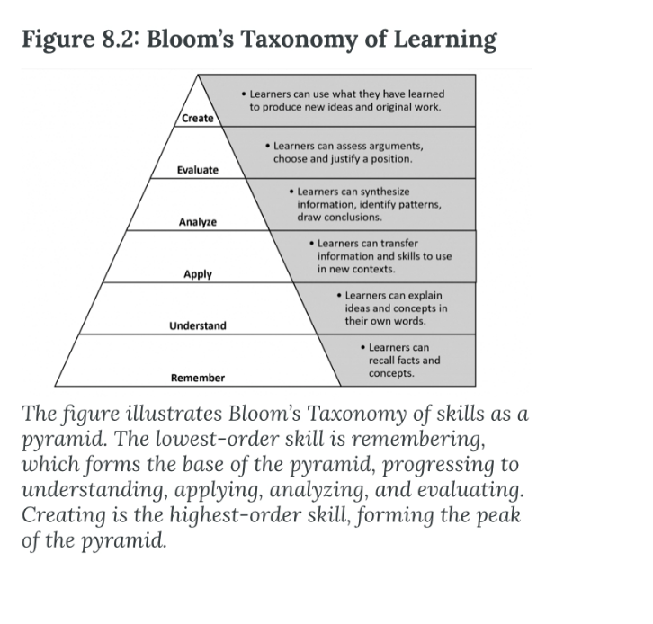
Figure 1- Bloom's Taxonomy (Anderson, et al., 2001)

2.5.3 Memory and Retention

The Ebbinghaus Forgetting Curve 1885 (figure 2) outlines retention over time. Nowadays, the human brain relies on technology to provide recall, contributing to lack of memory recall (Shrestha, 2017).
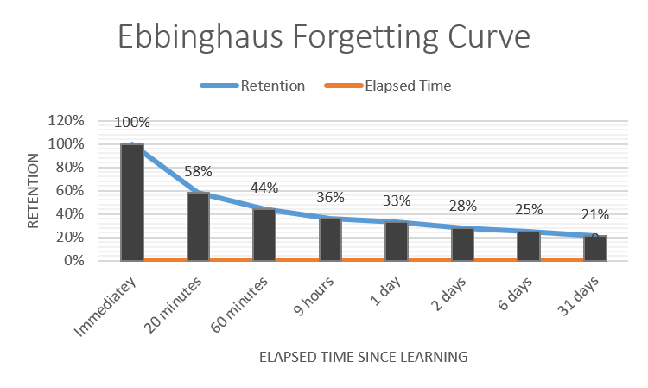
Figure 2 - Ebbinghaus Forgetting Curve (1885)

With 65% of classroom learning forgotten within 3 weeks (Shackleton-Jones, 2019), bitesize learning supports greater long-term learning and spacing repetition creates deeper learning (figure 3) and creating testing opportunities builds on long term memory (Kiefer, et al., 2010).

Figure 3 - Spaced repetition and expansion of memory (Kiefer, et al., 2010)

2.5.4 Learning Styles

VARK learning styles are assessed through questionnaire, labelling individuals as Visual, Aural, Kinaesthetic or Read/Write learners (figure 5), allowing facilitators to tailor sessions to meet individual learning styles (VARK, 2018). Neuroscientists question validity as information is processed by different parts of the brain (Lethaby, 2017). CIPD research also suggests oversimplification of the complexities of learning, impacting learner’s perception of learning strategies (CIPD, 2021). Varying learning techniques raises dopamine levels, increasing attention. Neuroscientists suggest multi-modal learning develops new learning preferences (Collins, 2019). HDUHB need to design learning interventions that provide learning to suit the multi-modal approach. 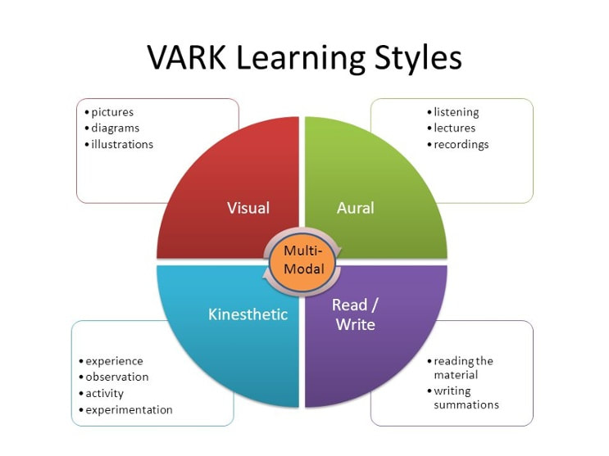
Figure 4 - VARK Learning Styles

2.6 Adult Learning Theories

Adults learn differently, are usually more self motivated, experienced and able to problem solve through self direction (Stewart & Cureton, 2014). Adult learning theories allow L&D to create relevant experiences (Valamis, 2020). Constructivism is about self-directed learning and self-discovery, teachers guide learning, activating prior knowledge and considering new ideas and concepts, chunking together topics. This could include design thinking, a human centred problem-solving approach, putting yourself in their shoes. This model recognises the need to transition to different phases, connecting with hearts and minds (CIPD, 2021d).

2.6.1 Andragogy

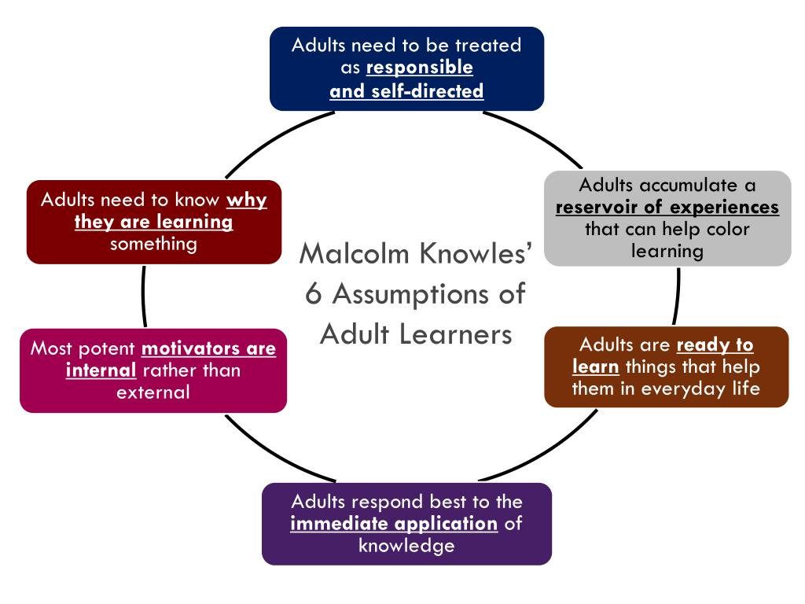
Popularised by Malcolm Knowles (1960), andragogy is learner centred, defined as the art and science of teaching adults. Six principles were developed (figure 5).

Figure 5 - Assumptions of Adult Learners (Knowles, 1968)

HDUHB can adopt best practice, co-designing the content with managers, meeting both learner and employer’s needs.

Being self-directed, learners work autonomously, and facilitators provide a collaborative environment to aid learning. The MSP should be task centred, allow self-reflection and promote research to explore subject matter, allowing them to relate this to their own work. Role play, case studies, simulation and self-evaluation are techniques to engage adult learners, however the reason must be clear and relevant (Stewart & Cureton, 2014).

Flipped classroom teaching is another contemporary method, where information transfer happens outside, bringing the homework concept within the classroom, learning through applying knowledge already gained prior through resources (Ozan & Adile, 2015). This supports blended learning, recognises the learners need to accept responsibility for learning prior to attendance.

2.6.2 Self Directed Learning (SDL)

SDL builds on andragogy, focussing on self-management, the learner identifies goals, finds resources, creates a plan and evaluates, suiting blended learning. Seeking our support, SDL relies on being in control and ideal for black and white answers, where the facilitator becomes a guide. SDL is less effective where low self-esteem or academic ability exists. Timescales and outcomes may vary considerably. Using a behaviouristic paradigm, HDUHB could use negative or positive reinforcement, modifying behaviour through digital learning badges, praise or certificates (Hauser, 2019).

2.6.3 Transformational Learning

Effective for personal and professional growth, this theory suggests facilitators introduce concepts and challenges perspectives. Learners are provided dilemmas to adjust beliefs. Involving behaviour and thoughts, the learning will be remembered (Stewart & Cureton, 2014). Focussing on evaluation and application, transformational learning links to the higher end of Blooms’s Taxonomy, needing a supportive space and trust to challenge (Valamis, 2020). HDUHB could challenging topics like unconscious bias, supporting the BAME issues identified in the press during the pandemic.

2.6.4 Experiential Learning Cycle

Within the constructivist paradigm, the experiential learning cycle (figure 6) is learner centred, requiring active involvement, reflection, conceptualisation and the ability use the knowledge gained (Kolb & Kolb, 2017). HDUHB could consider giving managers, challenges, asking to reflect and engage in research and hands-on activities to identify a solution.

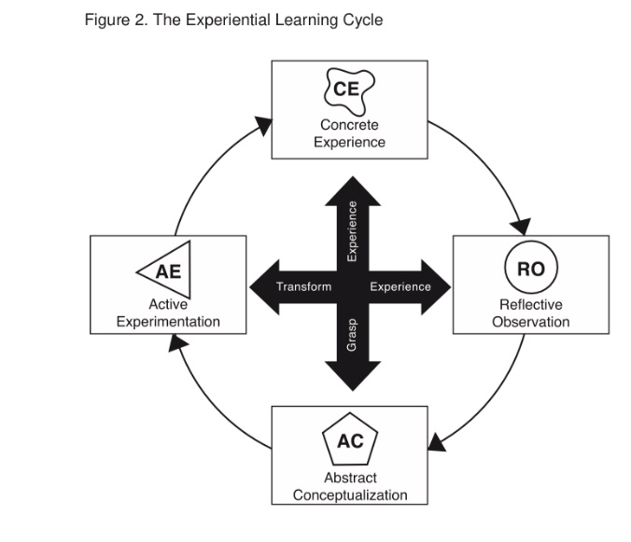
Figure 6 - Experiential Learning Cycle (Kolb & Kolb, 2017)

2.6.5 Project based learning

This learning intervention focusses on active exploration of issues, best suited to long-term projects and process improvement (Valamis, 2020). It requires the use of critical thinking, enquiry and problem solving (Stewart & Cureton, 2014). Recognising that HDUHB managers are fatigued, creating additional pressure through projects may increase fatigue, consideration should be given to appropriateness of this learning intervention recognising challenges.

2.6.6 Action learning

Action learning is structured, focusses on questioning, leading to insights about problems or issues and can often reduce the need for help from external sources (Faller, et al., 2020). It requires participation, providing immediate solutions or ideas. Effective within time constraints, suggesting 30 minutes per topic (Sadler-Smith, 2006), it requires limited resources, but only effective in groups between 4-7 participants (Hauser, 2019). The facilitator provides an issue or asks a person in the group to bring a problem/issue. HDUHB could consider this as a way of building peer support networks, whilst providing support to fatigued managers.

2.7 Evaluating learning

HDUHB need to consider evaluating the impact of learning as a key area for improvement to drive organisational performance (CIPD, 2021d). Kirkpatrick's Four-Level Training Evaluation Model 1959 (updated 1993) is one of many models providing differing levels of evaluation (figure 6).

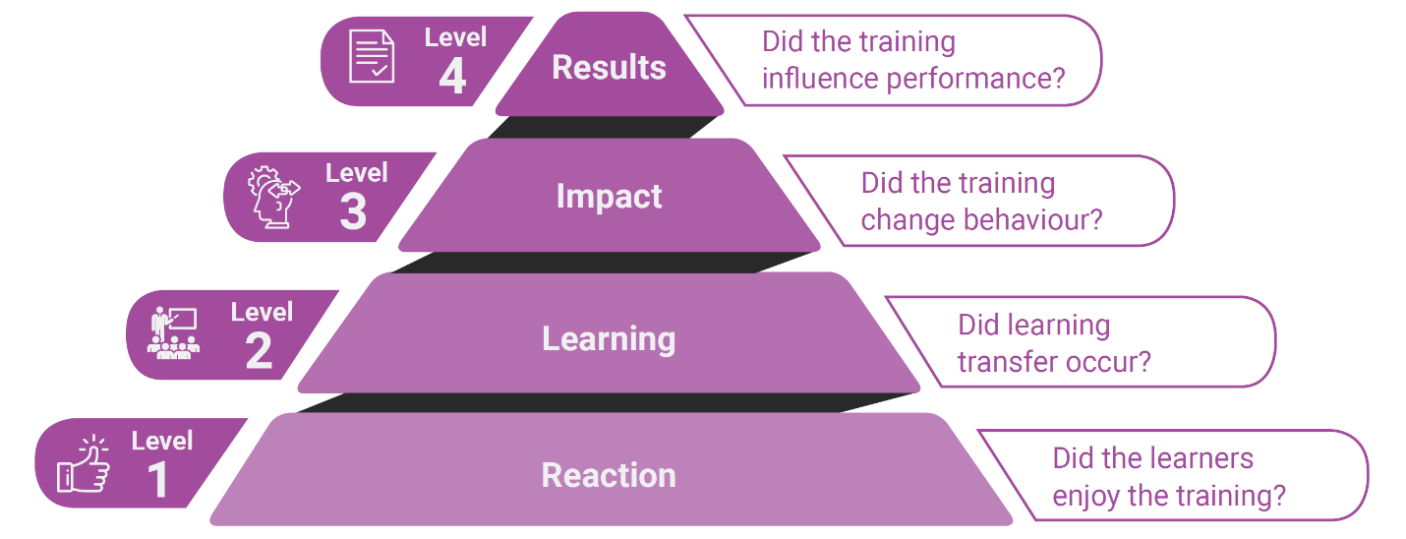
Figure 7 - Kirkpatrick's Four-Level Training Evaluation Model
Level 1 reactions can be captured through observing body language, and conducting surveys, level 2 through learning objectives and feedback from the workplace, level 3 through appraisal and follow up and level 4 through ROI. ROI is the most difficult to quantify although some of the KPI’s may include less sickness, increased productivity, less complaints, less grievances (CIPD, 2021c). The Kirkpatrick model provides a planning framework for evaluation, refining objectives and increasing its effectiveness (Mindtools, 2019).
HDUHB need to consider (CIPD, 2021d):
- What metrics, KPI’s and behaviour may improve and what timescales?
- Frequency of evaluation (once, periodically)?
- Evaluate spent and how to demonstrate the impact?

Prior to attending the learning, it is important to assess knowledge, skills and attitudes, creating the ability to measure distance travelled. This could be through interviews, questionnaires or online tools. (Mindtools, 2019)

2.8 Ethical considerations and Governance

As a public concern, HDUHB require stakeholder’s agreement from the executive board, unions and governance committees. L&D need engagement with managers as the ethos is to co-create programmes using focus groups, consultation, ensuring cross-sectional representation (Stewart & Cureton, 2014).

Other ethical considerations when designing and delivering include the development of inclusive materials (Equality Act, 2010) and training accessible to all. As there is a waiting list for management training, consideration need to be given as to how training will be rolled out fairly.

Conclusion

Extensive research underpins how adults learn, making it difficult to agree definitive practices that suit every learner. Contemporary research demonstrates the need to provide a variety of learning opportunities and resources, accessible to all, recognising the impact of changing demographics.

In order to build relationships and create a network, there is a benefit to a blended learning approach, with resources provide a multisensory learning and the ability to access learning at a time and pace that suits the learner. Research may conflict but provides an awareness and understanding of motivations needed. Approaches need to vary. A humanistic approach is needed for people management, work and when considering completion of pre-course learning, a behaviourist theory may suit through reward for completion of self-directed study. HDUHB should consider initial face to bootcamp that focusses on people management, creating motivation and trust.

There is a clear need to create a MSP that has a contemporary approach. This should be modular and therefore where prior knowledge exists, a self-reflection or evaluation will mean that attendance or completion is not mandatory. It needs to cater for differing levels of managers. Programme needs to provide pre-recorded webinars, checklists and resources as well as podcasts of interviews that will support learning.

Recommendations

The Executive Team are asked to support delivery of a new MSP, with a focus on the rest and recovery of their workforce, health and wellbeing, mental health and healthy relationship. Although a detailed action plan has been written (appendix 3), the main recommendations are outlined below:
- Due to differing skills/experience, recognise a need for a two-tier approach to MSP
  - Settling into management
  - Managing with confidence
Despite the tiered approach, all resources should be made accessible to all managers/aspiring managers for personal growth.
- Approve proposed delivery model for the tier 1 MSP (appendix 4) accepting the content of the report to incorporate adult learning theory, focussed on learning through reflection and emotion. This will be over six months, supporting memory recall, embedding the people management change culture.
- Fund the set-up cost of £20,702 and reoccurring annual cost of £92,838, based on a two-day face to face model outlined in the action plan
- Perform a LNA using the RAM framework, informing full content of the MSP.
- Recognise the value of resources, not courses to allow self-directed learning, providing a Digital Business Partner to support to the L&D digital transformation, creating a focus group to agree resource content.
- HDUHB need to agree an evaluation model from the outset, consider aims and objectives and return on investment. This should be a factor to overall programme sign off.
- Support the use of weekly short learning bursts to support (4-minute videos), reinforcing key management tips.
- Agree action plan (appendix 3) for implementation.

6.0 Appendix

6.1 Appendix 1 – PESTLE Analysis
Political | Economic | Social/Cultural
- Well-being of Future Generations (Wales) Act - Requiring managers to empower their staff and create an autonomous culture  - Brexit – Loss of European Funding for L&D Initiatives. Reduction on L&D Budget as a result in reduction in funding  - Apprenticeship Levy – Changes in funding rules impacting upskilling our workforce | - Impact of pandemic on staff attrition, impacting experience of managers  - Nursing shortages – The need to consider alternative roles to bridge the gap  - Joint posts and development opportunities can result in management turnover  - COVID-19 has resulted in burn out, with increased early retirement . | - Changing expectations of staff including split shifts to work around childcare, home working, lockdowns, shielding  - Employees choosing HDUHB based of development opportunities, creating pressure to create programmes supporting career progression  - Lack of registered/skilled staff, placing greater pressure on grow your own models  - Social media pressure  - Need to provide patients with Welsh speaking staff to support care  - Younger workforce expects ongoing development
Technological | Legal | Environmental
- External ESR system under review  - Greater choice of learning management systems,  - Increased mobility creates greater need for digital skills  - Increased capabilities of virtual training , new technology to design and deliver interactive learning  - Covid-19 resulting in increased workforce, greater demand for training | - Managers need greater awareness of how legislation impact their role (Welsh Language,  - Digital Accessibility Standards  - Equality Act – Equal access to training and development  - Health and Safety at Work, resulting in training needing to be delivered virtually  - Social Distance guidelines, resulting in classrooms not being suitable as training venues. | - Covid-19 and the need to consider different approaches to classroom delivery  - Virtual meetings, resulting in reduced carbon footprint  - Recycling pressure, with a greater force to reduce paper use.  - No space for staff numbers forcing home working  - H&S consideration – social distancing

6.2 Appendix 2 - SWOT Analysis

Strengths | Weaknesses
- Increased investment in Learning & Development  - Robust processes for compliance (EAGLE framework)  - Strong coaching network  - Staff continue to retire and return  - A committed workforce  - Investment in IT equipment & Software  - Creation of the Digital Transformation Strategy, including a learning platform  - Leading the way in the All Wales Clinical Induction Programme | - Absence rates  - Lack of registered workforce - nurses, doctors, therapists  - Lack of clarity around home working rules,  - Training to support the digital investment  - Increase in disciplinary and grievances cases in the 2020/2021 year, increasing by 12% year on year  - Current management training programme unsustainable due to three year waiting list and need to follow contemporary learning methods. In addition, not accessible to all as only available for Band 6 and above.  - No training provision for employability skills to support career progression  - Lack of career pathways in non-clinical routes, creating lack of parity of esteem  - No training provision for newly appointment managers or aspiring managers
Opportunities | Threats
- Telehealth and the advancement of digital care, providing employees development  - Digital transformation - providing greater collaboration  - Agile working, providing greater flexibility for workforce  - NHS branding, employer of choice  - New models of healthcare  - Digital investment to provide a new learning platform to create a new learning culture.  - New culture - Lucy Adams - New Health Board vision | - Legal Action due to grievance or disciplinary action – incorrect processes  - Fatigue of workforce  - IT infrastructure capabilities and lack of training  - Significant temporary workforce, having competed a shortened training programme as a result of Covid-19  - Greater continued reliance of temporary workforce including Agency/Bank  - Workforce retiring  - Increased demand of Occupational Health and Mental health due to pandemic  - Lack of management training opportunities

6.3 Appendix 3 – Management Skills Programme Action Plan
Action Plan Management Skills Training
Develop a programme to co-design with our staff at every stage a management skills programme that embody our values, addressing equitable access to training
PROJECT SCOPE | This objective focusses on the design, delivery and evaluation of a Management Skills Development Programme, recognising that not all employees follow the same path or require the same number of resources, but they should be exposed to the range of opportunities and experiences to manage their individual needs and preferences. This will be achieved using the ADDIE model, a dynamic, flexible guideline for building effective training and performance programmes (Analysis, Design, Development, Implementation and Evaluation).  Consideration will include:  - Being accessible to line managers at all levels, including first line, middle and senior managers  - Focussing on embedding values, equality and inclusiveness  - Including elements of the new planned customer service offer, understanding how management skills impact customer service.  - Using various teaching & learning strategies  - Identification of a robust recording and reporting mechanism to ensure compliance  - The progression to leadership training and talent pool as part of the Organisational Development initiatives  - Evaluation of the effectiveness of the management programme and measurement of the employee experience  - Drive the new learning culture, empowering our new workforce to own their own career.  - Use evidence-based research of best practice, with clear objectives.  - Be co-designed with managers at all levels based on previous experience, reflection of their own management skills and identification of skills needs of the managers they line manage.  - Develop an exemplary bilingual management programme  - Recognises the ‘point of need’ of when management information, training and resources are needed  - Provide bitesize learning opportunities to encourage participation |  |  | - A well-designed management development programme will improve relationships between managers and their team,  - Reduction in grievances and use of formal HR processes  - Greater understanding of organisations values and cultures as these will be embedded throughout the programme.  - Increased retention, resulting in lower recruitment costs and damage to the organisations employer brand.  - Development will create an environment where managers will feel supported, creating increase employee commitment and job satisfaction.  - A L&D function, with an excellent reputation for delivering high quality programmes.  - Recognition within the sector and local partners in relation to delivering an exemplary management programme.  - Opportunities for existing workforce to embrace the new learning culture, accessing innovative and inclusive programmes, which promote learning.  - Demonstrate the commitment of the Health Board to offer bilingual training opportunities.  - Attract local talent as a result of the development opportunities for our managers at all levels.  - Managers will have the opportunity to network with other managers, creating informal support networks.  - Promote the coaching management style and increase resilience in our managers |  |  |  |  |  | OUTCOME
PROJECT SCOPE |  |  |  | KEY PHASE |  |  | BY WHOM | Cost/Resources | WHEN | KEY DATES & DELIVERABLES
PROJECT SCOPE |  |  |  | - Recruit a B6 Management Skills Tutor and a B4 Workforce Development Advisor to design, deliver a administratively manage the MSP |  |  | Head of Workforce Education & Development | B6 = 44,226  B4 = 29,472  Per Annum = £73,698  Including On-costs/Top of Scale | 30/07/21 | KEY DATES & DELIVERABLES
PROJECT SCOPE |  |  |  | - Evidence based research - Identify sector leaders for management training, from both local, national and international organisations and CIPD, identifying best practice. This will also include feedback from previous management passport programme and inform a Learning Needs Analysis |  |  | Workforce Development Manager | Resources included in salary of B6 & B4 costings | 30/08/21 | KEY DATES & DELIVERABLES
PROJECT SCOPE |  |  |  | - Identify common areas requiring HRM intervention, identifying common themes. This could include feedback from Relationship Managers, Trade Union involvement, grievances, service feedback, exit interviews, staff surveys, etc. |  |  | Workforce Development Manager | Resources included in salary of B6 & B4 costings. Access to data. | 30/08/21 | KEY DATES & DELIVERABLES
PROJECT SCOPE |  |  |  | - Perform a Management Learning Needs Analysis, sourcing feedback from managers of all levels. Identify skills gaps, their own training needs and includes an analysis specific to middle and senior managers to assess the skills gaps of their direct reports who line manage. This should also include gathering information from grievance, disciplinaries, exit interviews and feedback from the previous management skills programme. |  |  | Workforce Development Manager | Resources included in salary of B6 & B4 costings. Use of MS Forms for LNA, Costing 4 Hrs B8a Data Analytics £128 | 30/09/21 | KEY DATES & DELIVERABLES
PROJECT SCOPE |  |  |  | - Create resource platform using SharePoint to house resources. This should include podcasts, checklists, videos and factsheets, providing point of need training aids. |  |  | Digital Learning Coordinator/ Workforce Development Manager | Covered through current establishment costs. Consideration for Business Partner Support from Digital Services. | 30/10/21 | KEY DATES & DELIVERABLES
PROJECT SCOPE |  |  |  | - Set up a focus group to agree content of resources/face to face and virtual delivery and build on the proposed tier 1 deliver model. This should focus on adult learning theories, considering a blended learning experience and contemporary learning. This includes multi-modal learning styles, six principles of andragogy, task-centred activities, role-play, case studies, simulation, action learning and self-evaluation. |  |  | Workforce Development Manager | Resources included in salary of B6 & B4 costings. Use of LNA feedback. | 30/10/21 | KEY DATES & DELIVERABLES
PROJECT SCOPE |  |  |  | - Create a suite of management training modules to support the development of managers whilst developing a full manager training package. This should link with specialist departments to provide ongoing skills development including recruitment, staff experience and OD. These learning opportunities should include a range of resources, courses, learning bursts, podcasts and action learning, recognising learning styles and providing equitable access to learning anytime, anyplace, anywhere!  This should have a focus on Rest, Recovery and People Management, embedding the EACH Model. |  |  | Workforce Development Manager | Resources included in salary of B6 & B4 costings.  Additional specialist wages, this ill only be present design of resources. Estimated cost 14 services x 37.5 hrs @B8a = £16,000 | 31/11/21 | KEY DATES & DELIVERABLES
PROJECT GOVERNANCE | Responsible Officers:  Executive Lead: Lisa Gostling, Director of W&OD  Strategic Lead: Amanda Glanville, Head of Workforce Education & Development  Delivery Lead: Workforce Development Manager  Programme oversight through:  Workforce Education & Development Project Plan  Governance through:  WF&OD Core Leadership Team  Delivery through:  Workforce Education & Development Team consisting of Head of Workforce Education & Development, Learning & Development Manager, Workforce Development Manager, Learning & Development Coordinator, Digital Learning Coordinator and Digital Learning Officer. Contribution will also be sources from colleagues within Workforce & OD, Senior leaders, IT Services, line managers and TU representatives. |  |  | - Based on the Kirkpatrick's Four-Level Training Evaluation Model. Identify aims and objectives of the programme and how evaluation will be achieved. This should include Return on Investment (ROI), considering both qualitative and quantitative data. |  |  | Workforce Development Manager | Resources included in salary of B6 & B4 costings. |  | KEY DATES & DELIVERABLES
PROJECT GOVERNANCE |  |  |  | - Agree Management Skills Programme brand and launch, along with the priority areas to roll out to all managers, promoting through OD Relationship Managers, Induction and Learning & Development, ‘making every contact count’ |  |  | Workforce Development Manager | Marketing budget £4575 (Includes short Film) | 01/11/21
PROJECT GOVERNANCE |  |  |  | - Agree programme roll out including dates, content, venues and delegated delivery responsibilities. |  |  | Workforce Development Manager | Resources included in salary of B6 & B4 costings.  Conference suite £125  Refreshments £40  Lunches 22 x £7 = £154  Based on 20 delegates  = £319 per day x 2 days  = £638 Per course  Maximum 30 courses per year £19,140 | 20/11/21
PROJECT GOVERNANCE |  |  |  | - Review and evaluation of management programme and identify improvements. All modules need to have greater participant and management evaluation. This should include immediate, short term and medium-term feedback, identifying improvements in KPI’s including Staff survey, exit interviews, PADR compliance. |  |  | Learning and Development Manager | Resources included in salary of B6 & B4 costings. Access to data. | End of Cohort 2
 |  | Description |  | Likelihood | Impact | Score | Mitigating Actions
RISKS |  | Delay in recruiting Workforce Development Manager, |  | Medium | Lack of progress |  | Interim scoping can be started by the Education & Development Officers to reduce risk
 |  | Evidence based research - Lack of engagement from organisations and Training Needs analysis |  | Medium | Lack of evidence to inform content |  | Wider scope of research both locally, nationally and internationally. Use of relationship managers to promote benefits of participation
 |  | Lack of digital learning platform to host new management skills programme |  | Low | Less engaging sessions |  | Scoping underway to identify digital learning requirements and platforms
 |  | Lack of tutors to deliver a bilingual training experience |  | Low | Lack of bilingual training |  | Appointment of a Welsh speaking tutor to provide bilingual learning opportunities
 |  | Lack of resource to cope with the demand for the programme |  | High | Accessibility of programme |  | Use of specialists to deliver sessions and greater consideration of videos, resources, etc
COMMUNICATE/ COLLABORATE |  | Who With |  | How |  |  | When
 |  | Health Board Partnership Forum |  | Strategic updates as required |  |  | Bi-monthly
 |  | Local Partnership Forum |  | Updates from working groups |  |  | Bi-monthly
 |  | PPPAC |  | Update from People Group |  |  | Bi-monthly
 |  | People Group |  | Update from Partnership Forum |  |  | Bi-monthly
 |  | Organisational Development Team |  | Team meetings – Identifying clear link to management skills training and leadership development, providing streamlined development of our workforce |  |  | Monthly Catch Up and involvement in key phases
 |  | Specialist services – including Recruitment, Risk, Finance, staff experience, workforce planning, IT |  | Collaboration to create a management skills programme, providing managers a range of skills |  |  | As and when needed – Monthly during initial phases
 |  | Set up Costs £20,702
 |  | Annual reoccurring costs £92,838

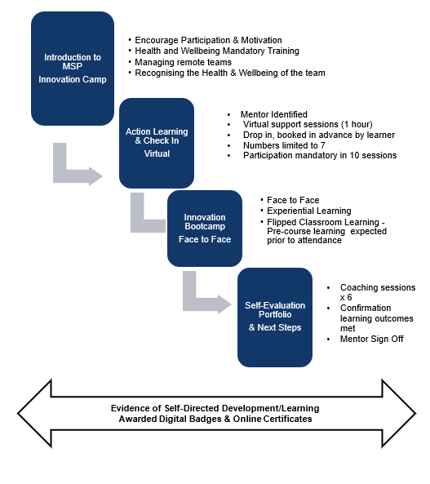
6.4 Appendix 4 - Suggested Outline

Management Skills programme draft outline – Phase 1

6.5 Appendix 5 – Content to consider (resource or course)

 | Level 1/Bronze | Level 2/Silver | Level 3/ Gold
Recruitment | Getting the right people  Values based recruitment  Interview skills | Shortlisting  Writing a JD  TRAC Training | Recruitment planning  Approval of roles
Onboarding | Meeting the team  Induction toolkit  Team cohesion | Settling in  Onboarding preparation
Finance | Understanding Oracle  Managing budgets  Understanding procurement  Expenses | Understanding Oracle Part 2  Essential skills for budget holders  Procurement | Using QlikView  Tendering
Team  Development | Building trust  Teambuilding skills  Understanding your team  Conducting Meetings  Motivating  Influencing  Remembering patients | Coaching skills  Transactional Analysis  Reward  Workforce planning  TNAs | Building high performance teams  Learning approaches
Team Support | Emotional Supporting  Supporting Wellbeing  Building resilience  Making yourself available
Developing You | Behaviours (Top 10 leadership skills)  Recognising leadership styles  Persona/Self-awareness  Values  Project Planning  Decision Making  Stepping back | Delegating Effectively  Emotional Intelligence
Driving change | Principles of driving change  Getting buy in |  | OCP
Health & Safety | Working Safely  Safe teamworking  Risk Assessments | Datix
Managing Performance | The role and importance of PADRs  PADR checklist  Managing poor performance  1-1's | Disciplinary & Grievance
Managing Attendance | Sickness  Holidays  Leave  Flexible Working  Training / Study Leave
Compliance | Organisation  Assessment and Interpretation  Using ESR  Workforce information | Record Keeping
Communication | Communicating effectively  Listening skills  Conducting meetings  Creating dialogue and checking understanding  Virtual Communication  Face to Face Communication  Understanding the importance of non-verbal communication  Responding effectively  Resolving conflict  Interviewing  Giving and receiving feedback | Recognising barriers to good communication  Presentation skills  Effective networking | Public speaking  Presenting at board
Project  Management | Action planning | Principles of Project Management
Workforce  Planning | Introduction to Workforce Planning  Top ten strategic documents for managers  Six Step Methodology  Team Around the Patient  Transforming Clinical Services | Role Design

