Name: Lucian – Mihai Ilie
Student Number: 2126669
__________________________________________________________

WORKSHEET 2 – TESTING (Tiles)

- Original code:

import math

print("Tile Calculator")
print("Each tile = 20cm x 20cm\n")

while True:
try:
wall_width = float(input("Enter wall width (cm): "))
wall_height = float(input("Enter wall height (cm): "))

if wall_width <= 0 or wall_height <= 0:
print("Error: Dimensions must be positive numbers.\n")

except ValueError:
print("Error: Please enter a valid number.\n")

- Code Testing

For each test below (i – vii), run your code and enter the values provided. Present a screenshot of the of what happened when the programme ran. Did the programme behave correctly or did it do something unexpected, and if so, why?

Input:

- Enter dimensions of wall: Width 40 Length 45
- Enter dimensions of wall: Width 100000 Length 200000
- Enter dimensions of wall: Width -16 Length -20

Logic:
- Enter dimensions of wall: Width 80 Length 80. The result should be 16 tiles
- Enter dimension of wall: Width 40 Length 45. The result should be 6 tiles
- Enter dimensions of wall: Width 85 Length 90. The result should be 25 tiles.
- Enter dimensions of wall: Width 15 Length 15. The result should be 1 tile.

Note: If you decided to include logic within your program to allow a tile to be cut such that 2 pieces can be used from the same tile where possible (therefore reducing the total number of tiles required), your results may differ from the above. In this case, explain your logic as part of your answer. If you did not, consider adding this logic to your final code.

Fill in a box for each test above. You should present 7 separate boxes, 1 for each test. (Note: the first box is provided as a template)

Test: Input
I. Enter dimensions: Width 40 Length 45

Screenshot(s) of output:
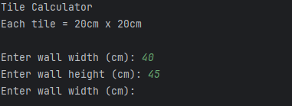
Result: Did the programme behave as expected ie syntactically and logically correct?
NO, the programme accepted the input values (40 and 45) correctly, but it did not calculate or display the number of tiles required. After entering the dimensions, nothing happened because the code does not contain any logic to compute or print results. This is a logical error—the program is incomplete.

Test: Input
ii. Enter dimensions of wall: Width 100000 Length 200000
Screenshot(s) of output:
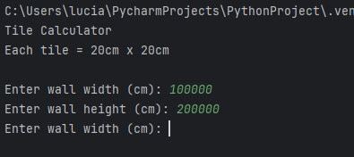
Result: Did the programme behave as expected ie syntactically and logically correct?
NO, the programme accepted the very large input values (100000 and 200000) correctly, but it did not calculate or display the number of tiles required. After entering the dimensions, nothing happened because the program does not contain any logic to process the input or print results. This is a logical error—it behaves the same way as Test i.

Test: Input
iii. Enter dimensions of wall: Width -16 Length -20
Screenshot(s) of output:
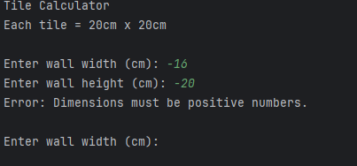
Result: Did the programme behave as expected ie syntactically and logically correct?
YES, the programme detected that the input values (–16 and –20) were not positive and correctly displayed the error message: “Dimensions must be positive numbers.” The code’s validation worked as intended and stopped the user from entering invalid measurements.

Test: Logic
iv. Enter dimensions of wall: Width 80 Length 80. The result should be 16 tiles
Screenshot(s) of output:
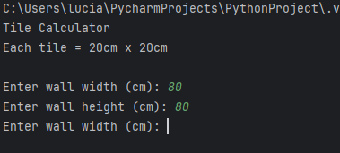
Result: Did the programme behave as expected ie syntactically and logically correct?
NO, the programme accepted the valid input values (80 and 80) but did not calculate or display the number of tiles required. The expected result for these dimensions is 16 tiles, but the code does not contain any logic to perform this calculation or print the outcome. As a result, the programme produced no output and failed the logical test.

Test: Logic
V. Enter dimension of wall: Width 40 Length 45. The result should be 6 tiles

Screenshot(s) of output:
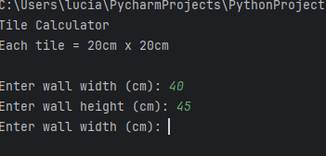
Result: Did the programme behave as expected ie syntactically and logically correct?
NO, the programme accepted the input values (40 and 45) correctly, but it did not calculate or display the number of tiles required. According to the worksheet, the expected output is 6 tiles, but the programme does not include any logic to perform calculations or print the result. Because of this, nothing was displayed and the test failed logically

Test: Logic
Vi. Enter dimensions of wall: Width 85 Length 90. The result should be 25 tiles.
Screenshot(s) of output:
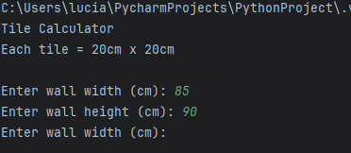
Result: Did the programme behave as expected ie syntactically and logically correct?
NO, the programme accepted the input values (85 and 90) correctly, but it did not calculate or display the number of tiles required. The worksheet states that the expected output is 25 tiles, but the programme does not include any logic to perform this calculation or print the result. Because the program contains no tile-calculation code, nothing was displayed, and the test failed logically.

Test: Logic
vii. Enter dimensions of wall: Width 15 Length 15. The result should be 1 tile
Screenshot(s) of output:
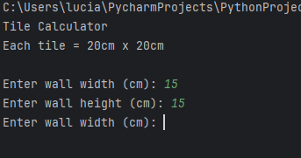
Result: Did the programme behave as expected ie syntactically and logically correct?
NO, the programme accepted the input values (15 and 15) correctly, but it did not calculate or display the number of tiles required. The expected result for these dimensions is 1 tile, but the programme contains no logic to perform the calculation or show the output. As a result, nothing was displayed and the test failed logically.

- Consider the results of the above tests and revisit your code in order to solve any problems discovered at the testing phase. (Note: you may not be able to solve all of them, but solve as many as you can.)

Paste your revised code here:

import math
print("Tile Calculator")
print("Each tile = 20 cm x 20 cm\n")
tileSizeCm = 20.0
while True:
try:
wallWidth = float(input("Enter wall width (cm): ").strip())
wallLength = float(input("Enter wall length (cm): ").strip())
except ValueError:
print("Error: Please enter a valid number.\n")
continue
if wallWidth <= 0 or wallLength <= 0:
print("Error: Dimensions must be positive numbers.\n")
continue
tilesAcross = math.ceil(wallWidth / tileSizeCm)
tilesDown = math.ceil(wallLength / tileSizeCm)
totalTiles = tilesAcross * tilesDown
wallArea = wallWidth * wallLength
tileArea = tileSizeCm * tileSizeCm
print("\n--- RESULT ---")
print(f"Wall size: {wallWidth:.2f} cm × {wallLength:.2f} cm (area {wallArea:.0f} cm²)")
print(f"Tile size: {tileSizeCm:.0f} cm × {tileSizeCm:.0f} cm (area {tileArea:.0f} cm²)")
print(f"Tiles across (width): ceil({wallWidth:.2f} / {tileSizeCm:.0f}) = {tilesAcross}")
print(f"Tiles down (length): ceil({wallLength:.2f} / {tileSizeCm:.0f}) = {tilesDown}")
print(f"Total tiles required = {tilesAcross} × {tilesDown} = {totalTiles}\n")
break

