University of Wales Trinity St. David

Website Specification Report
Internet Technology & Security (ACCA4018)

Joseph Ross
1702760
28/12/2019

Table of Contents

1. Introduction 2
1.1 Abstract 2
2. Requirements 2
3. Implementation 2
3.1 Screenshots 2
3.2 Validation 5
4. Evaluation 6
4.1 Website Usability 6
4.2 Accessibility 6
4.3 Search Engine Optimisation 7
5. Website Evaluation 7
5.1 Usefulness 7
5.2 SEO 8
5.3 Accessibility 8
6. Conclusion 8
7. References 9

1. Introduction
  - 1.1 Abstract
This report has been written to provide an evaluation for a website made for a small, local hair salon. The website has been designed to provide customers with the ability to book appointments online, as well as find up-to-date pricing for in-store services. The design has been created to suit the business’s branding as well as their primary customer base by providing a simple layout that presents all the relevant information someone may require before deciding to use the salon.
2. Requirements
This website has been created for two local business owners that require a website for their hair salon. The primary purpose for this website is to provide an online presence for the business that enables both existing and new customers to find relevant information about the salon while also providing the ability to advertise future offers, display pricing and allow for online bookings. The website has been designed to appeal more to the primarily female audience that the business deals with.

3. Implementation
  - 3.1 Screenshots
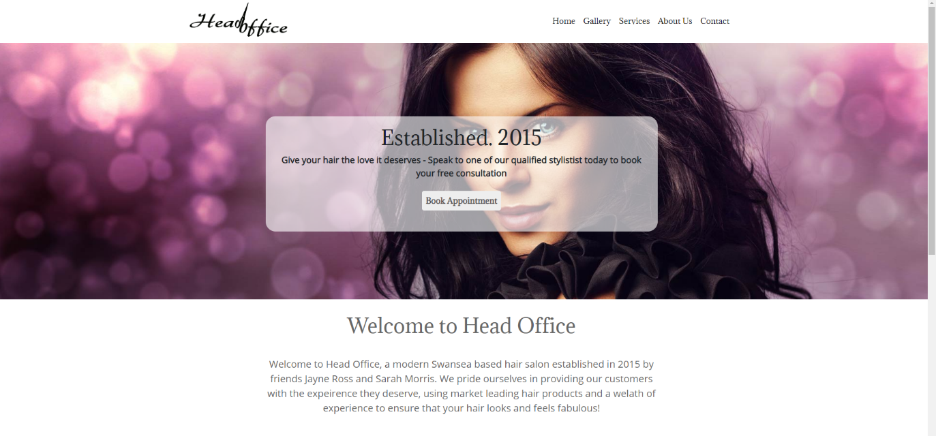
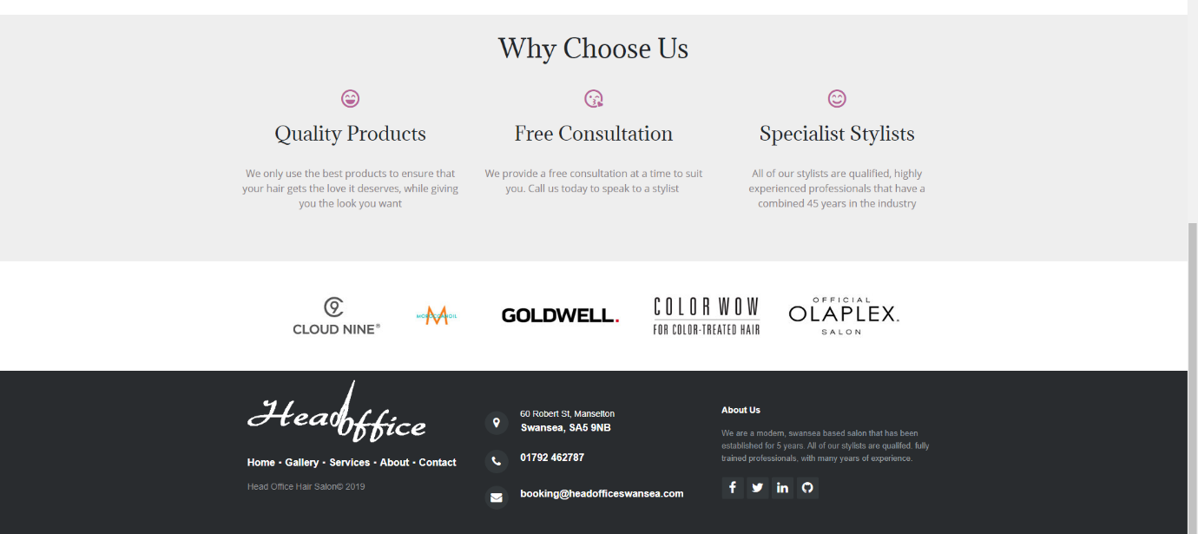

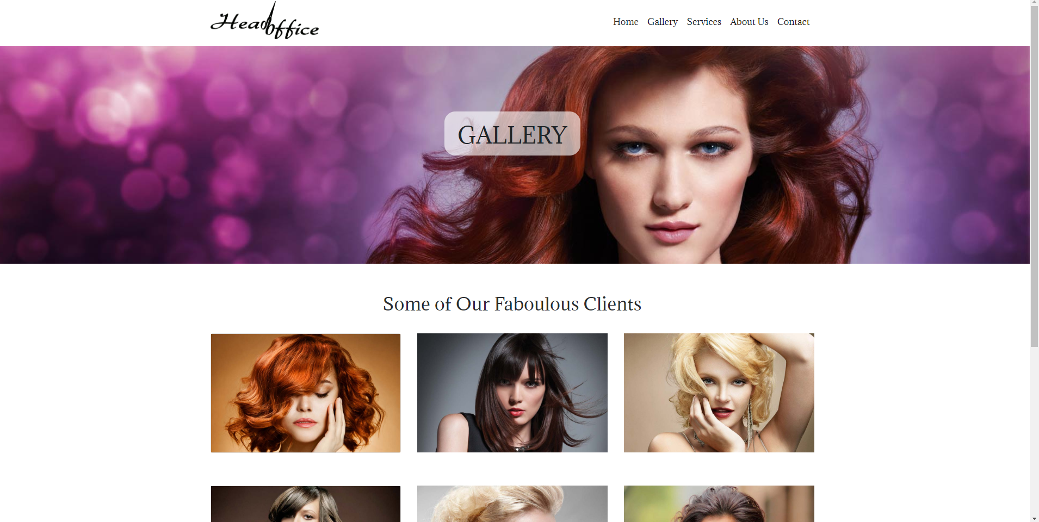
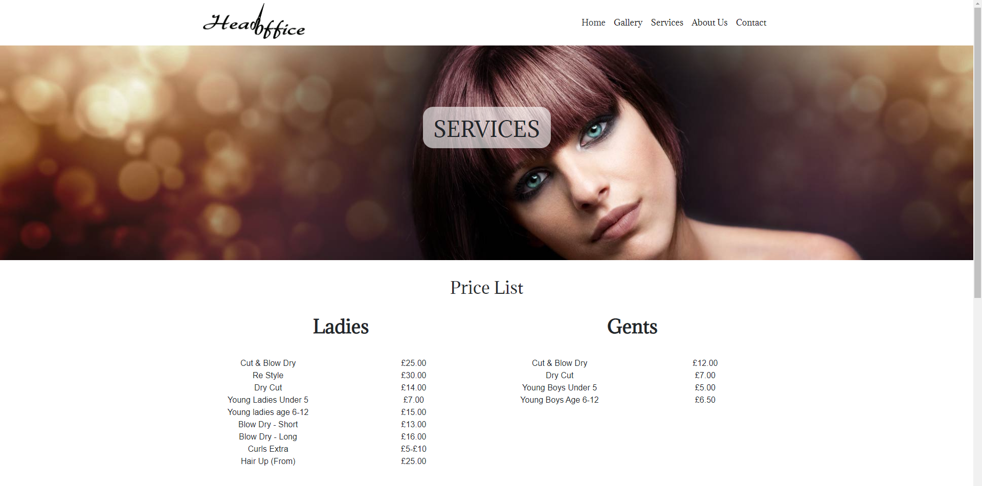
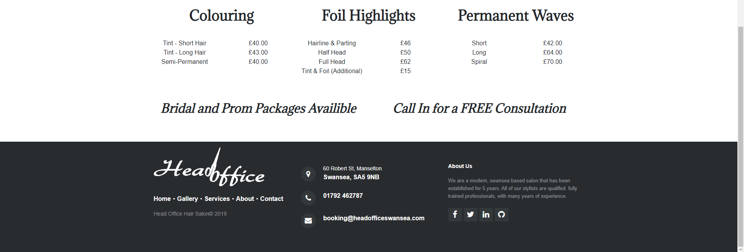

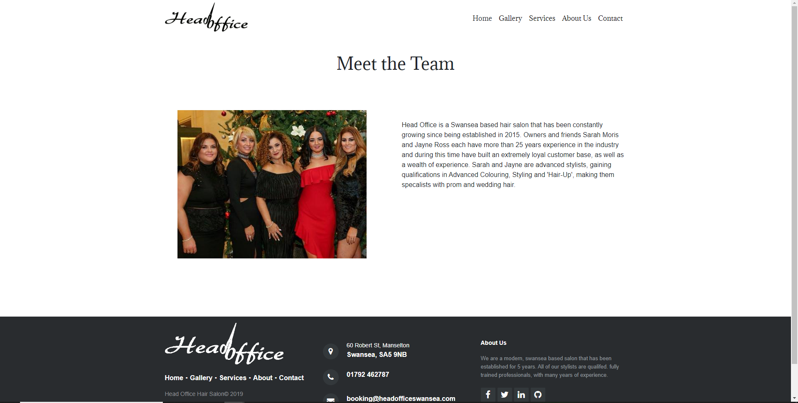
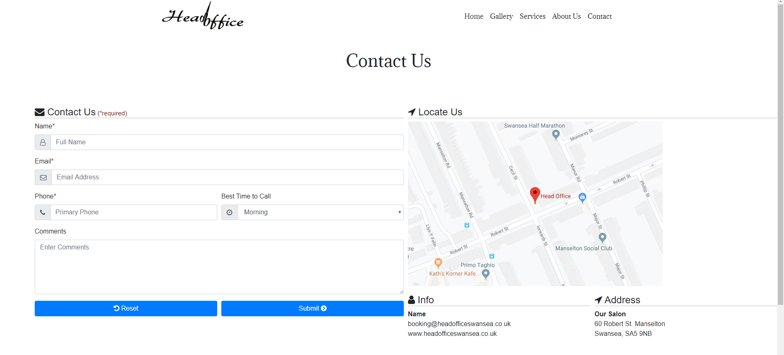

  - 3.2 Validation
The following errors were displayed while validating the HTML:
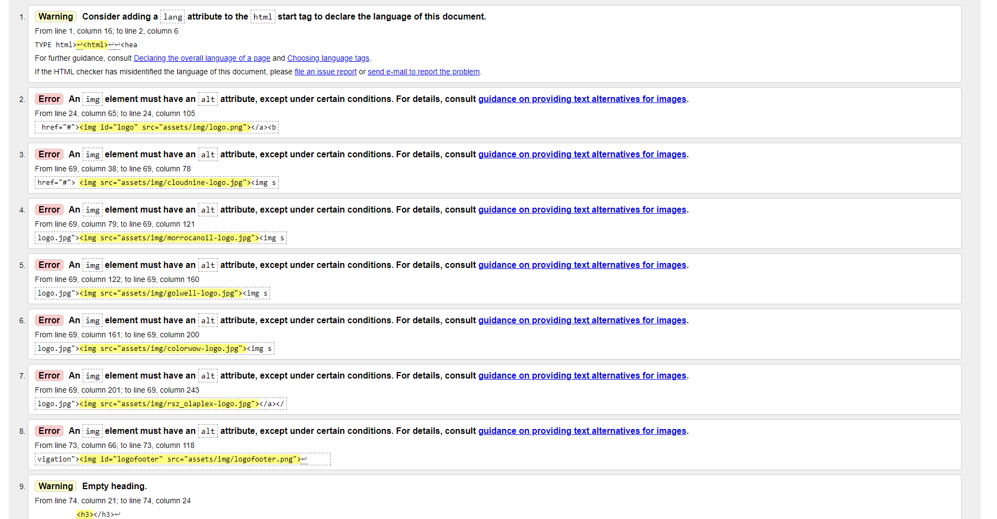
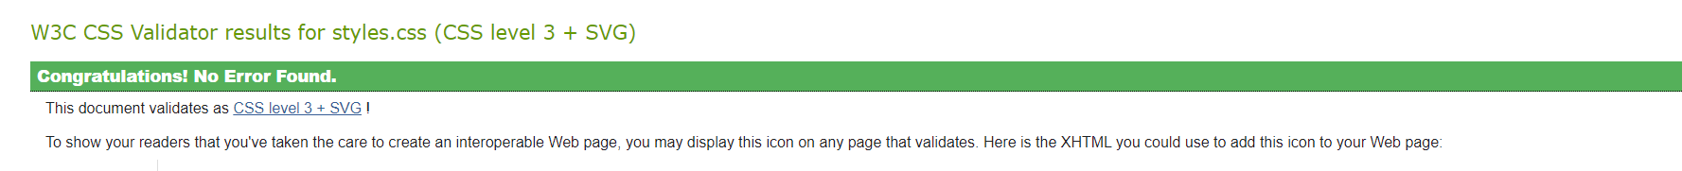

Warning 1 – The language tag was added to the HTML of the index.
Warning 2 – The empty <h3> tag was removed from the HTML of the index and padding was added to the footer CSS code to provide spacing below the footer logo.
Error – An ‘alt’ tag was added to the corresponding HTML of the image source for each of the images that was missing one on the index page. There were no errors in the styles.css file.
4. Evaluation
  - 4.1 Website Usability
Website usability refers to how easy the website is to use for the visitor as well as the level of convenience the website can provide. Website usability heavily involves the development of the UX (user experience) design which defines how easy it will be for the user to effectively and efficiently achieve their end objective, resulting in improved user satisfaction and loyalty. The emotional experience the user has when visiting a website is important and establishing an initial connection is crucial when trying to pro-long a visitor’s stay on a website or when selling a product through e-commerce. A website that’s usable improves ‘stickiness’ and increases revisit rates which eventually will stimulate an online purchase [1], and minimising the amount of visitors that leave a website without making a purchase or using a particular service should be a priority when considering the usability. The experience in which a user has should be as seamless as possible with the user being more-or-less guided through the process by providing an easy-to-use navigation bar and pages that flow into each other with relevant information.
In 2012 a study was performed on the usability of a website for college students. The study states that “a website is a university’s most visible resource and a reflection of what it has to offer” [2] and was conducted to analyse an opportunity to invest in a university website as a way to enhance the public face of the university and provide a platform for the student community. The study focussed on three points, improving the website’s engagement, generating more traffic, and making improvements based on the competitions’ websites. To summarise the findings, the study concluded that an updated interface design will be required to improve the website’s navigation, while also tailoring the student page on the website to the students’ unique requirements in order to increase traffic and popularity of the website
  - 4.2 Accessibility
Website accessibility involves not only making a website more appealing to use and more accessible, but it also provides people with disabilities with the ability to navigate and use a website equally. Providing better accessibility is an important part of designing a website and benefits both the user and the website owner(s), if more people can access a website then it will evidently allow for a larger customer base and/or more web traffic, as well as an increase in the amount of time people spend on the website. Web accessibility requirements can vary depending on what disability a person may have, for example people with low-vision will require larger font and better contrast, whereas colour-blind users will need colour-transmitted information turned into shades of grey [3]. Most of the features that relate to accessibility are built into the backend of a website and include things like better colour contrast, video captions, text to speech, alt text for images, and resizable easy to read text. These features aren’t just important for people with disabilities, but mostly everyone as they all come together to provide a more pleasurable user experience.
A study was carried out in 2018 that discussed the legal and ethical impacts of website accessibility. The study stresses the importance of website accessibility, explaining why it should be paramount for businesses to make their websites accessible to everyone, arguing that there aren’t enough legal requirements in place to push business owners to make the appropriate changes. The journal article states “it is paramount that business communication professionals become involved in website accessibility issues. An extensive search of the business communication journals revealed that this topic has largely been overlooked” [4], the study also found that not only corporate, but government websites also lack the characteristics of an accessible website, suggesting that there is an absence of ethics when considering the design of these websites as disabled people don’t make up the majority of web traffic.
  - 4.3 Search Engine Optimisation (SEO)
SEO is one of the most important things to consider when developing a website. SEO development in its entirety is not something that can be done straight away, and although immediate improvements can be made to a website, it will take time for those improvements to start working effectively before allowing a website to move up in a search engines rankings. When improving a website’s SEO, you are effectively defining how easy it is for search engines to be able to index your website and associate it with the appropriate search terms that relate to the purpose of the website, which ultimately increases its traffic. Better SEO will allow a website to rank higher in the search listings with the primary aim of reaching the top of the listings for specific search criteria, this is something that companies see as a major importance, and will get to the top either through marketing or organic SEO, which is the preferred method [5] that many use. SEO can be Improved by adding META titles and META descriptions to the backend of the website, adding appropriate keywords to the HTML and website content, and by adding alt tags to images.
A study released in 2013 was conducted to explore the economics of SEO and how it effects advertisers, consumers and search engines. The study found that consumers are highly affected by search engine marketing decisions that are made by website owners [6], however SEO as a whole is beneficially to consumers because they are given an advantage to view high-quality sites. The study also found that although SEO is an important and beneficial tool, the investment from advertisers in SEO and sponsored links has created a dilemma in how they need to allocate their budgets [6] which as a results has caused many of them to avoid over paying for pay-per-click views.
5. Website Evaluation
  - 5.1 Usefulness
The website has been designed with the audience in mind, providing relevant information that they would need to know, displayed so that it can be found and read with ease. The functionality of the website has been designed to be as simple as possible, with the relevant information being provided on each page, and five nav bar options linking to their corresponding pages that displays information the business considers to be the most crucial for clients to know. The website has been designed to suit the business’s primarily female clientele, displaying a consistent modern theme throughout the website as well as a font and colour scheme that compliments the business’s in-store and online branding. Professional HD quality images have also been used as part of the websites look to better suit the purpose of the website. The content provided is all relevant, especially if a new customer wants to consider using the salon in the future. The homepage displays logos of the products the business uses, as well as information with regards to stylist qualifications and experience which is found on both the ‘Home’ and ‘About Us’ page. The website would benefit from further improvements to the mobile view, most of the website is suitable for mobile devices but not all of it. It would be beneficial to add a ‘Testimonials’ section to either the homepage or as a separate tab. Another recommendation would be to change the static home banner to an interactive slider, displaying the same type of professional images that have text overlay containing product and service special offers. The last recommendation to improve the website in the future would be to add better SEO to the website. Adding more optimised on-page content would be beneficial, as well as multiple back-links and a Google Business ease the websites ranking.
  - 5.2 SEO
Here are the on-page SEO techniques that have been used on the website:
META Title – A META title was added into the head section of the webpage to display relevant keywords both in the search engine tab of the website, and in the search results. This will help with the organic growth of the website’s SEO.
META Description – A META description was added to the HTML which will appear on the search results page when people look for the website. This has been written to be between the recommended 50-160 characters in length and displays keywords relating to popular search terms.
Heading Tags – A variation of header tags have been used, mostly on the homepage and provide both structure for the user and structure for Google to better understand the webpage.
Keywords – Keywords have been input into both the backend of the website and the content. Some research was carried out into the most popular search terms relating to this website and were then integrating into some of the websites content, primarily on the ‘home’ page and ‘about us’ page. Some of these include ‘hairdressers Swansea’ and ‘hair stylists Swansea’, which were repeated in the body content, and added to the backend HTML.
  - 5.3 Accessibility
There are four main principles that make up a website’s accessibility, these are; perceivable, operable, understandable and robust. The website presents a simple layout and a few elements that make it more perceivable to the user, these would include the consistent use of headings and easy-to-read text, as well as alt-text that has been added to the images on the website. The website text can also be resized to suit the user. The website does not contain any moving banners, or flashing text, the easy-to-use navigation bar, combined with the large page titles allows the user to know exactly where they are on the website without getting lost. All these features combined make the website more operable. The website’s readability is quite good, but could admittedly be improved in places, such as on the home page body, where some text has been made a light grey colour to suit the design of the website. This may cause contrast issues for some users but is a feature that could easily be changed in the future. With regards to how robust the website is, there are no errors in the HTML of the homepage and the website should work seamlessly with assistive technology.
6. Conclusion
The website will be improved in the future in the areas discussed in the report, however in its current state it meets the basic requirements suggested by the company with regards to its design and the information it provides. The website’ mobile view will need to be improved on some of the pages, and additional changes can be made to further meet WCAG guidelines. Overall, the website presents good accessibility and provides some good on-page SEO enhancements.

7. References

[1] | K. A. K. Younghwa Lee, “Understanding of website usability: Specifying and measuring constructs and their relationships,” Decision Support Systems, vol. 52, no. 2, pp. 450-463, 2011.
[2] | F. M. Jean Snider, “Evaluating Web Usability,” Performance Improvement, vol. 51, no. 3, pp. 30-40, 2012.
[3] | B. P. X. Z. Stephanie Hackett, “A retrospective look at website accessibility over,” Behaviour & Information Technology, vol. 24, no. 6, pp. 407-417, 2007.
[4] | R. H. P. Zsuzsanna Bacsa Palmer, “Legal and Ethical Implications of Website Accessibility,” Business and Professional Communications Quarterly, vol. 8, no. 4, pp. 399-420, 2018.
[5] | U. Nursel Yalçın, “What is search engine optimization: SEO?,” Procedia - Social and Behavioral Sciences, vol. 9, pp. 487-493, 2010.
[6] | Z. K. Ron Berman, “The Role of Search Engine Optimization in Search Marketing,” Marketing Science, vol. 32, no. 4, pp. 644-651, 2013.

marking criteria and Student FEEDBACK

This section details the extent to which the assessment criteria are demonstrated by you, which in turn determines your mark. The marks available for each category of skill are shown. Lecturers will use the space provided to comment on the achievement of the task(s), including those areas in which you have performed well and areas that would benefit from development/improvement.

Common Assessment Criteria Applied (Assignment 1) | Marks available | Marks  awarded
1. Engagement with Literature Skills

Demonstrates very good engagement with relevant literature. A good discussion of the concepts with appropriate related research has been provided. (Grade mark: 80.00%) | 25 | 20
2. Knowledge and Understanding Skills

Demonstrates a generally, good understanding of the standards used to design and implement a website. As mentioned below, aim to improve your understanding of CSS styles and avoid using inline CSS styles. A good evaluation of the website based on the specified criteria has been provided, but I would have liked to see further evidence of tools used to support the evaluation of your website. (Grade mark: 75.00%) | 20 | 15
3. Cognitive and Intellectual Skills

4. Practical Application Skills

A good attempt featuring a simple website with well-thought-out content. There is, however, room for improvement and particularly in your use of CSS. You have also used inline styling (adding a style attribute to elements) on your pages and this is bad practice in web design. Your website also had different stylesheets for different sections of the page. Again, this is not good practice - see your report for additional comments. You must also specify an alt attribute for ALL images for accessibility - a lot of your images did not have an alt attribute. There were also some layout consistency issues and the layout of some pages for smaller screens needs to be revisited. Some other things to note: make your logo link to the home page as users expect this behaviour, open external links in a new tab, and a lot of the links on your site did not work - ensure all links are correctly linked to appropriate links and not to "#". (Grade mark: 64.00%) | 50 | 32
5. Transferable Skills for Life and Professional Practice

The report is of a good standard. See your report for additional suggested improvements. (Grade mark: 60.00%) | 5 | 3

Assignment Mark (Assessment marks are subject to ratification at the Exam Board. These comments and marks are to give feedback on module work and are for guidance only until they are confirmed. ) | Late Submission Penalties (tick if appropriate) |  | 70%
 | Up to 1 week late (40% Max) |  | 70%
 | Over 1 week late (0%) |  | 70%

