Digital Skills and Research Methods (BMSK4003_LON)
Tutor:

30 12 2018
Contents
- Introduction.......................................................................................................1
- Cloud storage ....................................................................................................2
- Web Conferencing..............................................................................................3
- Marketing on Instagram.....................................................................................4
- Social media accounts evidence..........................................................................5
- References..........................................................................................................6

Introduction
The Aim of this report is to evaluate how these two different technologies, cloud storage and web conferencing are effective in the workplace. Comparing two cloud storages providers Google drive and Amazon drive and for web conference comparing Gomeeting and Cisco WebEx and finally analysing the marketing benefits of Instagram in the workplace.
Cloud storage
Cloud storage is referred to as the online storage system for files. Harris (2018) mentioned that instead of keeping files in hard drive, flash drive, local hard drive, users can keep files online by using the cloud storage system.
There are several functionalities and reasons for using different cloud storage services. If any individual runs low on disk space in local hard drives, he or she can opt for cloud storage for extra storage. Using cloud storage enables a user to stream music online from anywhere, easy access and sharing files, accessing to work files, sharing videos, pictures, files from anywhere etc. Erl and Puttini, (2013) demonstrated that cloud storage functionalities also enable a user to keep a file secured by password protection and encryption.
As you work away from the office cloud storage gives you options like accessibility to multiple devices in case your computer at home is not working you can still access your files on your phone or tablet. This option is good in case you are sick or at home looking after your children but was working an important project, you can still have input into the project even if something did happen to your computer at home.
Another benefit of cloud storage is that you can store important information instead of having a filing cabinet system to store your documents saving you on space and paper with the encryption options your files are also more secure. Even when a server fails in your location, your stored files and applications could still easily be transferred to any available servers in another location.
There are some disadvantages about using cloud storage in terms of uploading a folder into a cloud storage service. In this way your file will be permanently moved to the cloud storage location from your original location. If you just drag and drop your file instead of copy and paste, your file will be removed from its original location. Therefore, if have not internet access you will not be able to change or access your original document. Cloud storage services have another issue with the allocated bandwidth from the internet service providers. Usually cloud storage services has specific bandwidth allowance. If your internet provider exceeds the limit of bandwidth, you will be charged additionally.
Another disadvantage could be the safety and privacy provision of the important data stored on remote servers, giving hackers a chance to steal your private information. TABLE 1. Cloud storage Google Drive Vs Amazon Cloud Drive products comparison. (BIDASARIA, 2018)
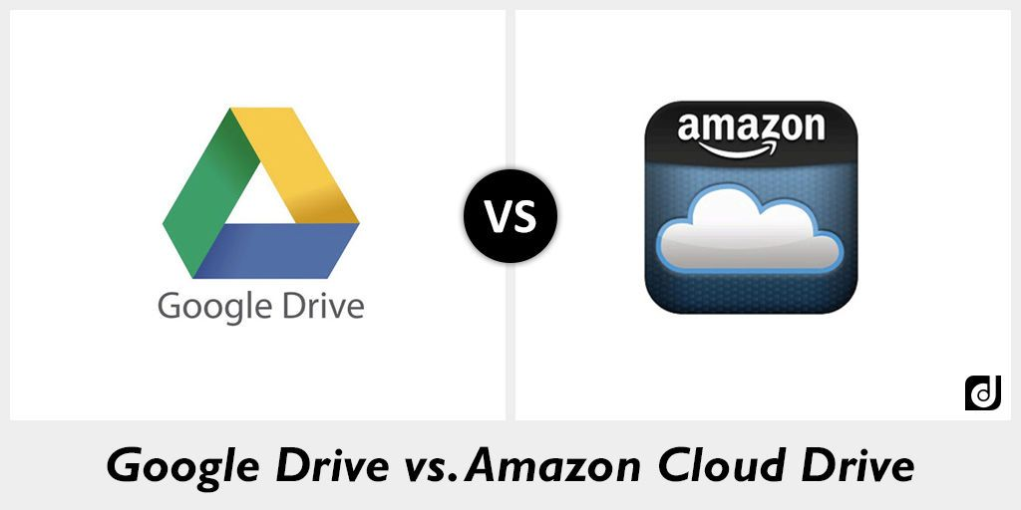
For the first time, when somebody downloads Google Drive and installs, this operation will create a folder which is named as ‘Google Drive’. The user can relocate the position of this file according to wish later on. | Unlike Google Drive, Amazon Drive will not normally create a new folder. The Amazon Drive will instead ask for synchronising the Videos and Photos to any folder. These folders can be manually created and renamed. Amazon Drive additionally offers another feature that enables the users to upload videos as well as photos in the Amazon Drive.
Google Pixel owners enjoy the facility for storing unlimited photo in the Google Drive. | Another link is sent to the users named as Amazon Photos that will provide the notion that users will think that this is another product. Here in Amazon drive, the users also enjoy unlimited photos and videos storage.
Google Drive provides different facilities for the users to edit and create different file formats such as sheets, slides, forms, sites, drawings etc. The users can sync the files with online storage as per demand and requirements. | In Amazon Drive, users enjoy different services such as Server Message Block, version history management etc. The Amazon management prioritises the consumers to provide the services and facilities.
The users of Google Drive, also enjoy different powerful facilities and gifted with powerful API. This facilitates the users to use third party applications to get works done. Different third party applications such as Zoho, PIxlr etc. are provided for the Google Drive users. | Amazon Drive offers the customers to share folders and files as per requirements, but the consumers face several difficulties. The users cannot control the permission in the sharing process. Individuals with the link can access and comment on the files and folders.
Users can bookmark different files and folders in the Google Drive applications, Users can get the facility to control the permission of the files and folders as per the requirements when they need it. | Amazon drive is user friendly and available for Mac and Windows. Amazon Drive is more suitable for personal and home use instead of business use.
Google Dive works in a more professional means. Users can control the files and permissions in different perspectives. Individuals can set rights regarding the requirements of the process. The users can regulate and control the permission of the files and folders in the Google Drive by setting the permission as per the requirements. | In Amazon Drive, there is less facilities for users as there is no backup option.

GOOGLE DRIVE VS AMAZON DRIVE Recommendation
The relative comparison between the two cloud providers somewhat related. Amazon Drive works better as the service to share and store files and photos. For the Prime members, the functionalities are even more.
Google Drive, on the other hand, is more suitable if you want to use it for business and general cloud storage. Another advantage about Google drive is that it cheaper than Amazon Drive and with apps like Gmail so I recommend Google Drive ahead of Amazon Drive because it is of a more user-friendly.
Web Conferencing
Web Conferencing is an online service which enables the users to arrange conferencing, live meetings, trainings, presentation online by using internet. You can get connected to any conference by using VoIP connection from computer or smartphones. Speaker, microphone and camera are needed for communication purpose.
Web conferencing renders real-time communication system which is point-to-point communication which can also be termed as multi-task communications from one sender to other receivers. This means you can conduct a meeting with colleagues on the other side of the world. Web conferencing allows companies and businesses to combine the advantages of a live video feed and a normal phone conversation. In this way, you can also conduct chats, communication via instant messaging. You can talk, listen, chat at the same time by using web conferencing. With active internet service, you can instantly have access to required files right on the smartphones and computers and share them at the time of conference at real time.
Different functionalities of web conferencing help to cut costs in terms of domestic and international travelling which can provide positive financial impact on your business operation. Costs regarding the hotel accommodation, car rentals, ticket costs can create financial burden to your business. When a large pool of professionals needs to communicate and their locations vary, web conferencing provides simple solution for such problems. Web conferencing enables you to work from home, not limiting you from meeting new clients. In this way, professionals can enjoy more time for leisure and communication purpose. Cutting down the commuting time gives you extra time to work.
However, web conferencing has some disadvantages as not all the platforms are user friendly and free of cost. Moreover, some applications have limited capacities. Internet speed of the different users have impact on the quality of the video calling, visibility, functionality of the meeting. Users need to have suitable hardware and training to operate in web conferencing simulation. Though there are some limitations, web conferencing has enabled the users to communicate easily with other users thus improving productivity for different businesses as well as for personal usage.
TABLE 2 Web Conferencing GoToMeeting Vs Cisco WebEx

Cisco WebEx | GoToMeeting
Video conferencing which can be full-screen or split-screen, up to 7 video feeds, enables the users to share whole screen or application feed using VoIP or phone call-in, you can add people during the meeting.  Mark-up tools and whiteboard allows all participants (including the presenter) to write (or draw) on a multi-page screen that is seen by everyone. You can select between freehand drawing (for graphs and diagrams) or text-based drawing (for writing numbers and words.  Record meetings (including video).  Free mobile apps.  WebEx has support for all common platforms that include Windows, Windows Phone, Linux, Android, MacOS, and iOS. For Windows users, the minimum version required is Windows Vista while for MacOS users, the minimum version required is Mac OS X Lion  Share the presenter role. | Up to 50 Participants  Recording capability  Personal Meeting Room better for one on one meetings  Mobile Apps options  Keyboard & Mouse Sharing.  Drawing tools: GoToMeeting has a mark-up tool by the name of “Drawing Tools” that allows the participants to write on a screen that is visible to everyone. However, this feature is just limited to Windows users right now and Mac users cannot access this feature.

GoToMeeting VS Cisco WebEx Recommendation
I can conclude that WebEx is better because of its better pricing plan and features. If you are looking for the ideal choice for a virtual conferencing tool, then I recommend that you make use of WebEx. GoToMeeting does not have support for third-party video recording devices and features. Cisco Webex pricing plan is suitable for businesses of all types (with all features being available with each package). In addition, features such as file sharing, selected screen sharing, and cloud storage make WebEx a better choice than in my Cisco WebEx vs. GoToMeeting comparison.
Marketing on Instagram
Instagram has emerged as a photo and video-sharing social networking service in recent times. Instagram is owned by Facebook with over 800 million active monthly users so it has a wide audience of potential customers. Among all the users of Instagram, around 50% follow at least one business. Around 60% of Instagram users have mentioned that they have learned of a product or service through using Instagram. Instagram has offered proven results from small to large businesses, family run shops, local shops, small to medium enterprises around the world (Instagram 2018).
With a direct link to your company's website, a simple click on the image can take customers directly to your website and potentially buying something from a simple promotion posted image, through sharing a variety of photos, which exposes company brand in a diverse way and engages followers more visually.
Some individuals like chefs, teachers etc... Can posts tips on the making or preparation process, because photos and videos serve in usually the quickest way to give instructions and these instructions are easy to follow.
Another way Instagram is used by businesses is having famous people, celebrity or well-known public figure, who campaign and serve for promoting their products. Instagram is also used to quickly pass on information to customers or potential customer regarding promotions, sales or opening times etc... for e.g. if a restaurant has been renovated that weekend and was going to be closed, having a picture of the renovation informs customers that you will be closed but at the same time letting potential customers aware of new look and features that are going to be adding to your business.
Through the ‘likes' and comments options customer give can give direct feedback on your product or service without the need for long surveys and questionnaires.
With 700 million monthly active users, Instagram is a powerful marketing tool. Instagram was once only photo and video sharing applications which now has transformed into a complete social experience for the users. In this way, the consumers can explore different businesses and companies seeing their visual identity and brand image. Instagram users acknowledge and value high quality contents on various business topics. Consumers are attracted to the visual appeal by which they can explore newer means to perform a task. Consumers also get valuable information on the preparation process for a certain task by following professional Instagram accounts. Businesses are becoming more interested to show case their business identity and enhance their brand image by adopting unique and creative means in different social media platforms like Instagram.
Social Media Accounts Evidence:
https://www.facebook.com/curtis.mckenzie.3785

https://twitter.com/CurtisM11527910

https://www.linkedin.com/in/curtis-mckenzie-68455b177/

REFERENCES
Harris, M. (2018)’What Is Cloud Storage? Access your data from anywhere using cloud storage’, [online] Available from: https://www.lifewire.com/what-is-cloud-storage-2438541 (Accessed: 30 December 2018)
Bidasaria, G. (2018) ‘Google Drive Vs Amazon Drive: In-Depth Comparison’, [online] Available from: https://www.guidingtech.com/google-drive-vs-amazon-drive/ (Accessed: 30 December 2018)
Arrow. (2016) ‘The pros and cons of web conferencing solutions for business’, [online] Available from: https://arrowvoice.com.au/blog/the-pros-and-cons-of-web-conferencing/ (Accessed: 30 December 2018)
Instagram (2018) ‘Why businesses love Instagram’, [online] Available from: https://business.instagram.com/?locale=en_GB (Accessed: 30 December 2018)
Erl, T. Mahmood, Z. & Puttini, R. (2013). Cloud computing: concepts, technology & architecture. Upper Saddle River New Jersey: Prentice Hall

