
International Hotel Management

International Meetings Management for the Hotel Industry BMIH6007

Cosmic Christmas at Winchester Science Centre

Student Name: Constatin Alin Nanu
Student ID: 2206483
Tutor's Name: Kathryn Flynn

Presentation

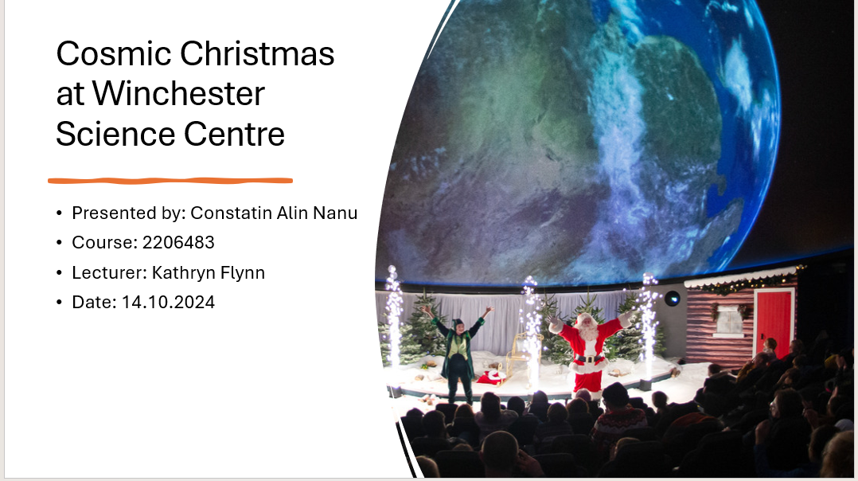

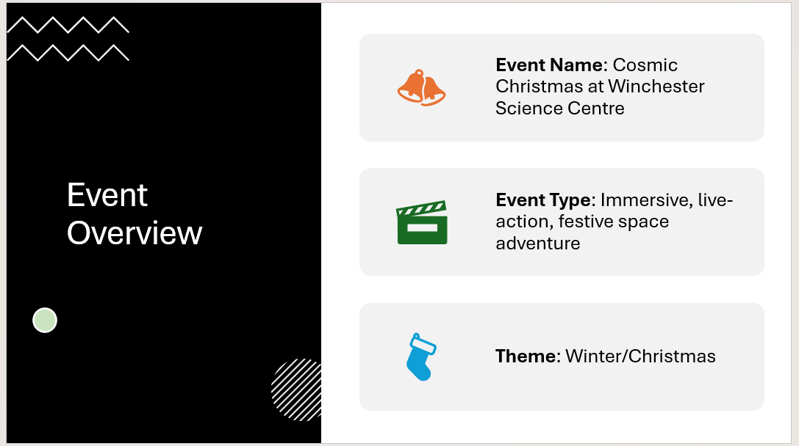

The Cosmic Christmas at Winchester Science Centre is an immersive, live-action festive space adventure designed to engage both families and children alike in the holiday season (Mair, 2024). This event will be scheduled for weekends throughout December and promises to create a holiday of wonder with the added benefit of learning about space and science. This can be considered a current trend within the MICE industry-that has increasingly been moving toward interactive and educational experiences (Getz, 2012).
This event is related to the hospitality sector because it brings families with children and tourists into the area, boosting local tourism and expenditure over the festive period. It provides opportunities for involvement at community level and improves the local economy by bringing guests into the Winchester area. Cosmic Christmas, on the other hand, creates a history or memory for the customers by formulating a fun and educative atmosphere with more emphasis on clarification of the relevance of science in an entertaining manner (Bowdin et al., 2023).
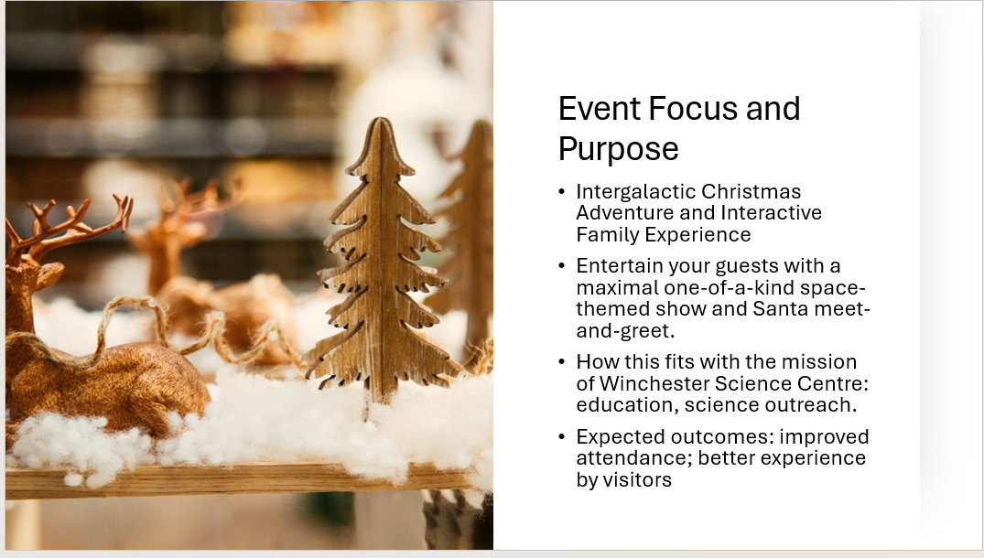

The Cosmic Christmas event at the Winchester Science Centre forms a functional festive fictional experience with aspects of an exciting winter theme paired with educational elements concerning space exploration. This serves not only as an extra festive experience one could have for the holiday period but to improve community involvement through higher numbers of family and tourist visitors in the Science Centre during the holiday period.
Additionally, Cosmic Christmas was also conceptualized to present an educative environment that would help kids, and their families learn about scientific concepts in a way that would be both fun and interactive (Mair, 2024). The event fully serves to further the greater mission at large of the Science Centre for the education and inspiration of people through activities involving interaction. It states, at long last, the relevance of science to everyday life, especially at a season that is quite symbolic of being united and full of joy (Smith, 2012).
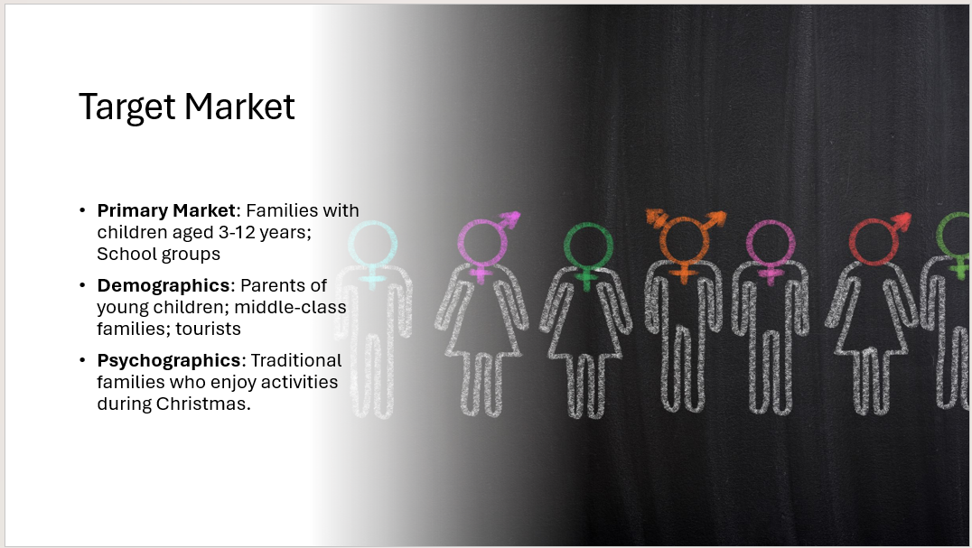
The major stakeholders of the Cosmic Christmas event at the Winchester Science Centre will be families with children and tourists visiting during the time. These families often visit these types of events, which are light-hearted and thematic in nature, that ensure child's play and education on a regular basis (Gursoy et al., 2020). Events like this attract a broad age range, and because it is an interactive, live-action event, it allows the parents and kids to have a similar experience they all will remember (Bowdin et al., 2023).
A significant sector of the audience would also be tourists coming to Winchester during the holiday period, as events related to holidays may drive the prospects of increasing tourism and improving economic activity in the area concerned. In fact, this initiative can be held to be different from conventional events celebrating holidays and, therefore, should be an attractive choice for those who seek something new and instructive in essence. The broad appeal ensures good attendance and engagement, particularly in the peak holiday period.

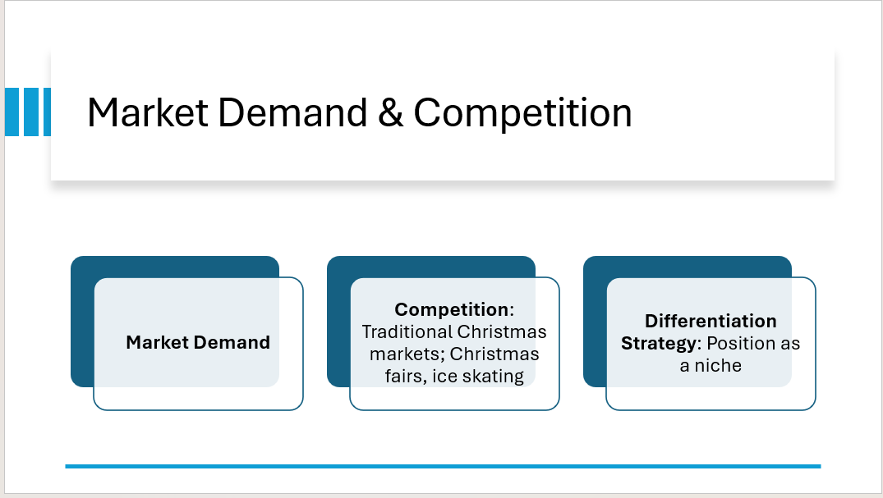

This has been on an upward trajectory in demand for immersive, family-friendly holiday experiences, especially those that amalgamate entertainment with education (Gursoy et al., 2020). More and more, families still seek activities that have some value in educating them during this school holiday period. Cosmic Christmas at Winchester Science Centre is, therefore, an attraction. As an event that combines science education with festive magic, the ZooLights addresses an emerging trend of experiential learning in children and families visiting the zoo for some fun yet intellectually stimulating times.
On the competitive level, leading entertainments are considered Christmas markets, Santa’s grottos, and themed festive parks. What is more, on the local family level Christmas fairs and provided ice skating attract many visitors' attention within this festive period (Smith, 2012). However, the Cosmic Christmas event stands out by its differentiation strategy. Mixing science education with holiday entertainment provides an interactive niche experience that sets it apart from the generic holiday activities, fitting the needs of families in search of something different and more instructive than the usual vacation activity (Bladen et al., 2012).

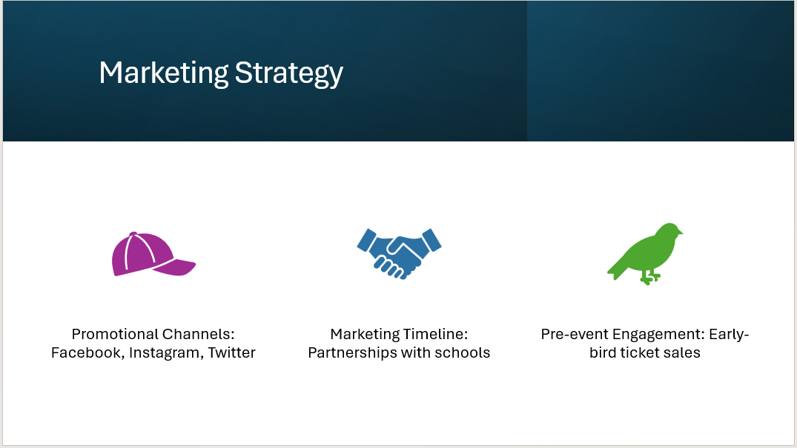

Central to the Cosmic Christmas event's marketing strategy at the Winchester Science Centre will be a focus on digital channels and local outreach for effectiveness in reaching both families and schools. In a world where online engagement is increasingly becoming the trend, digital marketing-media campaigns, targeted ad campaigns, and email marketing-will be crucial in reaching the main target markets, which include families with young children and tourists within the local community (Bowdin et al., 2023). Teaser videos and engaging posts on social media will serve to create awareness of and excitement in the event (Eventbrite, 2021).
These outreach initiatives will not only reach out to digital marketing but also to schools and community centers, including discounted group rates or educational packages that could enable school visits during the holiday period. Finally, local influencers and family bloggers would be considered to increase this event within the community's awareness( Bladen et al., 2012). The multi-level outreach will maximize such outlets to maximum coverage, ensuring a flow of visitors and locals in search of something different this holiday season in the town center (Getz and Page, 2019).
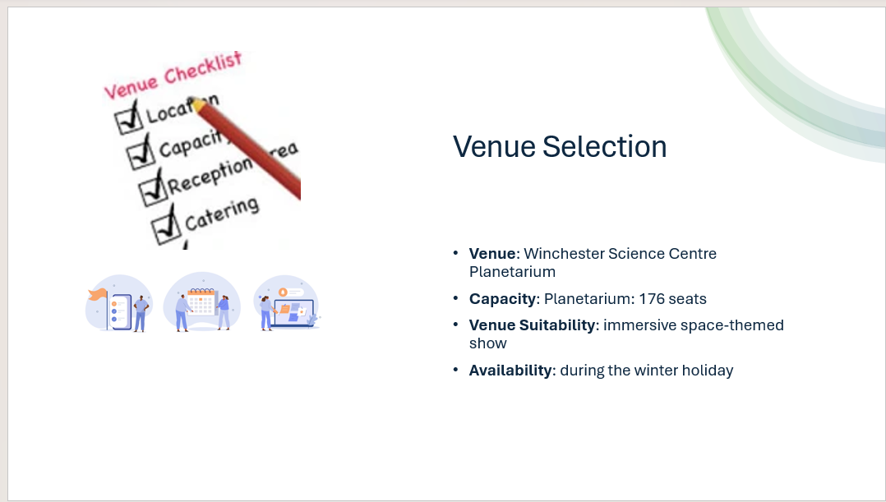
The Cosmic Christmas event will be held at no other venue than a state-of-the-art Winchester Science Centre, renowned for hosting spectacularly informative and entertaining events. The Winchester Science Centre Planetarium would be perfect for the Cosmic Christmas event because of its exceptional quality, offering a thrilling environment where families could celebrate Christmas as an Edu-entertaining space experience. For the purpose of convenience to visitors and ensuring that congestion does not build up in the venue yet allowing every individual of a single family to attend the same show, the facility will have the capacity to hold comfortably over 100 persons per show.
In addition to its capacity, it is very well-equipped with modern projection and comfortable seating to make the experience of visiting this venue even more enjoyable (Bowdin et al., 2023). The design of the Planetarium allows one to create an interactive atmosphere, which is highly appropriate for a family audience who comes seeking entertainment combined with cognitive input. The Science Centre is located in Winchester and provides easy access to facilities for parking, thus increasing its accessibility and attractiveness for locals and tourists during school holidays (Smith, 2012).

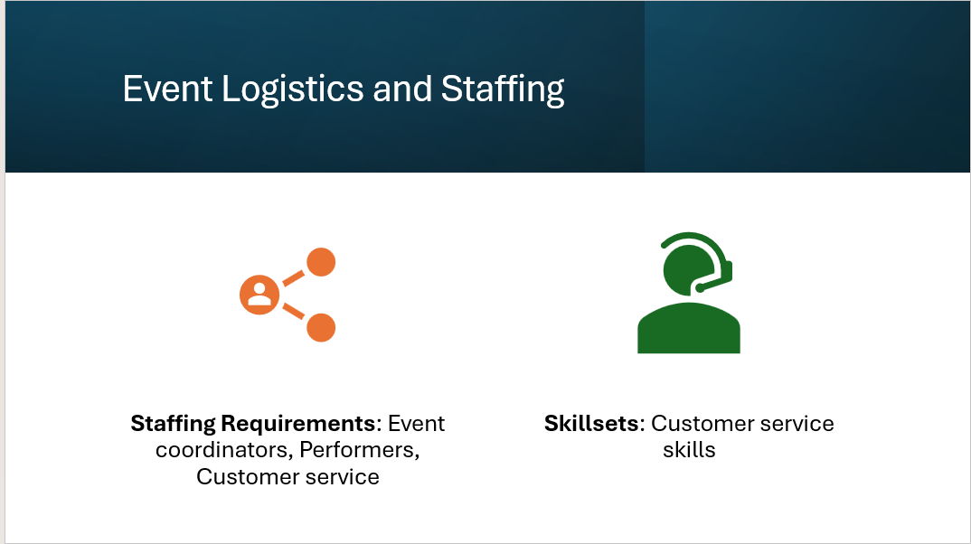

This would necessitate hiring different kinds of expertise, like event organizer, performers, technical team members and customer service representatives, into the full team of the Cosmic Christmas event at the Winchester Science Centre.
Event organizers (2-3) cater for and organize the provision, thereby seeing that the event goes well. They will have to be highly organized and capable communicators in managing time and organizing activities in support of the event (O'Toole, 2011).
The performances by performers such as actors playing the role of Santa, elves, and space characters will be fundamental in engaging the audience and taking them through a spectacular experience. Essential performance skills and connection with families will add to the festive environment of the event (Getz, 2012). Light and sound together with Planetarium projection will be operated by the technical team. Such a specialized technical team is highly required to operate sophisticated projection systems smoothly. However, customer service staff will arrange for ticketing, distribution of "gifts" mentioned below and safety. Customer Service staff will ensure a friendly atmosphere for the visitors (Bladen et al. 2012).

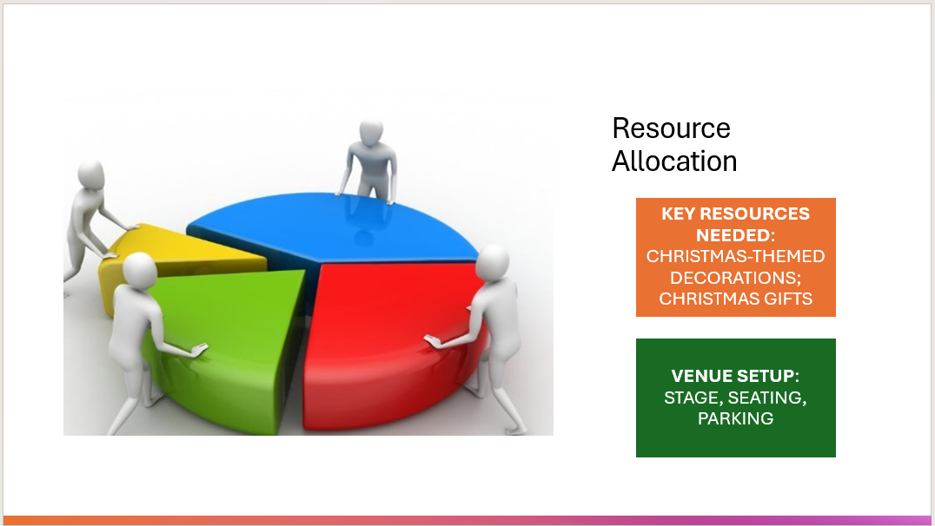

The Winchester Science Centre Cosmic Christmas event requires special logistical resources to put it all together as this magical experience for the family.
Main resources a Christmas-themed decoration would be required to turn the facilities of the Planetarium and the entrance into a Christmas wonderland, adding to the cheer of Christmas. Live-action props and costume elements like Santa, elves, and other space-themed characters are necessary as performers will be using these to tell the story. Special effect equipment such as light systems, sound systems, and even snow machines around key areas will add dynamism to the show environment created.
Christmas gifts for children will complement the festive experience: either small science-themed toys or personalized souvenirs will fit the educational aspect of the event (Getz and Page, 2019).
Other gatherings include the preparation of the venue, designing the stage in the Planetarium for the live action scenes, consideration of family seating ensuring safety and comfort, and parking to handle visitors with ease (Hesketh, 2023).
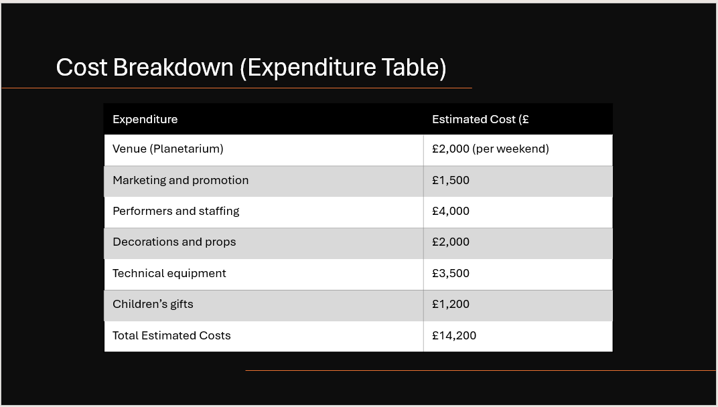

The costs for an event like Cosmic Christmas include some broad categories. Among the major costs is that of the venue and technical equipment, which usually includes a planetarium projector, lighting, and sound system. These have been affected by the inflationary pressures, particularly because of the inflation and disrupted supply chains, and are estimated to have increased audiovisual costs by about 7-8% (Etherio, 2023). The budget will have to include a fair amount of staffing, too, with labor shortages driving wages up, especially in the technical and customer service arenas. Food and beverage costs will continue to rise for any catered pieces at an average of 5.4%, according to recent statistics (Velvet Chainsaw (2023).
Other things to be considered include decoration and props, such as holiday theme decorations and interactive props for live-action performances to bring in an atmosphere. Of course, strong marketing, especially in the digital and local outreach areas, should also be budgeted; such efforts are vital in bringing family and school audiences together. With smart negotiations with vendors and technology utilized for budgeting, overall event costs can be optimized despite the inflationary pressures.

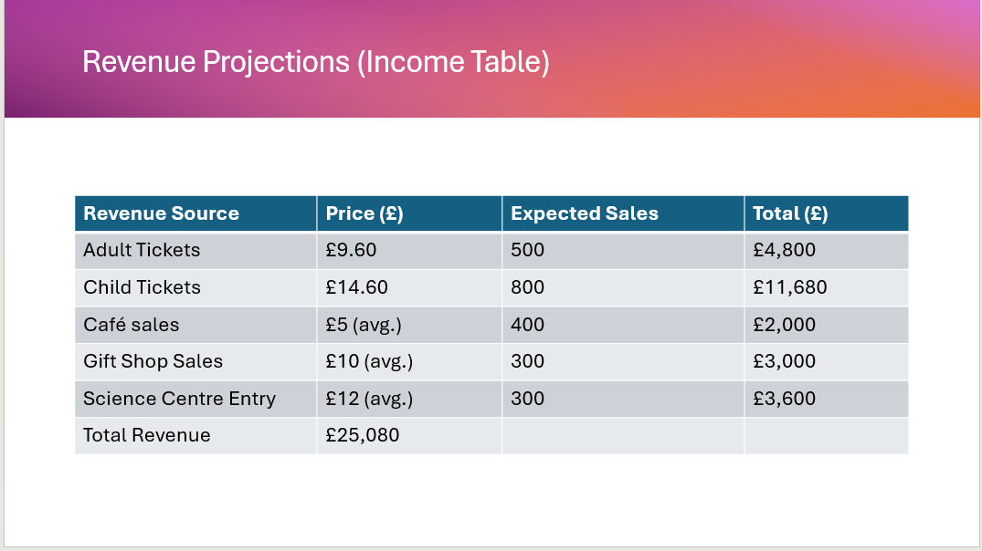
The forecasted revenues for the Cosmic Christmas event at Winchester Science Centre will derive from three main streams, namely, ticket sales, gift shop purchases, and sales of food and beverages. Ticket sales are the largest contributor and are forecasted on the pricing model using £9.60 per adult and £14.60 per child, while anticipating several hundreds of families to attend throughout the event period (Winchester Science Centre, 2024). Additionally, gift shops will experience increased sales resulting from science-themed toys and festive souvenirs. According to Getz (2007), event tourism often involves retail purchases, especially on themed events like Christmas, thus making the opportunity very lucrative.
Food and beverage sales are another crucial revenue source. These sales will most likely do well, especially with festive treats and drinks designed to cater to the theme of the event. And, as Jones (2017) had done his research on, catering and retail could not only improve visitor experiences but raise margins as well. Ticket sales mixed with retail and catering provide a good, mixed source of revenues, thereby reducing financial risk for an event.

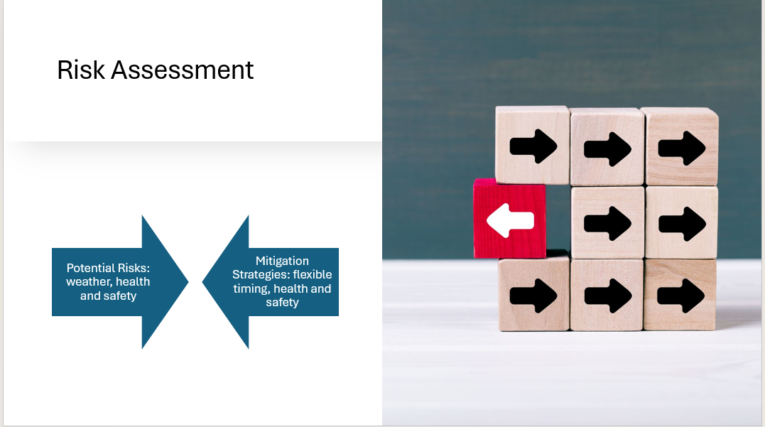

Risk evaluation for the Cosmic Christmas at Winchester Science Centre will help to build an effective event rather smoothly. The major risks are in operational, financial, and reputational aspects. Technical failures fall under operational risk as this is associated with the projection systems in the Planetarium or rigging of the lighting. The mitigation strategy will be maintenance checks on a regular basis accompanied by contingency plans such as standby equipment. The risks with regard to health and safety will be minimized in case of overcrowding or accident, provided there is a comprehensive safety check, adequate staffing, and crowd control measures clearly displayed (Thompson and Hopkin, 2021.
These are financial risks such as poor ticket sales from estimates or higher than expected costs. These best can be minimized through a proper feasibility study and a budgeting plan for the event (O'Toole, 2011). Reputational risks occur due to poor customer feedback or negative review of the shows. This can be minimalized by quality performances and excellent customer service (Bladen et al., 2012). One must also collect periodic feedback while the event is going on to address deficiencies on the spot for all customers to have an enjoyable time.
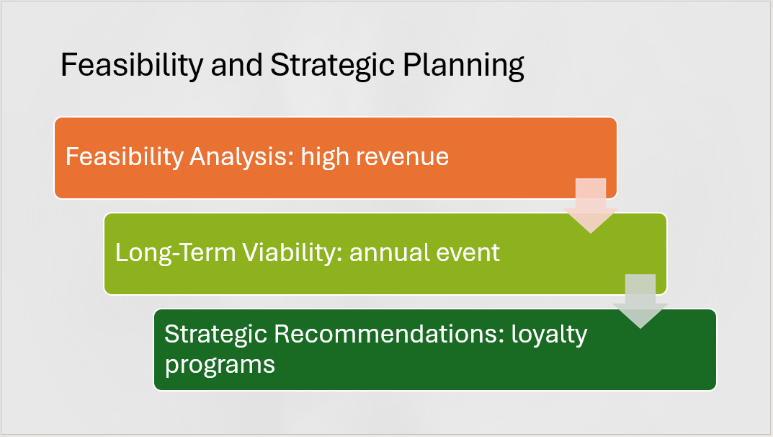

It is viable to go ahead with the Cosmic Christmas event at Winchester Science Centre grounded on the supporting financial structure of the event and long-term growth potential. Eventually, primed with a well-thought-out revenue model, hinged on the sale of tickets, gift shop merchandise, and food and beverage sales, it has the potential to make quite a big profit during holiday time (Winchester Science Centre, 2024). With several hundred families projected to attend and thus attractive pricing, a sure income stream is developed. The financial sustainability of such a festival is further supported through cost management strategies that include efficient usage of resources for staffing, setting up the venue, and marketing of the event (O'Toole, 2011).
This, combined with long-term potential, uniquely positions the offering in the local market, making it very likely that visitors would make it a recurring annual experience. According to Getz (2007), growing demand for immersive experiences among families during holidays creates fertile ground on which the event could realize its potential in future years. The synthesis of these factors brings forth a good foundation for a sure short-term success and scalability in future years.
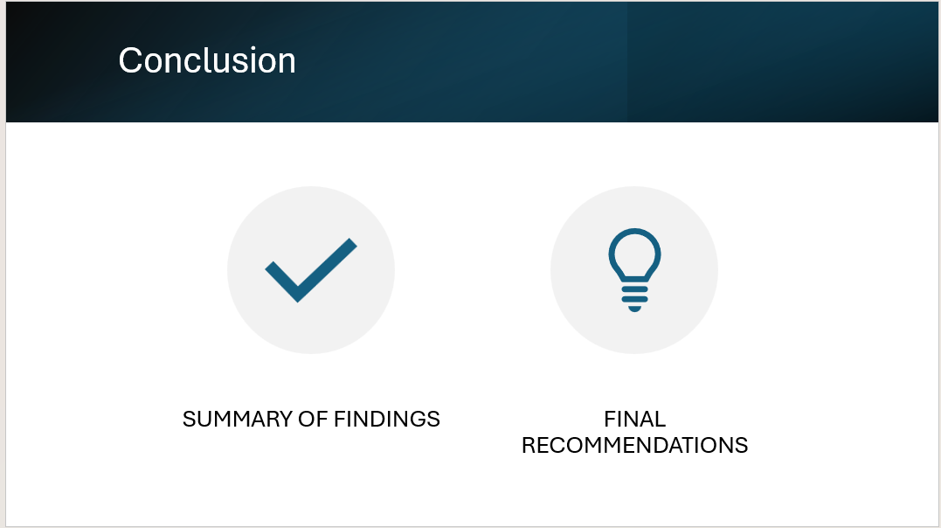

Overview of Key Findings:
The feasibility study of the Cosmic Christmas shows that there is a very good coincidence between the event and the market demand for holiday experiences that are both entertaining and educative (Jones, 2017). Christmas combined with space science is unique on the local market, so the competitive advantage certainly will be above average. Also, the capacity of the venue, its family-friendly atmosphere, and technical infrastructure are appropriate to host such an event (Rogers & Wynn-Moylan, 2022).
Feasibility Final Decision:
The event is viable, and profitable due to high demand in ticket buying, merchandise sales, as well as other forms of select marketing. The forecasted revenue that is going to be generated by admission and other complementary streams of revenue indicates that the event will break even or turn a profit (Mair, 2024).
Strategic Recommendations:
For example, it would be successful if, as Franklin (2020) says, "sturdy partnerships with local schools and well-organized community groups around families are cemented to drive in attendance." Enhancing the digital marketing campaign will further boost the audience figures and longer-term potential.


