PROJECT MANAGEMENT
1706147 | [Company address]
LECTURER: SHEHLA KHAN
Shafna Begum (1706147)
2019
Table of Contents
Executive Summary 1
Table of figures 2
Introduction 3
Week 1: The project initiation processes 3
Week 2: The Project Planning Phase 4
Week 3: Continuation of Project Planning Phase 7
Week 4 The project planning and monitoring phase 8
Week 5 The Execution Phase 9
References 12

Table of figures

Figure 1 This is the students Iron Triangle for their project, demystifying business plan 3
Figure 2This is the students Quad Chart for their project, demystifying business plan. 4
Figure 3 This is the students Stakeholder Analysis for their project, demystifying business plan 5
Figure 4 This is the risk assessment made up by the students for the Demystifying Business Plan 6
Figure 5 This is the students WBS for their project, demystifying business plan 8
Figure 6 This is the students Gantt Chat for their project, demystifying business plan 8

Introduction
This report will be delving into how the students from University of Wales Trinity Saint David conducted a project, by using project management tools and techniques. Along with other techniques such as, the project management life cycle this is used to help in their efforts. The students were introduced into a project called the Demystifying Business Plan by Eleri Williams who works for Swansea Council alongside the Umbrella organisation. This project was designed for the Black Minority Ethnic (BME) group. The project was carried out in a 5-week period, with each week being dedicated to a different task.

The project life cycle (Archibald,2016) is the phases a project goes through from the initial start to the end. It refers to the widely used four phase plan which are: Initiation, Planning, Execution and Closure. Having this structure put in place puts the project into manageable phases and gives clear indication of the order of tasks. As useful as this tool is, the first and second phases were found to be quite similar, with overlaps. In the initiation phase it is finding out the scope of the project, and the planning could start there instead of in a new phase.

Week 1: The project initiation processes
The students began the project by completing a Belbin Test to discover each person’s strengths and weaknesses within their behaviour and the result will be utilised to allocate each person in the role that they best fit. The Belbin test was created by Dr Meredith Belbin in 1881 and is still used today to identify a person’s behaviour and put them in one of the nine team roles according to their answers. (Belbin Associates, 2019). The results showed that Marjana Khatun would be the suited Project Leader, as she was eager to take on this task with her qualities, showing she was a ‘shaper’, which is someone who has necessary drive and keeps the team focussed. Marjana also showed great confidence and an ability to communicate well with the team, which made her a standout choice for the role of Project Leader. Using this tool helps effectively shows peoples skills and abilities allowing the team to know what jobs would be suited best for each person.
Project management requires a combination of skill, knowledge and understanding to accomplish the objectives that have been set. Some of what Project management consists of are outlining the project and the importance, specifying and estimating the resources and time needed, managing and motivating the team with a good use of communication, monitoring everyone’s progress so that everything runs smoothly and lastly evaluating the whole project.

Student’s Roles and Responsibilities
Project sponsor – BME Skills Project part of SCVS
Project champion – Eleri Williams
Project manager – Marjana Khatun
Project team – Nishat Choudhury, Shafna Begum and Jorna Ali
Stakeholders – Project Lead, Project Manager, Project Team, BME Skill Project participants
Audience – SCVS, BME Skills Project Participants
The students created an invitation, which included a blurb to give a brief insight into the student’s workshop on demystifying business plan, this was written in an attractive format to catch the attention of their target audience (BME). In order to receive a quick response, students sent out the invitation via email with an option to ‘save the date’. This technique allows students to receive a reminder on the recipient’s calendar of the event with just one click.

Week 2: The Project Planning Phase
A technique called the Iron Triangle or Project Management triangle (Dobson, 2004) can be used to assess the risk involved in such projects that could possibly affect the project and the way the project is executed. There are three main limitations that effect projects, these are:
- Time
- Cost
- Specification
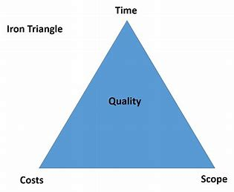
Figure 1 This is the students Iron Triangle for their project, demystifying business plan

For this project, within the Iron Triangle the most important of the main limitations are time and scope as the students were delivering a workshop to an adult group who have other responsibilities, the timing must be appropriate and be convenient to have the attendees arrive.
The third point of the triangle is the cost; this was not an issue for the students as they had the location of their workshop provided by the Swansea Council for Voluntary Service (SCVS). SCVS are a branch of Swansea Council that are partners alongside Black Minority Ethnic skills group. They have supported and are continuing to help various groups and communities in attaining advanced skills and experience.
The scope is just as important, as the information that the students provide to the BME people must be precise, informative and interesting, as without this the workshop will either be unsuccessful, or the recipients will not engage with the student’s information. There was an advantage for the students, as they had already completed a module on a business plan in a previous term. Students found the timing of the project the biggest hurdle as they were expected to have the whole workshop completed with relevant research on a relatively new concept of delivering, which was a change to the usual way they had known of standard presentations. The workshop was estimated to be three hours long and it was a challenge for the group to produce enough material to last for the whole duration.
The group then started to analyse the scope of the project by completing a QUAD chart. A quad chart could summarise the project intentions in a visual manner, using illustrations, photographs and writing whilst also being descriptive. It allows the stakeholders to see the ambition of the group and what steps they are planning to act upon to achieve this. The QUAD chart splits the issues found into four parts that intend to encourage management analysis and understanding. The four sections include, purpose, customers, desired results and measures of success (Paladino, 2010).
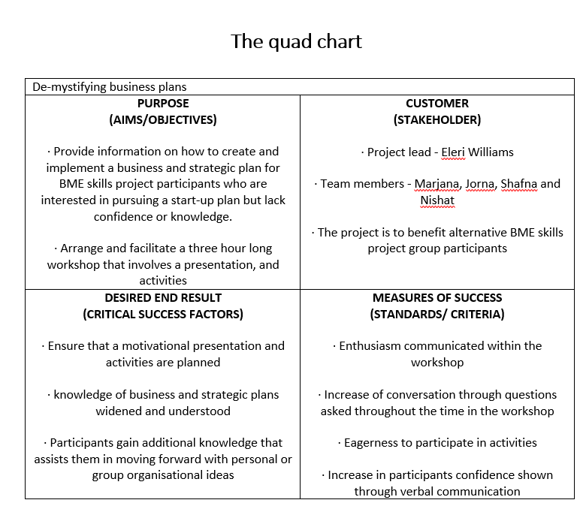
Figure 2This is the students Quad Chart for their project, demystifying business plan.
After completing the Quad chart, the group allocated the tasks to each member in the group. This provided a sole focus for the specific aspect of the project to the individual. This enables the group to save time and gave everyone an opportunity to play a part in the workshop.
Doing a QUAD chart gives the chance to have things such as the purpose of the project clearly stated so that throughout it can serve as a reminder for what all the work is for.
The students also conducted a stakeholder analysis, this helped the students to find out and show who the stakeholders were, what each stakeholder’s priority and perspective was and what actions were needed to keep each of them involved.
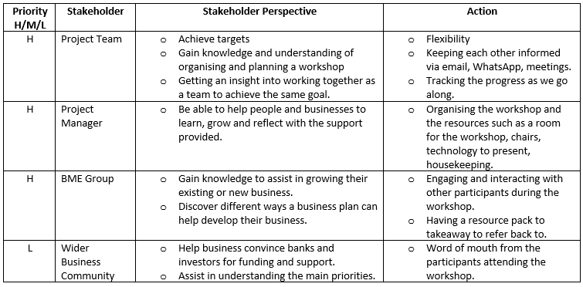
Figure 3 This is the students Stakeholder Analysis for their project, demystifying business plan
Stakeholder Analysis is an important technique for stakeholder identification & analyzing their needs. It is used to identify all key (primary and secondary) stakeholders who have a vested interest in the issues with which the project is concerned
Having the knowledge on who the stakeholders are and what level of priority they are gives you an idea on how involved you need to make each stakeholder feel and how the project will affect them. Using a stakeholder analysis not only shows how the project will affect internally but also the external entities.

Week 3: Continuation of Project Planning Phase
The group then carried out a risk assessment of the project, which identifies risks and plans to resolve any issues that arise. A risk assessment is made up to establish the feasibility of the project within what limits the project. Even with clear tasks and goals, a risk assessment is needed in the chance that something goes wrong. Even after planning a risk assessment however, there is still always the chance that the students may have missed a potential risk or that a risk you planned for still arose. Having a risk assessment put in place doesn’t guarantee the project to run smoothly, the students still would’ve had to keep flexible in their approach for any eventuality (Wood, 2011).

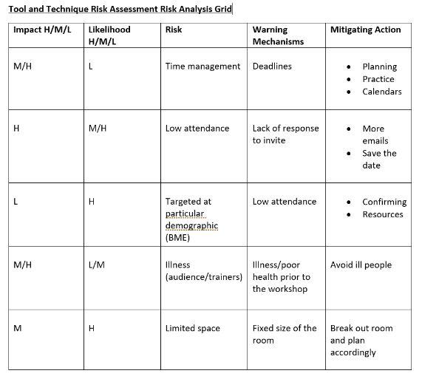
Figure 4 This is the risk assessment made up by the students for the Demystifying Business Plan

Throughout the week, the group continued to assess the workshop by using PESTLE (political, Economic, Social, Technological, Legal, Environmental) (PESTLE Analysis, 2019) to identify the way the outside may affect the workshop. Only three aspects of PESTLE, social, technical and legal, came into effect for the student’s project.
Socially, the students found that their demographic was limited as they were looking to attract only the BME group. This gave the group some uncertainty as to whether there was enough of an audience.
The technical side was a crucial aspect as the students were using laptops, monitors and speakers. If any of these were to fail the workshop would also be in danger of failing. Therefore, it was imperative that the students had someone that could resolve these issues also have a different way to present the information. The students did have whiteboards and leaflets if the technology was to let them down.
Legally the students were told that they were only to give out information and not to specifically advise, so that if anyone were to take the advice they could not be blamed for any potential problems. The BME group also signed a consent form so that their privacy was kept, whilst also being able to use their information.
From doing a PESTLE analysis, gives a deeper understanding of the project for example all the rules and regulations that must be followed the previously could’ve been overlooked. The group made good use of the technique as they found they had to get signatures from the BME group for them to be allowed to use photos of them according to the GDPR (General Data Protection Regulation)

Week 4 The project planning and monitoring phase
Monitoring a project is an important task to ensure that the project is on the right track throughout, it continues to be within budget and the team meets deadlines.
A GANTT chart and Work Breakdown Structure (WBS) is a planning tool but is also used to monitor your progress to make sure you keep on track.
Week 4 was about the students monitoring the progression of the workshop, this was done by making and then referring to a GANTT chart, which was made by using the work-breakdown structure (WBS). A GANTT Chart is as chart that shows the amount of work done in certain time frames in relation to the work planned to have been done for those periods of time. The Students made good use of the GANTT chart by listing all the activities, giving them a start and end date. They first broke the tasks down into smaller sections of each activity, which allowed the students to the make a WBS.
WBS or work-breakdown structure is the decomposing of a project into smaller more manageable component, it is key to help breakdown the student’s workload into easier more manageable sections. The students used the WBS to better understand the project scope as it was in more manageable parts, easier to read and understand. (Project Management, 2008).

The GANTT chart allows the students to have quick checks to see if they are on track and where they need to be at any given time. If any students do fall behind in certain parts according to the chart, then extra help or motivation can be given to increase the productivity. However, the GANTT chart must be produced properly as if the time period given for tasks are too little it can cause panic with the students as they feel they are behind. This panic can then result in rushed work, which often results in sloppy mistakes (Young, 2013).
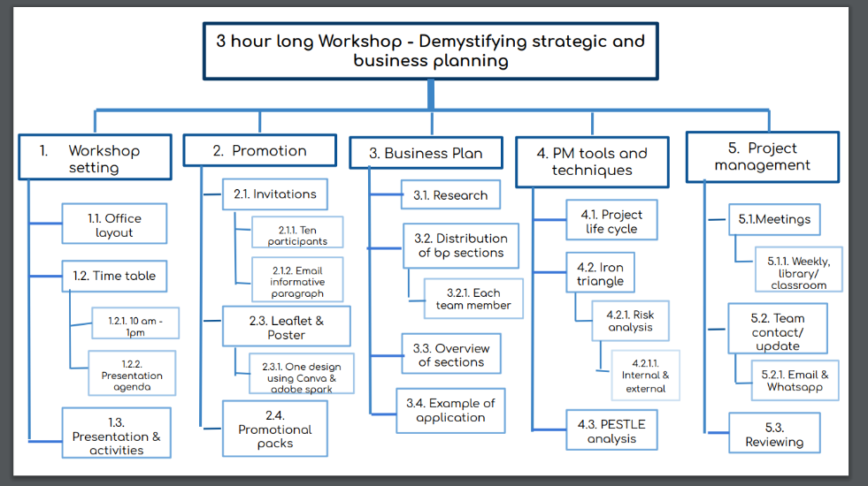
Figure 5 This is the students WBS for their project, demystifying business plan

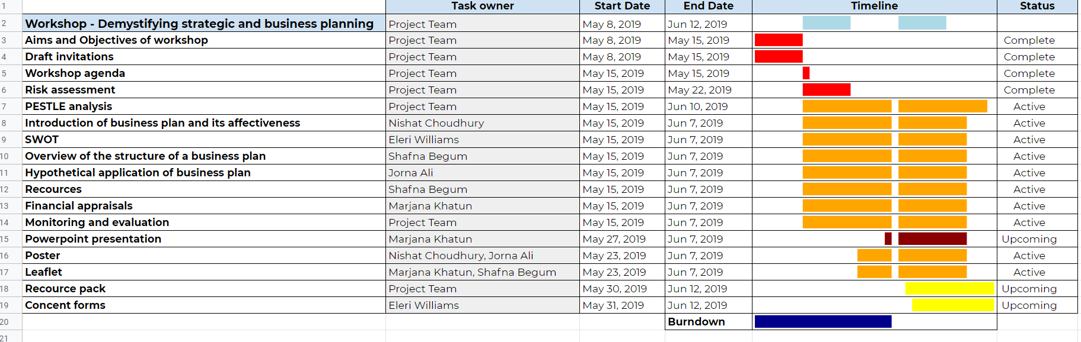
Figure 6 This is the students Gantt Chat for their project, demystifying business plan

Week 5 The Execution Phase

The Day of the Workshop
“Following completion of the workshop, evaluation may examine its immediate outcomes or long-term impact or summarize its overall performance, including, for example, its efficiency and sustainability” (Atsdr, 2019).
Evaluation phase: The workshop went well; everything went smoothly and how we planned for it to go. The students gave out feedback forms to the BME group to fill out based on how they thought the workshop went, the feedback was highly positive. This gives the students encouragement and a boost in confidence for future projects that they may take part in.

Gibbs (1988) – own project skills
Description – We used tools and techniques which were taught to us in class to structure a three hours workshop.
Feelings – I felt quite confident during the planning of the project, I understood how to use the tools and techniques.
Evaluation & Analysis
– I got along well with each member of the team and found it easy to communicate and give my point of view on each tool. Next time I would emphasise more on time keeping so that we are not planning until the end.
The work was delegated into equal parts and nobody felt they had more work than anyone else.
I would like to have had more assertiveness and confidence so that I could take up the leadership position in future projects.

Conclusion – overall it was a good project, and we covered all the tools and techniques to better the project. Using various tools and techniques such as risk assessment, allowed us to further develop our plan in a more professional setting.
Action Plan –
In future I would like to work on my confidence and be more courageous on giving my views and ideas.

References
Atsdr (2019). Chapter 7: Evaluation Phases and Processes | Principles of Community Engagement | ATSDR. [online] Atsdr.cdc.gov. Available at: https://www.atsdr.cdc.gov/communityengagement/pce_program_phases.html [Accessed 25 Jun. 2019].
Belbin Associates, (2019). The Nine Belbin Team Roles. [Online]. Available at: https://www.belbin.com/about/belbin-team-roles/
[Accessed 16 05 2019].
Dobson, M. S. (2004). The Triple Constraints in Project Management. USA: Library of Congress Cataloguing-in-Publication Data.
Freeman, E.R., Harrison. J.S., Wicks, A.C., Parmar, B.L. & De Colle, S. (2010). Stakeholder Theory: The State Of The Art. Cambridge: Cambridge University Press.
Gibbs, G., (1988). Learning by Doing: A guide to teaching and learning methods. Further Education Unit. Oxford Polytechnic: Oxford.
Paladino, B. (2010). Innovative corporate performance management: five key principles to accelerate results, New Jersey: John Wiley & Sons, p.300
PESTLE Analysis (2019). What is PESTLE Analysis? A Tool for Business Analysis. [online] PESTLE Analysis. Available at: https://pestleanalysis.com/what-is-pestle-analysis/ [Accessed 2 Jul. 2019].
Project Management. Com. (2018). ‘Work breakdown structure (wbs): top-down or bottom- up?’, [online]. Available: https://project-management.com/work-breakdown-structure-wbs-top-down-or-bottom-up/, [Accessed 25 05 2019].
Swansea council for voluntary service. (2019). ‘About us’, [Online]. Available: https://www.scvs.org.uk/about-us, [Accessed 16 05 2019].
Swansea council for voluntary service. (2019). ‘BME Skills project’, [Online]. Available: https://www.scvs.org.uk/bme-skills-project. [Accessed 16 05 2019].
Woods, M. (2011). Risk Management in Organisations. London: Routledge Taylor and Francis Group .
Young, T. L. (2013). Chapter 08: Planning the project, London: Kogan Page Ltd. (4th ed) [online]. Available at: https://search-proquest-com.ezproxy.uwtsd.ac.uk/docview/1810037349/B4ED2B5BCF5D403EPQ/1?accountid=130472, (pp.135-165) [Accessed 13 06 2019].

