Grade 2 Hamstring tear
A Grade 2 hamstring tear means the muscle fibers in the back of your thigh have partially torn. You may have felt a sudden sharp pain at the time of injury and notice some weakness when bending your knee. Swelling and bruising can also occur (Pollock et al., 2016).
Recovery from a Grade 2 tear takes time, and it’s important not to rush it. In the first 1-2 weeks, the focus is on protecting the area and managing pain. From 2-6 weeks, rehab aims to gradually restore movement and rebuild strength. After that, from around 6-12+ weeks, the focus shifts to running, speed work, and preparing for a safe return to sport. Most people can expect a return to rugby or similar activities in roughly 2-3 months, though recovery times can vary depending on severity (Mendiguchia et al., 2017).
Your body heals this injury in stages. First is the inflammatory phase ( 0-5 days) , where swelling and discomfort appear as the repair process begins. Next is the repair phase (5 days-3 weeks), during which new tissue forms but remains relatively weak and needs protection. Finally, during the remodelling phase (3 week+), the tissue becomes stronger and more organised, allowing gradual increases in load and intensity. This staged process is why rehabilitation progresses step-by-step rather than all at once (Jarvinen et al., 2016).
Most Grade 2 hamstring tears are treated without surgery, using a structured rehabilitation program. Surgery is rarely needed unless there is significant tendon involvement or a large gap in the muscle fibers, or if a very high level of athletic performance is required (van der Made et al., 2018).

Monday  Week 1  Aim = Activate hamstrings and begin restoring knee flexion.  Aim = Maintain cardiovascular fitness without loading hamstring | AM | Supine heel digs | Prone knee flexion | Supported standing hamstring curl | Heel slides | Donkey kicks
 | AM | 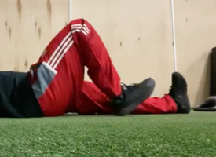  Closed chain, single plane. | 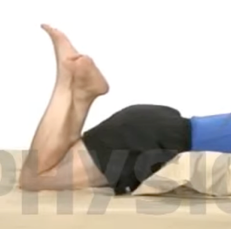  Open chain, single plane | 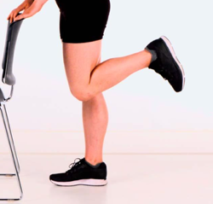  Open chain, single plane | 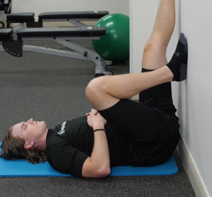  Open chain,  Single plane | 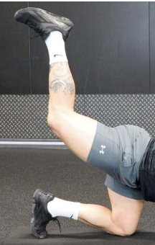  CC, SP
 | AM | Knee at 60°, Isometric hold, 3x8 holds, each hold to be 5 seconds long. 20% effort. | Isometric hold, 3x10 holds, each hold to be 5 seconds. | Hold onto the chair, lift leg so knee is at 90° and hold for 5 seconds. 3x10. | Place foot on the wall and drag heels back towards bum. Hold for 10 seconds. 3x10 reps. | On hands and knees, gently kick back one leg at a time. 3x10
 | PM | Upper body ergometer | Walk | Ice bath
 | PM | 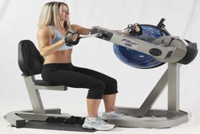  Closed chain, multi plane | 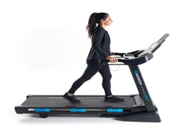  Closed chain  multiplane | 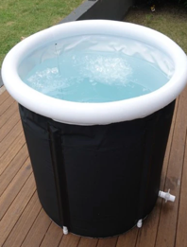
 | PM | 15 minutes of light to moderate work, RPE 4/10. | 10 minutes of slow walking on a treadmill, no incline. | 2 minutes after pool to help reduce inflammation.
Tuesday  Week 1  Aim = maintain upper body strength  Aim = Maintain hip and trunk mobility to support lower limb function | AM | Seated battle ropes | Seated shoulder press | Chest press | Seated lateral raises | Triceps pushdowns | Seated Bicep curls
 | AM | 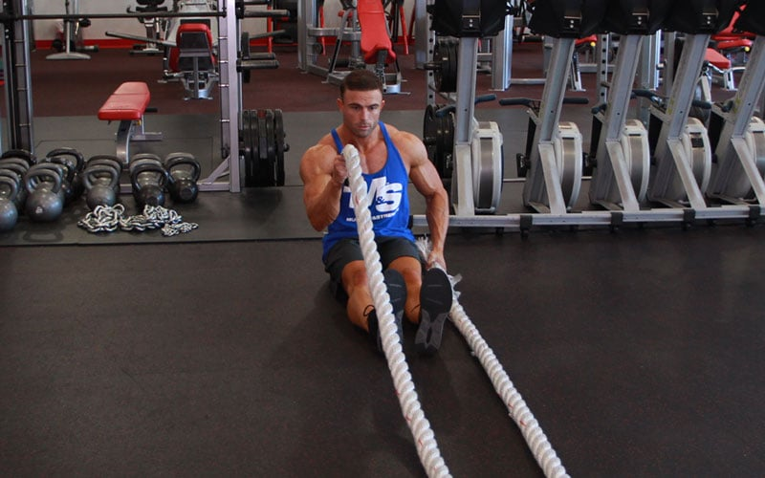  Closed chain  Multi plane | 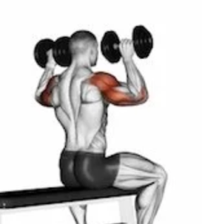  Open chain  Single plane | 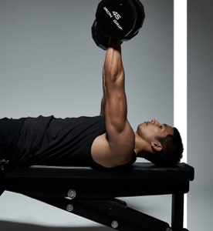  Open chain, single plane | 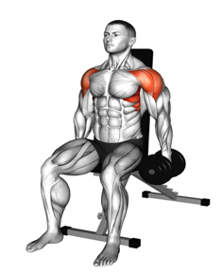  Open chain, single plane | 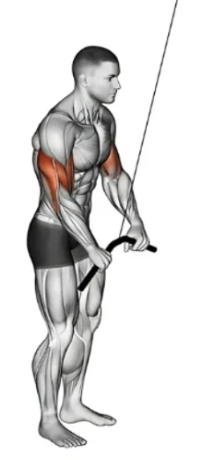  Open chain, single plane | 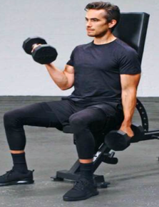  Open chain, single plane.
 | AM | 20 seconds working, 40 seconds rest, 8 rounds. | 3x10, seated with or without back support. | 3x10, avoid leg drive when extending arms. | 3x10, slight bend in elbows, avoid swinging | 3x10, avoid leaning or using leg movements. | 3x10, avoid leg drive, keep elbows in.
 | PM | Clam shells | Side lying hip abduction | Adductor squeezes | Lower back rotation | Ice bath
 | PM | 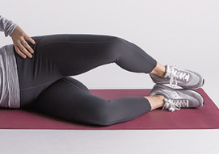  Open chain, single plane | 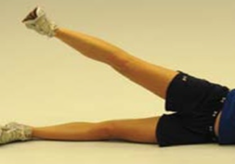  Open chain, single plane | 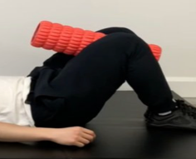  Closed chain, single plane | 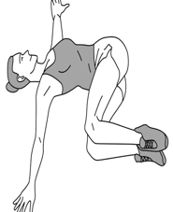  Open chain, multi plane
 | PM | 12x3, don’t roll backwards, controlled. 60s rest. | 3x10, hold for 5 seconds, 60s rest. | 3x8, hold squeeze 5 seconds. 40% squeeze. 60s rest | 3x10, slow and controlled movement, 60s rest. | 2 minutes after pool to help reduce inflammation.

Wednesday  Week 1  Aim = Promote low-level lower limb activation and improve neuromuscular control  Aim = Restore movement and circulation through low-impact hydrotherapy | AM | Double leg glute bridge | Quad contractions | Superman’s | Weight shifts | Supine heel digs | Bird dogs
 | AM | 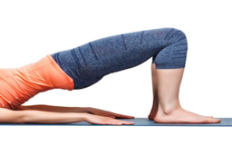  closed chain, single plane | 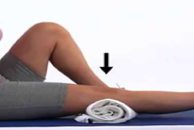  Open chain, single plane | 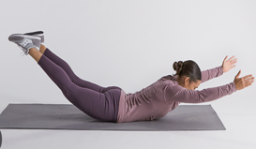  Open chain, multi plane | 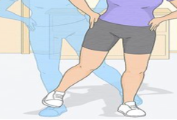  closed chain, multi plane | 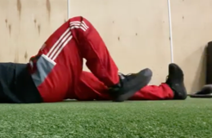  closed chain, single plane | 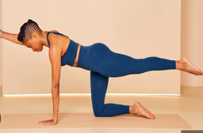  Closed chain, multi plane
 | AM | On back, bent knees and lift. 40% effort, slow controlled movement, 8x3. | Towel under the knee, contract quads/push knee into the towel. 3x10. | On front, lift both legs and both arms at same time, hold for 3s. 8x2. | Stand on one leg and shift weight from one leg to the other. 10x3. | Knee at 60°, Isometric hold, 3x8 holds, each hold to be 5s long. 30% effort. | Alternate arms and legs lifting, hold for 2 seconds, 30 seconds work, 15 seconds rest.
 | PM | Walking backwards in pool | Hamstring curls in pool | Leg swings in pool | Kickboard glute squeeze | Side leg swings in pool | Single leg stands in pool
 | PM | 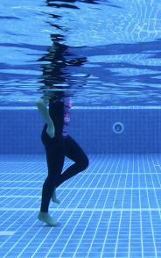  CC, MP | 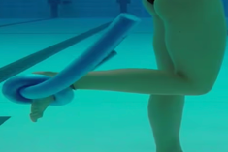  OC, SP | 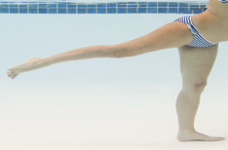  OC,SP | 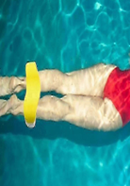  CC, SP | 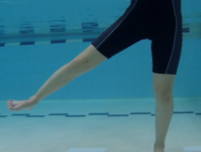  OC, SP | 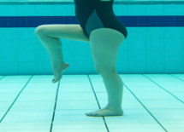  CC, MP
 | PM | Walk for 1 minute x 3. | 10x3, controlled movements. | 10x3, slow controlled movements, minimise rotation at trunk | Hold squeeze for 20 seconds x 3 | 10x3, slow controlled movements. | Hold single leg for 20 seconds, then swap legs. 30sx4.
Thursday  Week 1  Aim = Initiate gentle hamstring strengthening and improve range of motion  Aim = Strengthen surrounding musculature to support the injured limb | AM | Prone knee flexion with band | Clamshells with band | Donkey kicks | Seated backward heel drag | Z stretches
 | AM | 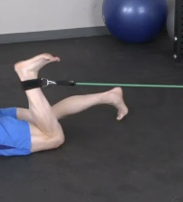  OC, SP | 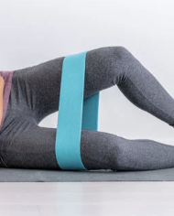  OC, SP | CC, SP | 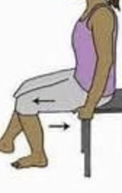  CC, SP | 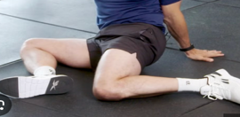  OP,MP
 | AM | Isometric hold, 3x10 holds, each hold to be 5 seconds. | 10x3, don’t roll back, controlled. 60s rest. Band on knees | On hands and knees, gently kick back one leg at a time. 3x10 | On a chair, alternate heel drags towards the chair. 3x10 | Sit with hips and knees and 90/90, rotate from side to side. 30s x3. 15 seconds rest
 | PM | Straight leg raise hold | Banded knee extension | Bridge pulses | Lateral walks with band
 | PM | 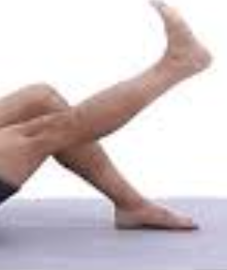  OC, SP | 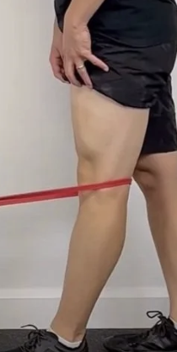  OC, SP |   CC, SP | 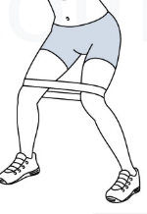  CC, MP
 | PM | Straight leg raise up to 30°. Hold for 15 seconds. 10x2. | Band round the back of the knee and full straighten leg. 10x3 | Lie on back, raise bum off floor and pulse up and down. 3x20s. 1min rest | Place a band round the knees, walk side to side. 3x30s. 30s rest.

Friday  Week 1  Aim = Maintain cardiovascular fitness and upper body conditioning  AMRAP 45 MINUTES  Aim = Reinforce hamstring activation and introduce light functional movement | AM | Circuit-AMRAP  Seated Ski erg | Circuit - AMRAP  Sit ups | Circuit - AMRAP  Seated plate hold | Circuit -AMRAP Seated battle ropes | Circuit -AMRAP Russian twists | CIRCUIT – AMRAP Seated med ball throws
 | AM | 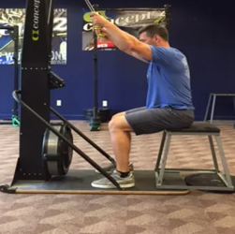 | 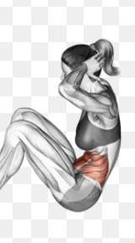 | 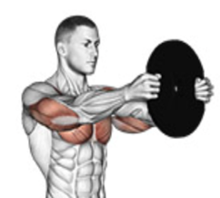 |  | 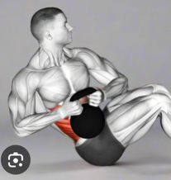 | 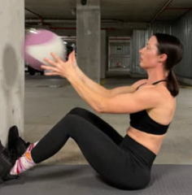
 | AM | 30 seconds maximum effort. | 15 sit ups, minimise leg engagement as much as possible. | Hold plate for 10 seconds, arms extended with plate at face level. | 30 seconds maximal effort | Keep feel on the floor, hold a light kettlebell. 10 twists. | Throw med ball to the wall, 10 throws.
 | PM | March holds | Donkey kicks | Dead bug holds | Heel digs | Walk on treadmill | Ice bath
 | PM | 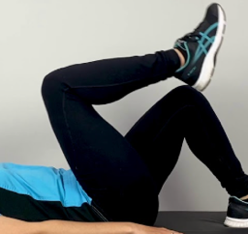  CC,MP | CC, SP | 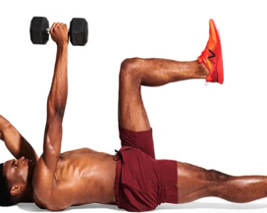  OC, MP | 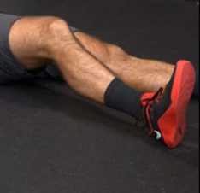  CC, SP | 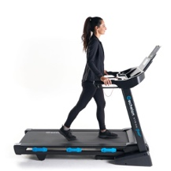  CC, MP
 | PM | Lift one leg up and hold it up. Hold for 5 seconds. 3x8 reps. | On hands and knees, gently kick back one leg at a time. 3x10 | Lie on back, extend alternative arms and leg, hold light weight. 3x12 | Lie on your back with legs straight, dig heel into the floor for 15sx3 | 10 minutes of slow walking on a treadmill, no incline. | 2 minutes after pool to help reduce inflammation.
Saturday  Week 1  Aim = Reduce muscle tension and promote recovery  Aim = Enhance circulation and maintain light movement | AM | Foam rolling – light | Contrast recovery | Bike
 | AM | 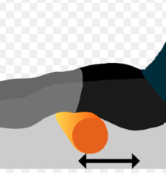 |  | 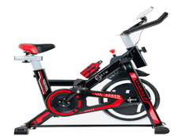  CC,SP
 | AM | 60 seconds x3 per area, surrounding areas. | Warm water or sauna for 3 minutes, then cold water for 1min. x6 | 20 minutes light resistance
 | PM | Soft tissue massage | Walk
 | PM | 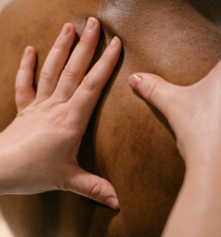 | 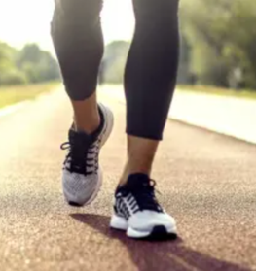
 | PM | 30 minutes of soft tissue massage on lower limb. Avoiding hamstring. | 25 minute walk, conversational pace.

Sunday  Week 1  Aim = Reinforce hamstring activation and improve range of motion  Aim = Promote movement and recovery using low-impact hydrotherapy | AM | Glute squeezes | Prone knee flexion with band | Heel slides | Supine heel digs | March holds | Donkey kicks
 | AM | 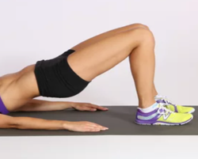  OC, SP | OC, SP | 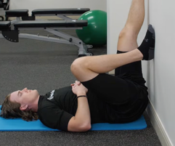  OC, SP | 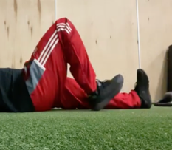  CC, SP | 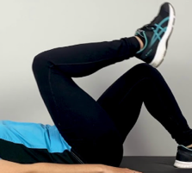  CC, MP | CC, SP
 | AM | Go up into glue bridge and hold for 10s. repeat 3 times. Rest 30s | Isometric hold, 3x10 holds, each hold to be 5 seconds. Rest 30s | Place foot on the wall and drag heels towards bum. Hold for 10s. 3x10 reps. | Knee at 60°, Isometric hold, 3x8 holds, each hold 5s long. 30% effort. | Lift one leg up and hold it up. Hold for 5 seconds. 3x8 reps. | Lift one leg up and hold it up. Hold for 5 seconds. 3x8 reps.
 | PM | Walking backwards in pool | Hamstring curls in pool | Leg swings in pool | Kickboard glute squeeze | Side leg swings in pool | Single leg stands in pool
 | PM | CC, MP | OC, SP | OC,SP | CC, SP | OC, SP | CC, MP
 | PM | Walk for 1 minute x 3. | 10x3, controlled movements. | 10x3, slow controlled movements, minimise rotation at trunk | Hold squeeze for 20 seconds x 3 | 10x3, slow controlled movements. | Hold single leg for 20 seconds, then swap legs. 30sx4.
Aim of week 1: To restore pain-free range of motion, reduce inflammation, and initiate gentle hamstring activation while maintaining overall fitness. (admission = controlled pain, swelling and have movement)(exit= improved AROM and no increased swelling or pain).
Monday  Week 2  Aim = Progress hamstring activation and introduce controlled strengthening  Aim = Improve lower limb control and neuromuscular coordination | AM | Supported standing hamstring curl | Side lying hip abduction | Heel digs | Seated backward heel drag | Bridge pulses | Clamshells with band
 | AM | 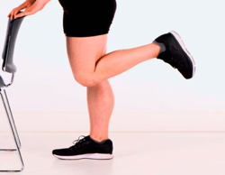  OC, SP | 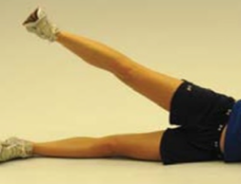  OC, SP | 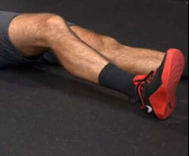  CC, SP | CC, SP | 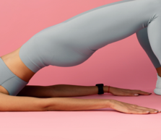  CC, SP | OC, SP
 | AM | Hold onto the chair, lift leg so knee is at 90° and hold for 5 seconds. 3x10. | 3x10, hold for 5 seconds, 60s rest. | Lie on your back with legs straight, dig heel into the floor for 15sx3 | On a chair, alternate heel drags towards the chair. 3x10 | Lie on back, raise bum off floor and pulse up and down. 3x20s. 1min rest | 10x3, don’t roll back, controlled. 60s rest. Band on knees
 | PM | Double leg glute bridge | Quad contractions | Superman’s | Weight shifts | Supine heel digs | Bird dogs
 | PM | 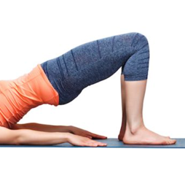  CC, SP | 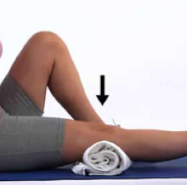  OC, SP | 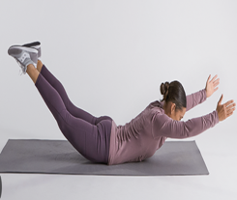  OC, MP | 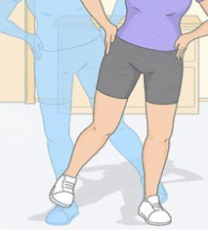  CC, MP | 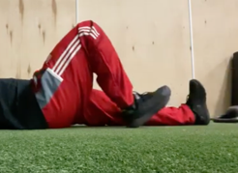  CC, SP | 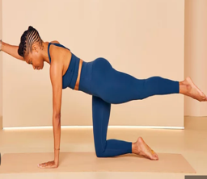  CC, MP
 | PM | On back, bent knees and lift. 40% effort, slow controlled movement, 8x3. | Towel under the knee, contract quads/push knee into the towel. 3x10. | On front, lift both legs and both arms at same time, hold for 3s. 8x2. | Stand on one leg and shift weight from one leg to the other. 10x3. | Knee at 60°, Isometric hold, 3x8 holds, each hold 5s long. 50% effort. | Alternate arms and legs lifting, hold for 2s, 30s work, 15s rest.
Tuesday  Week 2  Aim = Maintain upper body strength and conditioning  Aim = Reinforce hamstring activation and reintroduce functional movement patterns | AM | Seated battle ropes | Seated shoulder press | Cable chest flys | Lat Rows | Triceps pushdowns | Seated Bicep curls
 | AM |  | 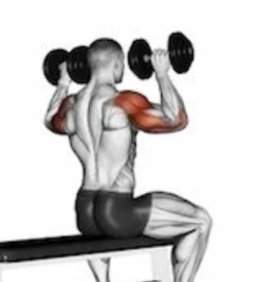 | 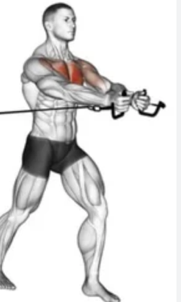 | 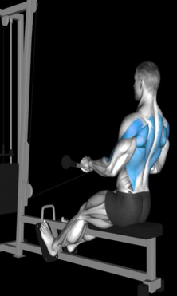 |  | 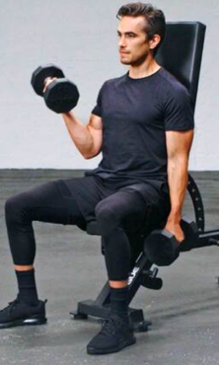
 | AM | 20 seconds working, 40 seconds rest, 8 rounds. | 3x10, seated with or without back support. | 3x10, avoid leg drive when bringing arms in. | 3x10, avoid using legs to gain momentum. | 3x10, avoid leaning or using leg movements. | 3x10, avoid leg drive, keep elbows in.
 | PM | March holds | Donkey kicks | Dead bug holds | Heel digs | Walk on treadmill | Ice bath
 | PM | 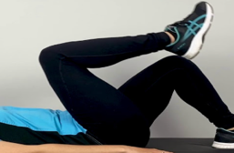  CC, MP | CC, SP | 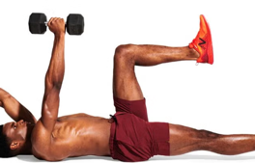  OC, MP | 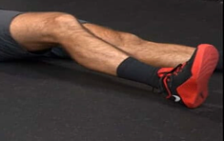  CC, SP | 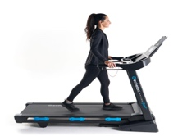  CC, MP
 | PM | Lift one leg up and hold it up. Hold for 5 seconds. 3x8 reps. | On hands and knees, gently kick back one leg at a time. 3x10 | On back, extend alternative arms and leg, hold light weight. 3x12 | Lie on your back with legs straight, dig heel into the floor for 15sx3 | 10 minutes of slow walking on a treadmill, no incline. | 2 minutes after pool to help reduce inflammation.

Wednesday  Week 2  Aim = Maintain cardiovascular fitness using low-impact modalities  Aim = Promote recovery and improve gait mechanics | AM | Seated ski erg for time – 10,20,30,20,10
 | AM | 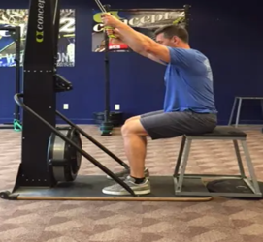  OC, MP
 | AM | Burn 10 calories then 30s rest, then burn 20 calories then 30s rest and so on.
 | PM | Pool session | Ice bath | Light foam rolling
 | PM |  |  | 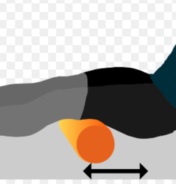
 | PM | Vertical Hydrotherapy, walking lengths of the pool for 30 minutes. | 2 minutes after pool to help reduce inflammation. | 60 seconds x3 per area,  Very light on hamstring
Thursday  Week 2  Aim = Progress hamstring strengthening and increase range of motion  Aim = Restore movement patterns through controlled hydrotherapy | AM | Prone knee flexion with band | Clamshells with band | Donkey kicks | Seated backward heel drag | Z stretches
 | AM | OC, SP | OC, SP | OC, MP | OC, SP | 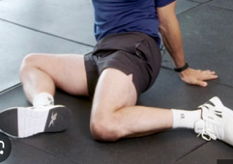  OC, SP
 | AM | Isometric hold, 3x10 holds, each hold to be 5 seconds. | 10x3, don’t roll back, controlled. 60s rest. Band on knees | On hands and knees, gently kick back one leg at a time. 3x10 | On a chair, alternate heel drags towards the chair. 3x10 | Sit with hips and knees 90/90, rotate from side to side. 30s x3. 15s rest
 | PM | Walking backwards in pool | Hamstring curls in pool | Leg swings in pool | Kickboard glute squeeze | Side leg swings in pool | Single leg stands in pool
 | PM | CC, MP | OC, SP | OC,SP | CC, SP | OC, SP | CC, MP
 | PM | Walk for 1 minute x 3. | 10x3, controlled movements. | 10x3, slow controlled movements, minimise rotation at trunk | Hold squeeze for 20 seconds x 3 | 10x3, slow controlled movements. | Hold single leg for 20 seconds, then swap legs. 30sx4.

Friday  Week 2  Aim = Strengthen quadriceps and glutes to support lower limb function  Aim = Improve overall lower limb coordination and stability | AM | Straight leg raise hold | Banded knee extension | Bridge pulses | Lateral walks with band | Monster walks | Ice bath
 | AM | OC, SP | OC, SP | CC, SP | CC, MP | 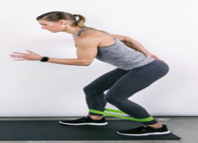  CC, SP
 | AM | Straight leg raise up to 30°. Hold for 15 seconds. 10x2. | Band round the back of the knee and full straighten leg. 10x3 | Lie on back, raise bum off floor and pulse up and down. 3x20s. 1min rest | Place a band round the knees, walk side to side. 3x30s. 30s rest. | Band round ankle, walk slow and controlled, 8 steps per leg. X3 | 2 minutes after pool to help reduce inflammation.
 | PM | Double leg glute bridge | Quad contractions | Superman’s | Weight shifts | Supine heel digs | Bird dogs
 | PM | CC, SP | OC, SP | 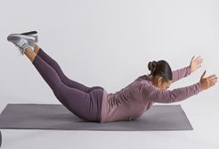  OC, MP | 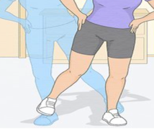  CC, MP | 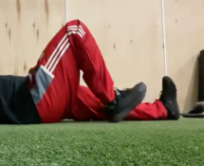  CC, SP | 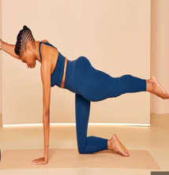  CC, MP
 | PM | On back, bent knees and lift. 40% effort, slow controlled movement, 8x3. | Towel under the knee, contract quads/push knee into the towel. 3x10. | On front, lift both legs and both arms at same time, hold for 3s. 8x2. | Stand on one leg and shift weight from one leg to the other. 10x3. | Knee at 60°, Isometric hold, 3x8 holds, each hold to be 5s long. 50% effort. | Alternate arms and legs lifting, hold for 2 seconds, 30s work, 15 seconds rest.
Saturday  Week 2  Aim = Promote recovery and reduce muscle tightness  Aim = Maintain hip and trunk mobility | AM | Soft tissue massage | Walk
 | AM | 30 minutes of soft tissue massage on lower limb. Avoiding hamstring. | 25 minute walk, conversational pace.
 | PM | Clam shells | Side lying hip abduction | Adductor squeezes | Lower back rotation | Ice bath
 | PM | 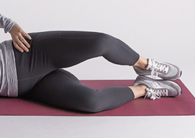  Open chain, single plane | Open chain, single plane | Closed chain, single plane | Open chain, multi plane
 | PM | 12x3, don’t roll backwards, controlled. 60s rest. | 3x10, hold for 5 seconds, 60s rest. | 3x8, hold the squeeze for 5 seconds. 40% squeeze. 60s rest | 3x10, slow and controlled movement, 60s rest. | 2 minutes after pool to help reduce inflammation.
Sunday  Week 2  Aim = Progress hamstring strength and range of motion  Aim = Introduce controlled strengthening of lower limb functional patterns | AM | Glute squeezes | Prone knee flexion with band | Heel slides | Supine heel digs | March holds | Donkey kicks
 | AM | OC, SP | OC, SP | OC, SP | CC, SP | CC, MP | 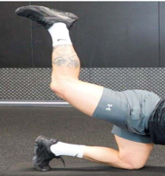  CC, SP
 | AM | Go up into glue bridge and hold for 10s. repeat 3 times. Rest 30s | Isometric hold, 3x10 holds, each hold to be 7 seconds. Rest 30s | Place foot on the wall and drag heels towards bum. Hold for 10s. 3x10 reps. | Knee at 60°, Isometric hold, 3x10 holds, each hold 5s long. 50% effort. | Lift one leg up and hold it up. Hold for 7 seconds. 3x8 reps. | Lift one leg up and hold it up. Hold for 7 seconds. 3x8 reps.
 | PM | Dead bug holds | Calf raises | Leg extension | Chair squat | Ice bath
 | PM | 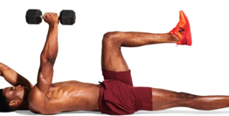  OC, MP | 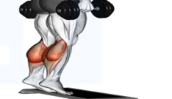  CC, SP | 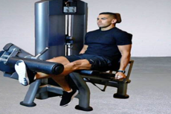  OC, SP | 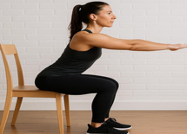  CC, SP
 | PM | On back, extend alternative arms and leg, hold light weight. 3x12 | Feet on a step or plate, full range at top ad bottom. 3x12 | Single leg, Hold at end extension, assist flexion with other leg. 3x10 | Squat down onto a chair. Controlled and slow. 3x8 | 2 minutes after pool to help reduce inflammation.
Aim of week 2: To progress hamstring activation and early strengthening while improving movement control and maintaining mobility and conditioning. (exit= and can perform low intensity isometrics without discomfort).
Monday  Week 3  Aim = Maintain aerobic fitness and promote recovery  Aim = Introduce controlled lower limb strengthening exercises | AM | Bike | Foam rolling – light | Contrast recovery
 | AM | 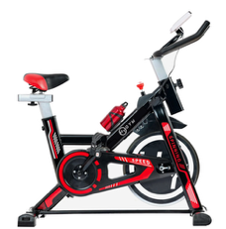  CC, SP
 | AM | 15 minutes, low resistance | 60 seconds x3 per area, surrounding areas. | Warm water or sauna for 3 minutes, then cold water for 1min. x6
 | PM | Wall sit | Heel elevated mini squat | Double leg glute bridge with march | Hamstring curl
 | PM | 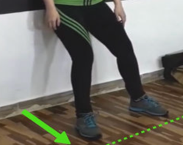  CC, SP | 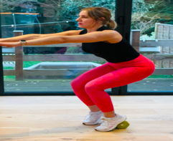  CC, SP | 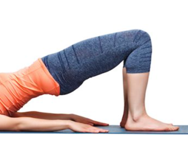  CC,MP | 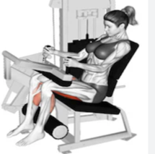  OC, SP
 | PM | Knees at 120°, hold for 20 seconds x 3 | Heels on a small plate, slow controlled squat to 120°. 3x8 | On back, bent knees and lift. Hold and march, controlled, 8x3. | Low weight, double leg, slow controlled. 3x8
Tuesday  Week 3  Aim = Introduce resistance through low-impact aquatic exercises  Aim = Progress hamstring strength and introduce functional loading | AM | Kick outs in pool | Hamstring curls in pool | Walking backwards in pool | Lateral water walking | Flutter kicks in pool
 | AM | OC, SP | 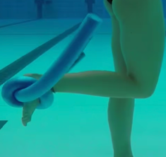  OC, SP | CC, MP | 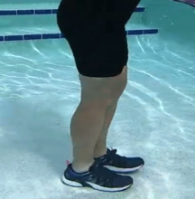  CC, SP | 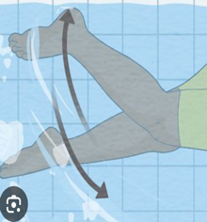  OC, SP
 | AM | Walking widths of the pool kicking leg out slowly and controlled. 30s x 5 | 10x3, controlled movements. | Walk for 1 minute x 3. | Walking sideways, controlled movement. 30s x 5. | Hold on to side of pool and slowly kick legs. 30s x5.
 | PM | Supine heel digs | Prone knee flexion with band | Clamshells with band | Donkey kicks on cable machine | Step ups
 | PM | CC, SP | OC, SP | OC, SP | CC, SP | 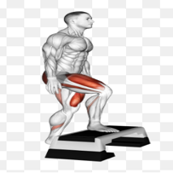  CC, SP
 | PM | Knee at 60°, Isometric hold, 3x8 holds, each hold to be 5s long. 70% effort. | Isometric hold, 3x10, each hold to be 7 seconds. Rest 30s | 10x3, don’t roll back, controlled. 60s rest. Band on knees | Foot tied to the cable, gently kick back one leg at a time, light weight. 3x10 | Slow and controlled on a shallow step. 3x8

Wednesday  Week 3  Aim = Improve balance and proprioception  Aim = Reinforce lower limb strength and movement control | AM | Double leg balance with eyes closed | Around the clock | Resistance band around waist | Lateral step and hold | Tandem balance
 | AM | 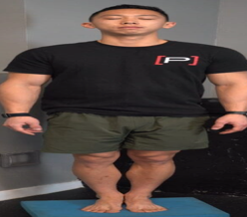  CC, MP | 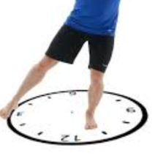  CC, MP | 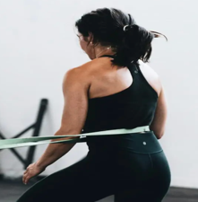  CC, MP | 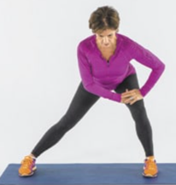  CC, MP | 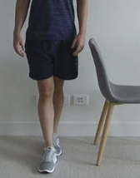  CC, SP
 | AM | Stand with feet shoulder width apart and close eyes. 30s x 5 | Stand on one leg and tap ankle to each number on a clock on the floor. X4 EL | Stand with 2 resistance bands around waist under tension.. 30s x4 | Laterally step and hold for 10s, only a shallow step. 10s x 5 | Stand one foot in front of the other touching and balance. 30s x 5
 | PM | Wall sit | Heel elevated mini squat | Double leg glute bridge with march | Hamstring curl | Donkey kicks cable machine | Chair squat
 | PM | CC, SP | CC, SP | CC,MP | OC, SP | CC, SP | CC, SP
 | PM | Knees at 120°, hold for 20 seconds x 3 | Heels on a small plate, slow controlled squat to 120°. 3x8 | On back, bent knees and lift. Hold and march, controlled, 8x3. | Low weight, double leg, slow controlled. 3x8 | Foot tied to the cable, gently kick back one leg at a time, light weight. 3x10 | Squat down onto a chair. Controlled and slow. 3x8
Thursday  Week 3  Aim = Maintain aerobic conditioning and mobility  Aim = Promote recovery and reduce muscle tightness | AM | Pool session | Ice bath | Light foam rolling
 | AM |  | 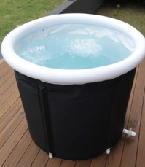 | 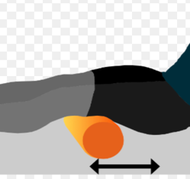
 | AM | Vertical Hydrotherapy, walking lengths of the pool for 30 minutes. | 2 minutes after pool to help reduce inflammation. | 60 seconds x3 per area,  light on hamstring
 | PM | Bike | Soft tissue massage
 | PM | CC, SP
 | PM | 15 minutes, low resistance | 30 minutes of soft tissue massage on lower limb. Light on hamstring.

Friday  Week 3  Aim = Maintain aerobic fitness through low-impact activity  Aim = Maintain upper body strength and conditioning | AM | Kick outs in pool | Hamstring curls in pool | Walking backwards in pool | Lateral water walking | Flutter kicks in pool
 | AM | OC, SP | OC, SP | CC, MP | CC, SP | OC, SP
 | AM | Walking widths of the pool kicking leg out slowly and controlled. 30s x 5 | 10x3, controlled movements. | Walk for 1 minute x 3. | Walking sideways, controlled movement. 30s x 5. | Hold on to side of pool and slowly kick legs. 30s x5.
 | PM | Seated battle ropes | Seated shoulder press | Cable chest flys | Lat Rows | Triceps pushdowns | Seated Bicep curls
 | PM |  | 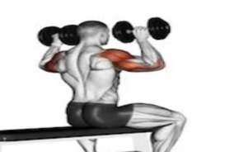 | 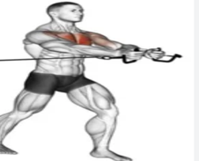 | 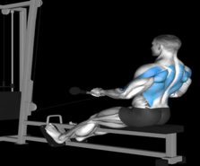 |  | 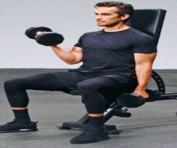
 | PM | 20 seconds working, 40 seconds rest, 8 rounds. | 3x10, seated with or without back support. | 3x10, avoid leg drive when bringing arms in. | 3x10, avoid using legs to gain momentum. | 3x10, avoid leaning or using leg movements. | 3x10, avoid leg drive, keep elbows in.
Saturday  Week 3  Aim = Maintain aerobic fitness through circuit training  Aim = Improve mobility and introduce gentle stretching | AM | Circuit-AMRAP  Seated Ski erg | Circuit - AMRAP  Sit ups | Circuit - AMRAP  Seated plate hold | Circuit -AMRAP Seated battle ropes | Circuit -AMRAP Russian twists | CIRCUIT – AMRAP Seated med ball throws
 | AM | 30 seconds maximum effort. | 15 sit ups, | Hold plate for 10 seconds, arms extended with plate at face level. | 30 seconds maximal effort | Keep feel on the floor, hold a light kettlebell. 10 twists. | Throw med ball to the wall, 10 throws.
 | PM | Z stretches | Assisted Cossack Stretch | Hamstring stretch with band | Assisted Leg swings
 | PM | OC, SP | 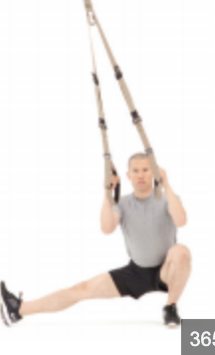  CC, SP | 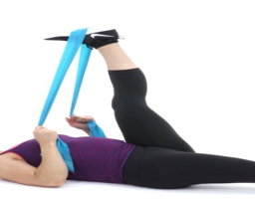  OC, SP | 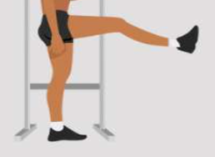  OC, SP
 | PM | Sit with hips and knees 90/90, rotate from side to side. 30s x3. 15s rest | Not deep. Use TRX or resistance band. Hold for 10s x 6 | Very light don’t go full range, use band to guide leg. Hold for 15s x 5. | Hold onto wall. Don’t go full range, 12 swings on each leg x 4.

Sunday  Week 3  Aim = Reinforce lower limb strength and functional movement  Aim = Progress aerobic conditioning through walking | AM | Wall sit | Heel elevated mini squat | Double leg glute bridge with march | Hamstring curl | Donkey kicks on cable machine | Chair squat
 | AM | CC, SP | CC, SP | CC,MP | OC, SP | CC, SP | CC, SP
 | AM | Knees at 120°, hold for 20 seconds x 3 | Heels on a small plate, slow controlled squat to 120°. 3x8 | On back, bent knees and lift. Hold and march, controlled, 8x3. | Low weight, double leg, slow controlled. 3x8 | Foot tied to the cable, gently kick back one leg at a time, light weight. 3x10 | Squat down onto a chair. Controlled and slow. 3x8
 | PM | Walking on treadmill
 | PM | 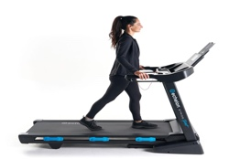  Closed chain  multiplane
 | PM | Slight incline walking not too steep. 25 minutes.
Aim of week 3: To introduce resistance training and develop hamstring strength, balance, and neuromuscular control.(exit= can do light weighted exercises with no increased pain, full rom, improved control).
Monday  Week 4  Aim = Develop eccentric hamstring strength  Aim = Improve balance and neuromuscular control | AM | Hamstring curl | Eccentric heel slides | Eccentric RDL | Eccentric step downs | Bosu balance | Donkey kicks on cable machine
 | AM | OC, SP | CC, SP | 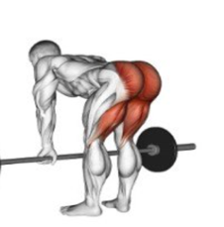  CC, SP | 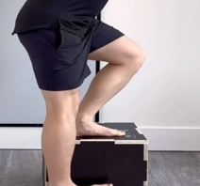  CC, SP | 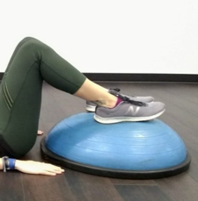  SP, MP | CC, SP
 | AM | Low weight, double leg, slow controlled. 3x8 | Start knees bent, slide heels away from body. 2x10 | Light weight. Hinge going down but come up normally. 3x8 | Step off step slowly, 4 seconds down. 3x8 | Glute bridge with feet on bosu or exercises ball. Hold for 20s x 4 | Foot tied to the cable, gently kick back one leg at a time, light weight. 3x10
 | PM | Double leg balance with eyes closed | Around the clock | Resistance band around waist | Lateral step and hold | Tandem balance
 | PM | 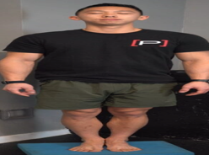  CC, MP | 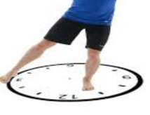  CC, MP | 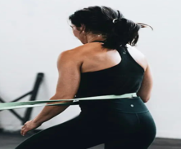  CC, MP | 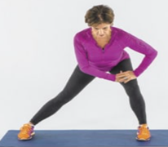  CC, MP | CC, SP
 | PM | Stand with feet shoulder width apart and close eyes. 30s x 5 | Stand on one leg and tap ankle to each number on a clock on the floor. X4 EL | Stand with 2 resistance bands around waist under tension.. 30s x4 | Laterally step and hold for 10s, only a shallow step. 10s x 5 | Stand one foot in front of the other touching and balance. 30s x 5
Tuesday  Week 4  Aim = Use hydrotherapy to strengthen lower limb with reduced load  Aim = Promote recovery and reduce muscle soreness | AM | High knee march in pool | Straight leg raises in pool | Pool lunges | Flutter kicks | Step ups in pool
 | AM | 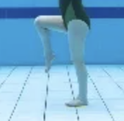  CC, SP | 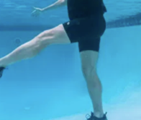  OC, SP | 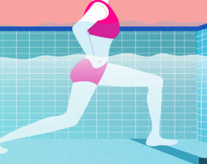  CC, SP | 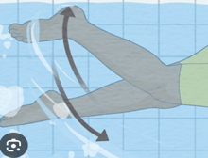  OC, SP | 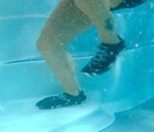  CC, SP
 | AM | Controlled high knee marches. 30s x 4 | Controlled SLR, 3x15 | Forward lunge, controlled, 3x10 | Hold end of pool, 45s x 5 | Step ups, controlled on my up and down. 3x10
 | PM | Bike | Light foam rolling
 | PM | CC, SP
 | PM | 30 minutes, low resistance | 60 seconds x3 per area,  medium on hamstring

Wednesday  Week 4  Aim = Improve lower limb mobility  Aim = Progress eccentric strength and functional control | AM | Z stretches | Assisted Cossack Stretch | Hamstring stretch with band | Assisted Leg swings
 | AM | OC, SP | CC, SP | OC, SP | OC, SP
 | AM | Sit with hips and knees 90/90, rotate from side to side. 30s x3. 15s rest | Not deep. Use TRX or resistance band. Hold for 10s x 6 | Very light don’t go full range, use band to guide leg. Hold for 15s x 5. | Hold onto wall. Don’t go full range, 12 swings on each leg x 4.
 | PM | Hamstring curl | Eccentric heel slides | Eccentric RDL | Eccentric step downs | Bosu balance | Donkey kicks on cable machine
 | PM | OC, SP | CC, SP | CC, SP | CC, SP | SP, MP | CC, SP
 | PM | Low weight, double leg, slow controlled. 3x10 | Start knees bent, slide heels away from body. 2x10 | Light weight. Hinge going down but come up normally. 3x8 | Step off step slowly, 4 seconds down. 3x10 | Glute bridge with feet on bosu or exercises ball. Hold for 20s x 4 | Foot tied to the cable, gently kick back one leg at a time, light weight. 3x10
Thursday  Week 4  Aim = Maintain aerobic conditioning and lower limb strength  Aim = Maintain upper body strength | AM | Monster walks | Wall sit | Heel elevated mini squat | Supine heel digs | Prone knee flexion with band | Clamshells with band
 | AM | CC, SP | CC, SP | CC, SP | CC, SP | OC, SP | OC, SP
 | AM | Band round ankle, walk slow and controlled, 8 steps per leg. X3 | Knees at 120°, hold for 20 seconds x 3 | Heels on a small plate, slow controlled squat to 120°. 3x8 | Knee at 60°, Isometric hold, 3x8 holds, each hold to be 5s long. 70% effort. | Isometric hold, 3x10, each hold to be 7 seconds. Rest 30s | 10x3, don’t roll back, controlled. 60s rest. Band on knees
 | PM | Seated battle ropes | Seated shoulder press | Chest press | Seated lateral raises | Triceps pushdowns | Seated Bicep curls
 | PM | Closed chain  Multi plane | 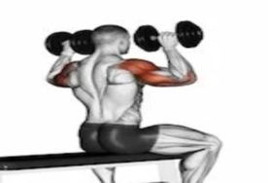  Open chain  Single plane | 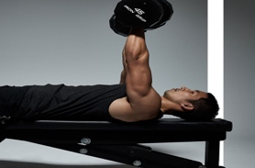  Open chain, single plane |   Open chain, single plane | Open chain, single plane | 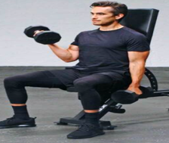  Open chain, single plane.
 | PM | 30 seconds working, 20 seconds rest, 8 rounds. | 3x10, seated with or without back support. | 3x10, hold at bottom for 2s | 3x10, slight bend in elbows, avoid swinging | 3x10, avoid leaning/ hinge at hips | 3x10, keep elbows in.

Friday  Week 4  Aim = Progress eccentric strength and functional movement patterns  Aim = Enhance balance and dynamic stability | AM | Eccentric heel slides | Eccentric RDL | Eccentric step downs | Bosu balance | Double leg glute bridge with march | Chair squat
 | AM | CC, SP | CC, SP | CC, SP | SP, MP | 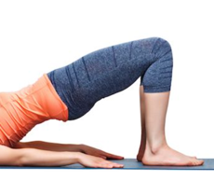  CC,MP | CC, SP
 | AM | Start knees bent, slide heels away from body. 3x10 | Light weight. Hinge going down but come up normally. 3x10 | Step off step slowly, 4 seconds down. 3x8 | Glute bridge with feet on bosu or exercises ball. Hold for 20s x 4 | On back, bent knees and lift. Hold and march, controlled, 8x3. | Squat down onto a chair. Controlled and slow. 3x10
 | PM | Single leg balance | Tandem balance with ball throw | Heel to toe walk | Bosu lateral shifts
 | PM | 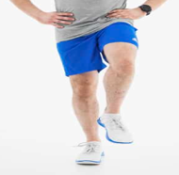  CC, SP | CC, SP | CC, SP | 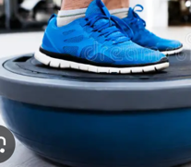  CC, MP
 | PM | Stand on one leg for 30s x5. | Stand one foot in front of the other touching and balance whilst catching ball. 30s x 5 | Eyes forwards, take 20 steps x 5 | Stand on bosu ball, shift weight from one leg to other. 30sx4
Saturday  Week 4  Aim = Maintain aerobic conditioning  Aim = Reinforce lower limb strength using hydrotherapy | AM | Walking on treadmill | Soft tissue massage
 | AM | Closed chain  multiplane
 | AM | Slight incline walking. 35 minutes. | 30 minutes of soft tissue massage on lower limb.
 | PM | High knee march in pool | Straight leg raises in pool | Pool lunges | Flutter kicks | Step ups in pool
 | PM | CC, SP | OC, SP | CC, SP | OC, SP | CC, SP
 | PM | Controlled high knee marches. 30s x 4 | Controlled SLR, 3x15 | Forward lunge, controlled, 3x10 | Hold end of pool, 45s x 5 | Step ups, controlled on my up and down. 3x10
Sunday  Week 4  Aim = Progress hamstring strength with increased load  Aim = Maintain cardiovascular fitness and upper body conditioning | AM | Hamstring curl | Eccentric heel slides | Eccentric RDL | Eccentric step downs | Bosu balance | Donkey kicks on cable machine
 | AM | OC, SP | CC, SP | CC, SP | CC, SP | CC, SP | CC, SP
 | AM | Increase weight slightly, double leg, slow controlled. 3x8 | Start knees bent, slide heels away from body. 3x8 | Light weight. Hinge going down but come up normally. 3x10 | Step off step slowly, 4 seconds down. 3x10 | Glute bridge with feet on bosu or exercises ball. Hold for 20s x 4 | Foot tied cable, gently kick back one leg at a time, increase weight. 3x10
 | PM | Circuit-AMRAP  Seated Ski erg | Circuit - AMRAP  Sit ups | Circuit - AMRAP  Seated plate hold | Circuit -AMRAP Seated battle ropes | Circuit -AMRAP Russian twists | CIRCUIT – AMRAP Seated med ball throws
 | PM | 30 seconds maximum effort. | 15 sit ups, minimise leg engagement as much as possible. | Hold plate for 10 seconds, arms extended with plate at face level. | 30 seconds maximal effort | Keep feel on the floor, hold a light kettlebell. 10 twists. | Throw med ball to the wall, 10 throws.
Aim of week 4: To build eccentric hamstring strength and improve dynamic stability and functional movement patterns. (exit= can tolerate load with no pain, can control eccentric movements).
Monday  Week 5  Aim = Develop strength and introduce moderate resistance  Aim = Improve lower limb mobility and flexibility | AM | Cross trainer | Hamstring curl | Single leg glute bridge | Bosu balance | Weighted hip thrusts | Swiss ball curl
 | AM | 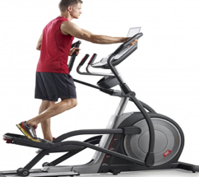  CC, SP | OC, SP | CC, SP | CC, SP | 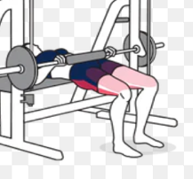  CC, SP | 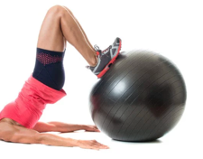  CC, SP
 | AM | 10 minutes easy pace, low resistance. | Increase weight slightly, double leg, slow controlled. 3x8 | Hold for 15sx 4 on each leg | Glute bridge with feet on bosu or exercises ball. Hold for 30s x 4 | Use smith machine, just bar. 3x8. | Curl ball towards body and then reset. Only do pull in phase. 3x8
 | PM | Z stretches | Assisted Cossack Stretch | Hamstring stretch with band | Assisted Leg swings
 | PM | OC, SP | CC, SP | OC, SP | 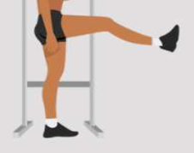  OC, SP
 | PM | Sit with hips and knees 90/90, rotate from side to side. 30s x3. 15s rest | Slightly deeper. Use TRX or resistance band. Hold for 10s x 6 | Use band to guide leg. Hold for 15s x 5. | Hold onto wall. Close to full range. 12 swings on each leg x 4.
Tuesday  Week 5  Aim = Progress functional hamstring strength and introduce higher load  Aim = Maintain core stability and trunk strength | AM | Hamstring walk outs | Lunges | RDL | Banded Nordics | Step downs | Eccentric heel slides
 | AM | 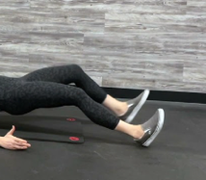  CC, SP | 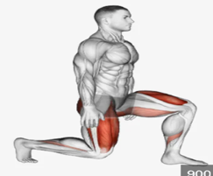  CC, SP | CC, SP | 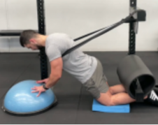  CC, SP | CC, SP | CC, SP
 | AM | Only the walking in phase. 3x8 | Body weight. 3x 10 | Just the bar, slow and controlled. 3x8 | Use band when going forward. Controlled lowering. 3x8 | Holding light weight. Step off step slowly, 4 seconds down. 3x10 | Start knees bent, slide heels away from body. 3x10
 | PM | Plank | Side plank | Russian twists | Pavlov press
 | PM | 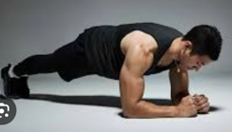  CC, MP | 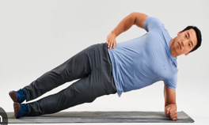  CC, SP | 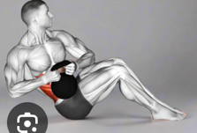  OC, MP | 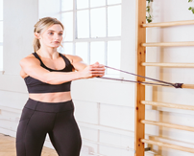  OC, MP
 | PM | 30s hold, x3 | 30s hold, x2 each side. | Hold kettlebell, lift legs off the floor. 3x15 | Hold band under tension at chest, push out and extend arms. 3x10.

Wednesday  Week 5  Aim = Maintain aerobic conditioning  Aim = Progress lower limb strength and functional movement | AM | Bike | Light foam rolling
 | AM | CC, SP
 | AM | 30 minutes, resistance 7. | 60 seconds x3 per area,  medium on hamstring
 | PM | RDL | Single leg glute bridge | Body weight squat | Wall sit | Cable pull throughs | Weighted hip thrusts
 | PM | CC, SP | 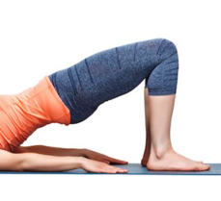  CC, SP | 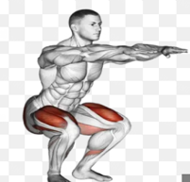  CC, SP | 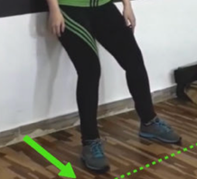  CC, SP | 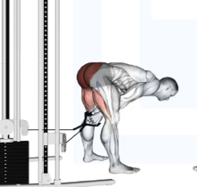  CC, SP | CC, SP
 | PM | Just the bar, slow and controlled. 3x10 | Hold for 15sx 4 on each leg | 3x8, slow and controlled, full rom. | Knees at 90°, hold for 30 seconds x 3 | Cable between legs, hinge forward and stand back up. Slight weight. 3x10 | Use smith machine, just bar. 3x10
Thursday  Week 5  Aim = Develop strength and control through hydrotherapy  Aim = Progress lower limb strength with resistance | AM | Butt kicks in pool | Single leg balance with ball throw (pool) | Single leg squat in pool | Flutter kicks | Pool lunges
 | AM | 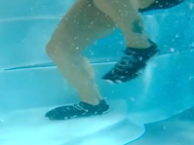  OC, SP | 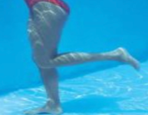  CC, MP | 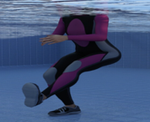  CC, SP | OC, SP | CC, SP
 | AM | Bring heels to glute controlled. 3x12 | Stand on one leg and catch and pass a ball. 3x12 | Hold onto side of pool and squat to 90°, 3x8 | Hold end of pool, 45s x 5 | Forward lunge, controlled, 3x10
 | PM | Cross trainer | Hamstring curl | Single leg glute bridge | Bosu balance | Weighted hip thrusts | Swiss ball curl
 | PM | CC, SP | OC, SP | 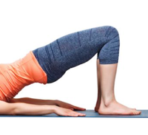  CC, SP | 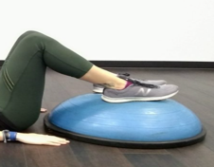  CC, SP | CC, SP | CC, SP
 | PM | 10 minutes easy pace, low resistance. | Increase weight slightly, double leg, slow controlled. 3x10 | Hold for 30s x 4 on each leg | Glute bridge with feet on bosu or exercises ball. Hold for 30s x 4 | Use smith machine, just bar. 3x10 | Curl ball towards body and then reset. 3x10

Friday  Week 5  Aim = Progress hamstring strength and eccentric control  Aim = Maintain upper body strength and conditioning | AM | RDL | Single leg  Heel slides | Hamstring curl | Banded Nordics | Step downs
 | AM | CC, SP | CC, SP | OC, SP | CC, SP | CC, SP
 | AM | Add weight, slow and controlled. 3x10 | Start knees bent, slide heels away from body. 3x8 | Increase weight slightly, double leg, slow controlled. 3x10 | Use band when going forward. Controlled lowering. 3x8 | Holding light weight. Step off step slowly, 4 seconds down. 3x10
 | PM | battle ropes | Seated shoulder press | Chest press | Seated lateral raises | Triceps pushdowns | Seated Bicep curls
 | PM | Closed chain  Multi plane | Open chain  Single plane | Open chain, single plane | Open chain, single plane | Open chain, single plane | Open chain, single plane.
 | PM | Squat at 90°, 30 seconds working, 15 seconds rest, 8 rounds. | 3x10, seated with or without back support. | 3x10, hold at bottom for 2s | 3x10, slight bend in elbows, avoid swinging | 3x10, avoid leaning/ hinge at hips | 3x10, keep elbows in.
Saturday  Week 5  Aim = Maintain aerobic fitness  Aim = Promote recovery | AM | Cross trainer | Ski erg
 | AM | CC, SP | 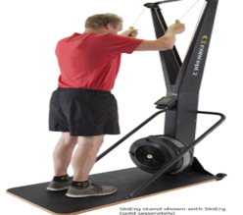  CC, MP
 | AM | 15 minutes easy pace, medium resistance. | 30 second intervals with 30 second rest. X8
 | PM | Ice bath | Light foam rolling
 | PM | 3 minutes | 60 seconds x3 per area

Sunday  Week 5  Aim = Reintroduce running and functional lower limb strength  Aim = Progress eccentric strength and functional control | AM | Running on treadmill | Weighted hip thrusts | Single leg glute bridge | Body weight squat | Wall sit | Cable pull throughs
 | AM | Closed chain  multiplane | CC, SP | CC, SP | CC, SP | CC, SP | CC, SP
 | AM | 15 minutes of slow jogging | Use smith machine, add weight. 3x8 | Hold for 30s x 4 on each leg | 3x10, slow and controlled, full rom. | Knees at 90°, hold for 30 seconds x 3 | Cable between legs, hinge forward and stand back up. Slight weight. 3x10
 | PM | Banded Nordics | Step downs | Lunges | Cable pull throughs | Soft tissue massage
 | PM | CC, SP | CC, SP | CC, SP | CC, SP
 | PM | Use light band when going forward. Controlled lowering. 3x10 | Holding light weight. Step off step slowly, 4 seconds down. 3x10 | Body weight. 3x 10 | Cable between legs, hinge forward and stand back up. Slight weight. 3x10 | 30 minutes of soft tissue massage on lower limb.
Aim of week 5: To develop advanced strength, introduce higher load and single-leg work, and begin return-to-running activities. (exit= good strength and joint control for single leg work, no pain or instability).
Monday  Week 6  Aim = Develop advanced hamstring strength and functional capacity  Aim = Maintain aerobic fitness and promote recovery | AM | Hamstring curl | Weighted hip thrusts | Hamstring walk outs | Bosu balance | Squat | Lunges
 | AM | OC, SP | CC, SP | CC, SP | CC, SP | 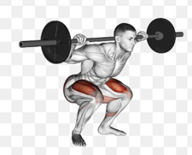  CC, SP | 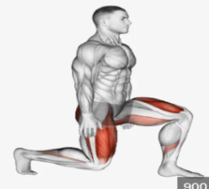  CC, SP
 | AM | Increase weight slightly, single leg, slow controlled. 3x8 | Use smith machine, add weight. 3x10 | Full range,  3x10 | Single leg, Glute bridge with feet on bosu or exercises ball. Hold for 30s x 4 | Squat with just the bar, 3x10 | Carry light dumbbells in each hand. 3x8
 | PM | Cross trainer | Ice bath | Light foam rolling
 | PM | CC, SP
 | PM | 10 minutes easy pace, low resistance. | 2 minutes after pool to help reduce inflammation. | 60 seconds x3 per area,  light on hamstring
Tuesday  Week 6  Aim = Progress single-leg strength and functional control  Aim = Enhance balance and neuromuscular coordination | AM | Single leg  Heel slides | RDL | Nordics | Swiss ball curl | Cable pull throughs | Squat
 | AM | CC, SP | CC, SP | 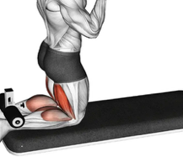  CC, SP | CC, SP | CC, SP | CC, SP
 | AM | Start knees bent, slide heels away from body. 3x8 | Single leg, no weight, slow and controlled. 3x8 | Slow and controlled. 3x8 | Curl ball towards body and then reset. 3x10 | Cable between legs, hinge forward and stand back up. increase weight. 3x10 | Squat with just the bar, 3x10
 | PM | Single leg balance with eyes closed | Around the clock with ball | Resistance band around waist | Lateral step and hold | Tandem balance
 | PM | CC, MP | CC, MP | CC, MP | CC, MP | 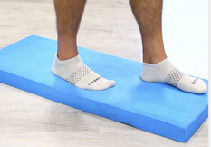  CC, SP
 | PM | Stand with feet shoulder width apart and close eyes. 30s x 5 | Stand on one leg and tap ankle to each number on a clock on the floor whilst catching a ball X4 EL | Stand with 4 resistance bands around waist under tension. Throw ball in hoop 30s x4 | Laterally step and hold for 10s, deep step 10s x 5 | Stand one foot in front of the other touching and balance on foam pad. 30s x 5

Wednesday  Week 6  Aim = Progress aerobic fitness through running  Aim = Develop unilateral strength and stability | AM | Running on treadmill
 | AM | Closed chain  multiplane
 | AM | 25 minutes of slow jogging
 | PM | Lunges | Split squat | Single leg hip thrusts | Hamstring curl | Single leg bosu balance
 | PM | CC, SP | 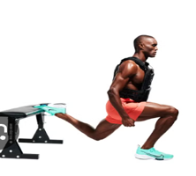  CC, SP | CC, SP | OC, SP | CC, SP
 | PM | Carry light dumbbells in each hand. 3x10 | Body weight, 3x8 | Use smith machine, no weight, 3x8 | Increase weight slightly, single leg, slow controlled. 3x10 | Stand on one leg and balance  3x 10s each leg.
Thursday  Week 6  Aim = Improve mobility and dynamic movement patterns  Aim = Promote recovery | AM | Inch worm | Straight leg walks | Bear crawl | Shoe the chicken
 | AM | 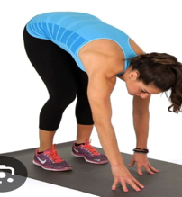  CC, SP | 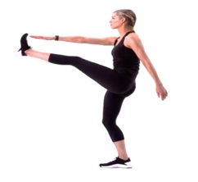  OC, SP | 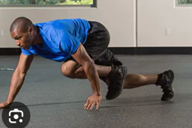  CC, MP | 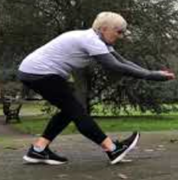  OC, SP
 | AM | Walk hands into plank position, then walk feet to hands. 3x10 | Walk forward kicking leg out straight whilst reaching out. 3x20 | Hands and feet on floor, crawl slowly keeping back straight.  3x15 | Step out, lean torso forward and bring arms to floor to ‘shoe away chickens’ . 3x10
 | PM | Soft tissue massage
 | PM | 30 minutes of soft tissue massage on lower limb.

Friday  Week 6  Aim = Maintain core strength and aerobic fitness  Aim = Progress advanced hamstring strengthening | AM | Plank | Side plank | Russian twists | Pavlov press | Ski erg
 | AM | CC, MP | CC, SP | OC, MP | OC, MP | 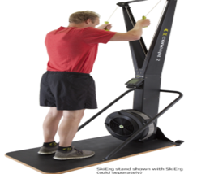  CC, MP
 | AM | 30s hold, x3 | 30s hold, x2 each side. | Hold kettlebell, lift legs off the floor. 3x15 | Hold band under tension at chest, push out and extend arms. 3x10. | 30 second intervals with 30 second rest. X8
 | PM | Single leg  Heel slides | RDL | Nordics | Single leg Swiss ball curl | Cable pull throughs | Squat
 | PM | CC, SP | CC, SP | CC, SP | CC, SP | CC, SP | CC, SP
 | PM | Start knees bent, slide heels away from body. 3x8 | Single leg, increase weight, slow and controlled. 3x8 | Slow and controlled. 3x10 | SL Curl ball towards body and then reset. 3x10 | Cable between legs, hinge forward and stand back up. increase weight. 3x10 | Increase the weight, 3x10
Saturday  Week 6  Aim = Maintain upper body strength and power  Aim = Reinforce lower limb strength and balance | AM | Face pulls with cable | Ground to over head | Lateral raises | Lat pull down | TRX chest press | Med ball throw with squat
 | AM | 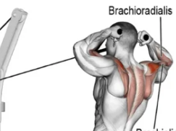  OC, SP | 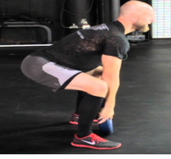  CC, MP | 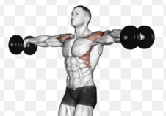  OC, SP | 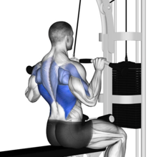  OC, SP | 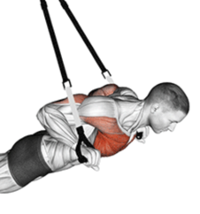  CC, SP | 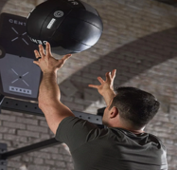  CC, MP
 | PM | Split squat | Single leg hip thrusts | Hamstring curl | Swiss ball curl | Single leg bosu balance
 | PM | CC, SP | CC, SP | OC, SP | CC, SP | CC, SP
 | PM | Body weight, 3x10 | Use smith machine, no weight, 3x10 | Increase weight slightly, single leg, slow controlled. 3x10 | Curl ball towards body and then reset. 3x10 | Stand on one leg and balance  3x 10s each leg.
Sunday  Week 6  Aim = Develop full lower limb strength and functional performance  Aim = Maintain conditioning and overall fitness | AM | Lunges | RDL | Single leg hip thrusts | Hamstring walk outs | Bosu balance
 | AM | CC, SP | CC, SP | CC, SP | CC, SP | CC, SP
 | AM | Carry heavier dumbbells in each hand. 3x10 | Single leg, increase weight, slow and controlled. 3x10 | Use smith machine, increase weight, 3x8 | Full range,  3x10 | Single leg, Glute bridge with feet on bosu or exercises ball. Hold for 30s x 4
 | PM | Circuit-AMRAP  Seated Ski erg | Circuit - AMRAP  Sit ups | Circuit - AMRAP  Seated plate hold | Circuit -AMRAP Seated battle ropes | Circuit -AMRAP Russian twists | CIRCUIT – AMRAP Seated med ball throws
 | PM | 30 seconds maximum effort. | 15 sit ups, minimise leg engagement as much as possible. | Hold plate for 10 seconds, arms extended with plate at face level. | 30 seconds maximal effort | Keep feel on the floor, hold a light kettlebell. 10 twists. | Throw med ball to the wall, 10 throws.
Aim of week 6: To maximise strength, progress running and conditioning, and prepare for a plyometrics. (exit= full strength and endurance, no pain, no instability.)

Week 1-2: Early Rehab (Protection + Activation)
- Goals:
  - Reduce pain, swelling, stiffness
  - Restore range of motion (ROM)
  - Reintroduce light muscle activation
- Key features:
  - Isometric holds (low intensity: 20-50%)
  - Mostly single-plane, controlled movements
  - No aggressive stretching
  - Pool work = gentle movement without load
  - Cardio = low intensity (bike, walking)

Week 3-4: Strength + Control Phase
- Goals:
  - Build strength + neuromuscular control
  - Introduce resistance + balance
  - Start eccentric loading (very important for hamstrings)
- Key features:
  - Light weights introduced
  - Balance work (single leg, unstable surfaces)
  - Eccentric exercises (e.g. RDLs, heel slides)
  - More functional patterns (step-ups, squats)

Week 5-6: Advanced Strength + Return to Function
- Goals:
  - Build full strength
  - Prepare for running + sport
  - Improve power + endurance

- Key features:
  - Single-leg work
  - Heavier resistance
  - Nordics, RDLs, hip thrusts
  - Running progression (Week 5-6)
  - Dynamic movements + circuits

Why are you starting off slow and gradually building?
- Followed a gradual, phase-based rehabilitation model to protect healing tissue
- Weeks 1-2:
  - Focused on pain reduction, ROM, and gentle activation
  - Avoided excessive strain while tissue is vulnerable
- Weeks 3-4:
  - Introduced strength and control as tolerance improved
  - Added resistance and eccentric loading to prepare for real movement
- Weeks 5-6:
  - Progressed to higher loads, single-leg work, and running
  - Aimed to restore full function and prepare for sport/activity demands
- Ensured each phase built on the previous one safely
- Reduced risk of reinjury by only increasing load when capacity improved
(van der Horst et al., 2015; Shield and Bourne, 2018), (Oranchuk et al., 2019), (Timmins et al., 2016), (van der Horst et al., 2015).

Why have I chosen these reps and sets?
- Early stage (Weeks 1–2):
  - Higher reps / low intensity (e.g. 3x10, 20–40% effort)
  - Promotes blood flow, activation, and confidence
  - Minimises stress on healing tissue
- Isometric holds (5–10 seconds):
  - Improve muscle activation and tendon stiffness safely
  - Help reduce pain without muscle lengthening
- Mid stage (Weeks 3-4):
  - Moderate reps (8–-2)
  - Focus on strength and muscular endurance
  - Controlled tempo improves movement quality
- Eccentric work:
  - Slow lowering phases (e.g. 3-4 seconds)
  - Builds load tolerance and injury resilience
- Late stage (Weeks 5-6):
  - Slightly lower reps with increased load
  - Develops strength, power, and fatigue resistance
- Overall: reps match the goal of each phase (activation then strength then performance)
(Malliaras et al., 2015), (Oranchuk et al., 2019), (ACSM, 2021), (Timmins et al., 2016), (Suchomel et al., 2016).

Why are you doing these exercises?
- Early phase exercises:
  - (e.g. heel digs, prone knee flexion, supported curls)
  - Target hamstring in safe, controlled positions
  - Limit strain while restoring activation
- Progression to functional movements:
  - (e.g. glute bridges, squats, step-ups)
  - Improve coordination between hamstrings, glutes, and quads
  - Reflect real-life movement patterns
- Eccentric-focused exercises:
  - (e.g. RDLs, Nordic curls, heel slides)
  - Train hamstrings to absorb force and decelerate movement
  - Key for injury prevention and return to sport
- Single-leg exercises:
  - Address imbalances and stability
  - Prepare for sport-specific demands
- Balance and core work:
  - Improve neuromuscular control and joint stability
  - Reduce reinjury risk
- Upper body + cardio included:
  - Maintain overall fitness during rehab
  - Prevent deconditioning
(Mendiguchia et al., 2017), (van der Horst et al., 2015; Timmins et al., 2016), (McCall et al., 2015)

Reference list
- American College of Sports Medicine (ACSM) (2021) ACSM’s Guidelines for Exercise Testing and Prescription. 11th edn. Philadelphia: Wolters Kluwer.
- Jarvinen, T.A.H., Jarvinen, T.L.N., Kaariainen, M., Kalimo, H. and Jarvinen, M. (2016) ‘Muscle injuries: biology and treatment’, American Journal of Sports Medicine, 33(5), pp. 745–764.
- Malliaras, P., Barton, C.J., Reeves, N.D. and Langberg, H. (2015) ‘Achilles and patellar tendinopathy loading programmes: a systematic review’, Sports Medicine, 45(4), pp. 567–581.
- McCall, A., Carling, C., Nedelec, M., Davison, M., Le Gall, F., Berthoin, S. and Dupont, G. (2015) ‘Risk factors, testing and preventative strategies for non-contact injuries in professional football’, Sports Medicine, 45(4), pp. 593–605.
- Mendiguchia, J., Alentorn-Geli, E. and Brughelli, M. (2017) ‘Hamstring strain injuries: are we heading in the right direction?’, British Journal of Sports Medicine, 46(2), pp. 81–85.
- Mendiguchia, J., Alentorn-Geli, E. and Brughelli, M. (2017) ‘Hamstring strain injuries: are we heading in the right direction?’, British Journal of Sports Medicine, 46(2), pp. 81–85.
- Oranchuk, D.J., Storey, A.G., Nelson, A.R. and Cronin, J.B. (2019) ‘Isometric training and long-term adaptations: effects of muscle length, intensity, and intent’, Sports Medicine, 49(10), pp. 1501–1514.
- Pollock, N., Patel, A., Chakraverty, R., Suokas, A. and James, S.L.J. (2016) ‘Time to return to full training is delayed and recurrence rate is higher in intratendinous (“c”) acute hamstring injury in elite track and field athletes’, British Journal of Sports Medicine, 50(5), pp. 305–310.
- Shield, A.J. and Bourne, M.N. (2018) ‘Hamstring injury prevention practices in elite sport: evidence for eccentric strength training’, Sports Medicine, 48(3), pp. 513–521.
- Suchomel, T.J., Nimphius, S. and Stone, M.H. (2016) ‘The importance of muscular strength in athletic performance’, Sports Medicine, 46(10), pp. 1419–1449.
- Timmins, R.G., Bourne, M.N., Shield, A.J., Williams, M.D., Lorenzen, C. and Opar, D.A. (2016) ‘Short biceps femoris fascicles and eccentric knee flexor weakness increase the risk of hamstring injury’, British Journal of Sports Medicine, 50(24), pp. 1524–1535.
- van der Horst, N., Smits, D.W., Petersen, J., Goedhart, E.A. and Backx, F.J. (2015) ‘The preventive effect of the Nordic hamstring exercise on hamstring injuries in amateur soccer players’, American Journal of Sports Medicine, 43(6), pp. 1316–1323.
- van der Made, A.D., Reurink, G., Gouttebarge, V., Tol, J.L. and Kerkhoffs, G.M.M.J. (2018) ‘Outcome after surgical repair of proximal hamstring avulsions: a systematic review’, American Journal of Sports Medicine, 46(7), pp. 1849–1857.

