Innovative Service Plan: An All-in-One Mental Health App: Meeting Emerging Customer Needs with Innovative Service Proposition

BA Leadership and Management Skills for the Workplace
Developing Innovation and Creativity for Business Advantage
Lecturer: Dr Abdullah Ijaz


Paulina Andone (2027237)

Table of Contents
An All-in-One Mental Health App: Meeting Emerging Customer Needs with Innovative Service Proposition 2
Introduction 2
Innovative Service Proposition 3
Sale Channels 4
Unique Selling Point 5
Addressing Emerging Customer Needs 5
Competition and Competitive Advantage 7
Ecommerce Perspective 8
Technological Framework 8
Content Creation 10
Financing 10
Equipment and Supplies 10
Staff 10
Payment Services 10
Marketing strategies using the framework of the 4Ps of marketing: Product, Price, Place, and Promotion. 11
Product 11
Price 12
Place 12
Promotion 12
Conclusion 13
References 14

An All-in-One Mental Health App: Meeting Emerging Customer Needs with Innovative Service Proposition

Introduction

In light of the increasing significance of mental health, individuals are actively pursuing services that place a premium on their overall well-being and aid in the management of stress, anxiety, and mental health conditions (Goetzel et al., 2018).
Multiple studies have provided evidence of a deterioration in the mental well-being of the population in England subsequent to the year 2020, as reported by reputable organisations such as the Nuffield Trust and The Kings Fund (2020). The evidence-based research conducted highlights the escalating burden of inadequate mental health among individuals across various age groups and diverse backgrounds. The lockdowns and the surge in Covid-19 cases were accompanied by heightened levels of anxiety, depression, feelings of isolation, and stress. The provision of pharmacological care has been more prevalent than that of psychological care, thereby impeding individuals' ability to access support or therapy. Gaining insight into the experiences of patients is crucial for enhancing mental health outcomes and the effectiveness of service provision (Naylor et al., 2020).
The growing consumer demand necessitates the development of an innovative service plan aimed at transforming mental health services through the utilisation of technology, thereby exerting a substantial impact on individuals seeking assistance for mental health concerns. The proposed methodology encompasses the integration of a novel service proposition, e-commerce perspective, and the fundamental elements of marketing known as the 4Ps (Product, Price, Place, and Promotion) (Dominici, 2009). This application aims to offer extensive assistance, guided interventions, and personalised resources to enhance mental well-being. It achieves this by integrating cutting-edge technology, expert guidance, and a user-centred design (Cornet et al., 2020).
According to Chandrashekar (2018), individuals can benefit from personalised mental health assessments, a diverse array of self-care resources such as guided meditation and journaling, the ability to set and monitor goals, virtual access to therapists, and a network of supportive peers.

Innovative Service Proposition

Venture name: MindZen4Everyone
Schumpeter defined innovation as the introduction of new products, services, processes, or organisational practises that substantially alter the economic structure. According to Schumpeter, entrepreneurs disrupt markets by introducing new concepts and technologies. He viewed innovation as a destructively creative process that could overtake established industries and businesses (Arnold et al., 2017).
This innovative service proposition targets the emerging need of increased demand for mental health support. MindZen4Everyone is an innovative digital platform designed to empower individuals to prioritise their mental health that provides personalised mental wellness programmes designed to promote emotional and mental health well-being through human-computer interaction (Balcombe and De Leo, 2022).
The increased demand for mental well-being apps since 2014 had grown with 566% in four years span according with the chart below (Building Better Healthcare, 2018).
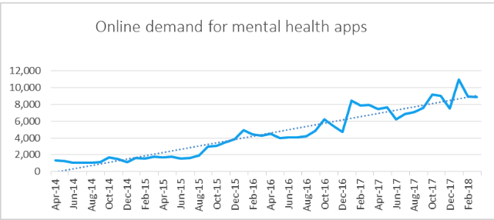
Figure1https://www.buildingbetterhealthcare.com/news/article_page/Demand_for_mental_health_apps_increases_fivefold/143898/cn161657

Using advanced Artificial Intelligence (AI) technology, user-focused approach (Ibarra et al., 2018) and customised coaching, this innovative service provides an extensive range of mental health and wellbeing programmes. By adapting to each user's specific requirements and preferences, this service aims beyond traditional self-help materials. Customers can get help with their unique mental health issues by using sophisticated algorithms and machine learning to tailor recommendations and assistance (Bidargaddi et al., 2020).
AI, a disruptive innovation, is already surpassing human physicians in the diagnosis of some medical diseases, notably in image analysis in dermatology and radiology. AI systems can learn from health records, genetic data, and real-time patient data and can be used in robotics and physician training (Arora, 2022).
Personalised experiences and customised content can significantly increase the platform effectiveness and user engagement. Using assessments and user preferences, the application can generate plans, recommendations, and interventions that are tailored to everyone’s requirements (Naslund et al., 2019). A comprehensive mental health application should go beyond addressing specific conditions or symptoms and investigate holistic approach too. It may include elements that promote physical health, mindfulness, stress management, better sleep, and nutrition. Moreover, incorporating AI-based chatbots, mood and behavioural tracking, diverse therapy options, personalised treatment plans, community support, virtual therapy sessions, real-time emergency support, and continuous improvement through machine learning this service can provide comprehensive support, personalised treatment, and accessible resources for individuals seeking well-being (Price et al., 2013).

Sale Channels

The sales channels of this service proposition can encompass both traditional and digital avenues (Rehman et al., 2022).
- Direct-to-Consumer (D2C): Direct-to-consumer app promotion and sales. Online advertising, social media marketing, and targeted email campaigns
- Business2Business (B2B) Partnerships: Collaborating with businesses, such as healthcare providers, organisations, or insurance companies. These organisations can integrate the app into their mental health programmes and provide it to customers and staff as a value-added service.
- App Stores: The Apple App Store and Google Play Store will expose the app to a big audience. App store optimisation and marketing can boost visibility and downloads.
- Professional Referrals: Collaboration with therapists, counsellors, and psychiatrists, can increase referral rates. These experts may recommend the app for mental health assistance as a medical reviewed product.
- Institutional Partnerships: The app can be used in mental health programmes and clinical studies in educational institutions, hospitals, and research organisations. This verifies the app's efficacy and credibility.
- Affiliate Marketing: Affiliate collaborations with mental health influencers or websites can create partnerships and promote the app.

Unique Selling Point

Tailored Recommendations: The app uses sophisticated algorithms and user data to recommend therapeutic exercises, self-care techniques, and relevant resources based on each user's needs and goals. This customised approach improves user satisfaction and app efficacy.
Focus on Accessibility and Convenience: The app provides 24/7 mental health support via mobile devices. It makes mental health services more accessible by providing a convenient alternative to in-person therapy.
Interactive and Engaging Features: The app uses gamification, progress monitoring, and goal setting to engage and motivate users throughout their mental health journey. This method increases user engagement and application use.
The comprehensive mental health application's distinct selling point shows its advantages and value proposition compared to other market solutions. (Ayobi et al., 2020).

Addressing Emerging Customer Needs

Numerous individuals with mental health conditions have indicated that their challenges are embedded since childhood, which create more emphasis on today’s children's mental health topic (Mental Health Foundation, 2016). These statements reflect the significance of mental health services, their increasing demand, and the intensification of mental health issues (McGorry et al., 2022). The following sheet composed by Centre for Mental Health in 2022,
presents evidence of children's mental health, irrespective of their geographical location, socioeconomic background, or social class. By placing a significant emphasis on the mental well-being of individuals from early childhood, there is a possibility towards a comprehensive improvement in the mental health outcomes of the broader population in subsequent years.

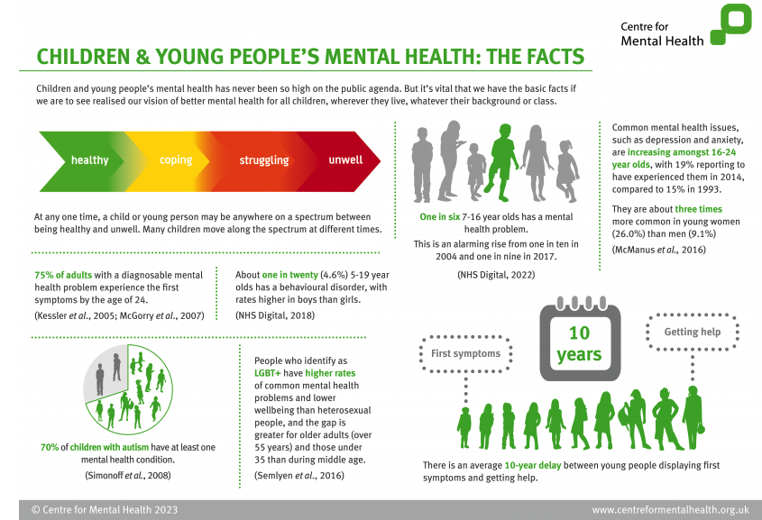
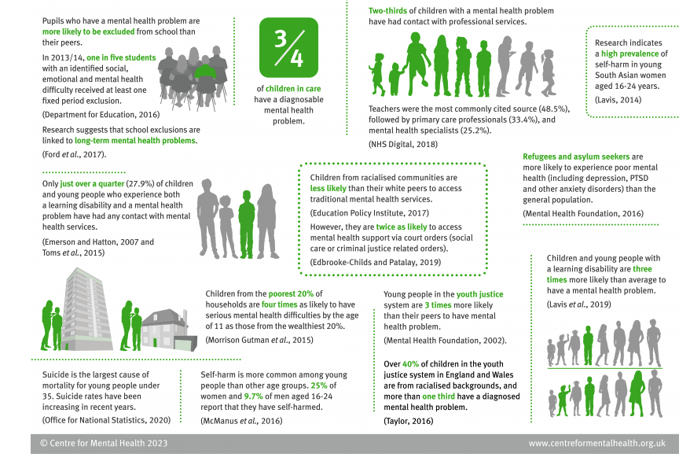
In contemporary society characterised by rapid pace, individuals are actively seeking viable strategies to effectively address and cope with various mental health concerns (McGorry et al., 2022).
To address the increasing demand, the app facilitate a user-friendly and comprehensive interface for easy navigation through all the features, personalised approach for easy customization, and stress-free access to professionals. Encrypted communication, secure data storage, and explicit consent options ensure user privacy and security in the app. General Data Protection Regulation, 2018, protecting individuals’ personal data is crucial.

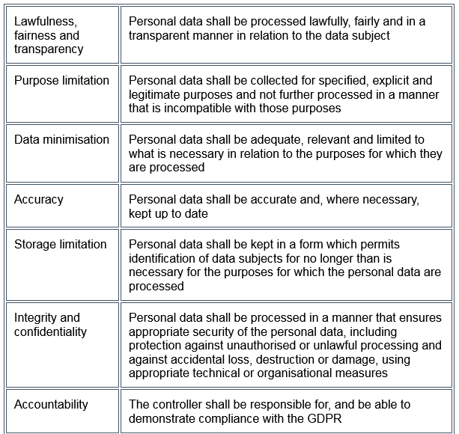

Competition and Competitive Advantage

According to Dorwart (2023) “10 Best Mental Health and Therapy Apps of 2023”, are as follow.
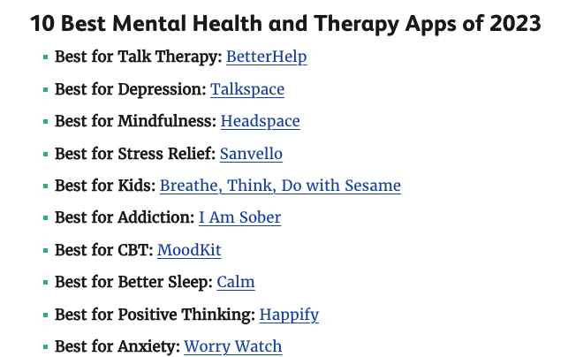
This list was created after evaluating fifty-five of the top apps based on evidence-based therapies, content updates, variety of therapies, cost, and user reviews. It seems that competition can provide comprehensive mental health resources or initiatives, while MindZen4Everyone possesses distinct characteristics, methods, and target audience. The operation of AI-driven algorithms and the provision of personalised coaching distinguish this product from its competitors. Furthermore, the integration of all these features into a single product enables it to acquire knowledge and adjust according to user preferences, thereby offering personalised recommendations and support ((Dwidedi et al., 2021).

Ecommerce Perspective

E-commerce has become a potent instrument for businesses to reach a larger audience and provide more convenient services in the current digital age. Creating a website and application devoted to mental health, a number of crucial factors needs to be considered. This section of the project will examine key aspects of technology, platforms, content creation, financing, operational necessities, and payment services.

Technological Framework
In order to develop a comprehensive mental health application that is compatible with both Android and iOS platforms, it is typically necessary to employ a technologically advanced and adaptable framework.
Cross-Platform Development Framework: In order to achieve compatibility on both the Android and iOS platforms, the adoption of a cross-platform development framework, such as React Native or Flutter. These frameworks enable developers to write code once and deploy it across multiple platforms (React native, 2023).
Backend Development: A combination of technologies is required to handle diverse functionalities (Columbia Engineering, 2023). Several frequently utilised technologies include:

- A server-side language for the application's logic and data processing, such as Node.js, Python, or Java.
- A database system, such as MySQL or MongoDB, for the secure storage of user information, treatment plans, progress, and other pertinent data.
- Application Programming Interfaces (APIs) to enable functionalities such as appointment scheduling, payment gateways, or mood tracking.
- User Authentication and Security such as OAuth or JWT (JSON Web Tokens) to validate and grant access to users, ensuring the safeguarding of their confidential information.
Data Storage and Encryption: Employ robust data storage methodologies, including encryption, to safeguard confidential user data that is stored on the application's servers (UK Data Service, 2023). Ensuring adherence to data protection regulations such as the General Data Protection Regulation (GDPR) or the Health Insurance Portability and Accountability Act (HIPAA) is of paramount importance within the field of mental health.
Integration of Communication Channels: The incorporation of various communication channels, such as chat and video calls, can effectively facilitate interactions between users and mental health professionals. WebRTC or third-party application programming interfaces (APIs) can be employed for the purpose of facilitating real-time communication (LSBU, 2023).
User Interface and Experience: Develop an interface that prioritises ease of use and intuitive navigation, with a particular emphasis on features related to mental health such as mood tracking, mindfulness exercises, and a library of therapy resources (Choi and Tulu, 2017). Frameworks such as React or Vue.js are commonly employed in order to facilitate efficient front-end development (Google Digital Garage, 2023).
Testing and Bug Tracking: Developing and testing strategy to ascertain the stability and functionality of the application. Utilise bug tracking tools such as Jira or Bugsnag to effectively detect and resolve any encountered issues (Google Cloud, 2023).
Analytics tools: Google Analytics or Firebase Analytics to monitor user behaviour, app performance, and the identification of potential areas for enhancement (Analytics, 2023).
A new mental health platform can be built upon the cloud using Infrastructure as a service (IaaS), as the cloud provides networking, virtualization, storage, and hosting (FourWeekMBA, 2023).
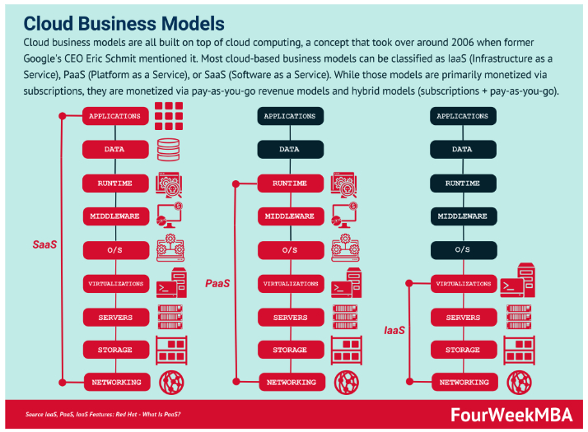

Content Creation
Creating informative and compelling content is crucial to engage with target audience. A copyright clearance is required for all website and application content, including text, images, and multimedia elements. In addition, employing professionals or forming a partnership with mental health specialists can develop high-quality content that resonates with the user needs and provides insightful insights and useful resources.

Financing
A financial outlay and a thorough business plan outlining the budget, revenue projections, and potential funding sources is compulsory for this kind of service. Self-financing, loans, crowdfunding, and pursuing investment from stakeholders who share the same mission and values are a few methods of financing.

Equipment and Supplies
The equipment and supplies necessary to support online operations include the following: hosting services, workstations, mobile devices, Internet connectivity, and software licences. Security measures to protect user data and combat cyberattacks are a priority.

Staff
The personnel required to effectively operate and maintain the online platform can be as follow: website developers, content creators, marketing specialists, customer support agents, and administrators. Depending on the budget and operational requirements, the engagement of full-time employees may be vital, outsource specific duties, or collaboration with freelancers and contractors.

Payment Services
The integration of secure and user-friendly payment services on the platform to facilitate transactions. Credit/debit card payments and PayPal are widely accepted and facilitate a seamless checkout process. For the card payments, the guidelines established by Payment Card Industry Data Security Standard (PCI-DSS) must be followed. Compliance with these standards protects sensitive customer data and reduces the likelihood of data breaches.

Marketing strategies using the framework of the 4Ps of marketing: Product, Price, Place, and Promotion.

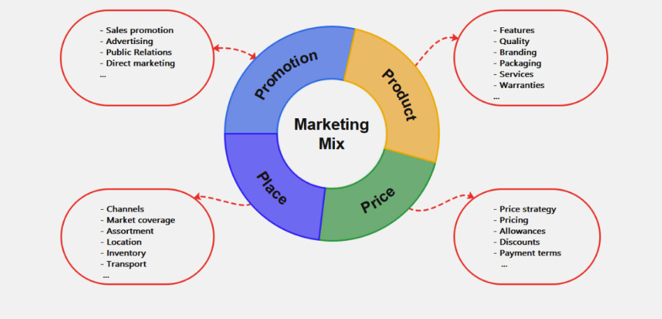
https://www.edrawmind.com/templates/4-ps-of-marketing-template.html

Product
In today's fast-paced and demanding world, the need for mental health support has never been greater. MindZen4Everyone addresses the increasing demand for a user-friendly and easily accessible platform that allows individuals to prioritise their mental well-being. By integrating technology with the knowledge and skills of mental health experts, this app offers a comprehensive solution tailored to the specific requirements of each client. The clients can confidently prioritise their mental well-being, as they have access to a comprehensive and personalised support system readily available.
According to Precedence Research, (2023), the market for mental health apps was projected at $5.19 billion in 2022 and is predicted to reach $26.36 billion by 2032 at a CAGR (compound annual growth rate) of 17.7%.
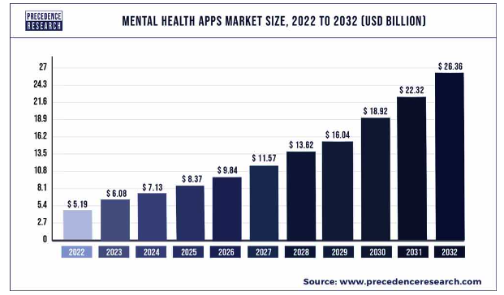

Price
The pricing for the all-in-one mental health app should be competitive and reflective of the value it offers. Factors like the cost of production, the perceived value of the product/service, and prices set by competitors should be considered. Balancing profitability with affordability is key to attracting customers. Offering different subscription options, such as monthly or yearly plans, free basic version or 7 days trial can attract more customers.
To justify the chosen price point, the app can emphasize the cost savings compared to traditional therapy sessions or other mental health services. Highlighting the accessibility and affordability of professional support through the app can be a persuasive selling point (Pratt, 2022).

Place
The distribution strategy for the app should focus on reaching as many potential users as possible. This could include selling the app online through app stores like Google Play or Apple's App Store. Additionally, exploring partnerships with third-party retailers or healthcare providers can help expand the distribution reach.
Providing a user-friendly and intuitive digital platform for seamless app installation and access is crucial. Convenience should be a priority, ensuring the app is compatible with different devices and operating systems.

Promotion
To promote the service effectively, a multi-faceted marketing campaign is essential. Traditional advertising channels can be utilized, such as television and radio spots, billboards, and print media. However, considering the technological nature of the product, digital promotion should play a significant role.
Social media platforms like Facebook and Instagram offer the opportunity to engage with a large target audience. Creative and engaging content, such as relatable illustrations or bite-sized mental health tips, can capture attention and encourage users to explore the app further (Rehman et al., 2022).
Paid search engines, such as Google, can be leveraged to ensure the app is easily discoverable by individuals actively searching for mental health solutions online. Strategic use of keywords and search engine optimization techniques can boost visibility in search results.
Understanding the customer journey is paramount in promoting the app effectively. Tailoring marketing efforts at various stages of the customer journey, from awareness to consideration and conversion, can foster engagement and increase user adoption.
Lastly, a pre-launch promotion can build anticipation and generate buzz around the app. Teasers, sneak peeks, and influencer partnerships can create excitement and raise awareness among the target audience (American Marketing Association, 2022).

Conclusion
MindZen4Everyone is a sophisticated and individualised application for promoting mental well-being, which presents a distinctive approach to addressing the needs of its users. By customising the application's content to cater to the unique requirements of each user, it guarantees personalised suggestions and assistance. The application's seamless user interface and user-friendly design facilitate effortless and pleasurable participation in mental well-being activities. Furthermore, MindZen4Everyone employs artificial intelligence-driven algorithms, individualised coaching, and a focus on user-centricity to deliver significant benefits in enhancing emotional well-being (Arora, 2022).
The co-opetition between mental health providers and comprehensive mental health platforms is imperative for the overall welfare of individuals (Hoffman and Boche, 2019, p. 2). It is essential to consider the integration of various features and functionalities to ensure a seamless user experience. Additionally, incorporating robust security measures and privacy protocols is crucial to safeguard sensitive user information. In order to proficiently promote the application, it is imperative to engage in meticulous analysis of the 4Ps framework, encompassing Product, Price, Place, and Promotion. Additionally, a comprehensive and inventive marketing strategy must be devised, capitalising on diverse channels to effectively reach a broad spectrum of potential users (Christina, 2020).

References
American Marketing Association (2022), The Four Ps of Marketing. Available at: https://www.ama.org/marketing-news/the-four-ps-of-marketing/ (accessed on 14 July 2023).
Analytics (2023) Welcome to Google Analytics. Available at: https://analytics.google.com/analytics/web/provision/#/provision (accessed on 2 July 2023).
Arora, A. (2020) ‘Conceptualising Artificial Intelligence as a Digital Healthcare Innovation: An Introductory Review’, Medical Devices: Evidence and Research, 13, pp. 223-230. doi: 10.2147/MDER.S262590
Ayobi, A., Marshall, P. and Cox, A. L. (2020)’Trackly: A Customisable and Pictorial Self-Tracking App to Support Agency in Multiple Sclerosis Self-Care’ In Proceedings of the 2020 CHI Conference on Human Factors in Computing Systems (CHI '20). Association for Computing Machinery, New York, USA, pp. 1–15. https://doi.org/10.1145/3313831.3376809
Bagri, S. (2023)’NHS mental health services: what’s changed?’ Quality Watch: Nuffield Trust and Health Foundation, 21 March. Available at: https://www.nuffieldtrust.org.uk/news-item/nhs-mental-health-services-what-s-changed (accessed on16 June 2023).
Balcombe, L. and De Leo, D. (2022) ‘Human-Computer Interaction in Digital Mental Health’, Informatics, 9. https://doi.org/10.3390/informatics9010014
Bidargaddi, N., Schrader, G., Klasnja, P., Licinio, J., and Murphy, S. (2020) ‘Designing m-Health interventions for precision mental health support’, Translational psychiatry, 10, p. 222.
Building Better Healthcare (2018), Demand for mental health apps increases five-fold. Available at: https://www.buildingbetterhealthcare.com/news/article_page/Demand_for_mental_health_apps_increases_fivefold/143898/cn161657 (accessed on 30 June 2023).
Centre for Mental Health (2023) Fact Sheet: Children and Young People’s Mental Health. Available at: https://www.centreformentalhealth.org.uk/fact-sheet-children-and-young-peoples-mental-health (accessed on 20 June 2023).
Chandrasheka, P. (2018) ‘Do mental health mobile apps work: evidence and recommendations for designing high-efficacy mental health mobile apps’, mHealth, 4(3). https://doi.org/10.21037/mhealth.2018.03.02
Choi, W. and Tulu, B. (2017) ‘Effective Use of User Interface and User Experience in an mHealth Application’, User Experience (UX) In Information Systems (IS) For Health And Wellness. Available at: https://aisel.aisnet.org/cgi/viewcontent.cgi?article=1474&context=hicss-50 (accessed: 5 July 2023).
Columbia Engineering (2023) 9 Skills You Need to Become a Back End Developer. Available at: https://bootcamp.cvn.columbia.edu/blog/back-end-developer-skills/ (accessed: 4 July 2023).
Cornet, V. P., Toscos, T., Bolchini, D., Rohani Ghahari, R., Ahmed, R., Daley, C., Mirro, M. J. and Holden, R. J. (2020) ‘Untold Stories in User-Centered Design of Mobile Health: Practical Challenges and Strategies Learned From the Design and Evaluation of an App for Older Adults With Heart Failure’, JMIR mHealth and uHealth, 8(7). https://doi.org/10.2196/17703
Dominici, G. (2009)’From Marketing Mix to E-Marketing Mix: A Literature Overview and Classification’, International Journal of Bussines and Management, 4(9), pp.17-24. Available at: https://ssrn.com/abstract=1961974 (accessed on 30 June 2023).
Dorwart, L. (2023)’Self-Improvement: Best Mental Health Apps’, VeryWellMind. Available at: https://www.verywellmind.com/best-mental-health-apps-4692902 (accessed on 25 June 2023).
Dwivedi, Y. K., Hughes, L., Ismagilova,E., Aarts, G., Coombs, C., Crick, T., Duan, Y., Dwivedi, R., Edwards, J., Eirug, A., Galanos, V., Ilavarasan, P. V., Janssen, M., Jones, P., Kar, A. K., Kizgin, H., Kronemann, B., Lal, B., Lucini, B., Medaglia, R., Le Meunier-FitzHugh, K., Le Meunier-FitzHugh, L. C., Misra, S., Mogaji, E., Sharma, S. K., Singh, J. B., Raghavan, V., Raman, R., Rana, N. P., Samothrakis, S., Spencer, J., Tamilmani, K., Tubadji, A., Walton, P. and Williams, M. D. (2021)’Artificial Intelligence (AI) Multidisciplinary perspective on emerging challenges, opportunities, and agenda for research, practice and policy’, International Journal of Information Management, 57. https://doi.org/10.1016/j.ijinfomgt.2019.08.002
Filippov, S., Mooi, H. G., Weg, R. and Westen, L. J. (2012). Strategic alignment of the project portfolio: an empirical investigation. Paper presented at PMI® Research and Education Conference, Limerick, Munster, Ireland. Newtown Square, PA: Project Management Institute.
Galderisi, S., Heinz, A., Kastrup, M., Beezhold, J. and Sartorius, N. (2015) ‘Toward a new definition of mental health’, World Psychiatry, 14(2), pp.231-233. https://doi.org/10.1002/wps.20231
Goetzel, R. Z., Roemer, E. C., Holingue, C., Fallin, M. D., McCleary, K., Eaton, W., Agnew, J., Azocar, F., Ballard, D., Bartlett, J., Braga, M., Conway, H., Crighton, K. A., Frank, R., Jinnett, K., Keller-Greene, D., Rauch, S. M., Safeer, R., Saporito, D., Schill, A., … Mattingly, C. R. (2018). Mental Health in the Workplace: A Call to Action Proceedings From the Mental Health in the Workplace-Public Health Summit. Journal of occupational and environmental medicine, 60(4), pp.322–330. https://doi.org/10.1097/JOM.0000000000001271
Google Cloud, (2023) Customer Care. Available at: https://cloud.google.com/support/docs/issue-trackers (accessed on 1 July 2023).
Google Digital Garage, (2023) Front-end developer. Available at: https://learndigital.withgoogle.com/digitalgarage/course/front-end-developer (accessed on 1 July 2023).
Hoffmann, E. Z., Boche, V.M. and Hoisl, K. (2019)’Innovation through co-opetition: A qualitative study aiming to explore factors promoting the success of co-opetition in product and service innovation’, Master thesis, Copenhagen Business School. Available at: https://research-api.cbs.dk/ws/portalfiles/portal/59804682/627703_Master_Thesis_Hoffmann_Boche.pdf (accessed on 24 June 2023).
https://doi.org/10.1002/cpp.1855
https://doi.org/10.1038/s41398-020-00895-2
https://wordpress.com (no date) (Accessed: 30 June 2023).
Hurriyet, H. and Nakandala, D. (2016) ‘Lean Thinking and the Innovation Process’ In Al-Hakim, L., Wu, X., Koronios, A. and Shou, Y. (Eds), Handbook of Research on Driving Competitive Advantage Through Sustainable, Lean, and Disruptive Innovation, pp. 39-58. https://doi-org.ezproxy.uwtsd.ac.uk/10:4018/978-1-5225-0135-0.ch002
Ibarra, D., Ganzarain, J. and Igartua, J. I. (2018) ‘Business model innovation through Industry 4.0: A review’, Procedia Manufacturing, 22, pp. 4-10. https://doi.org/10.1016/j.promfg.2018.03.002
Inal, Y., Wake, J. D., Guribye, F. and Nordgreen, T. (2020) ‘Usability evaluations of mobile mental health technologies: Systematic review’, Journal of Medical Internet Research, 22, e15337. https://doi.org/10.2196/15337
Leigh, S. and Flatt, S. (2015) ‘App-based psychological interventions: Friend or foe?’, Evidence-Based Mental Health, 18, pp. 97–99. https://doi.org/10.1136/eb-2015-102203
London South Bank University (LSBU), (2023) New Project Will integrate AI into Real-Time Communication Apps For The First Time. Available at: https://www.lsbu.ac.uk/about-us/news/new-project-will-integrate-ai-into-real-time-healthcare-communication-apps-for-the-first-time (accessed on 6 July 2023).
Luxton, D. D., Hansen, R. N. and Stanfill, K. (2014) ‘Mobile app self-care versus in-office care for stress reduction: A cost minimization analysis’, Journal of Telemedicine and Telecare, 20(8), 431–435. https://doi.org/10.1177/1357633X14555616
McGorry, P. D., Mei, C., Chanen, A., Hodges, C., Alvarez-Jimenez, M. and Killackey, E. (2022) ‘Designing and scaling up integrated youth mental health care’, World Psychiatry, 21, pp. 61-76. https://doi.org/10.1002/wps.20938
Naslund, J. A., Gonsalves, P.P., Gruebner, O., Pendse, S. R., Smith, S. L., Sharma, A. and Raviola, G. (2019) ‘Digital Innovations for Global Mental Health: Opportunities for Data Science, Task Sharing, and Early Intervention. Curr Treat Options Psych, 6, pp. 337–351. https://doi.org/10.1007/s40501-019-00186-8
Naylor, C., Bell, A., Baird, B., Heller, A. and Gilburt, H. (2020)’Mental health and primary care networks: Understanding the opportunities’, Available at: www.kingsfund.org.uk/publications/mental-health-primary-care-networks (accessed on 14 June 2023).
Ng, M. M., Firth, J., Minen, M. and Torous, J. (2019) ‘User engagement in mental health apps: A review of measurement, reporting, and validity’, Psychiatric Services, 70(7), pp. 538–542. https://doi.org/10.1176/appi.ps.201800519
Pratt, M. (2020) ‘What is the 4P Marketing Matrix’, Business.org. Available at: https://www.business.org/marketing/sales/marketing-101-4p-matrix/ (accessed on 12 July 2023).
Precedence Research 2023, Mental Health Apps Market (By Platform Type: Android, iOS, Others; By Application: Depression and Anxiety Management, Meditation Management, Stress Management, Wellness Management, Others; By Subscription: Monthly subscription, Yearly subscription) - Global Industry Analysis, Size, Share, Growth, Trends, Regional Outlook, and Forecast 2023-2032, Healthcare-Mental Health Apps Market, 2178. Available at: https://www.precedenceresearch.com/mental-health-apps-market (accessed on 28 June 2023).
Price, M., Yuen, E.K., Goetter, E.M., Herbert, J.D., Forman, E.M., Acierno, R. and Ruggiero, K.J. (2014) ‘mHealth: A Mechanism to Deliver More Accessible, More Effective Mental Health Care’, Clinical Psychology Psychotherapy, 21(5), pp. 427–436.
Punukollu, M. and Marques, M. (2019) ‘Use of mobile apps and technologies in child and adolescent mental health: A systematic review’, Evidence-Based Mental Health, 22(4), pp. 161–166. https://doi.org/10.1136/ebmental-2019-300093
React Native, (2023) Core Components and Native Components. Available at: https://reactnative.dev/docs/intro-react-native-components (accessed: 2 July 2023).
Rehman, S., Gulzar, R. and Aslam, W. (2022) ‘Developing the Integrated Marketing Communication (IMC) through Social Media (SM): The Modern Marketing Communication Approach’, Sage Journals, pp. 1-23. https://doi.org/10.1177/21582440221099936
UK Data Service, (2023) Encryption. Available at: https://ukdataservice.ac.uk/learning-hub/research-data-management/store-your-data/encryption/ (accessed on 5 July 2023).
Vernuccio, M. and Ceccotti, F. (2015) ‘Strategic and organisational challenges in the integrated marketing communication paradigm shift: A holistic vision’, European Management Journal, 33(6), pp. 438–449. https://doi.org/10.1016/j.emj.2015.09.001
Ziemnowicz, C. (2013), ‘Joseph A. Schumpeter and Innovation’, Encyclopaedia of Creativity, Invention, Innovation and Entrepreneurship. Springer, New York, NY. https://doi.org/10.1007/978-1-4614-3858-8_476

