Week 8: Introduction to Computer Systems tutorial.
Traditional Von Neumann and Modified Harvard architecture present the basic computer system as comprising of 3 main components, the Central Processing Unit (CPU), Input and Output operations (I/O) and Memory.
In this tutorial we investigate CPU architecture and characteristics. By gaining a better understanding of these concepts, we are able ascertain a comprehensive view of CPU performance factors that can directly affect overall system performance. We are then able to monitor and benchmark the system to ensure optimal efficiency, performance and stability.
1. A recap of how CPU executes instructions.
A program is a series of instructions and code, designed in such a way that it tells a computer what to do.
These instructions are executed by the CPU in a stage pipeline. This pipeline is commonly referred to as the Fetch – Decode – Execute cycle. The cycle is completed for every instruction in the program.
Example:
Fetch – CPU brings instructions from memory; it uses something referred to as the Program Counter (PC) which it uses to navigate to the exact memory address of the next instruction to be executed in the cycle.
Decode – This stage involves separating the opcode (the operation code, this specifies what operation the CPU is to perform) from the data (the operand) that the CPU will then perform this operation upon.
Execute – CPU then performs the opcode on specified operands (these could be arithmetic type operations or control operations).
Write-back – The result of the execute stage in the pipeline, is then written back to either memory or a register. This largely depends on the type of operation being performed.
The instructions are presented to the system CPU in Assembly language (Low level programming language).

Fig: Fetch – Decode – Execute cycle.
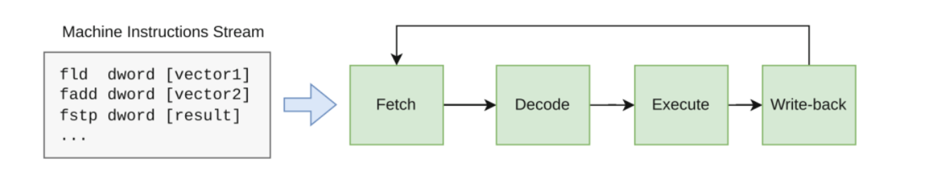
2. Multi-core CPUS.
Multi-core CPUs contain multiple processing units (referred to as ‘cores’) on one single physical silicon chip. This means that each core in a multi-core CPU can complete its own instruction pipeline, independently, thus making it capable of performing parallel computation. Multi-core CPUs provide solutions to the common computing problems shown below:
- The need to scale performance – Although it is possible to increase the clock speed of a CPU, there are physical and thermal limitations to this concept. Cores can perform operations simultaneously, so that rather than improving the time taken for one core to move through an instruction set, it is possible to have multiple cores working in parallel, improving the overall performance of programs and applications.
- Efficiency – since each core is able to run at lower frequency and voltages to complete instructions. This is more desirable than enhancing clock speeds of one physical chip, which requires more power and heat to improve performance.
- Demand for more ‘compute’ power – Modern applications ranging from Rendering in graphics to Data analytics entail larger more complex instructions. By having different cores, processing distinct types of tasks it is possible to achieve efficiency and lower latency in performance.
2.1. Core and Thread concepts (recap).
In the Operating System features such as CPU affinity, attempts to keep processes running on the same core for convenience and henceforth faster task completion utilising L1/L2 cache. The O/S uses a kernel scheduler to provide CPU affinity, aswell as functionality such as Load Balancing. Load balancing actively logs/monitors the workload of each CPU core and assigns and manages tasks to balance load.
A thread is a virtual representation of a physical core. It acts as a ‘logical core’ to achieve lower latency in tasks. Threads are a software level component that provide the core with the ability to work on several different tasks concurrently. A core can be thought of as a worker that executes ‘whole tasks’, while threads are the hands that provide different instructions (smaller parts of the whole tasks) to the core. Thus, giving the core the ability to work on several different tasks at the same time, rather than staying idle waiting for one task to be complete before undertaking the next one.
Multithreading technologies such as Intel Hyper-Threading or AMD SMT allow a single physical core to maintain two threads simultaneously. So, as an example, an 8 core CPU that supports hyperthreading is able to run up to 16 threads.
Modern CPU architectures from Intel provide P (Performance) cores and E (efficiency cores). P cores provide higher IPC (Instructions per cycle) and faster clock speeds. They P cores run single threaded workload, foreground tasks that require high priority and demand, such as gaming, rendering and mathematically complex computational tasks.. E cores provide the ability for the O/S to schedule and maintain hyperthreaded workloads. Using E cores makes it possible for the CPU to complete background tasks such as anti-virus programs and third-party software updates whilst concurrently assisting with parallel processing workloads.
How do Multicore CPUs implement parallel processing?
- “Data” parallelism – CPUs nowadays provide an instruction type known as SIMD (Single Instruction multiple data). This provides a way for the CPU to work on a range of data sets inside a single instruction. Common applications that make use of this parallel processing are video processing and multimedia software.
- ILP (Instruction level parallelism) – Multi core CPUs, just as their single core predecessors did, are able to process multiple instructions concurrently as part of the pipeline. The advantage here is that ILP now functions per core meaning that fetch decode and execute instructions are happening concurrently for each core in the CPU.
- Hyper-Threading – As discussed above, companies such as Intel and AMD utilise technologies such Hyperthreading and SMT which is based upon using ‘logical cores’. As modern CPUs are capable of complex methods of executing instruction pipelines, not all functional units necessarily need to be used during a single stage of the pipeline. Hyperthreading adds efficiency here by organising instructions into independently working ‘functional units’, so that hardware resources are not wasted or ‘idle’.
- Hyperthreading per core.
Task:
We will demonstrate CPU characteristics by investigating some techniques and system utilities available to conceptualise their function, manage, benchmark and monitor their performance.
Again, we will utilise VM(s) to examine these concepts. It is possible to use Windows (Client and Server) O/S and the Task Manager/Resource Monitor and Performance Monitor utilities. In this tutorial, we will primarily be using a Linux Ubuntu VM and investigate the top and htop applications along with some other useful features and functions.
Htop is the Linux based equivalent of the Task Manager utility. It was designed with a more ‘intuitive interface’ (than its predecessor top). The principal function of htop, is to enable users to actively monitor resources and manage processes in the real time operating system environment.
Real time resources such as CPU, memory and swap usage are displayed utilising colour coded metrics/statistics.
Processes can be viewed in a ‘tree-system’ (to understand parent-child relationships/dependencies). They can then be prioritised, killed, or terminated using simple shortcut keys as opposed to the more complex shell commands that are required with top.
Task:
Using ‘top’
- Type into the terminal > top
Real time resources and their current workload.
- Make a note of key System Performance areas of note; these are displayed in the upper quadrant of the ‘top’ application’s console window. We will specifically focus on the aspects of CPU performance.
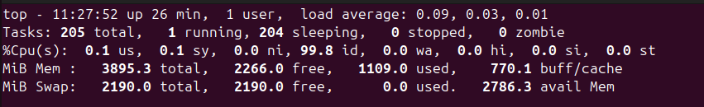
Breaking down the CPU usage metrics:
CPU Usage (%Cpu(s)):
- User space (us): Percentage of CPU time spent running user-level programs.
- System (sy): Percentage of CPU time spent running kernel code (system tasks).
- Nice (ni): Has two diverse representations; in the system performance area of the console window, ni relates to the percentage of CPU time that has been scheduled to running processes that have been ‘niced’. Processes can be set as ‘niced’, which basically means how friendly processes are in terms of sharing cpu resources with other processes. High negative values (-20 is the maximum) means that the process requires higher priority/demand of the CPU. Processes with negative values of -10 and greater can only be set by the root user of the system. A processes ni value can be viewed in the Process management component of the top window.
- Idle (id): The amount of CPU time that is not being used (idle).
- Wait (wa): Percentage of time the CPU spends waiting for I/O operations to complete.
- Hardware interrupts (hi): The percentage of time spent handling hardware interrupts. These interrupts are signals sent to the CPU by hardware devices like disks or network cards.
- Software interrupts (si): The percentage of time spent handling software interrupts, which are generated by software (e.g., by the operating system or applications) rather than hardware.
Process Management – Running processes and their dependencies.
The bottom area of the console window for top, provides information on running processes and threads.
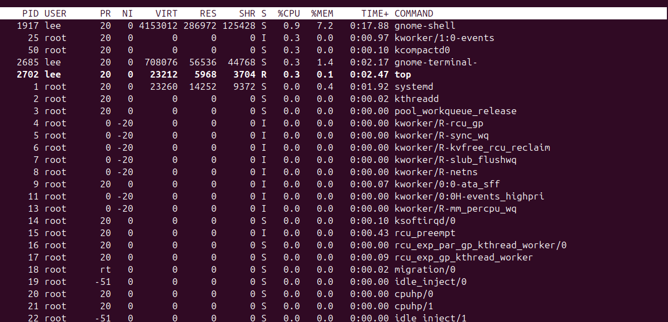
- NOTE: You need to run top -H in order to see the current threads running in top, htop provides a more convenient ‘tree view’ of processes in a parent – child dependency format.
Installing and using htop.
- In the terminal > sudo apt install htop
- When installed type in htop
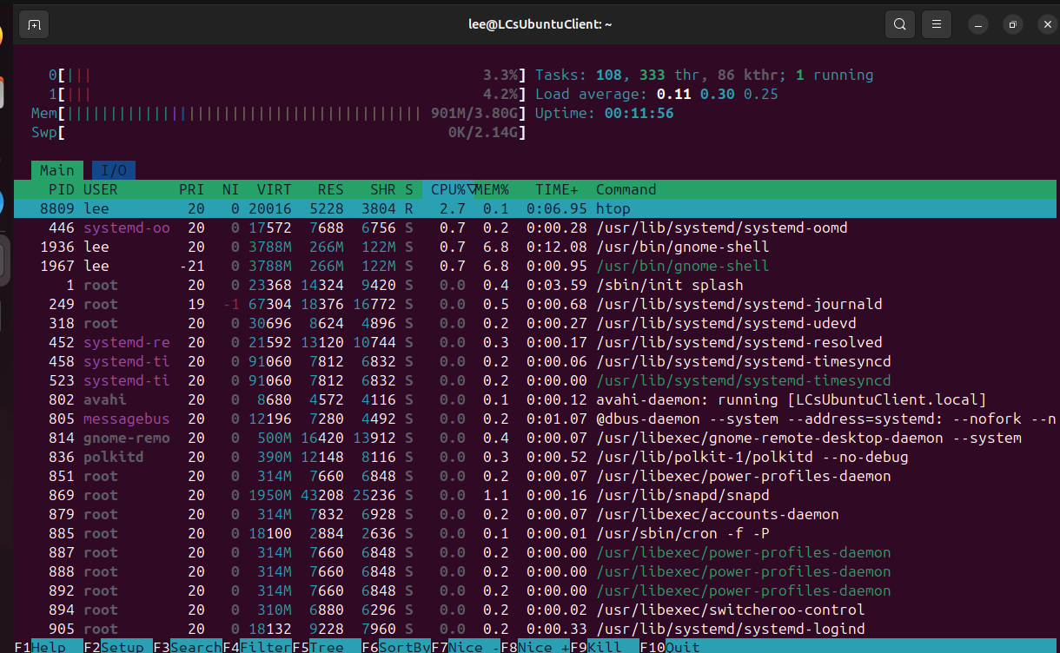
Installing and using stress-ng utility.
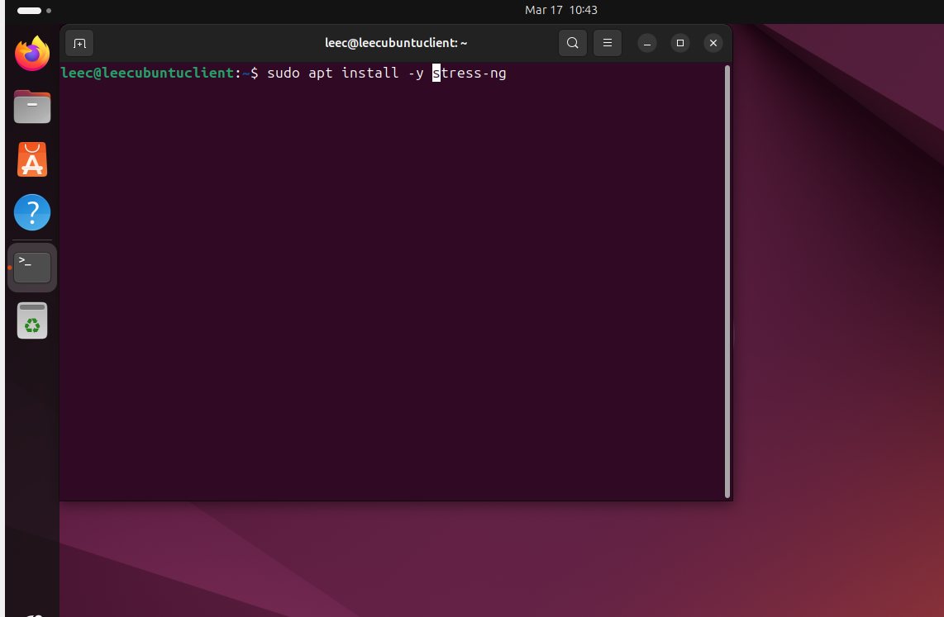

NB: You should use tools like stress-ng with a great deal of caution. This is because they can place resources under physical stress which could cause components to overheat or fail. As a tip, always use a set interval for the experiment, using the - - timeout argument.
Stress Load all cores:
In the terminal> stress-ng - -cpu 0 - -timeout 60s
This bash shell command selects all cores detected ‘online’ and stresses them at 100% load capacity for 60 seconds.
[Check htop window to verify that all cores are at 100 load capacity and restore to normal load after 60 seconds].
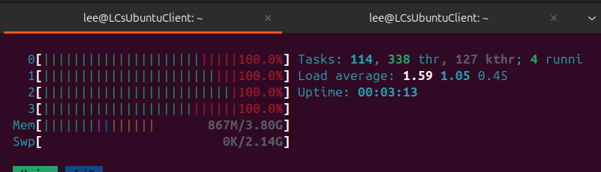

Loading CPU core 0 with 100% workload.
It is possible to load a specific cores’ workload using a single CPU stressor. Here we do this via a CPU intensive task (in the form of an infinite loop).
- In the terminal> taskset -c 0 bash -c “while true; do true; done”

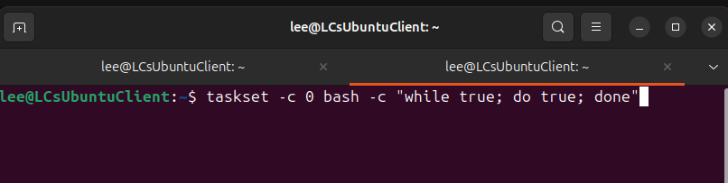
This command targets core 0 specifically and runs in bash using no I/O only the CPU. Core 0 is forced to continuously execute a ‘infinite busy loop’
- In the htop terminal window, click on the process, we can view it in the Process management component of the window. To kill the process with htop, select the right process and press the F9 key, to KILL it. You will need to confirm by pressing ENTER to send the signal.
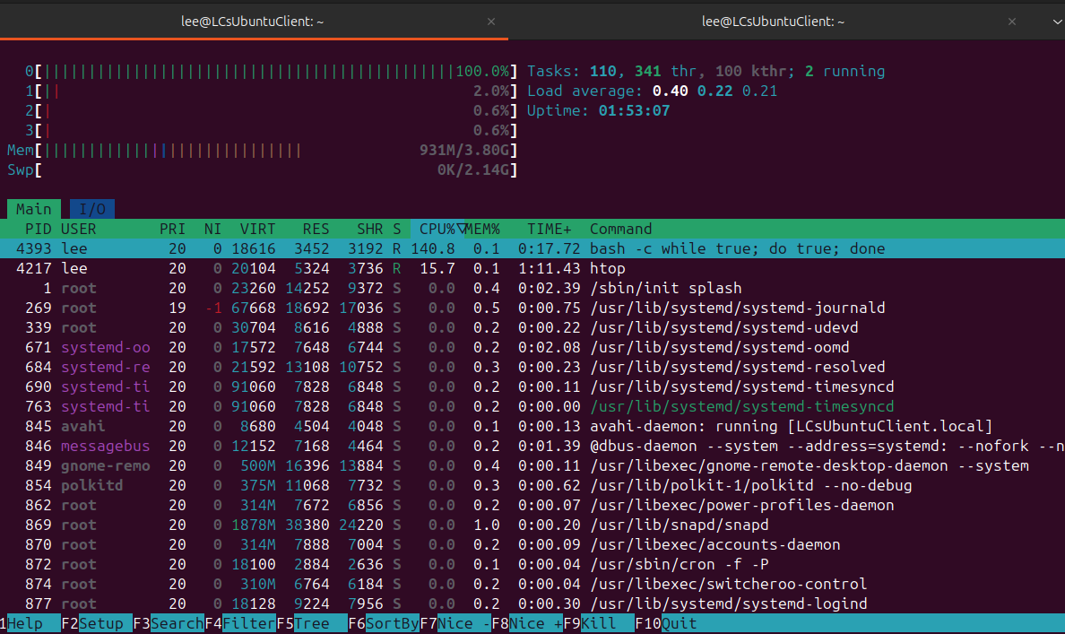
- Verify that CPU 0 is no longer at saturation (100%) usage.
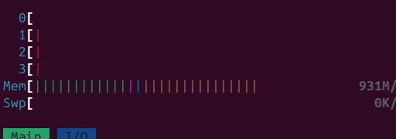
You can also ‘pin’ a specific process (already running) to a specific core (This is using CPU affinity to target workloads at specific cores):
- Close down all Terminal windows:
- Open Terminal > htop
- Click the create new terminal window button>

- In terminal as in the previous task, saturate core 0
- taskset -c 0 bash -c “while true; do true; done”
- Go to the terminal tab that is running htop and verify that core 0 is at 100% load. Take note of the PID (Process ID) associated with this command.
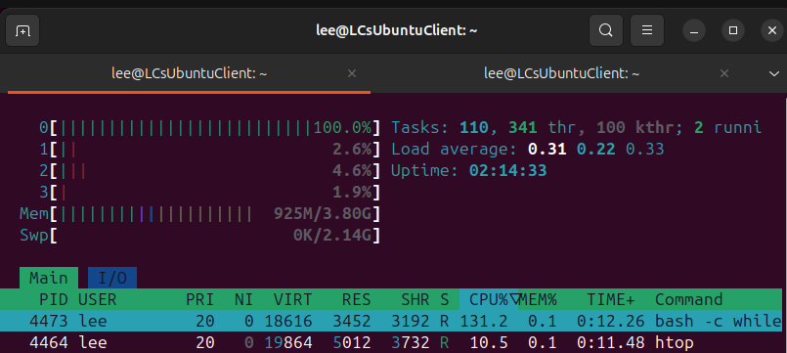
- Click the create new terminal window button>
- In terminal > taskset -cp 2 4473 (NOTE: your PID number may be different here, so use yours)

- Now return to the terminal tab running htop and verify that the process has been reallocated to core 2, core 0 is no longer saturated, the workload has been moved to Core 2.

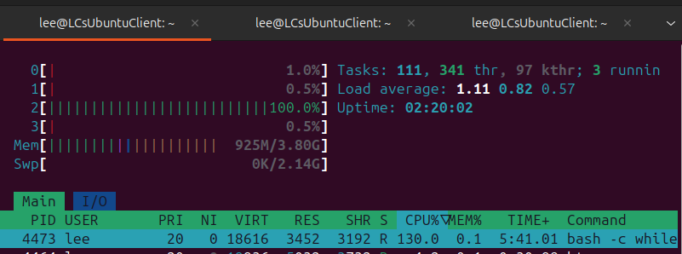
- Kill the PID above using F9 and Enter to send the KILL signal, as we did previously.
- Close down all terminal windows.

To visualise active threads and understand OS capabilities for threads:
- Terminal > ps -eLf (lists all running processes and threads on the system).
- Open a new Terminal tab > htop
- Press F5 > for Tree view (This will show you parent processes and all dependant threads (Can you determine which threads are dependent on which parent process)?
- Open a new Terminal tab > lscpu (This is a confirmation of how many threads your O/S can handle concurrently).
  - Check for the lines entitled: “Thread(s} per core and CPU(s)” lines to check this number and whether Hyper-threading is enabled.
IMPORTANT: ORACLE VIRTUALBOX IS A TYPE 2 HYPERVISOR PROGRAM. IT IS DEPENDANT UPON THE HOST FOR HYPERTHREADING SUPPORT. THE VM WILL ONLY SHOW THE AMOUNT OF CORES (vCPUs) IT CAN DETECT, BUT IF YOU GO INTO THE SETTINGS OF A VM; YOU WILL SEE THE NUMBER OF PHYSICAL (Cores) AND LOGICAL vCPUs (Cores+Available Threads) LISTED. NOTE: VIRTUALBOX DISTINGUISHES BETWEEN CORES AND LOGICAL CORES(THREADS) BY USING A GREEN TO RED INDICATOR (GREEN DENOTES THAT YOU ARE USING AVAILABLE PHYSICAL CORES, RED DENOTES THE START OF UTILISING SOFTWARE CONTROLLED LOGICAL CORES/THREADS).
THIS TOP END (RED) NUMBER WILL BE X2 of the PHYSICAL CORES IN YOUR COMPUTER. IF YOU ARE UNSURE OF WHAT THIS NUMBER SHOULD ACTUALLY BE, FOR YOUR PHYSICAL HOST, YOU CAN USE TWO METHODS.
- CONSULT THE DOCUMENTATION FOR YOUR SYSTEM HARDWARE
- OR, AN EASIER METHOD IS TO CHECK THE HOST OPERATING SYSTEM YOU ARE RUNNING ON (NOT THE VIRUAL OS).
IN WINDOWS THIS CAN BE DONE IN TASK MANAGER.
CTRL + ALT + DEL (NB: TAKE NOTE OF THE ‘CORES’ AND ‘LOGICAL PROCESSORS’ VALUES)


