Selection of in-class tasks
Module name and code: LCLM4005 Employability and Career Development
Lecturer’s name: Rebecca Stewart
Name and student ID: Jahanur Rashid (2419759)

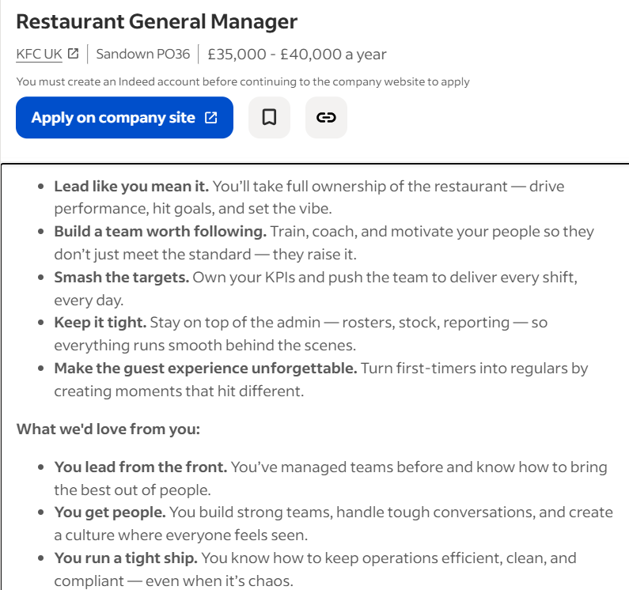
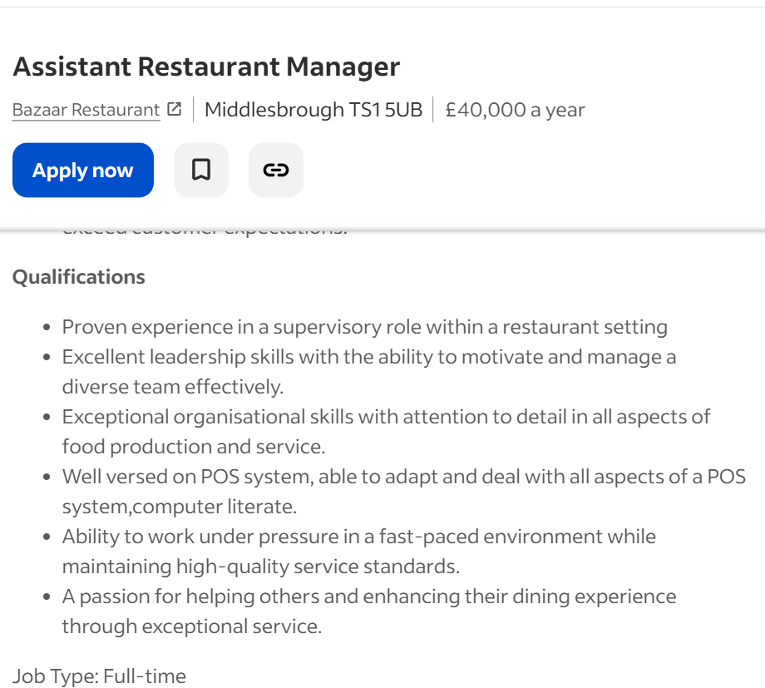
Task 1 – Compare job adverts
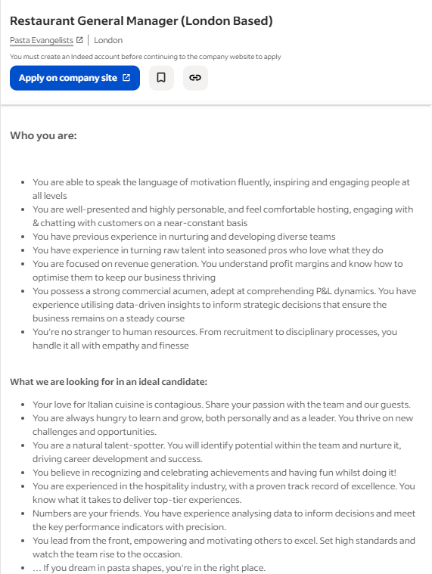
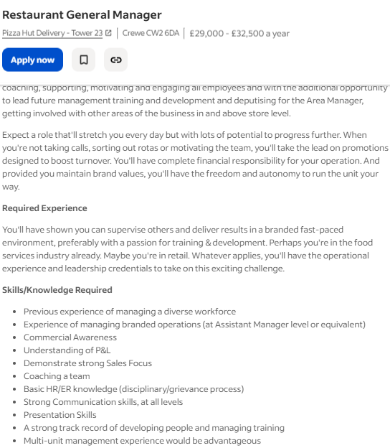

Leadership is key in all four adverts. Each company asks for individuals who can inspire and motivate teams, manage performance, and create a positive working culture. The adverts describe leaders as role models who set standards, train staff, and help to increase business performance.
In relation to this, teamwork is another common key skill mentioned in the adverts. Managers should integrate within the team, make staff feel welcomed and motivate them through words of encouragement and good leadership.
Strong organisational skills is another common skill seen amongst these adverts. Managers are expected to be able to multitask and handle staffing, scheduling, and maintaining standards across busy shifts and peak times. Attention to detail and the ability to plan ahead is important to ensure the restaurant runs smoothly and efficiently, particularly during peak service times.
In addition to this, communication is another key skill mentioned across all the adverts. Candidates must communicate clearly with staff, customers, and senior management. Effective communication is especially needed when giving feedback, training team members, and preventing misunderstandings or conflicts in the workplace.
Customer service is the central skill amongst all of the adverts. Every employer emphasizes the value of providing outstanding dining experiences, handling complaints in a professional manner, and giving customers a positive experience.
All four adverts mention some form of financial responsibility. For example, managing budgets, controlling costs, or understanding KPIs (Key Performance Indicators). Applicants should be aware of how to keep the restaurant successful by making good financial decisions and still providing great service.
These characteristics explain why all of the job adverts expect some type of previous experience of working in the hospitality industry in a more hierarchical role, because that can show the candidate is capable of meeting their standards and is aware of what is expected of them.

Task 2- SWOT analysis and evidence of readiness
One of my key strengths is people skills, I usually get on with people very well and am able to build a positive relationship with people easily through my kindness and friendly personality. El-sabaa, (2001) argues that people skills are even more important than technical skills in management because the business running smoothly is dependent upon the staff, if staff don’t cooperate, the business will not be able to function (El-sabba, 2001). Therefore, this acts as my strength because it means I can engage and build good relationships with staff and colleges, which will motivate them to work harder and help reduce conflict in the workplace.
Another strength I have is good organisational skills, this is proven by my ability to work and study at the same time whilst still maintaining a good work life balance. This comes from making to do lists, prioritising tasks and practicing self-care. This is a good strength to have as it allows good time management, better decision making, and reduces stress and mistakes, helping the business work more efficiently.
I also have good communication skills which I have improved upon from working as a restaurant manager for 10 plus years, where I have had to communicate with a large number of people like suppliers, customers, colleagues. Markovic and Salamzadeh, (2018) argue no organisation can succeed without effective communication skills because poor communication can cause ‘mismanagement and bad business results’. My communication skills act as a strength by allowing me to build positive relationships with teammates and customers through active listening and clear explanations.
An additional strength I have is good business knowledge which I have gained from studying a Cert HE in Business Skills for the Workplace at university and having my own business. These opportunities have taught me important skills such as budgeting, planning, customer service, and problem-solving. This is a good strength because it helps me make informed decisions, solve problems effectively, and understand how organisations operate. It also increases my confidence, employability, and ability to contribute successfully in professional settings.
Although I have several strengths, there are areas I need to develop further. One of my weaknesses is confidence especially during public speaking. Presenting in front of larger groups can make me nervous, and this is a skill I would like to improve to become more confident in professional settings. I am working on this by doing presentations in class in front of other students. I also tend to be overly self-critical, which can hold me back from taking risks or stepping out of my comfort zone.
There are many opportunities available that can support my personal and professional development. Continuing my education and completing further training will allow me to strengthen skills such as technology use, confidence, and leadership. Additionally, networking events and career fairs can help me build valuable connections within the industry.
Despite the opportunities available, there are also external threats that may affect my progress. One of these is the high level of competition in the job market, with many applicants holding advanced qualifications or more experience. Furthermore, with everything becoming more technology based, I might struggle as I am middle aged and haven’t had a lot of experience with technology, but I can continue to work on this, as at the beginning of my university course, I wasn’t great at using a laptop but now am able to use it quite well. Economic uncertainty or a lack of job openings may also create challenges, as I had to close my previous business due to difficulties during and after COVID 19.

Task 3 – employment goals and personal development plan
My short-term employment goals are based on the weaknesses that I mentioned earlier, such as my lack of confidence during public speaking and my tendency to be overly self-critical. One short term goal is to secure a role within a business environment that will allow me to improve my communication and confidence on a daily basis. Jobs such as administrative assistant, customer service advisor, or business assistant would give me regular opportunities to speak with colleagues, customers and supervisors, which will gradually help me feel more comfortable expressing myself and further improve my already existing skills such as people skills and team working skills. Another short-term goal is to develop my public speaking skills through training and workshops. For example, I plan to complete short courses in communication and presentation skills, as well as continue practising through class presentations and group discussions. These goals are important because gaining confidence in communication is essential for progressing in any business-related career. Improving my confidence will also reduce the impact of my self-critical nature, as I will start trusting my abilities more and feel less anxious about making mistakes. Achieving these short term goals will then help me to achieve my long term goals.
My long-term goal is to open my own successful restaurant. This is important to me because I previously had my own restaurant and unfortunately it had to close down during COVID because of supply chain changes and lack of customers because of the lockdown. This was quite disheartening for me as I had this restaurant for 10 years plus and ran it well with a supportive, loyal customer base. Due to this, I would like to open a new restaurant but before I do I would like to further improve my business skills so that I can better prepare for unexpected circumstances in the future. To do this, after completing my current course at university I would like it apply for a BA in business.
Personal development plan
1. Improve Public Speaking and Confidence
- Actions: Continue practising through class presentations, volunteering to speak in group tasks, rehearsing presentations at home, and completing an online course in communication or public speaking. I will also observe effective speakers, like my lecturers, to learn techniques such as body language and tone.
- Timeline: Ongoing- expected within 6 months, I only require a few more practices as I have already done multiple public speaking during presentations throughout my course.
- Resources Needed: Presentation opportunities, online learning platforms, feedback from tutors and peers, and time to practise.
- Measurement: Progress will be measured through increased confidence during presentations, reduced nervousness, and positive feedback from others.
2. Complete certificate in business skills and then get a BA in business
- Actions: Complete remaining assignments for the certificate, apply to the BA business course
- Timeline: 3 years to complete BA
- Resources needed: University support, Student finance, lectures and seminars, supportive teachers, guidance from university
- Measurement: Progress will be measured through receiving a pass after completing my certificate, keeping track of assignment and exam grades making sure that I revise plenty beforehand, graduating with a BA honours

3. Gain Practical Work Experience
- Actions: Apply for roles in restaurants, cafés, or business-related positions to develop skills in customer service, team management, and operations. This hands-on experience will prepare me for running my own business in the future.
- Timeline: Aim to secure a position within 6–12 months.
- Resources Needed: CV, job search platforms such as indeed or cv library, application support ie from university or careers advisors, and interview preparation.
- Measurement: Success will be measured by getting relevant experience and tracking improvements in confidence, communication, and problem-solving in the workplace.

References
El-Sabaa, S. (2001). The Skills and Career Path of an Effective Project Manager. International Journal of Project Management, [online] 19(1), pp.1–7. doi:https://doi.org/10.1016/s0263-7863(99)00034-4.
Radovic Markovic, M. and Salamzadeh, A. (2018). The Importance of Communication in Business Management. [online] papers.ssrn.com. Available at: https://papers.ssrn.com/sol3/papers.cfm?abstract_id=3578378.

