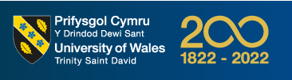
University of Wales – Trinity Saint David
MSc. Industry 4.0 Advanced Manufacturing

Assignment Title
Research Proposal
The use of Virtual Reality in promoting Industry 4.0 knowledge in Manufacturing SMEs

By
Fredrick Emeka Okwute (2134193)

Module
Research Methods and Professional Development (ACFA7004)

Lecturer
Graham Howe
Date
19/12/2022

Contents

Contents 1
Introduction 2
Research Aim and Objectives 4
Literature Review 5
The Role of Industry 4.0 in Manufacturing SME 5
Challenges of adopting Industry 4.0 in Manufacturing SMEs 5
The role of Virtual Reality in adopting Industry 4.0 in Manufacturing SMEs 6
Methods 10
The Use Case Structure 12
Timeline 15
Results 16
Evaluation 17
Reference 18

Introduction
The fourth industrial revolution remains a trending topic in large, medium, and small manufacturing companies. Growing globalization challenges are pushing these manufacturers to explore how Industry 4.0 and its technologies can be implemented to improve competitiveness. Vast research has been done to recognise the potential benefits of embracing Industry 4.0 technology. It is also apparent that several challenges could limit manufacturers from implementing Industry 4.0. Existing research have focused mostly on large manufacturers hence, posing a greater challenge for SMEs looking to adopt Industry 4.0. Just like lager companies, small/medium firms also require efficiency, sustainability, growth, and all other possible benefits of Industry 4.0.
Benefits of Industry 4.0 are enormous in manufacturing and so are the obstacles of implementation. According to research these obstacles are intensified for SMEs because of the limited existing pragmatic study. Amongst Industry 4.0 adoption critical success factors identified in studies, cost and knowledge play a huge role for manufacturing SMEs. Hence, making it difficult for SMEs faced with various operational and economic restrictions, to adopt Industry 4.0. Following these findings, manufacturing SMEs might have a chance at adopting Industry 4.0 if given a cost friendly and practical means of learning and testing Industry 4.0 concepts before fully committing to the implementation.
The goal of this research is to accelerate vocational learning of best practice manufacturing digitalisation technologies ensuring manufacturing SMEs are ready to exploit the 4th Industrial Revolution. The outcome of this study will enable manufacturing SME employees to experience simple manufacturing digitalisation scenarios from a classroom setting. These employees can problem solve and learn in a virtual and competitive environment which will increase enjoyment, engagement, and learning. The technology delivery strategy ranges from web-based interactive factory simulations via PC/smartphone or VR headsets. Therefore, anyone with Internet access can benefit.
The main goal of this research is to design and develop a novel virtual training platform that excites employees about digital transformation and new ways of interactive learning. This will raise awareness of potential skills gaps and teach state-of-the-art industry 4.0 technology skills. The project will focus on data related skills in a manufacturing environment and the main new technologies that are driven by it. It will teach how to capture data from machines, plant, and people and to analyse the data to make smart decisions. Additionally, fully understanding the concepts of IoT, Big Data, Augmented & Virtual Reality and Additive Manufacturing is a critical outcome. Users will be more informed about the latest technology and how to utilise these technologies in the workplace.
The learning experience must be intuitive, engaging, and deliver on clear learning objectives to drive Industry 4.0 skill development in employees of manufacturing SMEs. During the piloting phase each use case will be intensively tested with a wide range of users. During this process, user feedback will be considered to fine-tune the learning experience for users.
Each learner will undertake a skills diagnostic when signing up to the platform which records the skills level learners are at this moment in time. The completion of training courses will feed into the skills diagnostics dashboard and update the scores while completing courses and challenges on the platform. The project can then measure the change in skills levels across all users and companies that signed up to trial/test the platform.

Research Aim and Objectives
- Build Industry 4.0 training courses in collaboration with academic research and UK manufacturing SMEs.
- Provide diagnostics to Manufacturing SMEs to identify technology gaps & skills diagnostics for employees.
- Create a cost and time effective online training platform that is accessible from anywhere and any device.
Problem statement and proposal summary
Challenges | - Workforce lacks understanding of digitalization. Need to provide training.  - Current training done remotely is video content. Easy to consume, but low retention.  - Employee training programs are expensive to run.  - Want to implement new technologies but need skilled worked to use them.  - Difficult to get people to buy into the vision without real-world practical examples.  - Concepts of Industry 4.0 seem academic and impractical.
Goals | - Upskill workforce to adopt Industry 4.0 technologies.  - Have a more automated and operationally efficient factory.
Project Expectations | - A more engaging and immersive platform that provides practical application understanding to Industry 4.0 concepts.  - Free introductory courses for all users to get a taste of the platform and Industry 4.0.  - Monitor progress of multiple users on the platform and check their learning journey.  - Demonstration of practical applications of Industry 4.0 technologies rather than academic explanation.

Literature Review

The Role of Industry 4.0 in Manufacturing SME
Industries today are prone to numerous difficulties, and these are not unique to only SMEs but also applies to larger businesses. Globalization is forcing manufacturers to focus on improved responsiveness to customer demands and product quality if they are to survive and remain in business (Fatorachian and Kazemi, 2018). For manufacturers to succeed, and respond to new changing customer demands, they need to reinvent their businesses by adopting digital technology (Florescu and Barabas, 2020). Yildiz, Moller and Bilberg (2021) also argued that intelligent manufacturing, tailored by industrial 4.0, can support innovation, competition, and changing demands relating to processes, products, and production systems. Manufacturers have to adapt to an ever-changing ecosystem and reinvent their process, product and system as well as their objectives and strategies to stay competitive.
Industry 4.0 started as a German initiative for advanced factories where innovative technologies such as robotics, internet of things (IoT), artificial intelligence, and 3D printing, can be applied for environmental, societal, and economic sustainable manufacturing systems (Kamblea, Gunasekaranb and Sharma,2018). According to Castelo-Branco and Cruz-Jesus (2019), technology has been influencing manufacturing practices since industrial 3.0, however Industry 4.0 now presents manufacturers with better opportunities for improvement as never seen before. The increasing demand for automated and more efficient processes, shorter delivery timescales, improved quality products, is driving manufacturing companies towards Industry 4.0 (Zheng et al., 2021).

Challenges of adopting Industry 4.0 in Manufacturing SMEs
While the advantages of implementing Industry 4.0 are huge for manufacturers, there are still huge obstacles and challenges to consider (Fatorachian and Kazemi, 2018). Manufacturers, particularly SMEs are faced with uncertainties of high capital spending and no obvious benefits or return on investment if Industry 4.0 is adopted (Kamblea et al., 2018). It was also argued in Cotrino, Sebastián and González-Gaya (2020), that Industry 4.0 will benefit manufacturing SMEs but the challenges of adopting this technology could be massive.
The benefits of Industry 4.0 in manufacturing are enormous and so are the challenges of adoption. According to Surange et al. (2022), the journey of adopting Industry 4.0 technology is full of obstacles and these obstacles are intensified for manufacturing SMEs. Research in Industry 4.0 is still growing however a majority of these are only within the context of large manufacturing businesses (Ravinder, Rajesh and Yogesh, 2020). Cotrino, Sebastián and González-Gaya (2020) further argued that available studies addressing the use of Industry 4.0 in manufacturing SMEs from a practical viewpoint are limited. Surange et al. (2022), and Ravinder, Rajesh and Yogesh (2020), supports that the lack of research on practical application of Industry 4.0 in manufacturing SMEs makes the journey of adopting Industry 4.0 full of uncertainties and obstacles.
In spite of current gaps in practical knowledge of Industry 4.0, certain academic research has identified the potential obstacles of adopting Industry 4.0 (Luthra and Mangla, 2018). Ravinder, Rajesh and Yogesh (2020) identified untrained workforce and lack of IT infrastructure as parts of the major challenges of adopting Industry 4.0. Alok et al. (2020) research supports that cost of technological infrastructure could be a massive obstacle for SMEs in the adoption of Industry 4.0. The study further identified resource scarcity and lack of knowledge as barriers to adopting Industry 4.0.
Several other research such as Nwaiwu et al. (2020), Cotrino, Sebastián and González-Gaya (2020), and Surange et al. (2022), all highlighted funds, manpower, and skills as critical factors of success in adopting Industry 4.0 in Manufacturing SMEs. Elhusseiny and Crispim (2022), Dalenogare et al. (2018), and Ghobakhloo (2018), also found IT infrastructure, lack of skilled employees, lack of financial resources, level of education, and other barriers as crucial for the deployment of Industry 4.0 technologies in manufacturing SMEs.

The role of Virtual Reality in adopting Industry 4.0 in Manufacturing SMEs
Virtual Reality (VR) is known as a cog in the wheel of digital manufacturing (DM) and DM is one of the most dominate parts of Industry 4.0 (Abidi et al., 2019). With advancement in technology, digital manufacturing can be applied to training, designing, and prototyping. According to Mujber, Szecsi and Hashmi (2004), Virtual Reality has been applied to solve real-world challenges, and has boosted profitability, reduced time to market, and improved workers safety. Crucial manufacturing activities can be identified, developed, and validated before they are actually applied. The concept of Virtual Reality presents engineers with new ways to visualize problems and to interact with the virtual platform to solve the problems efficiently.
The concept of Virtual Reality in Virtual Factory (VF) is gaining attention from prominent manufacturers like Ford Motor and Volvo Group Global. These companies are utilising Virtual Reality for simulating, integrating, and controlling models from process, product, and system (Yildiz, Moller and Bilberg, 2021).
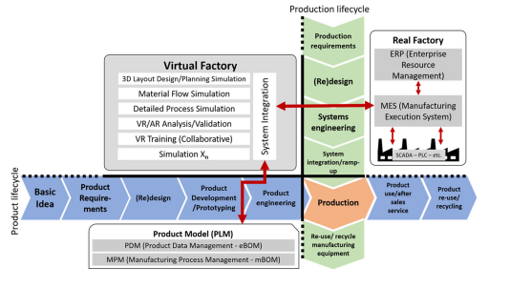
Virtual Factory Conceopt - Yildiz, Moller and Bilberg (2021).
Virtual Reality is centred on computer graphics, which can be used to develop virtual platforms with the possibility of item control by the user through input devices. This gamified aspect makes the user feel very immersed in the virtual platform (Dammacco et al., 2022). Virtual Reality, which is also described as immersive computing technology (ICT), offers a distinctive way to interact with the ever-growing digital environment (Berg and Vance, 2017). According to Mujber, Szecsi and Hashmi (2004), the concept of Virtual Reality is that of an allusion because it allows a user to walk into a computer 3D reality and the user is able to look, move, and interact with this 3D world as if it were real.
In Aurich, Ostermayer and Wagenknecht (2009), it was established that Virtual Reality is a technology used to create virtual environments comprising of realistic 3D simulations and their possible interrelationships. The work also highlighted that Virtual Reality is characterised mainly by 3 components, namely:
- Visualisation of a virtual platform
- Immersion of the user into this virtual platform
- Live interactions within this virtual platform
The concept of Virtual Reality has been projected over the last few years to enable industries to experience a virtual environment. These industries include bioengineering, construction, automotive and aerospace. Within these industries, the most promising and common applications of Virtual Reality has been for design, maintenance, and training (Dammacco et al., 2022). Aurich, Ostermayer and Wagenknecht (2009) research also highlighted employee training alongside product/process design and planning as industrial applications for Virtual Reality. According to Berg and Vance (2017), Virtual Reality technology is adopted in manufacturing for decision support in design, assessment, and training processes across various departments.
Abidi et al. (2019) argued that training employees have always been a challenge for firms as this involves cost and time and the employees rarely gets good value from such training due to the nature of the training. Aglan, Zhao and Yang (2022) also argued that decision making with inadequate problem-solving abilities in real world may result in pricey consequences. The immersive platform provided by Virtual Reality enables users to better comprehend and solve real-world manufacturing challenges. With Virtual Reality, training can be done via “learning by doing” instead of the normal “learning by observing & listening”. In Abidi el al. (2019) it was established that employees trained by VR committed less errors and took less time in carrying out their jobs when compared with employees trained via traditional training methods. Dammacco et al. (2022) study identified that all users of VR found training enjoyable, interactive, and easy to learn.
The results derived from Berg and Vance (2017), suggests that Virtual Reality is here to stay: it is stable, mature, and, most importantly, it works and is usable. Mujber, Szecsi and Hashmi (2004), established that Virtual Reality has been successfully adopted by hundreds if not thousands of circumstances in varied fields ranging from manufacturing, engineering, scientific visualisation, rapid prototyping, and education.
Virtual Reality systems mostly fall into three key classifications which include 1) non-immersive (Desktop) systems, 2) semi-immersive projection systems and 3) fully immersive systems. Huge amounts of Virtual Reality software packages are available on the market today and these can be selected based on intended applications (Mujber, Szecsi and Hashmi, 2004). Recently, Virtual Reality technology has become popular in manufacturing and has gained in cost effectiveness. Hence, it is now largely recognized that it is invaluable for manufacturers to invest in Virtual Reality (Choi, Jung and Noh, 2015).
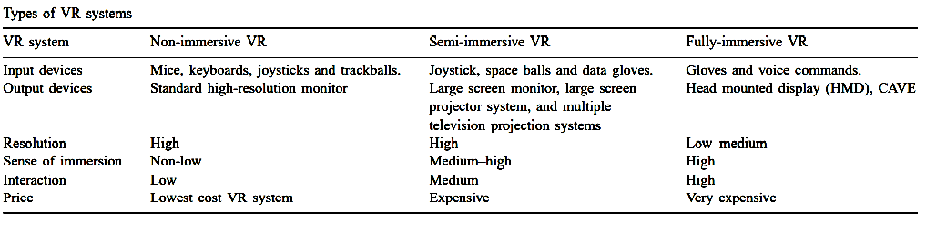Types of VR System - Mujber, Szecsi and Hashmi (2004).

Methods
This research foundation is based on exploring similar existing academic work and partnerships with Fitfactory Technology Ltd and Simulanis Solutions Pvt. Ltd. Fitfactory is a manufacturing digital transformation product and service provider based in the United Kingdom with a customer base of over 400 manufacturing SMEs. Simulanis is an Indian multi-award holding XR technology business devoted to providing excellence in building some of the most, immersive, interactive, and engaging AR-VR applications.
The platform will essentially be a website with a private user area. The virtual training environments will be hosted on a separate virtual machine (VM) which can communicate with the website and Fitfactory app server. The virtual training courses are embedded with web links that will launch the environment from the separate Virtual Machine which is not visible to the user. The user will have a seamless experience. While users perform training courses, data being captured in the environment will be written to a database on the Virtual Machine which can be queried by the website.
The virtual environments will be containerised to be easily deployable and to allow to spin off a new instance of an environment almost instantly. It will be based on open-source JavaScript frameworks such as Babylon.js to build the virtual experience on the web. This framework is utilising HTML 5 and OpenGL which are both open source and widely used and has a big community. Building on Fitfactory’s experience in building commercial cloud architecture application, this will make sure that the platform is user friendly, easy to deploy, secure and scalable.
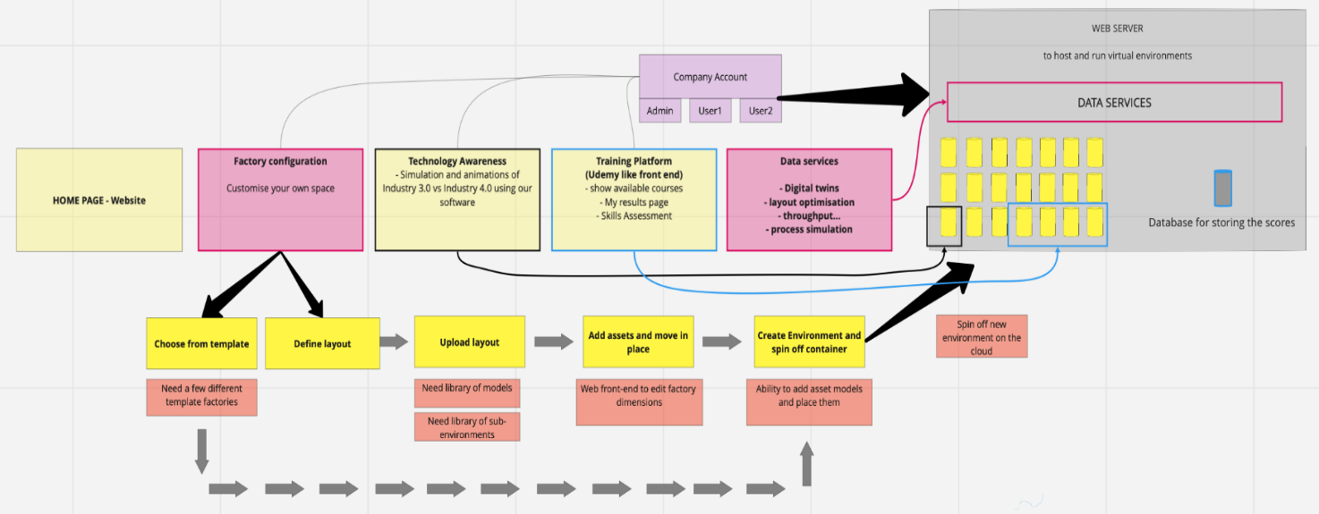

The learning design approach is to identify key challenges and blockages in knowledge, understanding and behaviour, and build these into complex, multi-directional case studies in which learners have to make appropriate decisions, and experience the consequences of these decisions. Consequences will be both visualised and explained, with learners able to correct their decisions and thereby learn the correct course of action or response. Learning pathways will be constructed in conjunction with academia and Fitfactory manufacturing clients.
Fitfactory Technology Ltd will create business scenarios, which are contemporary representations of today’s challenges within operations management and logistics environments which are driven by advanced technologies such as Industry 4.0 (I4.0), Internet-of-things (IoT) and artificial intelligence (AI). The business scenarios will focus on presenting real case-based examples within various industry sectors, where complex operational challenges are faced by organisations in their daily business environments and where the use of I4.0, IoT and AI enables them to gain competitive advantage in global markets. This will offer users the opportunity to apply valuable insights and gain practical understanding of operations as they are actually carried out.
These business scenarios are drawn from the wealth of experience and expertise which has been gained during many years of leading consultancy projects in industry as well as delivering specialised training and academic courses in the higher education sector. The contemporary subject areas presented in the scenarios are drawn from actual current and past research undertaken for real companies. This ensures ‘relevance’ of the learning pathways and evaluations thereof whilst reaffirming their alignment with the prevailing industry standards and operating challenges, such as operating under pandemic conditions.
The learning pathways and evaluations will enable user to achieve solution-based learning based on such real problem scenarios and comparative review against the “actual” solutions adopted and implemented in real-time. Users will have the opportunity to use interactive features and to test solutions to underlying problem areas whilst applying “what-if” scenarios to model the outcomes, enabling them to evaluate and adopt the optimal solution going forward. The business scenarios will be created from the user’s perspective and facilitate paced-learning techniques. The pathways therefore are users experience led, i.e., enabling each user to set the level of interaction with the platform, with more advanced users accessing higher levels of functionality, thus ensuring continued engagement at all learning levels.
The learning pathways have a distinct focus on optimisation and enabling efficiency gains. These learning pathways lead to identifying, creating, and enabling sustainable competitive advantage and they are relevant for most companies and across most sectors. In addition, the business scenarios, problem statements and solution developments to the business scenarios mentioned above shall be supplemented with advanced simulations, gaming and visualisation tools and developments. This enables users to apply the latest teaching and learning tools in contemporary areas, such as Industry 4.0 and Internet of Things (IoT) and Artificial Intelligence (AI).
Business scenarios will be validated through academic study. Content of training courses and workshops will be planned and developed in association with academic standards, emphasising specific learning pathways for users and aligning them with individual case studies. The above ensures the platform teaching and learning objectives on offer meet the individual institutional curricular requirements.
Evaluation of the learning pathways will offer several options including weighted assessment of the key learning goals. Practical work on Platform development will be evaluated through Groupwork and peer assessment. Individual assignments will offer users the opportunity to present their work in more structured formats of academic rigour and review their work against existing theoretical models and professional standards. In addition, evaluation shall feature several interactive elements, including stage quizzes, section questions & answers as well as end of unit on-line assessment tests to check and gauge progress. Tips will be offered to those which lower levels of achievement in order to facilitate catching up, in order to ensure learning pathways progress is uniformly achieved by user cohorts where possible.
The training platform will be designed and developed by partner Simulanis Solutions Pvt. Ltd. Fitfactory Technology will take lead with the course design, testing and dissemination. The over 400 customer-base of Fitfactory will be targeted for testing and feedback on the effectiveness of the platform in comparison to outlined project objectives.

The Use Case Structure
The project use cases will demonstrate how production planning can be made more efficient by showing the differences in technology across three industry ages: Industry 3.0, Industry 3.5, and Industry 4.0. The use cases will allow learners to see how the manufacturing and business process has changed from Industry 3.0 to Industry 4.0 and its subsequent business benefits. The project will have three use cases, with each use case focusing on a specific industry age. The three use cases are:
- Industry 3.0: Completing tasks manually
- Industry 3.5: Data is captured. User needs to take action
- Industry 4.0: Data is captured; Machine learning takes place and machines complete tasks on behalf of the user
Across all three modules, a learner will be completing the task of completing a customer’s order while managing unscheduled interruptions that are normal in a shop floor environment during normal day-to-day operations. By doing the same task, the learner will learn that by adopting new tech a task becomes easier and quicker to complete.
The objectives of this course are to train learners in the following
- Understand the differences between industry 3.0 and industry 4.0.
- Understand how decision making happens with industry 4.0.
- Understand how industry 4.0 can increase productivity.
Targeted users are experienced production manager, digital transformation lead, procurement manager, new professionals, apprentices, and machine operators. This can also be extended to cover Students.
Part of the use cases will be to showcase an immersive training environment where the user learns about the various aspects of a factory process such as an assembly using Industry 4.0 technologies (e.g. VR/AR). The course will allow learners to complete a full assembly process of a typical product supplied from a Tier 1 Small Medium Business (SME) to an Original Equipment Manufacturer (OEM). The assembly procedure will introduce a set of production equipment and tools that the user will be able to utilise along with a series of IN4.0 technologies such as shopfloor data capture, UAVs, RFID tagging and AR to monitor the progress of the procedure and collect valuable data to improve the process. This will effectively make the process easier, cheaper, and more efficient.
Project Cost:
This project is facilitated by voluntary support from Fitfactory Technology Ltd and Simulanis Solutions Pvt. Ltd
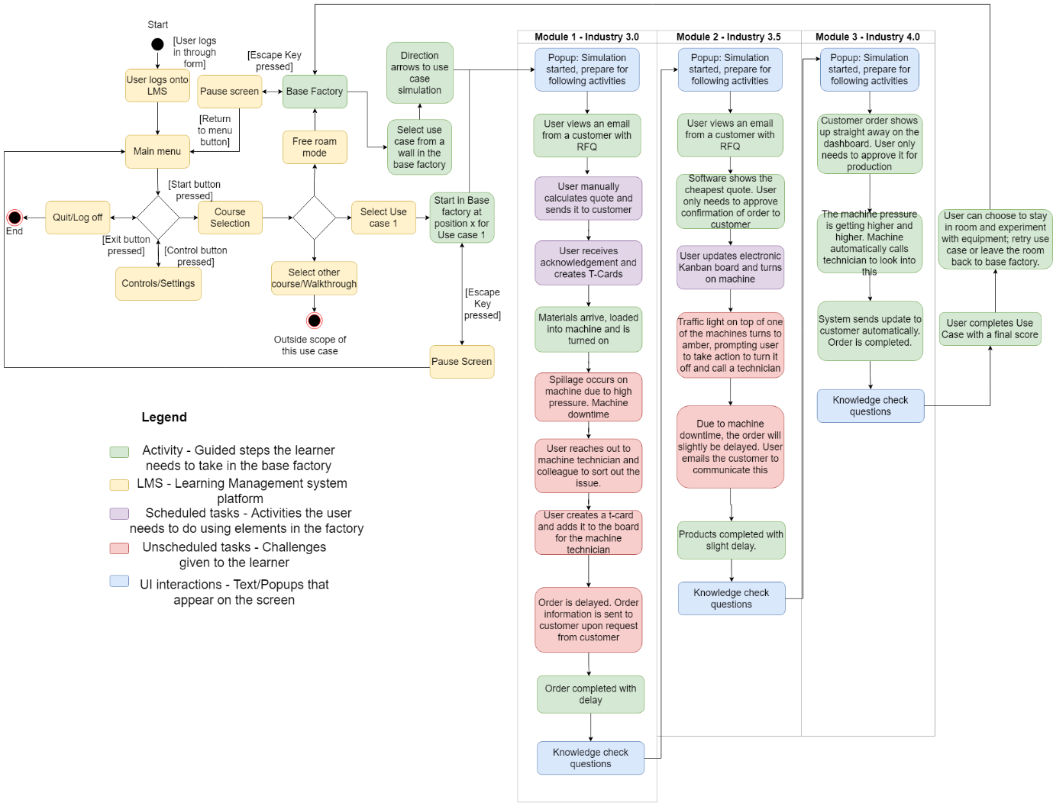

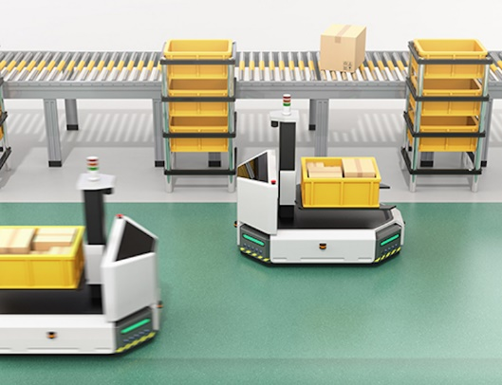
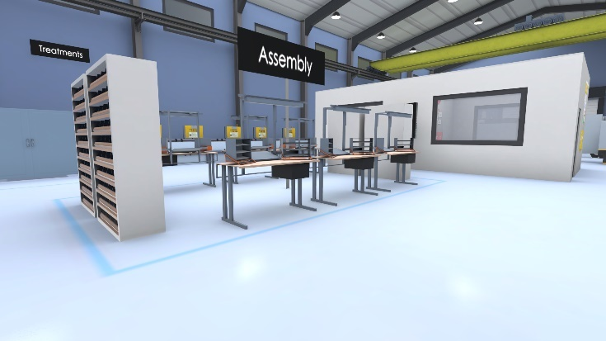
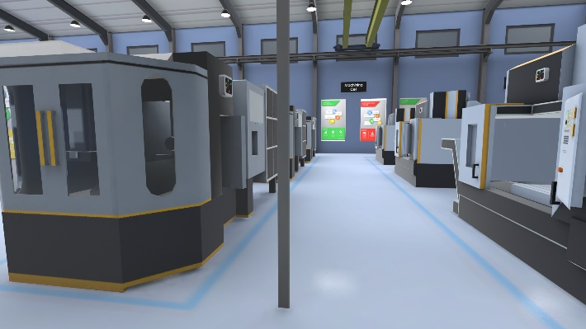
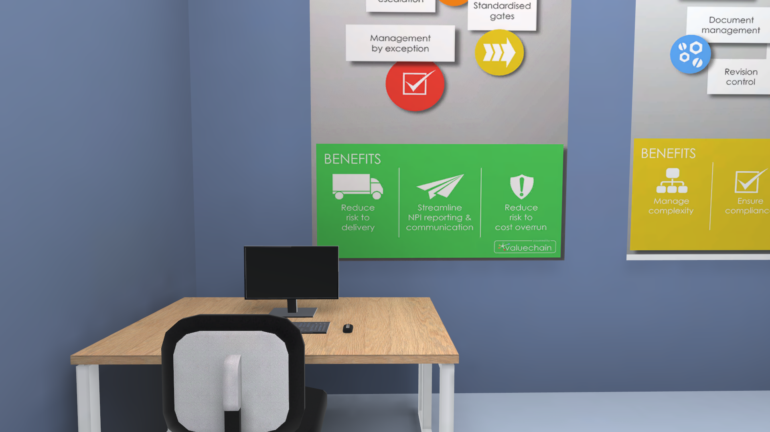

Timeline
Work package |  | Activity |  | M1 | M2 | M3 | M4 | M5 | M6
1.0 | Planning & Project Management  This workstream will set out the scope of works for each of the three products that will be developed out of this project. The outputs that are associated with each product will be listed and defined. Timeframes will for each product development will be outlined. | 1.1 | Agree all product deliverables for the project
1.0 |  | 1.2 | Review & sign off the project plan, including kick off meeting with Partners
1.0 |  | 1.3 | Project Steering group meetings
1.0 |  | 1.4 | Project Management
2.0 | Platform Development  The objective of this workstream is to create an online portal that allows users to access the virtual smart factory training playground via web browser. The training experience will be gamified to by implementing a scoring system which allows you to track your progress against others (benchmarking). After releasing every version of the platform, it will be tested with the user groups and feedback implemented for the next version. | 2.1 | Infrastructure
2.0 |  | 2.2 | Portal front-end (login on website)
2.0 |  | 2.3 | Website design
2.0 |  | 2.4 | Skills diagnostics & results
2.0 |  | 2.5 | Create private section of the website as online portal
2.0 |  | 2.6 | Course selection and content
2.0 |  | 2.7 | Virtual Interface
2.0 |  | 2.8 | Embed 2D and 3D virtual environment on Website
2.0 |  | 2.9 | Embed multiple headset types
3.0 | Virtual Design & Development  The main objectives of this work stream are the design and development of the virtual environments which includes the base environment and variations of it, plus and other virtual developments for use case. | 3.1 | Virtual Environment Modelling Foundation
3.0 |  | 3.1.1 | Familiarisation with WebVR framework
3.0 |  | 3.1.2 | Create base Factory based on previous model
3.0 |  | 3.2 | Industry 3.0 vs Industry 4.0 Animations & Walkthroughs
3.0 |  | 3.2.1 | Data driven decision making
3.0 |  | 3.3 | Use Case Development
3.0 |  | 3.3.1 | Use Case 1
3.0 |  | 3.3.2 | Use Case 2
3.0 |  | 3.3.3 | Use Case 3
3.0 |  | 3.4 | Add new virtual content
3.0 |  | 3.5 | Fitfactory app development for VR experience
4.0 | Learning/Skills Development & User Testing  This work stream will mainly focus on the development of virtual training courses. This will be done by collaborating with academic research and manufacturing partners to create content. Another essential part to this work stream is the piloting phase in which testing and evaluating the learning environment and experience with as many users as possible. | 4.1 | First version learning pathways (internal)
4.0 |  | 4.2 | Skills diagnostics
4.0 |  | 4.3 | Workshop around learning experience with Academia and Industry
4.0 |  | 4.4 | Evaluate & agree most suitable learning methodologies & course content based on workshop outcomes
4.0 |  | 4.5 | Develop engagement plan with target beneficiary groups
4.0 |  | 4.6 | Confirm participation of users
4.0 |  | 4.7 | User Testing & Course Improvement
4.0 |  | 4.7.1 | Use Case 1
4.0 |  | 4.7.2 | Use Case 2
4.0 |  | 4.7.3 | Use case 3
4.0 |  | 4.8 | User engagement
5.0 | Reporting  This workstream will focus on the production of all the monthly reports that are associated with the wider project. | 5.1 | Monthly monitoring reports
5.0 |  | 5.2 | Production of final evaluation report

Results
The expected outcome of this project is to meet the established aims and objectives as highlighted in the introduction. These include the below:
- To upskill employees in Industry 4.0 tech and show the benefits of achieving a more efficient process in production planning. To enable new employees to adapt themselves to an industry 4.0 shop floor setting.
- To understand the concept of data in a manufacturing environment, how data can be captured in an efficient and digital way, what kind of data can be available and how to use this data to make informed decisions.
To achieve the above, the courses will measure the learners’ knowledge and understanding through skills diagnostic tests before, after, and during the course.

Evaluation
Before progressing to subsequent use cases, the user will need to complete a pre-assessment. These will be questions based on the user completing preceding use cases. There will be 10 questions, which will be multiple choice. The correct answers will not be shown until the user submits all the questions. 10 points will be awarded for each correct answer. 50 points or more will be required to recommend access to next use case.
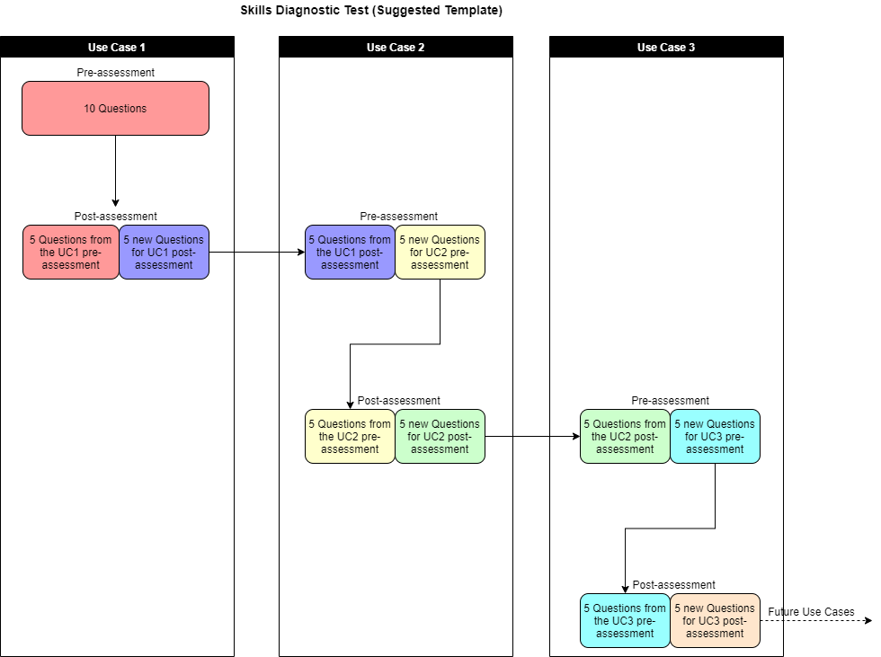

Reference
Abdullah, F. M., Saleh, M., Al-Ahmari A. M. and Anwar, S. (2022) ‘The Impact of Industry 4.0 Technologies on Manufacturing Strategies: Proposition of Technology-Integrated Selection’, IEEE Access, 10(2022), pp.21574-21583. doi:10.1109/ACCESS.2022.3151898.
Abidi, M. H., Al-Ahmari, A., Ahmad, A., Ameen, W. and Alkhalefah, H. (2019) ‘Assessment of virtual reality-based manufacturing assembly training system’, The International Journal of Advanced Manufacturing Technology, 105, pp. 3743–3759. doi.org/10.1007/s00170-019-03801-3.
Alok, R., Gourav, D., Ankit, S., Ana, B. L. J., and Sonu, R. (2020) ‘Barriers to the adoption of industry 4.0 technologies in the manufacturing sector: An inter-country comparative perspective’, International Journal of Production Economics, 224(107546), pp.1-17. doi: 10.1016/j.ijpe.2019.107546.
Aurich, J. C., Ostermayer, D. and Wagenknecht, C. H. (2009) ‘Improvement of manufacturing processes with virtual reality-based CIP workshops’, International Journal of Production Research, 47(19), pp. 5297-5309. doi.org/10.1080/00207540701816569.
Berg, L. P. and Vance, J. M. (2017) ‘Industry use of virtual reality in product design and manufacturing: a survey’, Virtual Reality, (21) pp. 1–17. DOI 10.1007/s10055-016-0293-9.
Bhaveshkumar, N.P., Subhash, K.M. and Santosh, B.R. (2021), ‘The current sustainability scenario of Industry 4.0 enabling technologies in Indian manufacturing industries’, International Journal of Productivity and Performance Management, 70(5), pp.1017-1048. doi.org/10.1108/IJPPM-04-2020-0196.
Bhaveshkumar, N.P., Subhash, K.M. and Santosh, B.R. (2020b), ‘Redesigning of smart manufacturing system based on IoT: perspective of disruptive innovations of industry 4.0 Paradigm’, International Journal of Mechanical and Production Engineering Research and Development (IJMPERD), 10(3), pp. 727-746.
Burinskas, A. (2021) ‘Transformation of industrial policy towards Industry 4.0 and its impact on firms’ competition’, International Journal of Economics and Management Engineering, 15 (5), pp. 579–584.
Castelo-Branco, I., Cruz-Jesus, F., Oliveira, T., (2019) ‘Assessing industry 4.0 readiness in manufacturing: evidence for the European Union’, Computers in Industry, 107(May 2019), pp.22–32. doi.org/10.1016/j.compind.2019.01.007.
Chen, B., Wan, J., Shu, L., Li, P., Mukherjee, M. and Yin, B. (2018), ‘Smart factory of Industry 4.0: key technologies, application case, and challenges’, IEEE Access, 6(1), pp. 6505-6519.
Choi, S., Jung, K. and Noh, S. D. (2015) ‘Virtual reality applications in manufacturing industries: Past research, present findings, and future directions’, Concurrent Engineering: Research and Applications, 23(1), pp. 40–63. DOI: 10.1177/1063293X14568814.
Cimini, C., Boffelli, A., Lagorio, A., Kalchschmidt, M. and Pinto, R. (2019) ‘How do industry 4.0 technologies influence organisational change? An empirical analysis of Italian SMEs’, Journal of Manufacturing Technology Management, 32(3), pp.695-721. doi:10.1108/JMTM-04-2019-0135.
Cotrino, A., Sebastián, M. A. and González-Gaya, C. (2020) ‘Industry 4.0 Roadmap: Implementation for Small and Medium-Sized Enterprises’, Applied Science, 10(8566), pp.1-17. doi:10.3390/app10238566.
Dalenogare, L. S., Benitez, G. B., Ayala, N. F. and Frank, A. G. (2018) ‘The expected contribution of Industry 4.0 technologies for industrial performance’, International Journal of Production Economics, 204(2018), pp.383-394.doi.org/10.1016/j.ijpe.2018.08.019.
Dammacco, L., Carli, R., Lazazzera, V., Fiorentino, M. and Dotoli, M. (2022) ‘Designing complex manufacturing systems by virtual reality: A novel approach and its application to the virtual commissioning of a production line’, Computers in Industry, 143 (103761). doi.org/10.1016/j.compind.2022.103761.
Elhusseiny, H. M. and Crispim, J. (2022) ‘SMEs, Barriers and Opportunities on adopting Industry 4.0: A Review’, Procedia Computer Science, 196(2022), pp.864-871. doi.org/10.1016/j.procs.2021.12.086.
Emre Yildiz, E., Møller, C. and Bilberg, A. (2021) ‘Demonstration and evaluation of a digital twin-based virtual factory’ The International Journal of Advanced Manufacturing Technology, 114, pp. 185–203. doi.org/10.1007/s00170-021-06825-w.
Hofmann, E. and Rüsch, M. (2017) ‘Industry 4.0 and the current status as well as future prospects on logistics’, Computers in Industry, 89(2017), pp.23-34. doi.org/10.1016/j.compind.2017.04.002.
Fatorachian, H. and Kazemi, H. (2018) ‘A critical investigation of Industry 4.0 in manufacturing: theoretical operationalisation framework’, Production Planning & Control, 29(8), pp.633-644. doi:10.1080/09537287.2018.1424960.
Florescu, A. and Barabas, S. A. (2020) ‘Modeling and Simulation of a Flexible Manufacturing System—A Basic Component of Industry 4.0’, Applied Science, 10 (8300), pp.1-20. doi:10.3390/app10228300.
Franka, A. G., Dalenogareb, L. S. and Ayalac, N. F. (2019) ‘Industry 4.0 technologies: Implementation patterns in manufacturing companies’, International Journal of Production Economics, 210(April 2019), pp.15-26. doi:10.1016/j.ijpe.2019.01.004.
Frank, A.G., Dalenogare, L.S. And Ayala, N.F. (2019) ‘Industry 4.0 technologies: implementation patterns in manufacturing companies’, International Journal of Production and Economics, 210, pp.15-26. doi.org/10.1016/j.ijpe.2019.01.004.
Gbededo, M.A., Liyanage, K., And Garza-Reyes, J.A. (2018) ‘Towards a life cycle sustainability analysis: a systematic review of approaches to sustainable manufacturing’, Journal of Cleaner Production. 184, pp.1002-1015. doi.org/10.1016/j.jclepro.2018.02.310.
Ghadimi, P., Donnelly, O., Sar, K., Wang, C. and Azadnia, A. H. (2022) ‘The successful implementation of industry 4.0 in manufacturing: An analysis and prioritization of risks in Irish industry’, Technological Forecasting & Social Change, 175(2022), pp.121394. doi:10.1016/j.techfore.2021.121394.
Ghobakhloo, M. (2018) ‘The future of manufacturing industry: a strategic roadmap toward Industry 4.0’, Journal of Manufacturing Technology Management, 29(6), pp.910-936. doi:10.1108/JMTM-02-2018-0057.
Gunjan, Y., Anil, K., Sunil, L., Jose, A. G., Vikas K. and Luciano, B. (2020) ‘A framework to achieve sustainability in manufacturing organisations of developing economies using industry 4.0 technologies’ enablers’, Computers In Industry, 122(103280), pp.1-13. doi: 10.1016/j.compind.2020.103280.
Hürkamp, A., Gellrich, S., Ossowski, T., Beuscher, J., Thiede, S., Herrmann, C. and Dröder, K. (2020) ‘Combining Simulation and Machine Learning as Digital Twin for the Manufacturing of Overmolded Thermoplastic Composites’, Journal of Manufacturing and Materials Processing, 4(92), pp. 1-20. doi:10.3390/jmmp4030092.
Jamwal, A., Agrawal, R., Sharma, M. and Giallanza, A. (2021) ‘Industry 4.0 Technologies for Manufacturing Sustainability: A Systematic Review and Future Research Directions’, Applied Sciences, 11(5725). doi.org/10.3390/app11125725.
Jimeno-Morenilla, A., Azariadis, P., Molina-Carmona, R., Kyratzi, S., and Moulianitis, V. (2021) ‘Technology enablers for the implementation of Industry 4.0 to traditional manufacturing sectors: A review’, Computers in Industry, 125(103390), pp.1-13. doi.org/10.1016/j.compind.2020.103390.
Kalsoom, T., Ahmed, S., Rafi-ul-Shan, P. M., Azmat, M., Akhtar, P., Pervez, Z., Imran, M. A. and Ur-Rehman, M. (2021) ‘Impact of IoT on Manufacturing Industry 4.0: A New Triangular Systematic Review’, Sustainability, 13(12506), pp. 1-22. Doi:10.3390/su132212506.
Kamblea, S. S., Gunasekaranb, A. and Sharma, R. (2018) ‘Analysis of the driving and dependence power of barriers to adopt industry 4.0 in Indian manufacturing industry’, Computers In Industry, 101(October 2018), pp.107-119. doi:10.1016/j.compind.2018.06.004.
Luthra, S. and Mangla, S.K. (2018) ‘Evaluating challenges to Industry 4.0 initiatives for supply chain sustainability in emerging economies’, Process Safety and Environmental Protection, 117, pp.168-179. doi.org/10.1016/j.psep.2018.04.0.
Malik, A. A., Masood, T. and Bilberg, A. (2020) ‘Virtual reality in manufacturing: immersive and collaborative artificial-reality in design of human-robot workspace’, International Journal of Computer Integrated Manufacturing, 33(1), pp. 22–37. doi.org/10.1080/0951192X.2019.1690685.
Matsas, E. and Vosniakos, G. (2017) ‘Design of a virtual reality training system for human–robot collaboration in manufacturing tasks’, International Journal on Interactive Design and Manufacturing (IJIDeM), 11, PP. 139–153. DOI 10.1007/s12008-015-0259-2.
Mittala, S., Khana, M. A., Romerob, D. and Wuesta, T. (2018) ‘A critical review of smart manufacturing & Industry 4.0 maturity models: Implications for small and medium-sized enterprises (SMEs)’, Journal Of Manufacturing Systems, 49(October 2018), pp.194-214. doi:10.1016/j.jmsy.2018.10.005.
Mujber, T. S., Szecsi, T. and Hashmi, M. S. J. (2004) ‘Virtual reality applications in manufacturing process simulation’, Journal of Materials Processing Technology, 155(156), pp. 1834–1838. doi:10.1016/j.jmatprotec.2004.04.401.
Nimawat, D. and Gidwani, B.D. (2021) ‘Identification of cause and effect relationships among barriers of Industry 4.0 using decision-making trial and evaluation laboratory method’, Benchmarking An International Journal, 10.1108/BIJ-08- 2020-0429.
Nwaiwu, F., Duduci, M., Chromjakova, F., and Otekhile, C. F. (2020) ‘Industry 4.0 concepts within the Czech SME manufacturing sector: an empirical assessment of critical success factors’, Business: Theory and Practice, 21(1), 58-70. doi:10.3846/btp.2020.10712.
Rai, R., Tiwari, M. K., Ivanov, D. and Dolgui, A. (2021) ‘Machine learning in manufacturing and industry 4.0 applications’, International Journal of Production Research, 59(16), pp.4773-4778. doi:10.1080/00207543.2021.1956675.
Ravinder, K., Rajesh, K. S., and Yogesh, K. D. (2020) ‘Application of industry 4.0 technologies in SMEs for ethical and sustainable operations: Analysis of challenges’, Journal of Cleaner Production, 275(124063), pp.1-13. doi:10.1016/j.jclepro.2020.124063.
Ribeiro da Silva, E., Shinohara, A., Petersson, N. C., Pinheiro de Lima, E. and Angelis, J. (2020) ‘Operating Digital Manufacturing in Industry 4.0: the role of advanced manufacturing technologies’, Procedia CIRP, 93(2020), pp.174–179. doi:10.1016/j.procir.2020.04.063.
Ricci, R., Battaglia, D. and Neirotti, P. (2021) ‘External knowledge search, opportunity recognition and industry 4.0 adoption in SMEs’, International Journal Production Economics, 240(108234), pp.1-18. doi: 10.1016/j.ijpe.2021.108234.
Rossit, D.A., Tohmé, F., and Frutos, M. (2019) ‘Industry 4.0: smart scheduling’, International Journal of Production Research, 57, pp.3802–3813. doi.org/10.1080/00207543.2018.1504248.
Singh, R.K. and Kumar, R. (2020) ‘Strategic issues in supply chain management of Indian SMEs due to globalization: an empirical study’, Benchmark International Journal, 27, pp.913-932. doi.org/10.1108/BIJ-09-2019-0429.
Somohano-Rodríguez, F. M. and Madrid-Guijarro, A. (2022) ‘Do industry 4.0 technologies improve Cantabrian manufacturing smes performance? The role played by industry competition’, Technology in Society, 70(102019), pp.1-13. doi:10.1016/j.techsoc.2022.102019.
Stock, T. and Seliger, G. (2016) ‘Opportunities of Sustainable Manufacturing in Industry 4.0’, Procedia CIRP, 40, pp. 536–541.
Surange, V. G., Bokade, S. U., Abhishek Kumar Singh, A. K. and Teli, S.N. (2022) ‘Prioritization of roadblocks to adoption of industry 4.0 technologies in manufacturing industries using VIKOR’, Materials Today: Proceedings, 50(5), pp.2194-2200. doi.org/10.1016/j.matpr.2021.09.448.
Tambare, P., Meshram, C., Lee, C. C., Ramteke, R.J. and Imoize, A.L. (2022) ‘Performance Measurement System and Quality Management in Data-Driven Industry 4.0: A Review’, Sensors, 22(224), pp.1-22. doi.org/10.3390/s22010224.
Wollschlaeger, M., Sauter, T., and Jasperneite, J. (2017) ‘The future of industrial communication: automation networks in the era of the internet of things and industry 4.0’, IEEE Industrial Electronics Magazine, 11, pp.17-27. doi.org/10.1109/ MIE.2017.2649104.
Yunrui Wang, Y., Ren, W., Li, Y. and Zhang, C. (2021) ‘Complex product manufacturing and operation and maintenance integration based on digital twin’, The International Journal of Advanced Manufacturing Technology, 117, pp. 361–381. doi.org/10.1007/s00170-021-07350-6.
Zheng, T., Ardolino, M., Bacchetti A. and Perona, M. (2021) ‘The applications of Industry 4.0 technologies in manufacturing context: a systematic literature review’, International Journal of Production Research, 59(6), pp.1922-1954, doi: 10.1080/00207543.2020.1824085.
Zhu, R., Aqlan, F., Zhao, R. and Yang, H. (2022) ‘Sensor-based modeling of problem-solving in virtual reality manufacturing systems’, Expert Systems with Applications, 201(117220). doi.org/10.1016/j.eswa.2022.117220.
Zutin, G. C., Barbosa, G. F., de Barros, P. C., Tiburtino, E. B., Kawano, F. L. F. and Shiki, S. B. (2022) ‘Readiness levels of Industry 4.0 technologies applied to aircraft manufacturing—a review, challenges and trends’, The International Journal of Advanced Manufacturing Technology, 120(2022), pp.927–943. doi.org/10.1007/s00170-022-08769-1.

