

Personal Weapon Display System

L5 Group Project
ACDA5017
Embedded Electronics Systems
Samuel Peppard
Oliver Atkinson
Benjamin Clark
Aaron Reason

Executive Summary

This report is a documentary of the process the group went through to design the personal weapon display system.
Background Research
-Off the shelf options
Design Methodology
-Thought process of the group
Design
-The process of creating the bespoke solution to the problem
Implementation
-Prototyping and debugging
Using manufactured PCBs designed by the group in order to solve the logistical problems faced by the armed forces.

Contents
Executive Summary 2
Table of Figures 5
Table of Tables 7
Table of equations 8
1. Introduction 9
2. Background Research & Literature Review 10
3. Development Methodology 12
3.1 Specification 12
3.2 Timeframes 12
3.2 Budget 13
3.3 Health and Safety 15
3.4 Facilities and requirements 15
3.5 Team Meetings and minutes 16
4. Design 17
4.1 Electronical Component 17
4.1.1 The Brains 17
4.1.2 Power Supply 19
4.1.3 Schematic and PCB Design 20
4.1.4.1 Main Schematic LRU 1 21
4.1.4.2 PCB Design LRU 1 25
4.1.4.3 Schematic Design LRU 2 28
4.1.4.4 PCB Design LRU 2 29
4.1.4.5 Schematic Design LRU 3 30
4.1.4.6 PCB Design LRU 3 30
4.2 Software Component 31
4.3 Mechanical Component 34
4.3.1 3D CAD 34
4.3.1.1 Box Housing 34
4.3.1.2 Box Attachment 36
4.3.1.3 Muzzle Attachment 37
4.3.2 3D Printing 39
4.3.2.1 Print Settings 39
4.3.2.2 Print Results 39
5 Implementation 40
5.1 Prototype Stage 1 44
5.2 Prototype Stage 2 45
5.3 Final Testing and Debugging 46
Issue 1 47
Issue 2 47
Issue 3 48
Issue 4 49
6 Results & Analysis 53
6.1 Comparison 53
6.2 Analysis 54
7 Conclusion & Evaluation 57
8 Reflection 58
8.1 Reflection of the current Project 58
8.1.1 In depth 58
8.1.1.1 Schematic Design 58
8.1.1.2 PCB Design 59
8.1.2 Software 59
8.1.3 Integration 59
8.2 Reflection of future capabilities 59
References 61
Appendix 63
Source Code 63

Table of Figures
Figure 1 - An image of the Glock Smart Slide 10
Figure 2 - An example of a Picatinny Rail 11
Figure 3 - STM32 32-bit Arm Cortex MCU's 18
Figure 4 - An image of the overall schematic for the whole system 20
Figure 5 - An image of the LRU1 Schematic 21
Figure 6 - Figure of the STM32 schematic design 22
Figure 7 - An image of the voltage regulator 23
Figure 8- An image of the battery management IC 23
Figure 9 - AN image of the 7-Segment display schematic 24
Figure 10 - An image of the chosen 7-Segment display 24
Figure 11 - An image of the PCB Design for LRU1 25
Figure 12 - An image of the 3d view for the LRU1 PCB 26
Figure 13 - An image of the schematic for LRU2 28
Figure 14 - An image of the PCB design for LRU2 29
Figure 15 - A 3D view of the LRU2 PCB 29
Figure 16 - An image of the schematic for LRU3 30
Figure 17 - A 3D view of the LRU3 PCB 30
Figure 18 An image of the PCB design for LRU3 30
Figure 19 - An image of a flowchart to show the system of work for the code 31
Figure 20 - An image of the counter settings 33
Figure 21 - An image of the 3D CAD for the Box housing 34
Figure 22 - An image of the 3D CAD for the Box housing lid 35
Figure 23 - An image of the whole Box in CAD 35
Figure 24 - An image of the physical box housing 35
Figure 25 - An image of the Picatinny rail 36
Figure 26 - An image of the Picatinny Connector 36
Figure 27 - A side profile image of the Muzzle attachment 37
Figure 28 - An angled image of the Muzzle Attachment 37
Figure 29 - A front image of the Muzzle Attachment 38
Figure 30 - An image of the Pin layout of the STM32 40
Figure 31 - An image of the Main loop of code 41
Figure 32 - An image of the High and lows regarding screen values 42
Figure 33 - An image to show code to turn the display off 42
Figure 34 - An image to show minimum sensor 43
Figure 35An image of the first prototype setup 44
Figure 36 - An image of the 2nd prototype setup 45
Figure 37 - An image of the final test setup 46
Figure 38 - An image of the Pinouts relating to issue 1 47
Figure 39 - An image of the decoder component 47
Figure 40 - An image of the decoder schematic 47
Figure 41 - An image of the pinouts relating to issue 3 48
Figure 42 - An image of the LM393 schematic 48
Figure 43 - Datasheet for the IR sensor 49
Figure 44 - PCB design for the IR Sensor 49
Figure 45 - An image of the debugging by using breadboarding techniques 49
Figure 46 - Nerf Gun before any modifications 50
Figure 47 - Assembly of PWDS 50
Figure 48 - LRU1 PCB fitting 51
Figure 49 - Complete build 51
Figure 50 - Complete unit including counter and solar panel 52
Figure 51 - An image of the solar panel and wiring 52
Figure 52 - Stage 1 of the system working 54
Figure 53 - Stage 3 of the system working 55
Figure 54 - Stage 2 of the system working 55

Table of Tables
Table 1 - A table to show the Gannt Chart for the Group Project 10
Table 2 - A table to show predicted costs for the project 11
Table 3 - A table to show the Final costs of the project 12
Table 4 – A table of Spec Points hit for the group project 51

Table of equations
Equation 1 - An equation to calculate preload values 32
Equation 2 - Speed, Distance, Time equation 32

Introduction
[ This project was initially proposed in response to an issue that serving men and women may face whilst in a combat theatre; lacking crucial information on the situation of those alongside you, or an officer not being able to keep track of the supplies of ammunition in a unit. The Personal Weapon Display System, (PWDS), aims to resolve this. By providing an individual with the necessary equipment to keep track of the rounds within their weapon, allows said individual to remain constantly informed of how many rounds they have fired, and how many are left. The initial requirements drawn up are follows:
- Tracks remaining rounds in magazine
- Solar powered
- Physical buttons
- Attaches to picatinny rail to be fitted to preference
- Resilient
There were several other proposed ideas that are not the priority for this proof of concept, but potential additions for a refined version:
- RF Tags track rounds in magazine
- Communication with section command to track rounds an individual soldier has, providing a live feed to the commander
- A kill switch to deny a hostile combatant access to the system and network in case of capture
Due to the nature of this project, firearms will not be used for obvious reasons, in their place utilising a set of nerf guns. These will allow the project to be demonstrated as interacting with a weapon system, showing how this could be utilised by armed forces.
The project has been divided up into several sections, with each team member managing these areas, which are as follows:
Sam - Hardware PCB, budget and procurement
Ollie - Hardware schematic, modelling, testing and debugging
Ben - Modelling, integration, logbook, health and safety
Aaron – Software, testing and debugging. ] BC

Background Research & Literature Review

[ This design has been created before for certain weapon types, an example of this implemented into a weapon can be seen by Tachyon Electronics. This device displays both the exact number and also a graphical progress bar to provide readout when your eye is not in direct focus [1]. This device runs off the airsoft weapons battery which is where the device we are creating will differ; due to military weapon systems rarely running off a battery. For example, the SA80 is gas operated [2]. This therefore means that there is no battery to run the device off, this means that a battery will have to be integrated into the Personal Weapon Display system to ensure that it is powered effectively.

Another example of this idea being implemented can be seen within the “Smart Slide”. This is a slider created for the Glock weapon system which can indicate the amount of shots taken. This idea will be very similar to ours with the main difference will be that ours won’t be attached to the weapon as a slide mainly due to the weapon system not having a slide. Therefore, the mechanical design will be completely different.
Figure 1 - An image of the Glock Smart Slide
In summary, the principle idea of our design will be very similar to the example above but will have slightly different workings inside.] (SP)

[ The design we need to make has a set number of requirements for its suitability. These are:
- Battery powered
This device will need to be powered by battery fitted internally to the device to allow for the system to be powered. There is no option to power from an external battery due to the weapon chosen not having any pre-fitted power supply.

- Ability to fit on the side (picatinny rails)
The weapon being used has the ability to have additional capabilities fitted onto the side of the weapon by using a picatinny rail. Therefore, it will be essential to integrate this to the device we produce.
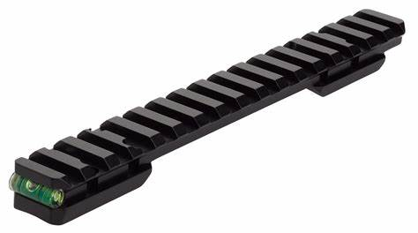

Figure 2 - An example of a Picatinny Rail
- Display the number of rounds left in the magazine fitted to the weapon
This is the fundamental idea of this system. Its main role is to give the operator an understanding of how many rounds they have left before having to change magazine. Therefore, optimising reload time and giving them more of an understanding of their ammunition situation. Additionally, it would benefit the soldier when it comes to the regroup stage of their section attack. This is because when a Regroup occurs the initial task to take place is a casualty ammunition check. Due to the soldiers having a full awareness of the ammunition they have, this can then be swiftly completed therefore leading to the section being able to either dig in or deploy at a faster rate [3].

- Be a physically small-scale device
Due to this being fitted onto a personal weapon system, this device will have to be relatively small and light to ensure that it does not hinder the soldier when it comes to the ability to use their weapon system.] (SP)

Development Methodology

Specification
[ The specification will include:
- Display the number of bullets left in the magazine on a seven-segment display
- Trigger the down counter with an IR gate
- Be compact enough to fit on a SA80 rifle body without hindering the operational capacity of a soldier
- Reset when a new magazine is inserted into the magazine well
- Run off 5V battery and be self-rechargeable
- Be lightweight and waterproof

Timeframes
The timeframes of this project were tight. The group only had 2 months from conception of the idea to a finished product. The Gantt chart below shows the different stages of the project, both planned and actual timings.
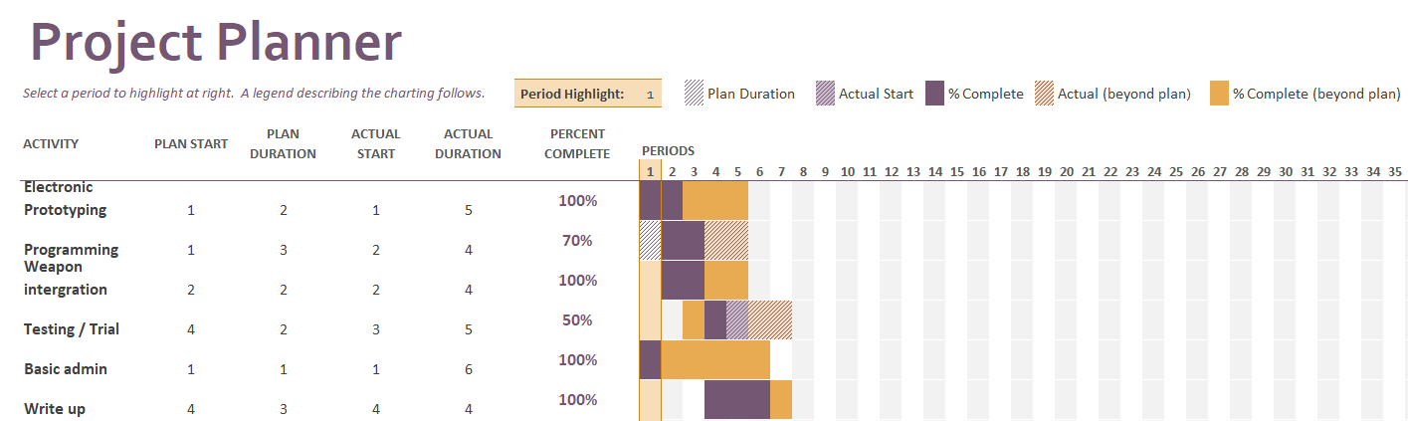

Table 1 - A table to show the Gannt Chart for the Group Project

Initially it was thought that the testing stage of the project was going to be the longest stage, however in actuality this changed quickly. The initial design of the system took the team the longest as we were initially restricted to one day a week. The Gantt Chart also shows how complete each stage of the project was at the end of the allotted time. ] OA

3.2 Budget
[ At the start of the project, one of the first tasks is to define a budget. After doing some calculations, it was predicted that the cost of this project would be £250.
Table 2 - A table to show predicted costs for the project
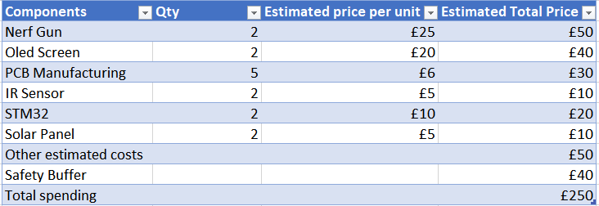
As seen above in Table 2 the initial plan was to invest in two Nerf Guns, these would cost £25 each. The decision was to go for the XSHOT Pro series [4]. These nerf guns are value for money and have the ability to be modified for the project. Other parts that were considered in the initial budget was an OLED screen. This did inevitably get changed out for 7 segment displays, this is due to 7 segments being cheaper, providing the same functionality.
There also was an additional safety buffer, in case the project didn’t go to plan or components cost more than initially anticipated.

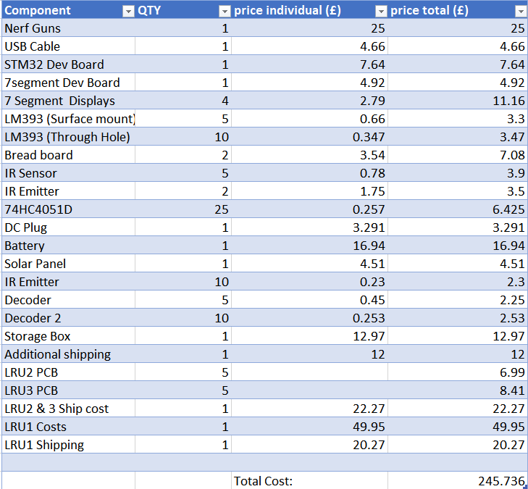
After completing the project was within budget. With a total spend of £245.74, this is £5 under budget. As seen below in table 3. The majority of the money goes to LRU1, this is due to it being designed and assembled externally, due to time constraints.] SP
Table 3 - A table to show the Final costs of the project

Health and Safety

[ Due to the project requiring the use of several tools which carry a variety of risk assessments, the decision was made to make use of a lab at our place of work with which all members of the project are familiar with, and in turn familiar with the expectations of safe working.
This lab contains the necessary tools such as soldering irons, cutters, electronic test equipment etc. which have risk assessments which all members have observed and followed. The group would ensure that all procedures were followed properly, to avoid any risk befalling a member of the team or the project itself. This includes utilising extractor fans when soldering the components for the project, to ensuring that individuals operated in an environment that had access to equipment to neutralise the effects of potential damage to electronic equipment and individuals. This included electrostatic flooring, removal of food and drinks from desks and avoiding lone working. Devices used outside of the lab environment, such as the 3D printer, are operated by members who have experience using them, and understand safe use of them. ] BC

3.4 Facilities and requirements
[ With regards to the facilities needed for this project. The group needed a Lab space with the correct tools to ensure that the unit can be built. For this it was decided to do it in a lab at our place of work. For the group to use this, it was crucial that everybody had a lab induction; ensuring an understanding of the safety and functionality of the Lab, the lab used was sufficiently stocked with the correct tools for the tasks that took place. This includes:
- Soldering Irons with installed extractor fans
- Multi-meters
- Various colours of wire
- Crimping tool to allow the group to connect the wires to the boards.
- Dremel
- Drill
After the team had the lab induction it was crucial that we stored all of our equipment in one area to ensure that nothing goes missing, therefore a plastic storage box was bought allowing us to label it to help notify other Lab users that the equipment in the box is the groups and not for external use.] SP

3.5 Team Meetings and minutes
[ Documentation of team meetings had been recorded since the initial week in which the group project started. Notes were made for everything relevant to the project, from initial designs and features, to budgets and division of labour.

Outside of the university environment, meetings were set for every Friday afternoon for working on the project, with days dedicated for the arrival of parts to begin assembly of the PCBs and the hardware. This recorded in a physical logbook, OneNote as well as updating calendars on work laptops to keep the team members in the loop with project updates.] BC

Design

Electronic Component
[ The electrical component was tasked to Oliver and Sam. This involved schematic and PCB design as well as the prototyping of the system. As mentioned previously the aim of this project is to produce a weapon mounted ammunition counter which shows how much ammunition has been fired out of the currently in use magazine.

The Trigger
There are a number of ways this can be achieved, by counting rounds in the magazine, by counting spent casings ejected from the rifle or by using a light gate that triggers when a round is fired through the light beam. Each of these methods has its issues.
An error is introduced if the rifle jams while counting rounds in a magazine. This means that whilst a round has left the magazine it has not actually been fired, leaving an inaccurate reading on the display. This also happens when counting spent casings. As when a round jams the whole round is ejected without being fired.
This leaves one option, the light gate. Whilst also having its flaws the group believes this will be the most accurate method of counting the ammunition.] OA

The Brains
[This project required a rather simple microcontroller, with the key considerations being that it has an appropriate clock speed, enough pins and a decently low power draw to ensure as long of a battery life as possible. As there are numerous families of microcontroller manufacturers, with ranges of products within those families, the decision was one based heavily on previous experience. Because of this, the STM32 family of microcontrollers were used. [5]
The microcontroller family chosen was the STM32F103 series, which has been used before on previous projects. This falls under the “Mainstream” category of STM32 microcontrollers, with a balance on performance and power draw. Additionally, ST sells Nucleo development boards which allow for rapid and cheap prototyping, which was exactly what was needed to help with the earlier development stage of the project. [6]
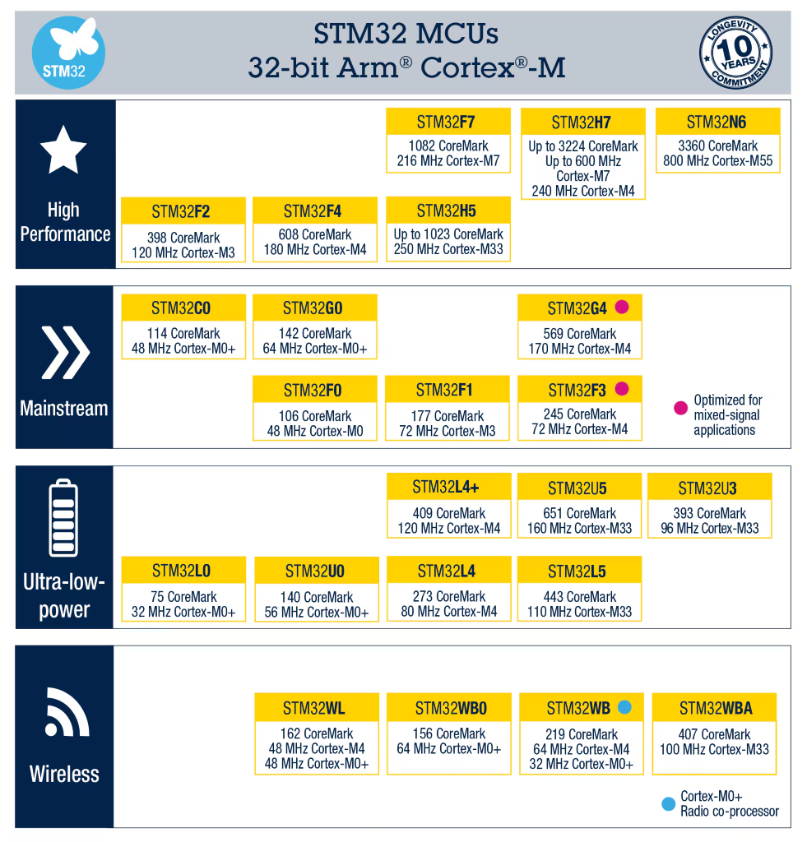
Figure 3 - STM32 32-bit Arm Cortex MCU's
[7]
This decision was shared with the other team members working on the PCB / schematic design in the project to ensure they knew which microcontroller to include in their design.
] AR

Power Supply
[Each unit will be powered by a solar panel and a 5V rechargeable battery pack. By using the solar panel, the battery life will be extended allowing for indefinite usage time if the sun is present.
The 5V battery pack will be connected to the board via a barrel jack connector be regulated down to 3.3V for use on the PCB using an AMS1117 regulator.
The solar panel needs a battery management IC. The Texas Instruments L6924D013TR Battery Charge Controller fulfils this role. This IC decides when the battery pack needs recharging and controls the output of the solar panel.] OA

Schematic and PCB Design
[ The first rendition of the schematic included every part of the system. This was to ensure nothing was missed and everything was connected logically and correctly. Shown below is the first version of the system.
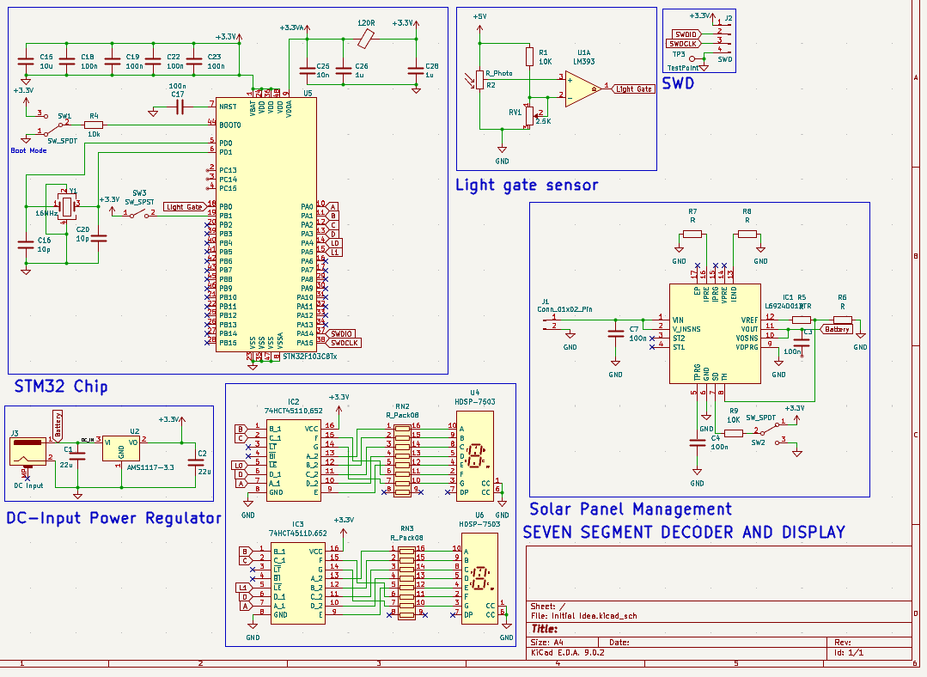
Figure 4 - An image of the overall schematic for the whole system
Later versions of the main PCB replaced the sensors and buttons with headers and connectors; ensuring that the final PCB that was being produced satisfied both the physical and electrical requirements of the system. Due to the size of the rifle and the chosen method of counting bullets, the schematic was split into separate subsystems. Labelled LRU 1,2 and 3.] (OA)

Main Schematic LRU 1
[ As mentioned previously, all of the peripheral subsystems were removed from the schematic in order to represent the end product more accurately.
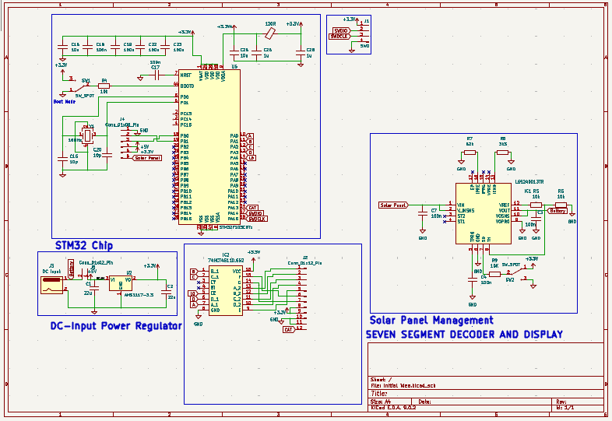
Figure 5 - An image of the LRU1 Schematic

Another alteration in this version is the single seven-segment display (header). This change was caused by the acquisition of an off the shelf development board for the seven-segment displays which included everything we would need to run a display.
Also, in this version, all of the resistor and capacitor values were added. Most of these were given by various datasheets for their respective components.] (OA)

STM 32
[ The STM32 has basic requirements that need to be met. These are found on the datasheet [9].
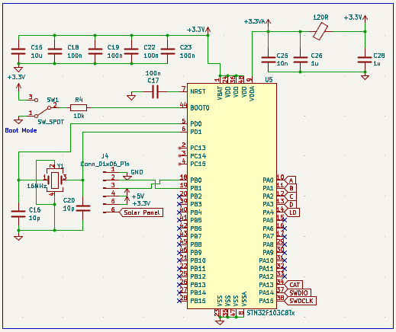

Figure 6 - Figure of the STM32 schematic design

Capacitors C15, 18, 19, 22 and 23 connected to the VDD and VBAT pins on the chip act as decoupling capacitors. The main function of a decoupling capacitor is to smooth the input signal acting as a filter, filtering out high frequency noise from the input voltage.
A quartz crystal oscillator is being used to create an accurate clock pulse for the chip. The crystal (Y1) used in the schematic is a 16Mhz oscillator as this is the optimal frequency for this STM32 chip.
The 6-pin header is used as the junction for every input, this includes the momentary switch in the mag well, the solar panel input, the light gate attached to the barrel and various voltage pins. A header was chosen over just connecting it because three different PCBs have been produced for the various parts of the rifle they are going to be attached to.
Port A pins 0 through 3 are connected as the binary input into the seven-segment decoder.] (OA)

Power Supply System
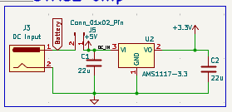
[ The power supply for this system includes a barrel jack connector for the battery, a voltage regulator, solar panel and a battery IC. Shown in figures 7 and 8.
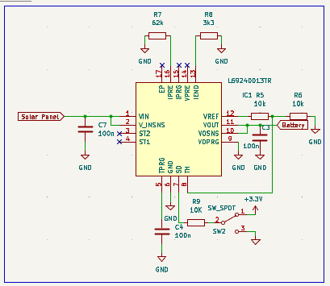
Figure 7 - An image of the voltage regulator
Figure 8- An image of the battery management IC

This configuration of the power supply, along with the solar panel, allows us to maintain a consistent supply of 5V and 3.3V. The battery charge controller sub-schematic was provided by the datasheet [10]. The voltage regulator functions similarly as a buck converter, dropping 5V to 3.3V. The main difference in this voltage regulator to a standard buck converter is the header on the main input trace. This enables us to have an on/off switch for the unit, as this will cut the main input line unless the button is pressed.] (OA)

Seven Segment Display
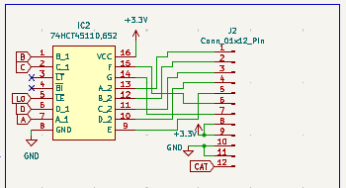
[ The seven-segment display sub-system uses a BCD decoder and a 12-pin header. Shown in figure 9
Figure 9 - An image of the 7-Segment display schematic

The BCD decoder is used to reduce the number of pins taken up by the seven-segment display. It has 4 pins A, B, C and D connected to the STM32. These pins will have a binary number outputted from them.
The role of the decoder is to convert this binary number into a form that the seven-segment can display. Powering the correct segments on the display in correlation to the binary value.
The header attached to the decoder is 12 pins because the chosen display (shown below) needs 12 input pins. The CAT pin allows the selection of each display.
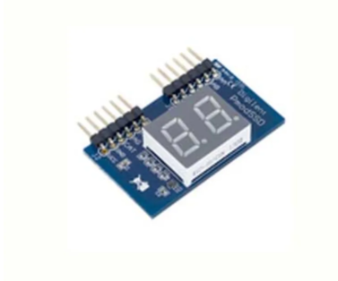
Figure 10 - An image of the chosen 7-Segment display

] (OA)

PCB Design LRU 1
[The next stage is to make a PCB which fits all of the above sections. The main constraint with the PCB is the size of the board, due to concerns in relation to the housing. The initial plan was to make its limitations 50 mm x 50 mm.
It was decided to be a 2-layer PCB due to this being a rather simple design and also due to the cost difference with having more layers. Two layers is ample as this allows us to have connections on both sides of the board, allowing the routing within the board to cross.
The majority of components on the PCB are surface mount with all resistors being the 0805 dimensions. The only components that are through hole are the connectors, due to the majority of connectors being through hole for its structural integrity.
The connectors were Molex SL [11], due to the size and accessibility of the components.
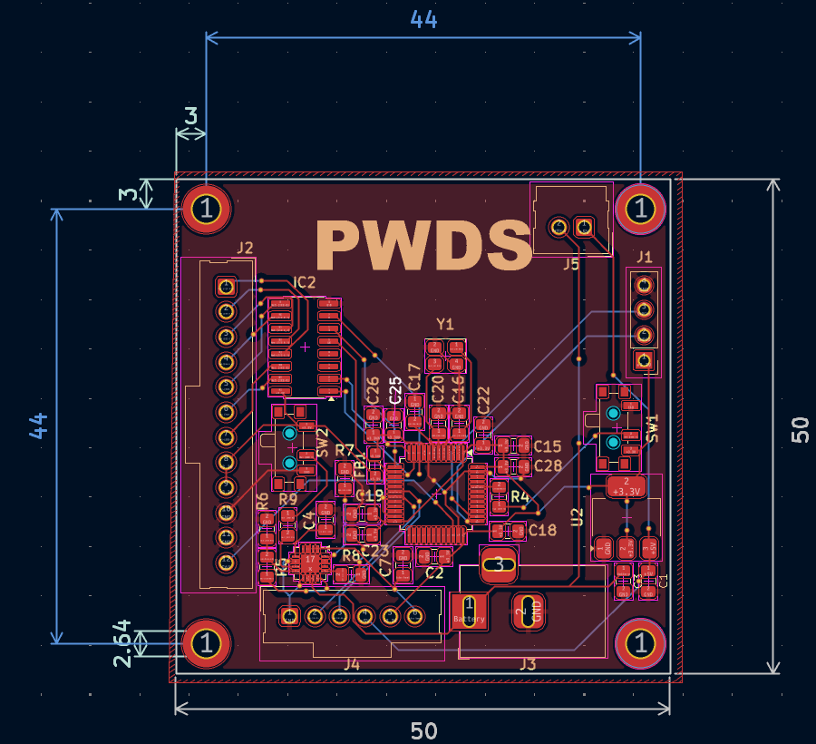
Below you can see the PCB Designed by Samuel Peppard. As seen below in Figures 11 and 12.] SP
Figure 11 - An image of the PCB Design for LRU1

[
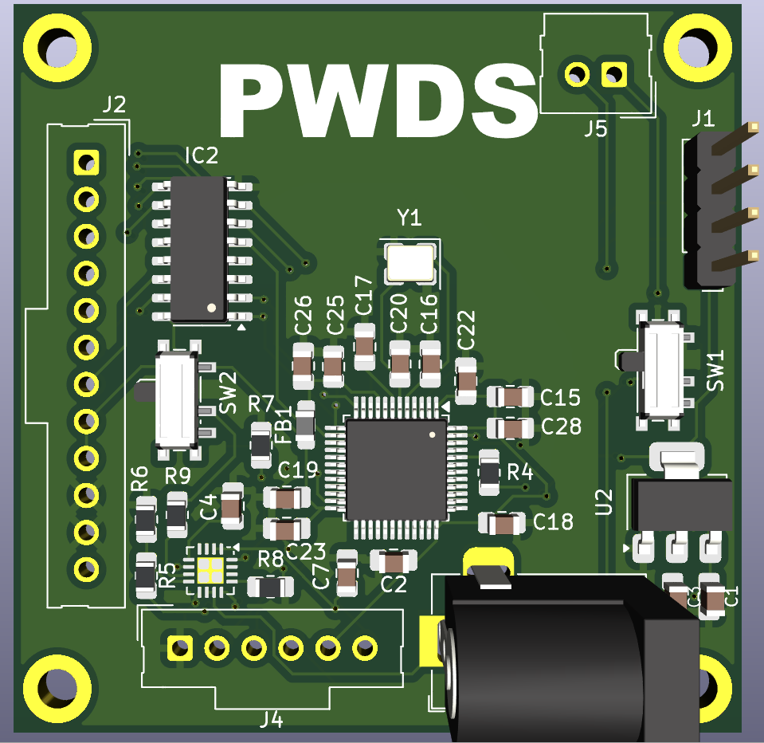
Figure 12 - An image of the 3d view for the LRU1 PCB
On the PCB the STM32 Chip is kept centrally, due to it being the key component with the most connections. Therefore, to put this centrally limits issues with crossovers. Additionally, connectors are placed on the edges, making them more accessible. There are also capacitors surrounding the STM32, these are decoupling capacitors which need to be as close to the STM32 as possible, to ensure their efficiency.
Each corner has a screw hole, to properly attach and secure the PCB to the box housing, with the PCB itself containing a ground plane for the mounted components.
After the PCB was designed, it was thoroughly inspected by the group to ensure that any errors were picked up before placing the PCB order. Some errors noticed were the occasional accidental right angle within the routing. Right angles within a PCB were avoided due to an increase in electromagnetic interference (EMI). Right angles lead to an electron build up and form high-energy states [12]. ] SP

Schematic Design LRU 2
[ The second LRU is the IR LED. The LED in this LRU is drawing voltage and current from the voltage regulator, however, due to the location of the LRU on the unit, it will be connected via headers and cables. This means that this PCB is incredibly small with only a header, LED and resistor.
One thing of note is that this LED was chosen specifically because the wavelength of the emitted infrared matches the wavelength of the LRU3 sensor.] OA
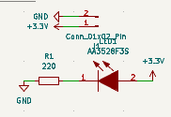
Figure 13 - An image of the schematic for LRU2

4.1.4.4 PCB Design LRU 2
[ This PCB consists of three components (LED, Resistor, Connector). The main priority is to design this board as small as possible, to avoid interference with the weapon system.
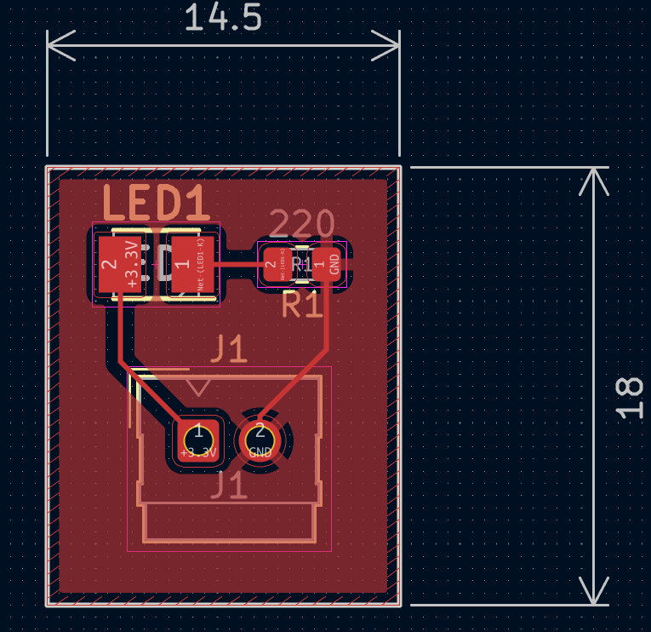
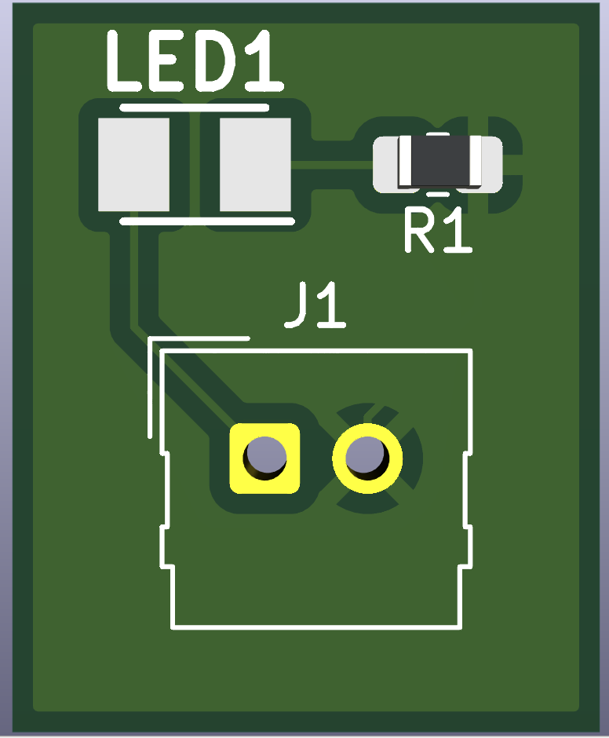
You can see the PCB Design below in Figures 14 and 15.
Figure 14 - An image of the PCB design for LRU2
Figure 15 - A 3D view of the LRU2 PCB
] (SP)

4.1.4.5 Schematic Design LRU 3
[ The final LRU in the system is the IR sensor, sitting on the end of the barrel. The choice was made to convert the output of the sensor from an analogue to a digital signal using an LM393 op amp. This was so the digital signal can be taken as an input by the STM32 IC.
The sensor and comparator system use a potential divider circuit, which has been tuned to allow the comparator to activate at the perfect voltage level from the sensor. As shown in the figure below, this LRU requires both 3.3V and 5V, which means a 3-pin header is required. ] OA
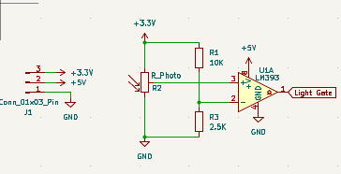
Figure 16 - An image of the schematic for LRU3

PCB Design LRU 3
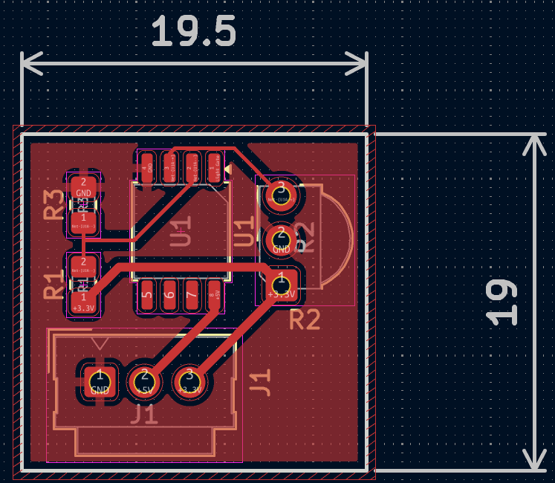
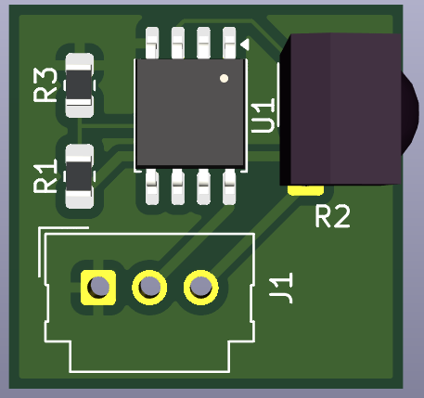
[ LRU 3 consists of five components as seen below.
Figure 17 - A 3D view of the LRU3 PCB
Figure 18 An image of the PCB design for LRU3

After designing this PCB one error was noticed. This is that pin 1 on the LM393 was not connected, meaning that the PCB doesn’t send a digital output back to LRU1 with information in relation to a bullet being fired. ] SP

Software Component
[Before the software was developed, the process of the system was created in a flowchart. This enabled a clear understanding of what should happen during the cycle of the main software loop. This flowchart does not include other parts of the software that is automatically generated by the IDE as it does not directly impact the operation of the main loop.] AR
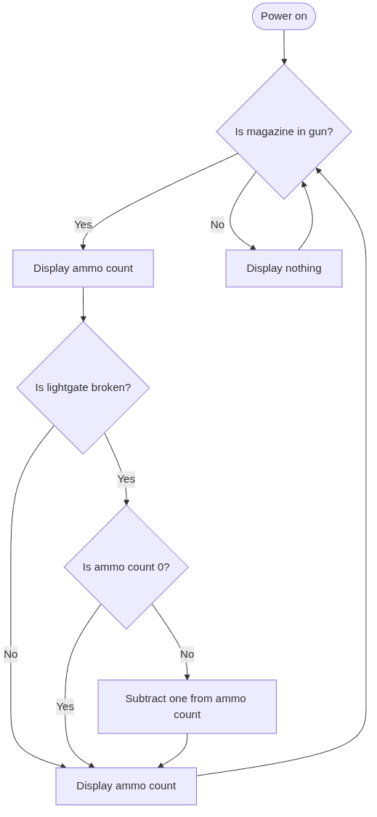
Figure 19 - An image of a flowchart to show the system of work for the code

[As most of the configuration of the device was handled by the IDE, all that needed to be developed was the functionality. The only parts not automatically handled by the IDE that needed to be manually adjusted were which pins were set to input and output, as well as clock configuration for the timer. These properties were edited through the IDE’s GUI for configuring the STM32. The flowchart was used for the flow of the program. Everything was initially developed using the Nucleo development board with the other individual components breadboarded, then ported to the final PCB later.
The first step in the development of the software involved configuring the pins to be GPIO output / inputs, as well as the timer. The timer is an important part of the code as if delays were used when waiting for the minimum and maximum delays for reading the IR sensor, the display would not be able to show both values at once. This is because the display works by continuously and rapidly switching between the two segments, giving the illusion of them both being on at the same time. [13]
The minimum and maximum delays for reading the IR sensor were important to avoid false positives and double readings. To configure the timer an online tutorial was followed to ensure the correct parameters were set [14]. The most important part of the tutorial was the calculation of the preload value, where time is in seconds and frequency is the clock frequency of the CPU in Hz:
Equation 1 - An equation to calculate preload values
$$Preload=\frac{Time × Frequency }{Prescaler}$$
Another important consideration for the software was the velocity of the projectiles as they exit the barrel to calculate how long the IR sensor would be triggered for. This information was gathered from a website that tested the same blaster that was purchased for this project. [15] Their findings included the use of a chronograph to get accurate and reliable results. The lowest velocity was measured as 142 FPS (feet per second). This value was chosen, as the lowest velocity gives the worst-case scenario for how long the IR sensor would be triggered for. This is approximately 43 m/s, which were used to calculate timings for the software.
Each dart was measured with a ruler to be roughly 70 mm in length. This value was used to calculate the duration that the IR sensor would be broken for using the equation for speed, distance and time:
Equation 2 - Speed, Distance, Time equation
$$Speed=\frac{Distance}{Time}$$
$$Time=\frac{Distance}{Speed}$$
$$Time=\frac{0.07}{43}=0.0016 seconds$$
] AR

[From the calculations it revealed that 1.6 ms was roughly the time it would trigger the IR sensor for. However, an upper limit was required to give a delay before the next reading as well, setting that value to 3ms gives a reasonable maximum time. So, for a 3 ms timer where the clock is 64MHz and the prescaler is 1000:
$$Preload=\frac{0.003 × 64×10^{6}}{1000}=192$$
This means there are 192 ticks for the timer before the timer triggers an interrupt. As 1.6 is roughly half of 3, this value can simply be divided by 4 to get the lower bounds for the light gate, which is 48 ticks. The upper bound can also be calculated as just 192 - the lower bound, which was 144 ticks. This was a preload value was then applied within the IDE’s GUI for configuring the STM32:
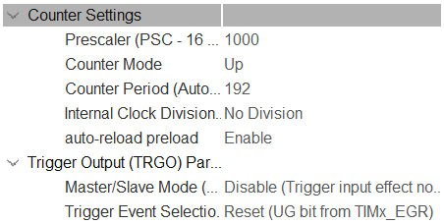
Figure 20 - An image of the counter settings
] AR

Mechanical Component
[This section would look at the additional attachments and changes made to the nerf gun to be able to accommodate the necessary electronic components. This will cover the use of 3D modelling and printing, due to having access to both 3D modelling software and a 3D printer. Due to little experience at this point using CAD software, time was spent familiarising with the various tools available, to effectively utilise it for the project

4.3.1 3D CAD
The modelling of the printed components for the PWDS was managed by Ben Clark, in which both Solidworks and FreeCAD have been used to model the necessary requirements for the fitting of the hardware of the system itself. The initial idea was to utilise two main housing units for the components, these being a muzzle attachment containing the infrared sensor used to register the passing of a dart, and a box attachment which would contain the solar panel, counter, primary PCB and battery.
Several other additional prints not required to house components were proposed, relating to actually attaching the muzzle and box attachments. The muzzle itself would be straightforward, simply fitting over the end of the existing barrel. The box would be more complicated, with either a picatinny attachment along the top rail, having an overhang to which the box can be attached, or the printing of a side picatinny to be fitted to the nerf gun to then be attached to the box. It was decided that a side picatinny would be most appropriate due to issues relating to the stability of the top mounted version.

4.3.1.1 Box Housing
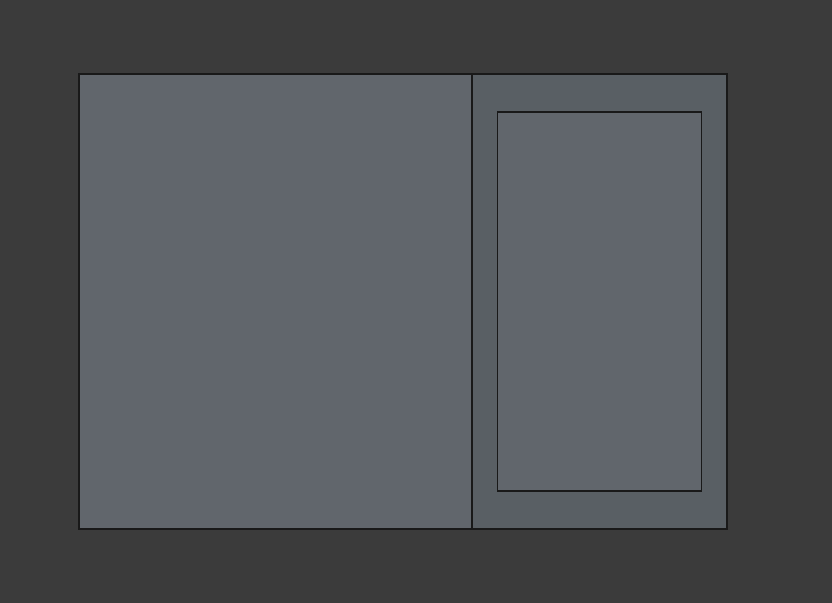
An initial design was made for the box housing, as seen below, but decided against due to the dimensions of the PCB. This box consists of two separate parts, a main unit and a cover piece to attach to the front which would contain a cut through for the double 7 segment display.

Figure 21 - An image of the 3D CAD for the Box housing
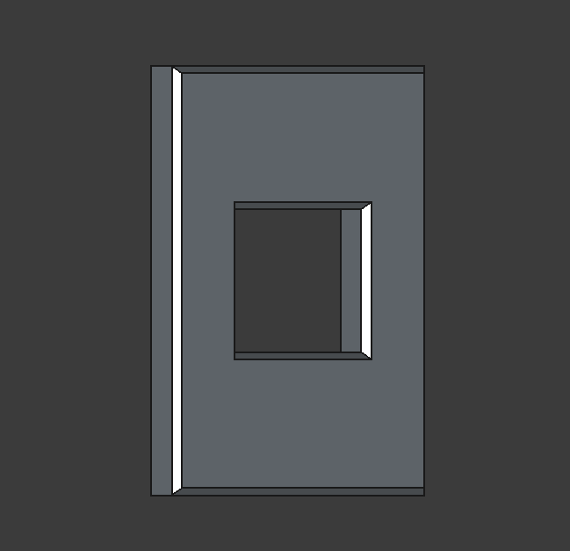
The main box also contains a top cut to fit the dimensions of the solar panel, as well as rear cuts to run the wires to the external muzzle attachment containing the sensor PCBs.
Figure 22 - An image of the 3D CAD for the Box housing lid

The front panel as seen above would fit over the opening of the box to seal in the components, with a cut through to view the 7-segment display, which will fit flush in the opening.
This design was scrapped in favour of the modified box as seen below.
This design features increased room by adding an additional spacer between the main box and the cap, along with three holes for wiring in the back as opposed to one, to be able to split the relevant wires from the muzzle attachment. The holes are for live wires, ground wires and a single signal wire from the receiver. ] BC
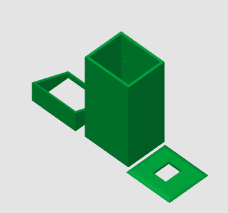
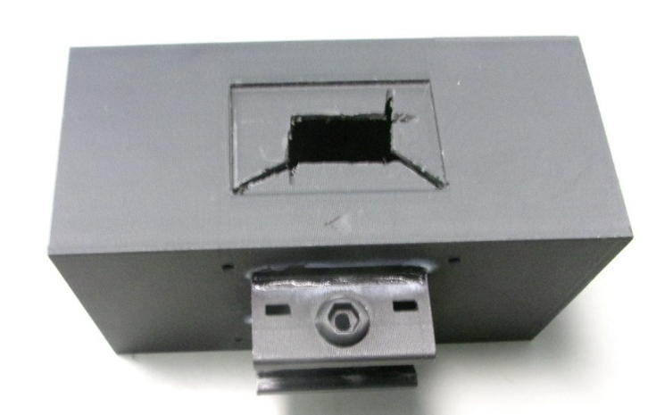
Figure 23 - An image of the whole Box in CAD
Figure 24 - An image of the physical box housing

4.3.1.2 Box Attachment
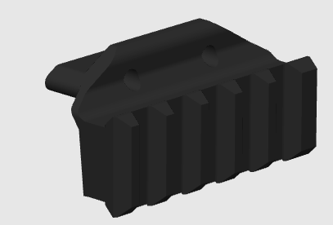
[ After designing the box, the next step is to work out how to attach the box to the weapon. For this we decided that a picatinny rail was the most effective way, due to picatinny rails being a standard on most weapon systems. The first part of this is to design a Picatinny rail to attach to the side of the weapon system. In reality this does not need to be big as it only needs to hold one clip, therefore, after searching on various 3D CAD websites, a 3D design of a picatinny rail that will work for this weapon was discovered[16] . As seen below in figure 25.
Figure 25 - An image of the Picatinny rail

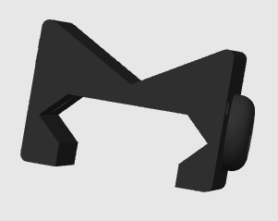
The next part was to make a connector which can fit on the side of the box which will let you attach the box to the Picatinny rail. Similarly, to the rail, there was a design on Thingiverse [17], which would work perfectly. Therefore, it was decided that this would be 3D printed and glued to the weapon system. the design can be seen below in Figure 26.] (SP, BC)
Figure 26 - An image of the Picatinny Connector

4.3.1.3 Muzzle Attachment
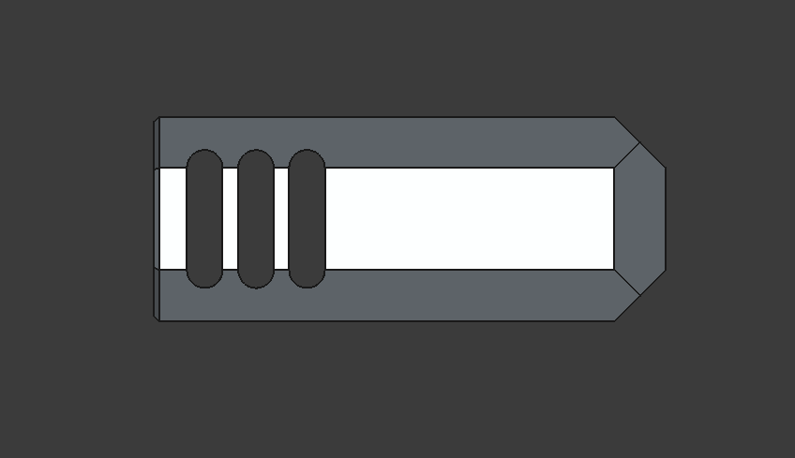
[ The muzzle attachment itself was the final aspect to modelled, as the gate itself and the relevant PCBs would need to function before being finally fitted inside of the relatively small area, to avoid issues with distributed weight across the nerf gun. Measurements were taken across the nerf gun itself to ensure that the muzzle would properly integrate with the system, and to avoid the risk of the print being too bulky.
Figure 27 - A side profile image of the Muzzle attachment

As seen above, the side profile of the muzzle is shown with cuts to reduce the amount of material used during a print, as well as minimising the weight placed onto the end of the nerf gun.
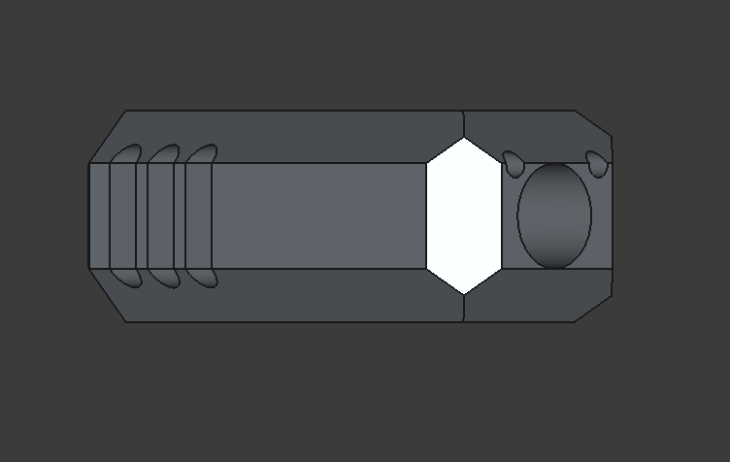
Figure 28 - An angled image of the Muzzle Attachment


The above image shows the previously seen side profile of the muzzle, as well as the primary cut through designed to slip onto the end of the barrel, with two secondary cut throughs to run the wiring from the two halves of the sensor system.
Figure 29 - A front image of the Muzzle Attachment

The above is a front view of the muzzle attachment, showing the cut throughs to integrate the muzzle with the nerf gun and electrical components as well as the required space to fit the two halves of the sensor system. The PCBs will sit either side of the barrel cut through to be in a position to register the passing of a dart, with the wire cut throughs allowing the wires to be run up and through to the side mounted box.] BC
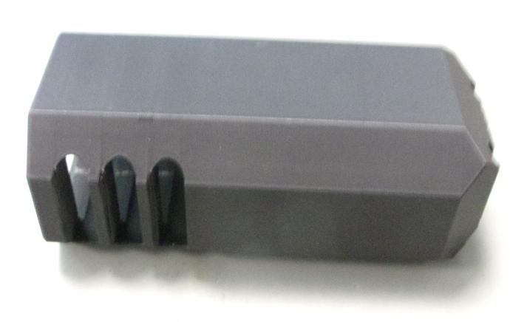

4.3.2 3D Printing

4.3.2.1 Print Settings
[To create these 3D designs as a group we decided to utilise Sam’s 3D Printer. This is due to the accessibility and also due to the time available with this project. The first print that was conducted was the box housing. For this, the STL files of the box were transferred to the 3D printing software, from here the settings for this design were set, the main settings decided are:
- Material - The material used for all designs was Matte Black PLA, due to how easy this material is to print, whilst also giving you a smooth and sleek design.
- Layer Height – For this 0.2 mm layer height was chosen as this means that the design will be detailed and also be accurate for sizing.
- Speed – the outer wall was conducted at 200 mm/s and the inner wall was conducted at 300 mm/s, infills were conducted at 250 mm/s.
- Supports - the picatinny rail needed supports, due to its overhanging top side, ensuring that the filament was able to print at a raised position.

] SP

Implementation

[This section will cover the prototyping and debugging of the PWDS unit. Overall the system had three main prototyping stages, both stages one and two used the Nucleo F1 development board:
- Main counting function determined by the press of a button
- The magazine integration simulated via a momentary switch
- All PCBs manufactured and debugged together.] OA

[Configuring the SMTM32F103’s pins through the STM32CubeIDE was the task that required modifying; on the PCB there are 3 pins that were pre-defined. The pins PA13/14/15 were used for CAT / SWDIO / SWCLK respectively. CAT is the pin for choosing which side of the display to program, SWDIO and SWCLK are pins required for programming the STM32 through the ST-Link USB.
The problem with this configuration was that pins PA13/14 are actually used for SWDIO / SWCLK and PA15 is pre-configured as JTAG only (GPIO disabled). To get around this, the programming method for the STM32F103 had to be manually set to ST-LINK, this allows PA13/14 to be used as SWDIO / SWCLK and enables GPIO on PA15 to be used for CAT.
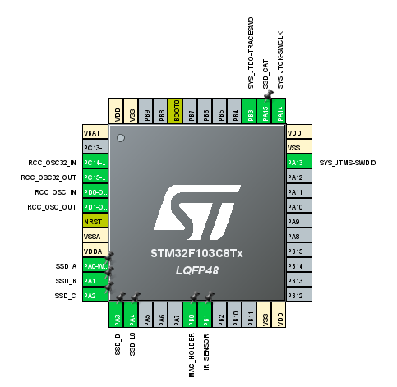
After configuring those pins correctly, the rest of the microcontroller’s pins were set up according to the schematic, with appropriate user labels. This would also pre-generate definitions within the code to be used within the functions provided by the hardware abstraction layer (HAL).] AR
Figure 30 - An image of the Pin layout of the STM32
[The main loop of the program was where the core logic of the system was performed. This was developed according to the flow chart that was previously designed. It was important to check the states of the inputs from the IR sensor and mag holder button ensuring everything was operating correctly. Additionally, the display had to count down to 0 and stop counting as well as resetting when the magazine is removed.
/* Infinite loop */
/* USER CODE BEGIN WHILE */
while (1)
{
// If there is no magazine and the display is already off, just keep waiting
if(!HAL_GPIO_ReadPin(MAG_HOLDER_GPIO_Port, MAG_HOLDER_Pin) && !display_power_state)
continue;

// LOW = light broken
if(!HAL_GPIO_ReadPin(IR_SENSOR_GPIO_Port, IR_SENSOR_Pin) && trigger_delay == 0 &&
HAL_GPIO_ReadPin(MAG_HOLDER_GPIO_Port, MAG_HOLDER_Pin))
{
// Checks if an object is still passing after the minimum amount of time required
if(!check_minimum_time())
continue;

// Set trigger_delay back to 1
trigger_delay = 1;

// Reset the timer count here to ensure the proper time between passes
__HAL_TIM_SET_COUNTER(&htim3, MAXIMUM_DELAY_TIME);

// Write the current value to the display
write_display(display_value);

// Decrement the low value if it is not 0
if(display_value.low > 0)
{
display_value.low--;
}
else if(display_value.high != 0 && display_value.low == 0)
{
// If the high value is not 0, reset the low value to 9 and decrement the high value
// If this is not checked the display would try to count down past 00
display_value.low = 9;

if(display_value.high > 0)
display_value.high--;
}

// Write the updated value to the display
write_display(display_value);
}
else if(!HAL_GPIO_ReadPin(MAG_HOLDER_GPIO_Port, MAG_HOLDER_Pin))
{
// Disable and reset the display if the magazine is removed
turn_off_display();

display_value.high = INITIAL_VALUE_HIGH;
display_value.low = INITIAL_VALUE_LOW;
}
else
{
// If no event has happened, just write the current value to the display
write_display(display_value);
}

/* USER CODE END WHILE */

/* USER CODE BEGIN 3 */
}
/* USER CODE END 3 */
Figure 31 - An image of the Main loop of code
] AR

[As previously mentioned, the display works by rapidly and continuously writing a value to either side of the display, this was done at a speed which creates the illusion that both displays are on at the same time. This was achieved by using a short delay, for example 5 ms between each write to the displays.
/**
* @brief Writes two values to the display, a high value and a low value
*
* @param display_value: A structure that contains the high (left) and low (right) value for the display
*/
void write_display(struct SSD_DisplayValue display_value)
{
// Set the display power state flag to true (on)
display_power_state = 1;

// Write to the CAT Pin to write to the high (left) part of the display
HAL_GPIO_WritePin(SSD_CAT_GPIO_Port, SSD_CAT_Pin, SSD_DISPLAY_HIGH);

// Write the high value to the display
HAL_GPIO_WritePin(SSD_A_GPIO_Port, SSD_A_Pin, display_value.high & 1);
HAL_GPIO_WritePin(SSD_B_GPIO_Port, SSD_B_Pin, (display_value.high >> 1) & 1);
HAL_GPIO_WritePin(SSD_C_GPIO_Port, SSD_C_Pin, (display_value.high >> 2) & 1);
HAL_GPIO_WritePin(SSD_D_GPIO_Port, SSD_D_Pin, (display_value.high >> 3) & 1);

HAL_Delay(CYCLE_DELAY);

// Write to the CAT Pin to write to the low (right) part of the display
HAL_GPIO_WritePin(SSD_CAT_GPIO_Port, SSD_CAT_Pin, SSD_DISPLAY_LOW);

// Write the low value to the display
HAL_GPIO_WritePin(SSD_A_GPIO_Port, SSD_A_Pin, display_value.low & 1);
HAL_GPIO_WritePin(SSD_B_GPIO_Port, SSD_B_Pin, (display_value.low >> 1) & 1);
HAL_GPIO_WritePin(SSD_C_GPIO_Port, SSD_C_Pin, (display_value.low >> 2) & 1);
HAL_GPIO_WritePin(SSD_D_GPIO_Port, SSD_D_Pin, (display_value.low >> 3) & 1);

HAL_Delay(CYCLE_DELAY);
}
Figure 32 - An image of the High and lows regarding screen values
Another consideration for the display was the ability to turn it off when there is no magazine inserted into the mag well. This was done by writing a value that would blank the display and then not writing anything else to the display while off.
/**
* @brief Blanks the display and sets the display power state flag to false (off)
*
*/
void turn_off_display()
{
// Only write once
if(display_power_state)
{
// Write a blank value to the display
HAL_GPIO_WritePin(SSD_A_GPIO_Port, SSD_A_Pin, GPIO_PIN_SET);
HAL_GPIO_WritePin(SSD_B_GPIO_Port, SSD_B_Pin, GPIO_PIN_SET);
HAL_GPIO_WritePin(SSD_C_GPIO_Port, SSD_C_Pin, GPIO_PIN_SET);
HAL_GPIO_WritePin(SSD_D_GPIO_Port, SSD_D_Pin, GPIO_PIN_SET);

// Set the display power state flag to false (off)
display_power_state = 0;
}
}
Figure 33 - An image to show code to turn the display off
] AR

[Finally, to check the minimum time before allowing a valid read from the IR sensor:
/**
* @brief Checks if an object is still passing after the minimum required time
*
* @retval bool - Whether the IR light is still broken (0) or not (1)
*/
bool check_minimum_time()
{
// Set trigger_delay back to 1 as the light has just been broken
trigger_delay = 1;

// Set timer to the minimum read time
__HAL_TIM_SET_COUNTER(&htim3, MINIMUM_DELAY_TIME);

// Wait until the interrupt is triggered again, resetting the trigger delay
while(trigger_delay == 1)
{
continue;
}

// if the light is no longer broken after the minimum time, disregard the break as a false positive
return HAL_GPIO_ReadPin(IR_SENSOR_GPIO_Port, IR_SENSOR_Pin);
}
Figure 34 - An image to show minimum sensor
] AR

Prototype Stage 1

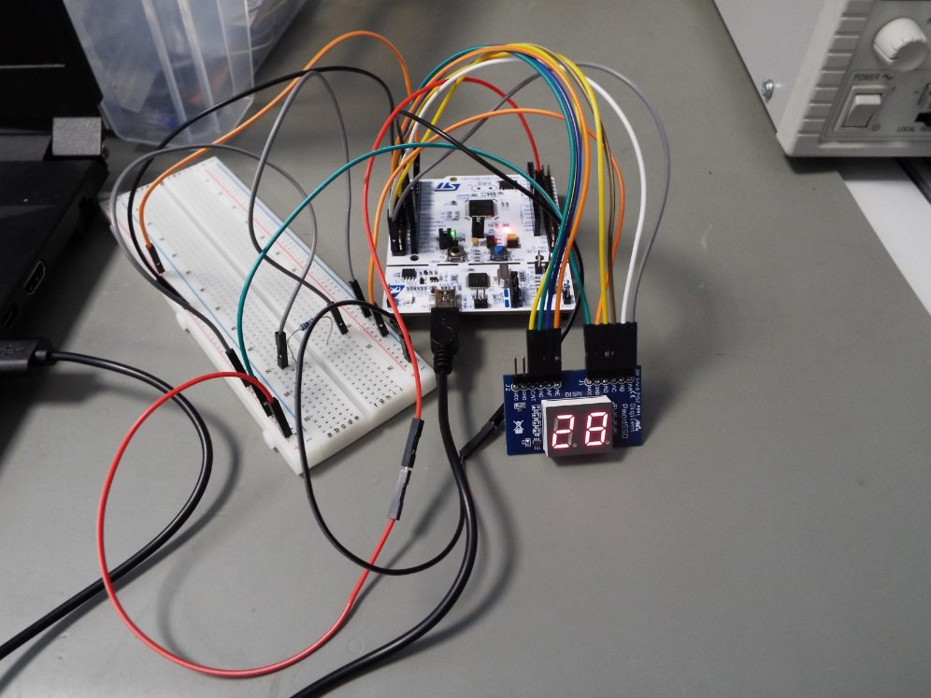
[To undertake the development of the software at this stage, the seven-segment display and a button was breadboarded alongside the Nucleo development board to create a simple version of the system. ] AR
Figure 35An image of the first prototype setup

Prototype Stage 2
[This stage in the prototyping, the magazine integration button was included. This allowed the simulation of a magazine being present in the magazine well. Only counting down if a magazine is inserted and resetting when the magazine is taken out.

Figure 36 - An image of the 2nd prototype setup

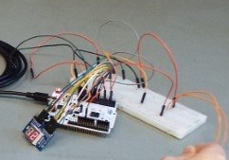
The button selected had to be momentary as it needed to break the connection as soon as it wasn’t being held down. The progress made in the previous prototype was developed upon, adding in another condition for the counter to operate.] OA

Final Testing and Debugging
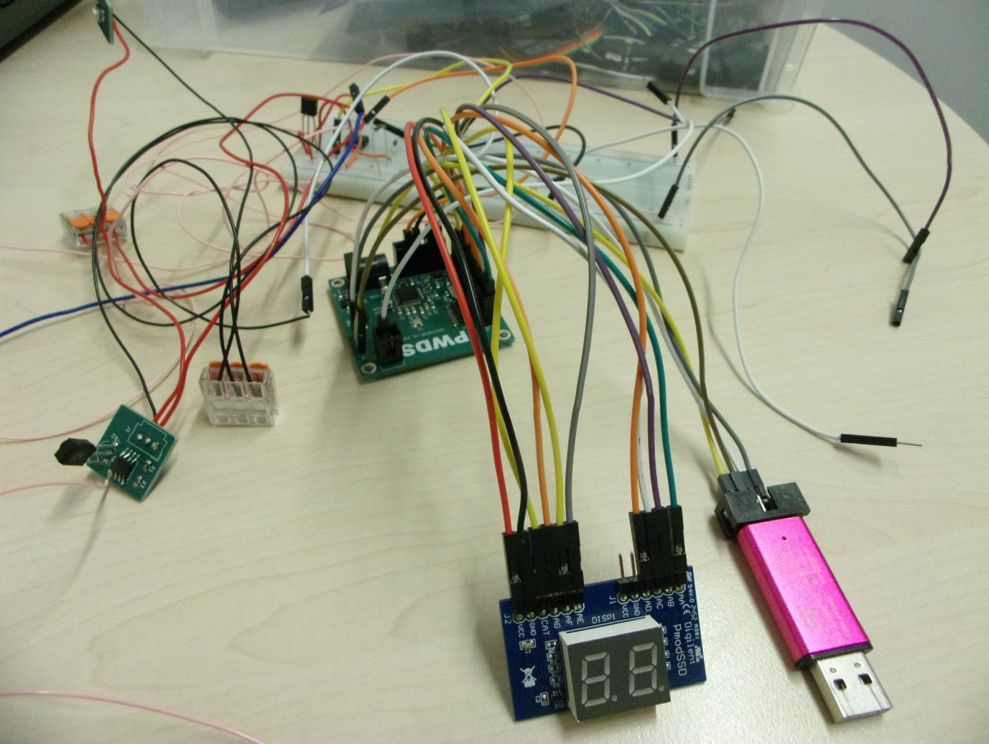
Figure 37 - An image of the final test setup
[This stage involved the completed and fully manufactured PCBs shown earlier in the report. This is where the debugging of the system occurred. All the issues that came to the surface either from the PCB design or the building/soldering of components, were addressed in this stage of the project.
The PCBs had 4 main issues:
- Transmit pins being swapped for the SWD
- The wrong IC chip being used
- Incorrect number of headers used
- IR sensor soldered incorrectly
] OA

Issue 1
[The first issue encountered, meant that the CAT pin and the SWDIO pin were incorrectly drawn. These were inverted, meaning the ST-LINK USB debugger could not connect to the STM32 on the PCB. This was fixed as the connections could be swapped around externally using various types of headers. Having been corrected, the ST-LINK could be connected and the code could be imported onto the STM32. Shown in figure x.

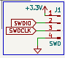
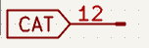
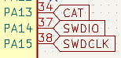
Figure 38 - An image of the Pinouts relating to issue 1

Issue 2
The second issue was unfortunately caused by a mistake made while procuring the components required for the PCBs. The chip used on the Schematic/PCB is the 74HCT4511D, a BCD decoder that converts a binary number to an output that makes sense on a seven-segment display.
The chip that was procured for this system was the 74HC4051D, a multiplexer. This meant that no matter what value was output from the STM32 the screen would not work
Once this chip was swapped for the correct BCD decoder the seven-segment display functioned as intended.] OA
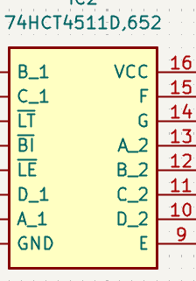
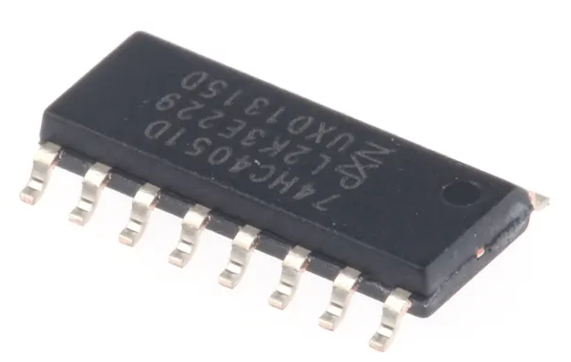
Figure 39 - An image of the decoder component

Figure 40 - An image of the decoder schematic

Issue 3
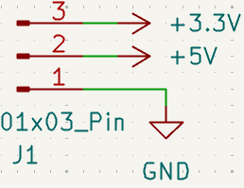
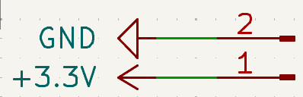
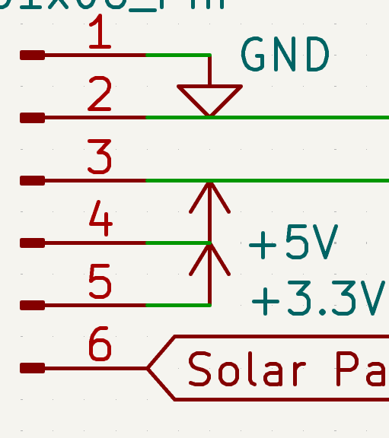
[The lack of headers on the PCB was an oversight during the design stage. This was fixed by splicing wires using Wago connectors. The main headers that the PCB lacked were the 3.3V and Ground connections. The PCB only had one of each whereas there were four different connections that needed 3.3V and 2 that needed Ground connections.

Figure 41 - An image of the pinouts relating to issue 3

Another issue that arose due to the lack of headers concerned the output pin of the comparator in the light gate. This was caused by not connecting it to a header in the schematic. Shown by the tag on PIN 1 pf the LM393 in figure 42
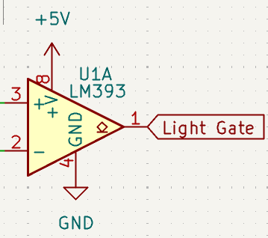
Figure 42 - An image of the LM393 schematic

This was fixed by soldering a wire onto the output pin of the op amp, PIN 1. This allowed the digital output of the op amp to be accessed by the STM 32.] OA

Issue 4
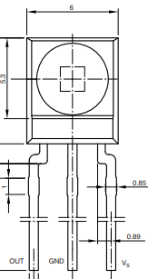
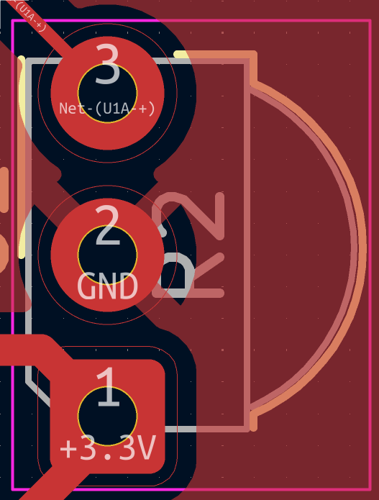
[The final issue noticed by the group was including the IR sensor. The mistake made with this component was caused by the incorrect pin out being used on the PCB. The pin out on the PCB had an inverted pin layout to what was required to use the sensor correctly. This meant that no change in IR was being sensed and this was not being communicated with the STM 32. The images show the differing pinouts.
Figure 43 - Datasheet for the IR sensor
Figure 44 - PCB design for the IR Sensor

This was tested using a bread board to rebuild this system easily. Once the sensor was flipped 180 degrees, the system functioned so that the counter worked when the IR LED was taken away from the sensor.
The changes were made to the PCB, without success. At this point it was decided to recreate the sensor LRU 3 on strip board with brand new components. Tthis did not fix the sensor LRU 3’s connectivity issues with LRU 1 and the STM 32. The image below shows the new strip board LRU 3.] OA
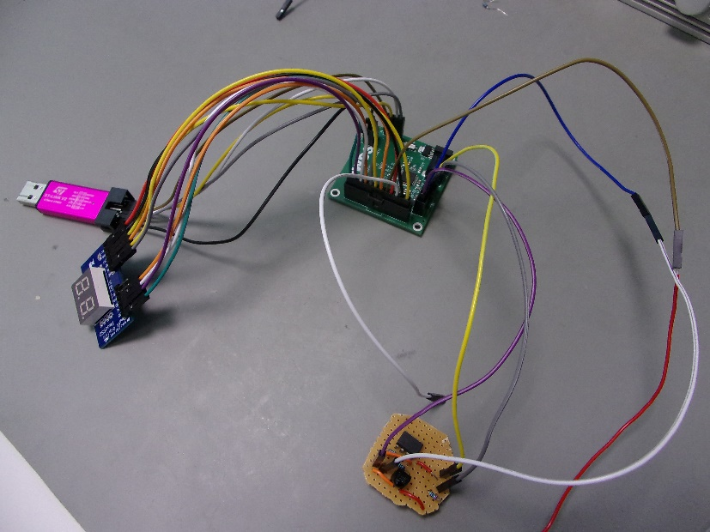
Figure 45 - An image of the debugging by using breadboarding techniques
[ Despite issues with getting the sensor system to work, the printed sections and the electronic components were still assembled to demonstrate the look of the final design.
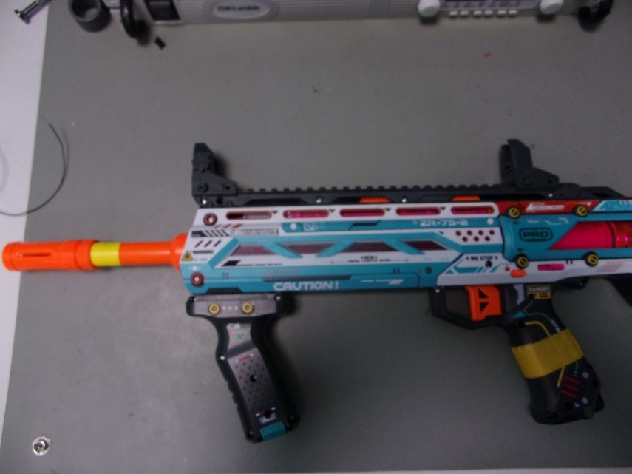
Figure 46 - Nerf Gun before any modifications

The above image shows the original nerf gun before any modifications have been made with the prints.
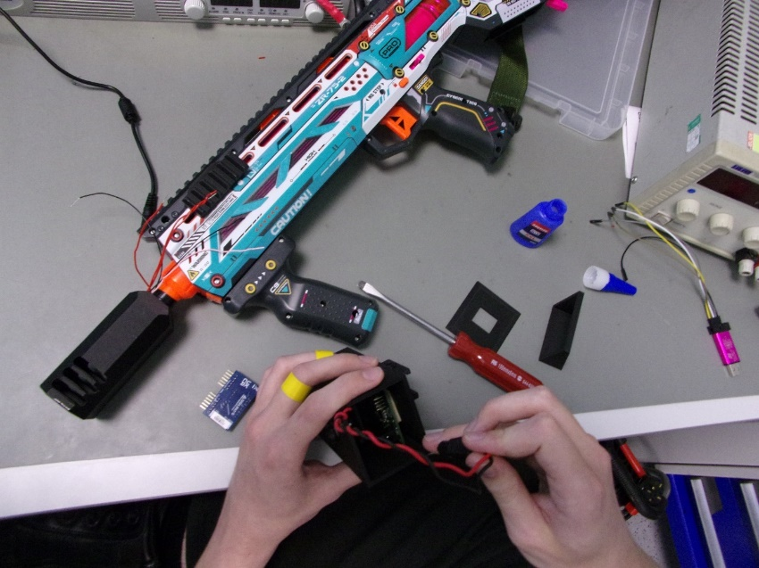
Figure 47 - Assembly of PWDS

Above can be seen the assembly of the PWDS, with the muzzle attachment fitted, with wires running from the inside sensor gate, which will be attached to the box on the side of the rifle.

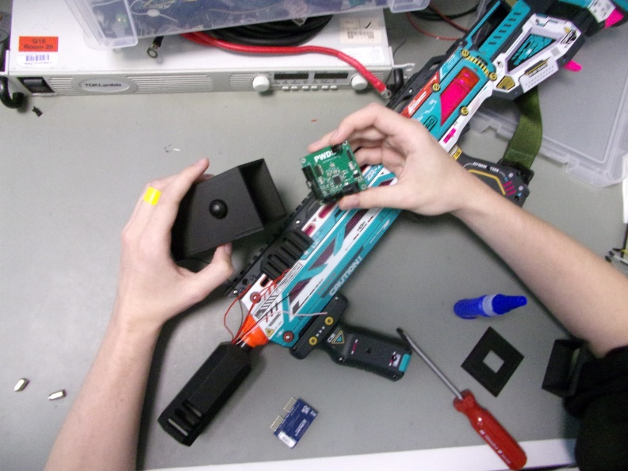

Figure 48 - LRU1 PCB fitting

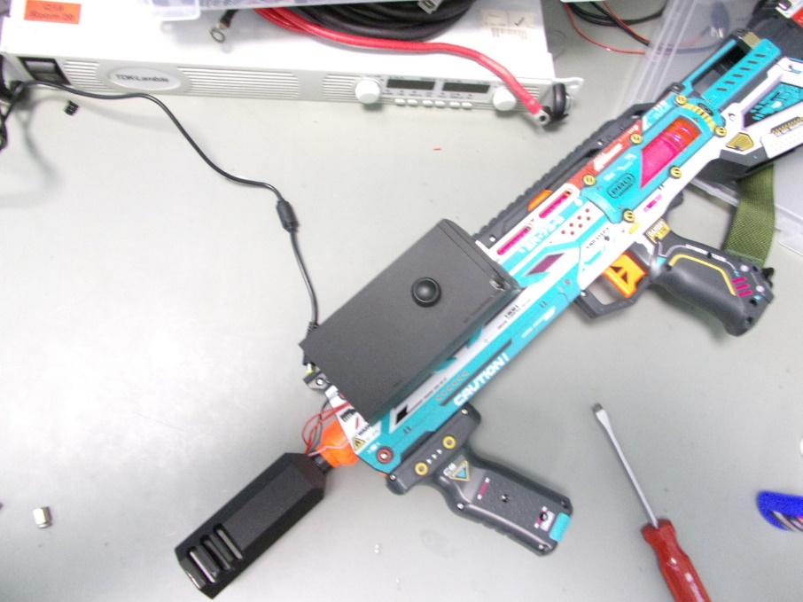
Here the central PCB is being fitted into the box, which will attach to the picatinny rail that has been printed to fit onto the side of the rifle.
Figure 49 - Complete build

Here is the complete unit with counter and solar panel. All components have been glued shut, as the solar panel will recharge the battery pack on the inside, removing the need to carry additional batteries or to recharge the unit.
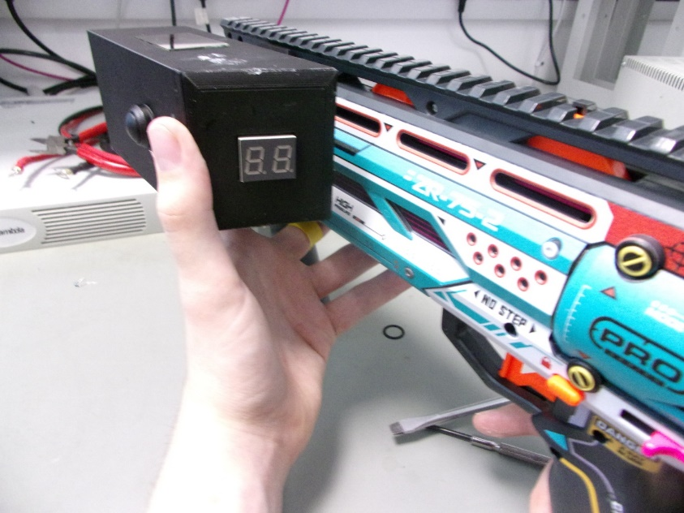
Figure 50 - Complete unit including counter and solar panel

Overall these modifications have had little impact on the weight and handling of the rifle, which was surprising due to how bulky the completed unit may look.
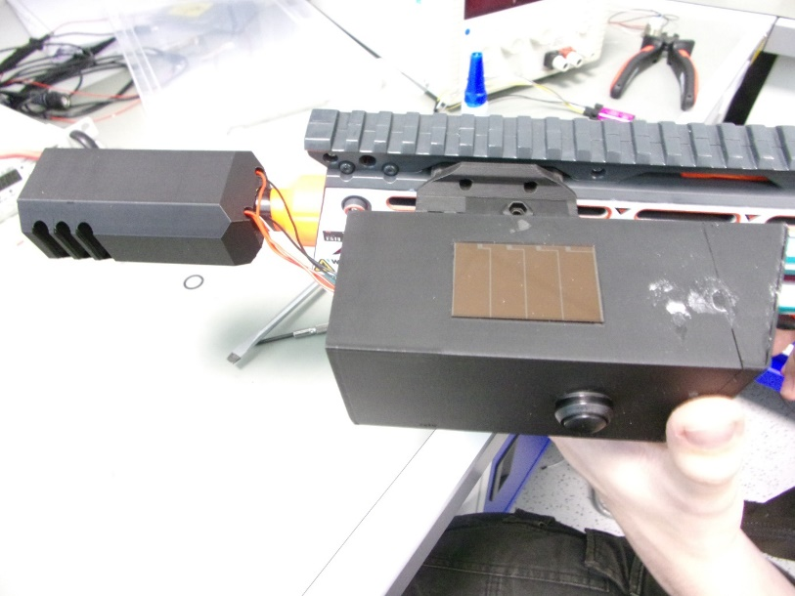
Figure 51 - An image of the solar panel and wiring

Final design showing solar panel and wiring.] BC

Results & Analysis
[Unfortunately, due to time constraints this project has failed to achieve all goals, meaning the results and analysis are based on the final rendition of the project; what was achieved by the final prototype.

Comparison
The table below shows which specifications we met, didn’t meet and haven’t addressed.] OA
Table 4 – A table of Spec Points hit for the group project
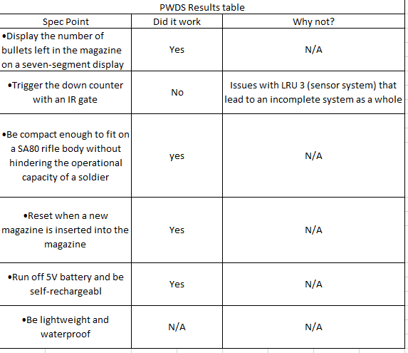

Analysis
•[Display the number of bullets left in the magazine on a seven-segment display.
The number of bullets was displayed on the screen, which was then decremented when pressing a button. The group implemented this with a button initially, in order to develop the code. Once this was achieved, the group switched to a sensor to begin debugging that part of the system.] OA
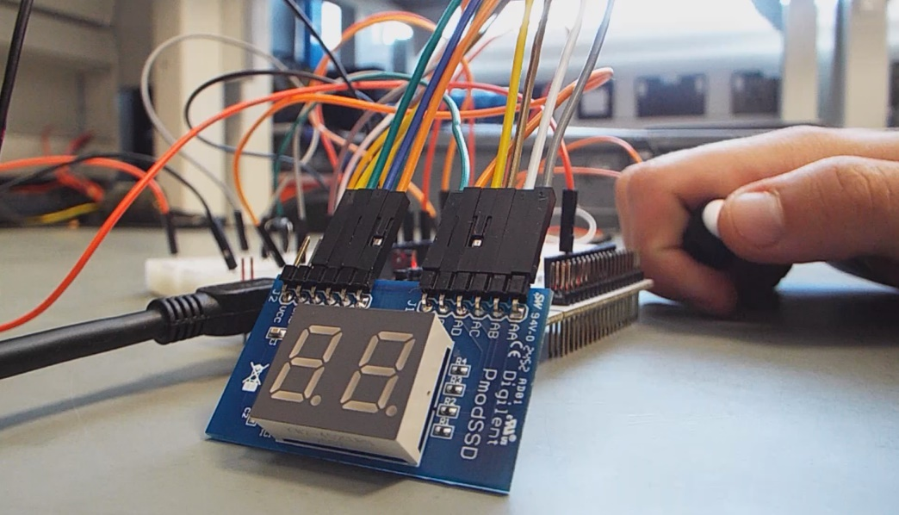
[As the IR sensor was unable to be implemented successfully, a second button was used to simulate the sensor. This was the same as an input from the IR sensor as the pin is only looking for a change in digital high or low. The pictures below show the process of counting down by holding the mag holder button and pressing the IR sensor replacement button:] AR
Figure 52 - Stage 1 of the system working

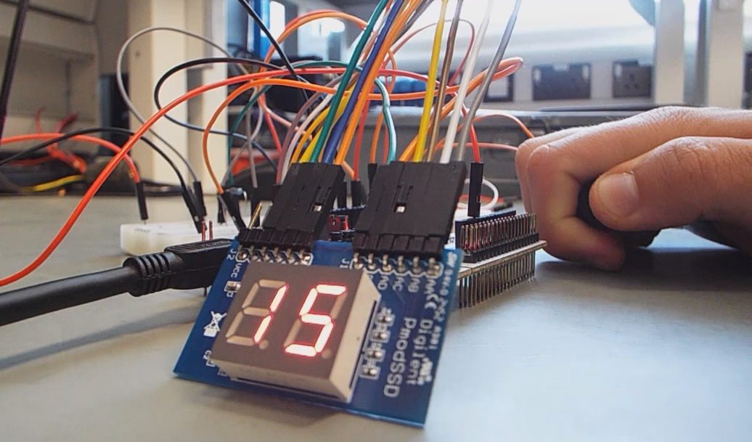
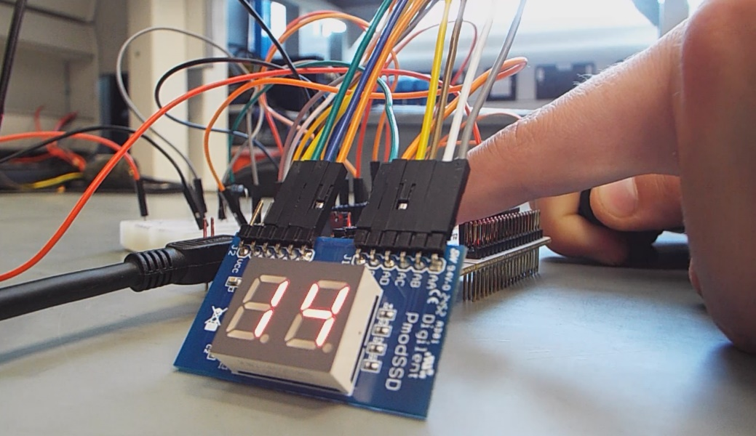
Figure 53 - Stage 3 of the system working
Figure 54 - Stage 2 of the system working
These pictures show that the software operated as expected, counting down when the IR sensor would have been triggered and only turning the display on when the mag holder button was held. This unfortunately did not allow for testing the exact timings that were calculated for the delays between readings. However, a longer duration was implemented for this test which shows the functionality of the delays works as intended.] AR
•[Trigger the down counter with an IR gate.
This is a major area of failure for the group. The IR sensor functioned on a breadboard when in prototype mode, however once this translated over to the manufactured PCB it ceased to function correctly.
•Be compact enough to fit on a SA80 rifle body without hindering the operational capacity of a soldier.
The main housing of the product was attached to the rifle with a sleek 3D printed design that does not remove any operational capacity of a soldier. The muzzle attachment does add to the overall length of the rifle minimally from the originally.
•Reset when a new magazine is inserted into the magazine well.
This was achieved by using a momentary switch inside the mag-well, where the pressure from the magazine would activate the switch. This would turn the entire system on and allow the counter to count down.
•Run off 5V battery and be self-rechargeable.
This was achieved by using a 4.8V battery and a solar panel. The idea being that the solar panel would not only charge the battery but increase the overall voltage of the input to 5V rail.
•Be lightweight and waterproof.
Due to the time constraints of the module, the group did not achieve this spec point.] OA

Conclusion & Evaluation

[The project achieved most of the goals set at conception. The project was within budget showing that this idea can be created at a low cost, with prototyping showing the ideal function of a completed unit.
The group failed to produce a final functioning unit. The group believe that with a small amount of extra time these issues can be resolved, leading to a profitable venture with this device at its centre. A failed test can still show results and allow the future potential of this project to be expanded on.] SP

Reflection

Reflection of the current Project
[ On reflection, there were many things with this project that could have improved its efficiency and success. One key aspect is the management of time and people, due to members of our team working in different areas of our company. With our own projects to manage and various working hours, being able to effectively communicate and plan was essential. This wasn’t entirely successful however, due to the aforementioned responsibilities and commitments that each member has to their respective teams. Finding times where every member was available to be able to contribute and discuss proved to be challenging, and was met with middling success.
This also led to a time crunch in the final two weeks, of which the delay on the arrival of PCBs was largely a contributor. The system on which Solidworks was used was also unavailable for a large period of time, hence the shift to FreeCAD, partially due to improper planning. If time was taken into consideration for these delays, it would have been possible to diagnose the fault with the sensor at an earlier date, and order the necessary replacement components.
The division of workload was a key strength of the team however, with each team member managing their respective area effectively and competently. This led to a nearly complete project, with the completion of the software, modelling, design, and integration with the weapon system
Due to these reasons, this project was largely a lesson for all of us in communication and planning. For most of us, this was the first time managing a project and having direct control over the design, research and construction of the product. It has been an enlightening experience, showing just how important it is for efficient and effective management of both time and people.] BC

8.1.1 In depth

8.1.1.1 Schematic Design
[This project has shown that building in time for mistakes is favourable in comparison to relying on the first version of a schematic to be perfect. This was the case for the group project due to the time constraints the group faced, there was only enough time to manufacture one PCB from the schematic designs.
This resulted in a lot of time being spent in the testing and debugging stage of the group project where, much to the groups dismay, the group failed to correct the issues present with the PCBs.
The main strength of the schematics is that is allowed it to be updated for future designs. Meaning the chip chosen had a number of free connections where add-ons could have been attached.] OA

8.1.1.2 PCB Design
[ One thing this Project has shown is that some complex circuits with devices with multiple pins can still be done on a 2-layer board. Additionally, it can show that PCB design can lead to challenges when working with small dimensions, you have to ensure that the PCB isn’t only effective electronically but also that it is suitable for the project that you are doing. For example, LRU1 is a relatively complex circuit that would be simple to design if space was not an issue. But when small dimensions are required it becomes a challenge to fit all components in a suitable space.] SP

8.1.2 Software
[Throughout this project I further developed my ability to program STM32 microcontrollers and gained some experience in developing software for an embedded system. An unexpected hurdle to overcome was the configuration of the misplaced pins, which required some research to understand how to properly configure them. This caused confusion initially as a pin labelled as supporting GPIO output was not functioning, which led to the discovery that explicitly defining how the STM32 is programming enables the GPIO functionality of it] AR

8.1.3 Integration
[ The integration side of this project was fairly straightforward, with adjustments to prints and the measuring of the rifle being something that was able to be performed in house, not restricting the ability to adapt to the changing requirements due to the size of the PCBs, different components etc. It has shown the versatility of being able to design bespoke housing and components as well as being able to produce them in a matter of hours, not waiting for delays of days or weeks to be able to continue developing the project.] BC

References

[1] | T. Electronics, “This is Tachyon V2,” Tachyon Electronics, [Online]. Available: https://tachyonelectronics.com/Tachyon2. [Accessed 13 June 2025].
[2] | B. Army, “British Army Vehicles and Equipment,” Ministry of Defence, 2011.
[3] | Ministry of Defence, “Dismounted Close Combat Fieldcraft Battle Lessons & Exercises,” Ministry of Defence, Andover, 2017.
[4] | “XSHOT Skins Pro Series Longshot Blaster (40 Darts),” Argos, [Online]. Available: https://www.argos.co.uk/product/5251373?msockid=2dc97708bbb9655b051a65febab964f5. [Accessed 18 June 2025].
[5] | ST, “STM32F1 Series,” ST, 2025. [Online]. Available: https://www.st.com/en/microcontrollers-microprocessors/stm32f1-series.html. [Accessed 10 07 2025].
[6] | ST, “Nucleo F103RB Datasheet,” ST, 2025. [Online]. Available: https://www.st.com/en/evaluation-tools/nucleo-f103rb.html. [Accessed 10 07 2025].
[7] | ST, “STM32-bit Arm Cortex MCUs,” ST, 2025. [Online]. Available: https://www.st.com/en/microcontrollers-microprocessors/stm32-32-bit-arm-cortex-mcus.html. [Accessed 10 07 2025].
[8] | ST, “STM32 Nucleo F103RB,” ST, 2025. [Online]. Available: https://www.st.com/en/evaluation-tools/nucleo-f103rb.html. [Accessed 10 07 2025].
[9] | STM, “STM32 Datasheet,” STM, 9 2023. [Online]. Available: https://www.st.com/resource/en/datasheet/stm32f103tb.pdf. [Accessed 19 6 2025].
[10] | STM, “Battery Charge controller Datasheet,” STM, 2 2022. [Online]. Available: https://www.st.com/content/ccc/resource/technical/document/datasheet/group2/50/c4/60/ab/e6/09/4f/80/CD00079821/files/CD00079821.pdf/jcr:content/translations/en.CD00079821.pdf. [Accessed 20 6 2025].
[11] | Molex, “SL Connectors,” Molex, [Online]. Available: https://www.molex.com/en-us/products/connectors/wire-to-wire-connectors/sl-connectors. [Accessed 27 June 2025].
[12] | IBE, “Why can’t PCB layout have right angles?,” IBE Electronics, 22 September 2023. [Online]. Available: https://www.pcbaaa.com/why-cant-pcb-layout-have-right-angles/. [Accessed 27 June 2025].
[13] | Diligent, “PmodSSD Reference manual,” 2025. [Online]. Available: https://digilent.com/reference/_media/pmod:pmod:pmodSSD_rm.pdf. [Accessed 10 07 2025].
[14] | Microcontrollers lab, “STM32 Nucleo Timer Interrupt with STM32CubeIDE and HAL Libraries,” 2025. [Online]. Available: https://microcontrollerslab.com/stm32-nucleo-timer-interrupt-stm32cubeide-hal-libraries/. [Accessed 10 07 2025].
[15] | Yairo, “X-Shot Pro-Series Longshot -FPS numbers,” 02 06 2023. [Online]. Available: https://www.blaster-time.eu/x-shot-pro-series-longshot-fps-numbers/?v=7885444af42e. [Accessed 10 07 2025].
[16] | RedCowl, “Xshot Longshot Side Picatinny Rails,” Printables, 18 March 2025. [Online]. Available: https://www.printables.com/model/556899-xshot-longshot-side-picatinny-rails/files. [Accessed 3 July 2025].
[17] | TheBlueSkywolf, “Universal picatinny zip tie flashlight mount,” Thingiverse, 7 March 2017. [Online]. [Accessed 4 July 2025].
[18] | ST, “STM32 Nucleo-64 development board with STM32F103RB MCU, supports Arduino and ST morpho connectivity,” 2025. [Online]. Available: https://www.st.com/en/evaluation-tools/nucleo-f103rb.html. [Accessed 10 07 2025].
[19] | ST, “Integrated Development Environment for STM32,” 2025. [Online]. Available: http://st.com/en/development-tools/stm32cubeide.html. [Accessed 10 07 2025].

Appendix

Source Code
/* USER CODE BEGIN Header */
/**
******************************************************************************
* @file : main.c
* @brief : Main program body
******************************************************************************
* @attention
*
* Copyright (c) 2025 STMicroelectronics.
* All rights reserved.
*
* This software is licensed under terms that can be found in the LICENSE file
* in the root directory of this software component.
* If no LICENSE file comes with this software, it is provided AS-IS.
*
******************************************************************************
*/
/* USER CODE END Header */
/* Includes ------------------------------------------------------------------*/
#include "main.h"

/* Private includes ----------------------------------------------------------*/
/* USER CODE BEGIN Includes */

/* USER CODE END Includes */

/* Private typedef -----------------------------------------------------------*/
/* USER CODE BEGIN PTD */
typedef unsigned char bool;

/**
* @brief Contains the high (left) and low (right) value for the display
*
*/
struct SSD_DisplayValue
{
uint8_t high; // Left part of the display
uint8_t low; // Right part of the display
};
/* USER CODE END PTD */

/* Private define ------------------------------------------------------------*/
/* USER CODE BEGIN PD */

#define SSD_DISPLAY_HIGH 1 // High status for the CAT Pin for the high value of the display (left)
#define SSD_DISPLAY_LOW 0 // Low status for the CAT Pin for the low value of the display (right)

#define INITIAL_VALUE_HIGH 1 // Initial high value for the display
#define INITIAL_VALUE_LOW 5 // Initial low value for the display

#define CYCLE_DELAY 5 // How many milliseconds between each cycle for the display values

#define TIMER_DURATION 192 //ticks
#define MINIMUM_DELAY_TIME TIMER_DURATION - 48
#define MAXIMUM_DELAY_TIME TIMER_DURATION - MINIMUM_DELAY_TIME

/* USER CODE END PD */

/* Private macro -------------------------------------------------------------*/
/* USER CODE BEGIN PM */

/* USER CODE END PM */

/* Private variables ---------------------------------------------------------*/
TIM_HandleTypeDef htim3;

/* USER CODE BEGIN PV */
bool trigger_delay = 0; // Status of the delay between the current and next reading
bool display_power_state = 0; // Power status of the display, 0 is off
/* USER CODE END PV */

/* Private function prototypes -----------------------------------------------*/
void SystemClock_Config(void);
static void MX_GPIO_Init(void);
static void MX_TIM3_Init(void);
/* USER CODE BEGIN PFP */
//
void write_display(struct SSD_DisplayValue value);
void turn_off_display();
bool check_minimum_time();
void HAL_TIM_PeriodElapsedCallback(TIM_HandleTypeDef* htim);
/* USER CODE END PFP */

/* Private user code ---------------------------------------------------------*/
/* USER CODE BEGIN 0 */

/**
* @brief Writes two values to the display, a high value and a low value
*
* @param display_value: A structure that contains the high (left) and low (right) value for the display
*/
void write_display(struct SSD_DisplayValue display_value)
{
// Set the display power state flag to true (on)
display_power_state = 1;

// Write to the CAT Pin to write to the high (left) part of the display
HAL_GPIO_WritePin(SSD_CAT_GPIO_Port, SSD_CAT_Pin, SSD_DISPLAY_HIGH);

// Write the high value to the display
HAL_GPIO_WritePin(SSD_A_GPIO_Port, SSD_A_Pin, display_value.high & 1);
HAL_GPIO_WritePin(SSD_B_GPIO_Port, SSD_B_Pin, (display_value.high >> 1) & 1);
HAL_GPIO_WritePin(SSD_C_GPIO_Port, SSD_C_Pin, (display_value.high >> 2) & 1);
HAL_GPIO_WritePin(SSD_D_GPIO_Port, SSD_D_Pin, (display_value.high >> 3) & 1);

HAL_Delay(CYCLE_DELAY);

// Write to the CAT Pin to write to the low (right) part of the display
HAL_GPIO_WritePin(SSD_CAT_GPIO_Port, SSD_CAT_Pin, SSD_DISPLAY_LOW);

// Write the low value to the display
HAL_GPIO_WritePin(SSD_A_GPIO_Port, SSD_A_Pin, display_value.low & 1);
HAL_GPIO_WritePin(SSD_B_GPIO_Port, SSD_B_Pin, (display_value.low >> 1) & 1);
HAL_GPIO_WritePin(SSD_C_GPIO_Port, SSD_C_Pin, (display_value.low >> 2) & 1);
HAL_GPIO_WritePin(SSD_D_GPIO_Port, SSD_D_Pin, (display_value.low >> 3) & 1);

HAL_Delay(CYCLE_DELAY);
}

/**
* @brief Blanks the display and sets the display power state flag to false (off)
*
*/
void turn_off_display()
{
// Only write once
if(display_power_state)
{
// Write a blank value to the display
HAL_GPIO_WritePin(SSD_A_GPIO_Port, SSD_A_Pin, GPIO_PIN_SET);
HAL_GPIO_WritePin(SSD_B_GPIO_Port, SSD_B_Pin, GPIO_PIN_SET);
HAL_GPIO_WritePin(SSD_C_GPIO_Port, SSD_C_Pin, GPIO_PIN_SET);
HAL_GPIO_WritePin(SSD_D_GPIO_Port, SSD_D_Pin, GPIO_PIN_SET);

// Set the display power state flag to false (off)
display_power_state = 0;
}
}

/**
* @brief Checks if an object is still passing after the minimum required time
*
* @retval bool - Whether the IR light is still broken (0) or not (1)
*/
bool check_minimum_time()
{
// Set trigger_delay back to 1 as the light has just been broken
trigger_delay = 1;

// Set timer to the minimum read time
__HAL_TIM_SET_COUNTER(&htim3, MINIMUM_DELAY_TIME);

// Wait until the interrupt is triggered again, resetting the trigger delay
while(trigger_delay == 1)
{
continue;
}

// if the light is no longer broken after the minimum time, disregard the break as a false positive
return HAL_GPIO_ReadPin(IR_SENSOR_GPIO_Port, IR_SENSOR_Pin);
}

/* USER CODE END 0 */

/**
* @brief The application entry point.
* @retval int
*/
int main(void)
{
/* USER CODE BEGIN 1 */

/* USER CODE END 1 */

/* MCU Configuration--------------------------------------------------------*/

/* Reset of all peripherals, Initializes the Flash interface and the Systick. */
HAL_Init();

/* USER CODE BEGIN Init */

struct SSD_DisplayValue display_value;
display_value.high = INITIAL_VALUE_HIGH;
display_value.low = INITIAL_VALUE_LOW;
/* USER CODE END Init */

/* Configure the system clock */
SystemClock_Config();

/* USER CODE BEGIN SysInit */

/* USER CODE END SysInit */

/* Initialize all configured peripherals */
MX_GPIO_Init();
MX_TIM3_Init();
/* USER CODE BEGIN 2 */
// Start the interrupt for the trigger delay
HAL_TIM_Base_Start_IT(&htim3);

// Disable the latch to allow the SSD to be written to
HAL_GPIO_WritePin(SSD_L0_GPIO_Port, SSD_L0_Pin, 0);
/* USER CODE END 2 */

/* Infinite loop */
/* USER CODE BEGIN WHILE */
while (1)
{
// If there is no magazine and the display is already off, just keep waiting
if(!HAL_GPIO_ReadPin(MAG_HOLDER_GPIO_Port, MAG_HOLDER_Pin) && !display_power_state)
continue;

// LOW = light broken
if(!HAL_GPIO_ReadPin(IR_SENSOR_GPIO_Port, IR_SENSOR_Pin) && trigger_delay == 0 && HAL_GPIO_ReadPin(MAG_HOLDER_GPIO_Port, MAG_HOLDER_Pin))
{
// Checks if an object is still passing after the minimum amount of time required
if(!check_minimum_time())
continue;

// Set trigger_delay back to 1
trigger_delay = 1;

// Reset the timer count here to ensure the proper time between passes
__HAL_TIM_SET_COUNTER(&htim3, MAXIMUM_DELAY_TIME);

// Write the current value to the display
write_display(display_value);

// Decrement the low value if it is not 0
if(display_value.low > 0)
{
display_value.low--;
}
else if(display_value.high != 0 && display_value.low == 0)
{
// If the high value is not 0, reset the low value to 9 and decrement the high value
// If this is not checked the display would try to count down past 00
display_value.low = 9;

if(display_value.high > 0)
display_value.high--;
}

// Write the updated value to the display
write_display(display_value);
}
else if(!HAL_GPIO_ReadPin(MAG_HOLDER_GPIO_Port, MAG_HOLDER_Pin))
{
// Disable and reset the display if the magazine is removed
turn_off_display();

display_value.high = INITIAL_VALUE_HIGH;
display_value.low = INITIAL_VALUE_LOW;
}
else
{
// If no event has happened, just write the current value to the display
write_display(display_value);
}

/* USER CODE END WHILE */

/* USER CODE BEGIN 3 */
}
/* USER CODE END 3 */
}

/**
* @brief System Clock Configuration
* @retval None
*/
void SystemClock_Config(void)
{
RCC_OscInitTypeDef RCC_OscInitStruct = {0};
RCC_ClkInitTypeDef RCC_ClkInitStruct = {0};

/** Initializes the RCC Oscillators according to the specified parameters
* in the RCC_OscInitTypeDef structure.
*/
RCC_OscInitStruct.OscillatorType = RCC_OSCILLATORTYPE_HSI;
RCC_OscInitStruct.HSIState = RCC_HSI_ON;
RCC_OscInitStruct.HSICalibrationValue = RCC_HSICALIBRATION_DEFAULT;
RCC_OscInitStruct.PLL.PLLState = RCC_PLL_ON;
RCC_OscInitStruct.PLL.PLLSource = RCC_PLLSOURCE_HSI_DIV2;
RCC_OscInitStruct.PLL.PLLMUL = RCC_PLL_MUL16;
if (HAL_RCC_OscConfig(&RCC_OscInitStruct) != HAL_OK)
{
Error_Handler();
}

/** Initializes the CPU, AHB and APB buses clocks
*/
RCC_ClkInitStruct.ClockType = RCC_CLOCKTYPE_HCLK|RCC_CLOCKTYPE_SYSCLK
|RCC_CLOCKTYPE_PCLK1|RCC_CLOCKTYPE_PCLK2;
RCC_ClkInitStruct.SYSCLKSource = RCC_SYSCLKSOURCE_PLLCLK;
RCC_ClkInitStruct.AHBCLKDivider = RCC_SYSCLK_DIV1;
RCC_ClkInitStruct.APB1CLKDivider = RCC_HCLK_DIV2;
RCC_ClkInitStruct.APB2CLKDivider = RCC_HCLK_DIV1;

if (HAL_RCC_ClockConfig(&RCC_ClkInitStruct, FLASH_LATENCY_2) != HAL_OK)
{
Error_Handler();
}
}

/**
* @brief TIM3 Initialization Function
* @param None
* @retval None
*/
static void MX_TIM3_Init(void)
{

/* USER CODE BEGIN TIM3_Init 0 */

/* USER CODE END TIM3_Init 0 */

TIM_ClockConfigTypeDef sClockSourceConfig = {0};
TIM_MasterConfigTypeDef sMasterConfig = {0};

/* USER CODE BEGIN TIM3_Init 1 */

/* USER CODE END TIM3_Init 1 */
htim3.Instance = TIM3;
htim3.Init.Prescaler = 1000;
htim3.Init.CounterMode = TIM_COUNTERMODE_UP;
htim3.Init.Period = 192;
htim3.Init.ClockDivision = TIM_CLOCKDIVISION_DIV1;
htim3.Init.AutoReloadPreload = TIM_AUTORELOAD_PRELOAD_ENABLE;
if (HAL_TIM_Base_Init(&htim3) != HAL_OK)
{
Error_Handler();
}
sClockSourceConfig.ClockSource = TIM_CLOCKSOURCE_INTERNAL;
if (HAL_TIM_ConfigClockSource(&htim3, &sClockSourceConfig) != HAL_OK)
{
Error_Handler();
}
sMasterConfig.MasterOutputTrigger = TIM_TRGO_RESET;
sMasterConfig.MasterSlaveMode = TIM_MASTERSLAVEMODE_DISABLE;
if (HAL_TIMEx_MasterConfigSynchronization(&htim3, &sMasterConfig) != HAL_OK)
{
Error_Handler();
}
/* USER CODE BEGIN TIM3_Init 2 */

/* USER CODE END TIM3_Init 2 */

}

/**
* @brief GPIO Initialization Function
* @param None
* @retval None
*/
static void MX_GPIO_Init(void)
{
GPIO_InitTypeDef GPIO_InitStruct = {0};
/* USER CODE BEGIN MX_GPIO_Init_1 */
/* USER CODE END MX_GPIO_Init_1 */

/* GPIO Ports Clock Enable */
__HAL_RCC_GPIOC_CLK_ENABLE();
__HAL_RCC_GPIOD_CLK_ENABLE();
__HAL_RCC_GPIOA_CLK_ENABLE();
__HAL_RCC_GPIOB_CLK_ENABLE();

/*Configure GPIO pin Output Level */
HAL_GPIO_WritePin(GPIOA, SSD_A_Pin|SSD_B_Pin|SSD_C_Pin|SSD_D_Pin
|SSD_L0_Pin|SSD_CAT_Pin, GPIO_PIN_SET);

/*Configure GPIO pins : SSD_A_Pin SSD_B_Pin SSD_C_Pin SSD_D_Pin
SSD_L0_Pin SSD_CAT_Pin */
GPIO_InitStruct.Pin = SSD_A_Pin|SSD_B_Pin|SSD_C_Pin|SSD_D_Pin
|SSD_L0_Pin|SSD_CAT_Pin;
GPIO_InitStruct.Mode = GPIO_MODE_OUTPUT_PP;
GPIO_InitStruct.Pull = GPIO_NOPULL;
GPIO_InitStruct.Speed = GPIO_SPEED_FREQ_LOW;
HAL_GPIO_Init(GPIOA, &GPIO_InitStruct);

/*Configure GPIO pins : MAG_HOLDER_Pin IR_SENSOR_Pin */
GPIO_InitStruct.Pin = MAG_HOLDER_Pin|IR_SENSOR_Pin;
GPIO_InitStruct.Mode = GPIO_MODE_INPUT;
GPIO_InitStruct.Pull = GPIO_PULLDOWN;
HAL_GPIO_Init(GPIOB, &GPIO_InitStruct);

/* USER CODE BEGIN MX_GPIO_Init_2 */
/* USER CODE END MX_GPIO_Init_2 */
}

/* USER CODE BEGIN 4 */
/**
* @brief Resets trigger delay to 0 after the timer reaches 500 (ms)
*
* @param htim
*/
void HAL_TIM_PeriodElapsedCallback(TIM_HandleTypeDef* htim)
{
trigger_delay = 0;
}
/* USER CODE END 4 */

/**
* @brief This function is executed in case of error occurrence.
* @retval None
*/
void Error_Handler(void)
{
/* USER CODE BEGIN Error_Handler_Debug */
/* User can add his own implementation to report the HAL error return state */
__disable_irq();
while (1)
{
}
/* USER CODE END Error_Handler_Debug */
}

#ifdef USE_FULL_ASSERT
/**
* @brief Reports the name of the source file and the source line number
* where the assert_param error has occurred.
* @param file: pointer to the source file name
* @param line: assert_param error line source number
* @retval None
*/
void assert_failed(uint8_t *file, uint32_t line)
{
/* USER CODE BEGIN 6 */
/* User can add his own implementation to report the file name and line number,
ex: printf("Wrong parameters value: file %s on line %d\r\n", file, line) */
/* USER CODE END 6 */
}
#endif /* USE_FULL_ASSERT */

