Student: Carl Daniels
Student Number: 97011030
Module Title: Authenticity and the Role of the Leader
Module Code: BMPF7021
Cohort: 6
Submission Deadline: 25th August 2023
Total Assignment Word count: 9,148 words

Assessment Component 1:

Leadership and management theories and models, and their appropriateness for my workplace.

Word count (excluding tables and reference list): 3,337 words.

As I embark on my 20th year working for the local authority, the landscape has never felt so challenging and interesting. The ‘job for life’ perception and the peaks of financial comfort seem to have been left far behind as public servants grapple with the identity and purpose of the organisation, coupled with the complexities faced at senior level and throughout the authority to create an effective leadership culture that continuously provides the best services to the public.
As a senior manager I feel well-positioned to reflect on leadership within my workplace given the close proximity to corporate and departmental management tables, being at the divisional management table, experiencing the way in which the elected member (councillor) system operates in parallel, and then directly being responsible for multiple facilities and approximately two hundred staff within my own portfolio. Add to that the internal and external partnerships that need to be healthily forged and maintained to achieve success and the fact that there is a truth and a belief (not always aligned) in a level of accountability we have to the public.
This makes for a complex leadership concoction and raises the question of whether there is one ‘best fit’ for a leadership approach and sets me off on an exploratory mission to critically evaluate five leadership models and theories in relation to their appropriateness to meet the needs of my workplace.

Given the ‘public service’ aspect of local authority, a logical model to start with would be ‘Servant Leadership’ introduced by Robert Greenleaf in 1970 as he argues that the roles of servant and leader can be “fused in one person” (Greenleaf, 1973, p. 1). Even Greenleaf himself wrestles with the notion throughout his early work and his thought process helps me reflect on this in my workplace, as he outlines the basis that a servant leader is servant first, and thus naturally wants to serve first.
This is a highly ethical concept; one that seems to ignore self-gain and be purely about the betterment of followers. Applying that to the ‘officer’ side of my workplace, with a legacy of significant salary and status that is afforded to the most senior leaders, I struggle with the notion that personal gain can be demoted to second or lower across the board, consistently.
Even considering servant leadership to the elected member (or councillor) side of the local authority that operates in parallel to officers, this is a difficult concept to wholeheartedly believe can be applied. Yes, by definition elected members are voted in place to represent the population. However, this immediately creates a quandary as the collective body of elected members – particularly when featuring on any of the Council’s committees – is there to shape the direction of the organisation in serving the whole population.
Elected members then need to balance this with political party direction and the needs and wants of their own ward, the latter being made up of the constituents that put them into the position in the first place. Without their votes in the next election, the councillor would no longer be the elected member. Under those conditions, is it realistic to expect elected members in general to be acting in accordance with the Servant Leadership model? Again, I struggle with that notion.
I also reflect on the way in which hierarchical decision-making structures are strongly embedded within the organisation’s DNA. Strategies, plans, policies and procedures are formulated, published and reported on as a matter of course due to the level of scrutiny and accountability to Welsh Government, local political parties, its partners, its staff and its population. Under those circumstances, is it appropriate for the organisation’s leaders to adopt a servant leadership style? Indeed, is it a style that one can ‘adopt’? Or, as Greenleaf outlines, do people already have to be of that style?
Simon Western (2007) explores this using Pantoja’s description of the biblical example of Jesus Christ washing his disciples’ feet like a lowly servant (Western, 2007). He goes on to deconstruct the seemingly ‘obviously good’ leader as they are placed in an organisation such as mine, seeing increases in factors such as narcissistic ego, undermining of solidarity, focus on self, etc. (Western, 2007, p. 181).
Further, given that the success of servant leadership depends on followership, there is a reliance on a strong match between employees at all levels. With a staffing compliment in excess of eight thousand and a constant turnover from a relatively finite pool (i.e. local population in the main), the broad, consistent success of servant leadership seems even more difficult to achieve and maintain.
That said, Russel and Stone (Russel & Stone, 2002) outline the ten attributes of servant leadership Larry Spears concludes from Greenleaf’s writings and expands them into a total of twenty, split into ‘functional’ and ‘accompanying’ on the guise that Spears describes the ten as being “by no means exhaustive.” (p. 146) These can be found alongside my organisation’s core values in Table 1 below and, when coupled with Spears’ view that servant leadership can be a long-term transformational approach, evidence that alignment to servant leadership could be a possibility under the right leader and conditions.

Workplace Core Values | Spears (2005) | Russel and Stone (2002)
Workplace Core Values | Spears (2005) | Functional | Accompanying
Listening | Listening | Vision | Communication
Take Responsibility | Empathy | Honesty | Credibility
Integrity | Healing | Integrity | Competence
Excellence | Awareness | Trust | Stewardship
Customers First | Persuasion | Service | Visibility
One team | Conceptualization | Modelling | Influence
 | Foresight | Pioneering | Persuasion
 | Stewardship | Appreciation | Listening
 | Commitment to the growth of people | Empowerment | Encouragement
 | Building Community |  | Teaching
 |  |  | Delegation
Table 1: Workplace Core Values, alongside attributes of Servant Leadership identified by Spears (2005) and Russel and Stone (2002)

Whilst there is a direct relationship between ‘lists’ in some cases (e.g. Listening and Integrity) the most interesting perhaps is ‘Customers First’. By definition, this implies that we - people of the workplace - prioritise those whom we serve and thus the dominance of a servant leadership style might be appropriate. However, I note that this relates to service provision and not leadership of the workforce – the critical followship. Arguably any leadership style present amongst the workforce could achieve a ‘customer first’ service provision.
Perhaps more important then is ‘One Team’, as this is the key indication to the workforce of the desire for togetherness with a link to ‘building a community’ included by Spears. But it does not go so far as to outline the ‘how’? This leaves unmatched attributes present in the list of Spears such as Stewardship and Commitment to the Growth of People, and Stewardship, Influence, Encouragement and Teaching from Russel and Stone which leads me to conclude that there is no explicit outlining of servant leadership attributes in the directional values of my workplace currently.
On balance, I concur with the comment of Western (2007) that suggests that more self-centred qualities of leaders may emerge in an organisation such as mine, making servant leadership less appropriate for my workplace.

Continuing to explore appropriate leadership styles, it strikes me that leadership often starts at the top. In my organisation’s case, that is the Chief Executive Officer (CEO) and there have been two in my time with the local authority. It is wholly appropriate to consider this, given the stark differences I experienced in their leadership styles and their effects on the culture of the workplace in general.
My early years were spent under a more autocratic CEO. Hierarchical structures were built accordingly, and the relationship between the corporate team and the elected member body impinged on being unilateral in the fact that councillors were directed as opposed to being free to debate and decide on key matters of the Council. If I am honest, he sent a shiver of nervousness down the backs of myself and colleagues. He had an unwavering demand for compliance, excellence and results, plus he demanded that his status was always recognised and respected, regularly over and above the main purpose of events themselves.
Is this appropriate for such a workplace? Interestingly, according to the metrics by which local authorities are judged nationally, my local authority was one of the highest performing in the country at this time. It also seemed able to financially invest in a way that demonstrated stability, innovation and dedication to progressing. This contrasted with investment in other most local authorities, particularly in the area of leisure, which was a particular focus of the CEO.
There is a suggestion here that autocracy worked for us, and this is not unusual. Whilst autocratic leadership is often seen as a negative for team moral and performance, theories on social hierarchy suggest it can also be positive under the right conditions (DeHoogh, et al., 2015). An examination of psychological safety as a key construct proposes that a hierarchically-ordered environment of predictability and security can positively affect morale and performance when team members accept the hierarchy.
I can partially relate this to my workplace at that time, as the CEO was strong and long-standing and there was a widespread acceptance of the hierarchy.
The Bass Handbook of Leadership (Bass & Bass, 2008) refers to a range of scenarios for ‘When It Pays To Be An Autocratic Leader’ that include the need for quick company turnarounds, military exercises and speedy and accurate production. Elements of these scenarios had been present in my workplace, most notably local government reform in 1996, resulting in the establishment of my local authority as its own entity, plus the challenge of austerity in the early 2000’s.
However, reflecting on ‘psychological safety’ I would not support that was in an entirely positive place, as mentioned earlier. On one side, if you were consistently performing well and that was known and in line with the desire of the CEO, security and rewards would likely follow. If not, psychological safety was under threat.
Feelings visible in the workplace then included frustration, alienation and helplessness, consistent with Bass and Bass’ review (2008) in ‘When Autocratic Leadership is Worse’.
A key turning point in the term of the CEO was an assessment by Wales Audit Office that found the governance to be too unilateral, requiring a rebalancing of power and decision—making. That was coupled with a change to the cabinet of elected members, most notably of the ‘Leader of the Council’, which made the prior autocratic leadership style unsustainable. The retirement of the CEO occurred shortly after.
I have therefore witnessed that autocratic leadership can work and be successful in achieving results but find it inappropriate for my workplace given the way in which it is required to operate as a public service. A CEO is appointed to lead the workforce and a Leader is elected to represent the people of the county. By design, neither they, nor any subordinate, is permitted to operate unilaterally and they are duty-bound to incorporate democracy in the way the public service is run. That is mimicked throughout the local authority, where Directors and Heads of Service are aligned with Cabinet Members and Scrutiny Committees to ensure a continuous thread of democracy, check and challenge. This leads me to rule out autocracy as an appropriate leadership style for my workplace.

The current CEO is markedly different, expressing a leadership style more aligned to the Authentic Leadership theory, which appears to have emerged in the 1960’s (Gardner, et al., 2011). To critically evaluate its appropriateness, it is important to recognise a sample of proposed definitions in Table 2 below:
Source | Definition
Henderson and Hoy (1983, pp. 67–68) | “Leadership authenticity is therefore defined as the extent to which subordinates perceive their leader to demonstrate the acceptance of organizational and personal responsibility for actions, outcomes, and mistakes; to be non-manipulating of subordinates; and to exhibit salience of self over role. Leadership inauthenticity is defined as the extent to which subordinates perceive their leader to be ‘passing the buck’ and blaming others and circumstances for errors and outcomes; to be manipulative of subordinates; and to be demonstrating a salience of role over self.”
Begley (2001, p. 353) | “Authentic leadership may be thought of as a metaphor for professionally effective, ethically sound, and consciously reflective practices in educational administration. This is leadership that is knowledge based, values informed, and skilfully executed.”
George (2003, p. 12) | “Authentic leaders use their natural abilities, but they also recognize their shortcomings, and work hard to overcome them. They lead with purpose, meaning, and values. They build enduring relationships with people. Others follow them because they know where they stand. They are consistent and self-disciplined. When their principles are tested, they refuse to compromise. Authentic leaders are dedicated to developing themselves because they know that becoming a leader takes a lifetime of personal growth.”
Luthans and Avolio (2003, p. 243) | “[W]e define authentic leadership in organizations as a process that draws from both positive psychological capacities and a highly developed organizational context, which results in both greater self-awareness and self-regulated positive behaviors on the part of leaders and associates, fostering positive self-development. The authentic leader is confident, hopeful, optimistic, resilient, transparent, moral/ethical future-oriented, and gives priority to developing associates into leaders themselves. The authentic leader does not try to coerce or even rationally persuade associates, but rather the leader's authentic values, beliefs, and behaviors serve to model the development of associates.”
George and Sims (2007, p. xxxi) | “Authentic leaders are “genuine people who are true to themselves and to what they believe in. They engender trust and develop genuine connections with others. Because people trust them, they are able to motivate others to high levels of performance. Rather than letting the expectations of other people guide them, they are prepared to be their own person and go their own way. As they develop as authentic leaders, they are more concerned about serving others than they are about their own success or recognition.”
Walumbwa et al. (2008, p. 94) | “[W]e define authentic leadership as a pattern of leader behavior that draws upon and promotes both positive psychological capacities and a positive ethical climate, to foster greater self-awareness, an internalized moral perspective, balanced processing of information, and relational transparency on the part of leaders working with followers, fostering positive self-development.”
Table 2: Definitions of Authentic Leadership from Gardner et al (2011, p. 1122)

Commonality can be found across the definitions. Accountable and self-awareness with the willingness and desire to develop self and others, being oneself – natural and genuine, building positive and enduring relationships with others resulting in others’ motivation and improved performance, putting the role before self-gain and resoundingly using one’s moral compass to bring good ethics, morals, values and principles to the fore.
There is certainly synergy between the noted aspects of Authentic Leadership with the Council as an organisation, given its role. It is not there to ‘do to’ and can only achieve great things as a jigsaw piece of the county landscape, and if people’s needs and wants are genuinely the priority.
Adopting a ‘5 dimensions’ approach (George, 2003, p. 18) of pursuing purpose with passion, practising solid values, leading with heart, establishing enduring relationships and demonstrating self-discipline is highly likely to develop an effective and trusted organisation. This leads me to conclude that an Authentic Leadership Model would be appropriate for my workplace.

The final leadership models I shall critically evaluate are Transformational and Transactional.
According to Northouse (2018) Transformational Leadership was a concept introduced by James MacGregor Burns in Leadership (1978), exploring transactional and transformational leadership side-by-side.
Summarised in political leader context, transactional politicians would promise voters something in return for their votes, e.g. tax cuts, whereas transformational politicians “appealed to the voter’s higher order wants and needs” (McGrath & Bates, 2013, p. 48) with reference to non-exploitation or manipulation, but ensuring such elements as trust, integrity, morality and personal growth and development of all present.
Northouse (2018, p. 169) includes Bass’ illustration of seven factors of the model transformational and transactional leadership, which assists my evaluation (note inclusion of Laissez-Faire and Factor 7, not evaluated in this work):
Transformational Leadership | Transactional Leadership | Laissez-Faire Leadership
Factor 1  Idealized influence  Charisma | Factor 5  Contingent reward  Constructive transactions | Factor 7  Laissez-faire  Nontransactional
Factor 2  Inspirational motivation | Factor 6  Management by exception  Active and passive  Corrective transactions
Factor 3
Intellectual stimulation
Factor 4
Individualized consideration
Table 3: Seven factors of Transformational and Transactional Leadership (Northouse, 2018, p. 169)

As factor 1 is concerned with the role modelling, morals and ethics of leaders, and thus the need for followers to emulate them, there is alignment with my workplace in the sense that we are a public service organisation requiring some eight thousand staff to be working towards one mission and vision for the organisation to be effective. We are continuously accountable to Welsh Government and various other stakeholders, plus to the local population whom our services affect through mandatory and voluntary access.
We have parallel lines of operational staff and elected members (councillors) and so the purpose of the local authority and its systems of recruitment, training and retention all support an obligation to high moral and ethical leadership.
Factor 2 is concerned with inspirational motivation. Again, the roles of the local authority are vast, from providing education and social care, to collecting refuse, to building and maintaining county infrastructure, to affecting the health and wellbeing of the population. Like a network of veins, arteries and capillaries support a heart to ensure that the whole body receives blood to give it the highest chance of functioning effectively, so too is it critical that the whole network of staff at all levels are effective. What better way than for each to be motivated to do so? I see a range of tools being employed by my workplace currently that work well on mass: weekly corporate e-newsletters, regular personalised written and filmed messages from our CEO, departmental and divisional staff conferences and an ongoing movement to ensure that manager-employee communication is regular to focus on both the work and the person.
This leads into Factors 3 and 4, intellectual stimulation and individualised consideration. Northouse (2018, p. 171) summarises Bass’ description of how followers are to be inspired to be creative, innovative, try new approaches and problem-solve. Leaders are to provide a supportive climate to individuals through listening, coaching, assisting and delegating to aid growth in accordance with each employee’s needs.
Within an organisation such as mine, expertise exists closer to the front line due to the diversity of services, thus the ability to solve problems and improve services is arguably best positioned there. Indeed, there is a strengthening approach to the use of a competency-based framework that further supports this approach; recruitment, training and appraisals, for example, will focus less on qualifications and more on the person as an individual and how they align with the local authority’s core purpose and core values. Coupled with a widespread encouragement of coaching and mentoring, the desire to empower the workforce is evident.
Somewhat in contrast, transactional leadership is associated with followers advancing their own agenda or that of their followers, making transactional leaders influential when it is in the best interests of the followers to do what the leaders wants (Kuhnert & Lewis, 1987).
Considering this in the context of my workplace, I find it very difficult to associate given the policies and procedures under which we work. Fairness and transparency are fundamental and the ability to use contingent rewards limited. Pay and grading systems are applied in accordance with a consistent framework linked to job profiles, with no bonuses paid, with any additional payments (overtime, expenses) subject to manager approval and audited periodically. ‘Time off’ is applied in accordance with policy, specifying who can have what leave, for what reason. Any deviation usually requires Head of Service approval. Personal interests, conflicts, gifts and hospitality all must be reported, with limited/no ability to personally gain linked to an action you have taken or will take. Any staff-related benefit is to be accessed via the staff benefits scheme, which is open and consistent for all staff regardless of level within the organisation, role, performance or any relationships.
A stark reminder of our inability to provide tangible rewards comes through the regular query I get from leisure centre staff members: “Can we get discount off a leisure centre membership?” On one hand, this request is a completely legitimate request and in the private sector is highly likely to be honoured. However, reviewing the context, multiple factors come into play. Whilst they are leisure centre staff members, they are ultimately local authority staff as are the other eight thousand or so. Why should they get a discount over and above others employed by the same organisation? Also, we operate a subsidised service. This means that public money is used to part fund the service. Is it then appropriate for staff to receive a discount, which one could easily argue tracks back to being publicly funded?
Even ‘high-quality’ or ‘less obvious’ transactions described by Kuhnert and Lewis (p. 649) feel difficult to administer. With the Council’s Code of Conduct, Behavioural Standards Guidance and the raft of other policies and procedures that set out the expected behaviour of managers and employees, the script for the interaction is largely written and to be consistent. Supporting this are the consequential processes if non-adherence occurs, thus displaying such aspects as trust, commitment, respect and appreciation as a reward for performance and loyalty aren’t leadership choices, they are institutional requirements.
This leads me to conclude that Transformational Leadership is appropriate for my workplace, but Transactional Leadership is not.

I set out to critically evaluate 5 leadership theories and models and their appropriateness for my workplace and conclude my findings below.
The first of these was Servant Leadership, which I deemed as possible under the right leader and a long, transformational approach. However, it was less appropriate overall given size and hierarchical structure of the organisation where more self-centred qualities of leaders may emerge (Western, 2007).
The second was Autocratic Leadership, which I had experienced in my workplace and had seen it achieve positive results. However, realignment of the organisation as a true ‘public service’ with relevant democratic processes rendered the leadership model unsustainable and so I deem it as inappropriate for my workplace.
Transactional Leadership was the fifth leadership model evaluated, which I deemed inappropriate given the incredibly limited ability my organisation has to enable rewards, tangible and intangible, to be used in the workplace.
The third and fourth leadership models were Authentic and Transformational, both deemed as appropriate for my workplace. Both have similarities in terms of being built from solid beliefs, morals and ethics, which aligns well to the very purpose of local authorities.
Out of the two models, Transformational Leadership appears most appropriate for my workplace. My rationale is that Authentic Leadership seems focused more on the leader themselves, whereas Transformational Leadership presents a more holistic system of leadership. Considering the first four factors of Bass’ seven factor model (Northouse, 2018), there is a requirement for an influential, charismatic leader that perhaps part-matches with what the Authentic Leadership model outlines.
But with Transformational Leadership the seven factors model suggests that influential, charismatic leadership is to be accompanied by inspirational motivation, intellectual stimulation and individualised consideration. This suggests explicitly that followers have to be engaged for it to be a complete, working model. If that were to be the case within my workplace with visionary leaders who effectively lead and empower the wider workforce, I believe we could foster a culture that would make the local authority fit to meet the challenges that lie ahead in order to provide public services that meet and exceed the needs and wants of the population.

Assessment Component 2:

Explore and critically reflect on personal leadership styles and behaviours, and interpersonal skills, and their impact on workplace relationships.

Word count (excluding tables and reference list): 5,811 words.

My earliest memory of using a leadership style dates back to primary school, where my mathematics capability inherited from my father led me to complete work accurately and efficiently, usually ahead of my classmates.
When I would finish, I would go around the class helping others. I wouldn’t be boastful or give the answers. Rather, I tried to find ways of helping others find their own answers to develop themselves and benefit from their own sense of achievement. I remember the satisfaction that they had, and I remember the feeling that gave me. I also remember the statement that featured in my school report as a result: Carl is very helpful in the class as he likes to teach others.
At ten years old I very much doubt I had even heard the word ‘mentor’ nor that mentoring would help develop me as a leader (Ayoobzadeh & Boies, 2020). I certainly wouldn’t have been aware of Slavery, Authentic or Transformational Leadership Models that the characteristics were typical of. However, I reflect on the positive feelings experienced by myself, my classmates, and my teacher, and subsequently my parents. I also reflect on the positive impact in the form of learning that occurred: within me due to cause and effect, and within classmates as they developed a greater mathematic ability and hopefully confidence. The sum of this leads me to conclude that the seeds of leadership behaviour were within me and starting to develop because of the positive experiences they were creating and the positive reinforcement I was receiving from others.
Being such a historical and noncomplex scenario, I can map the experience and reflections to the Experience-Reflection-Action (ERA) Cycle (Jasper, 2003) featured in Fig. 1 but it’s irrelevant to consider action in this case.
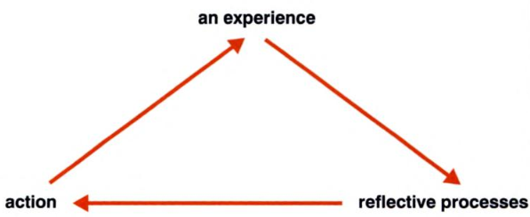
Fig. 1: ERA Cycle Diagram (Jasper, 2003, p. 2)

A decade later I found myself at Trinity University, Carmarthen, undertaking a teaching degree! Here, I probably took my first true steps into learning about myself in the context of influencing others. Whilst it’s only now I reflect on the parallels between teacher and leader (Akiyama, 2015), I learned that my preferred style was generally in the central zone of the teaching styles spectrum (Fig. 2) and began developing my awareness and ability to move along the continuum in order to have as positive an impact as possible on learners.
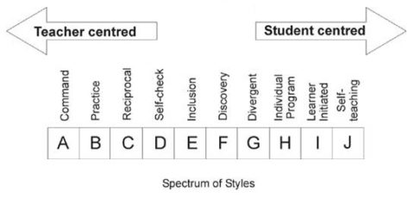
Fig. 2: Spectrum of Teaching Styles (Coaching, 2023)

A key milestone in my journey came in my second-year teaching practice at Penclawdd Primary School. Mandatory to alternate between ‘Infants’ and ‘Juniors’ in teaching practices one and two, my turn had come to experience infant teaching. ‘Out of my comfort zone’ is an understatement. I found it difficult to build relationships with the children of that age and, as a result, there was tension in my relationship with the school staff as they believed I wasn’t working or trying hard enough.
On completing the degree, I was fortunate enough to secure long term supply in the school I undertook my final teaching practice in, Morfa Junior School. This gave me confidence as I felt I had truly shaken off the negative experience a year prior, and shortly after they gave me a glowing reference to help me secure a contracted teaching position in Willow Bank Primary School, Reading.

Using Jasper’s ERA Cycle to add my reflections to the above teaching practice experiences, I refer to the relatively accurate Insights Discovery Profile (Insights Group, 2023) created for me using the Insights Preference Evaluator earlier this year.
“He is unlikely to be comfortable expressing his inner feelings to strangers,” (p. 5) reminds me that I never asked for help at Penclawdd when I was struggling. Had I done so, not only would colleagues have known I cared, but I’m sure they would have helped me overcome my issues and create a better experience for all.
“Carl gives the impression he believes in economy of effort. He must be careful that this is not seen as, nor leads to, laziness.” (p. 12) Added to that was, “Carl may reflect longer than is necessary before undertaking or beginning a project.” (p. 12) It’s true. I would rather take some time to think about he best, most efficient way of doing things but I would then class myself as one of the hardest-working, most dedicated people I know. There were situations where I’m sure that I stepped back for this purpose rather than step forward to do, which would have contributed towards the negative perception colleagues were building of me.
Conversely, at Morfa Junior School, relevant qualities referred to in the insights report include logic, structure, opportunities to display my deep technical knowledge and preferring a steady-paced environment. I recall the environment being much more aligned and the children’s maturity, higher level of ability and greater independence creating far more comfort and confidence in me, which resulted in better relationships and performance.

Considering actions from the above, I don’t think I have developed greatly in asking for help. I am very capable in many things, and I have an inner grit to find challenges and overcome them. However, I recognise that by asking for help I not only stand a greater chance of success, but I also show others humility and likely build stronger relationships.
I also feel I need to create a better balance of when to take time to analyse, and when sufficient analysis has been done to trigger action. It can be true that ‘He who hesitates is lost’ in the sense that opportunities can be missed, and others can be frustrated at time taken, or additional work needing to be done to get approval to proceed.

Aside from generally growing as a person through the ongoing experience I was gaining from teaching, one of the main benefits was to co-teach with, and be mentored by, the vastly experienced and straight-talking ‘Miss L’. Not only did I observe her leadership and teaching styles, I had regular feedback on my leadership and teaching styles. My teaching tactics and techniques developed immensely under her mentorship, and I certainly saw her use a variety of leadership styles with me. She was not afraid to show more autocratic tendencies, but sometimes I needed that when she knew the standards pupils could reach far better than I did and thus recognised when they were not giving of their best.

Reflecting on these experiences, I appreciate the forthrightness of Miss L. In my earlier teaching practice example, I didn’t ask for help or share my struggles and there are signs of this here too. With Miss L, she didn’t give me a choice and that worked. I count myself lucky for that, as if she had been less forthright, I don’t think I would have developed so much so quickly and that was a gain for all at the time and contributed to my continued growth as a leader.
The times when my class pupils did not put as much effort into their work is also worth reflecting on as my style and behaviours were more akin to student-centred, in accordance with the Spectrum of Teaching Styles (Fig. 1). Their under-performance and poor quality of work suggests the style was not as effective in that scenario for whatever reason, and had I deeply reflected on that at the time, perhaps a staffing issue described latter in this essay would not have been so profound. It seems my trust and empowerment of individuals led to that being perceived as acceptance of whatever performance level results.
I also wonder whether I was initially clear on my expectations, and this is something that is applicable to my current role, whereby hierarchical and service-wide groups are in place to ensure effective and efficient services are delivered and continuously improved. There have been several instances over the years where dysfunctionality has occurred, or under-performance of groups in my view, but I recall times when staff have said, “I can’t see what’s going on in your head.”

One appropriate action would be to emulate Miss L’s forthrightness when appropriate. My justification is two-fold: when used at the right time, in the right way and with good intentions it can get swift and positive results, but it can also help others learn quickly as it did me.
A second action would be to be clearer about expectations, and this can be done through a greater focus on effective communication through a variety of means. I had reflected on this previously, and since 2019 devoted effort to an overarching strategy with relevant action plans. I am supportive of the Intent-Based leadership model (Marquet, 2015) and have tried to emulate David Marquet’s approach to create a team of leaders to form and progress this, sharing and cascading the summary video as a statement of intent, ensuring discussion each time on how staff feel about it and what we do and don’t have in place to implement. Reactions have been positive; progress has been made but we are still on the journey to ‘get there’.

Due to a combination of my dream job coming up and my heart always having a yearning for home, I successfully applied to be Carmarthenshire County Council’s Dragon Sport Co-ordinator. Notifying the Headteacher was interesting on multiple levels. I observed him to be more of a manager than a leader, more focussed on creating goals, building systems and processes, showing limited openness to learning and being more instructional than being visionary, relatable, learning, or inspirational (Lush, 2019).

Homeward bound and into my new role, I now had my first experience of a proper ‘direct report’. A member of staff, 3 days per week, who worked for me as Dragon Sport Assistant. For the first time, it felt I had some leadership decisions to make. How did I want to be? How did I want this relationship to be? How would I manage the workload between us – would I share as an equal or would I level it according to co-ordinator and assistant? What effect would that have on leader-follower dynamics? How would I monitor work? How would I feed back to ensure she was effective in her role and grow as a person? This was made slightly more difficult as she had been in the assistant role under the previous co-ordinator, and acted up while I worked my notice in my previous role. Would I risk making her feel demoted, and what effect might that have?
Even the fact that I pondered over these questions now tells me a lot about myself as a leader back then. Analytical and always wanting to get things right with “a balance between concern for the people being managed and accomplishment of the task” (p. 5). I had limited awareness of leadership theories and models at the time, therefore limited tools in my armoury. This was possibly a good thing as all I knew was to be my authentic self, and I feel that was largely effective.
I showed humility and openness to learning given the assistant’s establishment and experience in the programme, whilst ensuring a divide between the more and less senior tasks. Overall creation of action plans and financial management are examples of what I took responsibility for, but when it came to whether the assistant would assist me with my area cluster roll-out or whether we would divide the roll-out to apportion clusters, we discussed and agreed on the latter. This was intentional on my part as I, unknown at the time, was adopting a transformational leadership style and attempting to create an effective culture emanating from the first four factors of Bass’ seven factor model (the four I’s): Influential leadership, Inspirational motivation, Intellectual stimulation and Individualised consideration (Northouse, 2018).

The Sport Development Team, made up of my manager, myself, my assistant and around 10 or so officers entered into a quality improvement and accreditation process called QUEST. Prior to this we were a team on paper but had less reason to work together on projects as most generally had a role to develop something specifically, such as a particular sport. Now we had cross-cutting themes and through being selected or volunteering, I found myself taking a more prominent role in the team and leading on wider developments and the associated experiences provide opportunity for reflective practice.
Under the theme of ‘Communication’ I suggested that we would work more efficiently if we were to all combine our events and courses into one calendar that we would produce and circulate as a wall planner to all schools and partners.
The impact of this piece of work, and what it asked of me from a leadership perspective, was profound. Within the team, I had to gain followship as there was only value if all contributed. However, setting plans for the whole academic year in advance was not something that was done, nor came easily to most. And it wasn’t only our team that needed to contribute. External organisations and groups ran events and courses too, such as the Urdd, Schools Associations, WRU and Scarlets. They didn’t have to answer to me, yet I now had to call on leadership skills to bring them on board and to map out their year and adhere to it.
Whilst the concept of a wall planner seems a simple one, it truly was transformational. Members of our team and of external organisations now saw their programmes as part of one leisure offer to schools, communicating and compromising to ensure a balanced spread of events and courses as opposed to offering their own opportunities ignorant of others. Schools were massively appreciative of the development, and it served multiple purposes in increasing profile of sport, sports development, the events and courses and, I have to say, me…which was simply a consequence rather than the intention.
All sports officers and organisations would communicate with me in terms of setting their programmes, and all would communicate with me regarding any considered changes. I felt I had galvanised a team and I felt proud.

As I reflect on my first line management experience and growth of a leadership position within the Sport Development Team, I recognise the emergence of many of the hallmarks of a crucial element of an effective leader (Goleman, 2004): emotional intelligence.
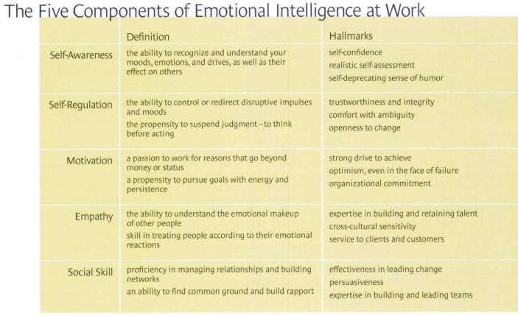
Fig. 3: The five components of emotional intelligence at work (Goleman, 2004, p. 88)

For example, the questioning of myself with the understanding of the effect it would have on others. The practising of self-regulation had to be present through the wall planner work as it was critical that people came on board as it was largely their choice, and I had to show the hallmarks to gain their trust. Motivation is key because I had a choice, It was a huge piece of work and the tangible gains were for others. I had no extra pay, no extra time, but I had an overriding sense that things would be better as a result, and that shone through to me, and I reflected that to others.
Empathy was continuously key. This was change for everyone. I had to sell the concept on mass, but I also had to connect with individuals in the process as they were all at different stages of the change process and had differing capabilities to do what was being proposed. I built positive relationships and adopted sensitivity to progress, spilling into social skill, which was evident through my leadership of this change journey, including persuasion and building a willing team through collaboration.

Given this happened naturally and I am realising the connection with emotional intelligence long after the experience, it strikes me that it is an area that I have not given a significant amount of focus to. An appropriate action would be to explore this further, to gain a deeper understanding of emotional intelligence and to understand myself in that regard, and what that might suggest in terms of my own development to becoming a more effective leader.

Welsh Government and Sport Wales saw the huge success of Dragon Sport and a key milestone in my journey occurred next. Funding was provided for a secondary school age programme mimicking Dragon Sport; it was named ‘5x60’. My manager asked if I would be willing to line manage the initial intake of officers, to which I agreed, and my role and leadership experiences expanded.
Within two years the 5x60 team grew to seven full time officers, and funding had been provided for a back-fill of the Dragon Sport Co-ordinator, so I was now Active Young People Co-ordinator managing a team of nine, with associated staffing and programme budget.

Being responsible for the team felt quite natural and as I reflect on this, I would like to say I was more a leader than a manager, preferring to inspire and empower. Again, I had not really explored leadership theory in any depth at that time, but I recall my constant emphasis on creating leaders and I particularly used coaching and mentoring techniques to help achieve this.
A common phrase of mine that has been played back to me is, “Come to me with solutions rather than problems.” Whilst I knew I was trying to create leaders in the team, it wasn’t until years later in my career that I discovered intent-based leadership (Marquet, 2015) and was able to understand myself in this context.

I need to continue action on this. I feel the intent-based leadership model is appropriate for my workforce given the tiers of staffing, breadth of portfolio and personal leadership preference. However, I have introduced the concept and some mechanisms to enable the model to be operational, but there is much to do to fully implement and realise its potential.

I experienced all of the previous was paying off. I observed the high-performing and positive culture and development of the team, as individuals and as a collective. I put a lot of trust and empowerment into the team but being responsible for the sports programme at two rural secondary schools, signs began to creep in to suggest all was not well with one officer’s performance, but I gave him the benefit of the doubt when he gave explanations to mitigate my concerns.
The year that followed tested my leadership significantly. On discovering that the officer had been far from honest with me and the school, challenge one was navigating my way through trying to support him to perform and helping him to maintain his wellbeing and presence in work, while having lost the trust in our relationship. Through my initial understanding of myself, further understanding resulting from my evaluations of leadership styles and my insights profile, principles and morals are incredibly important to me. That increased the personal challenge as I grappled with the way in which the local authority’s policies applied to the way I was to manage the situation in light of him stating that his anxiety was an issue.
Challenge two was in maintaining the spirit of the team. There is a requirement to maintain confidentiality but, for me, this was about more than that. While I felt let down, he was still my officer and I was loyal to that, but it was important to me to share what I could with the team so that they felt it was still a place of openness and honesty, and that they too felt support for the officer.
Challenge three was maintaining a positive relationship with the school, both in the early stages of the discovery whilst the officer was in work and when he was off work. The headteacher was formidable, and the only Head in the county who didn’t want an officer in the first place, preferring for me to give the school the money and let them find a staff member and run their programme.
I rarely planned the way I was going to act prior to that; ordinarily I allowed my authentic self to communicate naturally, and this usually ensured positive, smooth discussions and successful outcomes. This was different. On one hand I had to bring a dishonest officer into his office to confess to his wrongdoing, on the other hand I was mindful of the need to move forward to offer a positive 5x60 programme in the school and on the other hand I had to offer a degree of protection given he was my staff member and had expressed the anxiety he felt in that environment (albeit largely self-inflicted). The fact that I felt I needed three hands illustrates the quandary!
The meeting went as well as I could have expected. My emotional intelligence played a strong part, as I can now understand better how I tapped into all five of the components (Goleman, 2004) to strike a fair balance between the emotions of the situation, the rights and wrongs, the consequences and the plan for the future.
However, the officer’s long term sickness absence followed, and this was also something I had not experienced before. My initial priority was filling the gap he left so that the schools, and particularly their pupils, did not miss out on activity opportunities such was my “strong sense of duty” (Insights Group, 2023, p. 7).
The foundations laid repaid me the team filled the gaps without hesitation, which was testament to the team I had built. Other than reimbursing officers for travel costs incurred, I could not tangibly reward them for their efforts but the coming together of the team was an intangible reward for all.

As I supported the absent officer through the authority’s sickness absence procedure I struggled internally with my emotions. I tend to give trust until it is broken, rather than start from zero until trust is earned. Was that the wrong approach? Should I change? Am I too soft? I considered the wider team to regain perspective and concluded that out of nine staff, one has acted this way. On balance, I was doing ok and the important point to learn from this was to continue to be true to myself and take comfort in the fact that I was managing the situation well.
Interacting with the officer was interesting. I felt like two people. On the inside, the hurt at being lied to and let down constantly weighed heavy. I was angry. If I’m honest, I didn’t see it fair that I should be focussing my time on listening to someone who was purely wrapped up in themselves when their work-related situation was self-inflicted. I felt that I, and the compassionate policies of the local authority, were being taken advantage of but there was little I could do about it.
On the outside, I had to be professional and empathetic. If there was a chance that he would come back to work, I needed to facilitate that. If was not going to come back to work, I wanted that to be as positive a process as it could be. His wellbeing was still important to me either way.
It was only days before his planned September return when he suddenly tendered his resignation. I felt relief, and I also felt proud. I had represented myself well throughout, afforded him support and dignity, maintained a positive relationship with the school, been rewarded with loyalty and a willingness to ‘go the extra mile’ by the rest of the team and so the loss actually felt like a net gain.

As I reflect on this complete experience, I mostly take pride at the way I lead in that time. I was able to maintain an open and honest approach in that I professionally discussed what was acceptable and constructive to share, so that others knew that safety and trust were still paramount. This was both natural and deliberate, as I could not let the actions of one man negatively affect a principled team culture we had built over previous years, nor would I ‘cast him to the wolves’ such was the compassionate aspect synonymous of my relatively authentic style. The knock-on effect of this was reaffirmation that I was a strong and stable leader with an emphasis on principles, and this both encouraged others to have faith and confidence in me through good and bad, and that dishonesty and poor performance would not be accepted under my leadership.
In honesty, I had doubts at the recruitment stage and I should have been braver in not appointing. I also don’t feel I used the probationary period well enough to monitor performance and act accordingly.
Further, putting full trust in everyone all of the time should not be automatic as the law of averages would say that there will be issues with some people some of the time. Referring to my previous reflections (p. 5) I also wonder how clear my expectations were.
My final reflection on this is to think back to Miss L’s mentorship. What would she have done? A more forthright conversation would definitely have been had with the officer, which would have been unlikely to have led to a different outcome but would have been more likely to resolve the matter more swiftly.

One of the actions appropriate from these reflections is the willingness to have the tough conversations, being forthright if and when appropriate. I recall a HR training session reminding us that performance is to be managed every day, and it’s true that matters not addressed, or not addressed fully, can lead to the metaphorical weed growing stronger roots and/or spreading.
Second is to invest more into the recruitment and training process. It’s brave and time-consuming to not appoint or to hold additional recruitment stages, and it can be intensive to apply the probationary period effectively, but I found it to be far more time-consuming to deal with the consequences when things go wrong. It also sends a clear message to prospective and existing staff of the continuous quest for a high-performing, positive culture and that the workforce are the key to that.

Shortly after came the Leisure Division management restructure, reshaping twelve managers to three senior managers with the remainder moving below them structurally whilst they respectively restructured the three new portfolios. My manager and her two colleagues were in the mix, but the application process was open to all staff in the Leisure Division.
I considered throwing my hat in the ring, but due to being highly principled and loyal I felt the right thing was to discuss this with my manager. Her reaction showed me exactly what type of leader I did not want to be! Aside from trying to convince me not to, on the basis that she felt it would mean she would be out of a job at the next restructure and thus have to move house and take her son out of his current school, she barely spoke a word to me in the run up to the interviews or beyond.
I reflected on the situation with the officer the previous year and how I maintained professionalism and empathy despite being lied to and feeling taken advantage of. I felt I was experiencing the exact opposite when I was being honest and appreciative of how she had helped me grow, which resulted in a lack of professionalism and empathy.
As the bricks of my leadership journey had been building, this mentally confirmed to me that I was prepared to go to a higher floor.

So, we’re back to the start of this essay: I got the job!

Looking back over the decade since that point, I could call on countless scenarios from which I could reflect on my leadership styles and behaviours, and interpersonal skills, and their impact on workplace relationships. However, I feel there was one most profound situation that gives me a valuable opportunity to apply reflective practice.
Due to its greater complexity than previous experiences, I will use the reflective cycle developed by Graham Gibbs as shown in Fig 4 below.
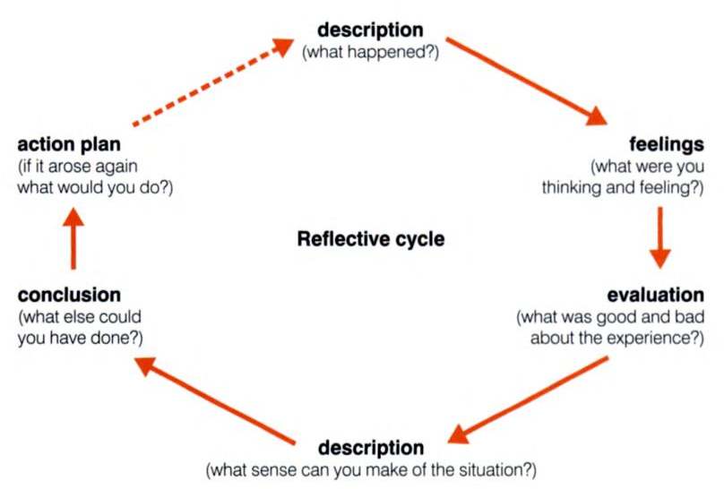
Fig. 4: Gibbs Reflective Cycle Diagram (1988). (Jasper, 2003, p. 77)

Description: In my interview presentation, my lead concept was ‘One Team, One Vision’ and in the early years I set about a five step plan to unite the management teams, unite the three sections under one brand, undertake a learning journey to help design a better future, realign the workforce and implement an effective communication system to ensure the wider team were informed, able to contribute and inspired by the transformation.
Various staff struggled through the change process, which is inevitable, but I generally found a decently positive way through with most and the plan was proving effective in motivating the workforce and improving performance. However, I could not find a way through with one manager and this created issues in multiple tiers and to the proportion of the portfolio he was responsible for.
I employed a range of strategies including ensuring good, regular communication, involving him in choices that determined his work programme and future, invited him to lead projects that were linked to the overall progression of Actif, provided a degree of direction whilst leaving space for creativity and ownership. Despite this, repeated examples occurred where he would not undertake what was being asked of him, continuously be negative or not contribute when needed, cause delay, negatively influence others and have eruptions in meetings. This included when changes discussed didn’t affect him.
Feelings: This was a very frustrating time, for me and for others. My communication and inclusion of the manager was genuine, but it was perceived by that individual as disingenuous. On several occasions I found myself reiterating, “I don’t lie,” thinking that would enable him to trust me and get us onto a healthy footing. The fact that this didn’t work made me feel helpless at times, and angry at other times.
I also felt disappointed on multiple fronts. In him for not believing and having faith and trust in me, in the fact that it was proving harder than it should have been for Actif to be progressing and that it was having a detrimental effect on others – staff and service-users.
Finally, I felt confused. I recall one particular outburst in a meeting when I explained a particular planning process which inadvertently had the new job title of his colleague on it. He could focus on nothing else and left the room in the end. At the time, this made no sense to me as it didn’t affect him in any way, and I had been through the right process to make the change.
Evaluation: There was little good about the experience other than the marginalisation perhaps strengthened the bonds of others. It did create a common negative at least.
Another positive I can take from it is my own overall development as a leader. In the round, informal and formal procedures applied and that has benefitted me now in the sense that I am more familiar with policies and procedures and had experience. I also practised a range of strategies that did and didn’t have the desired effect, which have helped me learn.
The bad aspects are easier to outline. I wore negative feelings for a lot of that period. The manager concerned went through a torrid time, including having multiple periods of sickness absence. It slowed progression. It affected others by lengthening he change process and increasing their negative feelings, including onset of stress.
Description: At the time, I could make little sense of the situation. The choices that I gave basically enabled the manager to choose where they worked and what they led. To me, he took issue with things that didn’t concern him. Since then, I have discovered the SCARF model (Rock, 2008) shown as Fig. 5 below and I begin to understand that what I saw was a threat response.
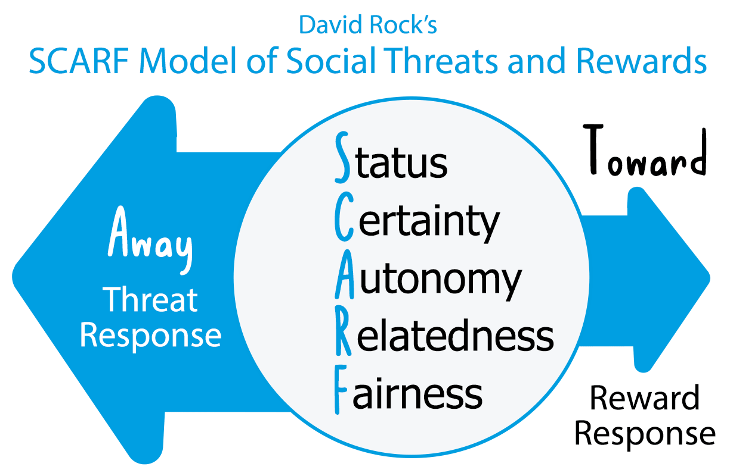
Fig. 5 SCARF Model (Rock, 2008) (Alvarez, 2021)

Whilst his status was not being affected – he retained the magnitude and pay grade – those who had been further down the hierarchy were now at his level, with the others rising in status too. In essence, his status would not have felt as superior as it would have previous to that.
Certainty was under threat given the realignment, and this clearly hung over the manager becoming a self-fulfilling prophecy. Seeing the other’s changed job title on a slide most likely felt as if security had been afforded to that individual that he didn’t have.
I felt I had given a good degree of autonomy, but it was not what he had before. There was limited management supervision and a degree of flexibility that had taken the portfolio in different directions, and I had made clear I wanted one team, one vision. Not being that manager’s preferred way of working, that helps explain reactions.
I tried to build the relationship, but I had come from a different corner of Actif and obviously had strong, positive relationships with that team. It was also incredibly difficult to create an maintain a positive relationship as the time was littered with negative exchanges and sickness absence.
The summation of everything would have seemed unfair, although I knew I was doing by best to act fair and in accordance with the policies and procedures of the local authority hat ensure fairness. But perception and reality weren’t aligned in this case, and the result is that a threat response was completely understandable under the circumstances.

Conclusion: In honesty, I don’t think the individual would have wanted to be in the environment and structure I was creating. Sometimes jig-saw pieces just don’t fit. However, I now know that I could have approached the situation with a greater awareness of the SCARF elements and have considered changes, my delivery, my timing or at the very least my specificity in conversations with the manager to have created a less volatile environment. If he was open to it, we could even have openly used the model to help him understand his own feelings and reaction. Who knows what the outcome of that would have been as it has been very insightful for me.

Action plan: One thing I’ve realised on undertaking this reflection is that I haven’t shared the SCARF model with my team. Why not do that regardless? On sharing the Intent-Based Leadership model with the team, there was an appreciation of what I was trying to do and that they were being brought onto the same page, literally. I am confident that it would trigger conversation and the sharing of feelings that would raise our relationship to another level and hopefully if and when threat or reward responses occurred in the future, we could return to the model and discuss and resolve amicably.
Also, in change processes I will map the people concerned with the SCARF model and evaluate whether I think it will generate a threat or reward response. That would enable me to take a group or individual approach to the change, and hopefully lessen the impact or reactions to introduce change positively.

That, coupled with the greater awareness and ability to apply reflective practice in my workplace will enable me to be a more effective leader in the future.

Create a personal development plan with a specific focus on leadership skills.

Personal Development Plan
Name | Carl Daniels |  | Student Number | 97011030
Covering the period from: | 25th August 2023 |  | To: | 31st December 2024
What do I want/need to learn? | What will I do to achieve this? | When will I achieve this by? | What resources or support will I need? (PDP log not to be listed) | What will my success criteria be? | How and when will this be reviewed?
Develop comfort in exposing own short-comings and invite and welcome help from others | Research: Further explore and understand Leadership Authenticity and the benefits of being, and being known as, a lifelong learner.  Practice: Ask others to help with various tasks and use reflective practice to evaluate. | 31/12/23  31/3/24 | UWTSD Library access.  10 hours study time.  Access to staff. | Research undertaken and learning logged.  Monthly example taken place and logged. | Self-review of PDP log 31/12/23  Self-review of PDP log 31/3/24.  Shared with Line Manager in end-of-year appraisal.
Achieve a greater balance in terms of analysis and action | Read: ‘Insights discovery profile’ and previous ‘Emergentics Profile’ extracting all supportive statements to ensure a comprehensive description of analytical tendencies and the drawbacks.  Shadow: Identify individual(s) who achieve a greater balance successfully and discuss and shadow them to experience the benefits using reflective practice models.  Plan: List the priority situations in which a better balance is to be practised, including simple and complex, and where redress is likely to apply.  Practice: Implement the ‘better balance’ approach in planned situations and log using a reflective practice model. | 30/9/23  31/10/23  30/11/23  31/3/24 | Insights Discovery Profile.  Emergenetics Profile.  6 hours study time.  Access to staff.  6 hours access time (1 per week for 6 weeks).  Plan template to be created.  None | Summary of relevant statement created.  Weekly example taken placed and logged.  Plan completed  Monthly log completed – minimum of one example per month December ‘23 – March ‘24 (4) | Self-review of PDP log 31/12/23  Self-review of PDP log 31/12/23  Self-review of PDP log 31/12/23  Self-review of PDP log 31/3/24.  Shared with Line Manager in end-of-year appraisal.
Enhance willingness and ability to hold critical conversations effectively | Course: Attend local authority ‘Critical Conversations’ course.  Practice: Ensure use and logging of critical conversations held, using reflective practice model to evaluate. | 31/12/23  31/3/24 | CPD Course  ½ day work time.  None | Course attended.  Monthly log completed – minimum of one example per month January - March ‘24 (3) | Self-review of PDP log 31/12/23.  Self-review of PDP log 31/3/24.  Shared with Line Manager in end-of-year appraisal.
Ensure clear expectations for staff and develop a workforce of leaders | Research: Further explore and understand Intent-Based Leadership (Marquet, 2015).  Plan: Develop a framework that facilitates a Leader-Leader relationship and consider implementation. | 31/12/23  31/12/24 | UWTSD Library access.  10 hours study time.  Support from management team.  12 days’ work time. | Research undertaken and learning logged.  Framework completed | Self-review of PDP log 31/12/23.  Self-review of PDP log 31/12/24.
Develop a deeper understanding of emotional intelligence, gain a greater understanding of my own emotional intelligence and use that to become a better leader | Research: Further explore and understand emotional intelligence in leadership, particularly the works linked to Daniel Goleman.  Assess: Undertake appropriate emotional intelligence test(s).  Plan: Update this PDP with further actions to develop and utilise emotional intelligence. | 31/12/23  31/1/24  31/3/24 | UWTSD Library access.  10 hours study time.  EQ test  ½ day study time  None | Research undertaken and learning logged.  Test completed.  PDP updated. | Self-review of PDP log 31/12/23.  Self-review of PDP log 31/3/24.  Shared with Line Manager in end-of-year appraisal.  Self-review of PDP log 31/3/24.  Shared with Line Manager in end-of-year appraisal.
Ensure I invest the time and effort into the recruitment and training of staff to respect the high value of the workforce | Course: Attend local authority ‘Recruitment and Selection Training’ course.  Research: Engage with local authority HR team and own ‘Workforce Development’ group to fully understand developments re: competency-based recruitment.  Practice: As own management team rarely has to recruit, join panels within Actif to influence and experience the changing process and use reflective practice model. | 31/3/24  31/3/24  31/10/24 | CPD Course  ½ Day work time  None  4.5 hours work time  None  6 days work time | Course completed.  Workforce Group Meetings attended (x3)  6 Interview rounds attended and log completed. | Self-review of PDP log 31/3/24.  Shared with Line Manager in end-of-year appraisal.  Self-review of PDP log 31/3/24.  Self-review of PDP log 31/12/24.
Develop and share a deeper understanding of people’s reactions to perceived threats and rewards and use that to become a better leader | Research: Further explore and understand change management and leadership, particularly the works linked to the SCARF Model (Rock, 2008).  Practice: Share learning with (at least) management team and revisit monthly, using reflective practice to evaluate. | 31/03/24  31/12/24 | UWTSD Library access.  10 hours study time.  None  4.5 hours work time | Research undertaken and learning logged.  9 x ½ hr discussions (Apr-Dec ‘24) undertaken and logged. | Self-review of PDP log 31/3/24.  Shared with Line Manager in end-of-year appraisal.  Self-review of PDP log 31/12/24.
Improve time management | Research: Further explore and benefit from literature on time management. Course attended but not proven effective.  Practice: Implement strategies learned (tbc) such as calendar/diary management, punctuality, daily work/life structure and task management to include prioritisation and delegation. | 31/10/23  31/3/24 | UWTSD Library access.  6 hours work time.  TBC | Research undertaken and learning logged.  Minimum of 5 improvement made and adhered to, logged monthly. | Self-review of PDP log 31/12/24.  Self-review of PDP log 31/3/24.  Shared with Line Manager in end-of-year appraisal.

Appendix 1: Insights Discovery Personal Profile: Carl Daniels (Insights Group, 2023)


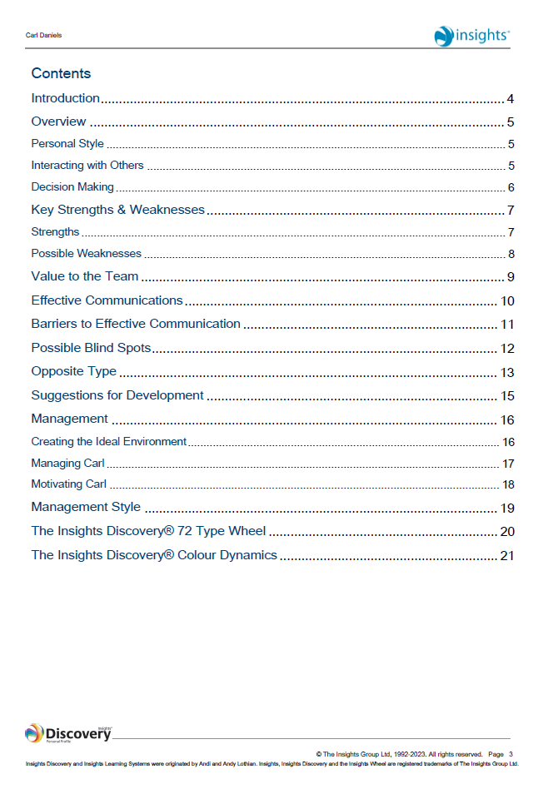
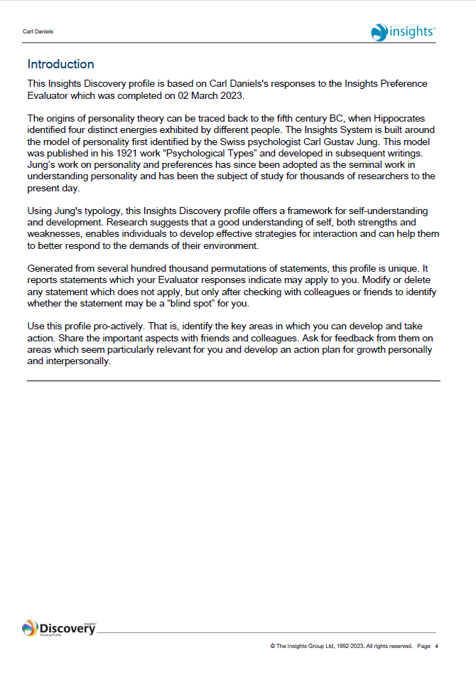
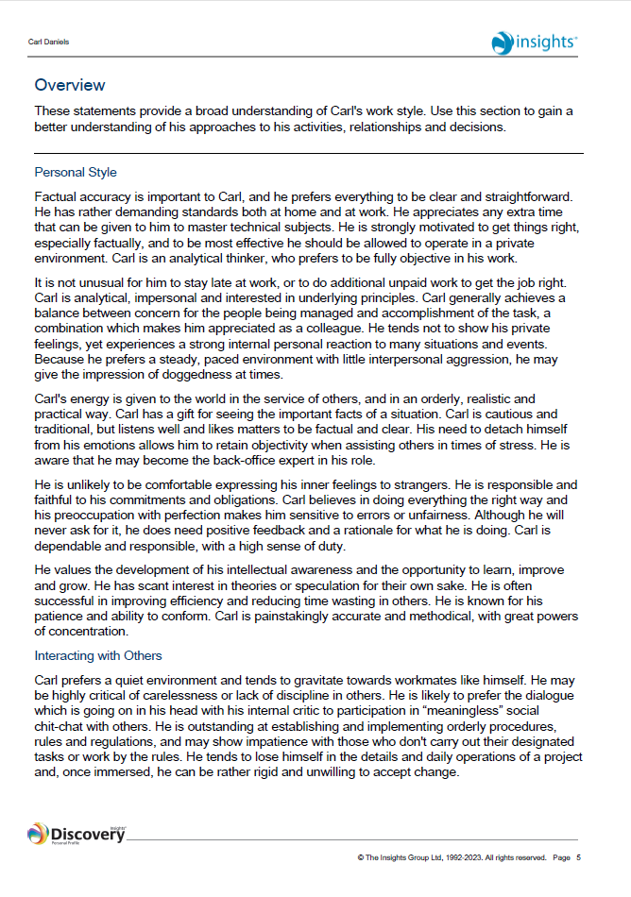
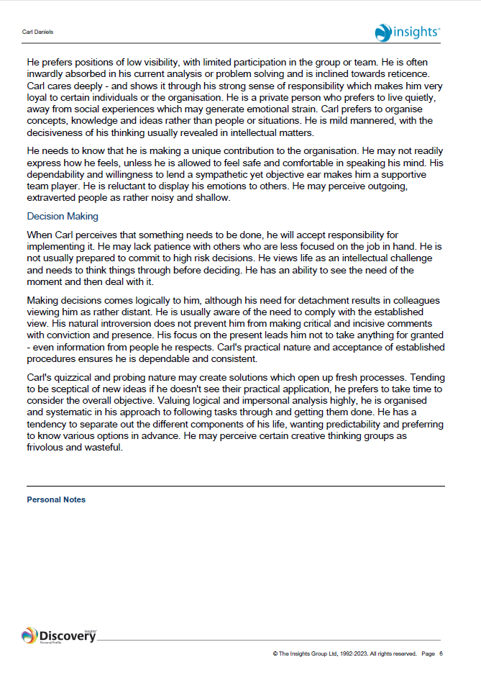
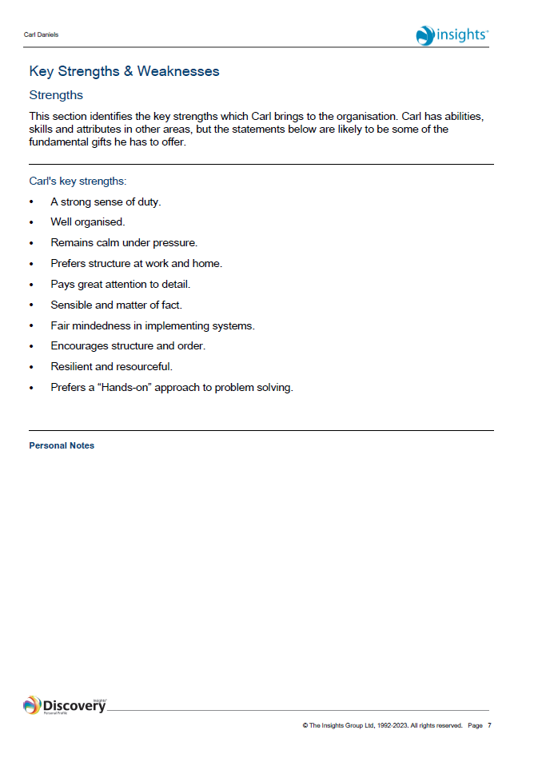
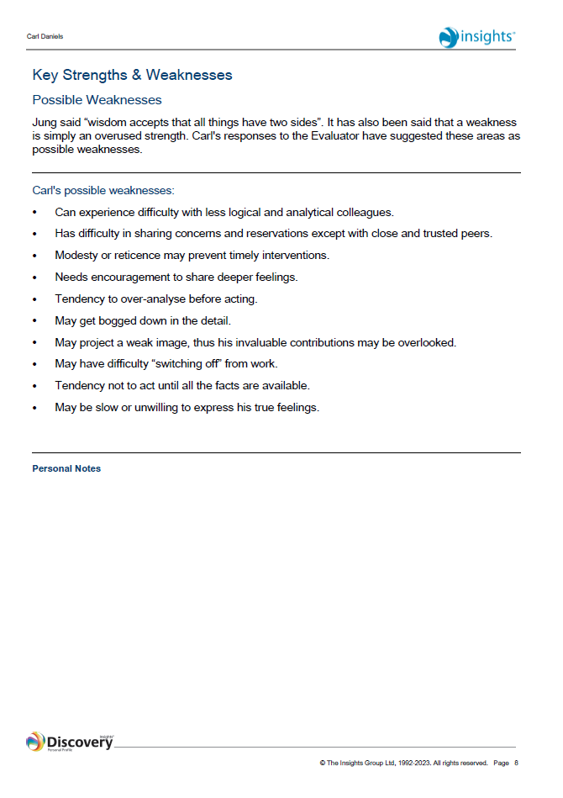
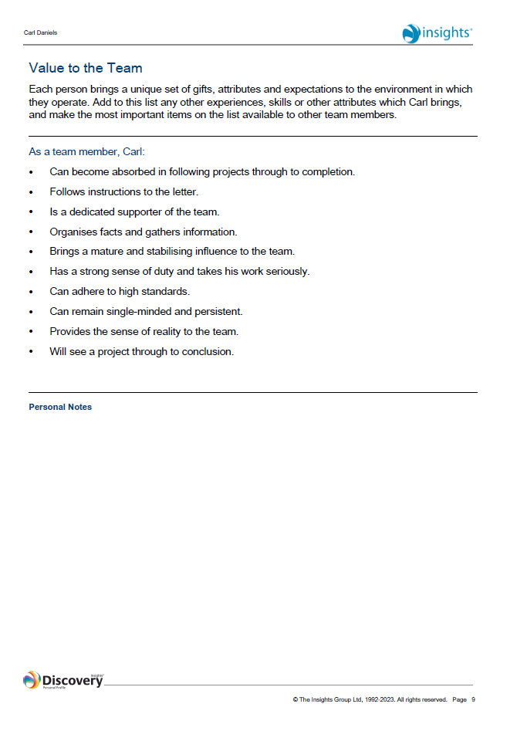
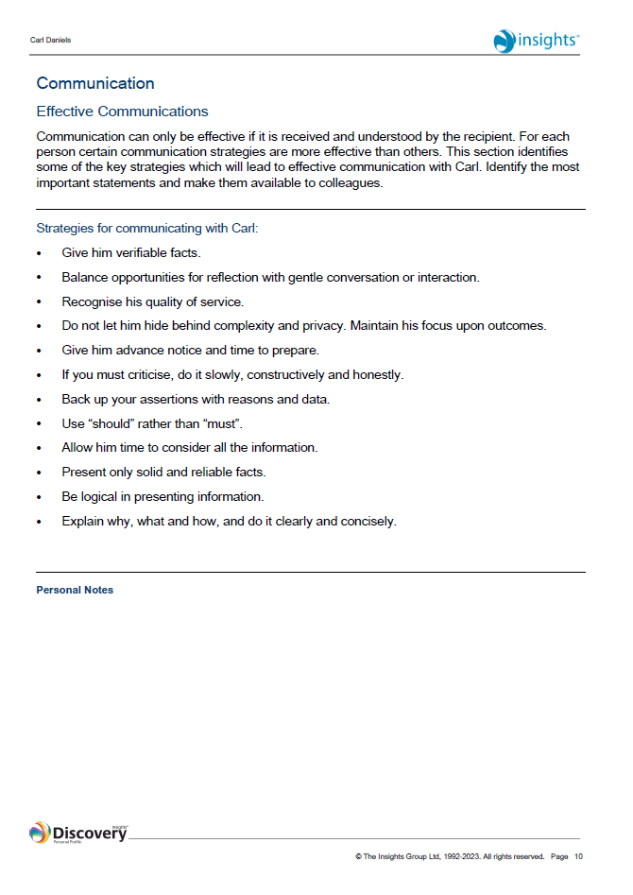
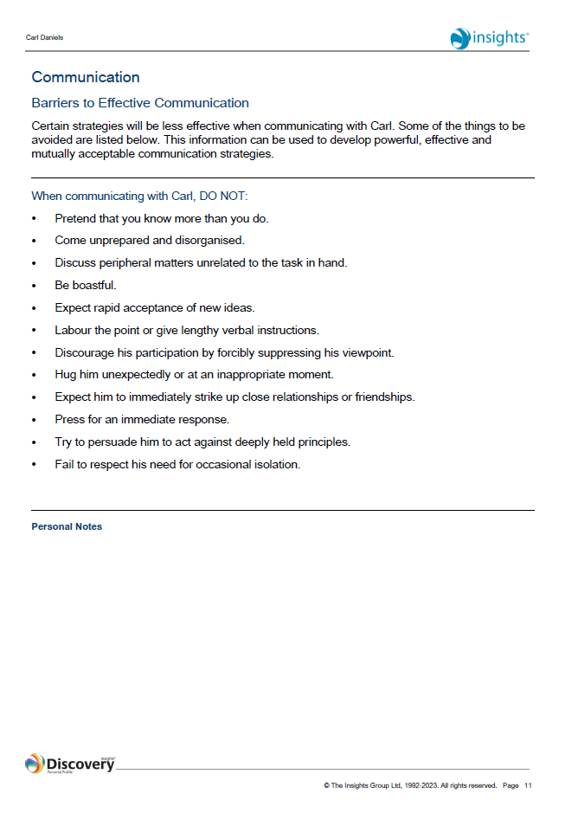
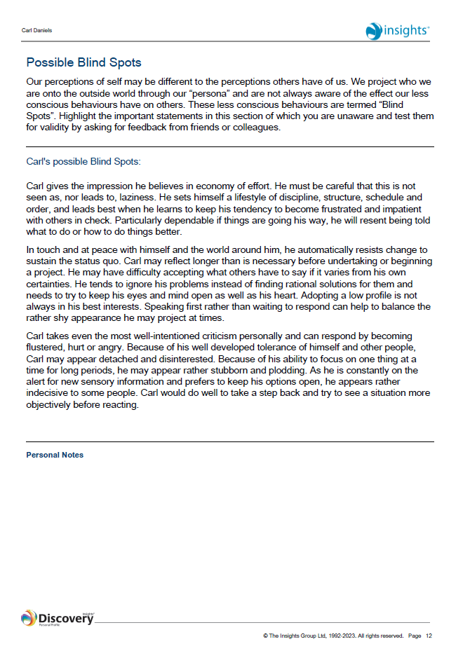
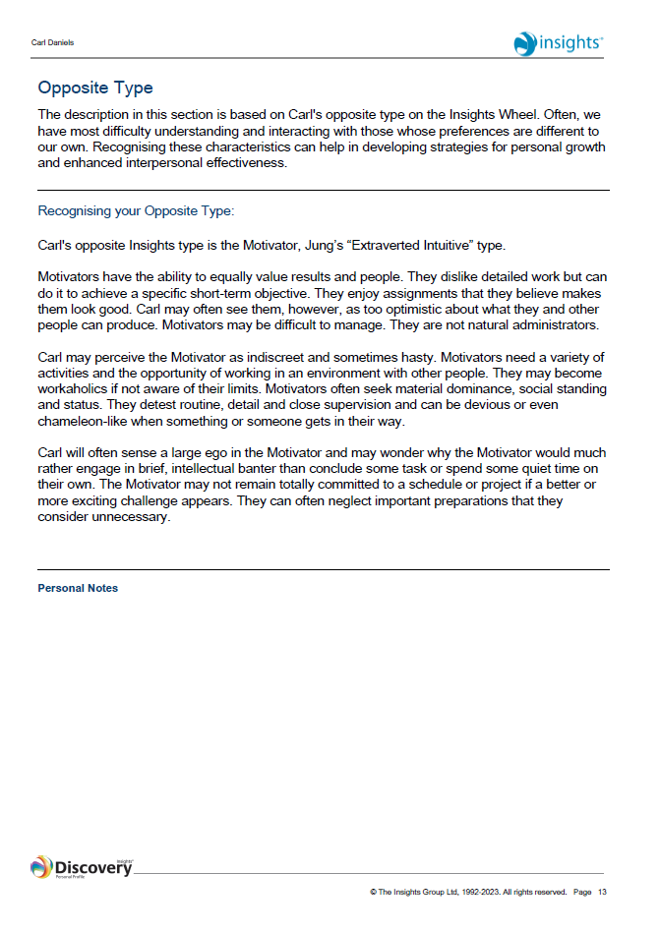
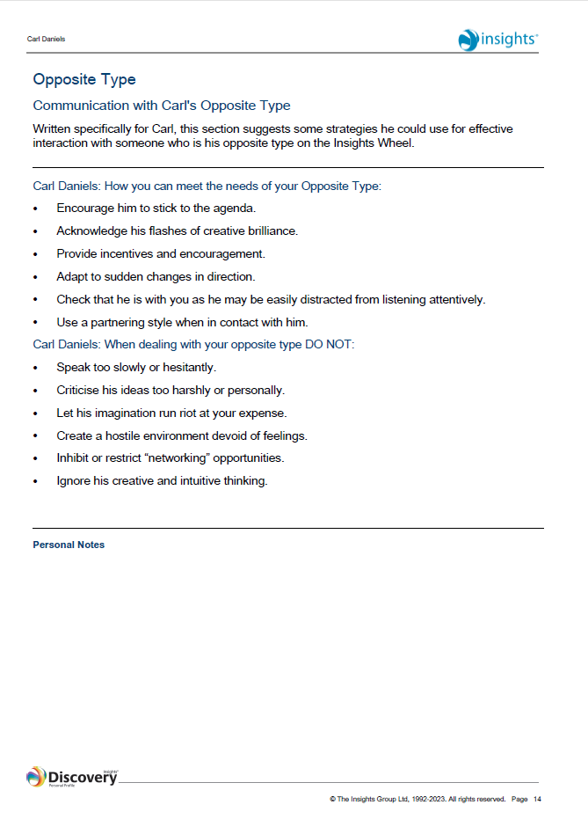
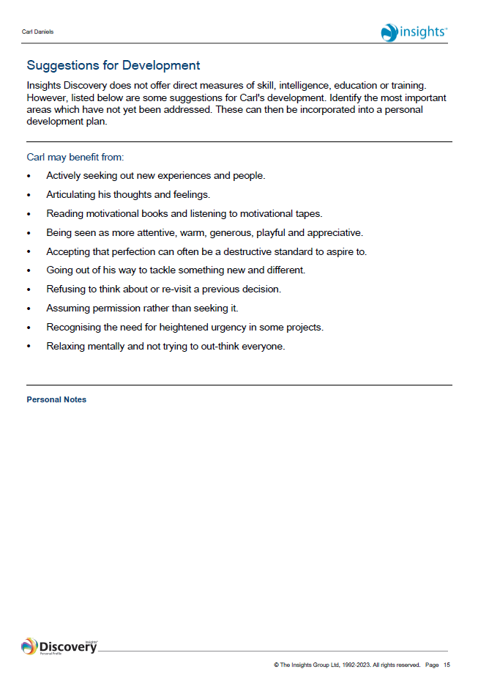
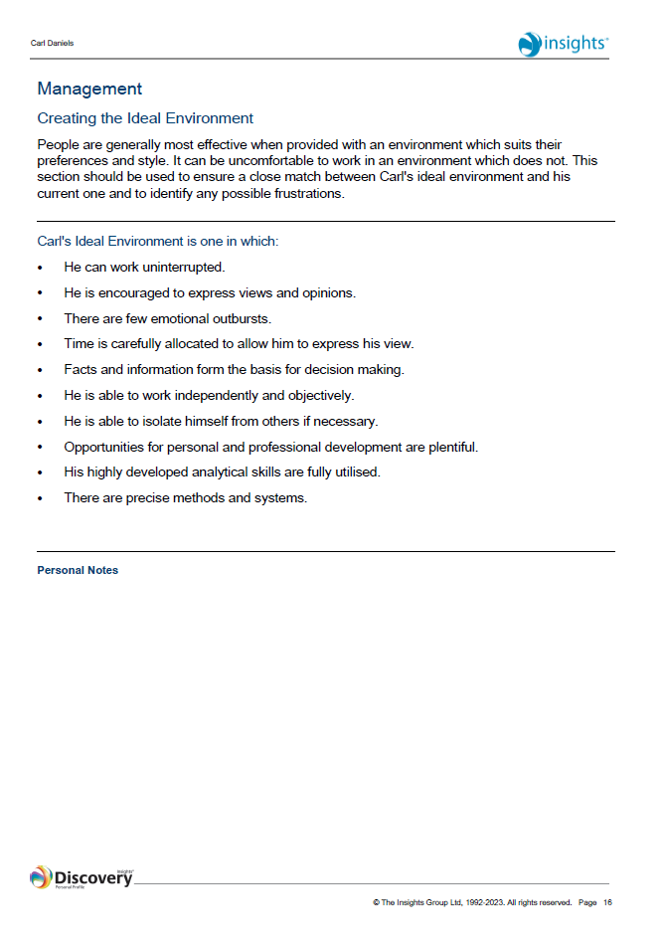
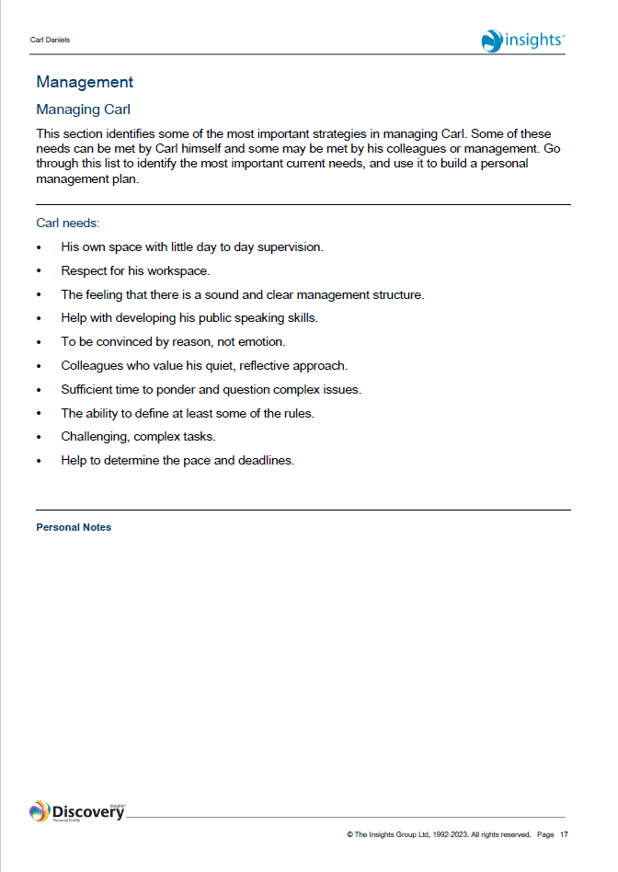
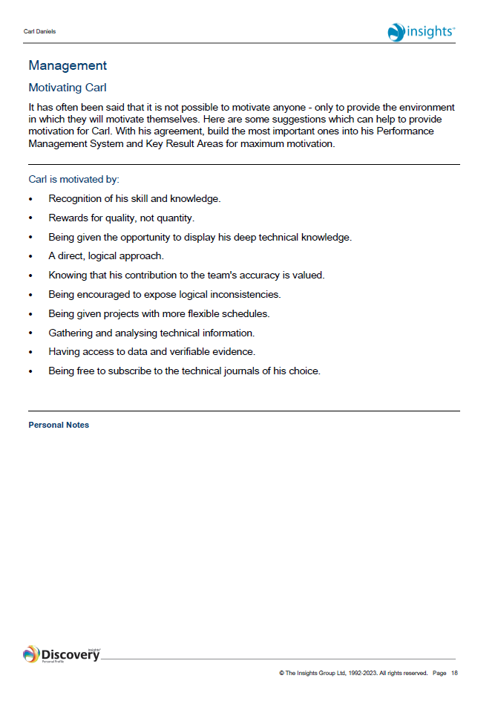
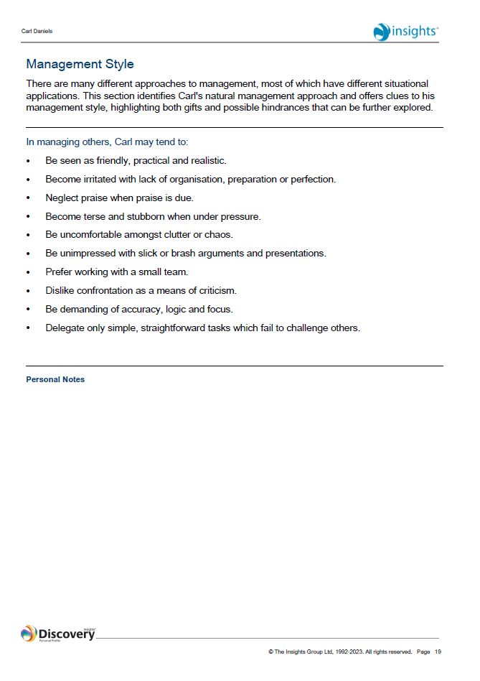
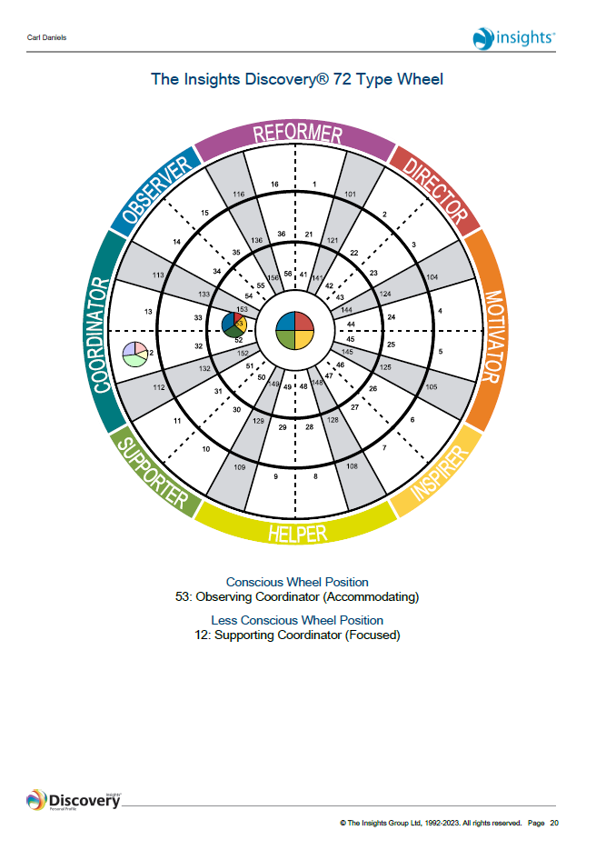
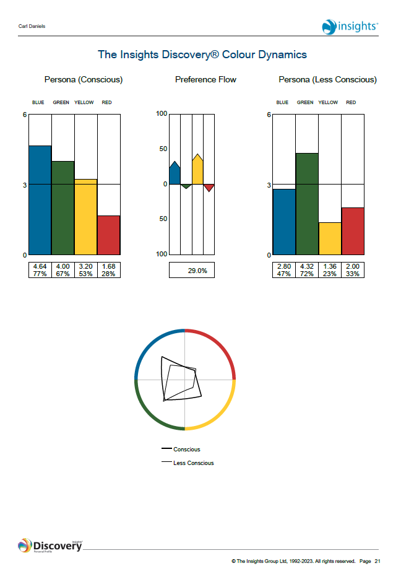


References
Akiyama, T., 2015. Psychology Today. [Online]
Available at: https://www.psychologytoday.com/us/blog/cutting-edge-leadership/201504/8-ways-teacher-is-leader
[Accessed 23 August 2023].
Alvarez, A., 2021. netmind. [Online]
Available at: https://netmind.net/en/neuroscience-for-agile-teams-the-scarf-model/
[Accessed 24 August 2023].
Ayoobzadeh, M. & Boies, K., 2020. From mentors to leaders: leader development outcomes for mentors. Journal of managerial psychology, 35(6), pp. 497-511.
Bass, B. & Bass, R., 2008. The Bass handbook of leadership: Theory, research, and managerial applications. 4 ed. New York: Free Press.
Begley, P. T., 2001. In pursuit of authentic school leadership practices. International Journal of Leadership in Education, Volume 4, pp. 353-365.
Coaching, S., 2023. Subzero Coaching. [Online]
Available at: https://www.subzerocoaching.com/2018/12/28/teaching-and-learning/
[Accessed 23 August 2023].
DeHoogh, A., Greer, L. & Den Hartog, D., 2015. Diabolical dictators or capable commanders? An investigation of the differential effects of autocratic leadership on team performance. The Leadership Quarterly, 26(5), pp. 687-701.
Dvir, T., Eden, D., Avolio, B. & Shamir, B., 2002. Impact of Transformational Leadership on Follower Development and Performance: A Field Experiment. Academy of Management journal, 45(4), pp. 735-744.
Gardner, W., Coglisa, C., Davis, K. & Dickens, M., 2011. Authentic leadership: A review of the literature and research agenda. The Leadership Quarterly, 22(6), pp. 1120-1145.
George, B., 2003. Authentic Leadership: Rediscovering the Secrets to Creating Lasting Value. San Fransisco: Jossey-Bass.
George, W., 2003. Authentic leadership: Rediscovering the secrets to creating lasting value. San Fransisco: Jossey-Bass.
Goleman, D., 2004. What makes a leader?. Harvard business review, 82(1), pp. 82-91.
Greenleaf, R. K., 1973. The servant as leader. Massachusetts: Robert K. Greenleaf Center.
Henderson, J. E. & Hoy, W. K., 1983. Leader authenticity: The development and test of an operational measure. Educational and Psychological Research, 3(2), pp. 63-75.
Insights Group, L., 2023. Insights Discovery Personal Profile: Carl Daniels, Dundee: The Insights Group Ltd.
Jasper, M., 2003. Beginning Reflective Practice. Cheltenham, UK: Nelson Thornes Ltd.
Kuhnert, K. & Lewis, P., 1987. Transactional and Transformational Leadership: A Constructive/Developmental Analysis. The Academy of Management review, 12(4), pp. 648-657.
Lush, M., 2019. THE LEADERSHIP VERSUS MANAGEMENT DEBATE: WHAT’S THE DIFFERENCE?. NZBusiness, 33(4), pp. 20-22.
Marquet, D., 2015. Turn the Ship Around. A true story of turning followers into leaders. 8 ed. Great Britain: Portfoilio Penguin.
McGrath, J. & Bates, ,. B., 2013. The little book of big management theories and how to use them. 1 ed. Harlow, UK: Pearson.
Northouse, P., 2018. Leadership: Theory and Practice. 8 ed. s.l.:SAGE Publications.
Rock, D., 2008. SCARF: a brain-based model for collaborating with and influencing others. NeuroLeadership, Volume 1.
Russel, R. & Stone, G. A., 2002. A review of servant leadership attributes: developing a practical model. Leadership & organizational development journal, 23(3), pp. 145-157.
Western, S., 2007. Leadership: A Critical Text. Los Angeles: Sage Publications.

