University of Wales Trinity Saint David

REPORT

Business plan
Student: Asen Gegov(2018572)
Course : Managing enterprise in the 21st century (BMSW4006)
Lecturer:Mohammad Rahman

Healthy diet, Ltd

Contents
Summary 3
DESCRIPTION OF BRANCH AND COMPANY 4
• Healthy eating aids in the maintenance of a young appearance, which is becoming a societal value. 5
• Healthy eating contributes to the maintenance and promotion of health, as well as the prevention of chronic illnesses. 5
• Healthy diet is essential for the future health of kids and progeny. 5
Company’s competitive advantages: 6
MARKET RESEARCH AND ANALYSIS 6
Customers 7
Marketing 7
Tactics: 7
Online 8
Offline 8
STRATEGY 8
DEVELOPMENT PLAN 9
KEY THREATS AND PROBLEMS 9
References 9

Brief Summary
Despite the fact that more and more governmental and non-governmental groups are advocating a healthy lifestyle as an individual health decision, physicians continue to caution us that we must protect ourselves against illnesses. A balanced diet, according to modern research, may do a lot to support long-term health. We think that our goods will be well appreciated and purchased by customers due to end-users' increased need for quick food and the fact that an increasing number feel the need to eat healthy.
The firm focuses on the food sector as a whole, with a section catering to the healthy food market and, within that, a part catering to the healthy fast food market, producing meals that are quickly available (rapid buy), delicious, and not damaging to health. In reality, the meals provide nutrients that aid in the prevention and treatment of many ailments. Competitors of Healthy Diet, Ltd. include fast food distributors, complete and semi-finished thermal treatment products (frozen, preserved, and other packaged items), and finished non-thermal treatment products (sandwiches, salads, snacks, and so on).In 2021, the concept for the firm Healthy diet, Ltd. was born. In August 2021, the firm was formed and registered as a limited liability company in London. The firm has not yet begun selling items. Initially, the firm will offer items over the internet (www.healthydiet.co.uk) for delivery to the client, as well as through a corporate newsstand. We will distribute items to big and medium-sized businesses across England, but exclusively to small businesses in central London. At the long run, the firm will increase its sales volume by utilising food vending machines in major educational institutes and other institutions with significant visitor traffic. We will also create a web platform dedicated to healthy living and eating. The website will also sell advertising space.
The company will produce and sell the following products:
Quick and Healthy Meals for People With :
Diabetes
High blood pressure
Low cholesterol
Pregnancy
Heart diseases
Good for the bones

DESCRIPTION OF BRANCH AND COMPANY

Customers have grown increasingly conscious of the importance of leading a healthy lifestyle during the last decade. Despite the fact that more and more governmental and non-governmental groups are advocating a healthy lifestyle as an individual health decision, physicians continue to caution us that we must protect ourselves against illnesses. Modern research indicates that we may do a lot to ensure long-term health by eating a well-balanced diet. Chronic noncommunicable illnesses kill more than two-thirds of the world's population. Poor nutrition is a major contributor to many illnesses. A healthy lifestyle, including a well-balanced diet, can assist to avoid illnesses such as cardiovascular disease, obesity, cancer, and diabetes.
In 2021, the concept for the firm Healthy diet, Ltd. was born. In August 2021, the firm was formed and registered as a limited liability company in London. The firm has not yet begun selling items. Initially, the firm will offer items over the internet (www.healthydiet.co.uk) for delivery to the client, as well as through a corporate newsstand. We will distribute items to big and medium-sized businesses across England, but exclusively to small businesses in central London. At the long run, the firm will increase its sales volume by utilising food vending machines in major educational institutes and other institutions with significant visitor traffic. We will also create a web platform dedicated to healthy living and eating.
The company's creators think there is a market for healthy diet meals for the following reasons:

• Healthy eating aids in the maintenance of a young appearance, which is becoming a societal value.
Our health is dependent on nourishing our cells, which is most visible on the skin and nails. Nourishing lotion protects the skin from the elements, but it does not address interior issues. Skin issues are frequently caused by a lack of nutrition. We do not feel this if the cells are not severely harmed. When they are severely damaged, abnormalities and disruptions become extremely obvious. A simple modification in dietary habits can sometimes enhance skin health. We believe that when attractiveness and young look become social ideals, more individuals will consume a balanced, nutritious diet.

• Healthy eating contributes to the maintenance and promotion of health, as well as the prevention of chronic illnesses.

The rise in noncommunicable chronic illnesses, occupational stress, a lack of time, and other repercussions of our fast-paced lifestyle will push people to consume healthier foods on a more frequent basis in order to mitigate the negative impacts of this fast-paced lifestyle on their health. This practise will be aided by increased knowledge and marketing of nutritious foods. The market must teach customers that healthy food does not have to be pricey in order to get people to eat nutritious fast food. Numerous research have contributed to a more comprehensive understanding of illnesses and health, and human development has enabled us to protect ourselves against a wide range of disorders. However, additional problems arise, such as allergies, chronic fatigue syndrome, cancer, bulimia, asthma, bronchitis, bowel syndrome, and depression. According to current study, the genetic effect on our health accounts for just 10% of our overall health; other influences include our lifestyle, working conditions, thoughts, and emotions.

• Healthy diet is essential for the future health of kids and progeny.
Infertility is becoming more of an issue. Due to a lack of nutrients, an imbalanced diet can cause issues with conception and severely lower fertility in both men and women. A healthy, balanced diet consumed over a lengthy period of time before to conception increases the likelihood of pregnancy.

Company’s competitive advantages:
We will provide cold, ready-to-eat meals that are both appetising and healthily balanced. The firm will also provide online guidance on healthy and balanced diets, as well as weekly meals. Such a provider does not currently exist on the market. As a result, the firm has four key competitive advantages: simple accessibility, excellent product quality, extensive services, and satisfying consumer demands.

MARKET RESEARCH AND ANALYSIS

In November 2019, 79 percent of Britons stated they ordered home delivery/takeaway meals, a modest decrease from 82 percent the previous year. However, demand among the sector's core base of affluent consumers is holding up well, as evidenced by the fact that 83 percent of those earning more than £50,000 have bought takeout. Those who stay in the market are also purchasing more frequently, with 26 percent ordering at least once a week, up from 22 percent a year before. (Mintel, Attitudes Towards Home Delivery and Takeaway in the United Kingdom, March 2020).

The ethnic takeout industry is fraught with competition, as restaurants face a growing challenge from nonspecialists, such as supermarkets, which compete on price and convenience. However, as more conventional eat-in restaurants enter the takeout industry, Mintel predicts a 12% increase in the ethnic takeaway/home delivery category over the next five years (2019-24), with a value of £7.7 billion in 2024. (Mintel, Ethnic Restaurants and Takeaways - UK, February 2020).
Recovery from the COVID-19 (coronavirus) pandemic would also benefit the sector, since unemployment would decline and earnings would rise. However, some type of distance measures are likely to stay in place until a coronavirus vaccine is developed, which might take a long time. As a consequence, customers may continue to be hesitant about dining out, which would assist the sector in the near run (IBISWorld, Pizza Delivery & Takeaway in the UK, August 2020)

Customers
Healthy Diet, Ltd. focuses on the production and marketing of cold completed meals to fulfil the need for quick, healthy, and balanced meals. Meals are for anyone (i.e., end-users) who does not have the time or inclination to cook meals. Meals are packed as tiny meals (basic line) or larger meals (premium line) (king line).
We believe that our goods would be warmly welcomed by people who enjoy fast food yet wish to eat more nutritious meals. According to studies, the majority of individuals (74 percent) understand how good eating affects their quality of life. We think that by offering a larger variety of items and sophisticated packaging that enhances the perception of product freshness, we can better delight customers. Customers will always believe that the goods is brand new. Initially, we will devote a significant portion of our resources on marketing in order to establish our brand. We also believe that businesses will be interested in acquiring our product because they recognise that motivated and healthy employees are excellent employees. All of this will contribute to our company's success.

Marketing

Tactics:
In September 2021, the firm will focus on the target groups through the specified channels, which include the internet, direct mail, and personal sales. The first day of sales will be in London in the morning for free distribution of a specific number of merchandise. This initiative will also be publicized. Such advertising is most suited for our target demographic since it will help us create brand image and awareness of our presence while giving justifications for why people pick our product and highlighting the various benefits available to companies and individuals. Personal selling is essential in the sector when the buyer is a corporation since the seller can only discuss the extra arguments to persuade the customer to make a purchase. We will stress product quality and its beneficial influence on health in marketing communications. We will also emphasize the higher benefit received by the product's pricing.
We will accomplish the following using this sort of marketing communication method:
- Promote the Healthy Diet brand and attain a strong consumer position
- Develop a system for direct marketing
- Provide the advantages of consumption products for businesses (long-term gains)
- Present the advantages of consumption goods for people (health preservation and enhancement, as well as time savings)

Online
- Promote the launch on all social media platforms, including Facebook, Instagram, Snapchat, YouTube advertisements (brief 10 second non-skippable ads), and Google AdWords.
- Make limited edition/pop-up meals that are only accessible during the debut week.
- The value proposition should focus on convenience, quick click-and-collect choices, and a new dine-in experience from a variety of establishments.

Offline
- Collaborate with local businesses, corporations (corporate discounts), and colleges (student specials and promotions).
- Ads in local newspapers and radio channels
- Billboards and banners placed across the city may raise a lot of awareness.

STRATEGY

- Pre-launch PR — To raise awareness and interest among users — This should be planned at least a month before the product launch. Pre-announcement of a product via online and offline sources. The goal of this phase is to measure the audience's interest in this new product range.
- Launch PR – At first, Healthy Diet,LTD should limit this function to one city and less than 5% of the entire user base. As a result, marketing activities should be tailored properly. The aim is for consumers to be convinced of the new product and to make a purchase. Healthy Diet,LTD should use offline, internet, and app alerts to do this.
- Post-launch public relations – The goal of this phase is to keep users. Based on the emotions expressed in social media and user interviews, we should be able to narrow down on one or two value propositions that customers appreciate — for example, "if you can't decide what to purchase, let us help you." Here are 20–30 set meals that you may buy with the click of a button for a flat price that includes delivery.”

DEVELOPMENT PLAN

The development process will be a continuous one. To date, the fundamental model of product and service marketing has been established, as has a web site that will be backed by the most recent online shop. The website will be supported by cutting-edge technology that will allow potential purchasers to communicate with you. Employees' continuous education will also be prioritised by the firm. Educated people will occupy certain positions inside the firm. We will pass on expertise to other colleagues as needed.

KEY THREATS AND PROBLEMS

- Poor harvests of vegetables and fruits among organic growers
- Quick response of competition -Other rivals will respond to our offer, notably in the business-to-business sales area. Because they have the capacity, they will create their own proposal for the delivery of meals to the firm.
- Larger sales volume than planned
- • Lower sales volume than planned

References
Bplans: Business Planning Resources and Free Business Plan Samples. (n.d.). Food Preparation Business Plan - Management Summary. [online] Available at: https://www.bplans.com/food-preparation-business-plan/management-summary/ [Accessed 11 Aug. 2021]
Uppaluri, S. (2019). Marketing plan for Go-Jek’s food delivery business. [online] Medium. Available at: https://medium.com/@uppu59/marketing-plan-for-go-jeks-food-delivery-business-2d27eb0dc5ba
Government Digital Service (2012). Marketing and advertising: the law. [online] GOV.UK. Available at: https://www.gov.uk/marketing-advertising-law
GOV.UK. (2019). Competition and Markets Authority. [online] Available at: https://www.gov.uk/government/organisations/competition-and-markets-authority
www.businessplantool.org. (n.d.). Handbooks and manuals. [online] Available at: http://www.businessplantool.org/Dokumenti/Handbooks_for_BP_55.aspx [Accessed 11 Aug. 2021]

‌

‌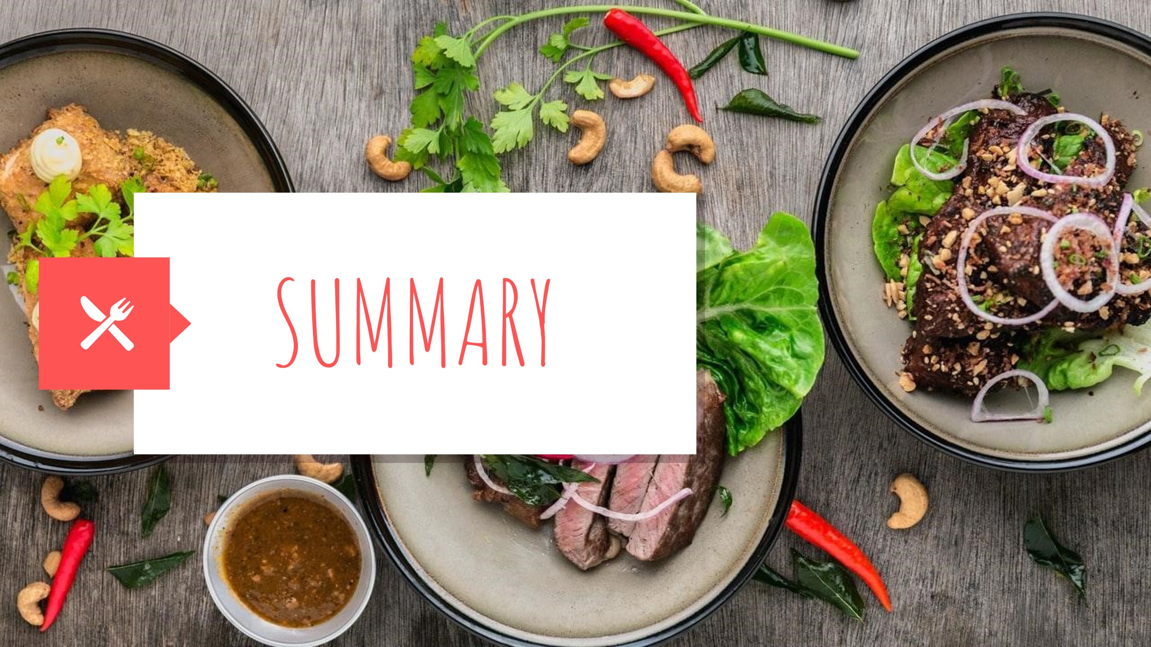
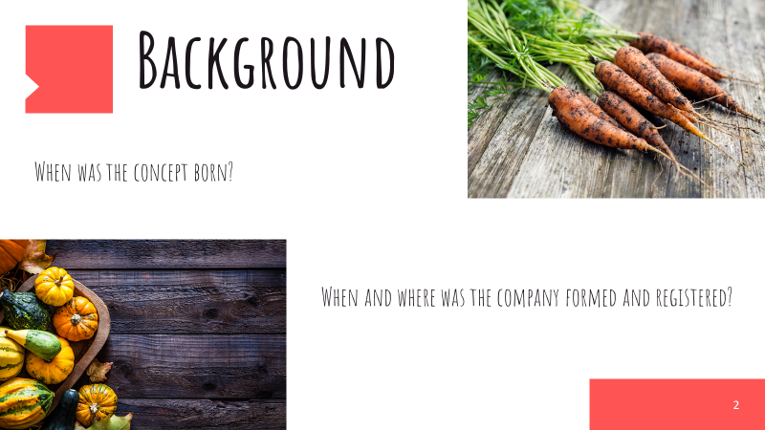
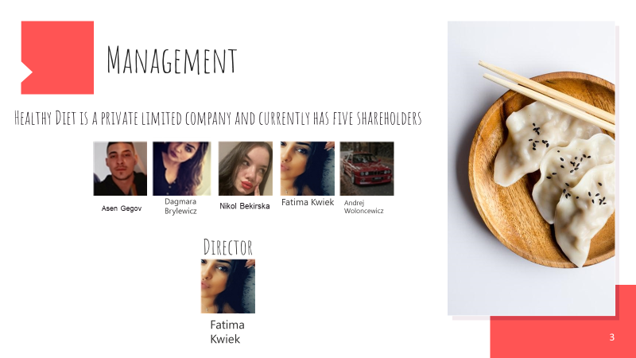
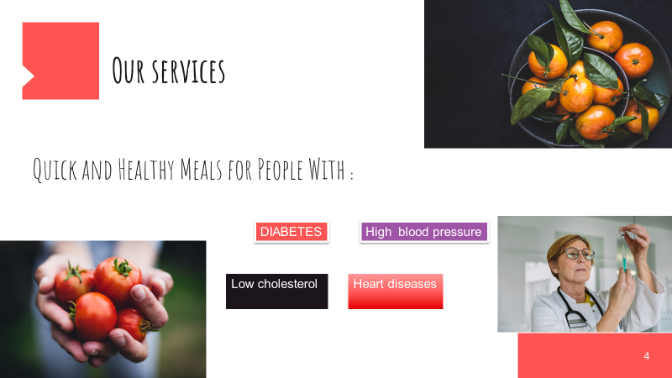
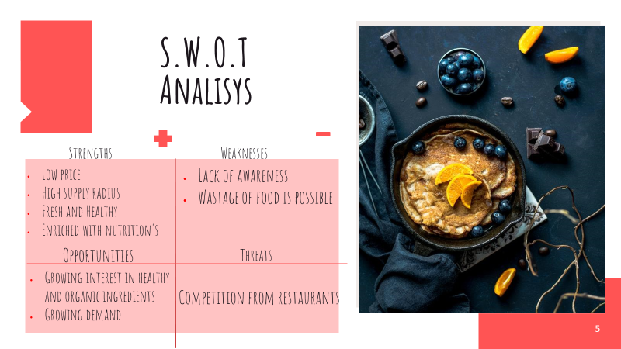

‌
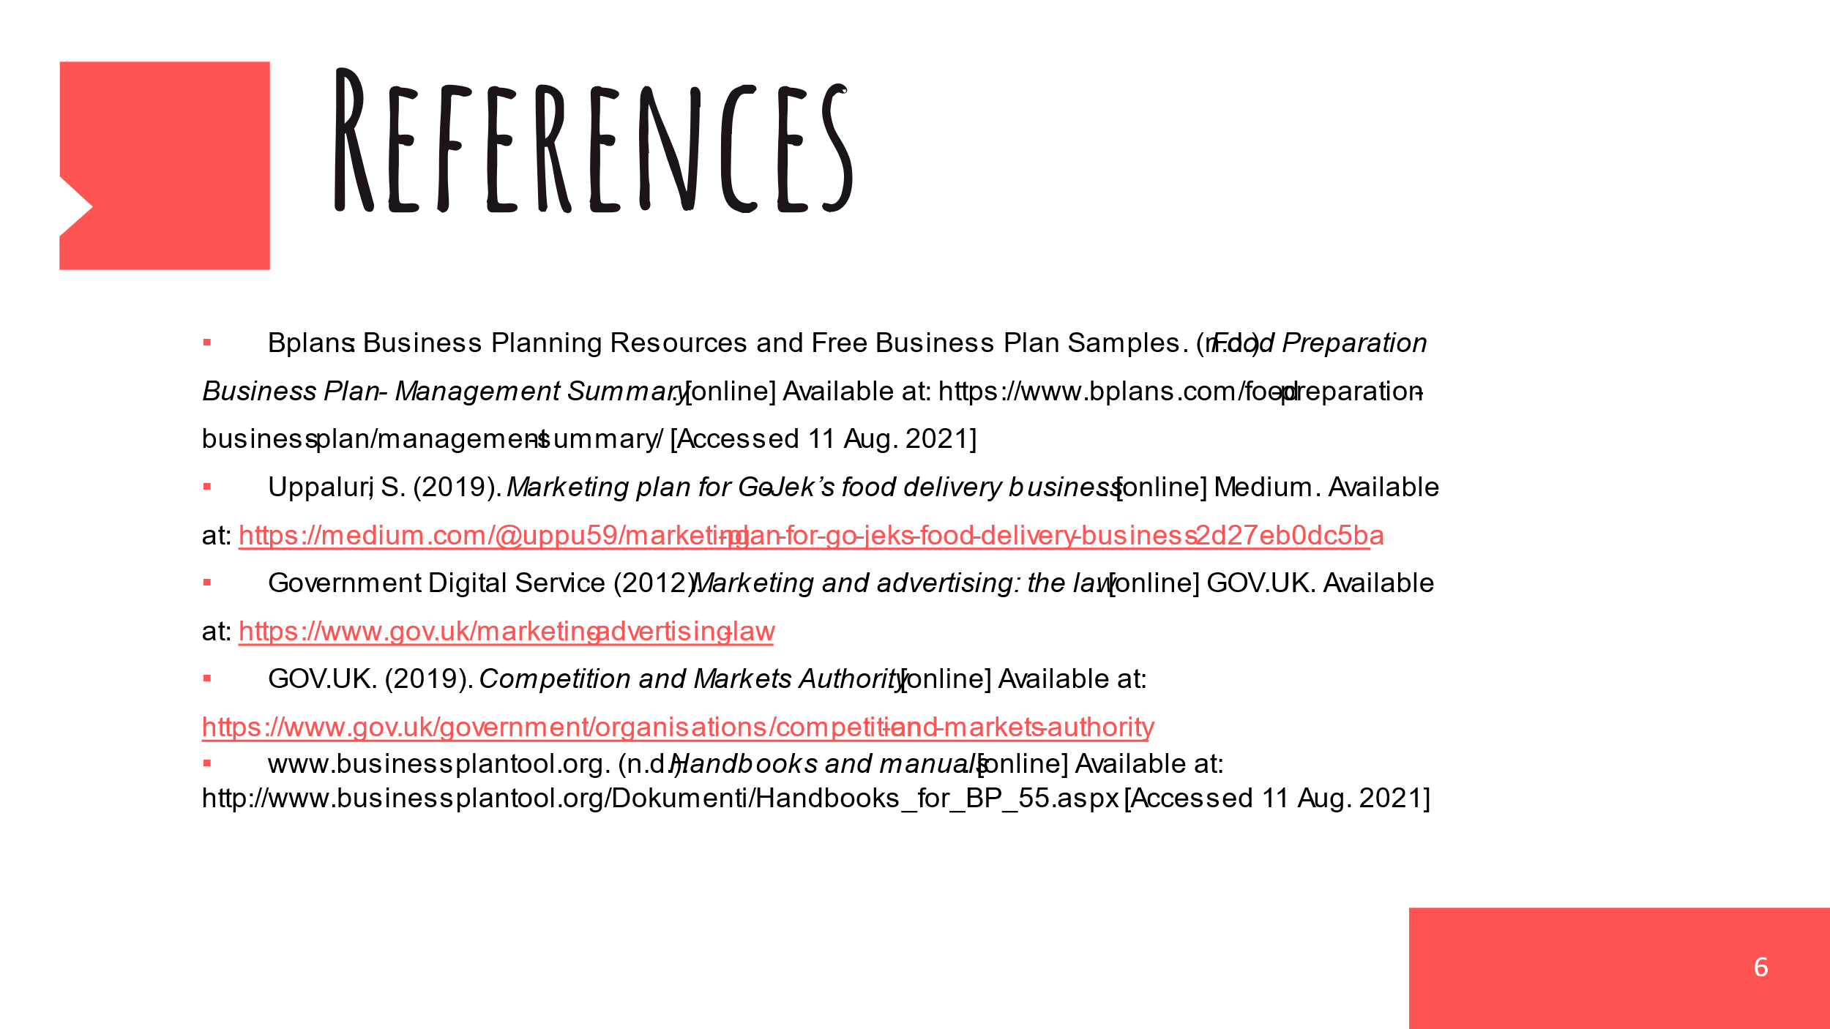
‌
Managing Enterprise in the 21st Century
Business plan

Name: Nikol Bekirska
Student number: 2023248
Module code: BMSW4006
Title: Managing Enterprise in the 21st Century
Lecture’s name: Mohammad Rahman

Contents
Executive 2
Mission 2
Management 3
Finance 5
Marketing 5
Technology Plan 6
Vision 6
Products and Services 7
Running Business 7
Conclusion 7
Reference list 8

Executive
In nowadays with so many restrictions and lockdowns it is critical that the people who have illness, disability or mental health issues will receive special support and help exactly when they need that. There is many people left with no enough support and help and many of them has serious illness which even prevent them to do shopping or their health is at risk if they go out to the store. Our team identify the opportunity for registering and creating of LTD company with the name ‘’ We care ‘’ with not only generating profit, but also to have mission and values for changing people’s life for better (Hempsall, J., 2021).
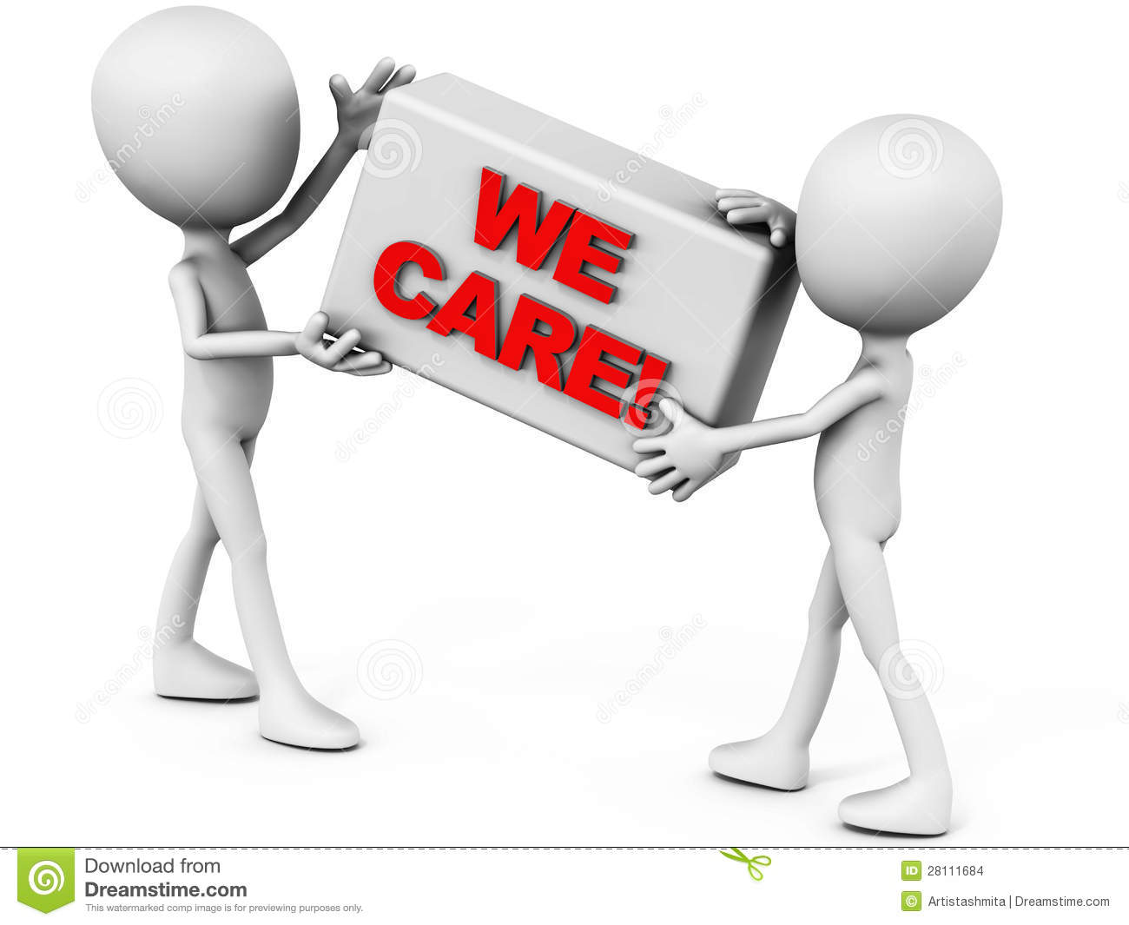
(Samuelsson, M., 2021).

Mission
The mission is important for every startup from any market. All the most highly popular brand names starting firstly with strong and proper mission which in the most successful examples is link to solving social issues and problems (Hoare, S., 2021).
The mission of the company is to support people who are with illness and really need help with their deliveries and food preparation. Currently due to covid19 and even before that the NHS did not provide enough support and help and people suffering alone at home which is not fair and need to be changed. Our company goal will be to become in future UK recognized company which supporting people health and needs straight to their home (Chatzitheodoridis, F., 2021).
Of course in order to achieve our mission there is need of strict strategy and business plan which will be provided below in details (Samuelsson, M., 2021).

Management

The operations are important to the early and long-term success of our firm. The daily actions and tasks required for creating our goods, ordering things, delivering to consumers, getting the essential materials and supplies, conducting daily meetings, and handling customer and employee issues in a positive and timely manner are referred to as operations (Hoare, S., 2021).
The company will start with two managers and five employees as a start, because there will be need of firstly advertising and attracting all people in need to understand our mission and values and then we can increase the volumes and the number of employees. In future as we expect the company to grow with fast temps there will be recruited extra supervisors so the quality and standards of the process and work will be under control. (Hool, C., 2019). At the start of the company will be used external Human Recourses for the documents control and procedures and in future when the company grows there will be permanent HR within our company. The two managers which will start from day one will be divided to operational manager and administration manager (Hempsall, J., 2021).
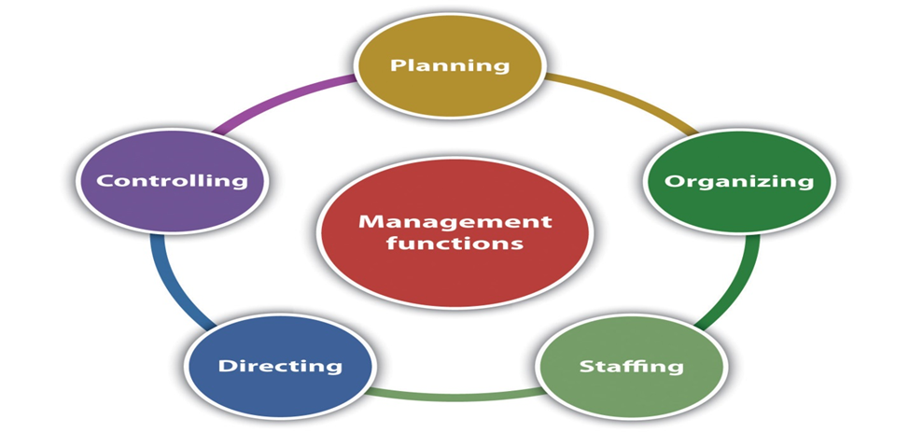
(Hempsall, J., 2021).
The operational manager will be responsible for the employees tasks productivity, operational daily customer service, control over the time of the deliveries, orders preparation, purchases, communication with the clients at their home, taking feedback from them, if need the completion of investigations, health and safety (Hool, C., 2019).
The administration manager will need to focus over the expanding the company, advertising, social media, contracts with suppliers, negotiations, finances, payments, contracts with clients, discounts, recruitment and ensuring in case there is complains they will be turned to positives (Samuelsson, M., 2021).
Our company's operations are critical since the entire process, from the client purchase to payment and delivery, involves a variety of varied and complicated activities that must be done in a very tight and timely way (Hoare, S., 2021).
The operation assists in the creation of a business, beginning with which type of business would like to be opened, whether there is a niche market in mind, whether there will be a unique selling point, whether the product can be liked or not, how the food can be sold, whether it will be take away, having own driver for delivery, or putting the shop on delivery app. In case our plan and strategy are successful then we will carefully recruit managers for each of the need departments as Marketing, Operational, Finance, HR, IT, Audit, Health and Safety. This organizational structure will ensure that the company growth and brand name will expand within the right direction and with the set mission and vision of the company (Hempsall, J., 2021).

Finance
The start of the company will be supported with bank loan for the total amount of 80 000 pounds. This will be repaid back for the period of 10 years with monthly payment of 750 each month of the period. The bank loan agreement have strict point that in case the company have enough funds from the sales then the loan can be fully paid after the fix period of the first one year of the start of the business (Hool, C., 2019).
The company will sign contract for accounting services in order to ensure that all financial movements are recorded and at any moment the management can have detailed reports from the accountant in order to analyses and take the right decision for delivering maximum profit and results (Samuelsson, M., 2021)
There is proper in advance budgeting with detailed discussion and set limits for expenses and costs, there is need to be set targets for short and long term. Budgeting is of main importance for every company and it is key element of delivering results for the company profit (Hool, C., 2019).

Marketing
At the start of the company the marketing function will be executed by the administration manager and the main focus will be for signing maximum contracts for food and deliveries with the people in need and those with illness. Of course the people with serious illness will be our priority and we will provide to them promotional price in order to comply with our mission and values (Samuelsson, M., 2021).
We will start with the social media and also with the local communities which have the contacts with the people in need. Also we will approach the local councils and we will offer them to work together with the mission of making people life better in these difficult times (Samuelsson, M., 2021)
The target marketing group is people mostly with the age between 40 and 85 years old, but not only as if there is ill people out of this age will be able to use our services and products.
Other main target is to negotiate subcontract with the local councils in order to help too more people in need and at the same time to take funding from the government for this provided help and support (Hool, C., 2019).

Technology Plan
When offering fresh food there is need of having special proper technology plan, which also will help to calculate the exact cost of each meal. The technology plan need to set specific meals, the equipment need, the cups, the need of avoiding as much possible plastic materials. All this need to be calculated properly and there is need to be set what will be the net margin for each meal. The target also is to have such an negotiations with the suppliers so the final selling price plus the margin to be enough low in order to be affordable from the people in need and with low incomes. The whole process need to be very detailed and strict full way measured so the mission and company values to be not damaged from the profit interest for the company (Hoare, S., 2021).
Here also need to be included in the cost of the each pack the logistics and transportation cost. This cost can be properly negotiated with the local council to be covered by them in order to provide to the local society better quality of live (Hoare, S., 2021).

Vision
Despite we have financial interests and we will operate for generating profit, we will focus also over making the difference for the people lives and to prove our company name ‘’ We care ‘’. With strong and proper strategy we can build strong and recognizable name with in the UK market (Samuelsson, M., 2021)
The vision is critical important for every company and for our the main responsibility will be taken for delivering our values and vision at real to the operational and administration managers as they will set full control over the all company processes (Samuelsson, M., 2021).

Products and Services
We will use mix of products and services. First one will be products mostly food ones, but also can be any from the first need for the people who have difficulties to go to the store or to go out (Hool, C., 2019).
The services will be mostly when people place orders or shopping and they cannot afford to pay extra for delivery or they have difficulties for accepting the delivery.
The products are 50% shopping grocery and 50% cocking fresh prepared food, so this way the person can choice and receive better quality food on time when need (Samuelsson, M., 2021)
Both the administration and the operational manager need to control and ensure that the quality of the food and the services are of the high possible level. There is need of strict and consistent quality control and this is the reason there is need to be implementing proper system of collecting the clients feedback and recommendations daily (Quang, H.N., 2021).

Running Business
In order to run and control the business properly there is need of weekly meetings, running reports which need to be analyzed and discussed for better control and results. There is need of daily proper audit of the completed tasks, issues, problems, achievements, adopting new procedures if need and any changes with the main focus delivering maximum results, net profit and loyal clients (Hool, C., 2019).

Conclusion
With the provided business plan we hope that the company will have great and successful start. The most important of the company targets is the mission for helping and supporting ill people which need support. There is need of being consistent with the values and mission in the years, because this will build the company reputation and brand name which will increase the profit and will make the people life better and comfortable (Hoare, S., 2021).

Reference list
Calvert, M.J., Marston, E., Samuels, M., Rivera, S.C., Torlinska, B., Oliver, K., Denniston, A.K. and Hoare, S., 2021. Advancing UK regulatory science and innovation in healthcare. Journal of the Royal Society of Medicine, 114(1), pp.5-11.
Fichter, K. and Tiemann, I., 2020. Impacts of promoting sustainable entrepreneurship in generic business plan competitions. Journal of Cleaner Production, 267, p.122076.
He, H. and Harris, L., 2020. The impact of Covid-19 pandemic on corporate social responsibility and marketing philosophy. Journal of business research, 116, pp.176-182.
Hempsall, J., 2021. Plot your route to success. Early Years Educator, 22(9), pp.7-7.
Honig, B. and Samuelsson, M., 2021. Business planning by intrapreneurs and entrepreneurs under environmental uncertainty and institutional pressure. Technovation, 99, p.102124.
Hool, C., 2019. Setting up shop in the UK? Considerations before transferring or starting a business. Journal of Aesthetic Nursing, 8(1), pp.43-44.
Kalina, C.M. and Fitko, J., 1997. Successful business process design: Business plan development for the occupational health services unit. AAOHN Journal, 45(2), pp.61-67.
Kalogiannidis, S. and Chatzitheodoridis, F., 2021. Impact of Covid-19 in the European Start-ups Business and the Idea to Re-energise the Economy. International Journal of Financial Research, 12(2), pp.56-61.
Thanh, T.L., Mohiuddin, M. and Quang, H.N., 2021. Impact of uncertainty and start-up opportunities on technopreneurial start-up success in emerging countries. Transnational Corporations Review, pp.1-11.

The presentation:




