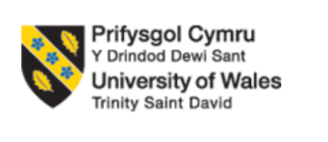
BACHELOR OF ARTS BUSINESS MANAGEMENT

ENTREPRENEURSHIP
(LCBB5001)

LECTURER
Dr. AMER KAREEM

COMPONENT 2 : COURSEWORK : WRITTEN REPORT

STUDENT NAME : DIANA VERONICA NEGRU
STUDENT ID : 2233646

Table of Contents
Introduction 3
Business Derscription/Market opportunities 4
Industry Analysis 5
Operations and management team planning 7
Marketing plan and strategy 9
Financial Plan 11
Conclusion 13
Reference list 14

Introduction
The main objective of the report is to elaborate the effectiveness of instant plumbing. The context is popular in the United Kingdom that affect the whole nation effectively and negatively. The result of the instant plumbing can be both positive and negative. To elaborate the total report, it is necessary to describe the instant plumbing that has some great impact on the business economy. The total report is about the business planning on instant plumbing in the United Kingdom. Sometimes the instant plumbing affect the economy in the United Kingdom crucially (Pickles, Revill and Historic England, 2024). To make an effective planning for the instant plumbing context, there are many infrastructure should be evaluated properly. To make a good planning for the business, the business policy maker needs to observe the business environment. Business environment can be both macro business environment, micro business environment. The macro business environment for the context of business highlights the external business environment, on the other hand, the micro business environment highlights the internal business environment. Business environment and observing the business environment makes the business planning more cautious. To cover the total report according to the instant plumbing context, the team management overview, industry analysis, financial analysis, monetary advantages, competitive advantages, business opportunities, business challenges, business growth, and business management will be assessed. On the other hand, another part of the report is about the marketing procedures or marketing strategies of the planning business in the United Kingdom. In addition, to cover the whole report, the marketing (4ps) will be explored effectively based on the UK perspective. Eventually it is said that the major theme of the whole report is about the instant plumbing related business planning in the perspective of the United Kingdom, especially London (Pickles, Revill and Historic England, 2024).

Business Description/ Market opportunities
The business is relevant to the instant plumbing that can be established using various resources in the business environment in the United Kingdom. The business can be situated and the business also can face some challenges and issues that should be overcome by using various tools and technique. For establishing the business, the business owner should concentrates on the business commodities, business infrastructure, business model, business distribution channel. For the business related to the instant plumbing, the United Kingdom is the best region to expand the business, because in this area the business environment is more suitable. Because of the suitable and preferable business environment, every business owner related to the instant plumbing feel comfortable and preferable (Gitman, Mcdaniel and Shah, 2023). On the other hand, in this business area, the instant plumbing business also can face some challenges because of the political issues, technological issues, environmental issues, legal issues. In this area, the business can spreads its outlet for increasing the business function all over the United Kingdom. In addition, the main product of the business is service related to the plumbing that bring the most revenue from the business landscape. To enter the business in the world related to the instant plumbing, the business owner and business manager needs to improve the idea about the business theory and business model and the concept of business environment (Gitman, Mcdaniel and Shah, 2023).
The business has also some advantages and opportunities that affect the livelihood of the people of the United Kingdom crucially. The advantages can be the financial benefit, the advantages can be the monetary support. In this business, a person can utilize his knowledge related to the instant plumbing properly. Knowledge practice is one of the most effective and powerful part of a human life, in this business a person can get that (Gitman, Mcdaniel and Shah, 2023).

Industry Analysis
Instant plumbing industry is the concentration on the speed reliability. When there is not a particular sector, ‘Instant Plumbing’ the term probably highlights to the plumbing service which prioritize that instant response and effective problem solving actions.
The VRIO framework assesses a firm's resources and capabilities to determine their potential for sustained competitive advantage. According to Barney and Hesterly, VRIO examines whether a resource is Valuable, Rare, Inimitable, and Organized to capture value. Resources meeting all four criteria can provide a lasting competitive edge, while those that are only valuable and rare offer a temporary advantage (Barney & Hesterly, 2015).

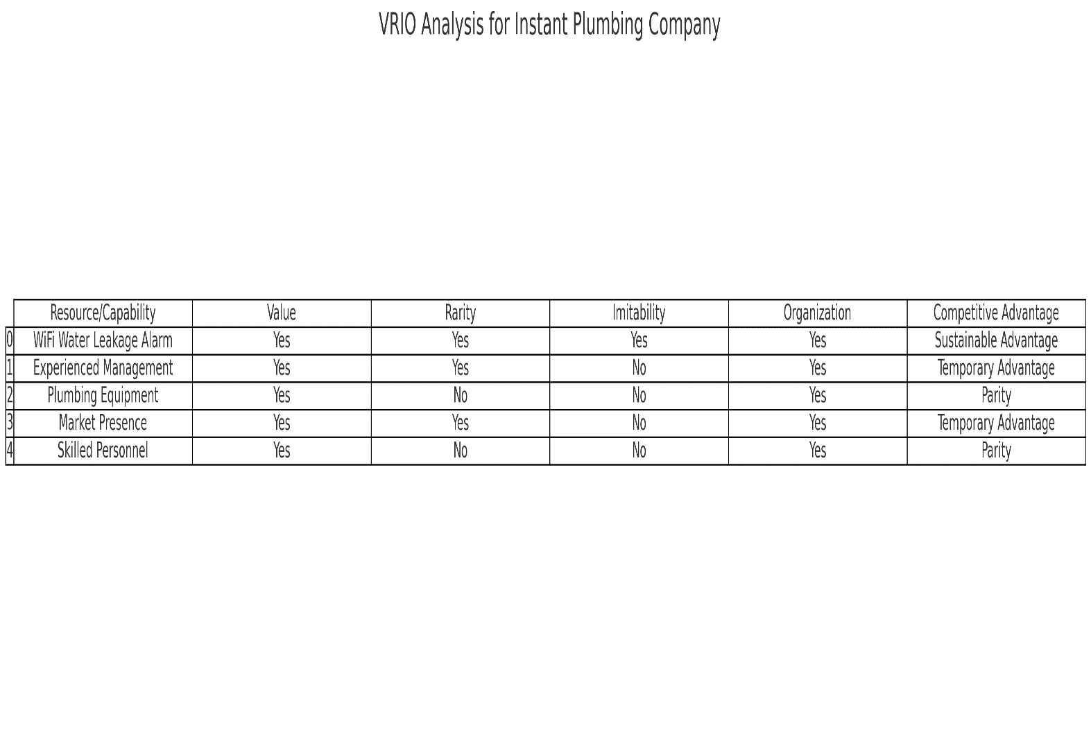
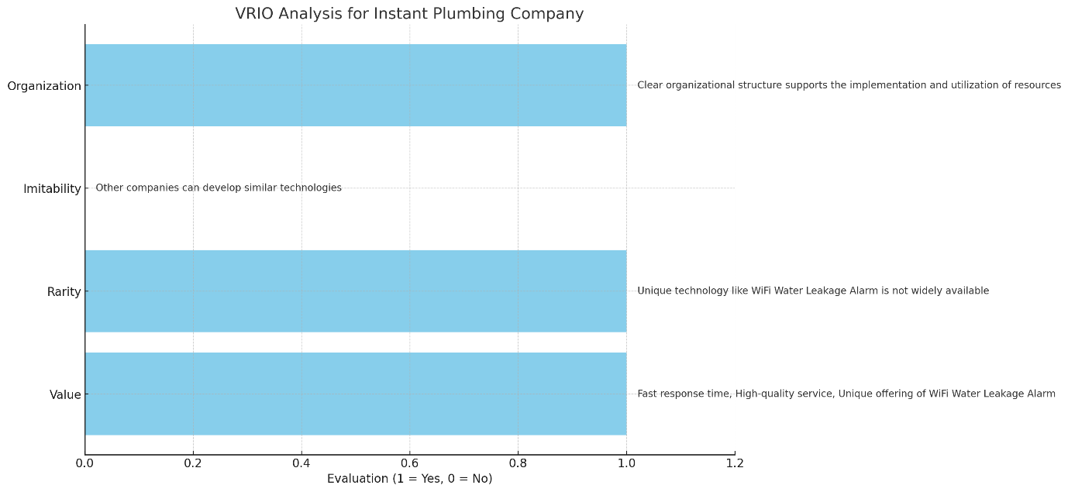
The VRIO analysis reveals that Instant Plumbing Company's primary sustainable competitive advantage lies in its innovative WiFi Water Leakage Alarm. Other resources and capabilities provide temporary advantages or competitive parity, emphasizing the need for continuous innovation and effective management to maintain a competitive edge in the market.

Operations and management team planning
Managerial body and operational body is the core part of a business who manage and operate the business properly. To establish a new business properly, at first the business ought to fix the managerial body. Without fix the proper managerial body in the instant plumbing related business, the success cannot be expected (Crandall and Crandall, 2023). Poor management can destroy the business and strong management can improve the business for a long time, that’s why to establish the new business in the competitive business landscape, at first the business managerial body needs to establish the top management and middle management of the business. The managerial body needs to remain the idea about the related idea as if the manager could overcome any kind of critical situation. Management body can be three categorized, for instance top management, middle management, and lower management (Crandall and Crandall, 2023). The top management can utilize the decision, and make any kind of proper planning for the instant plumbing related business. After making the business planning from the top level manager, the middle manager can utilize this idea using various labor and worker. The main activities of the middle manager is utilization of planning in business. Then the lower level manager maintain the task in the business. The internal supply is applied in this business. The business can get the revenue using the upselling system, upgrading system, etc. The business can prevent the loss using various effective marketing and effective promotional activities. After the effective planning for the marketing, the business also can reduce the loss through becoming cautious about the business. Sometimes the success depends on the management activities of the top management. Because of the managerial activities of the top management, the success can be measured properly. Eventually it is said that the business also needs to do strong management team for the ultimate success (Crandall and Crandall, 2023).

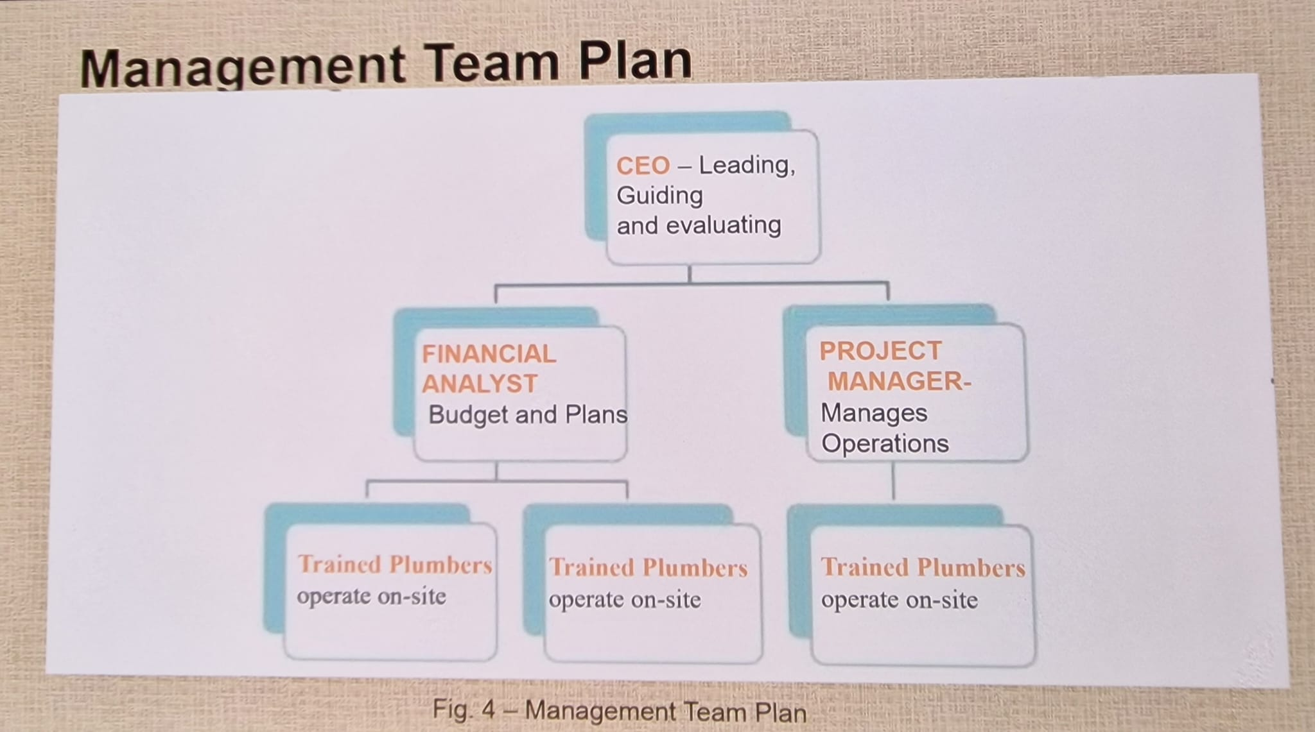
Instant Plumbing needs capable managers. The management plan includes employing key staff for smooth operations and great service. CEO will lead the entire company by guiding and evaluating. Project managers coordinate with construction workers, oversee daily operations, and meet deadlines. Financial analysts plan, budget, and allocate resources. Plumbers and technicians on-site will provide project expertise. Each task is crucial to establishing a strong team that can grow Instant Plumbing and provide excellent service (Harris, 2022).

Marketing plan and strategy
The success sometimes relies on the effective marketing of the business, especially instant plumbing business. When the business wants to become the leader in this industry, the business ought to focus on the proper marketing. Besides the promotional strategies, the business also needs to take idea about the promotional platforms. In this section, all the context will be delivered based on the instant plumbing related business (Passman, 2023).
Marketing can be both online and offline. At a time, the offline or analogue marketing was very famous, but at this time the online marketing or the digital marketing is very famous because of its opportunities. For the online marketing, the business can get huge audience and the business also reach a massive audience that has a great impact on the business.
Marketing mix play a vital role for the business. Product concept provide the product development ideas, pricing concept provide the ideas and concepts how to fix the price and how to apply the price. The promotional concept provide the concept where the business can promote the business product and how the business can utilize the platforms. After the promotional stages, the place strategies should be utilized. The place strategy provide the distribution ideas. There are many social media platforms that can be utilized for the promotional activities for the instant plumbing business. These social Medias are FACEBOOK, X, INSTAGRAM, YOUTUBE, etc. (Kishel and Patricia Gunter Kishel, 2024). These social media play a vital role for the marketing. Besides the social media marketing, search engine optimization also is used properly to promote the business. Besides the social media and other digital marketing activities, the instant plumbing business can use the celebrity endorsement procedures to promote the business product. Celebrity endorsement procedure is another productive marketing strategies for the instant plumbing business in the perspective of the UK (Kishel and Patricia Gunter Kishel, 2024).

Marketing 4Ps Table
Component | Description
Product | Instant Plumbing offers prompt and reliable plumbing services, including the innovative WiFi Water Leakage Alarm for early leak detection.
Place | Services are primarily offered in London, targeting builders, developers, and contractors. Future expansion to other regions is planned.
Promotion | Marketing strategies include a dedicated plumbing website, promotions and discounts, vehicle branding, social media marketing, and local advertising.
Price | Competitive pricing tailored to different service packages. Discounts and promotional pricing are used to attract new customers and contracts.

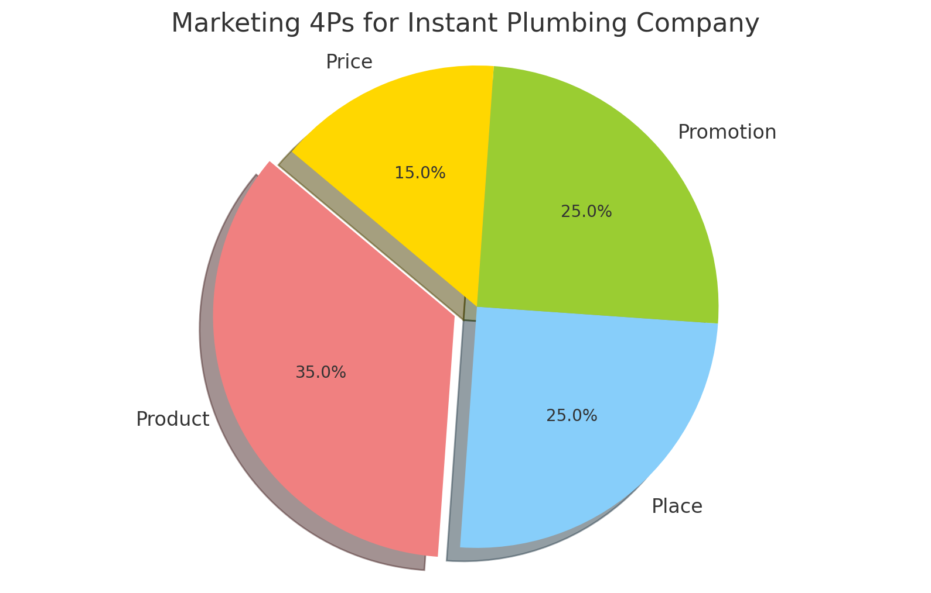

Financial Plan
Financial Planning sometimes depends on the financial capabilities. For any kind of business organization, the financial planning play a great and vital role on the business. Without the financial planning, a business cannot utilize its startup cost properly. For the mismanagement of the financial planning, a business can be destroyed rapidly, that’s why every business needs to make the financial planning. In the financial planning, everything about the finance become calculated. The pricing strategies are the part of the financial planning (Herist, Rollins and Perri, 2023). On the other hand, in financial planning, there are many cost related to the business can be included, for instance managerial cost, operational cost, fixed cost, constant cost. In the financial planning, the previous income statement is calculated because of getting monetary ideas, that’s why the financial planning is the major part of the business structure, and every business management needs to analyze the financial planning (Herist, Rollins and Perri, 2023).
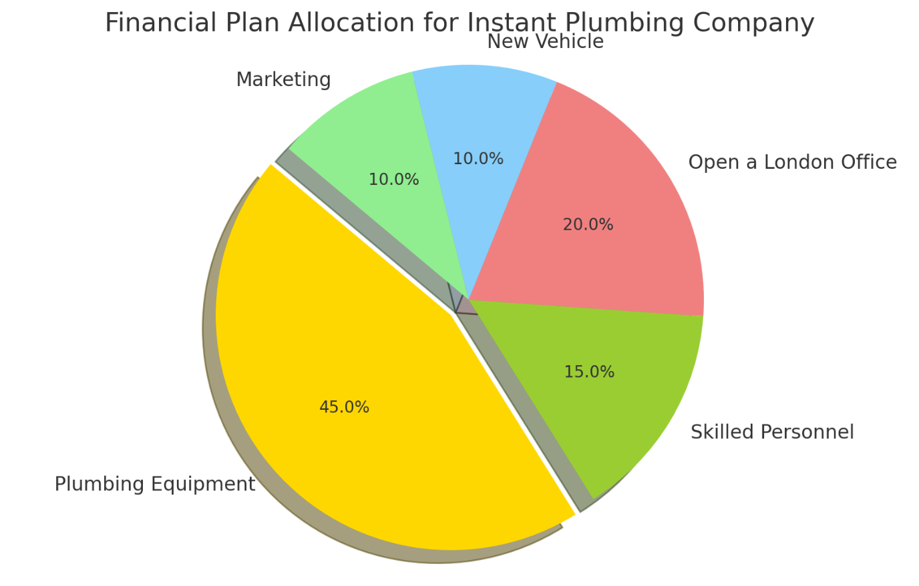

The financial allocation for Instant Plumbing Company is strategically designed to ensure effective launch and growth of operations. The budget distribution is as follows: 45% (£45,000) for plumbing equipment, 15% (£15,000) for skilled personnel, 20% (£20,000) for opening a London office, 10% (£10,000) for a new vehicle, and 10% (£10,000) for marketing.
The largest portion, 45%, is allocated to plumbing equipment, which is essential for providing high-quality services and ensuring the company is well-equipped to handle various tasks efficiently. Investment in skilled personnel accounts for 15%, which is crucial for hiring and training qualified plumbers to deliver exceptional service. Allocating 20% to opening a London office establishes a physical base for operations, supporting administrative functions and providing a professional space for client interactions.
Purchasing a new vehicle, allocated 10% of the budget, ensures reliable and efficient transportation of equipment and personnel across different locations. Lastly, 10% is dedicated to marketing, which includes promotional activities such as a website, social media marketing, local advertising, and vehicle branding. This helps in creating brand awareness and attracting new customers. This comprehensive financial plan ensures that Instant Plumbing Company invests in critical areas necessary for its success and growth.

Conclusion
In conclusion, the main and key theme of the whole report is to demonstrate the business planning related to the instant plumbing. The instant plumbing can be the potential industry in the United Kingdom from where people can get a huge revenue, that’s why the industry has many potential growth and challenges. In this total report, the planning for the business, the infrastructure of the business, the financial decision of the business have been evaluated (Williamson, 2022). After evaluating the whole report, it is observed that the business needs more financial support. If the government body can help the industry in the United Kingdom, the industry can be great in the UK for a long time. In this industry, the major problem is lower sustainable that can be overcome using the strategic business tools and technique. Eventually it is said that, the business planning can be proper, whether the planning is implemented (Gitman, Mcdaniel and Shah, 2023).

Reference list
Barney, J. B., & Hesterly, W. S. (2015). Strategic Management and Competitive Advantage: Concepts and Cases. Pearson Education.

Crandall, R.E. and Crandall, W. (2023). How management programs can improve performance : selecting and implementing the best program for your organization. Charlotte, North Carolina: Information Age Publishing, Inc.

Freinkman, L.M. and World Bank (2022). Growth challenges and government policies in Armenia. Washington, D.C.: World Bank.

Gitman, L.J., Mcdaniel, C. and Shah, A. (2023). Introduction to Business. Independently Published.

Great Britain. Parliament. House Of Commons. Trade And Industry Committee (2023). Success and failure in the UK car maunfacturing industry. London: The Stationery Office.

Harris, P. (2022). PH Plumbing Inc. : A Long-Term Construction Case Study. The Accounting Educators’ Journal, 32. Available at: https://www.aejournal.com/ojs/index.php/aej/article/view/739 (Accessed 9th August 2024).

Herist, K.N., Rollins, B.L. and Perri, M. (2023). Financial analysis in pharmacy practice. London: Pharmaceutical Press.

Kishel, G.F. and Patricia Gunter Kishel (2024). How to start, run & stay in business : the nuts-and-bolts guide to turning your business dream into a reality. Hoboken, Nj: Wiley.

Passman, D.S. (2023). All You Need to Know About the Music Business. Simon & Schuster.

Pickles, D., Revill, S. and Historic England (2024). Energy efficiency and historic buildings : insulating early cavity walls. Swindon: Historic England.

Teong Wan Ong (2024). RESULTS MANAGEMENT : Effective People Management to Achieve Excellent Results. Singapore: John Wiley & Sons (Asia) Pte. Ltd.

Williamson, O.E. (2022). Transaction-Cost Economics: the Governance of Contractual Relations. The Journal of Law and Economics, 22(2), pp.233–261.

