

Student Name: Sabina-Alexandra Sotir
Student ID: 1915929
Module name: Blogging to communicate - Assessment 1

Teacher name: Tushara Balendran

Assignment title: Christian Dior Blog

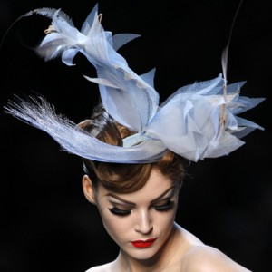
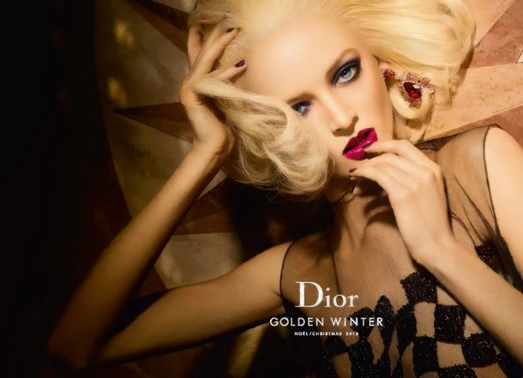



Blog
Individuality will be always one of the conditions of real elegance.
Christian Dior

History
The Brand
Mission and Vision
Christian Dior founded Dior company on October 8, 1946 with headquarter in Paris. And only a year after that, the designer presented his debuted collection. As it was almost two years after the end of World War it represented a transition from an old to a new post war society. Christian Dior become the legend of Parisian haute couture. He transformed the wardrobe of women drastically by presenting an image of a radical and glamorous style. His first collection New Look become one of the most memorable collections that wrote a new chapter in fashion. Dior brand was valued approximatively six billion dollars. The luxury brand has as its targets audience wealthy people which share the its values such as high quality, elegance, power and excellence. The mission statement of Dior is to become the world’s most popular brand. The concept is to create happy, flower women and make them dream. As Christian Dior said” Respect tradition and dare insolence because one can not go without the other”. The mission also includes creating an environment that welcoming and encourages clients to tap into their creativity and explore their personal styles. The codes are bright colours, leopard print and flowers. The worship products include J’Adore, Lady Dior bag and Rouge Dior Addict. The brand identity distinct itself via exclusive couture, elite status, fashionable and heritage brand.

Women’s Fashion
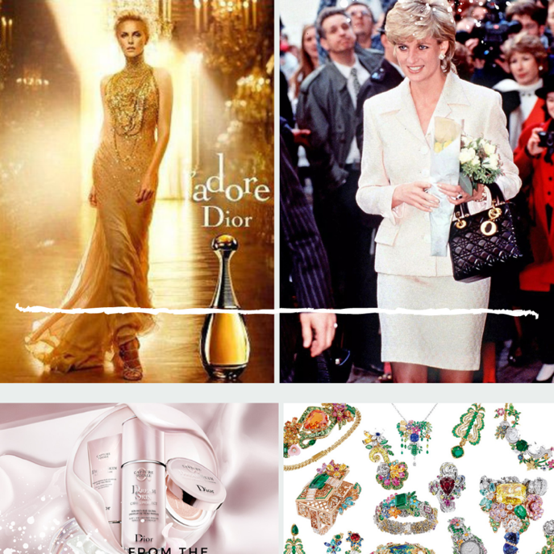
Dior displays a series of products for women bags, ready-to-wear clothes, shoes, fashion jewellery, accessories, couture shows. Dior's bags inflict a feeling of refinement and femininity. There are many styles and colours created to accommodate whatever event. There is a variation of vogues and patterns such as handbags, Tate bags, mini and belt bags, messengers.

Some famous products are related to fascinating stories such as Dior's iconic bag, the Lady Dior, features all the trademarks of Dior leather goods. Lady Diana Spencer, Princess of Wales, received this bag as a gift as she was one of the most loved royalties, this bag becomes very popular as Diana liked it and photographed with it. As a recognition Dior renamed it from “Chouchou” to “Lady Dior” which seems to influence the clients. You might be a dog lover if you said yes then you should know that Christian Dior loved his dog, Bobby, very much and some products such as limited-edition perfume, bags and suit gives tribute to this friendship.

The soul of Dior vibrates at 30 Avenue Montaigne where the Dior icons were produced. This presents its signature to a collection of unique pieces which incorporate Bar jacket from the first Dior collection New Look. Maria Grazia Chiuri reimagined it later and combined with new designs. On the other hand, Dior’s jewellery is stylish and artistic. The pieces are the expression of professionalism in Dior sophisticated but elegant spirit. As Christian Dior quoted “As, a rule I would say use jewellery generously to get the most of it". We can deduct from the quotation that Dior considers jewels an essential accessory for a woman. Leave a comment below and let me know what you think. It is crucial to mention the extraordinary shows such as Teddy Girls Subculture; Couture goes to the circus, Dior Cruise 2019, For the Spring-Summer 2020 Ready-to-Wear collection etc. All the shows are created based on a unique vision of life and fashion.
Men’s Fashion
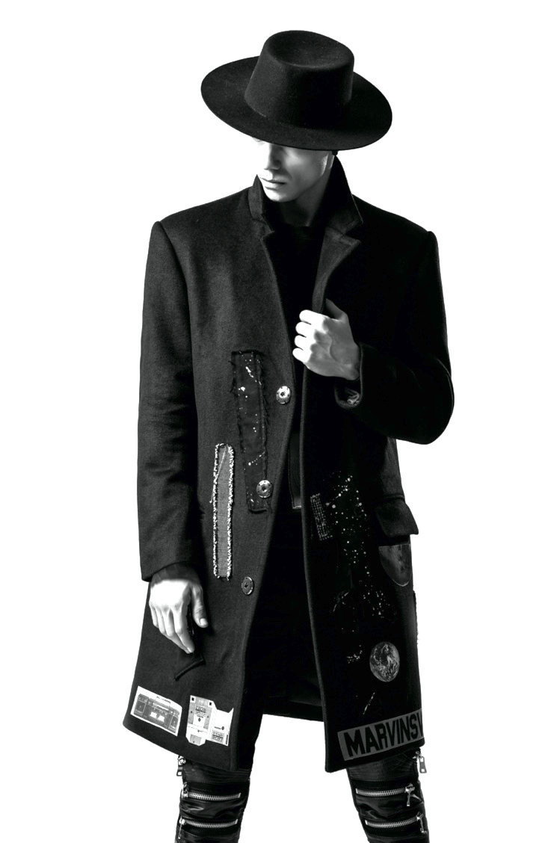
Products

Dior it is not only about women, the Maison launched lines for men as well. Starting from suits jackets, coats, t-shirts and continuing with leather goods such as backpacks, briefcases. Also, Dior has a wide range of styles shoes including ankle boots, oxford loafers, sneakers and sandals. On the other hand, the unique savoir-faire, all Dior Men accessories enhance the look. Accessories products that can be bought include sunglasses, wallets and card holders, key rings, cufflinks, belts, gloves etc.

The Perfuming Art
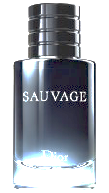
The best-selling and most popular perfume is Sauvage. Dior Sauvage was launched in September 2015, and Johnny Depp advertised it. The main accords of Souvage flagrance are citrus, aromatic, fresh spicy, musky and herbal. Dior perfumer, François Demachy is the creator of the Sauvage perfume. The scent is advertised as fundamentally fresh, natural and noble. Also, for those who appreciate woody notes and leather Dior Homme Intense is a good choice and can be bought at a price of 55£ from Dior website.

Kids ’s Fashion
Dior Kids Fashion display a celebration of happy and comfy childhood

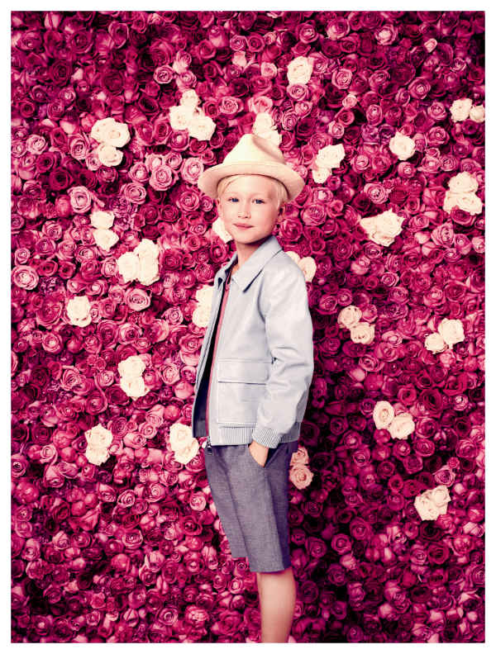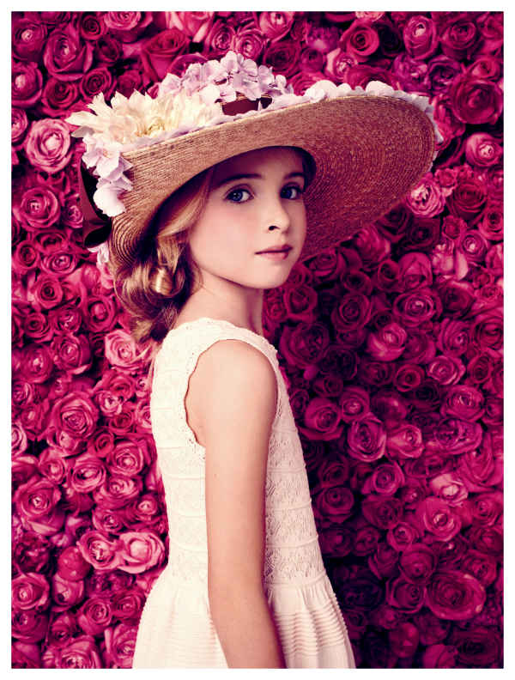
Dior collections for boys (3-13 years) include four main categories ready-to wear clothes, shoes, bags and accessories. However, Dior provides a range of products for baby boys as well (1-36 months which include booties, cuddle toys, changing bags and new-born gift set. The high quality and classy style register a high demand worth the price.
The girls range products are similar to boys. These designs mirror Cordelia de Castellane's creative and romantic personality created especially for children. If you want to discover more about voguish doll, summer dresses for girls you can leave a comment below and new post will be available for you soon.

(Dior, 2018)

Marketing Strategies
Dior uses many tactics to attract customers which involve celebrities, promotion through fashion shows, exhibitions, social media and influencers. Based on Forbes Dior sells its products through its chains of retails stores and online stores. As the target customers are high income group Dior products are visualised as symbols.
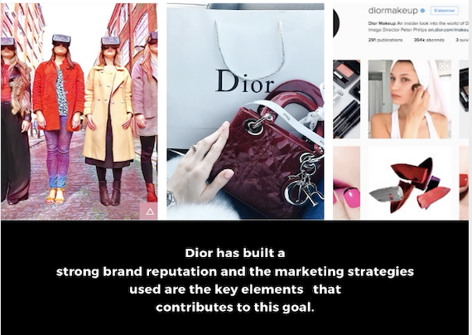
Social media marketing strategy increased in its popularity and it became one of the main tactics to communicate with customers, understand their interest and of course making the most of existing features to promote the product and to make new products accessible for existing clients and new audience as well. The most used social media channels include Instagram which mainly focuses on specific niche.
Also, Facebook is another important channel with an overage of 17,413,765 of fans. If you are not following yet than you can access the link https://www.facebook.com/Dior and subscribe to be up to date with new products and promotions. Dior launched VR headset innovation which it is a completely new virtual experience of fashion in a world of technology and fast grown innovation. See for yourself! Click on VR!


Premium-price strategy
Price mainly refers to product value. When deciding upon the product price, certain aspects are considered, such as the production costs, the cost supplies, the demand and other factors. Dior uses a premium price strategy as they try to produce a unique, high-quality product; therefore, the price is high as well. Also, considering its high price, the clients perceive it as being unique, less accessible and branding product which increases its value. Dior develops a personalised relationship with their clients by embedding their products, experience and feeling about it, which somehow motivates its high price. Luxury products with high-quality materials mean a luxury price. For example, Lady Dior bag cost around 4 thousand pounds. The bag has a good quality, designed by famous designers, and it is sold along with the brand image.
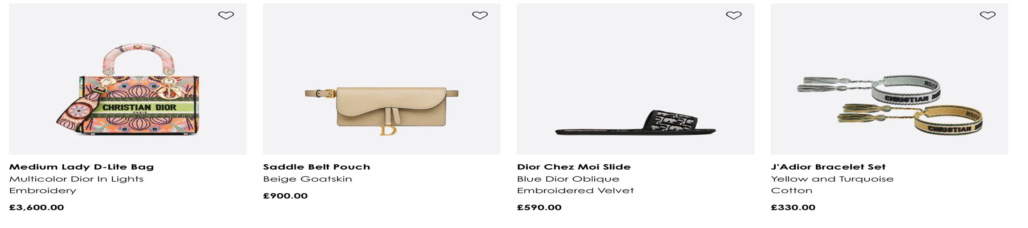
Choose some amazing products from Dior!

Distribution Strategy
Dior distributes its products via channels such fancy stores, e-commerce and supermarkets. It is fascinating how the Dior expanded globally. It is registered a total of 198 stores worldwide. If you never visited a Dior boutique than you missed the most exclusive and extravagant style and chic. You can find Dior boutiques in London, Paris, Florida, Sweden etc. If you are unable to travel than you can buy online, and it can be shipped and delivered to your home address isn’t it great?

The New Bond Street boutiques
If you are looking for a stanning expensive night dress, unique piece of jewellery, fragrance or even a gift for your loved ones then Dior boutique on Bond Street is for you. American architect, Peter Marino created a masterpiece, French fashion in classic grey, pale pink and turquoise. He created a Parisian entourage which inspire a feeling of exceptional beauty and elegance.
This is one of the spacious boutiques on Bond Street. It has four floors; on the ground floor you can find a variety of products designed for men. On the first floor there is a charming collection of clothes for women along with jewels and accessories. The boutique provides high quality customer service by offering tea and warm welcome for customers. Dior marketing strategies are not only about selling but also create valuable experiences for their clients.
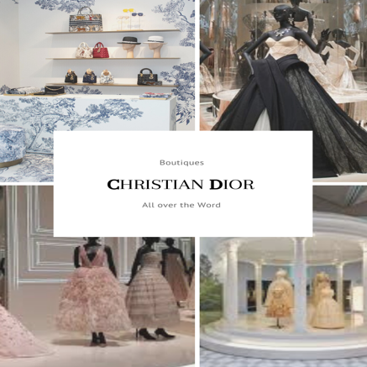

E-commerce in China
According to Jing Daily” The French fashion powerhouse Christian Dior just became the first luxury brand in China to leverage livestreaming to sell on the country’s biggest social messaging app WeChat” It is evidenced that Dior understand the power on of using Digital marketing to reach a high number of international customers. It is important to consider the accessibility of apps used. We Chat is an excellent example as it was registered a high number of purchases during live streaming session.

Bibliography

- Best, K., 2017. The history of fashion journalism. Bloomsbury Academic.
- Bloomberg, 2020. Christian Dior SE. [Online] Available at: bloomberg.com [Accessed November 2020].
- Carreon, B., 2020. 20 Years of Victorie De Castellane and Dior Fine Jewelry. Forbes, Volume Style and Beauty .
- Dior, 2020. Lady Dior. [Online] Available at: www.dior.com [Accessed November 2020].
- Dior, C., 2018. Anual Report, Paris :
- Homer, K., 2020. Litlle Book of Dior. London : Amazon Publishing.
- Kingsnorth, S., 2019. Digital Marketing Strategy: An integrated approach to online marketing. 2nd Edittion ed. London: Kogan Page.
- Saillard, O., 2018. Dior by Christian Dior. Paris: Assouline.
- Salessy, P. H., 2020. From Princess Diana to today: The history of the iconic Lady Dior. [Online] Available at: www.vogue.fr
[Accessed 22 November 2020].
- West End , 2020. Christian Dior, 160-162 Bond Street. [Online] Available at: www.westend.com/bond-street/christian-dior/
[Accessed 24 November 2020].

