UNIT TITLE: GLOBAL BUSINESS ENVIRONMENT
UNIT NO: LCBB4005 A2
STUDENT NAME: MARIA DIMITROVA
STUDENT ID: 1906321

GLOBAL BUSINESS ENVIRONMENT

Contents
Introduction 3
Company overview 4
Case study of the company 5
Task 1 6
Critical analysis of the changes that H&M has made in the last few years to adapt to the concern of its stake-holders 6
Analysis of the benefit of the changes that H&M will get with some relevant recommendations 10
Conclusion 12
References 13

Introduction
In this report, the global business environment analysis will be presented based on a case study of the H&M business environment. To carry out the discussion, different models relevant to the business environment will also be discussed. How the companies of the fashion industry doing business following the changing environmental changes will be the focal point of this report. The report aims to provide a clear understanding of the factors of the business environment that affects the fashion industry.

Company overview
Hennes & Mauritz (H&M) is a Swedish multinational fashion retailer that deals with fashion clothing for men, women, teenagers and kids. The company was established in 1947 and headquartered in Stockholm, Sweden. Currently, it has an operation in 74 countries with more than 5000 stores (Story, 2021).
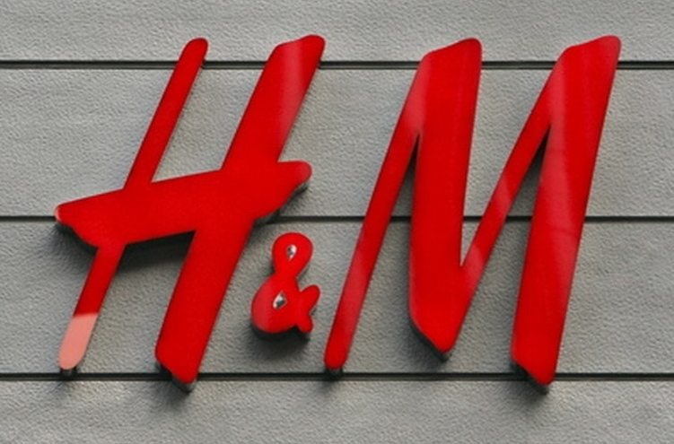
Image: H&M logo
Source: (marketing91, 2019)

Case study of the company
Promoting sustainable fashion business, green clothing and buying sustainable and organic raw materials are subjected to the huge cost. But despite all of these, H&M is providing its variety of clothes at a cheap price. Well, in spite the cost for sourcing and making of sustainable clothes are high, but this company is making their products in an underdeveloped country with very cheap labour cost, and that facilitate them to offer a low price for their products. Investigator reporting that in front of world H&M is flaunting about the green and sustainable fashion business with affordable price but behind the scene, the huge production of garment products for this company creates tons of garbage in the underdeveloped country likely Bangladesh, China, Botswana, etc. (Cotton, 2019). A recent investigation report published on Greenpeace reveals that H&M has a pollution problem and it is a core contributor to the dump of chemical toxic to the Chinese river named Yangtze and Pearl (Laskow, 2019).

Task 1

Critical analysis of the changes that H&M has made in the last few years to adapt to the concern of its stake-holders
Being a major player in the fashion industry, H&M is not out of the environmental regulations of it. Some recent news reveals the issues of huge garbage production, exploiting cheap labour, selling one-time-use sustainable cloths, etc. against the H&M. It is addressing these issues in the following ways:-

Figure: Sustainability move made by H&M
Source: (self-made)
Planning to develop clothing rental service: According to the UN, the global fashion industry is responsible for 20% of global wastewater and 10% of global carbon emission (Salazar, 2021). This is causing a huge concern for H & M as they have put forward a plan to reduce carbon emission to negative by 2040 (Salazar, 2021). To reduce the wastage it has been trialling cloth rental service in a very limited arrangement. Currently, it is testing this idea out in its Stockholm flagship store with only 50 different clothes. If they get a positive result in this trial, they will extend this strategy which will eventually contribute to the reduction of wastage.
Trying to meet up fair living wage strategy: Following the headline “your cheap fashion, our misery”, the German TV had revealed the severe labour exploitation of H&M. The company reportedly, In Bangladesh & Uzbekistan, employ 12 years old labour, get them to work 14 hours a day and the wage is too poor to live hand to mouth (Gurdian, 2020). However, H&M has been trying to addressing the problem since 2013 by implementing a fair living wage strategy. And following this strategy, currently, this company can pay 930,000 garments worker a fair living wage by the end of 2019 (Gurdian, 2020).
Planning to develop long-lasting sustainable clothes: H&M is already working on Green Clothing but consumers urge that though those clothes are cheap but they don’t last long and require more clothes at a particular time (Gaynor, 2019). So eventually it requires more production and more dump of wastage. Taking this concern into account, they are now developing the design of sustainable cloths that will be sustainable and worth repeating several times.
Well, apart from the above facts, H&M has obligations to the wider macro-environmental factors. The obligations towards different forces of the environment are explained below with the help of PESTLE analysis:-
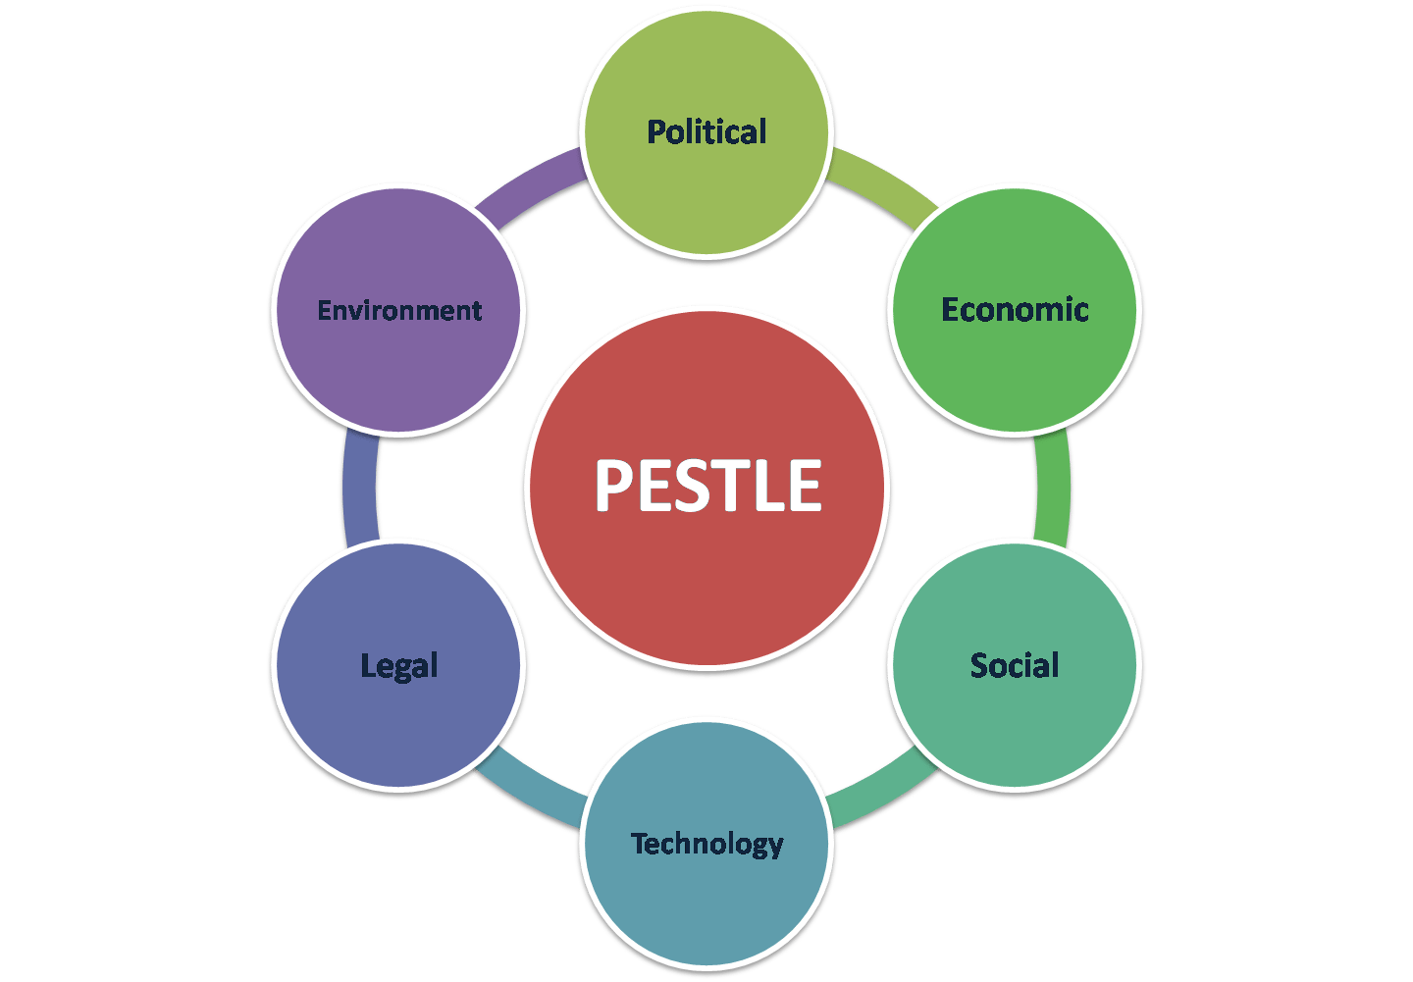
Figure: PESTLE analysis
Source: (advertize, 2017)
Political element: Political environment consists of foreign trade policy, political stability of the host countries, and Political endorsement to the fashion industry, etc. countries like Myanmar, Uzbekistan, Bangladesh, Turkey, and Ethiopia are the major labour source for M&H. And those countries have full endorsement towards the use of their cheap labour as garment industry is a major source of income in those countries. H&M has opened a showroom in Israel and that made them hugely controversial and some even boycotted the company. In such a situation, it doesn’t take any step but it should have been (Adamkasi, 2021).
Economic elements: The currency rate, per capita income, GDP rate, unemployment rate, interest and inflation rate, etc. affect the international operations of H&M. For example, Bangladesh provides the cheapest labour in the world with the cheapest raw materials for garment products (Adamkasi, 2021). H&M is sourcing a lion portion of their product from Bangladesh to reduce their operations cost which enables them to charge a lower price for their products. And due to the increased rate of unemployment in that country, the labour supply is high and demand is a little low and that cause the labour there too cheap. However, it is thinking of introducing a fair living wage strategy in that country too.
Social element: Social elements affect the fashion industry more. Since H&M is responsible for the pollution of the environment that cause harm to society so it must do some social care to make that up. Well, it has been found that H&M is engaged with employing child labour and giving them unfair wages. So it should make the immediate step to impose an age restriction to work in all the manufacturing site in the world. Well, as a social obligation, the company has arranged safe and hygienic drinking water for 150,000 people in Pakistan, India and Bangladesh (Adamkasi, 2021).
Technological element: The fashion industry needs to be up-to-date with the changing technology to bring and forth more unique and faster design and processes. To make its activities easier, H&M has introduced big data and Artificial intelligence to spot trends and improve product assortment. This may create less demand for labour in future. However, since a huge portion of people is associated with this sector, it might take some step to balance technology and manual labour.
Legal element: various laws and policy namely minimum wage policy, hygiene and safety in the workplace, data protection laws, intellectual property laws, laws related to minimum labour age, related to maintenance of the workplace are related to the fashion industry. Though H&M is trying to comply with all these laws it records for law violation is not rare either. For example, In Cambodian, it has been reported that H&M is engaged with labour law violation. It was published that H&M factories in that country don’t meet the sustainability guideline (Jocheb, 2021). Besides, the wage is not fair also. However, H&M has announced Zero tolerance against these issues.
Environmental element: Since the fashion industry has caused most of the pollution in the environment, hence H&M has huge responsibility and obligation in these particular forces of the environment. Already some of the environmental pollution cases have been highlighted in the report. However, H&M is taking so many measures to develop a more sustainable and green business. For example, H*M is already started its campaign for developing re-cyclable cloths and dress rental facility to reduce wastage from garment production.
So, as a giant retailer, H&M has so many negative impression on the sustainability of the environment but it is actively taking action to address all the concern raise by its stake-holders and move forward to a better environment-friendly business.

Analysis of the benefit of the changes that H&M will get with some relevant recommendations
Addressing all the environmental issue will bring so many benefits for H&M in both national and international context. The benefits that H&M are most likely to get are discussed with the help of Porter’s Diamond model.
The diamond-shaped porter’s diamond model state out why some companies can achieve a competitive advantage in some countries while some do not. However, there are some forces and factors that let a company be successful in a particular market. Porter’s diamond model has been applied to H&M in the following section:-
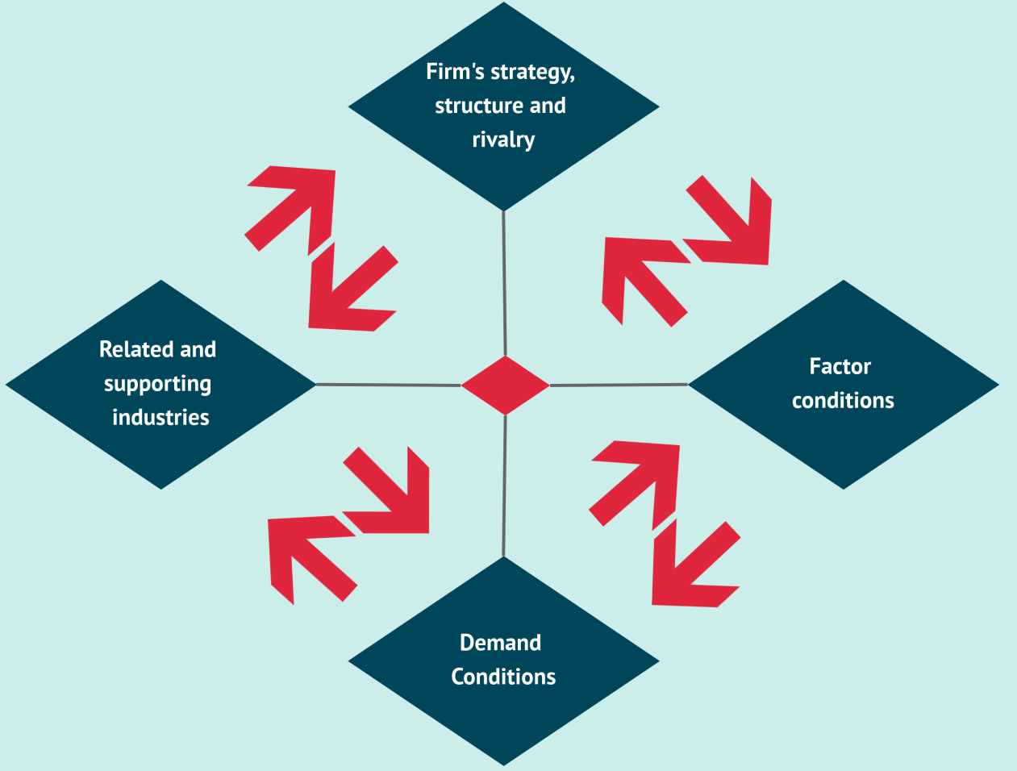
Figure: Porter’s diamond model
Source: (fourweekmba, 2020)
Firm strategy, structure and rivalry: This includes how the strategy, structure of the firm enable it to get a competitive advantage (Coufano, 2020). It also looks into how the intensity of rivalry affects its recognition in the international market. In H&M, their sustainable and fair wage strategy has already emerged huge attention and for this reason, it is getting a competitive advantage in those countries where it implemented its fair wage and sustainable business policy. In case of rivalry, Zara is the close competitor of H&M, but the huge presence of replicated Zara products aren’t letting the company come focus over H&M.
Factor condition: Factor condition refers to the resources that are must for quality product and process (Coufano, 2020). H&M has access to the most skilled and affordable labour in the world. Besides, it has a good sourcing of quality raw materials that enable it to produce a high-quality product at a cheap price. This also helps the company to derive a competitive advantage.
Demand condition: Demand for clothing is always so high. Moreover, since H&M is one of the affordable brands, hence it has quite a good demand in developing countries. And the clothing rental idea is going to create more demand for this brand.
Related and supported industry: It has a good endorsement from the government, good trade relation with all of the labour supplier country and with all this, it has been able to be the second-biggest fashion retailer in the town.
So, addressing all these concern it could able to create a good impression and relationship with all of the host countries that enable it to get a competitive advantage.
Analysis of porter’s five forces will also show how H&M will get a better position in the market compared to its competitors with the help of sustainable business.
Factors | Degree of competitiveness | Explanation
The threat to new entry | Moderate | Entry into the fashion industry is not that hard, but developing sustainable production policies during entry days is tough. In that sense, H&M has an advantage.
Threat to substitute | Low | The re-cyclable clothing, the rental clothes are very hard to be substituted (Collins, 2020).
Power of buyers | Moderate | Though buyers have plenty of other cheap potion, they won't get environment-friendly clothing at such a cheap price as H&M. so, it also gives H&M an advantage.
Power of suppliers | Low | H&M has got plenty of options to source their labour and raw-materials at a cheap price hence, the supplier has very little to say in such context (Collins, 2020). Most of the supplier country has a labour surplus.
Competitive rivalry | High | Competition in the fashion industry is so intense. But H&M can still derive some advantage by introducing their environment-friendly cheap fashions (Collins, 2020).

Recommendations
The H&M can follow the following recommendations to promote a more sustainable business:-
- Since no means of production can reduce the dumping of wastage so it should take responsibility for the proper disposal of this wastage so that the intensity of pollution reduces.
- It must strictly enforce the labour policy law so that minor, underage, unfair wage and other safety-related issues minimise in its manufacturing firm and it gets exempt from a legal obligation.
- It must ensure fair wages for each of its supportive labourer. And besides that, it needs to ensure that every manufacturing facility is of standard and safe working condition.
- Eventually, it should encourage the people to repeat their wardrobe this may require them to produce less in a given time and this can save the environment.

Conclusion
Overall the sustainability move take by H&M is appreciative but somehow it is not able to ensure the application of green business properly. That’s why it is getting into pollution and unfair controversy. Only proper implementation of an environmental policy can ensure success for the company.

References
Adamkasi, J., 2021. PESTEL Analysis of H & M | Free PESTEL Analysis. Free PESTEL Analysis | Free PESTEL Aanlysis.
Collins, N., 2020. Porters 5 Forces in case of H&M. studocu.com.
Cotton, B., 2019. H&M and Zara, the ‘sustainable’ fashion brands killing the environment | Business Leader News. Business Leader.
Coufano, G., 2020. What Is Porter’s Diamond Model And Why It Matters In Business - FourWeekMBA. FourWeekMBA.
Gaynor, K., 2019. H&M tests clothing rental service to address environmental concern. Fox News.
Gurdian, T., 2020. H&M factories in Myanmar employed 14-year-old workers. the Guardian.
Jocheb, J., 2021. Labour rights violations in H&amp;M's "best in class" supplier factories in Cambodia. Clean Clothes Campaign.
Laskow, S., 2019. Low Fashion: H&M Has a Pollution Problem. GOOD.
Salazar, A., 2021. H&M For Rent? The Company Is Testing A Service To Tackle Environmental Concerns. Refinery29.com.
Story, S., 2021. H&M Story - Profile, History, Founder, CEO | Industry Companies | SuccessStory. Successstory.com.

