[Date]
LDE Assignment 1
E-Portfolio
Module Name: Learning in the Digital Era
Module Code: ACCA 4025
Student Name: Dzhenifer Oleksandra Safutina
Student ID: 2514100
Group: 2
Lecturer’s Name: Koushik Modak
E-Portfolio Link:
University of Wales Trinity Saint David
London campus

Table of Contents

Introduction 2

Task 1: Essential Academic and Employment Skills for the future career Path 2

Task 1 (a): Report on Essential Academic and Employment Skills 2

Task 1 (b): Evaluation of Task 1 (a) based on Similarity report 3

Task 2: Collaborative Mind Map and Individual Poster 3

Mind Map (Collaborative) 3

Poster (Individual) 3

Task 3: Virtual Collaboration and RefWorks 4

Report on Virtual Collaboration 4

Step-by-step process of using RefWorks with visuals 4

Task 4: E-Portfolio Creation and Evaluation 4

Task 4 (a): E-Portfolio Creation 4

Task 4 (b): Illustrative Review of E-Portfolio tool Selection 4

Conclusion 4

References 5

Introduction:

Body:

Task 1: Essential Academic and Employment Skills for the future career Path

Task 1 (a): Report on Essential Academic and Employment Skills
Introduction
In today’s job market, employers are looking for people who have both strong academic knowledge and employability skills. These skills are important for getting a job, keeping it, and doing well. For my future career as a business manager, developing these skills will help me become more confident, flexible, and professional.
Essential Academic Skills
Basic academic skills form the foundation for any career. These include reading, writing, math, science, speaking, and listening. Employees with these skills can understand instructions, analyse information, and explain ideas clearly. Reading and writing help prepare reports and documents, while good communication ensures teamwork and cooperation. Academic skills also help employees learn new things and improve over time.
Higher-Order Thinking Skills
Employers also value people who can think critically and solve problems. Higher order thinking skills include learning, reasoning, decision-making, creativity, and problem-solving. These skills help workers adapt to changes, solve challenges, and find new solutions. Using technology and information effectively also depends on thinking skills, making employees more capable and independent.
Personal Qualities and Employability Skills
Personal qualities such as responsibility, self-confidence, teamwork, adaptability, and motivation are also very important. Workers with a positive attitude and good habits, like being punctual and reliable, build trust with colleagues and managers. These qualities help create a positive and productive workplace.
Conclusion
Employability skills can be learned and improved through education, practice, and experience. By combining academic skills, thinking skills, and personal qualities, I can become a skilled, confident, and adaptable professional in my chosen career.

Task 1 (b): Evaluation of Task 1 (a) based on Similarity report
The Similarity Report showed a low percentage of matches. Most of the text is written in my own words, even though I based it on The Workplace: What Are Employability Skills? (2000). To reduce similarity further, I could rephrase a few definitions or examples. Overall, the report shows I understand the topic and can write about it clearly in my own words.

Task 2: Collaborative Mind Map and Individual Poster

Mind Map (Collaborative)
Poster (Individual)
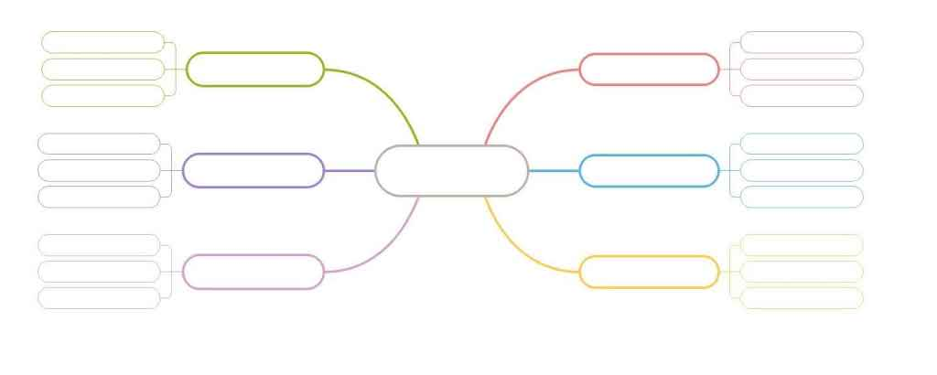
Conclusion
Both the collaboration mind map and the individual poster are useful. The mind map helps to share ideas and develop teamwork skills, while the individual poster shows personal understanding and creativity. Together, they balance group learning and independent thinking.
Task 3: Virtual Collaboration and RefWorks
RefWorks is a web based reference management tool that allows users to collect, organise, and store references, work with sources, and automatically generate citations and bibliographies. It also support collaboration: users can share reference lists, contribute to group projects, and work in a cloud environment accessible from multiple devices.
Put your Chosen topic here
Report on Virtual Collaboration
Virtual collaboration is not only about working together remotely. It involves teamwork through shared documents, tasks, and virtual content management even when participants are not in the same complete projects together. It is important to stablish clear goals, roles, and tools in advance: openness, structured communication, and strong digital collaboration skills all contribute to better outcomes.
Task 4: E-Portfolio Creation and Evaluation
Task 4 (a): E-Portfolio Creation
An e-portfolio is a digital collection that showcases a learner’s achievements, experiences, and goals for a specific audience. When creating an e-portfolio, it is important to: plan, organise, and structure the content effectively. Select materials thoughtfully to demonstrate progress, achievement, and reflection.
E-Portfolio Evaluation
When evaluating an e-portfolio, it is essential to: align it with course objectives and learning outcomes, ensuring clarity about what is being assessed. Provide proper support for both students and educators, including training, resources, and clear rubrics. Consider technical and organizational aspects such as accessibility, data security, and system management.
Task 4 (b): Illustrative Review of E-Portfolio tool Selection


