
From Doom to Desire: How have perceptions of Brutalist housing estates changed over the last 45 years?

School of Architecture, Built and Natural Environment
Course: BSc Architecture

Name: Amy Louise Frohwein
Student Number: 1900811
Module code: M6X01986
Word count: 10,988
Date: 05/05/2023
I declare that the work in this dissertation was carried out in accordance with the regulations of the University of Wales, Trinity Saint David. The work is original except where indicated by special references in the text and no part of the dissertation has been submitted for any other degree.
Any view expressed in the dissertation are those of the author and in no way represent those of the University of Wales, Trinity Saint David.
The dissertation has not been presented to any other University for examination either in the United Kingdom or overseas.
I hereby give permission for my work, if accepted, to be available for photocopying and inter-library loan, and for the title and summary to be made available to outside organisations.

Signed: Amy Louise Frohwein

Date: 05/05/2023

The copyright of this dissertation rests with the University of Wales, Trinity Saint David. No information derived from this dissertation shall be published without the prior written consent of the University.

Signed: Amy Louise Frohwein

Date: 05/05/2023

Acknowledgements

A very special thankyou to my supervisor Dr Paul Harries for his patience and guidance during my years of study at the University of Wales, Trinity Saint David, and the enthusiasm he showed towards my research into this topic, which made this process so much more enjoyable.

I would like to additionally thank Dr Liz Walder and Ian Standen for the informative lectures and advice that they provided throughout this past year.

And finally, a big thankyou to my parents, Amanda Wyatt and Andrew Frohwein for supporting me for all these years, and always believing in me.

Abstract

The Brutalist movement was a social movement, led by architects who aimed to provide a decent standard of living for everyday people, an architecture befitting of post-war Britain. Brutalism is currently undergoing a revival of interest in magazines and coffee table books, however, the ethics and aims of the movement are often being lost in a total aestheticization of the style.

The first part of this dissertation seeks to gain an understanding of how we perceive this architecture and have done over the last 45 years since the emergence of the movement. This will be conducted through a case study of Trellick Tower, West London, arguably the most iconic and well-known example of the style.

This research has been carried out through an analysis of a series of online interviews from residents of Trellick Tower, where common value judgements have been observed to gain an understanding of how this building is perceived by those who live there, and how feelings are attached to this architecture. While a review of newspaper archives has been carried out to gain an understanding of how these perceptions may have changed over time, through its portrayal by journalists who are often expressing the wider public opinion through these articles.

The two following chapters will explore the effects of these changing perceptions happening today, firstly through the exile of social tenants at Balfron Tower, East London, with the controversial recent privatisation of the tower, with views expressed from residents and housing campaigners through a literature review. Then secondly, the chapter regarding Robin Hood Gardens, East London, will explore the listing process for these post-war estates and what happens to those estates which aren’t perceived to ‘return to fashion’.

Based on all the findings, this dissertation concludes that through the aestheticization of the style, now appropriated by the rich, it is severing the link between the form and original ethical content of this architectural movement.
A full bibliography and one appendix are included as part of this dissertation.
List of Illustrations
PAGE TITLE | PAGE NO
Figure 1: Trellick Tower with digital sketch overlay - reflecting the recent rise in tourism to the tower. (Credit : Author) | 9
Figure 2 : Le Corbusier's Unite d'Habitation (Credit: Gili Merin) | 11
Figure 3: Trellick Tower from Elkstone Road, featuring a graffiti wall (Credit: Author) | 17
Figure 4: Trellick Tower entrance. (Credit: Author) | 18
Figure 5: Trellick Tower's facade full of clothes drying lines. (Credit: Author) | 19
Figure 6: Balfron Tower's refurbished facade. (Credit: Author) | 19
Figure 7: Balfron Tower ‘Book a Viewing’ Sign (Credit : Author) | 20
Figure 8 : A rainwater-stained facade at Robin Hood Gardens. (Credit : Author) | 21
Figure 9 : A sign warning non-residents to 'stay out'. (Credit: Author) | 21
Figure 10: Low quality housing adjacent to the Balfron Tower. (Credit: Author) | 22
Figure 11: Robin Hood Garden's damaged facade, 2023. (Credit: Author) | 22
Figure 12 : Trellick Tower on approach from Golborne Road. (Credit: Nicola Muirhead) | 23
Figure 13: Map showing the location of Trellick Tower (Credit: Google Maps) | 23
Figure 14: Looking up at Trellick Tower’s service tower and cantilevered boiler room. (Credit: Author) | 25
Figure 15: Trellick Tower section drawing by Erno Goldfinger in 1976. (Credit: Royal Academy of Arts) | 28
Figure 16: Trellick Tower's separated service tower and link bridges. (Credit: Author) | 29
Figure 17 : Erno Goldfinger standing in beneath Balfron Tower in 1969. (Credit: Keystone Pictures USA) | 36
Figure 18: Map indicating the location of Balfron Tower. (Credit: Google Maps) | 36
Figure 19 : Balfron Tower façade, with concrete ventilation columns exposed from the boiler room. (Credit: Author) | 37
Figure 20: Balfron Tower view from Carradale House. (Credit: Author) | 37
Figure 21: Typical floorplan from Balfron Tower since its refurbishment. (Credit: Studio Egret) | 38
Figure 22 : Balfron Tower on approach. (Credit: Author) | 38
Figure 24 : Robin Hood Gardens - Northern Block before demolition. (Credit: Steve Cadman) | 47
Figure 23 :P Map indicating the location of Robin Hood Gardens. (Credit: Google Maps) | 47
Figure 25 : Robin Hood Gardens site plan. (Credit: Peter Vidani) | 49
Figure 26 : Girl on a Street in the Sky, Robin Hood Gardens, 1972. (Credit: Sandra Lousada) | 50
Figure 27 : Robin Hood Gardens during its demolition in 2017 (Credit: Deezen) | 53
Figure 28: Blackwall Reach redevelopment project underway in 2023. (Credit: Author) | 55
Figure 29 : Highlighted section of facade salvaged by the V&A Museum. (Credit: V&A) | 56

Table of Contents

PAGE TITLE PAGE NUMBER
Copyright statement
Author’s Declaration
Abstract
List of Illustrations
Introduction
Selection of case studies
Methodology
Chapter 1: From Tower of Terror to a Grade II* Listed Icon – How
perceptions of Trellick Tower have changed.
Chapter 2: Balfron Tower and Gentrification
Chapter 3: A Brutal Failure: Robin Hood Gardens and the Loss of
a Brutalist Council Estate
Conclusion
Bibliography
Appendix A: Trellick Tower Interview Notes

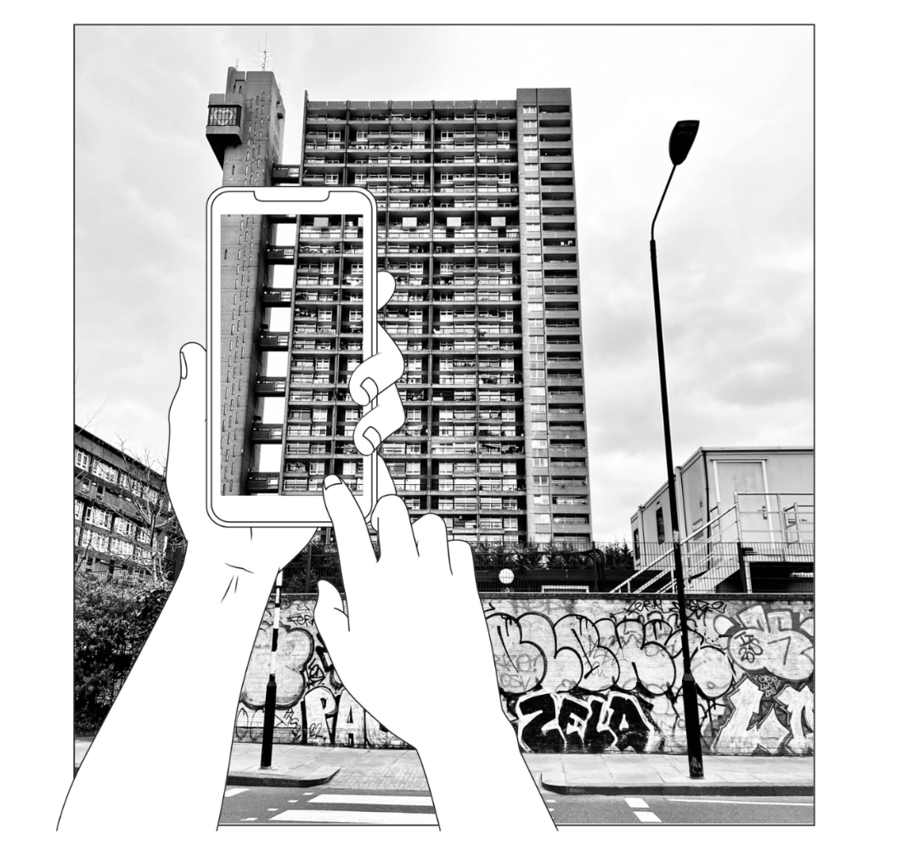
From Doom to Desire: How have perceptions of Brutalist housing estates changed over the last 45 years?
Figure 1: Trellick Tower with digital sketch overlay - reflecting the recent rise in tourism to the tower. (Credit : Author)

What is Brutalism?

‘Considering Brutalism just as concrete buildings would be a complete misunderstanding and misrepresentation of what it is.’ ‘Brutalism was a political aesthetic, an attitude, a weapon, dedicated to the percept that nothing was too good for the ordinary people’. Owen Hatherley.

What is social housing?
Social housing, also commonly known as ‘council housing’, is provided by local councils or now more frequently, housing associations - not-for-profit organisations that own and manage rented properties. These properties aim to be more affordable than private renting, whilst providing long-term secure tenancies.

Social housing can be dated back to the late 19th century, but it wasn’t until 1919 under the Housing and Town Planning Act that the government devised plans to build new homes for this purpose. In the three and a half decades, after the Second Word War, local authorities built 4.4million new homes, which would be provided to millions of ordinary people.

Under Margaret Thatcher’s Conservative government , there was a marked shift in social housing policy, through the Right to Buy scheme, which allowed social tenants to buy their homes at a substantial discount. This caused the numbers of social properties to halve in only three years. Since then, housing associations have provided most of the low number of new social properties built in recent years, however, these associations often lack the finances and resources needed to sufficiently maintain them, which ultimately causes social housing to be sold off to housing developers.

Aims and Objectives
Aim:
To understand the reasons behind the changes in perception of Brutalist architecture over the last 45 years and identify what effects this has had on these estates.
Specific Objectives:
- Find out how much social housing remains within each estate.
- Understand the ideological context for these perceptions / portrayals i.e., social changes, political issues, personal experiences, etc.
- Analyse online interviews to observe changes in perceptions of Trellick Tower over the past 5 decades.
- Identify how people attach feelings to architecture through common value judgements, in this case, through the residents’ perceptions.
- Compare the media portrayals of these buildings, to the perceptions of residents and architects.

The Emergence of Brutalism
Le Corbusier, a Swiss-French architect, was a pioneer of the use of exposed, often textured and board marked concrete construction in France This form of concrete construction became known as ‘beton brut’ meaning raw concrete. After the devastation caused by bombing during the Second World War, the need for housing was at an unprecedented level. Le Corbusier saw this as an opportunity to develop a prototype for a new type of urban housing to provide a new high quality of life to its inhabitants. The Unite d’Habitation, situated in Marseille, was to be the architects first large-scale project and the building that many consider to be the birth of the Brutalist style, though the term ‘Brutalism’
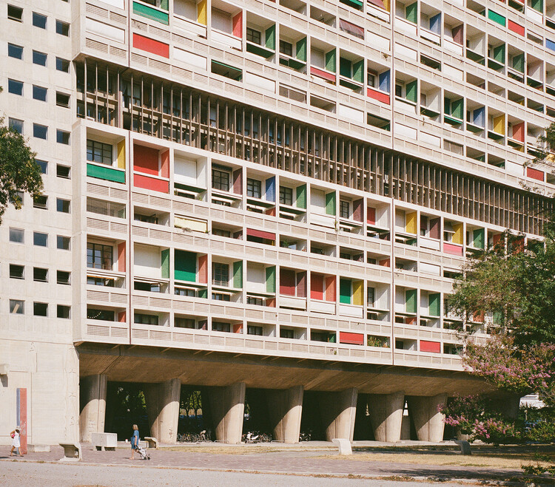
was not coined until later.
Figure 2 : Le Corbusier's Unite d'Habitation (Credit: Gili Merin)

The design focused on communal living, with both the resident’s homes and community amenities such as schools, shops and doctors’ surgeries, brought together to promote social interaction, in what he called a ‘vertical garden city’. 1.600 residents would go on to live within the complex, spread across 18 floors. Unlike a lot of Corbusier’s earlier work, which featured white facades, the Unite d’Habitation would be constructed from reinforced rough cast concrete, which was the most cost effective and readily available material in post war France. The term Brutalism would later be derived from the French term ‘beton-brut’.

Le Corbusier's Unité d'Habitation is arguably the most influential Brutalist building of all time. With its vast geometric forms, it’s honest use of raw concrete and interior "streets" at every third level, it redefined housing by reimagining the city, inside an 18-storey tower block.

But it was Reyner Banham, a British architectural critic and historian, that was instrumental in popularizing the movement in his 1955 Architectural Review in Britain. The article was an attempt to define this new architectural style that was emerging in post-war Europe, where Banham first coined the phrase ‘New Brutalism’ in describing Alison and Peter Smithson’s school at Hunstanton, seen as one of the earliest examples of the style in Britain in 1954. While appreciating the architect’s emphasis on the raw use of brick and steel and expression of the building’s structural elements, he argued that these features rejected the ornate styles of the past and signalled a turning point in international architectural trends.

As well-known theorists and fierce advocates of ‘streets in the sky’ approach to housing. The Smithson’s soon came to be central figures associated with British Brutalism. Their most notable housing project, Robin Hood Gardens estate, situated in Poplar, East London, sought to combine the community of the Victorian slums, with the efficiency and density of Le Corbusier’s housing blocks, in attempt to establish high quality living for the country’s poorest.

The Brutalist movement would go on to have a powerful impact on twentieth-century architecture, establishing a new ethical architectural style, befitting of a post Second World War Britain. For this reason, it became a popular style for public buildings, including social housing, universities and government offices.

Case Studies

Erno Goldfinger, a Hungarian born architect, became another influential player in the British Brutalist movement. Two notable designs, The Trellick Tower in West London, and Balfron Tower situated in East will be studied within this dissertation. The Trellick Tower, now arguably the most iconic example of British Brutalism, is a Grade II* listed tower block, conceived as social housing. Formerly known as the ‘Tower of Terror’ in British newspapers, the tower has undergone an unlikely renaissance, now becoming a much-loved example of post war architecture. The tower block surprisingly, still retains a majority of social residents despite being highly sought after. This chapter will evaluate views of the residents and press, gaining an understanding of the social and political context of the time, and how perceptions have changed over 5 decades.

By contrast, Balfron Tower retains none of its social housing, now 100% privatised by the housing association, Poplar HARCA. Many argue that the tower has been gentrified as a result of these changing perceptions of Brutalism. Views of the residents and housing campaigners, as well as arguments from Poplar HARCA will be analysed to discover if the Balfron really has been gentrified.

Lastly, this chapter will focus on what happens to those buildings where perceptions perhaps have not changed, in this case, Robin Hood Gardens by the highly influential, Peter and Alison Smithson. Despite the influence of its architects, the estate has been denied listed status and since been partially demolished, despite pleas from influential architects and the Twentieth Century Society.

Literature Review

A wide range of literature was explored surrounding the work of Erno Goldfinger, with case study specific literature including architectural journals, such as ArchDaily and Deezen, as well as a study of the ‘Erno Goldfinger : Works 1’ book, written by a close aide of Goldfinger himself, architect James Dunnett in 1983.

The author has used a series of recorded interviews (accessed via YouTube) of current residents of the building in question, by SpidTheatre group, as well as accessing historical newspaper archives, to form a range of sources throughout the time period being studied.
For more recent material, several pieces of literature have been used from notable critics writing in distinguished newspapers such as the Guardian, including Owen Hatherley, Nicholas Thoburn and Oliver Wainwright across all three case studies.

With regards to Robin Hood Gardens, ‘Alison and Peter Smithson’ by Mark Crinson and ‘Brutalism as Found’ by Nicholas Thoburn have been essential in understanding the historical context of these buildings. The author has additionally used press statements and publications from Historic England, to further expand on this case study research and gain an understanding of the listing process for Brutalist buildings.

Methodology

In researching material for this dissertation, I engaged with three different approaches:
- Library research
- Online interview analysis
- Site visits

- Library research
A desktop study was undertaken at the beginning of the research period into the emergence of Brutalism, which led the author to the discovery of each of the case study, being three of the most commonly appearing examples of Brutalist architecture across online architectural books and magazines.

Through the literature research, the author used a range of books in order to gain knowledge of the historical social and political context of the case studies, which became a focus later into the dissertation.

Historic newspapers were accessed through an online newspaper archive to gain vital press portrayals of the buildings in question, to be able to observe any changes in perceptions over time.

- Online interview analysis
During the research period, newspaper articles and online videos were identified, which recorded appraisals/attitudes/express feelings towards the buildings under study. This list was then arranged chronologically into a table, and notes of statements regarding any value judgements made about the architecture were recorded, as well as the date of entry and who made the statement, i.e. a resident, a journalist. Notes from these interviews will be recorded in appendix 1.

From here, common themes could be identified, and any change in perceptions over time. This was seen as an appropriate method to review material portraying historical and current perceptions, not just the perceptions of people today if this was conducted though live interviews. It was believed that contacting past residents of the buildings in question would likely be difficult.

- Site visits
The final part of the research approach entailed a visit to each of the case studies, to form a personal critical opinion/judgement of the architecture and further understand the surrounding context in which these buildings lie. These judgements/opinions could then be compared against the value judgements made by residents, journalists and architects.

This is research which seeks to understand the changing perceptions of Brutalism, both over time and between different participants/observers- such as for example, residents and journalists. It is, to a large extent, an account of the meanings that people attach to architecture. These perceptions derive from different viewpoints, for example, the residents whose observations are based on personal experience, whilst a journalist may seek to portray a wider public mood or political viewpoint.

Within this framework, I offer some of my own reactions/observations concerning the buildings that form my case studies. In this sense, some of the dissertation is based upon my own experience. This follows a long tradition of architectural writing which is experiential. Research of this type is obviously value laden, but I feel it is important to acknowledge my own values within this framework. Inevitably, this section that concerns my own experience is written in the first person. The thoughts recorded can be read below.

Case Study Visits

Trellick Tower 04/03/2023
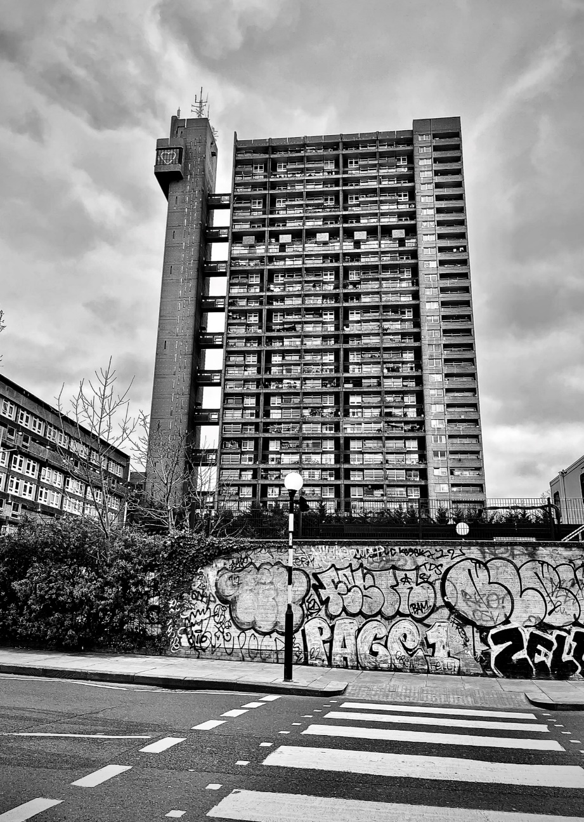
To get from the tube station to Trellick on foot, I walked through the parkland, along the canal to the rear of the tower. This area was quiet and overgrown, but amongst the foliage, colourful graffiti emerged on almost every surface. Though unlike most areas, this graffiti seemed to be a celebrated feature of the neighbourhood, particularly along the basketball courts which the tower looks down upon. These ever-changing graffiti walls added an element of temporality to Trellick, which contrasted considerably with the rigidity and permanence of the concrete block.
Figure 3: Trellick Tower from Elkstone Road, featuring a graffiti wall (Credit: Author)
Concrete walls, fencing and gates separated most of Trellick and the adjoining blocks, from the surrounding area, which left the area feeling extremely disconnected – like a foreign object had been dropped within the area and cordoned off, with no attempt to integrate with its surroundings.
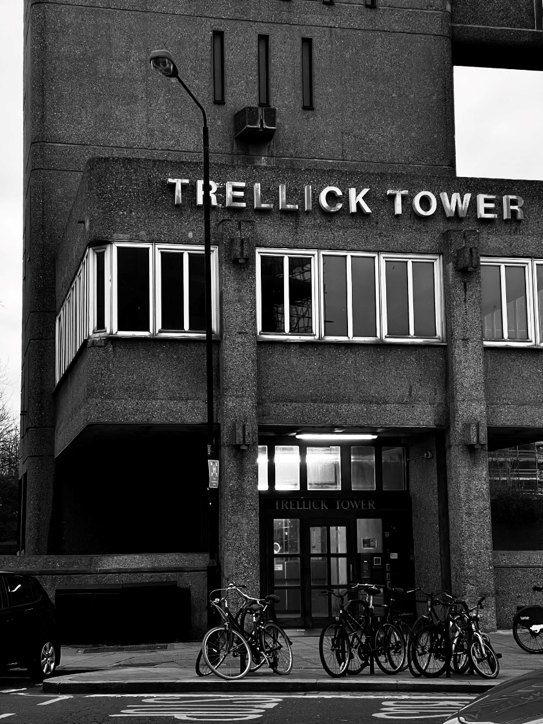
Upon arrival to the front entrance of the tower, I was totally taken back by the sheer size of the building, and it wasn’t until I stood at the foot of the elevator shaft and looked up, did I finally understand why so many people described the tower as ‘intimidating’ and ‘scary’. No other building in the area came close to the height of Trellick, which made the block seem so alien in such a dense low rise urban environment.
Figure 4: Trellick Tower entrance. (Credit: Author)

But what was even more daunting was the several groups of men stood around the small shops situated on Golborne Road, beneath the tower, which left me feeling very intimidated. Perhaps not what one would expect in the area of a tower block where flats sell for up to £1,000,000. This social environment made all the past stories of Trellick seem so much more believable.

It was also apparent that the local residents are growing sick of tourists and architects alike, flocking to the area to photograph the tower, as I received many disapproving glares when I stopped on the pavement to take a few photos which led me to quickly move on.

Balfron Tower 05/04/2023
Before heading to Balfron Tower, I held the preconceived assumption that East London, particularly the Poplar area in which Balfron is situated, is a somewhat less appealing area when compared to Kensington and the Trellick Tower. This area has a strong dominance of social housing. Which is why many, including myself, may have perceived the area to be ‘rough’, especially in comparison to the ‘posher’ west side of London.
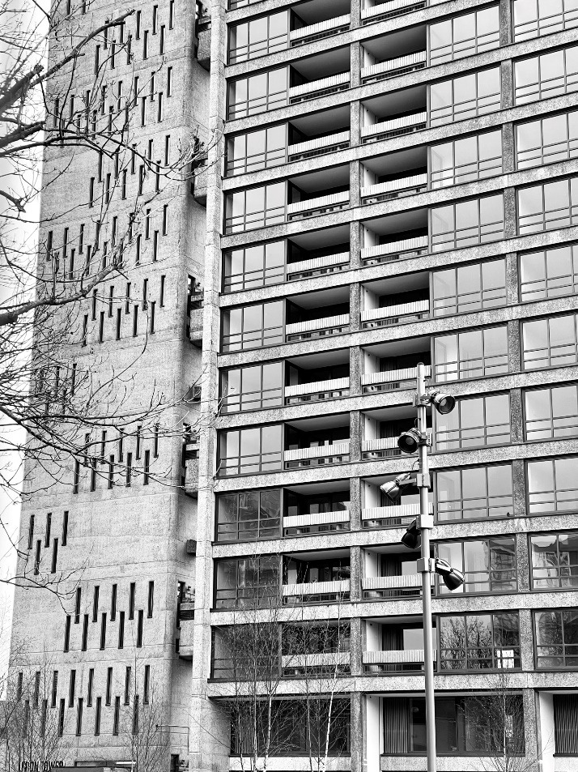
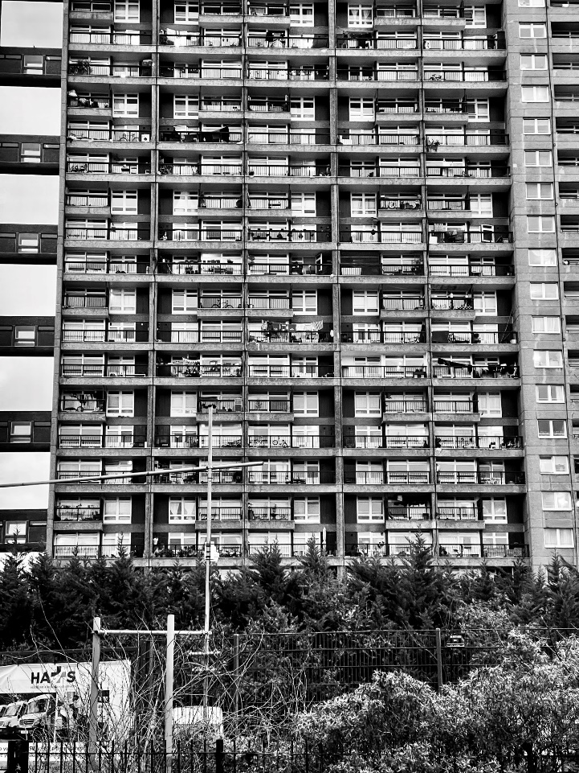
Figure 5: Trellick Tower's facade full of clothes drying lines. (Credit: Author)
Figure 6: Balfron Tower's refurbished facade. (Credit: Author)
What surprised me the most about Balfron, was how much safer the area felt, especially when compared to my visit to Trellick tower. There were no groups of men stood in shop doorways, just families, dog walkers and elderly couples. The estate was set back from the busy main road, behind a decorative archway, with picturesque cherry blossom trees along the pavement. The area was less built up, with open parkland to the left of the tower, with low quality terraced housing adjacent. The area had a much stronger sense of a greater residential community with no fencing or walls creating a barrier between the tower and the rest of the street.

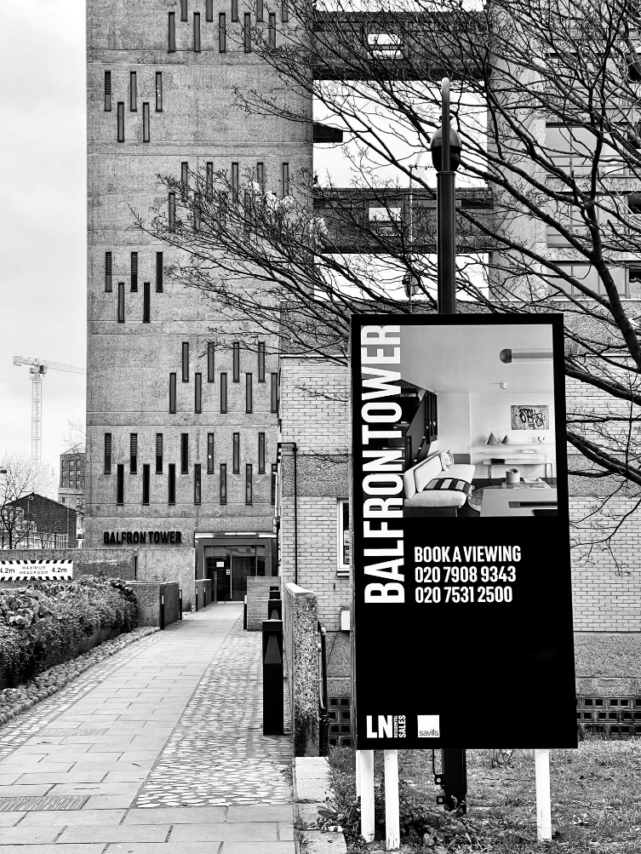
It was clear upon approach, that the tower was undergoing redevelopment, as the tower appeared to have been fitted with new windows and frames, which gave the tower a fresh, clean appearance. The balconies were bare, with no washing lines full of drying clothes or kids toys and bikes, which is a well-recognised feature of the Trellick Tower, which maybe helped the Balfron tower to feel of a higher class.
Figure 7: Balfron Tower ‘Book a Viewing’ Sign (Credit : Author)

Tall signage was posted along the street, advertising the newly refurbished flats being open for viewing, clearly aimed at higher end residents. I imagine the proximity to Canary Wharf, which is visible from the estate, is going to be a big selling point for the flats.

Robin Hood Gardens 05/03/2023
Robin Hood Gardens was visible from the moment the overground tube pulled into Blackwall station, with Balfron tower standing tall in the background. I soon questioned why these two iconic brutalist estates, so close in location, could end up with such different fates.
Robin Hood Gardens comprised two blocks enclosing a landscaped communal space. Only 1 block was still standing. This huge monolithic block was lower rise than Balfron but remains in a dire state. Smashed windows and satellite dishes littered the façade, and overgrown planting has taken over the temporary scaffolding to the rear of the building. Compared to Trellick and Balfron, it was clear to see that Robin Hood Gardens had aged badly, the smooth cast concrete had clear cracks and was stained by years of rainwater.
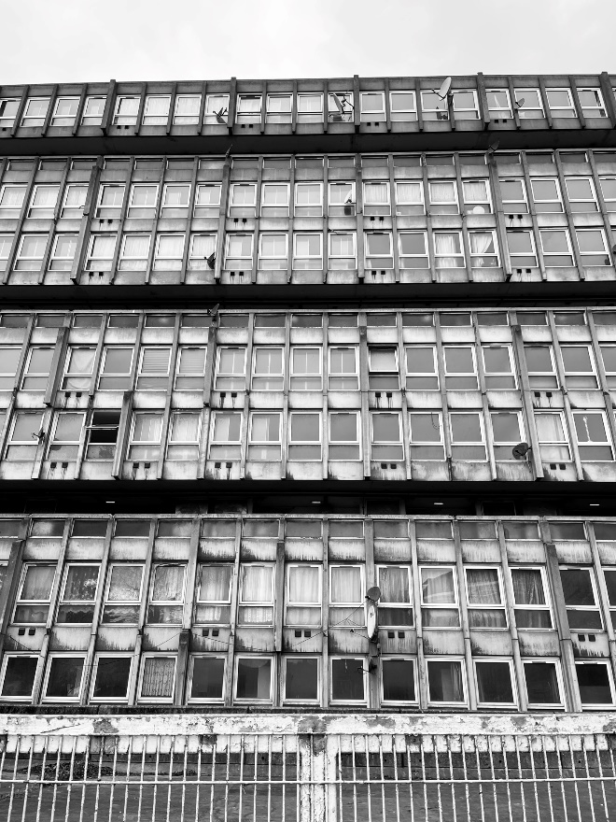
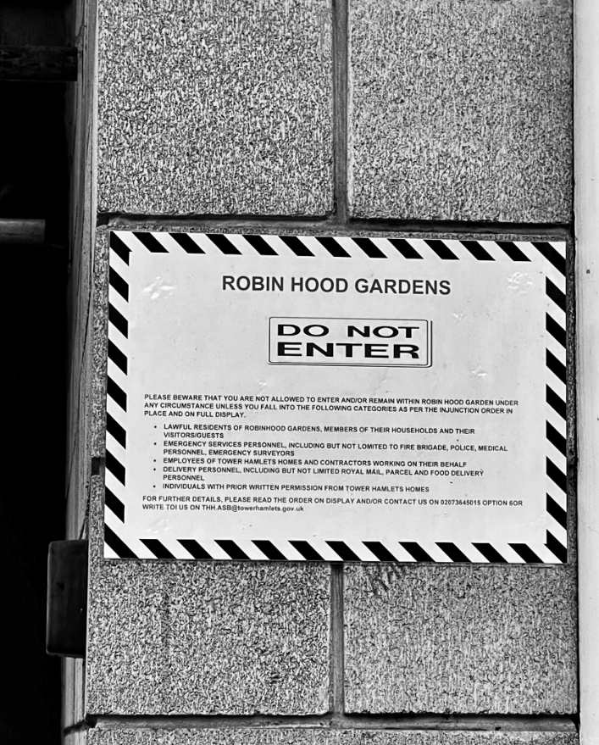
Figure 8 : A rainwater-stained facade at Robin Hood Gardens. (Credit : Author)
Figure 9 : A sign warning non-residents to 'stay out'. (Credit: Author)
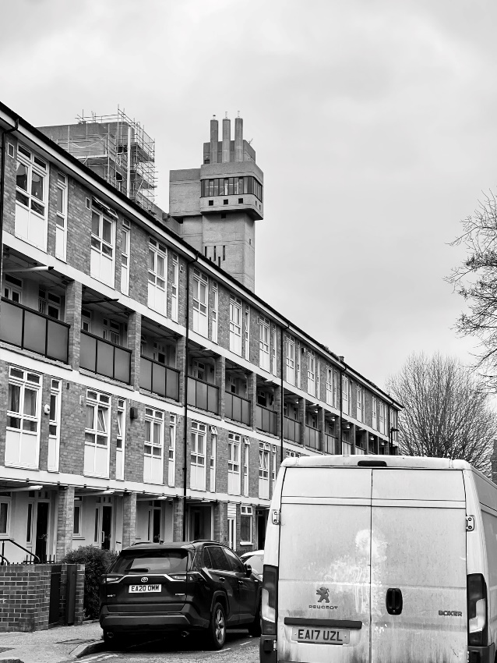
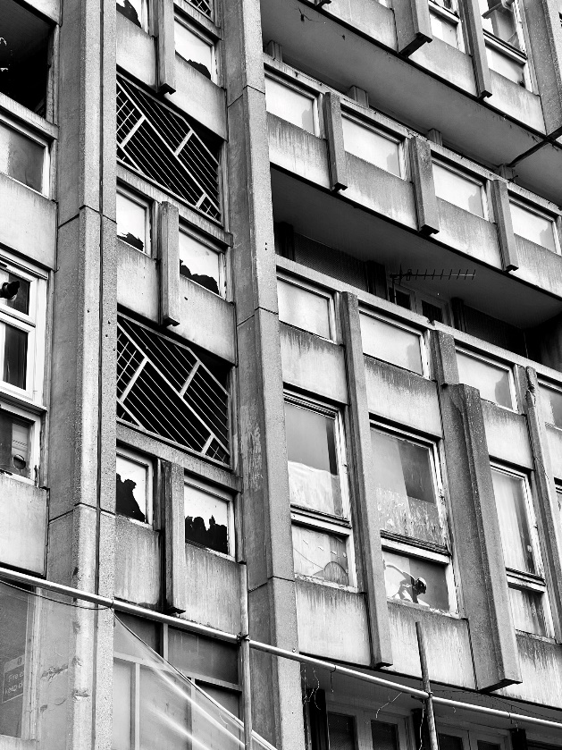
A bold sign next to the entrance warned of anyone who is not a resident, or an employee with links to the block, to stay out following an injunction order, but was this aimed at brutalist enthusiasts being a nuisance? or linked to social problems of the past?
Figure 10: Low quality housing adjacent to the Balfron Tower. (Credit: Author)
Figure 11: Robin Hood Garden's damaged facade, 2023. (Credit: Author)

Ultimately, I felt the Smithson’s design lacked any impressive sculptural form, there were no private outdoor spaces, only dark communal walkways coined as ‘streets in the sky’, which faced loud busy traffic. Robin Hood Gardens just did not feel worthy of listed status when compared, and sadly felt dated and below the standard of current day housing.

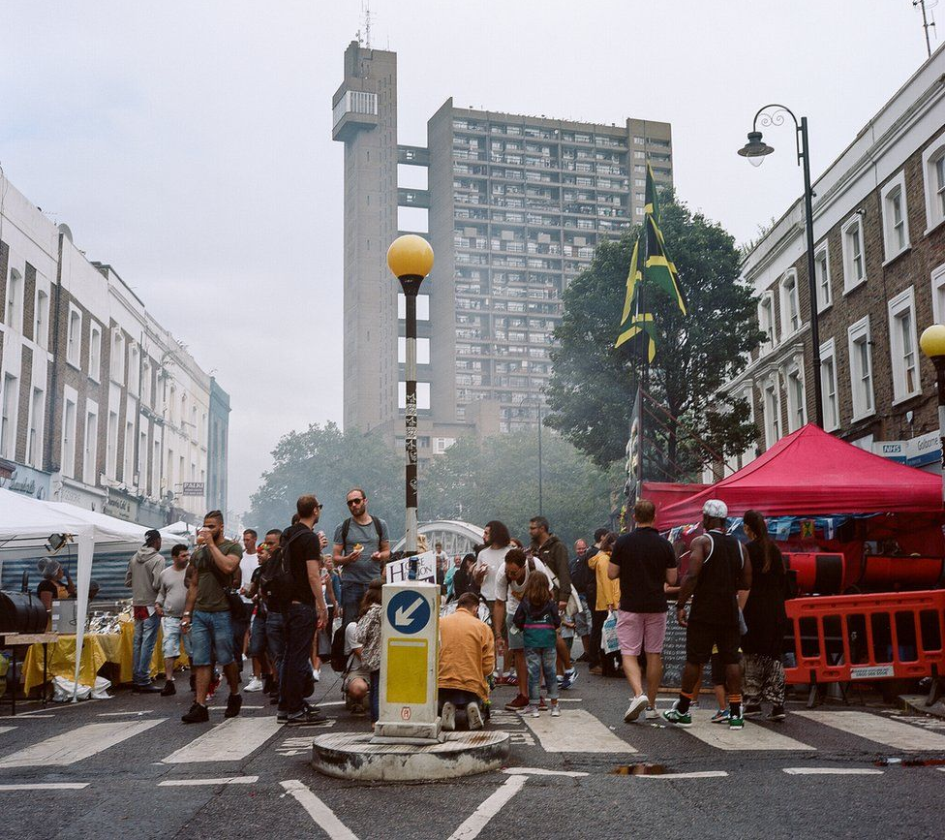
From Tower of Terror to a Grade II* Listed Icon – How perceptions of Trellick Tower have changed.
Figure 12 : Trellick Tower on approach from Golborne Road. (Credit: Nicola Muirhead)
Today, the Trellick Tower is arguably one of the most iconic and highly celebrated examples of brutalist architecture, appearing in almost every article, book or journal concerning the brutalist style. The tower block, devised as social housing for the local council, is situated in North Kensington, West London, as part of the Cheltenham Estate. Designed by Hungarian architect Erno Goldfinger and completed in 1972, the Trellick is the younger, yet more defined sister of the Balfron Tower, which was completed in 1968..

The tower has notoriously divided opinion between those that view its design as a masterpiece of post-war architecture built on egalitarian ideals, and those that have correlated this architectural style with hostility and social deprivation – believed to be ill-suited to the needs of its occupants and a breeding ground for crime.
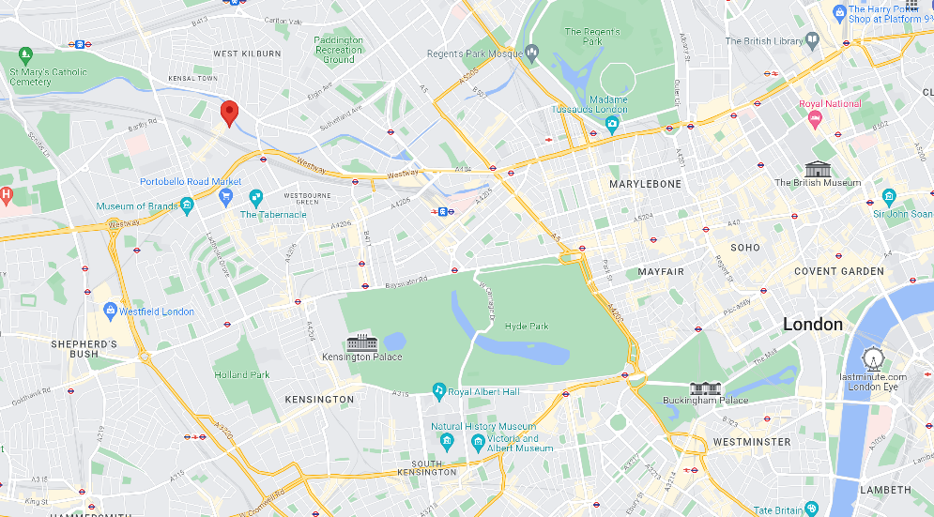
Figure 13: Map showing the location of Trellick Tower (Credit: Google Maps)
The History of Trellick Tower and its Portrayal in the Media

The Greater London Council (GLC) was created in 1964 and came to succeed the London City Council which had devised the plans for the creation of Trellick Tower and the Cheltenham Estate. Tragically for Trellick, the plans for a concierge in the lobby were soon axed, as budgets were tightened, and corners in Goldfinger’s design needed to be cut.
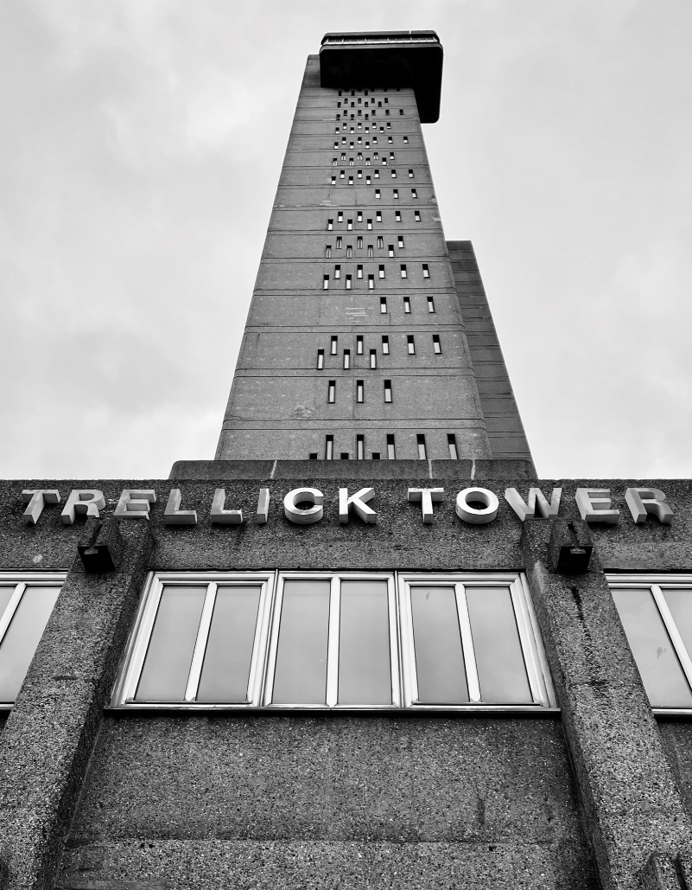
The Trellick stands at an impressive height of 98 meters, built of bush-hammered in-situ reinforced concrete, with 217 flats spread throughout its 31 floors. Making it one of London’s tallest buildings at the time of its completion. The concept of the Le Corbusier’s Ville Radieuse, where large tower block allow for more open parkland, is evident in the design, Goldfinger expressed in a letter to the Guardian that ‘the whole object of building high is to free the ground for children and grownups to enjoy Mother Earth..
Figure 14: Looking up at Trellick Tower’s service tower and cantilevered boiler room. (Credit: Author)

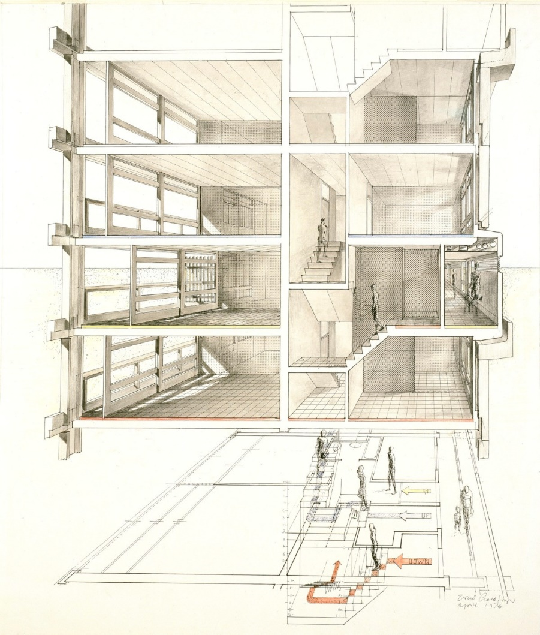
Built 4 years the Balfron Tower, Goldfinger further refined several details when designing the Trellick. The most striking feature of tower is the separate service shaft which links to the residential core via partially glazed walkways at every third floor, with the ‘crowning jewel’, the cantilevered boiler room situated at the top. Goldfinger rotated this service tower 90 degrees from his Balfron design, to present its narrower face to the front, to emphasize the building’s verticality. Three lifts, the lift motor room and escape stairwells, as well as a club room and laundry facilities are all situated within this zone. The separation of these elements allowed any noise created by the buildings services to remain isolated from the dwellings.
Figure 15: Trellick Tower section drawing by Erno Goldfinger in 1976. (Credit: Royal Academy of Arts)

Trellick’s section clearly derives from Le Corbusier’s Unite d’Habitation– with an enclosed bridge link at every third-floor lead from the service tower into the residential block down through a corridor, where residents have access to their flats. A 1-bedroom flats is wholly situated within this access level, while 2- or 3-bedroom apartments is accessible via an internal stairwell to the upper floor, with another on the lower floor – so by limiting the floorspace dedicated for public corridors, these apartments above and below the access level can stretch the whole width of the floorplate, with windows exposed at each end for optimum daylight¹⁸.

The south facing facade features floor to ceiling height windows and provide access to a private balcony – meaning every resident has access to their own outdoor space, even while living 30 floors up in the sky. Upon the twenty-fourth floor, are situated six two-storey 4-bedroom maisonettes and 2 two bed flats. This expresses the visible change in the balcony rhythm within the block’s façade, with a series of pulpit balconies on the upper floor of the maisonettes. The balcony walls are lined with cedar boarding, these warm tones contrasting greatly with the cold blush hammered concrete.

Following the GLC’s cuts to Goldfinger’s design, when residents began to move into the block in 1972, Trellick was left without security despite the residents’ pleas. Crime soon began to soar and accounts from residents as early as December 1972 recall events affecting the social environment within the tower. Lee Bolland remembered vandals opening the fire hydrant within the service shaft, causing the lifts to flood and much of the block being left without electricity, in complete darkness over the Christmas period, ‘things really started to go downhill after that’ she recalled.
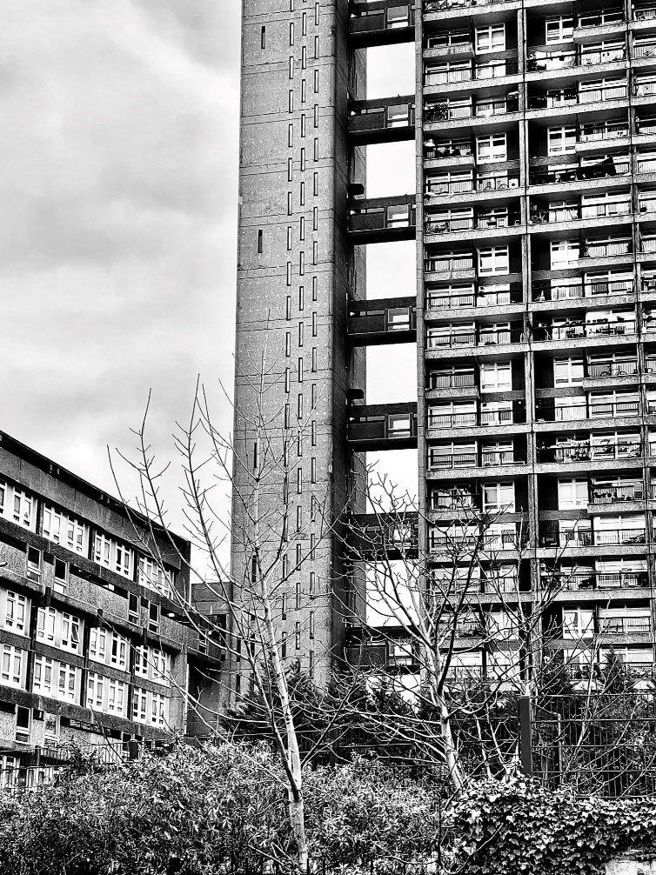
Sean O’Donnell, another resident, explained that nobody would deliver to the building, ‘a tv or white goods might get jacked halfway up the lift and never make it to the door’.
Figure 16: Trellick Tower's separated service tower and link bridges. (Credit: Author)

‘The nightmare would start moments after entering the lobby’. Rory Carroll wrote of the tower’s early days. ‘Stench of urine, beer and stale sweat would seep from shadows, the lights would be smashed again, and the corridor vandalised into gloom. Silence did not mean no one was there. Walk, and the broken bottles and syringes crunched underfoot. With luck, one of the tower's three lifts would be working. Fresh graffiti, used condoms and a passed-out vagrant might have been waiting inside when the doors parted’²⁰ .

The media quickly took notice of the storm of issues occurring within the block, and so, the notorious tabloid nickname, the ‘ Tower of Terror ’ came to be known. Trellick epitomized the stereotype of these crime-ridden, socially deprived council-owned ‘sink-estates’ in Britain for over a decade.

As early as 1978, the Observer reported ‘The high-rise block is the structural phenomenon which once seemed like the answer to everything, instead has become the nightmare symbol of bad twentieth century planning’The reporter claimed, ‘everywhere you look in modern cities there they are towering reproachfully, often ruining the skyline and oftener ruining the lives of the people who live in them’.

Newspaper articles referring to ‘suicidal mothers’, ‘drug overdosing teenagers’ and ‘sex attacks on young girls’ were all too common throughout the 70s and 80s. ‘Look up and you’ll probably see a tower block. They stand. Dingy grey stumps on the land, full of trapped and suicidal young families with screaming babies and frail pensioners struggling breathlessly up the stairs’.

Some of this negative media coverage was based on actual events, such as the ‘Knife man in sex attack flees naked’ which involved the attack of an 11-year-old girl within the lift of the tower, which contributed to the buildings reputation of becoming a breeding place for crime and social decay. Reports of various deaths surrounding the tower only furthered the tower’s sinister appearance, with the Evening Standard reporting of ‘The woman who threw herself and her baby from a tower last year expressed in the most tragic way how it feels to live on top of the world’ in 1978.

Blame was often placed upon the architect, Goldfinger, who became vilified in the media as a man who only designed with his ego in mind, The problem is that people actually have to live in his building, reported Stephen Games in the Guardian in 1983, ‘this argument is not merely about aesthetics, or ‘style’, it’s about habitable urban streets and communities versus abstract designs on architects’ drawing boards‘. Games goes on to describe Goldfinger’s design as a ‘modern abomination – a grim, brutal structure, with it faces pitted by bush hammers’ concluding that the Trellick simply isn’t an easy building to love.

Nonetheless, the fate of Trellick Tower was soon to change, and the estate would undergo an unlikely renaissance, dated to October 1984, when the Trellick’s resident’s association was set up. The association’s influence began to grow, with petitions and phone calls to the local council’s housing department and articles reaching local newspapers. By 1986, the council changed its policy for flats to only be given to those tenants who wanted to live in the block, while a year later, a concierge was introduced within the lobby to prevent non-residents from entering, and as a result crime and vandalism plummeted.

It was no coincidence that around the time of the introduction of the concierge, with the social environment of the towers greatly improving, did the way in which the media perceived the towers begin to change too. And by the 1990’s journalists and architects alike, were publicly calling for the towers to be listed.

‘Building Sights’ led by American Architect Sand Helsel, praised Trellick Tower and hoped to change the public’s perception by giving an insight into the design features of the building. She finished the episode by announcing. ‘I think Trellick Tower is a great building, it has a clear idea of its place in the city, its roots and a vision of how we might live there, then it’s up to us as individuals. It’s not an easy building, but who says architecture should be easy?’.

The Tower of Terror’s dark age had lasted almost two decades, but suddenly the residents were living in some of London’s most sought-after flats. After a campaign led by James Dunnett, who formerly worked with Goldfinger, by December 1998 the Trellick Tower gained Grade II* Listed status due to its historical and architectural significance. Seen to be the ultimate expression of Goldfinger's philosophy of high-rise living, the tower embodies the best ideas for brutalist social housing of its time. ‘ Post War Estate seen by so many as a social failure is now protected’ reported Giles Worsley in the Daily Telegraph in 1998, who goes on to describe the Trellick as a building to be of outstanding architectural quality.

What happened inside the Trellick was an evolution, with appropriate management the social environment changed dramatically, the tower’s reputation was dragged out of the abys. But outside, nothing changed, the concrete never shed its austere, but feelings towards the architecture softened and became widely accepted.

So, how do the residents perceive Trellick Tower now?
‘The client does not care about architecture; he cares whether the building works. The architecture is my own private pleasure,’ Erno Goldfinger. To what extent is this true?

Through analysis of 16 online interviews, a range of value judgements were made by residents, revealing what Trellick means to those who live there. All interviews were undertaken in 2017 and includes a variety of residents from those who have and still lived in Trellick since its opening in the 1970s, to residents who have more recently moved in. A primary question ‘What does Trellick mean to you?’ was asked to each resident, but each interviewee was able to lead the conversations from this point. (See Appendix A)

During the research period, it has been difficult to separate the residents’ views and perceptions of living in tower blocks from their perceptions of brutalist style architecture itself. To most, the fact they lived within a brutalist style building seemed unknown, with little to no mention of the styles features or knowledge of the architect Goldfinger. Despite the dramatic architectural style of the block, very few residents associated their perception of Trellick tower with the aesthetics of the building at all.

Community Spirit
The functional value of the community within Trellick Tower was a common theme throughout the interviews. When asked ‘what does Trellick mean to you?’ Resident 1 stated it was the community that made her fall in love with the building, after meeting several other residents who spoke her native language – Portuguese. This made her feel ‘at home’ in Trellick.Similarly, Resident 12 stated she has ‘never lived in a place in London where the people have been so friendly’ and claimed this gave Trellick a ‘magical feeling’, making it very different from other tower blocks.

This importance placed on the community spirit of the building naturally led to many residents fearing that possible future privatisation or gentrification will destroy what makes the tower so special, particularly whilst being aware of what is currently ongoing at Balfron Tower. Resident 8 believed it ‘would be a crime if these two building classics should be sold to the few, in the private market, rather than being available to the ever-changing volume of social people who come and go, that would be a real shame’.

Resident 6 complained of his ‘posh neighbours’ ‘buying their way into the building’ and claimed, ‘they don’t want us here even though we grew up in the area’. He believes the community spirit of the 80s and 90s had already been destroyed due to a significant minority of the flats within the building, being sold to a new demographic of residents. This comes as a result of the ‘Right to Buy’ scheme in the 1980s, where privately owned flats in Trellick, once purchased by original residents, have since returned to the market .

However, other residents held the view that Trellick Tower in fact alienated its residents, leaving many feeling isolated and lonely, with no sense of community between the residents. Resident 16 recalled growing up in the tower as a young girl, but being of white ethnicity in a tower of primarily Afro-Caribbean and Moroccan people left her feeling isolated and outcast. She claimed there is little interaction between residents, especially cross racial interaction. Resident 13 reiterated this viewpoint when describing Trellick as a ‘melting pot of different nationalities’ and claimed each nationality ‘sticks to their own’.

When asked ‘what does Trellick Tower mean to you?’ residents recalled personal experiences within the tower which had an effect on the way in which they perceived the building. Resident 10 commented on her experience of seeing groups of men hanging around the area and the tower, leaving her feeling intimidated and somewhat unsafe in the public spaces of Trellick. This is a very similar experience to my own upon visiting the estate. Similarly, Resident 12 recalled a time where ‘two men in hoods’ tried to kick her apartment door down during the night, but she refused to let this ‘one little scary thing’ hinder her experience of living in the Tower.

Trellick’s Cultural Significance
More recent residents of Trellick had a clear understanding of the tower’s architectural and historical significance which led them to pursue a flat within the block. Resident 14 said he had always been interested in architecture and admired the building, ‘I know it’s like marmite, you either love it or you hate it’ he explained ‘but it’s like a street in the sky and I like that very much’ a reference to the theory from the Smithson’s, no doubt.

Three of the interviewed residents passed comment on the increase in tourism to Trellick Tower. ‘You go out on the balcony, there’s always people pointing cameras up, people taking photos all the time, phones, cameras, people come all the way to this area just to stand up and stare at Trellick, it’s like you’ve become a tourist attraction you know’ recalled Resident 6 clearly reflecting the recent revival of interest in Brutalist buildings.

Spatial Experience
Seven of the sixteen residents interviewed, claimed it is the views from their apartment that make Trellick so special to them. Resident 2 spoke fondly of being able to see special holiday events from her window throughout the year ‘fireworks on bonfire night, the lights at Christmas, it’s like looking down on a little picture sometimes’. While Resident 8 described her flat in the sky, to be of great value within a city, ‘Not being in the traffic or passing public, its quieter, almost like being in the countryside’ .

This spatial experience being the most commonly referenced value judgement by the residents suggests that their feelings towards Trellick tend to be influenced by the nature of living in a high-rise building, rather than living within a brutalist style building.

Functional Value
The functional value of the building is another key theme throughout the interviews. Resident 16 spoke fondly of the sheer size of her apartment, arguing that ‘architects don’t design flats this size anymore’. Whilst Resident 11 initially felt terrified of the buildings ‘dark and nasty’ exterior, and only fell in love with Trellick once she saw the flats, commenting on how modern, spacious and light they were, especially in comparison to the other homes she had been offered by the council.

Goldfinger took inspiration from Le Corbusier’s Unite d’Habitation of having all amenities in one place, and his design included community facilities such as the laundry room and club room. However, due to vandalism many of these features never became reality in Trellick. Resident 14 and Resident 16 both felt disappointed in the council for never helping to revive these facilities, no plans have been devised to make use of the boiler room which has been disused for many years.

Many residents were concerned with the council’s maintenance of the block. ‘I’m 25 years looking off my balcony, seeing the entire neighbourhood get scaffolded twice for repair work and Trellick has had nothing, bar the east windows being replaced out of necessity, rather than regard for the building’ explained Resident 8 . Residents claimed that it was the fault of the council, that Trellick fell into squalor in the 70s and 80s, failing to introduce adequate security, before this ‘you could go to buy a newspaper and your house is burgled by the time you return’ explained Resident 13. The introduction of the concierge played a pivotal role in changing perceptions, with many of the long-term residents speaking fondly of how much life improved after this point.

It is clear to see, from the evaluation of these interviews, that the resident’s perception of their building, and their homes are shaped by the functionality of these spaces, rather than the aesthetic value of the architecture. With the exception of two interviews, the majority of residents seemed unaware that they in fact lived within a brutalist style building, with more attention paid to the high-rise nature of the block.

The spatial experience Trellick Tower provides, with views across London is clearly a highly appreciated element of the resident’s day to day lives. The community spirit throughout the block is very controversial amongst residents, with some speaking positively of their experience here, while others feel pushed out by the new demographic of residents. The lack of maintenance is also a major concern for some residents, which again strengthens the argument that ‘residents do not care for architecture, they care whether the building works.’

Balfron Tower and Gentrification
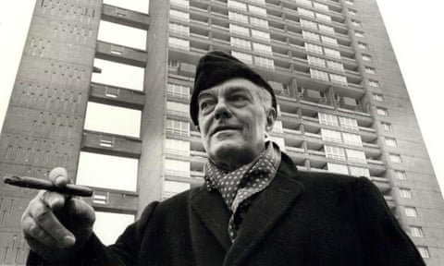
What are the consequences of these changing perceptions of Brutalism today?
Figure 17 : Erno Goldfinger standing in beneath Balfron Tower in 1969. (Credit: Keystone Pictures USA)
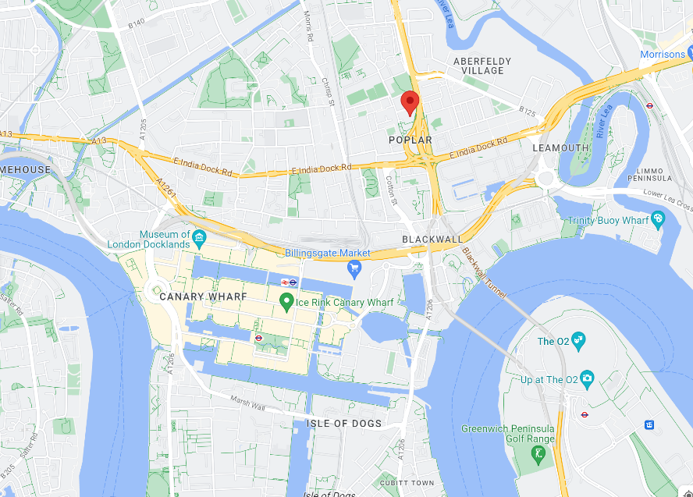
Figure 18: Map indicating the location of Balfron Tower. (Credit: Google Maps)

Balfron Tower is situated in Poplar, East London, and forms part of the Brownfield Estate. Construction was completed in 1968 and designed by Erno Goldfinger. The Balfron is the older of his two towers and shares many distinct design features with its more refined West London sister – Trellick Tower. Balfron Tower has a separated service shaft, with its concrete walls pierced by an array of slit windows. The service shaft is topped with a series of concrete ventilation columns from a cantilevered boiler room, creating a silhouette appearance of embattlements. This feature makes the architecture seem almost warlike, making a bold impact on the London skyline.
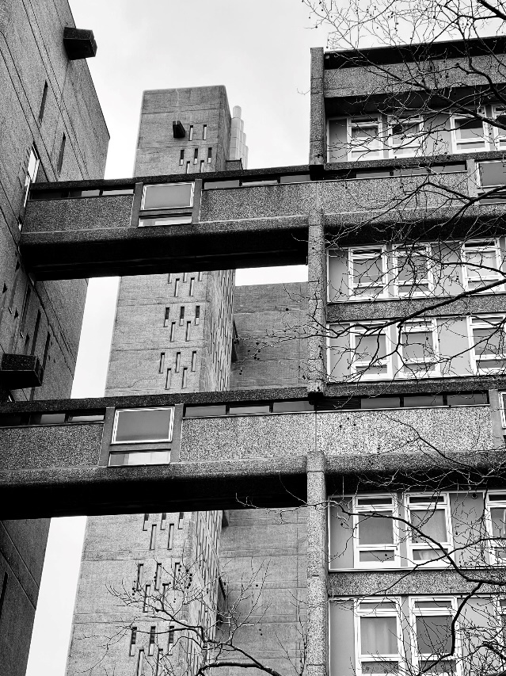
Figure 20: Balfron Tower view from Carradale House. (Credit: Author)
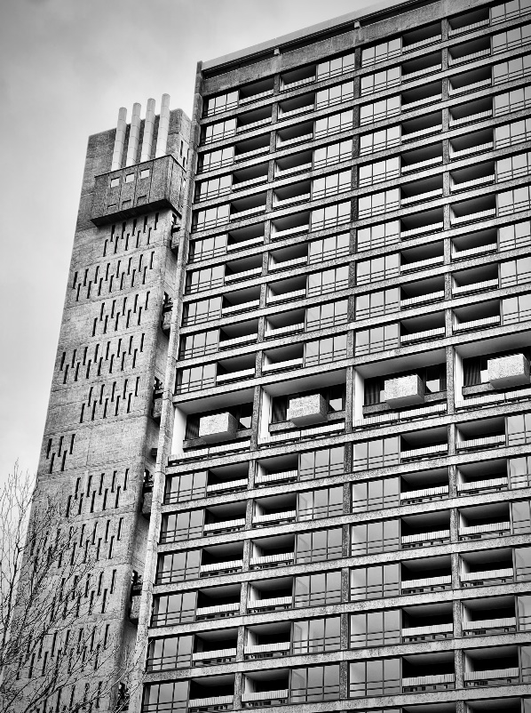
Figure 19 : Balfron Tower façade, with concrete ventilation columns exposed from the boiler room. (Credit: Author)
The tower rises to 84 meters, with 28 floors, looking down upon its neighbouring buildings – Glenkerry House and Carradale House – which were also designed by Goldfinger to form the Brownfield Estate. The tower houses 136 flats and 10 maisonettes. The flats in Balfron are accessed via this third floor and then internal stairwells take occupants up or down to the main volume of their flat.

Goldfinger moved into the Balfron with his wife Ursula, for a two-month period in 1968. His aim, to gain an understanding of how well his design worked in practice, he spoke to residents and asked about what they enjoyed and disliked about their apartments. One resident famously recalled speaking to Goldfinger in the lift, to which she complained of his lack of a broom cupboard in the design of the kitchen, to which he replied, ‘Bloody women… never satisfied’. Goldfinger noted all of these concerns and carried them through into his design of Trellick Tower, in 1972.
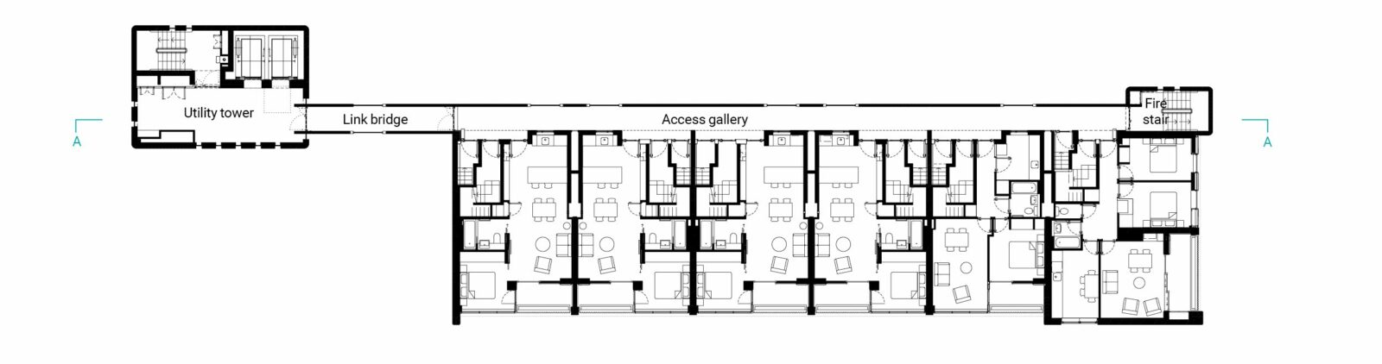
Figure 21: Typical floorplan from Balfron Tower since its refurbishment. (Credit: Studio Egret)

For decades this high-rise council estate was condemned by the media as an inhumane ‘sink-estate’. ‘Although perversely beautiful, it conjures up thoughts of prisons and pillboxes. Here, too vandalism is setting in’ reported the Guardian in 1969, only months after the tower opened its doors to residents.
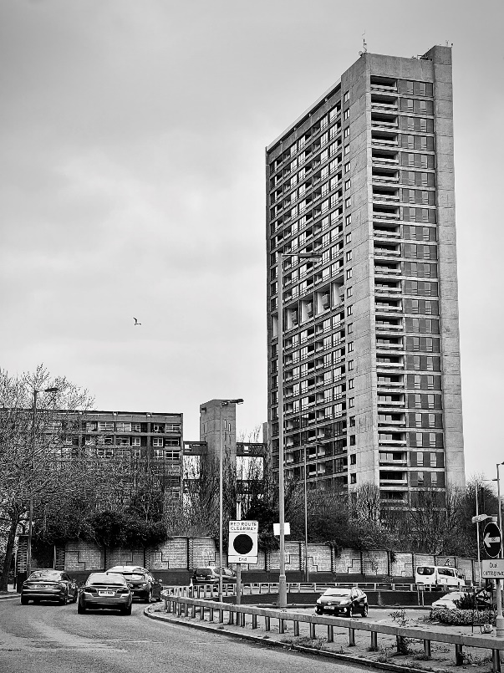

Figure 22 : Balfron Tower on approach. (Credit: Author)

Fast forward a few years, along with the forever rising London house prices, the Right to Buy made a range of former council flats within the Brutalist tower block estates available on the housing market. Whilst this has contributed to a temporary social class mixing that has not often been seen before, with council residents now living alongside young working professionals and wealthier individuals, overtime it is reducing the number of social-rented properties available.

This is a growing phenomenon in many brutalist housing estates across the United Kingdom, a notable example is the previously discussed Trellick where a significant minority of the apartments were bought under the Thatcher scheme, but with those original residents now gone from the block, these apartments have now moved onto the private housing market

However, this loss of social housing has more recently been hugely accelerated by when ownership of these estates is transferred from councils into the hands of housing associations, who ultimately sell entire estates to housing developers. This is the case happening right now at Balfron Tower, arguably one of the most celebrated examples of such sales, with has created a media storm of bitter past residents and housing campaigners alike.

Yet as the popularity of brutalism is growing by the day, these such estates are now being recognised as excellent housing examples. Now, the social tenants are being forced to make way for property developers to house the better off.

In 2006 residents were asked to vote whether the management and ownership of their homes within the tower should be transferred to housing association Poplar HARCA or remain under the control of Tower Hamlets Council. The vote went in HARCA’s favour. At this time, the number of social residents within the Balfron stood at 99, with 36 lease holders and 11 vacant properties.

Poplar HARCA own and manage 6,000 social rented homes in Poplar and have also built over 1,000 additional homes over the last 15 years. The association has carried out refurbishments in all of its properties, supported social enterprises in the locality and helped many unemployed residents into work, just to name a selection of the improvements they have made to the area – arguably seen as a far greater influence than that of the council. This could suggest why residents of the Balfron, and the rest of the Brownfield estate may have opted to vote for the ownership and management of the block to be transferred to the housing association in 2007. However, what is currently happening in the Balfron is far from the outcome its residents thought they were voting for.

Two options were proposed to the residents, firstly they could remain living in the flats whilst a refurbishment was carried out, or they could opt to move into a new HARCA owned home elsewhere in Poplar, if the second proposed option was chosen then the flat would be sold privately. The money from the selling of the properties would go towards the refurbishment project.

This was offered to residents from Balfron Tower and Cardale House. It was anticipated that approximately 130 residents from the blocks would choose to leave immediately. Balfron was notoriously known for suffering from a lack of maintenance, as well as anti-social behavioural problems and many families lived in crowded conditions. This led many residents to take HARCA up on their offer, though many residents did opt to stay. So, this meant that the private sale of some of the flats in the Balfron was always HARCA’s plan, though the prospect of the social tenants retaining their tenancy was supposedly too. HARCA made no mention of any plans to ‘decant’ the residents during the refurbishment process, neither on a permanent or temporary basis.

However, the residents who were told to leave their homes for refurbishment works in 2010 due to safety risks, left with the understanding that after completion they could return to their homes. Any communication distributed from HARCA during the decant made no mention of the residents return, which caused alarm amongst the residents. For the next 5 years, HARCA maintained that the social residents would ‘possibly but not probably’ be permitted to move back into their homes.

To add more fuel to the fire, as the building was emptied of its residents, HARCA invited artists in collaboration with the Bow Arts Trust, to occupy the tower’s empty flats temporarily as live/work studios through a guardianship scheme.

It is widely believed that this practice of inviting artists to live in an area during redevelopment, helps to rejuvenate these lower-class, deteriorating neighbourhoods, bringing vibrancy to the area which in turn helps to raise property prices. This process has been termed as the ‘classic profit-driven regeneration maneuver : artwashing’. The properties were let out on a short-term basis to the artists. Once these agreements expired, the full-scale refurbishment of the block could begin.

So how is this being perceived?

This situation at Balfron Tower is being referred to by some as ‘gentrification’, described as a process where wealthier, and generally higher educated individuals move into poorer working-class communities. Often improving housing and attracting new businesses, whilst simultaneously uplifting the reputation of the area. However, this often displaces the original residents in the process . So, can the current situation at the Balfron be defined as gentrification?

This redevelopment of the Brownfield estate is starting to split the Brutalist’s fanbase, there are those who are fundamental fans of the stylised aesthetic of this concrete architecture, and those who stand by the ethics of the movement, wanting Balfron to continue to serve its original purpose of housing social tenants.

One of Balfron Tower’s residents’ greatest advocates was Rab Harling, a photographer who moved into Balfron under the Bow Arts Trust scheme in 2010. Upon moving into Balfron, he undertook a new project named ‘Turning Balfron Tower Inside Out’ where Harling would photograph homes of residents and in turn hear their stories, many of which spoke of their heartbreak of being forced to move from the tower. ‘It is wrong to believe that residents did not value what they had, that it was wasted on them. It was rare to meet anyone who did not speak passionately about the building and/or their community’.

In 2014, Harling founded Balfron Social Club, an online campaign, with the aim of exposing the privatisation of the tower in the media and to put pressure on Poplar HARCA. A petition demanded a minimum of 50% of social housing to be retained within the block, which gained over 3,000 signatures from leaseholders and local activist groups. Despite this forcing the planning meetings to be held in public session, the messages of this campaign were otherwise unnoticed.

Concerns over the privatisation of Balfron Tower even reached the House of Lords, on 5th November 2015, Lord Cashman declared there had been poor communication and poor attitude towards tenants from Poplar HARCA during the decant and refurbishment, especially with regard to the changing of plans upon the deceptive decanting and the eventual decision to 100% privatise the tower.

‘There is a lot of nonsense talked about gentrification, but if you want a pure description of how it works in practice – Balfron is the place to turn.’ reported Owen Hatherley, who believes Poplar HARCA’s treatment of Balfron Tower is a clear indication of how housing associations have shifted their focus towards becoming part of the developer industry, rather than serving their purpose of providing affordable social housing. The shockingly unempathetic treatment’ of Balfron’s residents throughout this process, further highlights his point. Hatherley believes the social and moral damage within the Balfron, and its community is irreparable.

‘Step one, residents are induced to opt into a ballot to go from renting from the council to renting from a charitable quango by telling them their building will be renovated if they do. Step two, upon realising that renovating a listed building is hard to do cheaply, decide that selling the newly fashionable building off can "offset" the cost of the renovation of other social housing in the area. Step three, move in artists to have cheap studios in said building during the process of "decanting", so that affluent people start to visit and become familiar with an area that otherwise they might feel uncomfortable in. Step four, sell to the highest bidder.’

But Hatherley also states a clear understanding of the housing associations standpoint in this argument, explaining that this is often the only viable financial solution to these associations undertaking such vast projects. However, this makes the situation worse with a more expensive market housing and with considerably less social ‘non-market’ housing available. And the greatest irony here, is that this is happening to Balfron Tower which was envisioned in every aspect to be affordable social housing, by an architect so vocal of his socialist values.

‘It is not the residents who need to be saved from the brutalism, but indeed the brutalism that needs to be saved from the council residents.’ claimed critic Nicholas Thorburn. He shares a similar view to Hatherley, reporting of the change in recent architectural tastes in his book ‘Brutalism as Found’- with favours moving from the white box designs of the early modernist, International Style, to now embracing the post war style of Brutalism, being the cause of the gentrification of Balfron Tower.

Thorburn puts forward his theory called ‘Beauitiful Brutalism’ in which the architecture is ‘appropriately indexed’ to allow for middle class buyers to move into ex-council owned homes, whilst cleansing it of its working-class associations and easing its transition into the property market.

First the Balfron served as an ‘artefact of cultural consumption’, then it becomes purchasable high-end property. The National Trust facilitated sell out tours of the refurbished apartment in which Goldfinger inhabited for a period, decorated in 1960s vintage interiors. While the previously mentioned Bows Art Trust guardianship scheme allowed artists to inhabit the vacant properties and a huge array of pop-up art and cultural events became the new face of Balfron Tower.

Under this sway of ‘Beautiful Brutalism’, the way in which council housing is perceived culturally is changing. Balfron Tower, after being notoriously slandered for being inhumane and inhabitable, is no longer seen as anachronist, but instead now desirable to the middle class. Thorburn further states that it is this dismantling of council estates that has created the housing crisis today.

What happened to the residents?

In 2015, Poplar HARCA announced that Balfron Tower would no longer contain any social housing. The decision was made that the flats would be sold as luxury flats in partnership with developer London Newcastle. A one-bedroom flat within the Tower starts at £365,000, with larger apartments being sold for up to £800,000.

Despite the campaigns, this privatisation is seen as a feasible solution for the tower, given the lack of government funding for social housing. By concentrating sales in the higher valued, sought after Balfron Tower, it was found that fewer social rented properties would need to be sold overall.

Since 2010, HARCA has worked to rehome all residents with 95% of Balfron’s residents being rehoused within Tower Hamlets, with 81% of those in HARCA owned properties. Of which 35% of families were moved into larger homes. With 1 in 3 families already registered to move due to overcrowding and over 20,000 other households already on a waiting list to upsize, this was an opportunity for Balfron’s residents to move to better suited homes far sooner. A number of residents were moved into the adjoining lower rise Carradale House, helping to retain some of the Balfron community within the Brownfield estate.

Money from the sale of apartments allowed HARCA to build new low-rise flats close by to the Balfron, with the Chief Executive of the housing association, Steve Stride, in referring to these newly built flats, stated ‘this is all social rent, the quality is fantastic. Low-cost home ownership right there. There’s no way you can say that is gentrified’. It is to be noted these statistics came from Poplar HARCA’s own publicity, the views of the residents were not documented during this.

Hugh Thompson, a former resident of the Balfron, angrily speaks of the developers plans to convert the old laundry rooms into ‘community facilities’ in an online video, ‘they’ve just kicked out everybody, there’s never going to be a community here again, there’s been a community here since 1968 when they built it’.While Michael Newman, a resident of the Balfron since the 1980’s, spoke of the ‘unimaginable’ psychological stress caused since he was told to leave his home, living for years without knowing if he could return.

So, has Balfron Tower been gentrified?

Balfron Tower is often described as an icon of Brutalist architecture, however, its legacy now seems ‘ironic’ instead of ‘iconic’. A tower built by Goldfinger, the architect with explicit social ideas, to house the working-class communities of the east end, has now been appropriated by the rich in what appears to be a blatant exploitation of the rising popularity of the Brutalist aesthetic.

The ethics behind the Brutalist movement have been undoubtably lost on the Brownfield estate, with residents forced to leave their properties on false pretences, leaving their homes which have been lived in by generations of the same families. Whilst all of the Balfron Social Club campaigns have been overlooked.

While considering the obvious financial struggles of the housing association in refurbishing the block, which may possibly have been HARCA’s only viable option, it is still very likely that it is the publics change in perception and desire for such architecture led to the voices of the social residents being ignored in pursuit of financial gain.

But what makes Balfron’s privatisation so brutal when compared to the fate of most other Brutalist council estates, is that the whole of the building was sold into private hands. Whilst most other estates such as the Park Hill estate in Sheffield, still retain at least some social housing – 20% in this case. It is a real shame, that not even a small minority of the tower could retain a social presence.

A Brutal Failure: Robin Hood Gardens and the Loss of a Brutalist Council Estate.
Not every estate, however, is seen to come back into such fashion. So, what happens to those buildings where perceptions perhaps did not change?
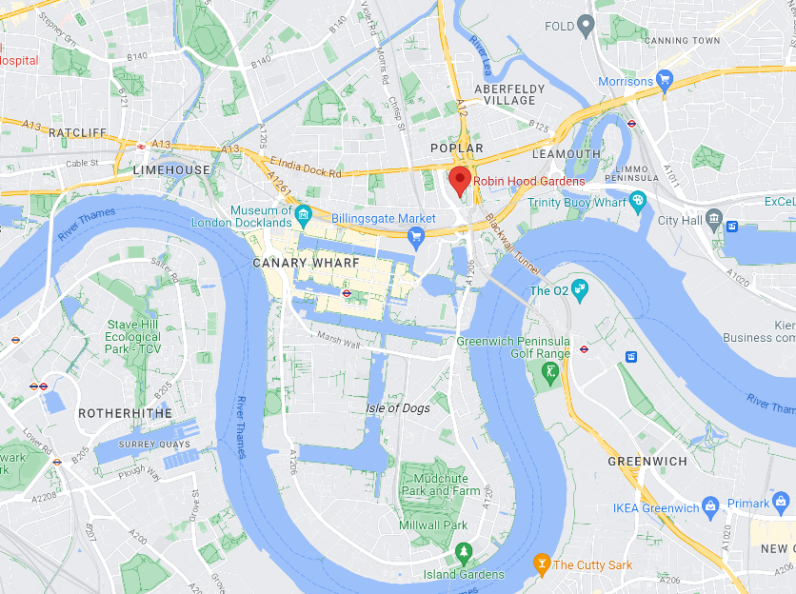
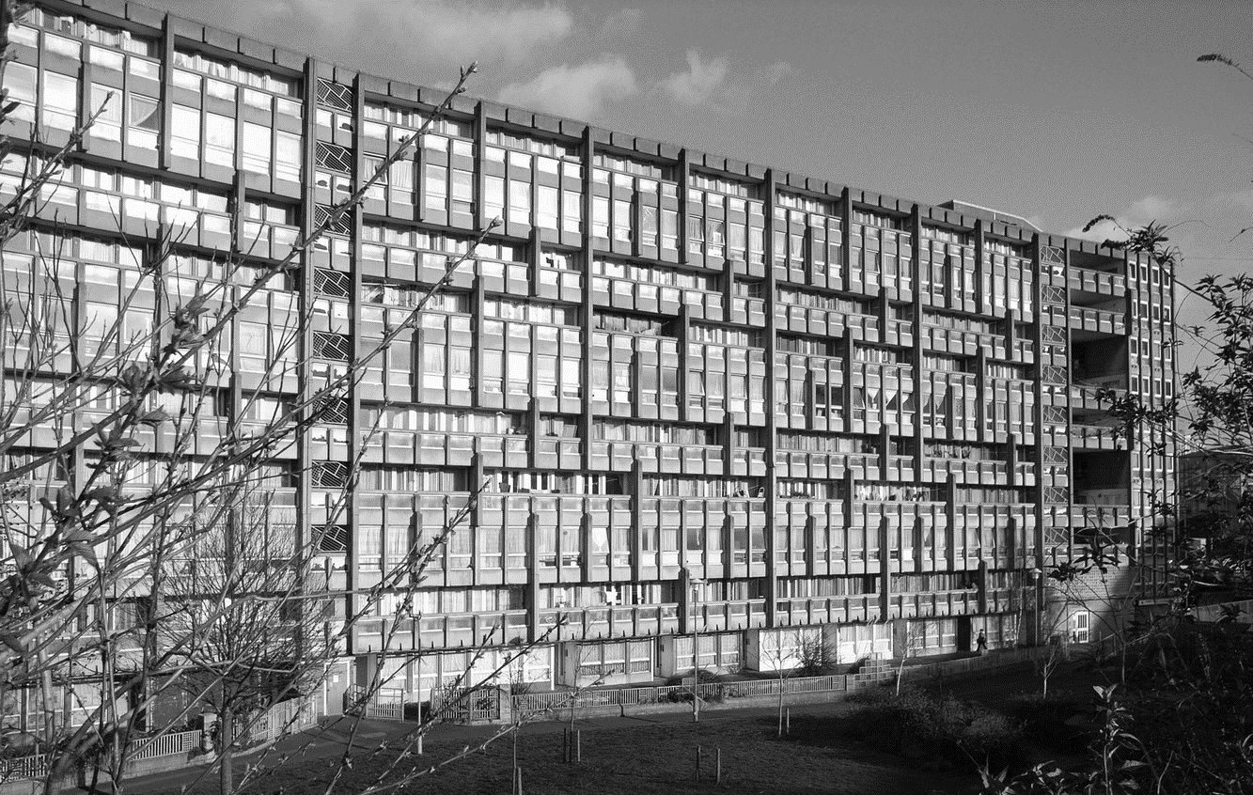
Figure 23 :P Map indicating the location of Robin Hood Gardens. (Credit: Google Maps)
Figure 24 : Robin Hood Gardens - Northern Block before demolition. (Credit: Steve Cadman)
At a stones-throw away from Balfron Tower, you’ll find Robin Hood Gardens, designed by Peter and Alison Smithson. Built within 1 decade of each other, but there is one fundamental difference between these two Brutalist icons. Whilst the Balfron remains protected under Grade II* Listed status, Robin Hood Garden has been denied of such privilege, which has ultimately led to its recent demolition.

Robin Hood Gardens was completed in 1972. For years, the architects, Peter and Alison Smithson were well known theorists amongst the architectural community and became known as the duo that led the British Brutalist movement⁶⁷. They had completed some earlier projects such as the Smithdon High School, in Hunstanton, where Alison first coined the phrase ‘New Burtalism’. Robin Hood Gardens was to be the Smithson’s opportunity to finally build social housing on an urban scale, which would become the culmination of their years of research.
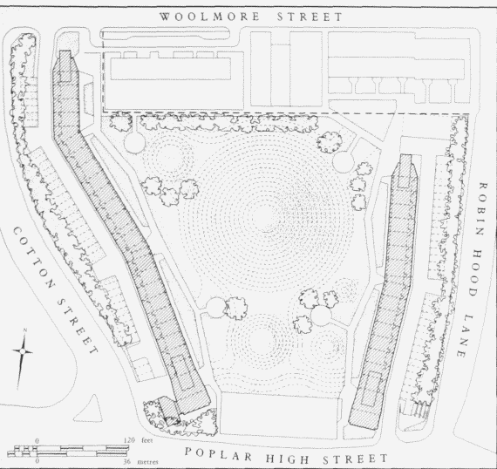
Figure 25 : Robin Hood Gardens site plan. (Credit: Peter Vidani)
The estate comprises of 213 apartments, spread across two horizontal blocks, which are low rise in comparison to the Goldfinger Towers. One built of ten storeys and the other of seven, this lower block allows in more southern light to the urban communal garden found between the two buildings. The two blocks bend slightly inwards, protecting this inner sanctuary - which features a large grass mound .

The blocks were built using a precast concrete, with a smooth cast finish, and the complex is surrounded by a ring of intimidating concrete walls, which are tilted outwards in attempt to block out traffic noise. Whilst distinctive concrete fins can be seen on the building façade, which were designed with the same aim of reducing sound transmission, due to the estate being situated next to the busy Blackwell Tunnel Northern Approach.

As seen in the Goldfinger Towers, with the idea taken from Le Corbusier’s Unite d’Habitation, the Smithson’s design features public access routes via every third floor, in the case via a ‘street’. From here, there is access to two flats via each bay, each has access to a kitchen on this same level and then internal stairwells within the apartment take the occupants up or down to their living spaces and bedrooms. Beneath this, on the ground floor, were one-bedroom apartments for retired residents.

The Smithson’s embedded several other social design elements within the estate, but most famously their concept of creating ‘streets in the sky’ is clearly visible within the building’s façade. Every third floor includes a wide concrete balcony, intended as a place for children to play and neighbours to stand and chat to one another – taking idea of a typical urban neighbourhood street but instead, stacking it vertically.
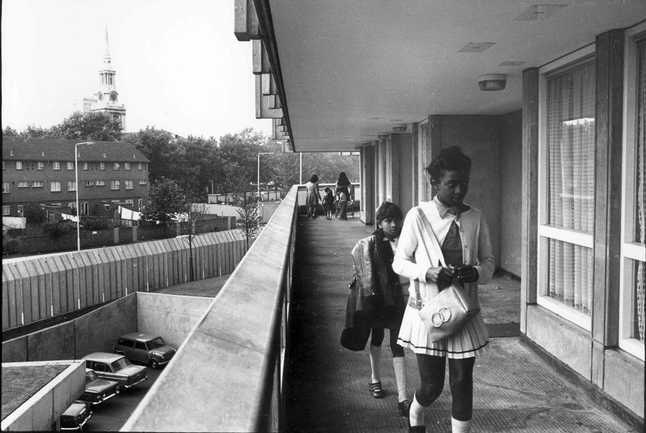
Figure 26 : Girl on a Street in the Sky, Robin Hood Gardens, 1972. (Credit: Sandra Lousada)
The bedrooms faced in towards the central garden space, to ensure noise from the adjacent heavy traffic was felt at a minimum. However, this meant that the ‘streets in the sky’ decks faced the busy roads instead, leaving an area envisioned to be a child friendly area to play and neighbourly meeting zone, very loud and uninviting.

The apartment doors were set perpendicular to the walkways to provide an element of privacy, and with 2 sets of doors facing towards each other, the Smithson’s hoped this would further promote interaction between neighbours.

However, Robin Hood Gardens soon fell into disarray, becoming synonymous with anti-social behaviour and crime. The social environment of the block was far from the urban utopia the Smithson’s had envisioned. A lack of maintenance left the apartments as undesirable places to live. The estate was ridiculed as an ‘appalling example of new Brutalist architecture’ in the Evening Standard.

Conversely, the architectural community soon recognised the estate as an important example of Brutalist architecture, and calls were made to list the building.

What is the listing process for such an estate?
Under Historic England’s listing selection guidelines, concerning post war housing, due to the ongoing evolution of our understanding of post war housing, it is difficult to establish the criteria required for listing. However, some benchmarks have been identified. A building is valued on :
Its architectural interest,
The degree of survival of the design,
If the design was influential,
If it represents a particularly good example of a development in housing,

The important factor for any post-war building is whether it fulfilled its original brief. What were the original intentions of the architects, and how did the estate originally look? In this case, public housing benefits from being well documented, in surviving council records and architectural magazines.

Robin Hood Gardens was first denied listed status in 2009. A certificate of immunity from listing was issued in 2009 for the estate meaning the estate could not be reconsidered for listing for 5 years. It was expected that the Tower Hamlets council would demolish the complex in this time. However, by 2014 no action had been taken on the site, with both blocks and their residents remaining. Tower Hamlets council then applied to Historic England for this certificate to be renewed but this also allowed the case to be reopened into the possibility of listing.

Several famous and influential architects have called for the estate to be preserved. Richard Rogers urged fellow architects to join a campaign to save the estate in an open letter, written with Simon Smithson, where they regarded Robin Hood Gardens to be the ‘most important social housing development from the post war era in Britain’.

The letter followed the revival of a high-profile campaign by the Twentieth Century Society to save the estate, which was backed by hundreds of architects across the world, including Zaha Hadid and Frank Gehry. Henrietta Billings, from the Twentieth Society hoped that listed status would bring a fresh look at the architecture and a new appreciation of its design features. However, despite the high profile calls for listing, Robin Hood Gardens was denied this status for a second time. Upon the denied request for listing, Emily Gee, Head of Designation at English Heritage issued this statement.

‘In recommending a building for listing, particularly one so recently built, we need to consider whether it stands up as one of the best examples of its type. We don’t think that Robin Hood Gardens does. It was not innovative in its design – by the time the building was completed in 1972 the ‘streets-in-the-air’ approach was at least 20 years old. The building has some interesting qualities, such as the landscape, but the architecture is bleak in many areas, particularly in communal spaces, and the status of Alison and Peter Smithson alone cannot override these drawbacks. The complex does not equal the architectural achievement of other 20th century estates which have been listed such as the Barbican and Brunswick Centre in London, and Park Hill in Sheffield.’
Unlike many other much-criticised estates, Robin Hood Gardens never seems to have experienced its heyday. It was born into bad times – with public feelings towards brutalist tower blocks was already struggling, it became notoriously known for its social deprivation. And now with its listed status denied, not once but twice, demolition was to be the estates fate.
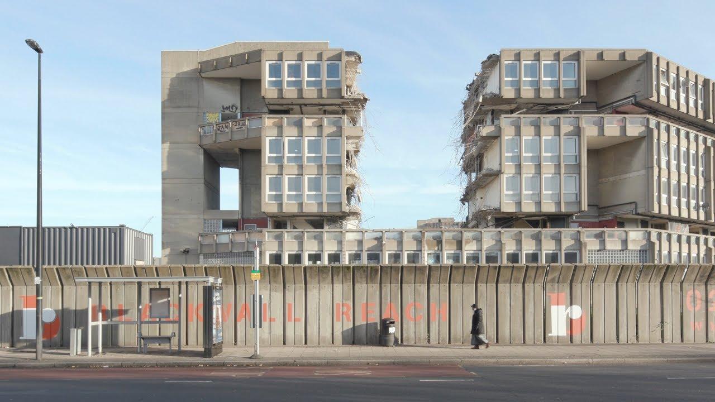
Figure 27 : Robin Hood Gardens during its demolition in 2017 (Credit: Deezen)
The major difference between the design of Robin Hood Gardens and the Goldfinger towers is that the Smithson’s designed a relatively low-rise block, but ironically this is the biggest argument in favour of its demolition.

In 2017, the first block was demolished to make way for the planned Blackwall Reach Regeneration, with the remaining block scheduled for future demolition. Simon Smithson wrote an article in Deezen architectural magazine, calling the demolition of the estate an ‘act of vandalism’, referring to the decision to deny listing of the building as a ‘failure of all those charged with protecting the nations architectural heritage’.

The new development, the Blackwall Reach project, plans to create 1,500 new homes compared to the 213 homes within the Robin Hood estate. Only the central grass mound will be retained from the Smithson’s estate.
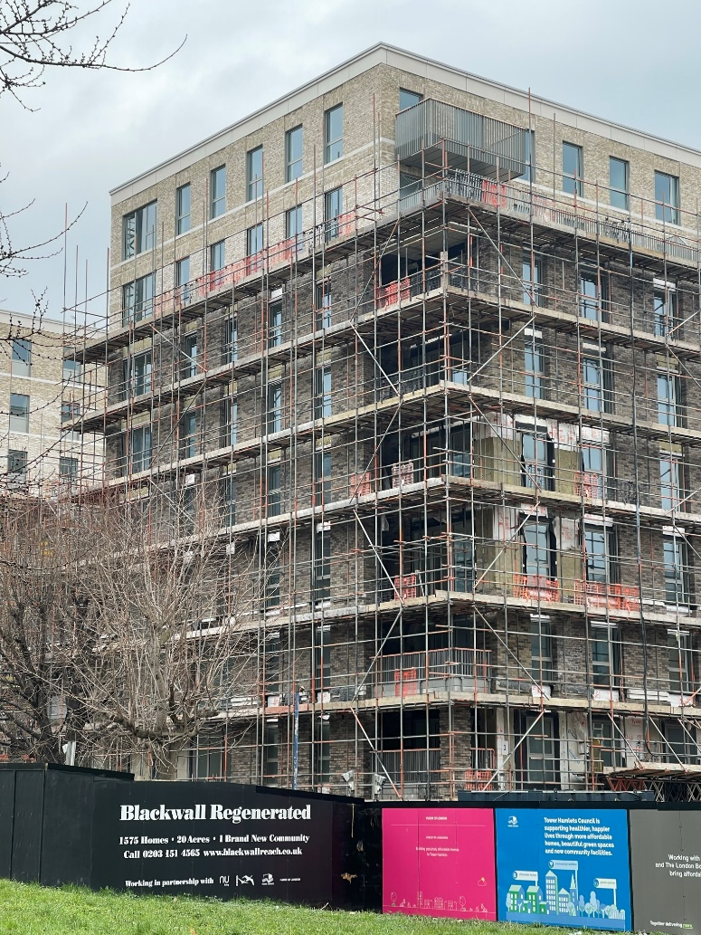
Figure 28: Blackwall Reach redevelopment project underway in 2023. (Credit: Author)
Sadly, none of the proposed homes will be allocated to social rent, however, the developers Haworth Tompkins, have claimed the new development will be kept ‘affordable’, though the accuracy of this term is debatable within the UK. The apartments will be allowed to be priced up to 80% of that of the market value of the area. Some apartments are valued to cost as much as £1,500 a month.

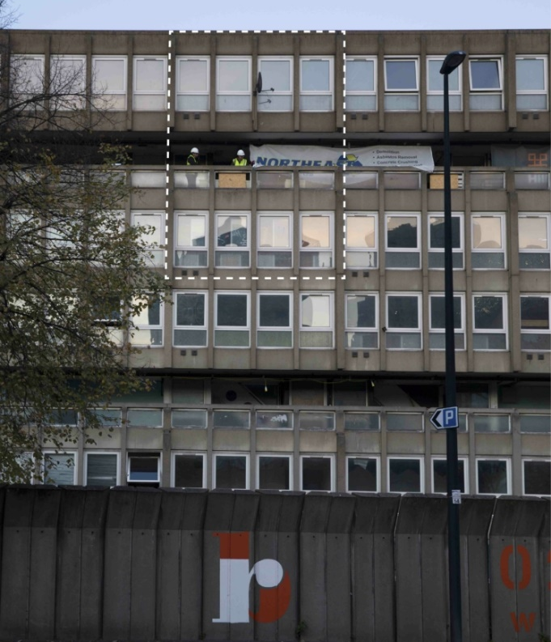
Despite the estates tragic end, by way of tribute, the V&A Museum has acquired a three-storey section of demolished wing. This includes the interiors and exterior facade of an apartment, and a section of the concrete ‘sky deck’, regarding the as a significant example of the Brutalist movement.
Figure 29 : Highlighted section of facade salvaged by the V&A Museum. (Credit: V&A)

Conclusion

Despite the growing appreciation for Brutalism, Trellick Tower has surprisingly managed to retain its social agenda, whilst becoming one of the most ‘iconic’ examples of the style. The Trellick became a symbol of the social problems associated with Brutalist tower blocks throughout the 70s and 80s, but appropriate management, led by a group of residents who refused to give up, gave the tower a fresh start, which in turn helped to change public perceptions and its portrayal in the media.

Overall, through the resident interviews, it was clear that Brutalist architecture as an aesthetic style, does in fact not play a big role in their perception of the tower, with little to no commentary referring to this. Instead, the functionality of the building including the community interaction and the maintenance upkeep of the building, were the key drivers of their perceptions. Just as Goldfinger himself said ‘The client does not care about architecture; he cares whether the building works.’

But perhaps the biggest travesty of all, is that the Brutalist movement, the social mission set upon by architects to provide a decent standard of living for everyday people, an architecture befitting of a post war Britain, has since been lost in translation in an appropriation by the rich.

With the biggest shift in perception being from the ideals of the architecture of the welfare state – the social provision of homes for all, via council housing building programmes, to a system that relies on market forces to provide housing. The problem with the market forces model is twofold- it doesn’t deliver enough homes to satisfy the housing demand, and what it does deliver many cannot afford.

Brutalism was bound up with this welfare state model of social provision of housing, it is therefore ironic that that it should now be aligned with fashionable places sold on the open market, such as the case at Balfron Tower. In aesthetic terms, it is severing the link between the form and original ethical content of this architectural movement.

A textbook example of ‘gentrification’ as some critics have said, and despite pleas from campaigners, including The Balfron Social Club, not even a small percentage of the tower could retain its social presence. Ultimately, forcing residents to leave their homes, in which their families have lived in for generations.

Even with everything Poplar HARCA has achieved, it is a real shame, it was unable to set an example of how to successfully refurbish a Brutalist estate, without displacing residents in the process.

Whilst Robin Hood Gardens demonstrated that not every Brutalist estate became the utopian vision of its architect. Never really experiencing its heyday, Historic England branded the estate as unoriginal, with the ‘streets in the sky’ concept already 20 years old at the time of the estate’s creation, despite this being what the duo are best known for. Not even the status of the Smithson’s or other high-profile architects campaigning could save this building from its demise.

Ironically, what separated the estates design from that of the Goldfinger’s towers, was the low density of the blocks, which resulted in the estates demolition in order to greatly increase this density of property in the area, and ultimately greater profits. Similarly, to Balfron, the Robin Hood Gardens is another example of a huge loss of social housing within London, becoming an all too familiar story in Brutalist estates across the United Kingdom.

Limitations

During the gathering of online interviews, it became apparent that material from the earlier years such as the 1970s and 80s was hard to come by. The initial methodology sought to gather sources from each decade since the creation of the Trellick, to then be arranged chronologically to be able to observe common themes and changes in perceptions accurately. However, instead a range of sources from the same interviewer, SpidTheatre, were identified, which ranged from original residents who moved into Trellick in the 70s and still live there now, to those who have moved in more recently. This gave insight into how residents attached feelings to the architecture they live in at this current time but didn’t really highlight the changes in perception as anticipated.

Further research into the public perceptions of perhaps low-rise brutalist estate such as the Alexandra Road estate in Camden, would likely prevent the variable of high-rise living perceptions, distorting the perceptions of Brutalist architecture. Alternatively, research into the perceptions of other public buildings, such as the National Theatre in London or the Civic Centre in Swansea, could uncover if these Brutalism is perceived in a different way when not affiliated with social housing.

Bibliography : Published Works

Balters, S. (2011) A.D Classics: Robin Hood Gardens / Alison and Peter Smithson. Available at: https://www.archdaily.com/150629/ad-classics-robin-hood-gardens-alison-and-peter-smithson (Accessed on 15 April 2023)

Banham, R. (1955, republished 2010) ‘The New Brutalism’ The Architectural Review. Available at: https://www.architectural-review.com/archive/the-new-brutalism-by-reyner-banham (Accessed: 30 April 2023)

Bendixson, T. (1969) ‘Box Mania’ The Guardian, 24 January, p. 11.

Business Times, The. (2022) From ‘Tower of Terror’ to brutalist icon: A London landmark abides. Available at: https://www.businesstimes.com.sg/property/tower-terror-brutalist-icon-london-landmark-abides (Accessed: 20 April /2023)

Burrows, T. (2019) Balfron 2.0: how Goldfinger’s utopian tower became luxury flats. Available at : ://www.theguardian.com/cities/2019/sep/19/balfron-20-how-goldfingers-utopian-tower-became-luxury-flats (Accessed on : 21 April 2023)

Calder, B. (2022) Raw Concrete : The Beauty of Brutalism. Dublin: Penguin Books. 2 edn.

Carroll, R. ( 1999 ) How did this become the height of fashion? Available at : https://www.theguardian.com/theguardian/1999/mar/11/features11.g28 ( Accessed on 21 March 2023)

Crinson, M. (2018) Alison and Peter Smithson. Swindon: Historic England, p. 69-71.

Dunnett, J. (1983) Erno Goldfinger : Works 1. London: Architectural Association. p. 83.

East End Review (2015) How the Balfron Tower residents were ‘decanted’ and lost their homes. Available at : https://www.eastendreview.co.uk/2015/03/24/balfron-tower-poplar-harca/ (Accessed on 15 April 2023)

Evening Standard, The. (1987) ‘Pressures of life in London…in the home and in the mind’ The Evening Standard, 15 June, p. 25,

Fisher, J. (1998) Architecture: Goldfinger. He’s the man with the modern touch. Available at : https://www.independent.co.uk/arts-entertainment/architecture-goldfinger-he-s-the-man-with-the-modern-touch-1174530.html (Accessed on 15 April 2023)

Frearson, A. (2014) Brutalist Buildings: Unite d’Habitation, Marseille by Le Corbusier. Available at : https://www.dezeen.com/2014/09/15/le-corbusier-unite-d-habitation-cite-radieuse-marseille-brutalist-architecture/ (Accessed on 30/ April 2023)

Frearson, A. (2015) Richard Rogers calls for architects to help save ‘exceptional’ Robin Hood Gardens. Available at : https://www.dezeen.com/2015/06/18/richard-rogers-calls-for-architects-help-save-brutalist-robin-hood-gardens-brutalism-poplar-london-england/ (Accessed on 25 April 2023)

Games, S. (1983) ‘Brute Source’ The Guardian, 15 June, p. 9.

Goodwin, D. (2020) Alison and Peter Smithson: The Duo that Led British Brutalism. Available at: https://www.archdaily.com/645128/spotlight-alison-and-peter-smithson (Accessed on 20 April 2023)

Grindrod, J. (2013) Concretopia. Breacon: Old Street Publishing Ltd, p. 324.

Hatherley, O. (2019) "We couldn't stop Balfron Tower from being privatised. In fact we probably helped it along".Available at https://www.dezeen.com/2019/05/03/balfron-tower-brutalist-renovation-gentrification-owen-hatherley-opinion/ (Accessed 19 April 2023)

Harling, R. (2017) Balfron Tower : The Artwash of an Icon. Available at: https://journal.urbantranscripts.org/article/balfron-tower-artwash-icon-rab-harling/ (Accessed on 29 April 2023)

Harwood, E (2014) 100 Years 100 Buildings 1954: Smithdon High School, Hunstanton. Available at: https://c20society.org.uk/100-buildings/1954-smithdon-high-school-hunstanton (Accessed: 29 April 2023)

Historic England. (2015) Robin Hood Gardens Estate. Available at: https://historicengland.org.uk/whats-new/news/robin-hood-gardens/ (Accessed: 26 March 2023)

Historic England (2017) Domestic 4: Modern Houses and Housing Listing Selection Guide. 2nd edn. Available at: https://historicengland.org.uk/images-books/publications/dlsg-modern-housing/heag105-domestic4-modern-houses-and-housing-lsg/ (Accessed: 29 April 2023)

Icon. (2020) Robin Hood Gardens: A brutal failure? Available at: https://www.iconeye.com/architecture/robin-hood-gardens-a-brutal-failure-2 (Accessed: 24 April 2023)

Johnson, S. (2023) Trellick Tower & The Cheltenham Estate. Available at: https://www.ribapix.com/trellick-tower# (Accessed: 20 March 2023)

Julius, C. (2003) ‘At home with the Smithsons’ Evening Standard, 03 December, p. 92.

Kroll, A. ( 2023 ) AD Classics : Unite d’Habitation / Le Corbusier. Available at : https://www.archdaily.com/85971/ad-classics-unite-d-habitation-le-corbusier?ad_source=search&ad_medium=projects_tab (Accessed: 29 April 2023)

Lynch, P. (2017) Demolition is Underway on Peter and Alison Smithson’s Robin Hood Gardens. Available at : https://www.archdaily.com/878674/demolition-is-underway-on-alison-and-peter-smithsons-robin-hood-gardens-in-london?ad_campaign=normal-tag (Accessed: 04 May 2023)

Mairs, J. (2017) Robin Hood Gardens demolition is an ‘act of vandalism’ says Simon Smithson. Available at : https://www.dezeen.com/2017/08/10/robin-hood-gardens-demolition-simon-alison-peter-smithson-post-war-housing-estate-london-uk-news/ (Accessed: 25 April 2023)

Merin, G. (2013) AD Classics : Ville Radieuse / Le Corbusier. Available at : https://www.archdaily.com/411878/ad-classics-ville-radieuse-le-corbusier (Accessed: 25.03.2023)

O’Sullivian, F. (2014) The Pernicious Realities of 'Artwashing'. Available at : https://www.bloomberg.com/news/articles/2014-06-24/the-pernicious-realities-of-artwashing (Accessed: 15 April 2023)

Phillips, B. (1978) ‘Rising Cramp’, The Observer, 23 April, p. 32.

Shelter. (2023) The Story of Social Housing. Available at: https://england.shelter.org.uk/support_us/campaigns/story_of_social_housing (Accessed on 30 April 2023)

Thoburn, N. (2022) Brutalism as Found : Housing, Form and Crisis at Robin Hood Gardens. London :Goldsmiths Press.

Victoria and Albert Museum (2023) Robin Hood Gardens. Available at: https://www.vam.ac.uk/articles/robin-hood-gardens (Accessed: 29 April 2023)

Wainwright, O. (2022a) ‘The council tenants weren’t going to be allowed back’: how Britain’s ‘ugliest building’ was gentrified. Available at : https://www.theguardian.com/artanddesign/2022/jul/26/balfron-tower-britain-ugliest-building-gentrified (Accessed: 20 April 2023)

Wainwright, O. (2022b) ‘It always felt good here’: how Sheffield’s brutalist Park Hill estate survived the haters and their bulldozers. Available at : https://www.theguardian.com/artanddesign/2022/apr/07/park-hill-from-brutalist-glory-to-sink-estate-to-contentious-regeneration (Accessed: 29 April 2023)

Wilder, S. ( 2022) Trellick Tower Residents are Still Fighting to Save Their Homes. Available at : https://www.huckmag.com/article/trellick-tower-residents-are-still-fighting-to-save-their-home (Accessed: 29 April 2023)

Winstanley, T. (2019) Architecture Classics : Trellick Tower / Erno Goldfinger. Available at : https://www.archdaily.com/151227/ad-classics-trellick-tower-erno-goldfinger (Accessed: 20 March 2023)

Winstanley, T. (2011) AD Classics: AD Classics: Balfron Tower / Erno Goldfinger. Available at : https://www.archdaily.com/160672/ad-classics-balfron-tower-erno-goldfinger (Accessed on 30 April 2023)

Worsley, G. (1998) ‘Notorious tower block listed’ The Daily Telegraph. 23 December. p. 7.

Bibliography : Unpublished Works

Balfron Social Club (2020) Dispossession: The Great Social Housing Swindle: Balfron Tower excerpt. Available at :
https://www.youtube.com/watch?v=0M10Hz_6SsM&list=PLRaW2wjQ71dWNjuuS9w5q6yixU3yPL58o&index=20 (Accessed on : 01/01/2023)

Building Sights Series 3 Episode 4 (2020, first transmitted in 1991) Building Heights – Trellick Tower. Available at: https://www.youtube.com/watch?v=66z3ppdDElc&t=15s (Accessed: 30 March 2023)

London Film School (2008) Capturing Space. Available at : https://lfs.org.uk/films-and-filmmakers/watch-our-films/188/capturing-space (Accessed on : 30/03/2023)

Lord Cashman (2015) Response in Debate: The regeneration of East London since the 2012 Olympic and Paralympic Games and the remaining challenges [Televised proceedings]. House of Lords, British Parliament, London. [Speech at: 15:58:30]. Available at: https://parliamentlive.tv/event/index/667e22e7-c184-4d12-a33a-07a0e9737a07 (Accessed: 30 April 2023)

SpidTheatre. (2017a) Reimagining Goldfinger Oral History Testimonies #1. Available at : https://www.youtube.com/watch?v=T8ZFNG35S0g&t=252s (Accessed on : 28/03/2023)

SpidTheatre. (2017b) Reimagining Goldfinger Oral History Testimonies #2. Available at : https://www.youtube.com/watch?v=DVpwHMmC6F4 (Accessed on : 28/03/2023)

SpidTheatre. (2017c) Reimagining Goldfinger Oral History Testimonies #3. Available at : https://www.youtube.com/watch?v=nv62Pt-TQ2E (Accessed on : 28/03/2023)

SpidTheatre. (2017d) Reimagining Goldfinger Oral History Testimonies #4. Available at : https://www.youtube.com/watch?v=KrjYgG_tSZg (Accessed on : 28/03/2023)

SpidTheatre. (2017e) Reimagining Goldfinger Oral History Testimonies #6. Available at : https://www.youtube.com/watch?v=rAHUTadsVr4&t=1s (Accessed on : 28/03/2023)

SpidTheatre. (2017f) Reimagining Goldfinger Oral History Testimonies #8. Available at : https://www.youtube.com/watch?v=ylUlHLMoJZw&t=1s (Accessed on : 28/03/2023)

SpidTheatre (2017g) Reimagining Goldfinger Oral History Testimonies #9. Available at : https://www.youtube.com/watch?v=2MgL4651UzE&t=898s (Accessed on : 28/3/2023)

SpidTheatre (2017h) Reimagining Goldfinger Oral History Testimonies #10. Available at : https://www.youtube.com/watch?v=-1hgw1gDsiE (Accessed on : 28/3/2023)

SpidTheatre (2017i) Reimagining Goldfinger Oral History Testimonies #11. Available at : https://www.youtube.com/watch?v=_4aJL5jcP0M (Accessed on : 28/3/2023)

SpidTheatre (2017j) Reimagining Goldfinger Oral History Testimonies #12. Available at : https://www.youtube.com/watch?v=8pXEdEUh3wo (Accessed on : 28/3/2023)

SpidTheatre (2017k) Reimagining Goldfinger Oral History Testimonies #13. Available at : https://www.youtube.com/watch?v=rBytdyHUd5A&t=1026s (Accessed on : 28/3/2023)

SpidTheatre (2017l) Reimagining Goldfinger Oral History Testimonies #14. Available at : https://www.youtube.com/watch?v=JjvGXpuowdM&list=TLPQMjkwNDIwMjPtPO9dzd0DXw&index=2 (Accessed on : 28/3/2023)

SpidTheatre (2017m) Reimagining Goldfinger Oral History Testimonies #16. Available at : https://www.youtube.com/watch?v=XkcNty8RLos (Accessed on : 28/3/2023)

Mengyan, S. and Xianyi, Z. (2021) Balfron and Trellick Tower, London. Available at : https://www.youtube.com/watch?v=Xi9GJEZxrVs&list=PLRaW2wjQ71dWNjuuS9w5q6yixU3yPL58o&index=12 (Accessed on 29/04/2023)

Appendix 1 – Trellick Tower Online Interview Notes
V I D E O T I T L E | D A T E | C O M M O N  T H E M E S | I M P O R T A N T  Q U O T E S / N O T E S
TrellickTowerCapturingSpace | 2008 |  | Lee Bolland -wow what a great building, I love the height of this building and the clear-cut lines, this is a modern building, and this will go with me, I like modern things.  The first Christmas in 1972, someone opened the fire hydrant on the landing and flooded out all of the lifts, it was complete darkness, the whole building had no lights, things really started to go downhill after that’  I do get mad when people say this and that about Trellick Tower, I say oh shut up, you don’t live there, you haven’t seen inside, you haven’t seen the apartments, please don’t say anything until you have come in and taken a look at it’  Sean O’Donnell – familiar with the size of the flats before moving in.  Heard stories of people within the building going up a floor or two to rob their neighbours, things never really left the building, things got robbed but were never seen to leave’.  ‘likewise, people wouldn’t deliver to the building, tv or white goods might get jacked half way up the lift and not even make it to the front door’ ‘had this reputation previous to me coming here’
REIMAGINING GOLDFINGER  ORAL TESTIMONIES #1 | 2017 | Community.  Social environment. | ‘it’s not the area that makes the people, it’s the people that make the area’.  First impressions – ‘little bit scary’  Heard many stories about the social environment of the tower, that it wasn’t a good area to raise children.  Diverse community.  Felt at home as so many people in the building spoke her native language – Portuguese  The community made her fall in love with the building.
REIMAGINING GOLDFINGER ORAL TESTIMONIES #2 | 2017 | ‘Life in the sky’  Social environment. | Lots of artists and creatives living in the tower now – compares Trellick to the Chelsea hotel  ‘Someone had their tv stolen, but the tv was never seen leaving the tower on cctv, so it must have remained in the building ‘  Private rented flats are rare, either council flats or a number of flats are private bought to live in.
REIMAGINING GOLDFINGER ORAL TESTIMONIES #3 | 2017 | Importance of the concierge.  Social environment. | Many of the community facilities never used - laundry room etc due to vandalism.  ‘The council have been amazing when it comes to the block’ new kitchens/bathrooms fitted 5 years ago.  Stressed the importance of the concierge within the block.
REIMAGINING GOLDFINGER ORAL TESTIMONIES #4 | 2017 | Diverse community.  Fear of the area being gentrified.  Clear understanding of the architecture. | Clear understanding of the architecture and history, loved the building before moving in.  Understands the concept of the streets in the sky and referred to key brutalist features.  His mother was an architect who was taught by Goldfinger.  Prominent Moroccan and Muslim community.
REIMAGINING GOLDFINGER ORAL TESTIMONIES #6 | 2017 | Disproves of the new demographic  Gentrification .  Bad perception of Tower blocks and Trellick tower  Trellick has become a tourist attraction.  Bad community spirit.  Council doesn’t maintain the building | Resident of Trellick for 8 years but lived in the area his whole life. Only moved in as he had no other option while waiting for the birth of his first daughter.  Bad memories of Trellick, particularly before the concierge.  Negative perception of all tower blocks - believes this come from the way they’ve been portrayed in the media. Though his wife and children love the building and don’t want to leave.  Clearly a council resident – complains of the ‘posh’ neighbours who ‘bought their way into the building’.  ‘They don’t want us here even though we grew up in the area’.  Claims the council don’t look after the building ‘ complain all you want, they won’t do anything’.  The area is being gentrified, Trellick is being sold out – ‘look down Golborne Road, those shops there, they’re not for us, no one from our area goes into them’ ‘local shops used to be for the local people’  ‘You go out on the balcony, there’s always people pointing cameras up, people taking photos all the time, phones, cameras, people come all the way to this area just to stand up and stare at Trellick, it’s like you’ve become a tourist attraction you know’.  Lots of lonely people in the building ‘I think it’s the building, it brings out a different mentality, it makes you feel more isolated’, says the community from the 80s/90s has gone.
REIMAGINING GOLDFINGER ORAL TESTIMONIES #8 | 2017 | ‘Life in the sky’  Fear of privatisation / gentrification  Council doesn’t maintain the building. | Values the views more than a garden.  ‘I love living in the sky, I love being able to see the horizon’  ‘Not in the traffic or passing public, its quieter, almost like being in the countryside’  A concrete building ‘structurally the quietest address you could have’ real value in a city, the calmness of the address.  Block has been ignored by the council – ‘I’m 25 years looking off my balcony, seeing the entire neighbourhood get scaffolded twice for repair work and Trellick has had nothing bar the east windows being replaced out of necessity, rather than regard for the building’.  Fear of gentrification / privatisation after Balfron Tower, ‘ would be a crime if these 2 building classics should be sold to the few, in the private market, rather than being available to the ever-changing volume of social people who come and go, that would be a real shame’.
REIMAGINING GOLDFINGER ORAL TESTIMONIES #9 | 2017 | Modern large flats.  Stories of the social environment within the tower.  Importance of the concierge.  Understanding of the social context of Brutalism.  Diverse community.  Brutalism rises in popularity – like a tourist attraction. | Moved in when Trellick first opened, flat seemed out of this world. ‘Like being in Dubai looking up at the first big tower.’  ‘Everyone wanted to move in when it first opened.’  No security was to blame for Trellick’s issues, talks about the girl who was attacked in the lift, people sleeping in stairwells, using it as a place to take drugs, recalls many break ins.  ‘You never know who you’re getting into the lift with, or who’s going to follow you to your door.’  Life improved dramatically after the introduction of the concierge, ‘you could leave your home knowing your place wasn’t going to get turned over.’ ‘There were more happy faces in the lifts.’  Up to 40/50 different nationalities within the tower, people move in and out very often.  Talks about the vast amount of people taking photos of Trellick – indicating the rise in popularity.  Believes ‘Goldfinger would be proud to see the way Trellick is today, he would turn in his grave to see the privatisation of Balfron.’
REIMAGINING GOLDFINGER ORAL TESTIMONIES #10 | 2017 | Modern, spacious apartments.  Social environment  Strong community  Life in the sky  Understanding of the social context of the building.  Area changing – gentrification? | Moved to Trellick in 1972/73 as a young girl.  Housed in Trellick with great excitement after living in a one room apartment in Paddington.  Loved the modern, spacious rooms, decorated with bright colours of the 70s.  At the time, there was a 7 year waiting list for houses in the area, hence why they opted for the apartment in the tower.  ‘Complex community’ very rough start, lots of social issues.  Much stronger community now, than in the early years.  Enjoys the views of London.  Understands the social context of the building, Goldfinger’s intention.  The local area is changing, lots of higher end shops and cafes, but she likes this – better to have a coffee shop on the corner of the street than a kebab shop or betting shop.  Comments on gangs of men hanging around the area and around the tower – similar experience to my own.
REIMAGINING GOLDFINGER ORAL TESTIMONIES #11 | 2017 | Areas changing  Fear of the exterior  Modern, spacious apartments | Areas changed a lot, not so much crime in the area.  Young offenders institute now nearby has positively impacted the area and the towers.  Initially terrified of the buildings ‘dark and nasty’ exterior, only fell in love with Trellick once she saw the flats, modern, spacious and light.
REIMAGINING GOLDFINGER ORAL TESTIMONIES #12 | 2017 | Strong community  Understanding of the social context of the building. | Past resident of Trellick, now lives further down the road, also lived in Balfron.  Describes the tower as ‘magical’ very different from other tower blocks, everyone talks to each other.  Strong sense of community, ‘never lived in London where the people have been so friendly.’  ‘There’s more to the architecture than just the aesthetic, it’s the magic of the story of Goldfinger and his vision that makes Trellick so special.’
REIMAGINING GOLDFINGER ORAL TESTIMONIES #13 | 2017 | Importance of the concierge  Trellick as a tourist attraction | Expresses the importance of the concierge in saving Trellick, before this ‘you could go to buy a newspaper and your house is burgled by the time you return’  Melting pot of different nationalities – but people keep to themselves.  ‘so famous, that virtually every other person walking by takes a photo’  Stronger community when the tower was full of local people.  Each nationality / culture sticks with their own.  Lack of involvement from many residents during resident committee meetings.
REIMAGING GOLDFINGER ORAL TESTIMONIES #14 | 2017 | Life in the sky  Keen interest in architecture | Keen interest in architecture – always admired the building which is why he moved in – recent resident.  Loves living high up, can see for miles.  Much safer now than before. used to be a no-go area.  ‘It really is like a street in the sky’.  Boiler room has not been used for decades, oil boilers could not be used since oil crisis, no one has come forward with plans to use this space, same goes for many of the community facilities within the tower.
REIMAGINING GOLDFINGER ORAL TESTIMONIES #16 | 2017 | Life in the sky  No sense of community | Change in demographic – from an Afro-Caribbean population to a majority Moroccan / somalin demographic.  Felt isolated growing up in the tower, being of white ethnicity.  Loves the views.  There isn’t a strong sense of community, little interaction between residents.  Referenced Le Corbusier’s idea of all amenities in 1 place, never became a reality in Trellick.  Loves the huge apartment – ‘architects don’t design flats this size anymore.’

Hatherley, 2011, p.87.
Shelter, 2023
Kroll, 2023.
Frearson, 2014.
Banham,1955, republished 2010.
At this point, Brutalism was taken to mean the honest use of materials in general, with the link to the concrete expressionism coming later in the movement.
Balters, 2011.
Winstanley, 2019.
Winstanley, 2011.
The Business Times, 2022.
East End Review, 2015.
Balters, 2011.
Frearson, 2015.
Winstanley, 2019.
Hatherley, 2019.
Dunnett, 1983, p. 83.
SpidTheatre, 2017.
Crinson, 2018.
Thorburn, 2022.
Winstanley, 2011.
Carroll, 1999.
Merin, 2013.
Johnson, 2023.
Dunnett, 1983, p.83.
Kroll, 2023.
Dunnett, 1983, p.83.
Carroll, 1999.
Lee Bolland – one of Trellick’s original and longest standing residents.
London Film School, 2008.
The Business Times, 2022.
Phillips, 1978, p.32.
The Evening Standard, 1987, p.25.
Phillips, 1978, p.32.
Games, 1983, p.9.
Carroll, 1999.
Building Sights Series 3 Episode 4, 2020, first transmitted in 1991.
Worsley, 1998, p. 7.
Dunnett, 1983, p. 1.
SpidTheatre, 2017a.
SpidTheatre, 2017j.
Also referring to Balfron Tower, Goldfinger’s earlier tower block design.
SpidTheatre, 2017f.
SpidTheatre, 2017e.
Wilder, 2022.
SpidTheatre, 2017m.
SpidTheatre, 2017k.
SpidTheatre, 2017h.
SpidTheatre, 2017j.
SpidTheatre, 2017l.
SpidTheatre, 2017e.
SpidTheatre, 2017b.
SpidTheatre, 2017f.
SpidTheatre, 2017m.
SpidTheatre, 2017i.
SpidTheatre, 2017f.
SpidTheatre, 2017k.
Grindrod, 2013, p.324.
Winstanley, 2011.
Fisher, 1998.
Bendixon, 1969, p.11.
Wilder, 2022
Wilder, 2022.
Calder, 2022.
Balfron Social Club, 2020.
Poplar HARCA – Housing and Regeneration Community Association.
East End Review, 2015.
East End Review, 2015.
East End Review, 2015.
East End Review, 2015.
O’Sullivan, 2014.
Calder, 2022.
Harling, 2017.
Harling, 2017.
Lord Cashman, 2015.
Hatherley, 2019.
Thorburn, 2022.
Thorburn, 2022.
East End Review, 2015.
Wainwright, 2022a.
Burrows, 2019.
Burrows, 2019.
Mengyan, Xianyi, 2021.
Burrows, 2019.
Wainwright, 2022b.
Goodwin, 2020.
Harwood, 2014.
Victoria and Albert Museum, 2023.
Victoria and Albert Museum, 2023.
Crinson, 2018.
Goodwin, 2020.
Victoria and Albert Museum, 2023.
Icon, 2020.
Julius, 2003.
Historic England, 2017.
Historic England, 2015.
Simon Smithson, the son of Peter and Alison Smithson.
Frearson, 2015.
Frearson, 2015.
Historic England, 2015.
Mairs, 2017.
Lynch, 2017.
Lynch, 2017.
Victoria and Albert Museum, 2023.

