BA Business Management
LCBB5000: Data Handling and Business Intelligence
Lecturer: Joy Botu
Assignment Title: Assessment 2 Coursework (Written Report)
Student name:Tsvetelina Marinova
Student number:1812790

Part 1 – 60% of 75% (1750 words):
Introduction
By September 2021, the pandemic caused by the coronavirus (COVID-19) and the government's limits on social interaction will have had a substantial impact on the patterns of criminal activity. During this period of time, there were a wide variety of restrictions that were in effect, as well as disparities throughout the regions. The task of establishing the possible impact that constraints may have had on crime patterns is made more difficult as a result of this. When the nation was under a state of lockdown, there was a general decrease in crime of all types. However, according to data collected by the police during the past six months, the incidence of some crimes has either recovered to or even surpassed the levels seen before the pandemic (Walczak, 2021). According to the findings of the Telephone-operated Crime Survey (TCSEW1), this pattern has not yet manifested itself. It's possible that this is because of the delay in reporting incidences through the survey. Estimates from the Crime Survey for England and Wales (CSEW) are the most reliable tool for predicting long-term shifts in criminal activity. According to estimates provided by TCSEW for the year ending September 2021, compared to the year ending September 20192 prior to the outbreak of the coronavirus2, the number of crimes involving fraud and computer misuse increased by 47 percent, while crimes not involving fraud or computer misuse decreased by 14 percent. The decrease in crimes not involving fraud or computer misuse was largely driven by an 18 percent decrease in theft offences (Elkin, 2022).
Analysis of crime patterns and trends using systematic procedures that offer timely and useful information is known as "crime analysis" in the field. For example, efficient crime analysis has an impact on all parts of a police agency's operations. Criminology analysis has been utilised by police agencies to improve operational and administrative efficiency; officer job satisfaction; patrol deployment system capacity to match demand; and patrol activities' ability to prevent crime. The offence report serves as the primary source of raw data for crime analysis purposes (Elkin, 2022). Information must be timely, complete, accurate, and relevant in order to be effective. Using Pivot Tables and VLOOKUP functions in Excel, the next paragraph will analyse some data regarding the crime rate in the United Kingdom.

Data analysis
Before I begin with the data analysis, I will calculate the measures of central tendencies for our data.
Mean (average): Sum all number together and divide by the number of values will give you
the mean. Mean (average of a crime rate) is – 102.8085. To calculate it, the AUTOSUM function in excel was used: =AVERAGE (A2:A48)
Median: The middle value in a data set ordered from least to greatest.
The median value for crime rate is 101.45, Autosum was used again but this time for MEDIAN =MEDIAN(A2,A2:A48)
Data Mining
The original dataset was formatted by sorting the values the highest to the lowest.
The first Excel function which will be used in order to determine the crime rate per million population will be PIVOT TABLES. In order to do so, a PIVOT TABLE was from the insert menu. From then on, descriptive fields had to be added to the table in order to maternalise and organise our data into meaningful graphs and tables. In the rows section of the data, the dataset for crime rates was put where in values – sum of youth; sum of males and sum of more males were extracted from the original dataset. From then on, a pivot table was produced (Table 1)
The crime rate is higher that the sum of males included in the dataset.

4832 | 13026 | 92404 | 18
48 | 49 | 49 | 49
4880 | 13075 | 92453 | 67

The PIVOT CHART findings
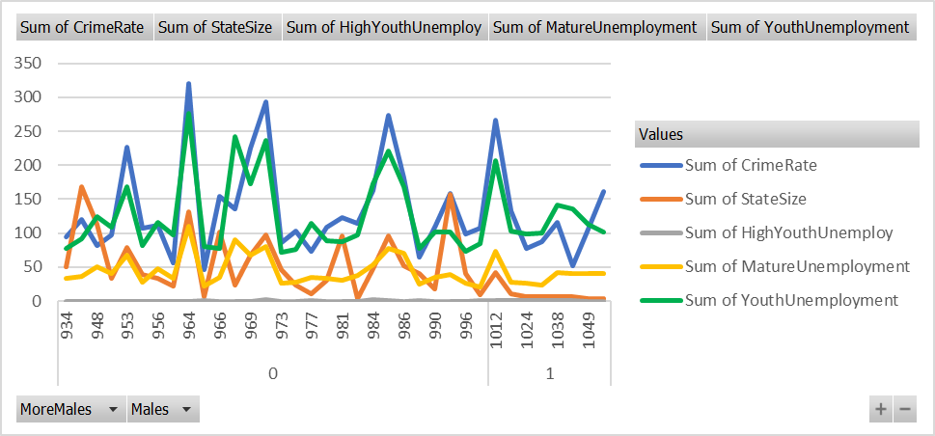
The findings, which are eloquently represented in the TABLE CHART, indicate that there is a positive correlation between the crime rate and the unemployment rate. This is the conclusion that can be drawn from the data. This is the inference that can be made from the information provided.
LOOKUP Function in Excel to analyse the data
When you need to search a single row or column in order to find a value that is located in the same position in a different row or column, use the LOOKUP function, which is one of the lookup and reference functions (Microsoft.com, 2021).
This is the output of the function =LOOKUP(A2:A48,I2:I48), which was designed to compare the data regarding the crime rate and the size of the state. Regrettably, in spite of numerous attempts, the formula turned out to be inaccurate, which means that it cannot be utilised for the aforementioned purposes.

Evaluation 500
Charts in Excel can be used to visualise any set of data. For example, in a Bar Chart or Line Chart, you can see the data represented by symbols such as bars or lines. One of the options that Excel provides is a variety of chart types, and you can choose one that best suits your data or you can use this feature and select one of the custom-made charts that Excel recommends for you (Tutorialspoint.com, 2015).
What exactly does "Data Preprocessing" entail?
A method known as "data preprocessing" is a process that is applied to raw data in order to produce a clean data set. In other words, whenever the data is gathered from various sources, it is collected in raw format, which is not feasible for the analysis. This makes it impossible to draw conclusions from the data. As a result, particular procedures are carried out in order to transform the data into a compact and clean data set. Before beginning the actual process of Iterative Analysis, you will first complete this technique. The term "Data Preprocessing" refers to the series of steps that are taken. It consists of cleaning up the data (Kaur, 2022).
- Data Integration
- Transformation of the Data
- The reduction of data

The presence of real-world data that has not been formatted makes it necessary to perform data pre-processing. The majority of data collected from the real world consists of:
Incorrect data (missing data) - There are many reasons for missing data, such as the fact that data is not continuously collected, a mistake in data entry, technical problems with biometrics, and many more of these kinds of issues, all of which require adequate data preparation (Kaur, 2022).
The existence of noisy data (including erroneous data and outliers) - The reasons for the existence of noisy data could be due to a technological problem with the device that collects the data, a human error made while entering the data, or a number of other factors (Kaur, 2022).
Data that is inconsistent — The presence of inconsistencies are due to the reasons such as the existence of duplication within the data, human data entry, containing mistakes in codes or names, i.e., violation of data constraints, and much more, which call for Data Preparation and analysis (Kaur, 2022).
In our situation, the handling of the raw data set included formatting it before conducting the analysis.
The process of "data wrangling" is an essential component of putting the model into action. Because of this, the data must first be transformed into an appropriate format before any model can be applied to it. It may be possible to improve the model's accuracy and performance by performing operations such as filtering, grouping, and making appropriate data selections. Another idea is that when time-series data needs to be handled, each algorithm is carried out with its own unique set of parameters to consider. As a result, Data Wrangling is utilised so that the time series data can be converted into the required format of the model that is being applied. To put it another way, the complicated data is reorganised and presented in a format that can be used to carry out analysis on it (Kaur, 2022).
Conclusion
Excel provides multiple options for displaying the results of your data research. To help your audience understand what you're trying to communicate about the data, it's a good idea to produce graphs and charts to reflect the outcomes of your data research. This practise can also improve presentation style. Excel permits the creation of visual representations of the relationships between distinct data sets. A chart is a graphical representation of data in the form of symbols such as bars or lines, depending on the type of chart being displayed. With Excel's Recommended Charts feature, you may select the most suitable chart type for your data. As a second alternative, you can choose a chart type from Excel's broad selection and modify it to match your data. As you may already be aware, it is difficult to visualise how the aims in this chart relate to actual outcomes. It will have little effect on your outcomes (Tutorialspoint.com, 2015).
Utilizing pivot charts makes it easy to graphically summarise and investigate complex data.
PivotCharts contain the same sorts of data series, categories, and graphic axes as standard charts. Using the chart's interactive filtering tools, you may also examine a portion of your data quickly. These options are displayed directly on the chart (Tutorialspoint.com, 2015).
Occasionally, it is necessary to visualise a large PivotTable or numerous complex worksheets including both numerical and non-numerical data. It is possible that a PivotChart will assist you in making sense of this data (Tutorialspoint.com, 2015).

Part 2
- How many students like vanilla flavour?
Ice_Cream
 |  | Frequency | Percent | Valid Percent | Cumulative Percent
Valid | 1 | 95 | 47.5 | 47.5 | 47.5
Valid | 2 | 47 | 23.5 | 23.5 | 71.0
Valid | 3 | 58 | 29.0 | 29.0 | 100.0
Valid | Total | 200 | 100.0 | 100.0
From the table above we can see that 95 out of 200 (47.5 percent) students like ice cream with vanilla flavour. 47 (23.5 percent) of them like chocolate, and 58 (29 percent) strawberry.
- How many students are Male and Female?
Gender
 |  | Frequency | Percent | Valid Percent | Cumulative Percent
Valid | 0 | 91 | 45.5 | 45.5 | 45.5
Valid | 1 | 109 | 54.5 | 54.5 | 100.0
Valid | Total | 200 | 100.0 | 100.0
From the table above we can see that there are 91 (45.5 percent) male students and respectively, 109 (54.5 percent) female students in this research from 200 in total.

- What are the Mean and Median of participants who like chocolate and strawberry flavour?

Statistics
 |  | Gender | Ice_Cream
N | Valid | 105 | 105
N | Missing | 95 | 95
Mean |  | .58 | 2.55
Std. Error of Mean |  | .048 | .049
Median |  | 1.00 | 3.00
Std. Deviation |  | .496 | .500
Range |  | 1 | 1
From the table above we can see that the Mean for participants who like chocolate and strawberry ice cream is 2.55, and the Median is 3.

a)

Number of Cases in each Cluster
Cluster | 1 | 95.000
Cluster | 2 | 105.000
Valid |  | 200.000
Missing |  | .000
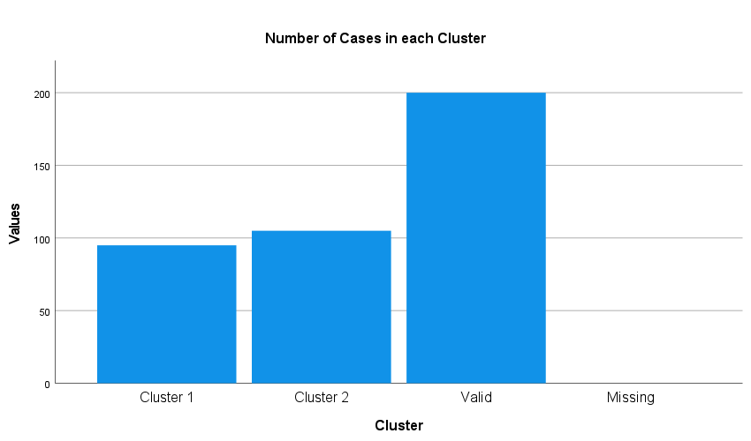
Above we can see the number of each cluster (Cluster 1-Male; Cluster 2-Female).
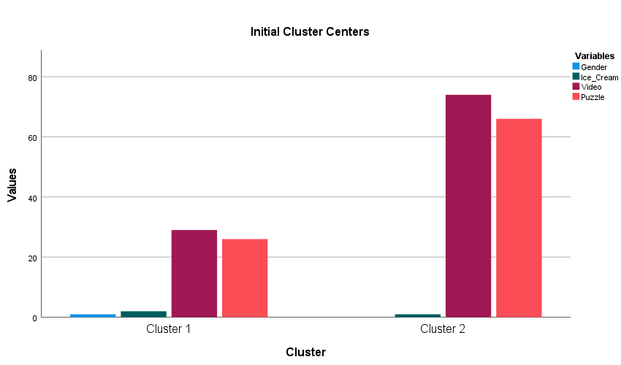
From the bar-chart above we see the results for the Initial Cluster Centres. Cluster 2 (females) score significantly high on Video and Puzzle variables, while Cluster 1 (males) also score higher on Video and Puzzle variables, but considerably less than Cluster 2 (females).

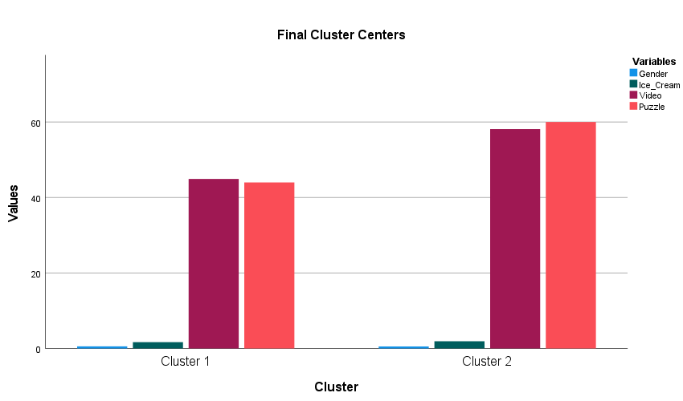

From the bar-chart above we see the results for the Final Cluster Centres. Cluster 2 (females) yet again score very high on Video and Puzzle variables, as well as Cluster 1 (males) who score significantly higher on Video and Puzzle variables, compared to analysis of initial cluster centres, but still considerably less than Cluster 2 females).

b)
Text mining is the act of transforming unstructured text into structured information for more efficient analysis. Natural language processing (NLP), a kind of text mining, has become able to process human language. It's a double-edged sword for companies because of the tremendous amount of data they acquire on a regular basis. In order to discover what your consumers think about the product or service, you'll need to gather data from the clients. Consider about all the potential concepts we may get from reading emails, customer reviews, social media posts, customer comments, support requests, etc (Weiss et al., 2010). Another issue is how to analyse all this information. Text mining has a vital function to play here. Non-specialists may be perplexed by text mining, as well as many other NLP-related terminology. In actuality, it doesn't have to be. It is possible to do text mining in a number of methods. Some of the more popular examples are as follows:

- Word Frequency - To identify the most commonly recurring words or concepts in a dataset, use word frequency. Customers' reviews, social media discussions, and customer reviews could all benefit from discovering the most popular phrases in textual information.
- Collocation - Phrases that appear frequently in the identical environment are known as "collocations." A bigram is a pair of words that are inclined to do it together, while a trigram is a three-word combo.
- Concordance - The term "concordance" refers to the usage of a word or a group of words in a given context or contexts. It's possible to use the same word in a number of contexts because of the ambiguity of language. Concordance research can be used to establish the meaning of a word depending on its usage in the environment (Weiss et al., 2010).

In order to extract explanation of vast volumes of dispersed data and transform it into useful knowledge, data mining uses automated or semi-automated technological methods. Anomalies, patterns, and correlations among millions of data are searched for in order to make predictions about the outcome. Data mining's ability to forecast corporate outcomes has altered the way plans are devised (Larose, 2006). Your ability to forecast the future is now enhanced since you have a better grasp of the present. In today's business, these are some instances of how data mining is used:

- Marketing - To better understand and target a certain market, data mining is currently being utilized in marketing. It is feasible to predict a customer's behaviour based on their age, gender, taste preferences, and more by examining the correlations between these variables. Analytics in marketing may be used to identify which customers are most likely to unsubscribe from a service, what they are searching for, or what they should include in a mailing list in order to have a greater response rate.
- Retail - Product placement in supermarkets and on shelves is based on cooperative purchase trends. Customer value or increased sales in the checkout queue may also be discovered via data mining.
- Banking - Data mining is being used by banks to properly assess the dangers in the market. Intelligent anti-fraud systems, credit ratings, and transaction data such as credit card purchases, purchase trends, and client financial information all use this technique regularly. Using data mining, financial institutions are able to learn more about our online habits and preferences in order to optimise their marketing efforts, examine the efficacy of sales channels, or handle compliance requirements duties (Larose, 2006).
c)

N | Excel |  | SPSS
 | Advantages | Disadvantages | Advantages | Disadvantages
1 | Excel is used to gather and organise data, which is one of their most basic functions. It's simple to arrange data into clean columns and rows, and then to sort the data according to its kind. There are capabilities inside the application that enable you to make presentations where the data is evaluated and inserted into pie charts or tables for simple viewing and comprehension, even when the raw data may be overwhelming. | Calculations have to be typed into a spreadsheet as formulae, which many users find challenging. This necessitates familiarising yourself with the precise syntax for each different form of computation. Numerous people find these formulae challenging, despite the fact that many courses are available to teach them. | Using a database, students may integrate data from other sources, such as Excel. | Large datasets cannot be analysed using SPSS because of this constraint. In the medical and nursing disciplines, researchers often utilise SAS rather than SPSS to analyse clinical data because of the vast amount of data involved.
2 | Excel's main selling point is that it handles all of the arithmetic for you. After writing a formula and setting up a command for the software, sophisticated calculations may be made for the data that has been entered. | For one thing, your files aren't safe in Excel. As a result, spreadsheets are more susceptible to data corruption and incompetence than other types of files. | A user-friendly interface makes SPSS Statistics an excellent tool for analysing and understanding your data, and solving difficult business and research challenges. Improve the accuracy and quality of your decision-making by swiftly analysing huge and complicated data sets using powerful statistical processes. | Perhaps the biggest disadvantage of SPSS is its price. This is the most expensive predictive analysis software on the market at the moment.
3 | It is possible to share spreadsheets in Microsoft Excel, but only one person may edit the data at the same time. The latest research will not be accessible to other users if local versions are produced and maintained. | Other relevant information which might impact decision-making may be ignored accidentally since these displays only show the data which the user chooses to analyse. It is becoming increasingly common for firms to utilise reporting technologies like Tableau and Qlik instead of spreadsheets to make data reporting more user pleasant and thorough. | Statistical models from a wide variety. At the outset of a research endeavour, you may not know which statistical models are most suited to your specific topic. You may have a rough concept when you begin, but when you dig more into the data, you may discover that your original statistical model was incorrect. | A major disadvantage of SPSS that it is a limited software due to its only graphical use. Formulas cannot be used directly, which seems as a drawback for many advanced users.
(Abbott, 2016)

References
Abbott, M. L. (2016). Using statistics in the social and health sciences with SPSS and Excel. John Wiley & Sons.
Elkin, M. (2022). Crime in England and Wales. [online] Ons.gov.uk. Available at: https://www.ons.gov.uk/peoplepopulationandcommunity/crimeandjustice/bulletins/crimeinenglandandwales/yearendingseptember2021 [Accessed 18 May 2022].
Kaur, J. (2022). Data Pre-processing and Data Wrangling in Machine Learning. [online] Xenonstack.com. Available at: https://www.xenonstack.com/blog/data-preparation [Accessed 19 May 2022].
Larose, D. T. (2006). Data mining methods and models. John Wiley & Sons.
Microsoft.com. (2021). LOOKUP function. [online] Available at: https://support.microsoft.com/en-us/office/lookup-function-446d94af-663b-451d-8251-369d5e3864cb [Accessed 19 May 2022].
Tutorialspoint.com. (2015). Excel Data Analysis - Data Visualization. [online] Available at: https://www.tutorialspoint.com/excel_data_analysis/excel_data_analysis_visualization.htm [Accessed 19 May 2022].
Walczak, S. (2021). Predicting Crime and Other Uses of Neural Networks in Police Decision Making. Frontiers in Psychology, [online] 12. doi:10.3389/fpsyg.2021.587943.
Weiss, S. M., Indurkhya, N., Zhang, T., & Damerau, F. (2010). Text mining: Predictive methods for analyzing unstructured information. Springer Science & Business Media.

‌

